**Experiment 2.2**

**Student Name: Yash Gupta UID: 20BCS5009**

**Branch: Computer Science Engineering Section: 709-A**

**Semester: 4th Date of Performance: 27/3/2022**

**Subject Name: Microprocessor Subject Code: 20CSP-253**

1. **2’s compliment of 8bit data.**

Code :-

**#BEGIN 0000**

**LDA 3000**

**CMA**

**ADI 01**

**STA 3001**

**HLT**

**#ORG 3000**

**#DB 02**

Output :-

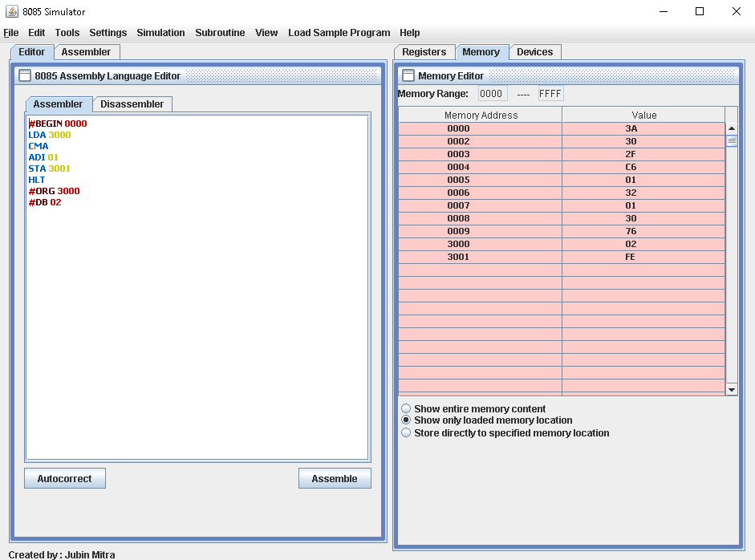

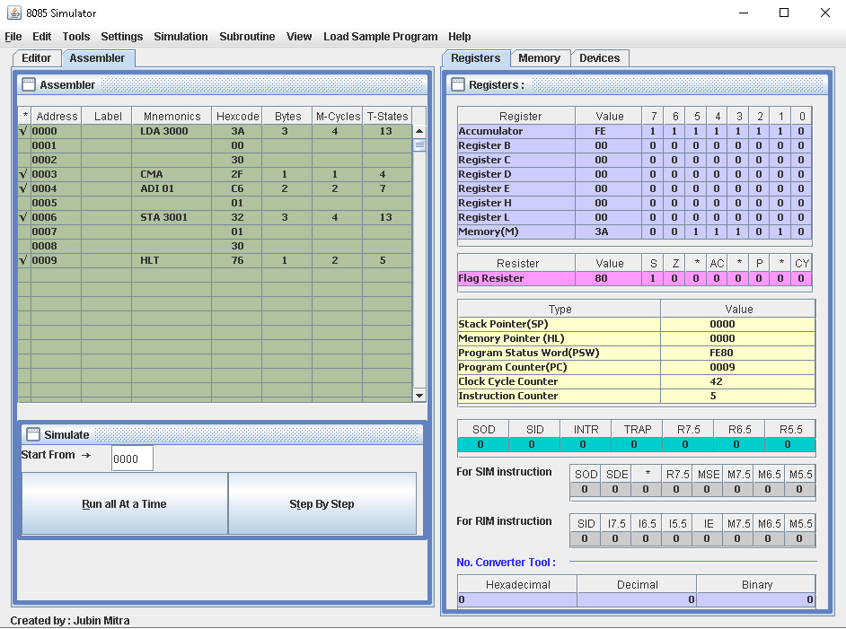

1. **2’s compliment of 16bit data.**

Code :-

**#BEGIN 0000**

**LHLD 3000**

**MOV A,L**

**CMA**

**MOV L,A**

**MOV A,H**

**CMA**

**MOV H,A**

**INX H**

**SHLD 3002**

**HLT**

**#ORG 3000**

**#DB 01,02**

Output :-

