**Experiment – 2.4**

**Student Name: Yash Gupta           UID: 20BCS5009**

**Branch: CSE     Section: 709 - A**

**Subject Name: Microprocessor and Interfacing Lab**

**Subject Code: 20CSP-253**

# **Aim :-**

**a) Shift left 8-bit number by 1 bit.**

**b) Program to Shift Left 8-bit Number by 2 Bit**

# **Theory :-**

RAL

* Rotate accumulator left through carry
* Each binary bit of the accumulator is rotated left by one position through the Carry flag.
* Bit D7 is placed in the Carry flag, and the Carry flag is placed in the least significant position D0.
* CY is modified according to bit D7

**Shift left 8-bit number by 1 bit.**

# **Code :-**

**#BEGIN 0000**

**LDA 2000**

**RAL**

**STA 2001**

**HLT**

**#ORG 2000**

**#DB 25**

# **Output :-**

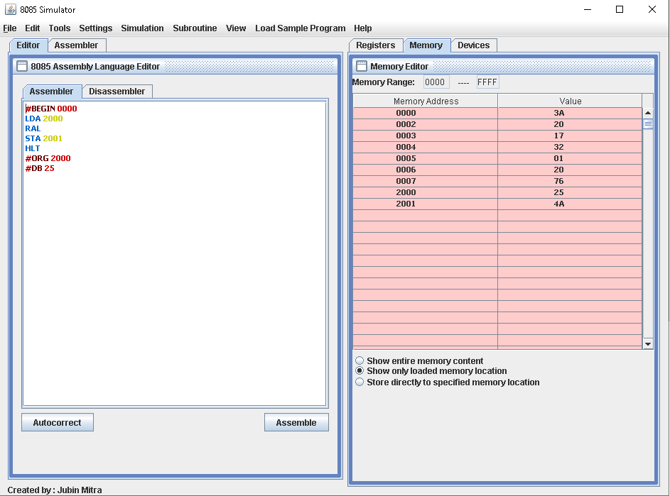

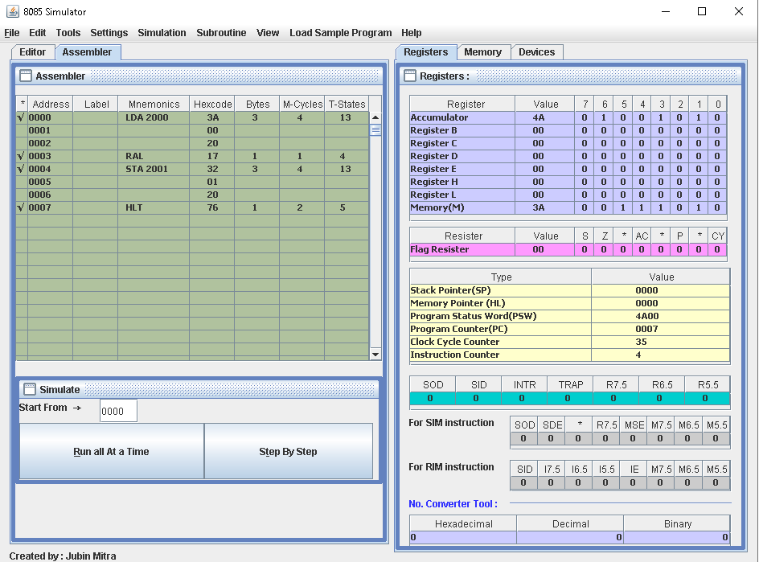

**Program to Shift Left 8-bit Number by 2 Bit**

# **Code :-**

**#BEGIN 0000**

**LDA 2000**

**RAL**

**RAL**

**STA 2001**

**HLT**

**#ORG 2000**

**#DB 25**

# **Output :-**

