**Experiment – 2.5**

**Student Name: Yash Gupta           UID: 20BCS5009**

**Branch: CSE     Section: 709 - A**

**Subject Name: Microprocessor and Interfacing Lab**

**Subject Code: 20CSP-253**

# **Aim :-**

**a) Shift left 16-bit number by 1 bit.**

**b) Program to Shift Left 16-bit Number by 2 Bit**

# **Output :-**

**a) Shift left 16-bit number by 1 bit.**

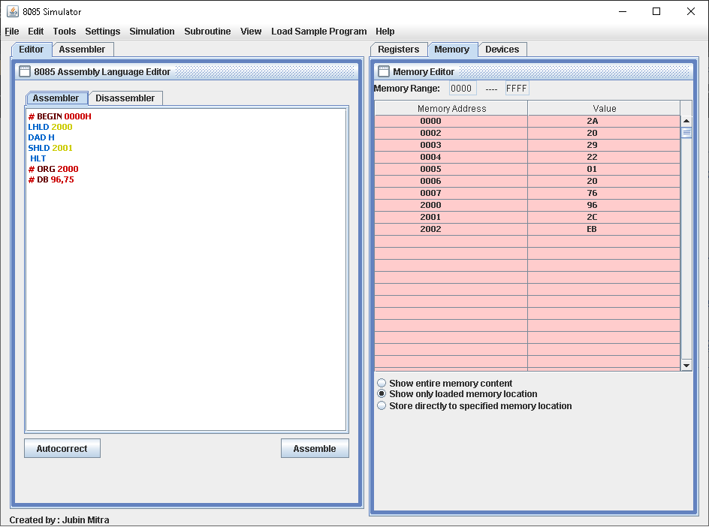

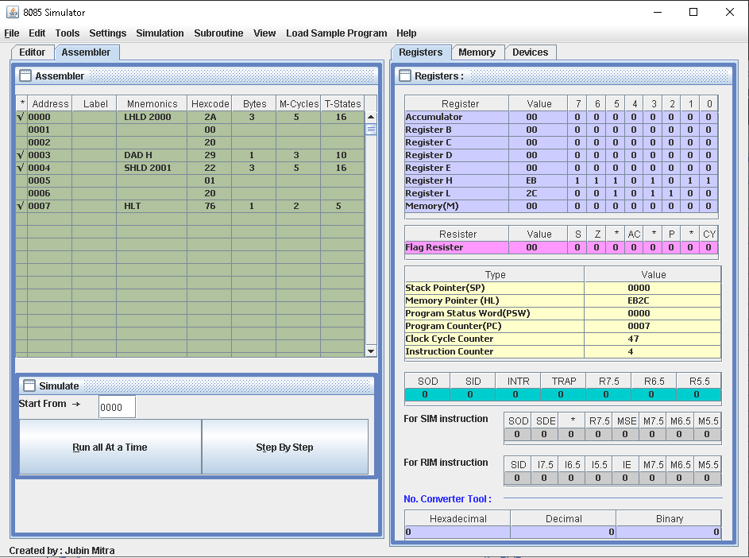

**b) Program to Shift Left 16-bit Number by 2 Bit**

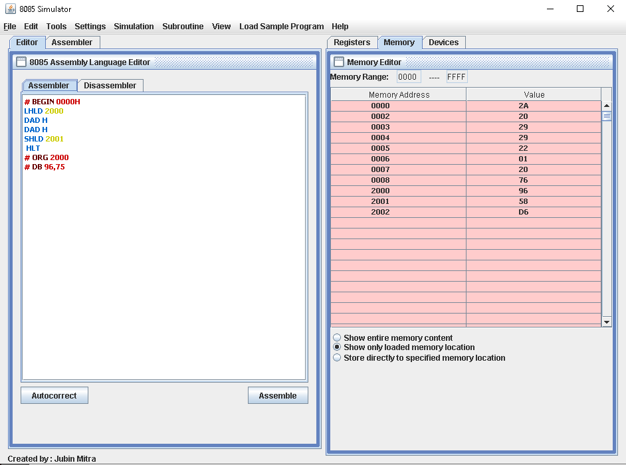

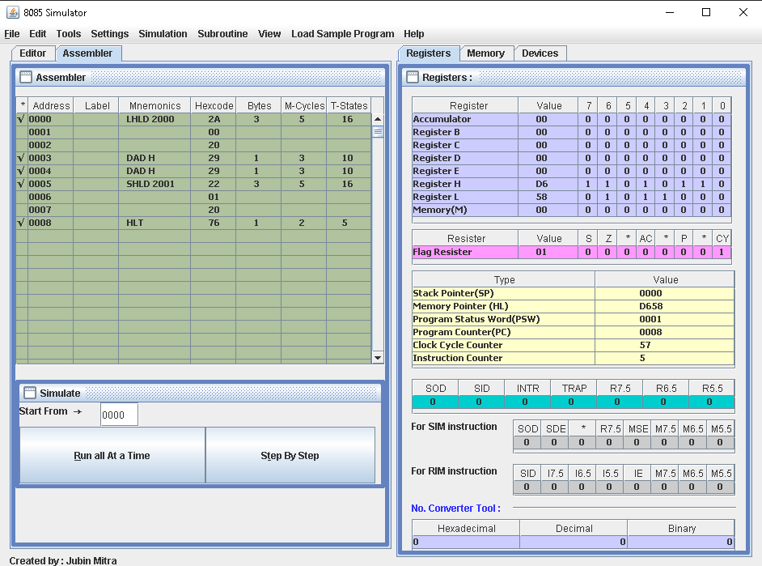

# **Code :-**

**a) Shift left 16-bit number by 1 bit.**

**# BEGIN 0000H**

**LHLD 2000**

**DAD H**

**SHLD 2001**

**HLT**

**# ORG 2000**

**# DB 96,75**

**b) Program to Shift Left 16-bit Number by 2 Bit**

**# BEGIN 0000H**

**LHLD 2000**

**DAD H**

**DAD H**

**SHLD 2001**

**HLT**

**# ORG 2000**

**# DB 96,75**