**Experiment – 3.1**

**Student Name: Yash Gupta           UID: 20BCS5009**

**Branch: CSE     Section: 709 - A**

**Subject Name: Microprocessor and Interfacing Lab**

**Subject Code: 20CSP-253**

AIM:

a) Mask the lower nibble of an 8-bit number.

b) Mask the higher nibble of an 8-bit number.

THEORY:

**In 8085 Instruction set, ANI is a mnemonic, which stands for “ANd Immediate with Accumulator” and “d8” stands for any 8-bit or 1-Bytedata. This instruction is used to AND 8-bit immediate data with the Accumulator’s content. The result of this ANDingoperation will be stored in the Accumulator itself over writing its previous content. As it is an arithmetic operation do S, P, and Z flags are affected based on the result. Cy is reset to 0, and AC is set to 1. It occupies 2-Bytes in the memory.**

**Mnemonics-ANI**

**Operand -Data**

**Bytes-2**

CODE :-

1. Mask the lower nibble of an 8-bit number.

#BEGIN 0000

LDA 3000

ANI 0F

STA 2001

HLT

#ORG 3000

#DB 45

1. Mask the higher nibble of an 8-bit number.

#BEGIN 0000

LDA 3000

ANI F0

STA 2001

HLT

#ORG 3000

#DB 45

Outpt:-

1. Mask the higher nibble of an 8-bit number.

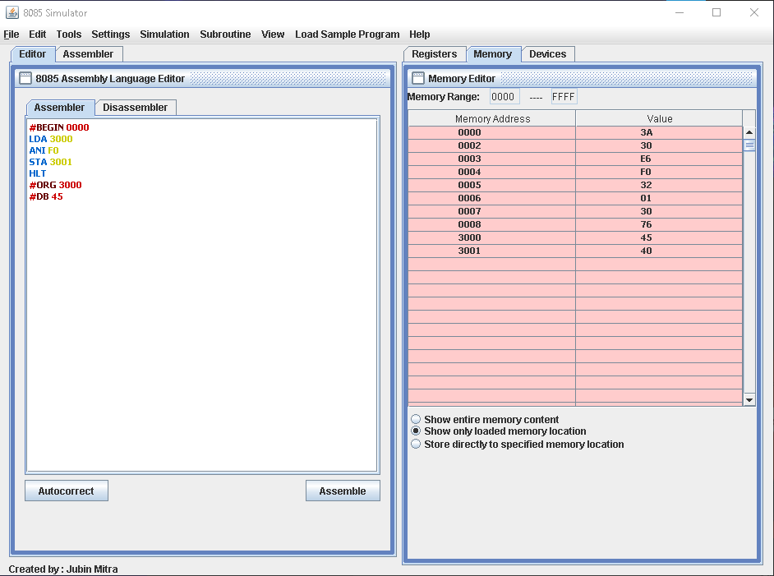

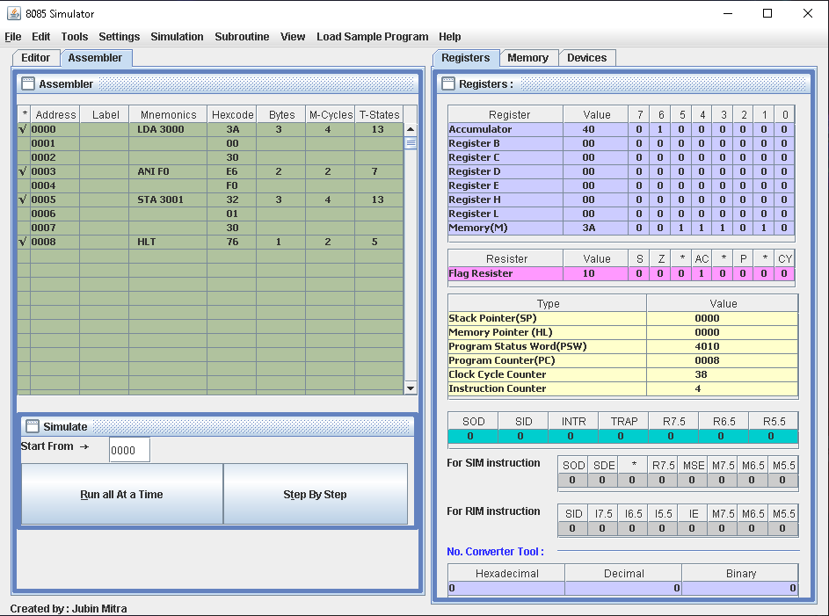

1. Mask the lower nibble of an 8-bit number.

