**Experiment-09**

**Student Name:** Yash Gupta **UID:** 20BCS5009

**Branch:** B.E.CSE **Section/Group:** 709-A

**Semester:** 4th **Subject Name:** MPI Lab

**Code:**20CSP253

**1. Aim/Overview of the practical:**

**a)**Find the smaller out of two numbers.

b) Find the larger out of two numbers.

**2. Task to be done:**

**a)**Find the smaller out of two numbers.

b) Find the larger out of two numbers.

1. **Apparatus/Simulator used (For applied/experimental sciences/materials based labs):**

Jubin , Java

1. **Description/ Code:**

***a****)****Find the smaller out of two numbers.***

#BEGIN 0000H

LXI H,3000H

MOV A,M

INX H

MOV B,M

CMP B

JC 200BH

MOV A,B

INX H

MOV M,A

HLT

#ORG 3000H #DB 24H,16H

*b****) Find the larger out of two numbers.***

#BEGIN 0000H

LXI H,3000H

MOV A,M

INX H

MOV B,M

CMP B

JNC 200BH

MOV A,B

INX H

MOV M,A

HLT

#ORG 3000H #DB 14H,18H

**5. Result/Output/Writing Summary:**

**a)**Find the smaller out of two numbers.

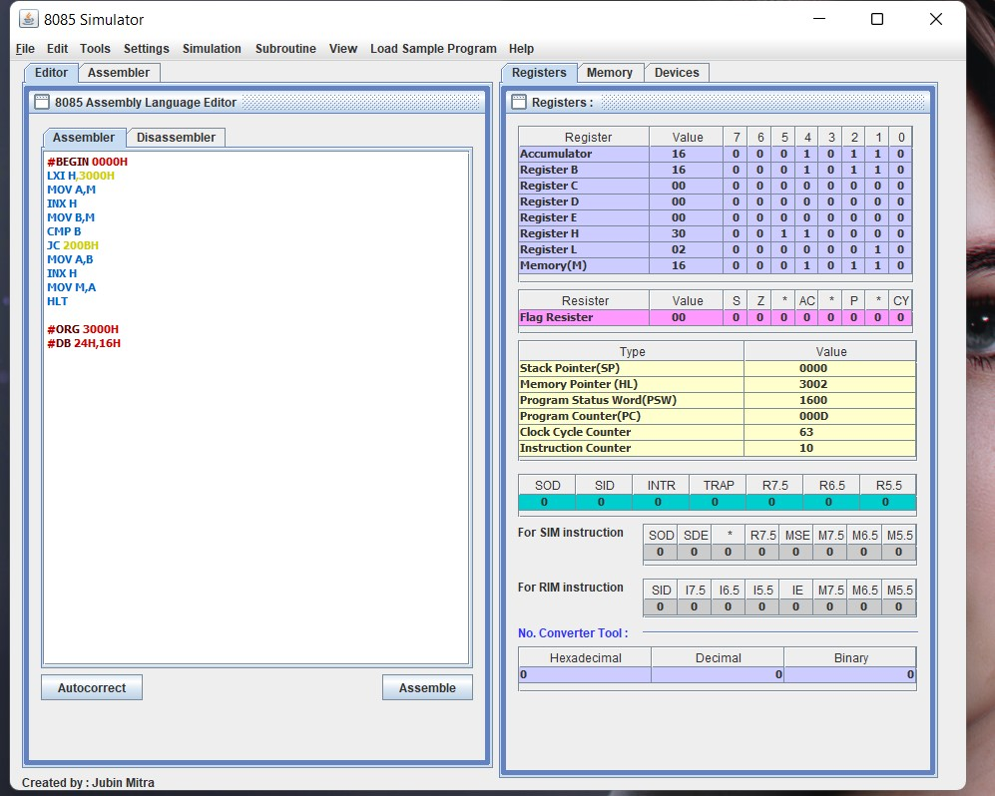

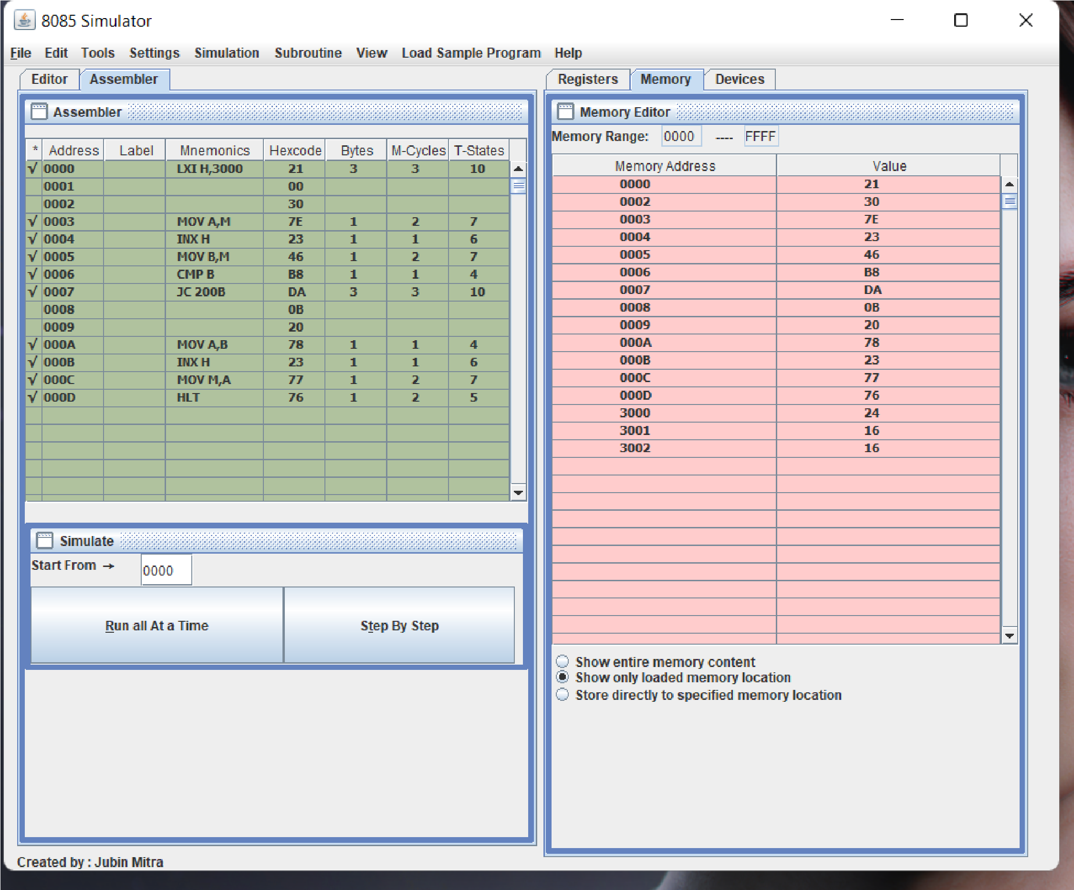

b) Find the larger out of two numbers.

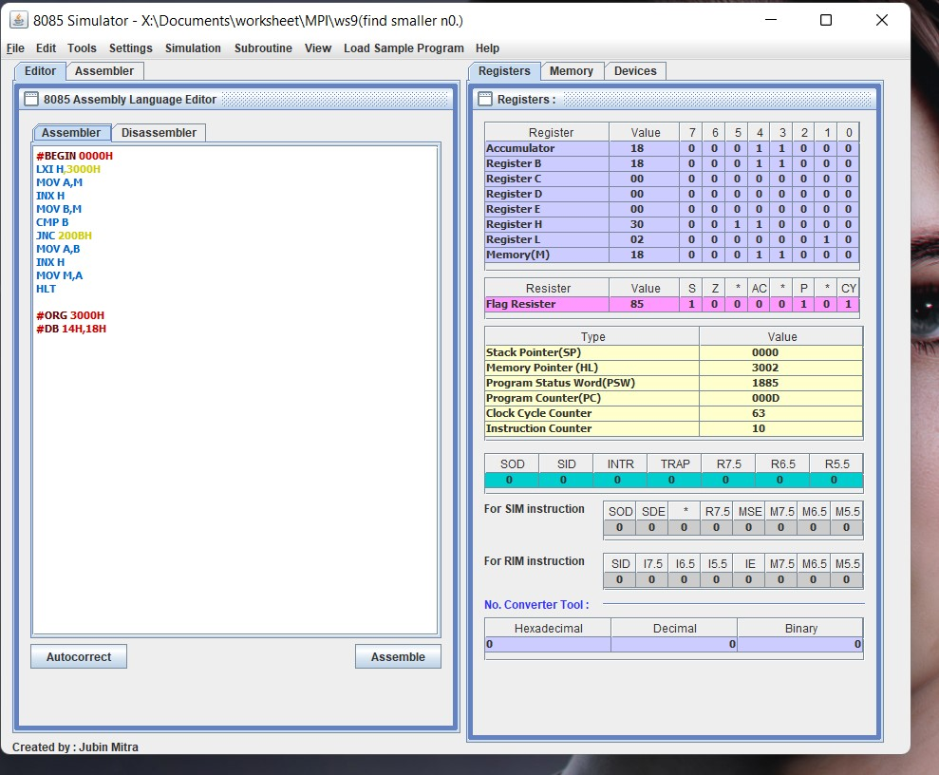

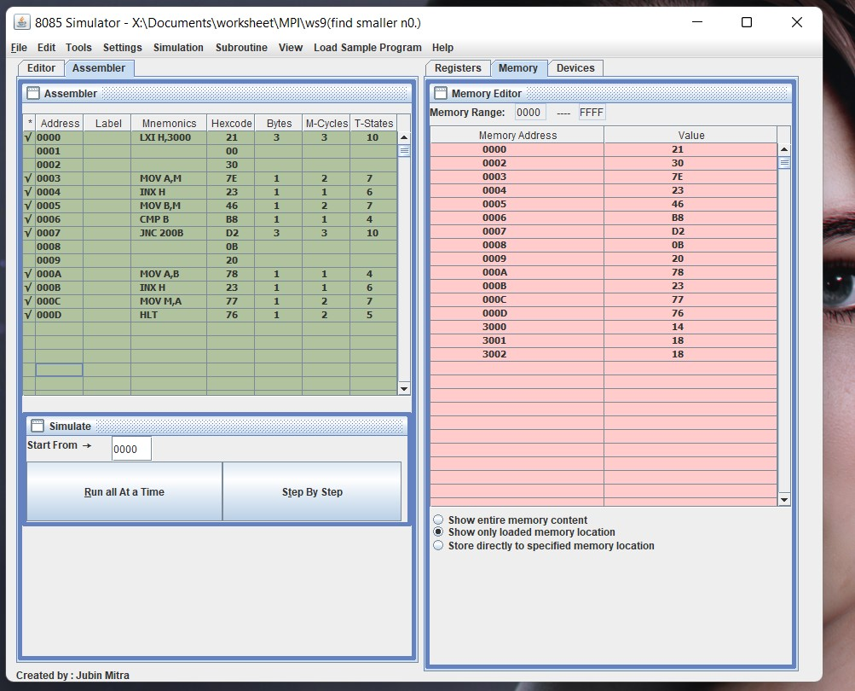

**Evaluation Grid (To be created as per the SOP and Assessment guidelines by the faculty):**

|  |  |  |  |
| --- | --- | --- | --- |
| Sr. No. | Parameters | Marks Obtained | Maximum Marks |
| 1. |  |  |  |
| 2. |  |  |  |
| 3. |  |  |  |
|  |  |  |  |