SpendLens — Intent Engine
From Expense Tracker to Behavioural Mirror
March 31st, 11:47 PM.
Salary came in 4 days ago.
I've already spent ₹62,000.
I open PhonePe. I scroll.
rzp.payu@zomato BLR_MTP_12 PYTM0987
I close the app.
I still don't know where my money went.
People don't change spending habits because of a pie chart.
They change when they realise they spent ₹4,000 on Late-Night Stress-Eating.

YASH CHAUDHARY  Roll No: 22UEC147  LNMIIT, Jaipur  April 2025 | TL;DR  PhonePe shows rzp.payu@zomato instead of "Zomato — late-night (4x this week)". SpendLens fixes that with TF-IDF classification + a Value Rating prompt that turns spend data into savings insights.  v1 = Telegram bot, freemium, no LLM.

PART 1 — The Broken Thing

This is broken because: UPI apps show you reconciliation codes designed for banks — not human beings.
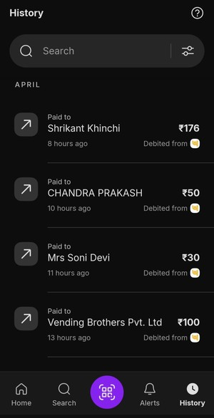  My real PhonePe — April 2025 | THE RECOGNITION MOMENT: You don't remember placing 8 food orders.  You remember one bad day, one late night, one 'I deserve this.'  But your bank statement remembers everything — in a language you can't read.  The app didn't hide anything. It just didn't help you understand anything.  This is broken because: UPI transaction strings ('rzp.payu@zomato') are designed for bank reconciliation, not user readability.  SpendLens fixes this by: running every VPA string through a TF-IDF classifier that maps it to a human category + behavioural intent tag.

1.1 Before & After — The Translation

This is what SpendLens actually changes. Left: what PhonePe shows. Right: what SpendLens returns. Same transactions, completely different signal.

Lens OFF — today  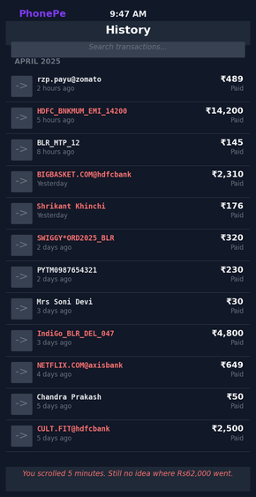 |  | Lens ON — SpendLens  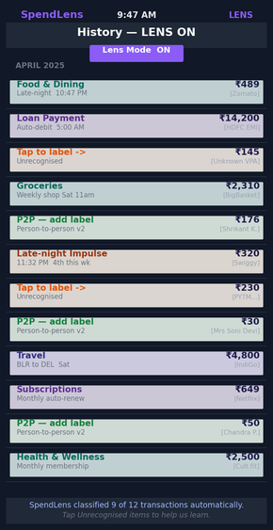

1.2 Fig 1 — The VPA Transformation Engine

How 'rzp.payu@zomato' becomes 'Food & Dining — Late-night — 4th time this week':

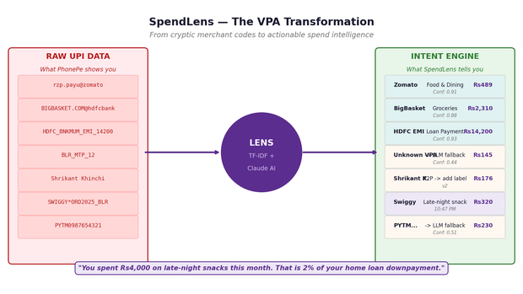
Fig 1 — Raw UPI strings (left) → Lens classifier → Intent-aware output (right)
1.3 Root Cause — Five Whys

# | The Why | The Answer
1 | Why can't I see 'Zomato'? | App displays the raw Merchant Trade Name from the banking switch. UPI never promised human-readable names.
2 | Why is the name raw? | NPCI's UPI protocol prioritises settlement speed. The UPI header has no mandatory 'Common Merchant Name' field — readability is out of scope at the rails layer.
3 | Why hasn't PhonePe fixed it? | Requires a constantly-updated VPA-to-brand mapping for millions of merchant IDs. Significant compute, zero direct revenue. A Volume Engine doesn't build Value tools.
4 | Conflict of interest? | If PhonePe tells you that you spend too much on Zomato, you might spend less — using PhonePe less. They have a structural disincentive to make you a disciplined spender.
5 | Root constraint | A deliberate structural trade-off: UPI apps are Volume Engines (KPI: transactions per second). Their incentive is to make you spend faster, not spend less. Spend intelligence is a Vitamin, not a Painkiller.

1.4 Who Suffers — Segments

Segment | Severity | Specific impact
Salaried professionals, 24–35 | High | ₹62k mystery every month. Cannot see patterns across 44 cryptic merchant strings. Aspirational Savers with no mirror.
Freelancers & gig workers | Medium | Need to separate business vs. personal expenses for taxes — manual spreadsheets currently.
Couples sharing expenses | Medium | Cannot tell who spent what on shared UPI IDs without interrogating each other.
Students & first-jobbers | Medium | No baseline for healthy budgeting. Habits form early — bad ones stick.

PILOT SEGMENT + KNOWN LIMITATIONS: Pilot target: salaried professionals (24–35) in Bengaluru and Pune with >30 UPI transactions/month. Exclude existing expense tracker users.
Known limitations: cannot track cash spending, cannot split one transaction across categories (e.g., grocery + medicine from same store), relies on AA consent or PDF export.

PART 2 — The Intent Engine

SpendLens fixes this by: transforming cryptic UPI codes into intent-aware spend intelligence — then asking the one question no other app asks.
PRODUCT POSITIONING: SpendLens is proposed as: (A) a native feature inside PhonePe/GPay, or (B) a standalone Telegram bot for v1 MVP.
The core product — the Intent Engine — is the same regardless of distribution. The difference is acquisition cost.

2.1 The Original Spike — Beyond Categorization

Standard trackers give you a pie chart. You look at it. You feel vaguely guilty. You close it. Nothing changes.
SpendLens asks a different question. Not what did you buy — but was it worth it?

THE VALUE vs. COST NUDGE: 7 days later, when the emotion is gone, SpendLens asks:
"You spent ₹2,000 on late-night Swiggy this week. Was this actually worth it?"
When the hunger is gone and the receipt is a memory — that's when the honest answer comes.

I ran SpendLens on my own March 2025 data. I thought food delivery was my biggest category. It wasn't. Travel was — ₹13,765, nearly identical to groceries and EMI. I would never have guessed that from scrolling transactions. That's what a mirror does.

2.2 Step 1 — Transaction Detection & Signal Extraction

SpendLens extracts three parallel signals from every transaction: category (what), time context (when), and frequency (how often). Together they move from 'Food: ₹489' to 'Late-night Swiggy — 4th time this week'.

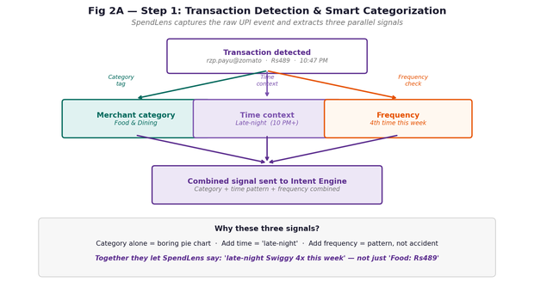
Fig 2A — Step 1: Three parallel signals extracted per transaction, combined into Intent Engine input

2.3 Step 2 — The Value Rating Prompt

Sent 7 days after the first report — when the emotional context has faded. The question deliberately waits until the hunger is gone.

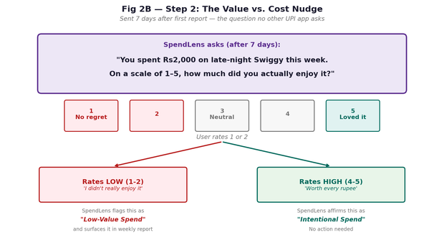
Fig 2B — Step 2: Value Rating prompt — user rates 1-5 after 7 days, outcome branches to flagged or affirmed

2.4 Step 3 — Savings Insight (No Guilt, Specific Actions)

Low-value spends surface as specific, actionable opportunities — not vague warnings. Every nudge ends with a concrete action, not just a number.

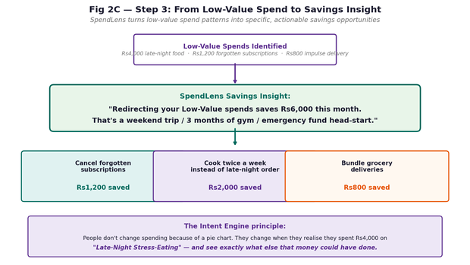
Fig 2C — Step 3: Low-Value spends → specific monthly savings with exact actions, no judgment

2.5 The Intent Dashboard + Monthly Report

What users actually see: a behavioural mirror, not a pie chart.

Intent Dashboard (mobile)  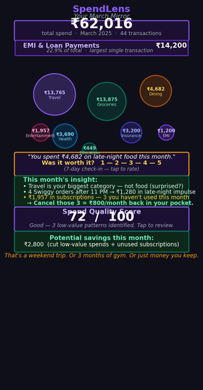 | Monthly Report (Python output)  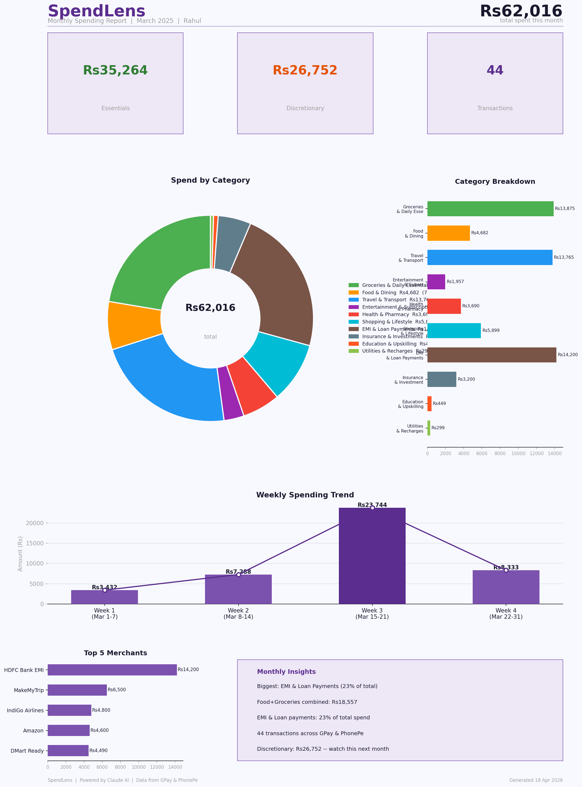

WHAT IT REVEALED: ₹62,016 total. The insight I didn't expect: Travel (₹13,765), Groceries (₹13,875), and EMI (₹14,200) were nearly equal.
I thought late-night Swiggy was my problem. Travel was. SpendLens showed me in 4 seconds.

2.6 Alternatives Rejected

Alt A: Manual categorization
Rejected. Users stop after 3 days. Zero-effort automatic tagging is the entire value.
Alt B: Gamification / rewards for saving
Rejected. Financial shame is not a retention strategy. I also rejected the AI suggestion to add a savings goal progress bar — that's just a prettier pie chart. The Intent Engine is about why, not how much left.
Alt C: Browser extension for net banking
Rejected. Extension stores credentials (privacy nightmare), banks change HTML constantly — maintenance hell.
Alt D: SMS scraping
Rejected. Privacy-invasive, blocked by modern Android and iOS. AA framework is the right infrastructure.

2.7 North Star Metrics

Metric | Why it matters | Target (90 days)
Categorization Correction Rate | User changes AI tag = AI wrong. Primary accuracy proxy. | <2% (>85% accuracy)
First-report open rate | No open = no return. The first report is everything. | >70%
Value Rating response rate | Do users engage with the 1-5 prompt? Core Intent Engine signal. | >35% by week 4
Insight click-through rate | % who tap an insight and take an action. | >15%
First-report drop-off rate | Counter-metric: % who never open report 2. Failure signal. | <45%

PART 3 — The ML Pipeline

3.1 TF-IDF Classification — Intuition + Math

The problem: 'rzp.payu@zomato', 'ZOMATO_DEL_BLR', and 'Zomato Internet Private' all mean the same thing but look completely different to a character-level model.
TF-IDF (Term Frequency – Inverse Document Frequency) represents each VPA as a vector of token weights, then uses cosine similarity against a labelled corpus of 50,000 Indian merchant strings.

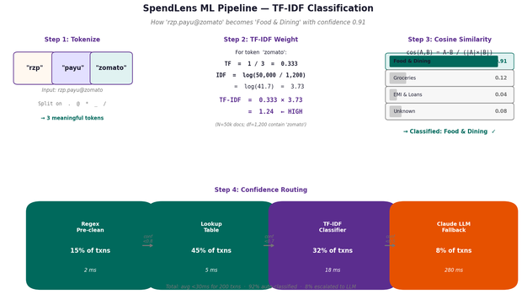
Fig 3 — TF-IDF pipeline: tokenize → weight → cosine similarity → confidence routing
Worked example:

Input: 'rzp.payu@zomato' -> tokens: ['rzp', 'payu', 'zomato']

TF('zomato') = 1/3 = 0.333
IDF('zomato') = log(50,000 / 1,200) = 3.73 <- rare in corpus, high signal
TF-IDF = 0.333 x 3.73 = 1.24 <- strong classification weight

cos(VPA, 'Food & Dining' centroid) = 0.91 -> CLASSIFY (above 0.80 threshold)
cos(VPA, 'Groceries' centroid) = 0.12 -> reject

Score <0.50 -> flag as 'Unrecognised — tap to label' (no LLM in v1)

3.2 No LLM in v1 — Deliberate Decision

DELIBERATE v1 DECISION: LLM removed from v1 deliberately:
· Cost: API calls at scale make free tier financially unviable.
· Latency: 280ms LLM vs 18ms TF-IDF breaks the <30s report target.
· Privacy: sending transaction strings to external API increases risk surface.
v2 adds LLM as optional paid 'enrichment' for unrecognised VPAs.

3.3 Privacy Architecture

- Only anonymised merchant tokens sent — never amounts, names, phone numbers, or PII.
- User labels stored locally, retained 90 days, used to improve personal model. User can delete all data at any time.
- Option to share labels anonymously for crowd model improvement — opt-in, not opt-out.
- Failure mode: long-press any transaction → 'Wrong Category' → logged, used for weekly retraining.
- Security: we never store raw transaction descriptions server-side. DPDP Act 2023 compliant.

PART 4 — Business Model & Distribution

4.1 The Honest Problem First

THE GRAVEYARD: Expense tracker graveyard: Walnut (shut down), MoneyView (pivoted to loans), ET Money (bundled with investments), Goodbudget (tiny niche).
People love the idea of tracking spending. They don't love paying for it.
My weakest assumption: the Intent Engine — 'Late-Night Stress-Eating' vs 'Food: ₹489' — is different enough to justify ₹99/month. I'm not confident. I'd run a willingness-to-pay survey before writing a line of code.

4.2 Distribution — Three Options

Option A: Proposal to PhonePe / GPay (preferred for scale)
Pitch SpendLens as a native feature. Zero acquisition cost — they have 500M+ users. Revenue share or licensing. No app store friction. Lowest-risk path to users.
Option B: Standalone app via Account Aggregator
Free 14-day trial. ₹499/year after. Partner with employers for B2B free perk. Higher acquisition cost, full product control.
Option C: Telegram bot — v1 MVP (ship fastest)
Users forward PhonePe/GPay exported PDF. Bot returns categorized report in 10 seconds. Zero app store friction. First report free, ₹49/month ongoing. Test willingness-to-pay before building anything bigger.

RECOMMENDED ORDER: Recommended order: C (Telegram bot) first to validate willingness-to-pay → A (UPI app partnership) once there's data to show.
PM principle: cheapest path to user feedback first. Build only what the data demands.

4.3 Revenue Sizing — With Honest Caveat

HONEST CAVEAT — READ FIRST: What I don't know: actual willingness-to-pay data, real acquisition cost, conversion rates.
These numbers are illustrative — not a forecast. I'd need a 2-week paid pilot before presenting to leadership.

Scenario | MAU (5% conversion to paid) | Annual revenue
Conservative (0.1% penetration) | 5,000 → 750 paid | ₹7.5 lakh/year
Base case (0.5% penetration) | 25,000 → 3,750 paid | ₹37 lakh/year
Optimistic (2% penetration) | 100,000 → 15,000 paid | ₹1.5 Cr/year

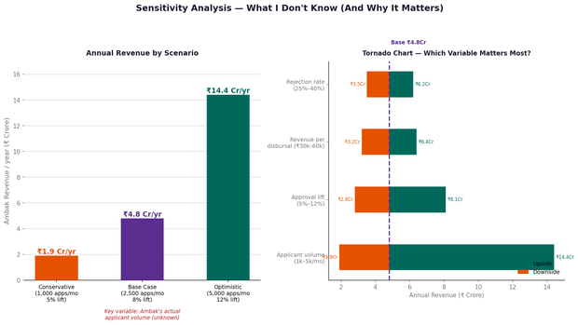
Fig 4 — Sensitivity tornado: which variable moves the revenue needle most
Honest conclusion: standalone expense tracking is a hard business. The real play is Option A — licensing to PhonePe/GPay where SpendLens is a premium native feature with zero acquisition cost.

PART 5 — The Honest Part

5.1 My Two Weakest Assumptions

WEAKEST ASSUMPTIONS: Weakest: users will pay for this. Expense trackers are a graveyard. I'm betting Intent Engine changes the equation. I'd run a willingness-to-pay survey before coding.
Second weakest: users want to see the truth. Some prefer 'head-in-the-sand' budgeting. Seeing ₹4,000 on late-night Swiggy may cause shame, not action. If SpendLens feels like judgment instead of control, users churn.
That's why every nudge ends with a specific action — not just a warning.

5.2 If I Had One More Week

First: scrape 1,000 random UPI strings and measure how many are truly unidentifiable. If it's 30%, not 8%, the TF-IDF corpus needs to be 3x larger and the model gets harder to ship.
Second: interview 10 people who tried an expense tracker and quit. Why? Manual work? Guilt? No actionable advice? That shapes v1 more than any technical benchmark.
Third: run a 'Wizard of Oz' test — manually categorize 50 transactions for 5 friends, send them the report, observe. Success = at least 3 of 5 say 'I felt helped, not judged' and ask to see the next month. Failure = they feel guilty or annoyed.

5.3 AI Tools — Full Transparency

# | Prompt used | Output | What I kept / rejected
1 | 'Why do UPI apps show cryptic merchant names? Technical + business constraint.' | Business trade-off logic. Suggested gamification, social leaderboard, savings goal progress bar. | Kept trade-off framing. Rejected gamification (shame ≠ retention), social leaderboard (spending is private), savings progress bar (prettier pie chart — not the point).
2 | 'Risks of LLMs for real-time financial transaction categorization?' | Hallucination, latency, privacy, cost per call. | Used all four. Removed LLM from v1 entirely. Added Correction Rate metric as the hallucination catch at scale.
3 | 'TF-IDF cosine similarity for text classification — show the math.' | Clean formula. Suggested BERT as superior alternative. | Chose TF-IDF over BERT: lower compute, faster inference, sufficient for structured VPAs. BERT overkill for v1. Kept the math, cut half the formula details.

PART 6 — Spec + Closing

6.1 Product Spec

Field | Detail
Feature | SpendLens — Lens Mode + Intent Engine + Monthly Report v1
Goal | Help users understand where their money goes and whether their spending aligns with their values.
User story | As a salaried professional, I want to see what I spend on AND whether those spends make me happy — so I can cut what doesn't matter and save for what does.
Parsing | VPA → parent company: (1) exact lookup table, (2) TF-IDF cosine similarity, (3) 'Unrecognised — tap to help us learn' for <0.50 confidence. Tapping opens: Food / Transport / Entertainment / Other. Stored locally, auto-tags future same VPA.
Intent layer | Time context (late-night 10PM+, weekend), frequency (Nth time this week), Value Rating prompt after 7 days.
UI | Lens toggle in top-right of history tab. Long-press any transaction → 'Wrong Category'. User labels stored locally.
Out of scope v1 | P2P auto-categorization, multi-bank, real-time alerts, iOS, LLM fallback, social features.

Acceptance criteria

- Lens toggle responds in <200ms. History reloads with enriched labels immediately.
- Categorization Correction Rate <2% at 30-day mark — primary accuracy proxy (>85% accuracy).
- Report generated within 30 seconds for 200 transactions.
- Value Rating prompt sent exactly 7 days after first report.
- All <0.50 confidence transactions shown as 'Unrecognised — tap to help us learn.' Never silently wrong.
- Monthly report includes at least one specific actionable insight with exact rupee savings.

6.2 v1 / v2 / v3 Roadmap

Version | Feature | Why this order
v1 | Structured VPA categorization + Intent Engine + Value Rating + Monthly Report | Solves 70% of value. Ships without LLM complexity.
v2 | P2P labeling (pattern detection + prompts + crowd labels) + LLM paid enrichment | Needs labeling corpus + different product surface.
v3 | Predictive nudges: 'At current pace you will overspend on dining by ₹8k this month' | Needs 6+ months of user history.

6.3 Closing

SpendLens started with one question:
"Where did my money go?"
But the real question is:
"Was it worth it?"
If we can answer that — we're not building an expense tracker.
We're changing how people make decisions.

If I'm selected, the first thing I want to do is find 5 people who tried an expense tracker and quit — and find out why. Everything else follows from that conversation.

