AMBAK PM INTERNSHIP — SCREENING ASSIGNMENT
The Loan Discovery Problem
YONO SBI doesn’t have a credit problem. It has a discovery problem.

YASH CHAUDHARY
Roll No. 22UEC147 | B.Tech ECE, LNMIIT Jaipur | April 2026
PRODUCT | SUBMITTED | SCOPE
SBI YONO (2026) | April 2026 | Personal Loan Discovery

PART 1 | THE PROBLEM

The Wall
A friend texted me: “Yash, I need ₹80k for my flat deposit. YONO should just give me a loan, right?” I said yes. Five minutes later: “It says visit branch. I’ll try KreditBee.” She got the loan at 24%. SBI lost that transaction — and possibly her as a future home loan customer. I opened YONO myself. Two-year salary account. No pre-approval. I closed the app.

YONO’s loan section is built entirely around customers it has already decided to lend to. If you are a first-time borrower, you are digitally invisible.

What a First-Time Borrower Sees
Pre-Approved Loan | Not visible. Requires 6+ months history.
Personal Loan | Leads to branch visit form. No digital path.
Home / Car Loan | Irrelevant to need. Clutters discovery.
Xpress Credit | Government and PSU salary accounts only.
Check Eligibility | Does not exist as a standalone flow.

PART 1.5 | COMPETITIVE TEARDOWN

SBI vs the Competition: The Click Count
Click count excludes data entry for simplicity. Time-to-decision is the more meaningful metric.

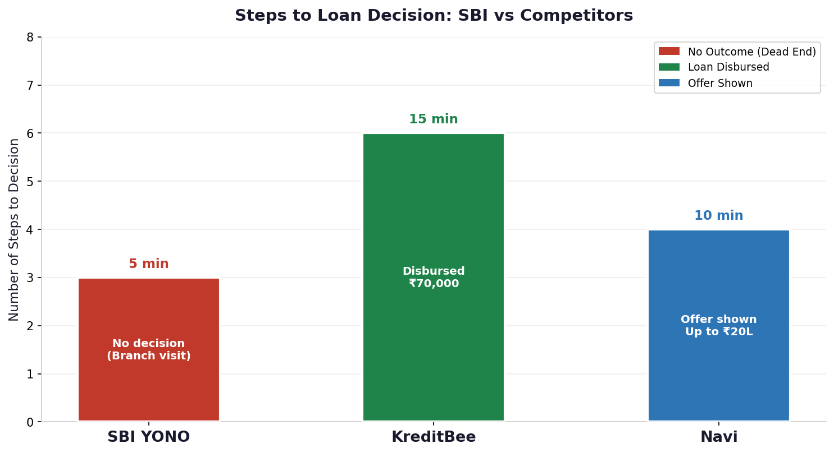
Fig 1. Steps to loan decision — SBI YONO vs KreditBee vs Navi

SBI YONO | KreditBee | Navi
1. Open YONO app | 1. Download app | 1. Open Navi app
2. Navigate to Loans | 2. Mobile no. + PAN | 2. PAN + selfie
3. Tap Personal Loan | 3. Income details | 3. Offer shown
— Visit nearest branch | 4. Soft credit check | 4. Accept and confirm
 | 5. Offer: ₹70k at 24%
 | 6. Disbursed
₹0 | No decision | 5 min | ₹70,000 | Yes | 15 min | Up to ₹20L | Yes | 10 min

The real competition is not just fintech apps — it is any faster source of liquidity. Pathfinder competes with a 10-minute disbursal, not just SBI’s current UX.

KreditBee sent Priya a push notification 10 minutes after she closed YONO. SBI sent no SMS, no email, no follow-up. This is a retention problem, not a credit problem.

PART 1 | ROOT CAUSE

Why This Wall Exists
RBI’s Jan 2025 Master Direction: first-time borrowers cannot be rejected solely for lacking credit history. The Finance Ministry reiterated this in Parliament in August 2025.

Four Reasons — Only One is Fixable in a Sprint
A REGULATORY: RBI capital adequacy rules require significantly more capital provisioning for unscored borrowers. Cannot fix in a sprint.
B TECHNICAL: SBI’s core banking system (Finacle) processes credit decisions in overnight batch mode. Real-time alternative scoring requires a middleware layer that doesn’t exist. Expensive to change.
C ORGANISATIONAL: The YONO product team scoped loans as a disbursement tool, not a discovery surface. Entirely fixable.
D INCENTIVE MISALIGNMENT: Unlike fintechs, SBI doesn’t face immediate revenue loss when a user drops off. The product team is measured on disbursal volume, not discovery completion. A dead end doesn’t hurt their OKR.

This problem sits at the intersection of UX and credit risk — two teams that rarely optimize for the same metric. That’s why it persists.

Two User Segments, One Product Surface
 | Pre-approved users | First-time borrowers
Size | ~30% of active YONO users | ~18–22% of active YONO users
YONO experience | Banner → 4 clicks → instant disbursement | No path. No message. No redirect.
LTV potential | Moderate (already acquired) | Highest (30-year relationship starts here)

PART 2 | THE FIX

YONO Pathfinder
Current vs Pathfinder: Flow Diagram
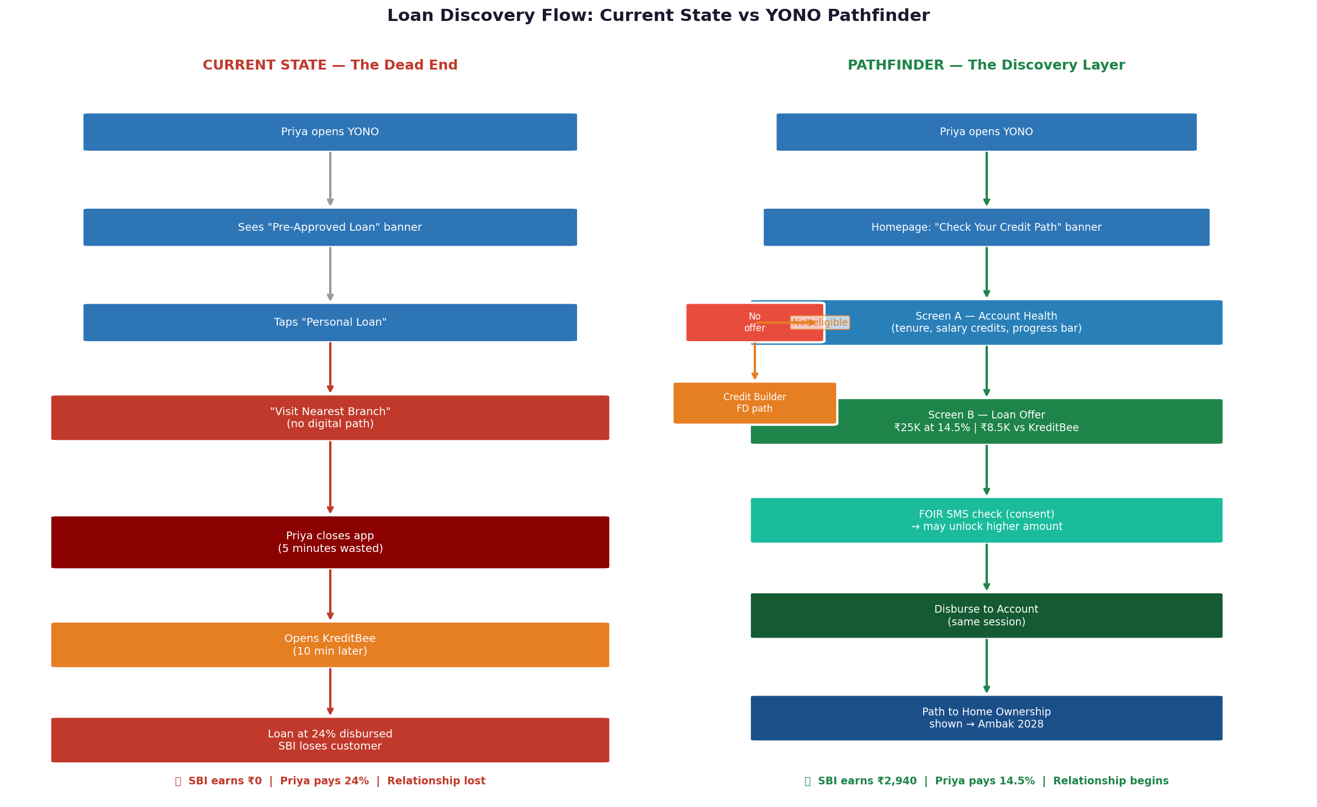
Fig 2. Current dead-end flow (left) vs YONO Pathfinder discovery layer (right)

Pathfinder activates when the pre-approval flag is absent. Instead of silence, the user gets a signal. The product does not change underwriting — it only surfaces users who already pass internal risk thresholds but lack a pre-approval flag due to batch timing.

System Architecture
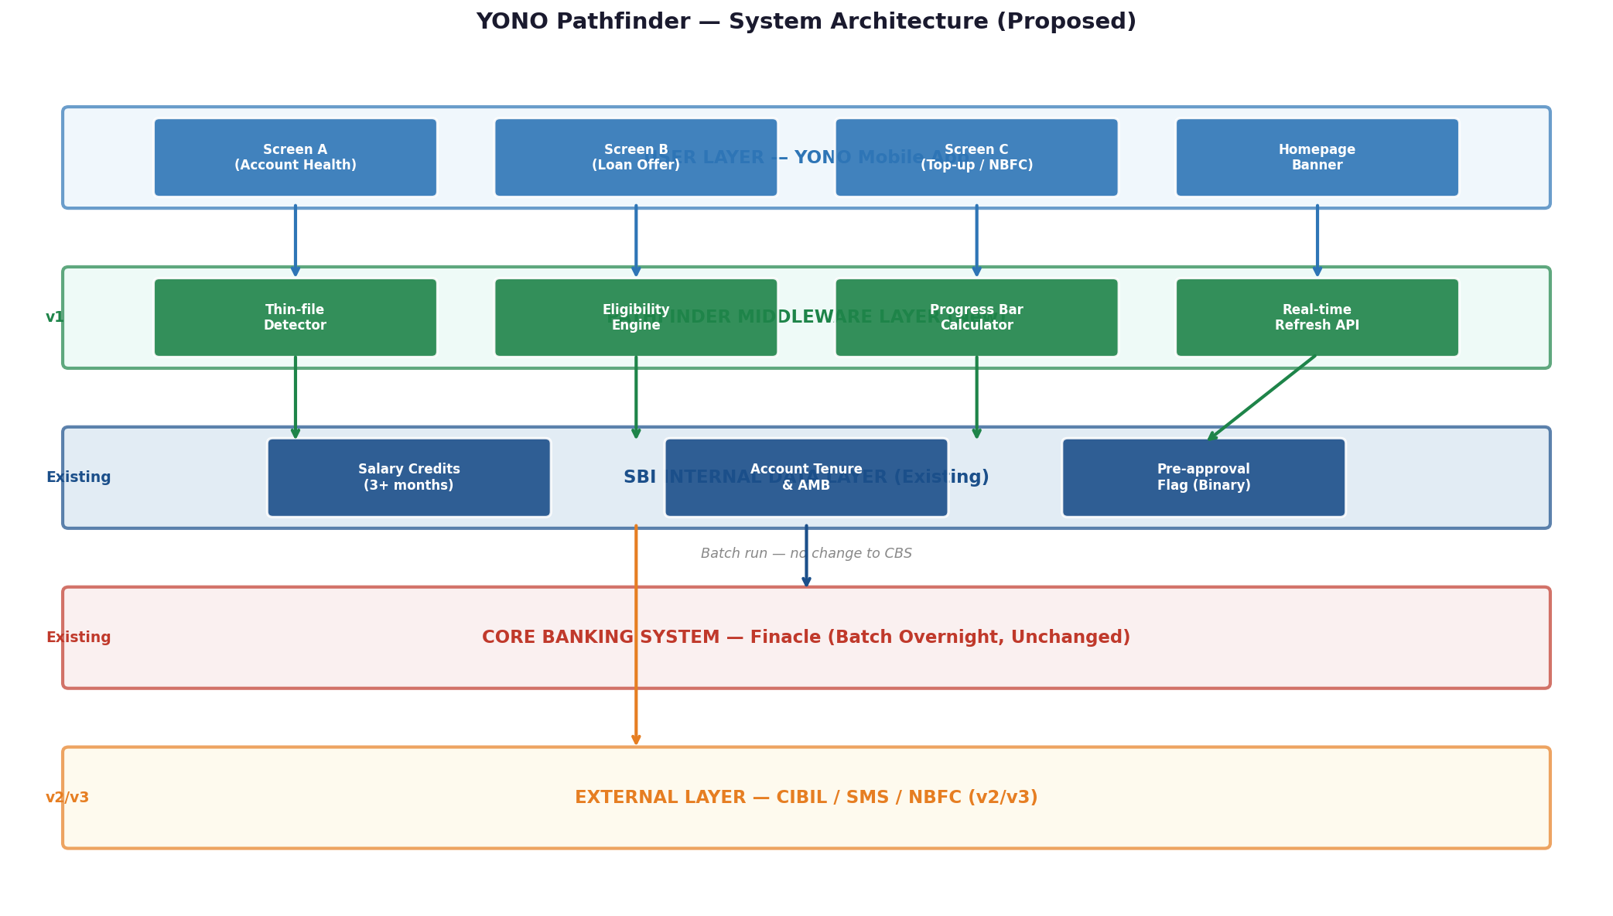
Fig 3. Proposed Pathfinder architecture — new middleware layer sits above existing Finacle batch system (unchanged)

Finacle and the core banking system are completely unchanged. Pathfinder is a read-only middleware layer over existing salary credit and tenure data.

The Three Screens
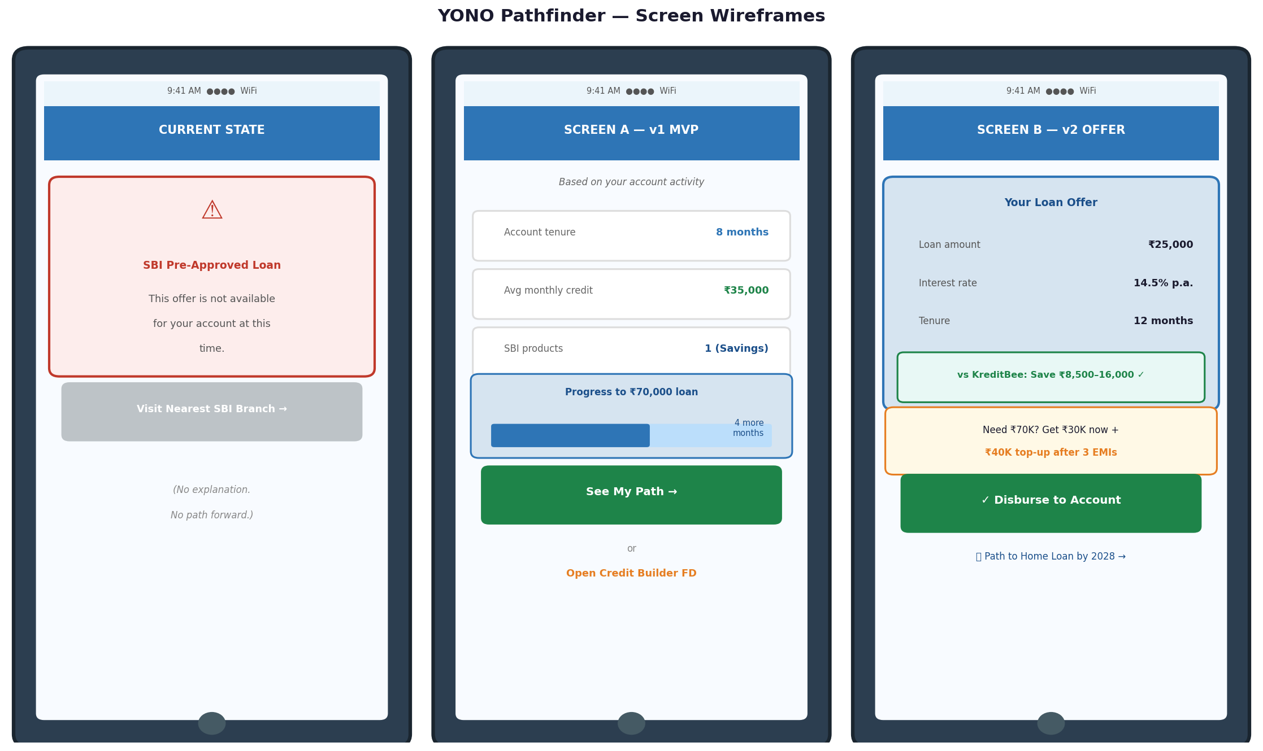
Fig 4. Screen wireframes: current dead-end (left), Screen A eligibility signal v1 (middle), Screen B loan offer v2 (right)

Screen-by-Screen Breakdown
 | Screen A — v1 MVP (2–3 weeks) | Screen B — v2 Offer (4–6 weeks)
What user sees | Account health: tenure, avg monthly credit, products. Gamified progress bar to target loan amount. | ₹25K loan at 14.5%. Interest savings vs KreditBee shown inline. Top-up bridge for ₹70K gap.
CTA | "See My Path" (no CIBIL pull). No loan offer yet in v1. | "Disburse to Account" — single-tap, same session.
No-offer path | Credit Builder FD path. "6 months from first payment — we’ll remind you monthly." | NBFC partner at 22–24% (still cheaper than KreditBee’s 24–36%).

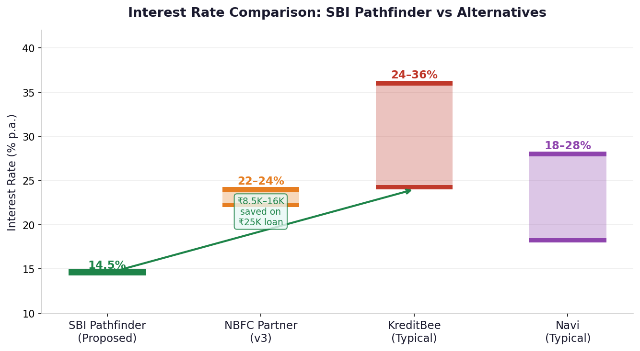
Fig 5. Interest rate comparison: SBI Pathfinder vs alternatives. ₹8,500–16,000 savings on a ₹25K loan.

Scoping: What Ships When
Version | What ships | Engineering effort | What you learn
v1 (MVP)  2–3 weeks | Screen A: account health + gamified progress bar + ‘See My Path’ + link to existing Credit Builder FD. No loan offer yet. | 1 backend check + 1 screen. No credit policy sign-off needed. | Do thin-file users engage? Does banner or dead-end screen drive more traffic?
v2  4–6 weeks | Screen B: loan offer ₹10K–50K + FOIR check via SMS scraping (consent). Ring-fenced pilot: 50K users, 22–26 y/o, Tier 1 cities. | Credit policy sign-off. Offer engine wired to batch output. | Acceptance rate. 90-day NPA. If NPA delta <1%, expand nationally.
v3  3–4 months | Real-time ‘Refresh My Eligibility’ button. NBFC top-up bridge. ‘Path to Home Ownership’ feature. Graduation notifications. | NBFC partnership + legal review. Home loan copy. | Does top-up bridge close the ₹70K gap? Home loan inquiry rate at 24 months.

If forced to ship in 48 hours: replace the dead-end screen with an eligibility explanation + ‘Open Credit Builder FD’. Near-zero engineering. That’s real PM thinking.

PART 2 | METRICS

How to Know If It Worked
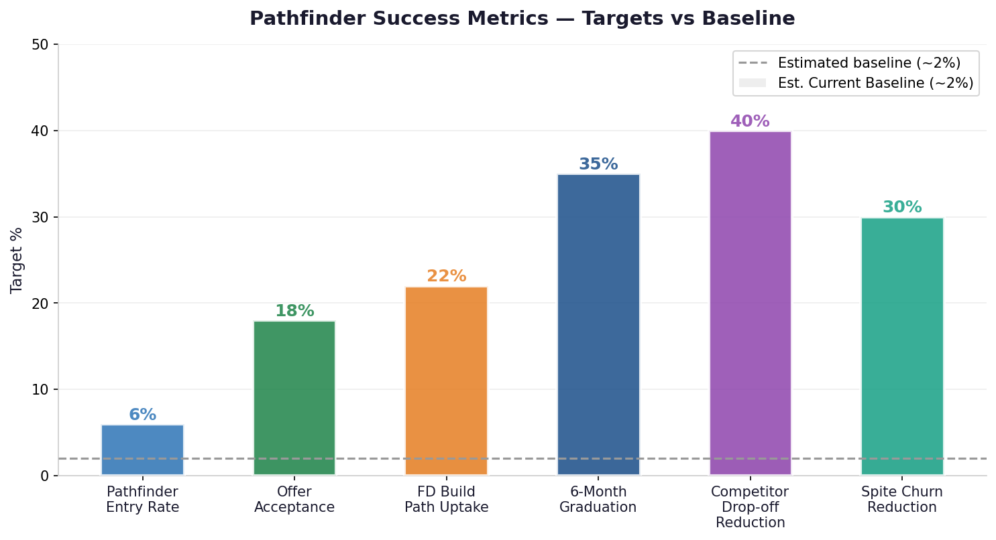
Fig 6. Pathfinder success metrics vs estimated baseline (~2%). Targets set at 3× baseline after 2-week A/B test.

Metric | What it measures | Definition | Target
Pathfinder entry rate | Thin-file users who engage | Clicks ‘See My Path’ on Screen A | ≥3× baseline
Offer acceptance rate | % who disburse | Disbursed within 7 days of offer | 3× baseline (post A/B)
FD Build Path uptake | No-offer users who open FD | FD opened within 30 days | ≥22%
6-month graduation | % who get pre-approval | Pre-approval flag within 6 months | ≥35%
90-day NPA | Default rate on Pathfinder loans | Must stay <1.5× control cohort | <1.5× control NPA
Drop-off to competitor | Exit to loan app within 24h | App-switch tracking / survey | Reduce by ≥40%
Spite churn reduction | Account closures post-rejection | Account closed within 30 days | Reduce by ≥30%

PART 3 | THE HONEST PART

Three Honest Answers
Q1: The Single Weakest Part of My Analysis
My weakest assumption: SBI’s credit policy team will allow a digital-only, unsecured loan of ₹10K–50K to thin-file borrowers with no branch verification. Without that approval, v2 never happens. v1 (just a path) doesn’t solve Priya’s immediate need for money.

The partial-loan retention risk is also real. What I’d do: prototype test with 50 thin-file users before building. If >40% say ‘I’d still go to KreditBee’ for ₹25K, redesign Screen B to lead with the top-up bridge (₹30K now + ₹40K in 90 days) before building the offer engine.

Q2: One More Week — What Would I Learn First?
3 days interviewing 5 SBI branch managers: ‘What is the smallest loan you’ve approved digitally for a first-time borrower? What would make you trust a digital-only decision?’ Then 4 days interviewing 8 rejected applicants. Branch manager interviews would tell me whether the dead-end screen or upstream discovery is the bigger failure — which changes what I build first.

Q3: AI Tools Used
Prompt | What I took | What I changed / rejected
RBI regulations for PSB thin-file borrowers | Pointer to RBI Master Direction Jan 2025 + capital provisioning framework. | Added specific dates and parliamentary source from direct reading.
Current YONO loan flow for no pre-approval user | General PAPL banner model, branch-visit CTA. | Verified copy from SBI’s official PAPL page. AI gave shape only.
PM alternatives for this fix | AA scoring, BNPL, NBFC referral as stress-test checklist. | Rejected NBFC framing as ‘brand awareness’. The four-forces + incentive misalignment framing is entirely mine.

PART 4 | BONUS — REVENUE SIZING

What Is the Opportunity Worth?
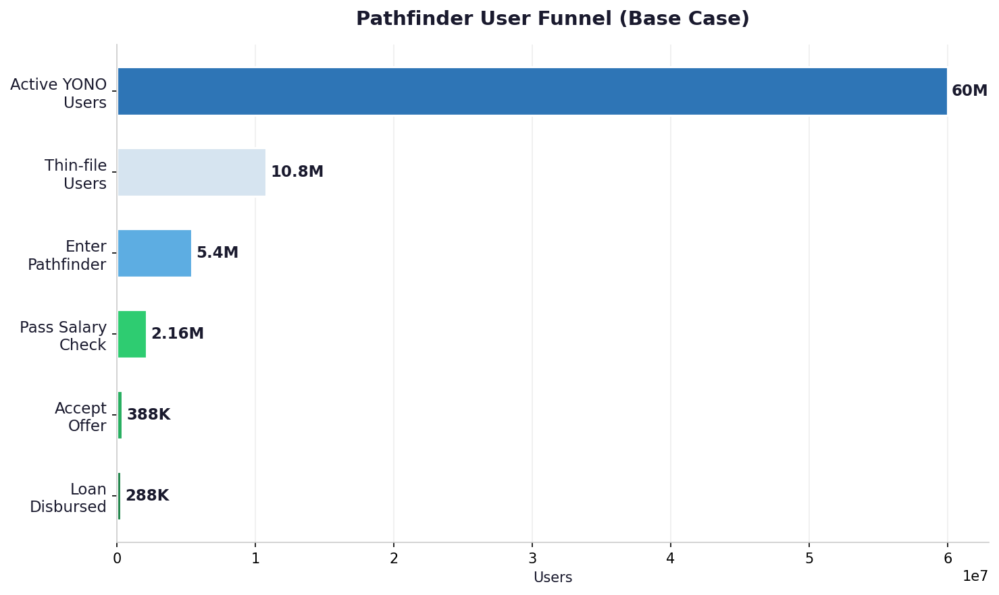
Fig 7. Pathfinder user funnel — base case. 60M YONO users → 288K loans disbursed in Year 1.

The Math (Base Case, After Cost of Funds + Ops Costs)
Line Item | Amount
8M thin-file YONO users × 50% entry × 40% pass × 18% accept | 288,000 loans
Net interest margin (14.5% lending − 6% CoF − 2% ops costs) | 7% p.a.
Net interest income per loan (₹28K × 7% × 1.5 yrs) | ₹2,940
× 288,000 loans | ₹84.7 Cr
+ Processing fees (1% × ₹28K × 288K) | ₹8 Cr
Year 1 Net Income | ₹93 Cr (conservative)
+ CAC advantage (KreditBee spends ₹500–1,000/user; SBI: near zero) | ₹14–28 Cr strategic benefit

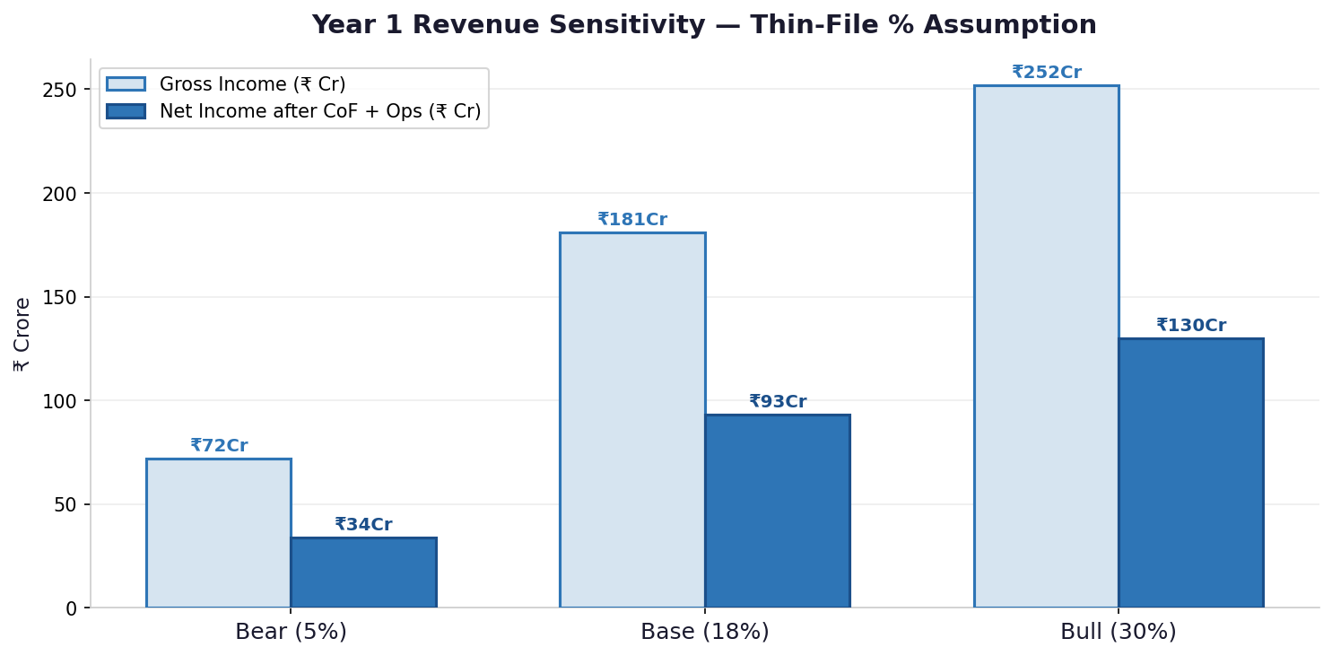
Fig 8. Revenue sensitivity across thin-file % scenarios. Base case: ₹93 Cr net income Year 1.

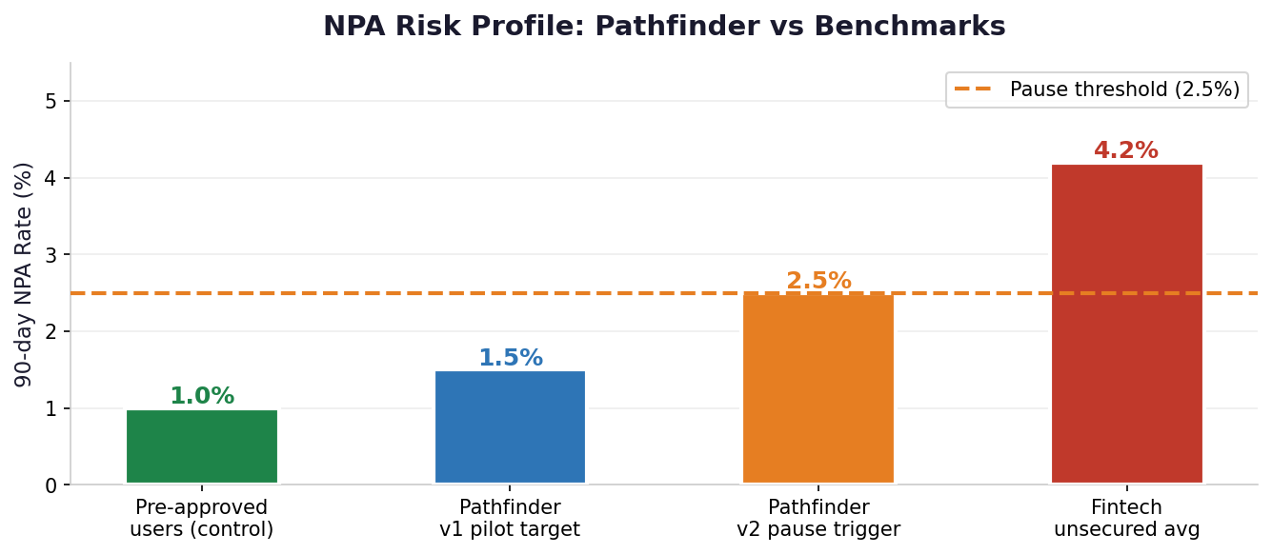
Fig 9. NPA risk profile. Pathfinder target: <1.5× pre-approved cohort. Pause if >2.5%.

The Real Prize: Customer Lifetime Value
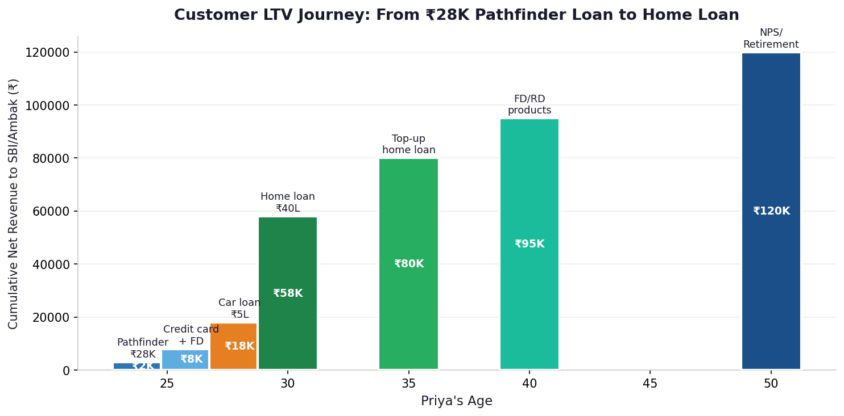
Fig 10. LTV journey from ₹28K Pathfinder loan (age 24) to home loan (age 30) to retirement products. 10% cross-sell assumed.

The ₹93 Cr is not the home run. It is the proof of concept. A customer acquired at age 24 with a ₹28K Pathfinder loan — assuming 10% cross-sell — generates ₹5,000 incremental LTV from home loan + car loan alone. Pathfinder’s cost to acquire her: near zero. That is why this matters to Ambak.

SUMMARY
YONO SBI’s loan section has a hard wall for first-time borrowers: no pre-approval flag, no digital path, no explanation. Root cause: RBI capital provisioning (can’t fix), Finacle batch architecture (expensive to fix), product scope decision (fixable in a sprint), and incentive misalignment (SBI doesn’t feel the pain when Priya leaves). The fix is YONO Pathfinder: an MVP screen shippable in 2–3 weeks that replaces silence with a signal. Net income Year 1: ~₹93 Crore. The real prize: those 288,000 users are Ambak’s home loan customers in 2030.

Part | What I did
1 | Found the wall. Traced root cause to 4 forces including incentive misalignment. Competitive teardown vs KreditBee and Navi.
2 | Proposed Pathfinder v1/v2/v3 with FOIR SMS check, gamified progress bar, real-time refresh, Path to Home Ownership. NBFC rate corrected to 22–24%. CIBIL timeline fixed.
3 | Reframed weakest assumption as credit policy approval risk. Added branch manager interview questions.
4 | Added operational costs (~2%). CAC in strategic section. LTV with 10% cross-sell rate.

Priya is not a risky borrower. She is just an unseen one. Today, SBI doesn’t reject her. It ignores her. Pathfinder doesn’t change who SBI lends to. It changes who SBI sees.

Yash Chaudhary · 22UEC147 · B.Tech ECE, LNMIIT Jaipur · April 2026

