Git HandsOn 5: -

- Verify the Repository is Clean.

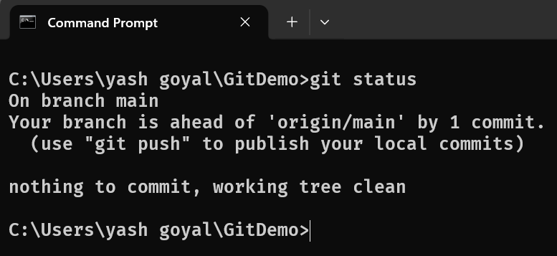

- List All Available Branches.

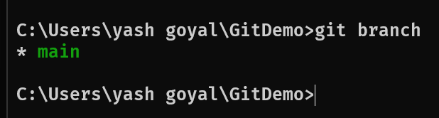

- Pull the Latest Changes from the Remote Repository.
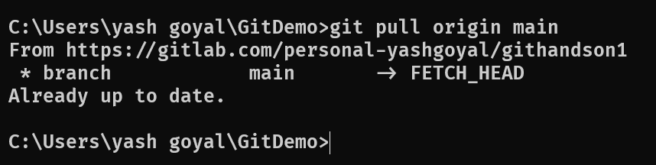
- Push Pending Changes to the Remote Repository.
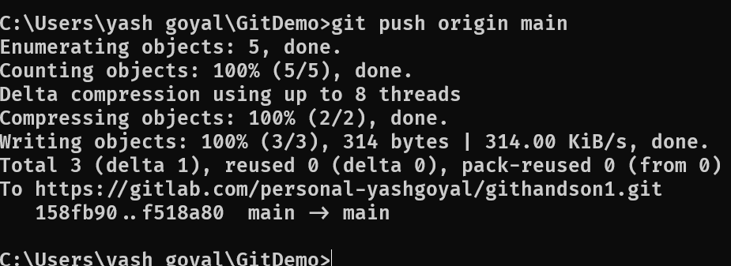

- Verify the Remote Repository.
