Git HandsOn 4: -

- Verify the Repository is Clean

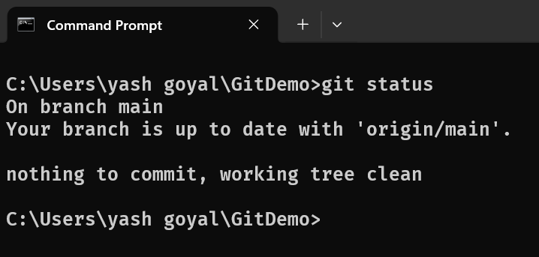

- Create and Switch to a New Branch

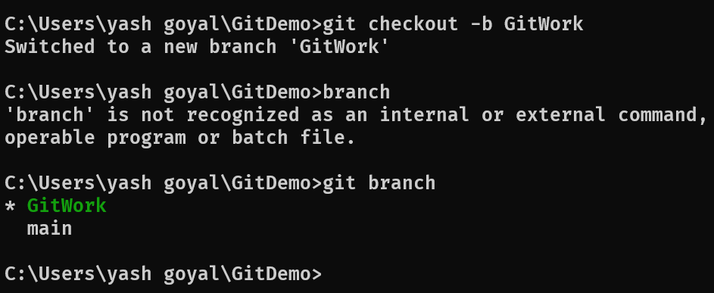

- Create hello.xml

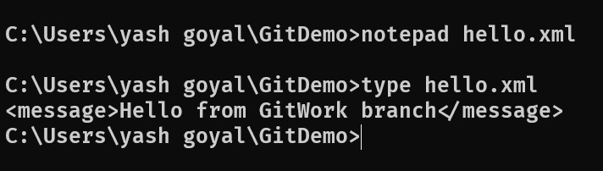
- Commit the Changes.

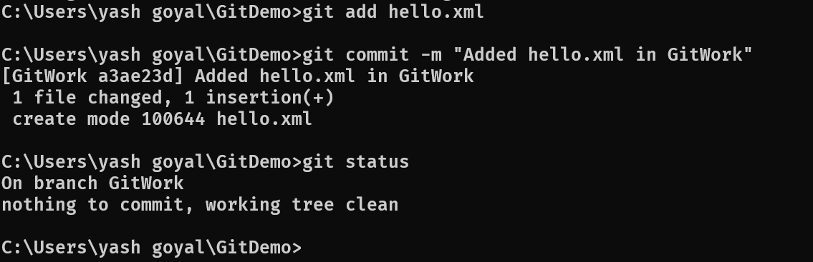

- Switch Back to Main

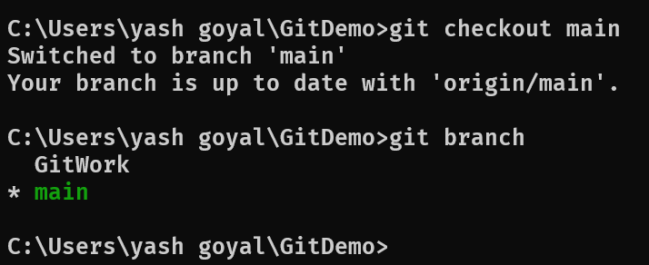

- Create a Conflicting Version - Modify the Same File in Main

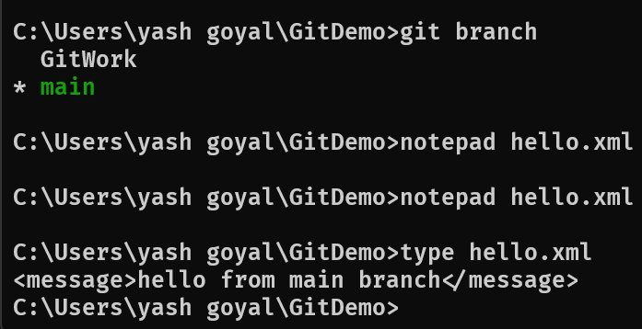

- Commit Changes in Main

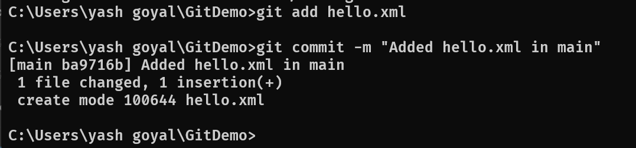

- View the Commit History

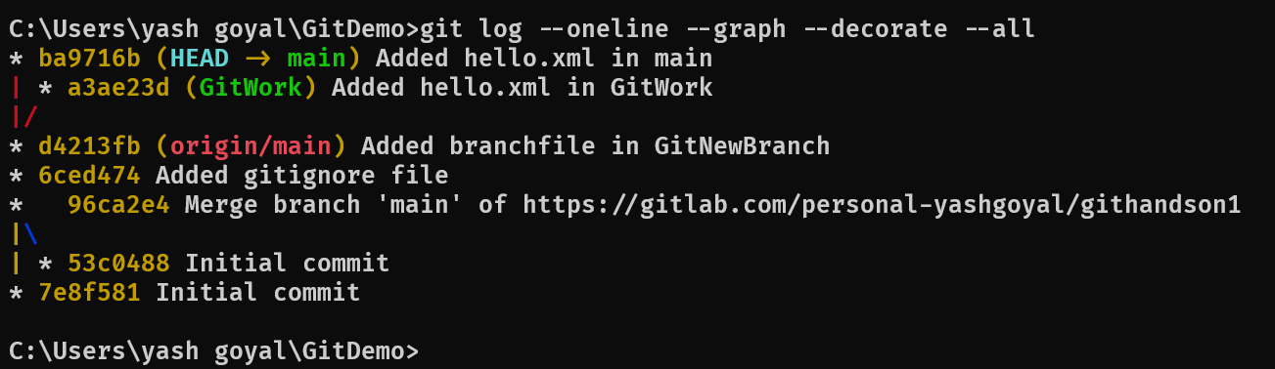

- Compare Branch Differences

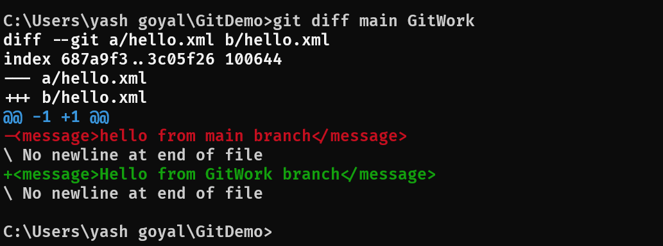

- Merge the GitWork Branch into Main.

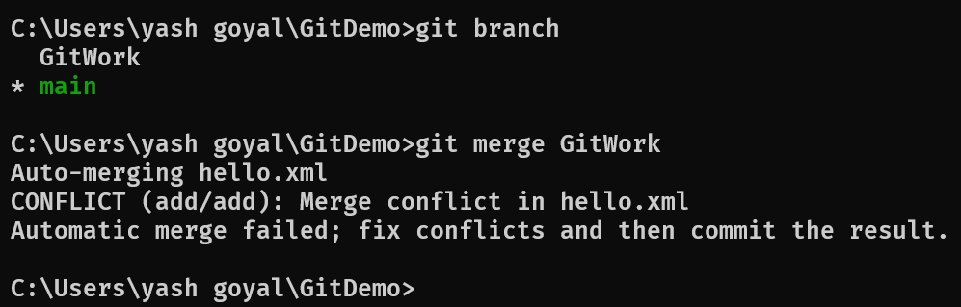

- Resolve the Merge Conflict.

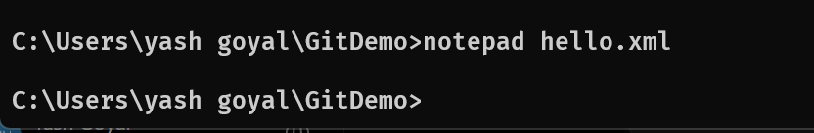
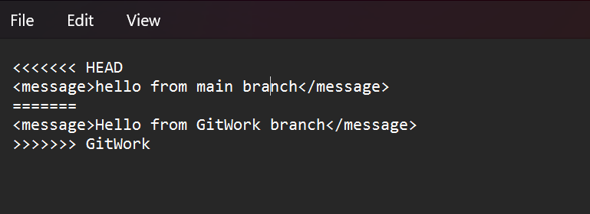
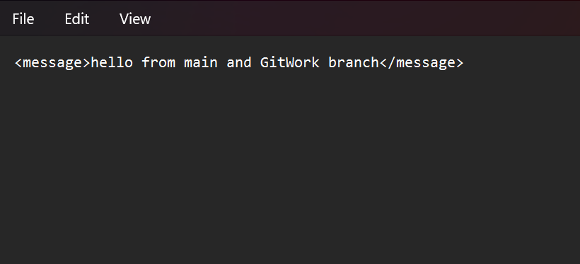

- Commit the Resolved Merge

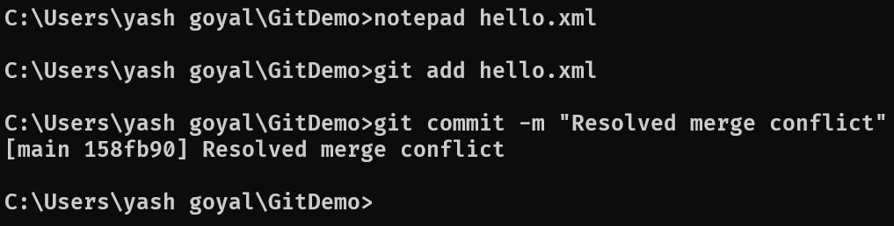

- Verify the repository

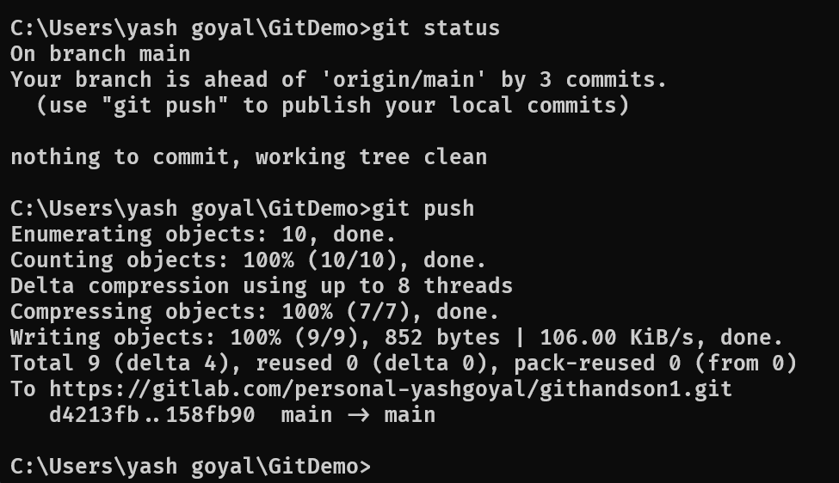

- Add Backup Files to .gitignore - Update the .gitignore File

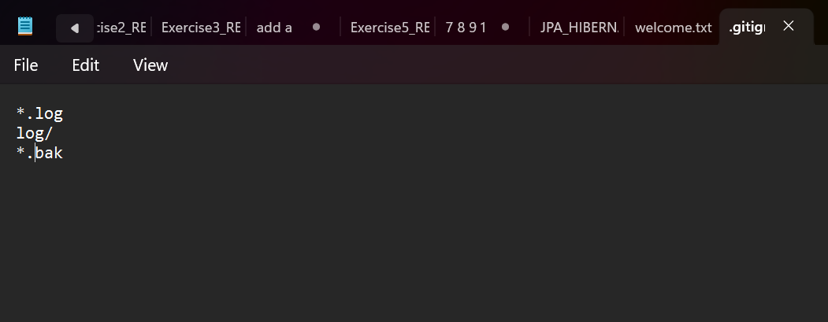

- Commit the .gitignore Changes

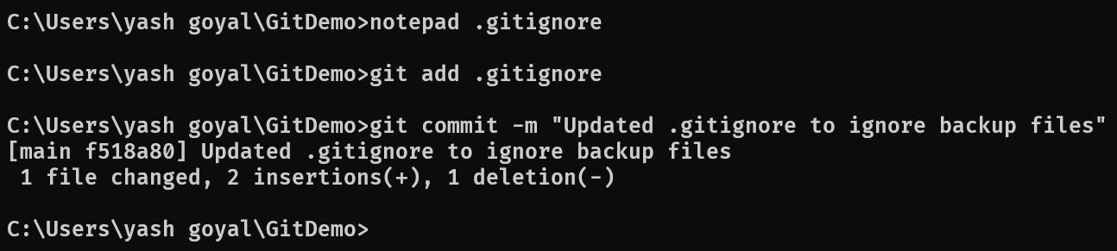

- List All Branches - Display Available Branches

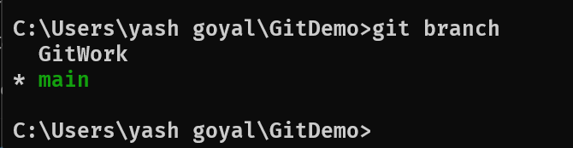

- Delete the Merged Branch.
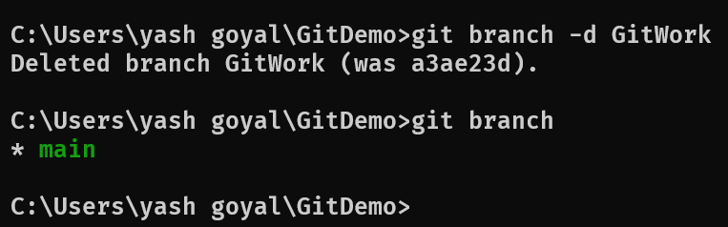
- Display the Final Git Log.

