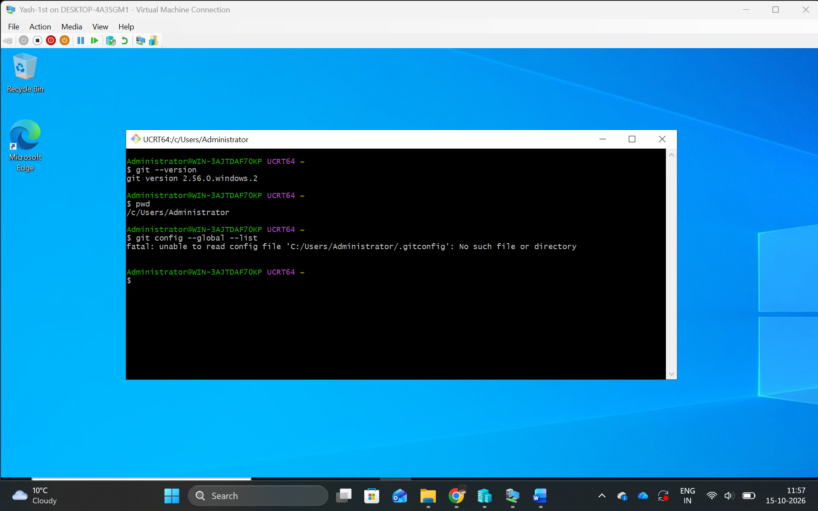
I installed Git Bash on Windows Server and verified the installation using git --version. I used pwd to check the current working directory and git config --global --list to review the Git configuration. These commands helped confirm that Git was ready for use on the server.
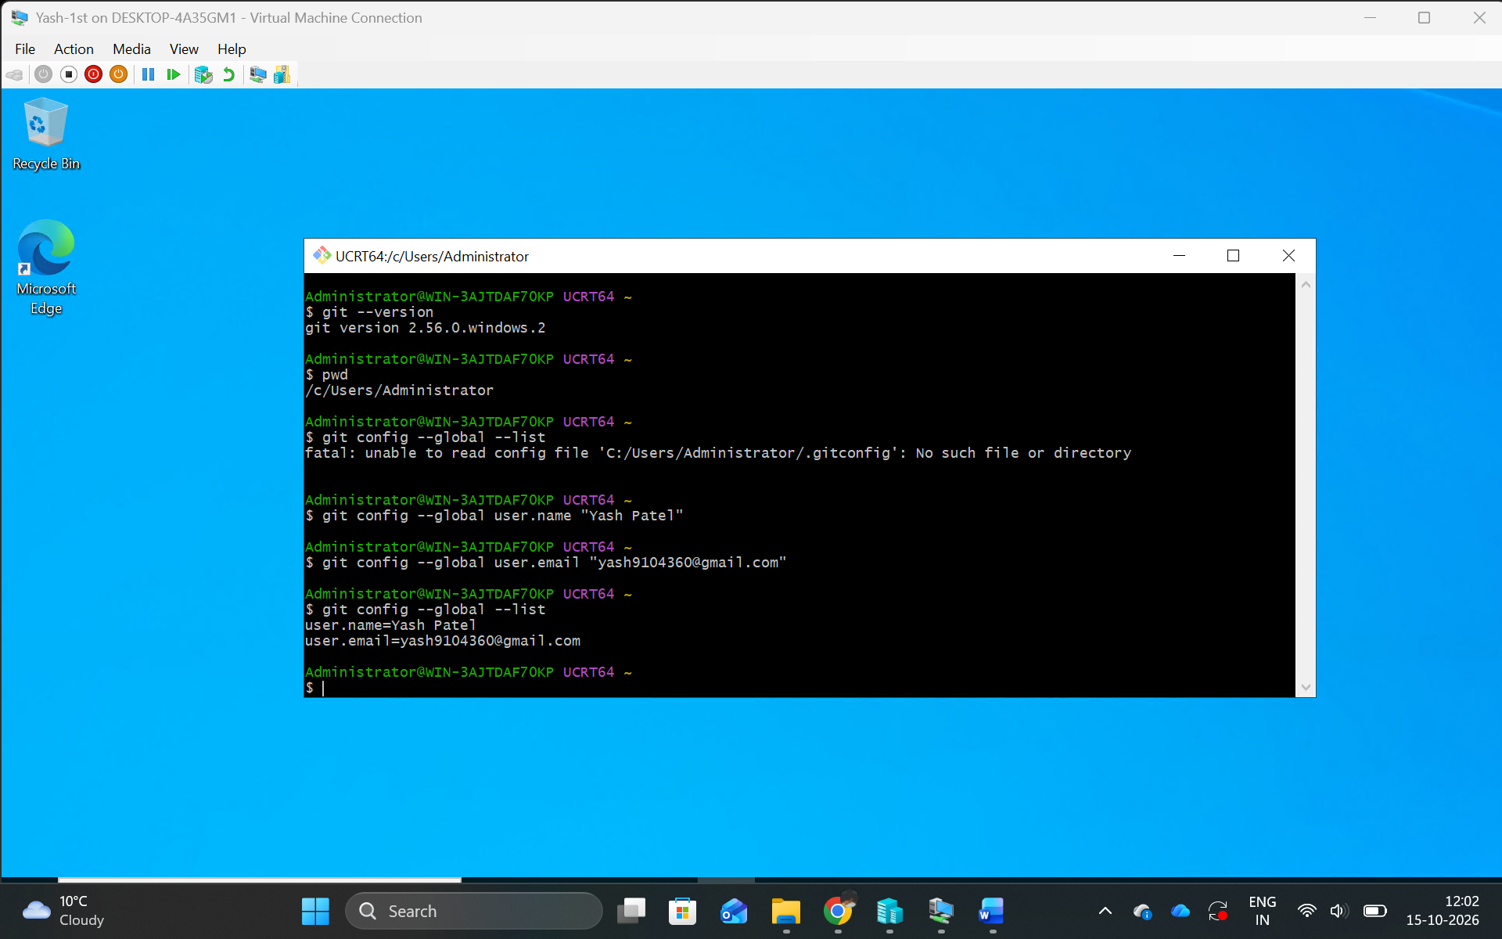
I configured Git on Windows Server using my name, Yash Patel, and my email address. I verified the settings using git config --global --list. This configuration identifies me as the author of commits in my Git projects.
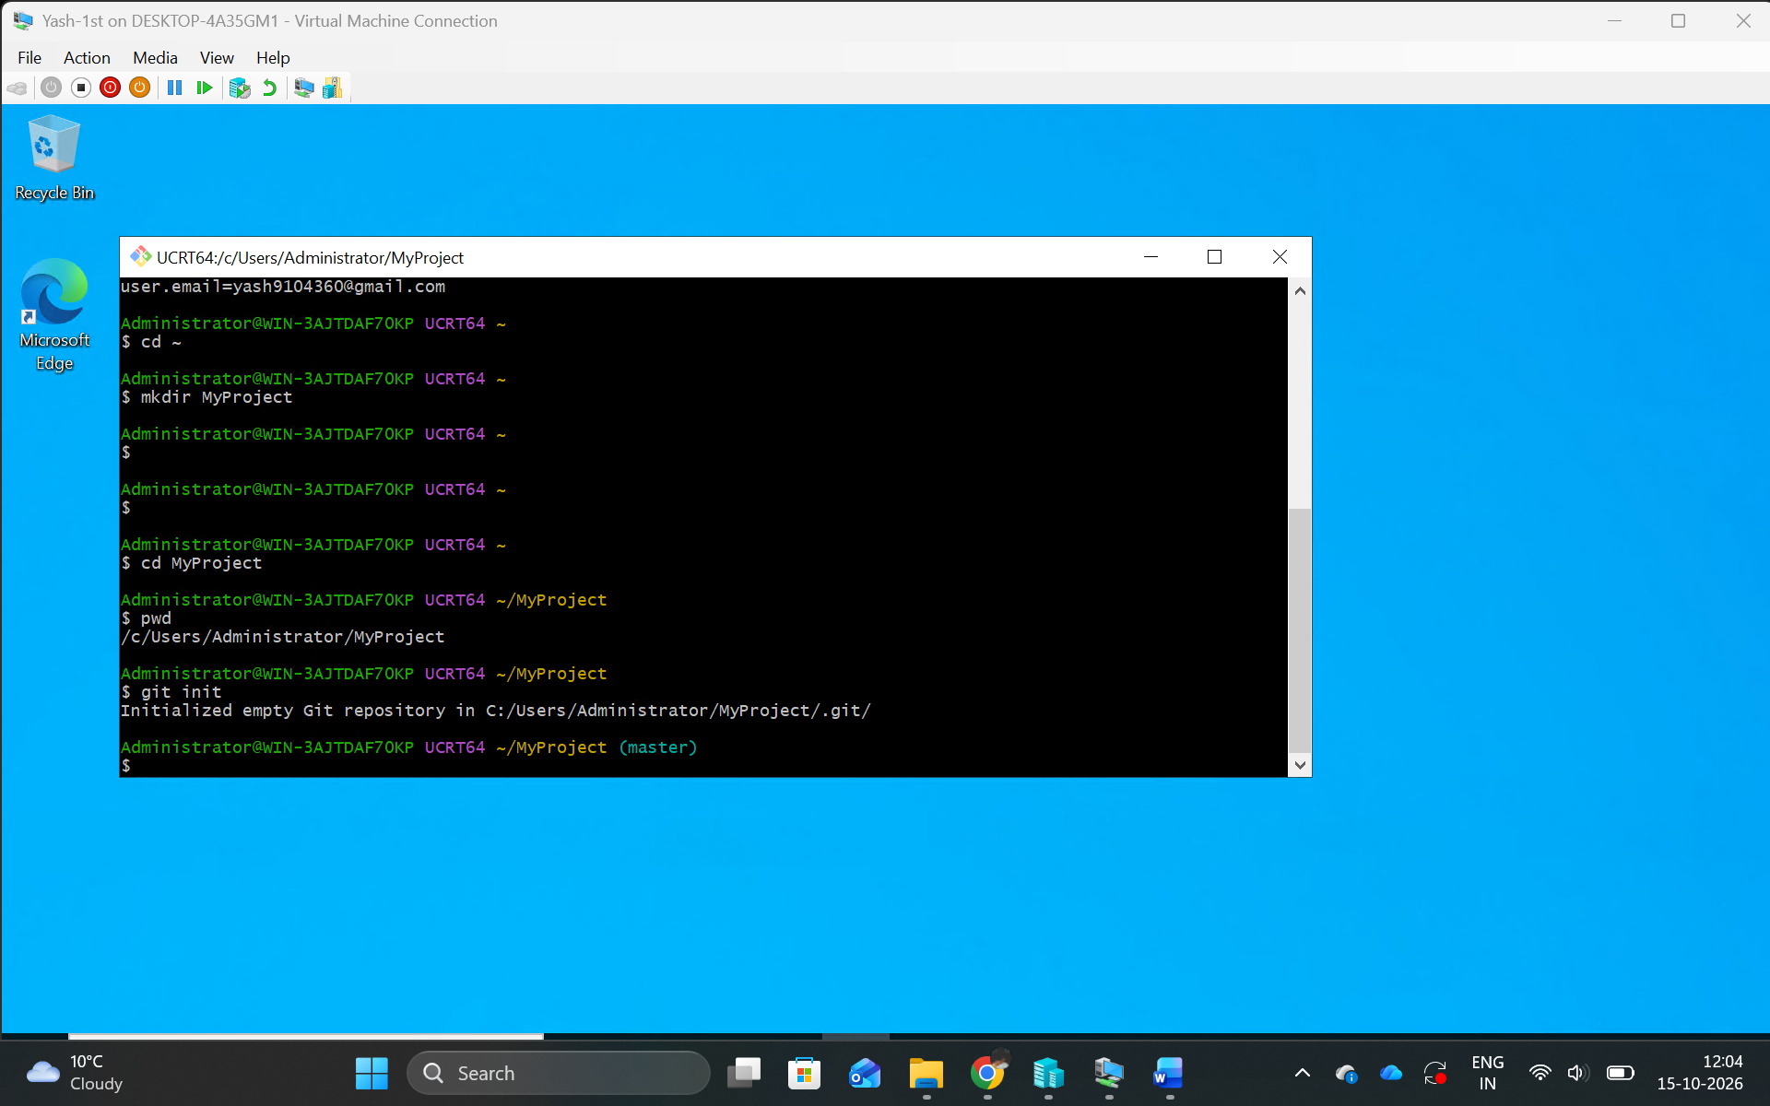
I created a project folder named MyProject on Windows Server using Git Bash. I navigated into the folder and executed git init to initialize a local Git repository. This allows Git to track changes made to my lab files.
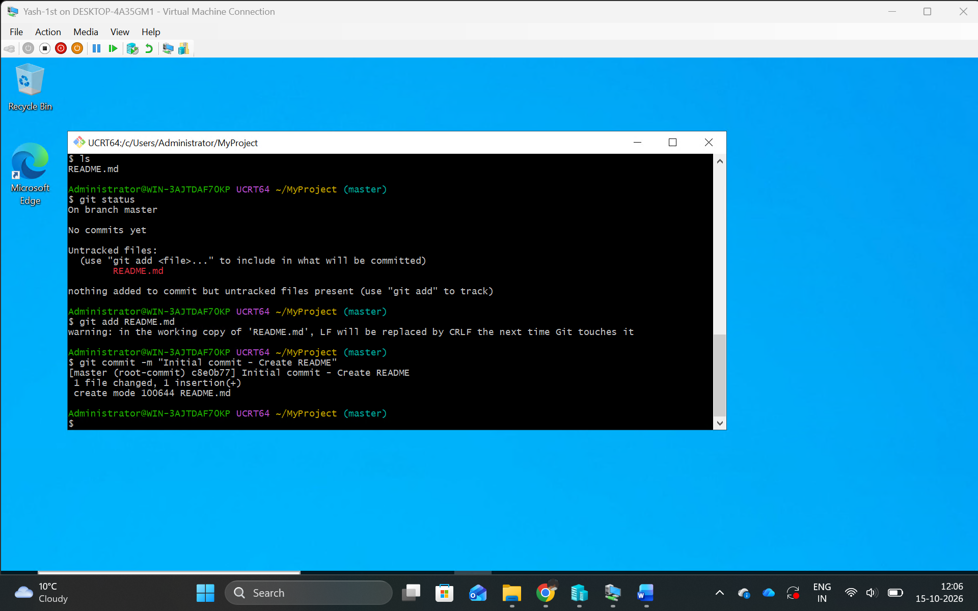
I created a README.md file in my project folder on Windows Server. I used git add to stage the file and git commit to save it in the local repository. This created the first version of my project under Git version control.
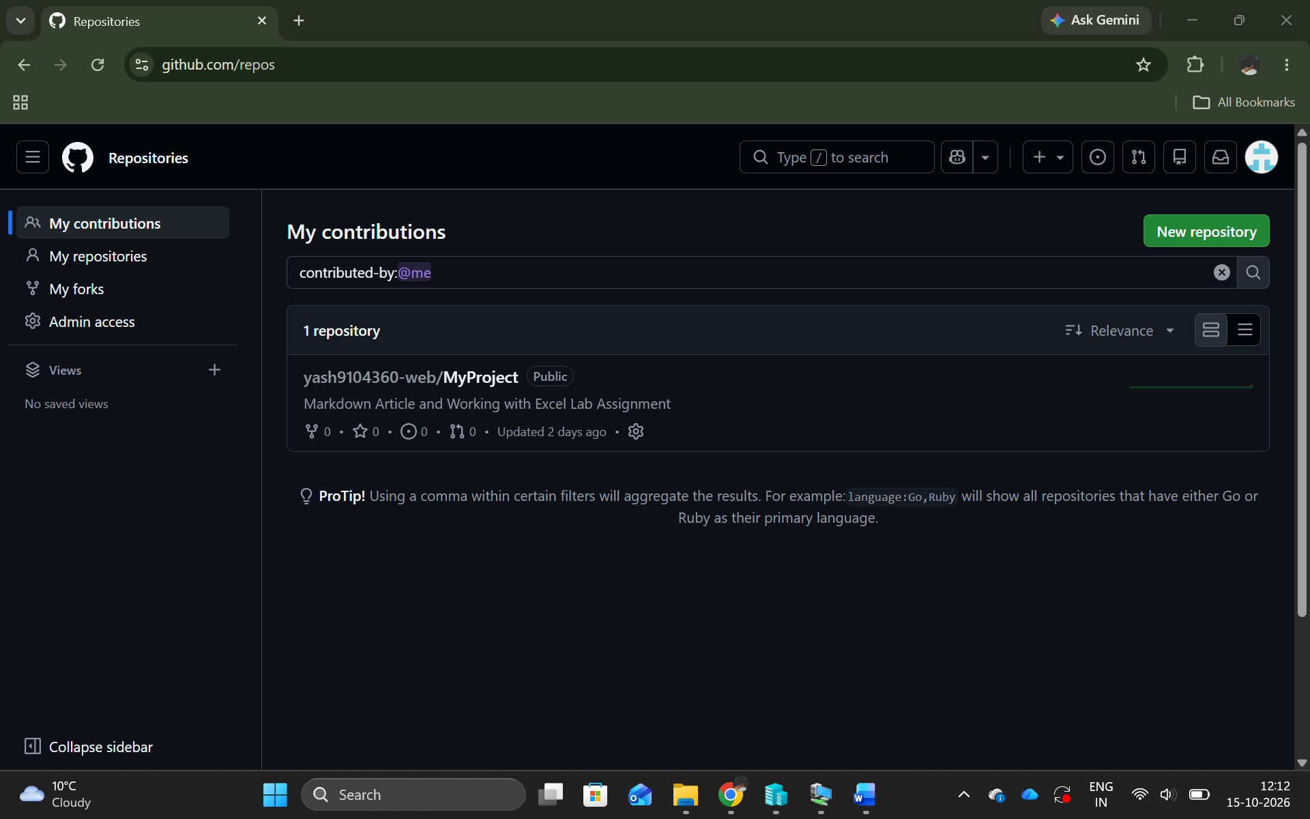
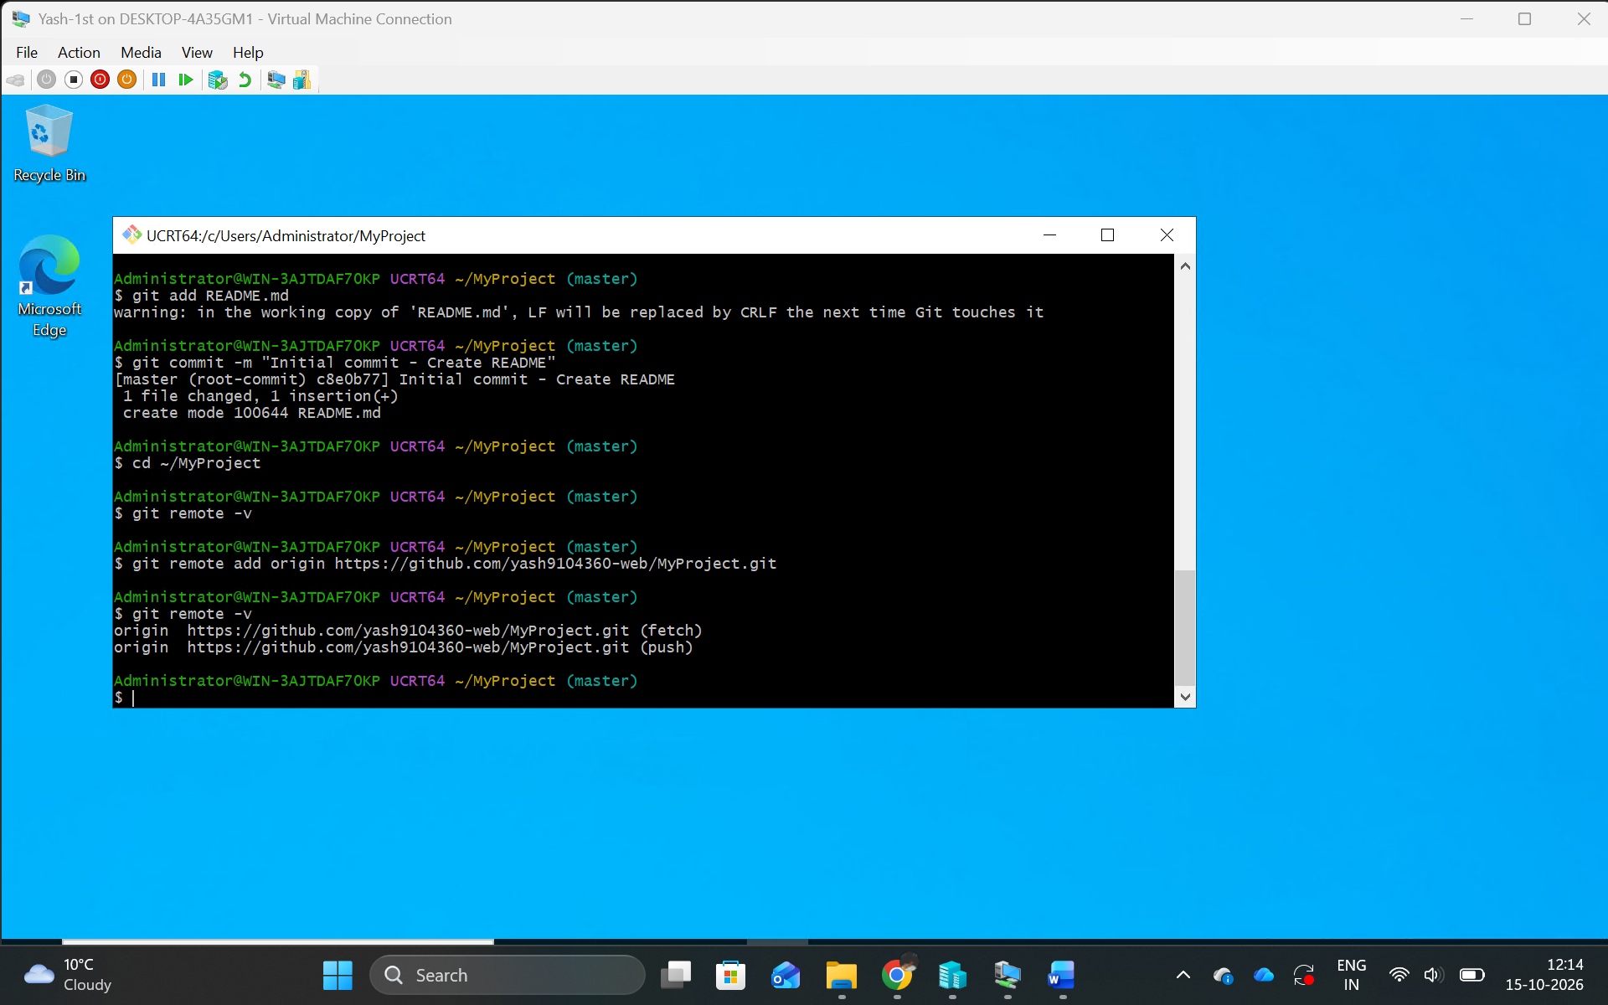
I connected my Windows Server project to my existing GitHub repository using Git Bash. I used git remote -v to verify the repository connection. This allows me to manage my lab files on Windows Server while using the same GitHub repository.
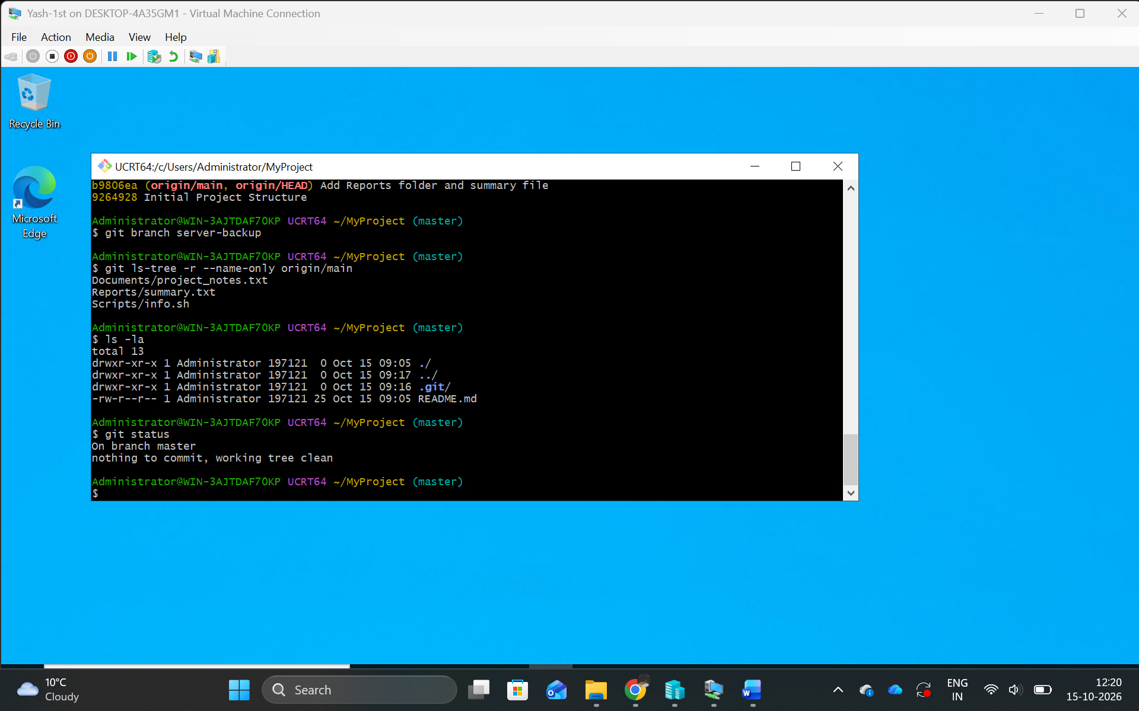
I verified the connection to my existing GitHub repository and checked the local and remote branches. I created a backup branch and compared the project files before synchronization. This helped protect my existing work from accidental changes.
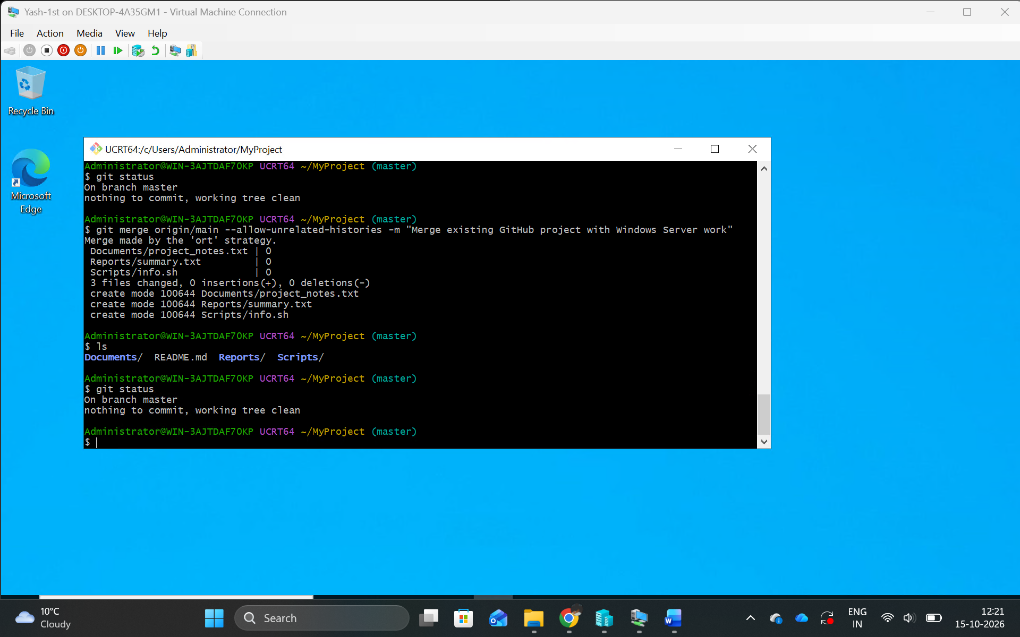
I merged my existing GitHub repository with the local project created on Windows Server. I used Git to combine the project histories and verified the merged files. This allowed me to continue the assignment using my existing GitHub repository.
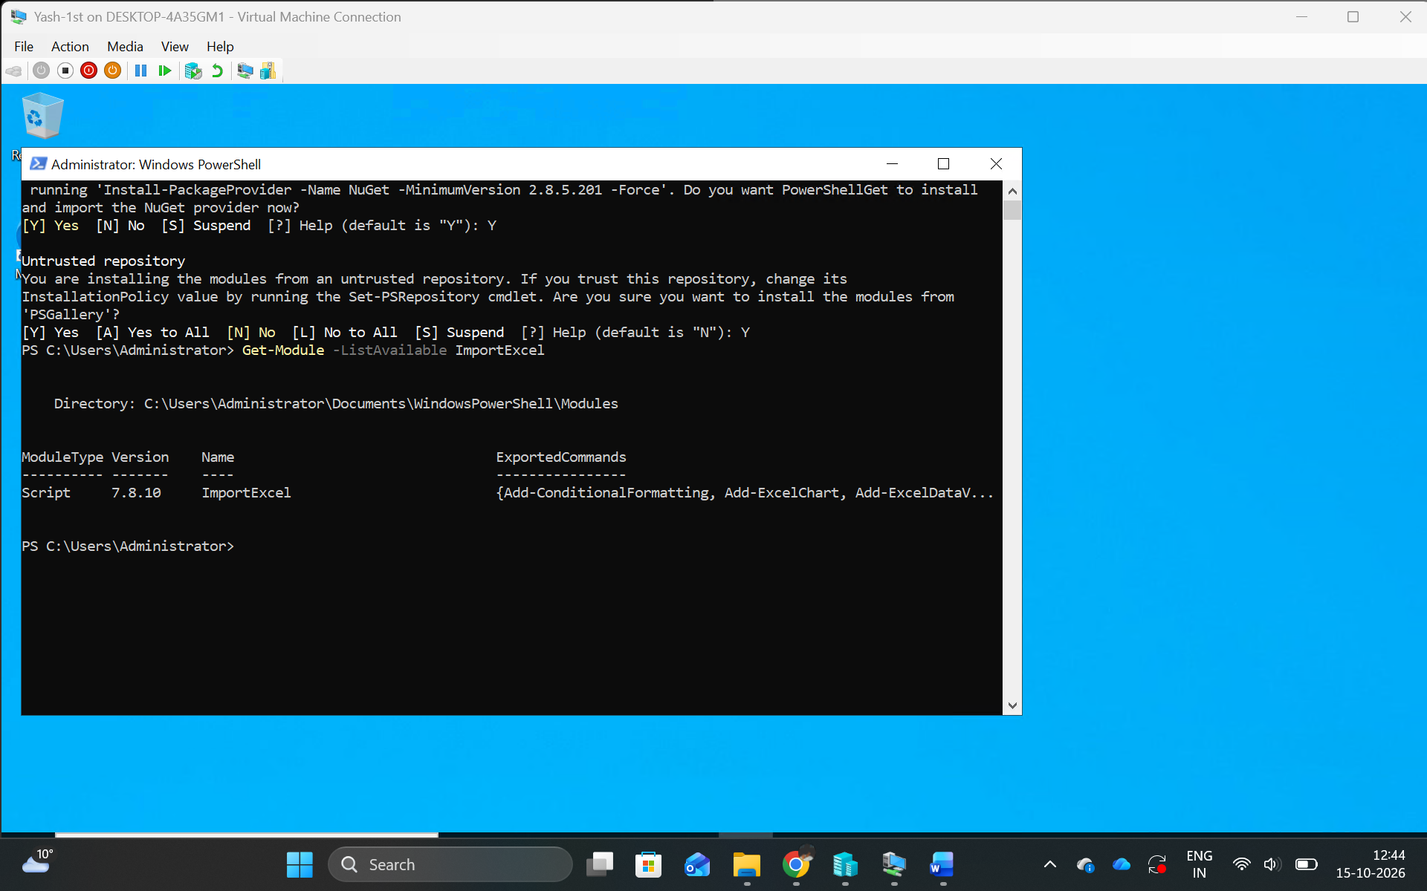
I installed the ImportExcel PowerShell module on Windows Server using the Install-Module command. I verified the installation using Get-Module. This module allows PowerShell to create, import, and modify Excel files without requiring Microsoft Excel to be installed.
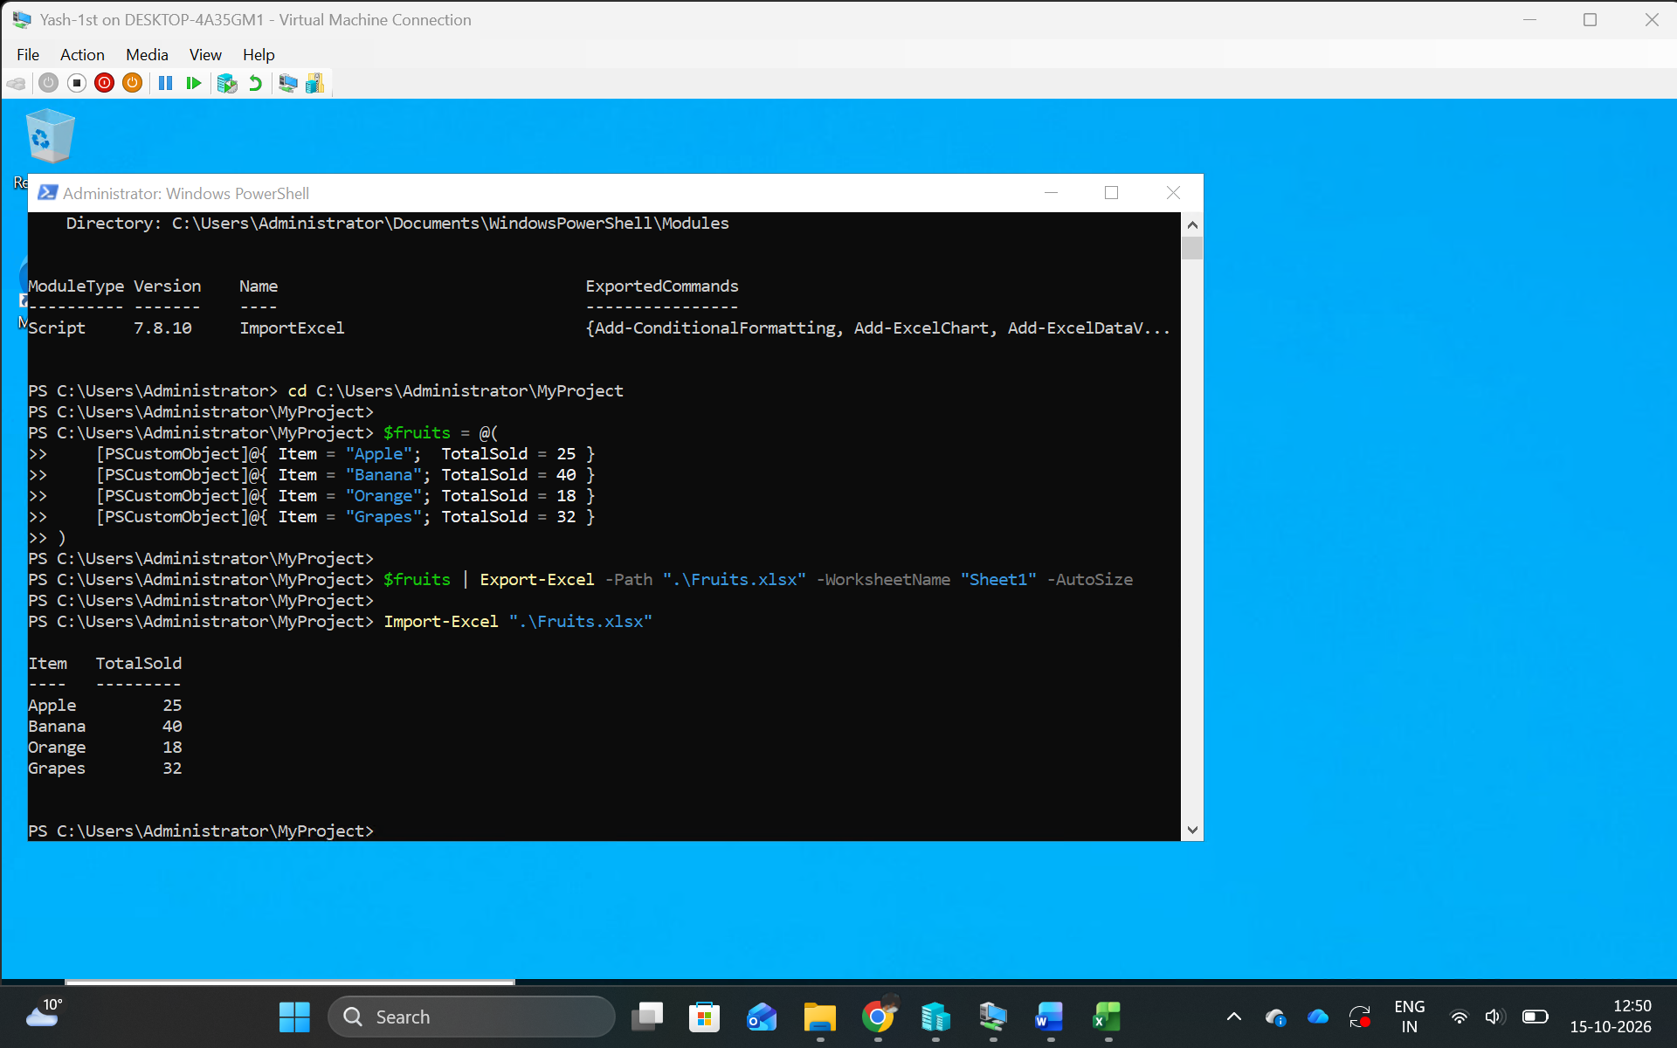
I created a Fruits.xlsx workbook on Windows Server using the ImportExcel PowerShell module. I then imported the workbook using Import-Excel and verified that the fruit names and sales totals were displayed correctly.
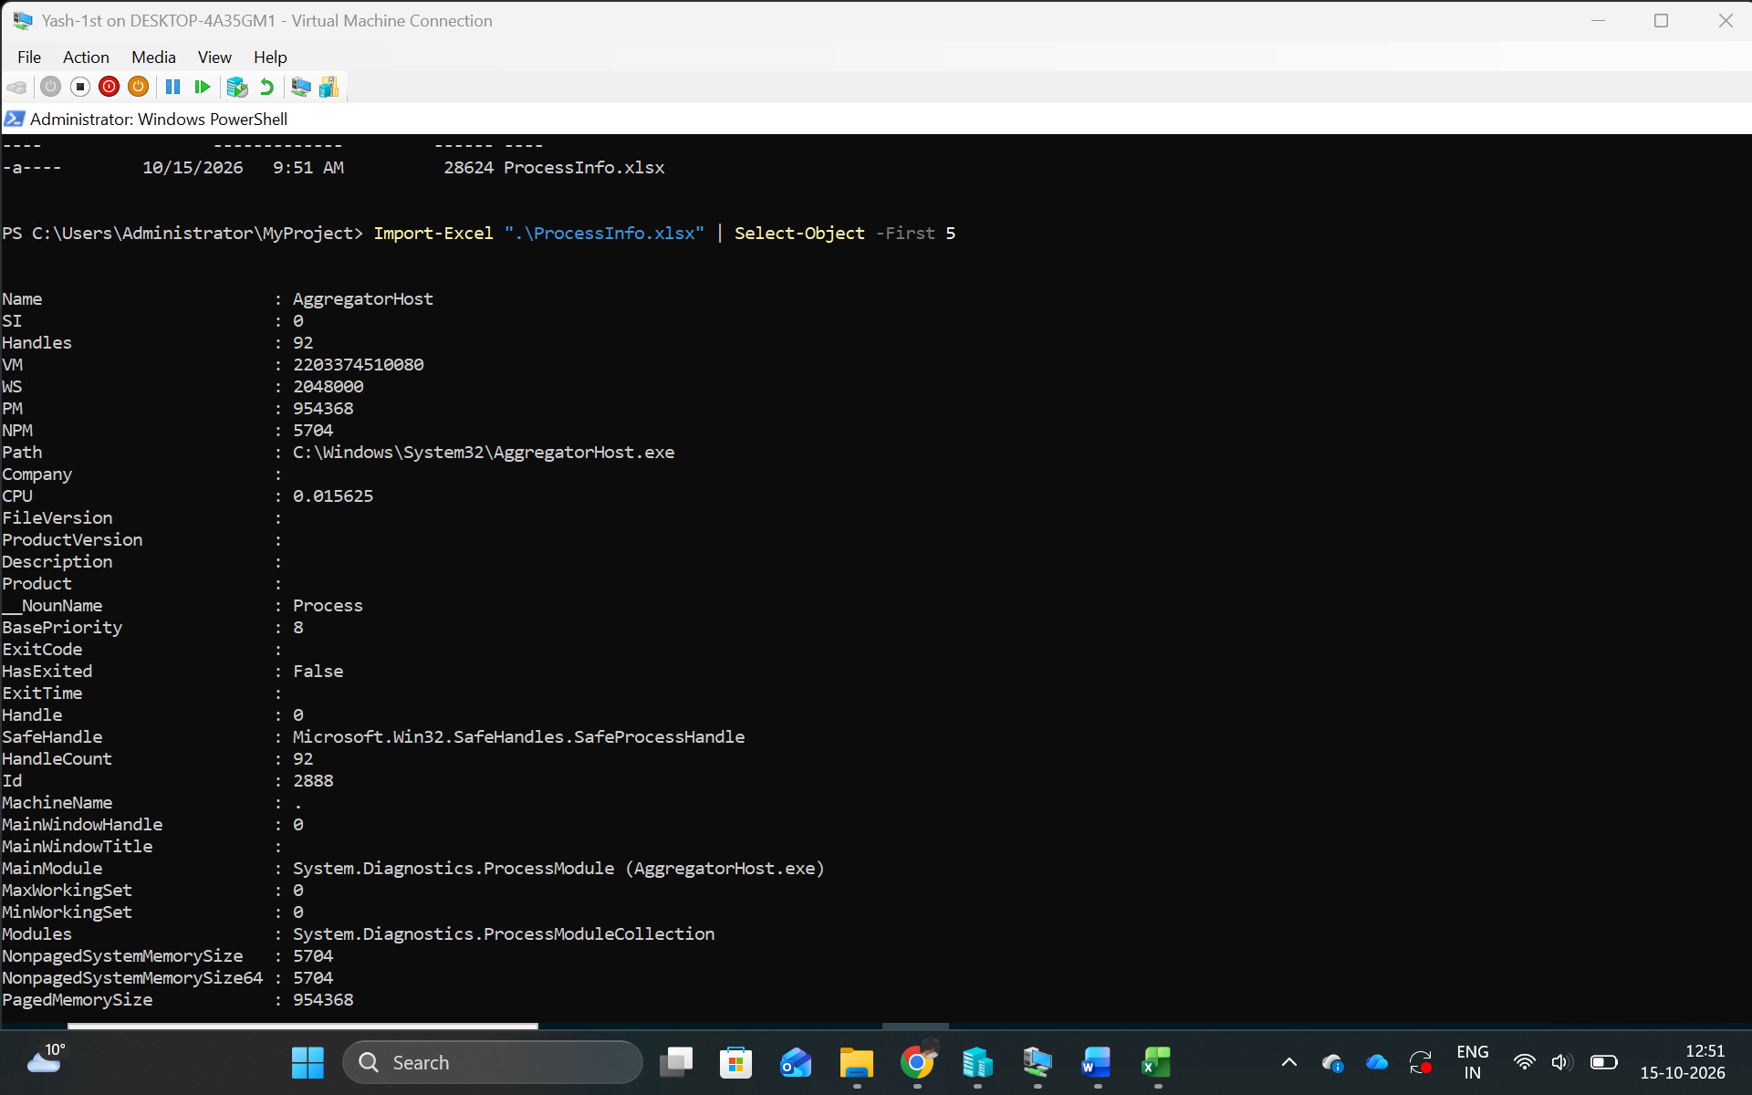
I used PowerShell on Windows Server to retrieve running process information with Get-Process. I exported the results into ProcessInfo.xlsx using Export-Excel and imported the workbook again to verify the data. This demonstrated how PowerShell can create and read Excel files.
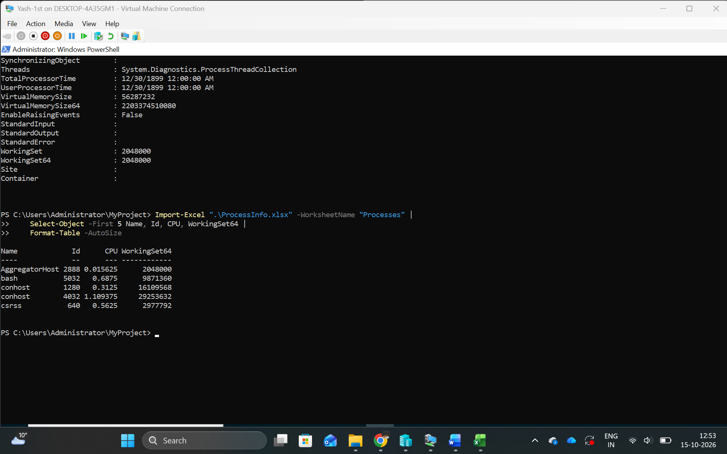
I used the Import-Excel command to read process information from ProcessInfo.xlsx on Windows Server. I selected specific columns, including Name, Id, CPU, and WorkingSet64, to display only the required information. This demonstrated how to filter Excel data using PowerShell.
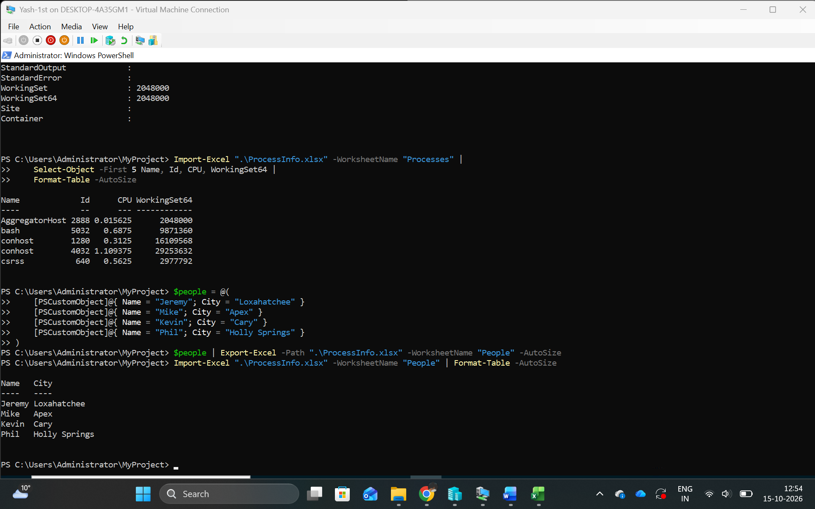
I created a PowerShell object containing four people's names and cities. I exported this data to a new worksheet named People in ProcessInfo.xlsx. I then used Import-Excel to verify that the worksheet contained the correct records.
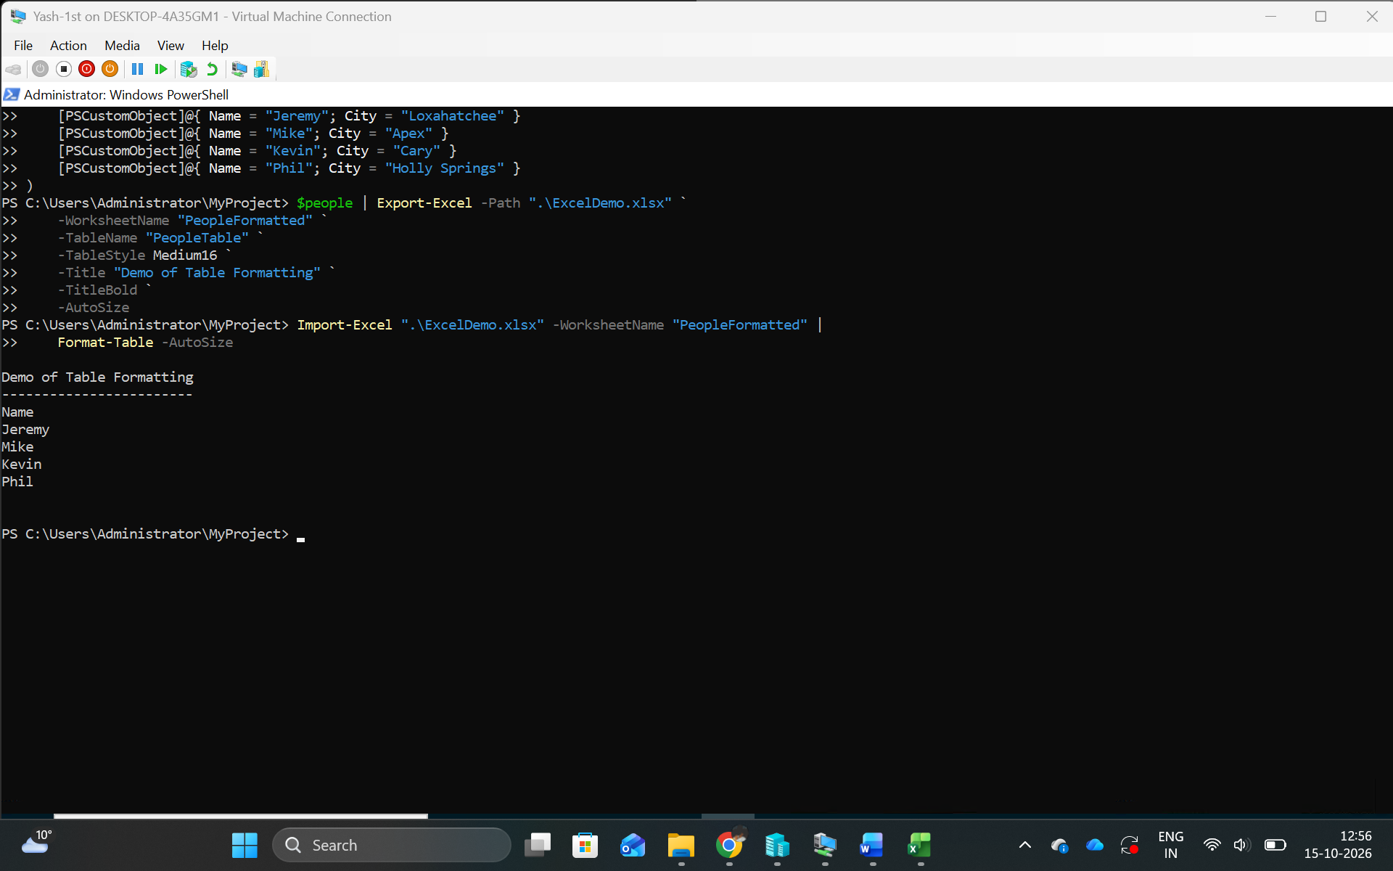
I used PowerShell and the ImportExcel module to create ExcelDemo.xlsx with a formatted table. I applied the Medium16 table style, added a bold title, and adjusted the column widths automatically. I verified that the workbook contained the correct names and cities.
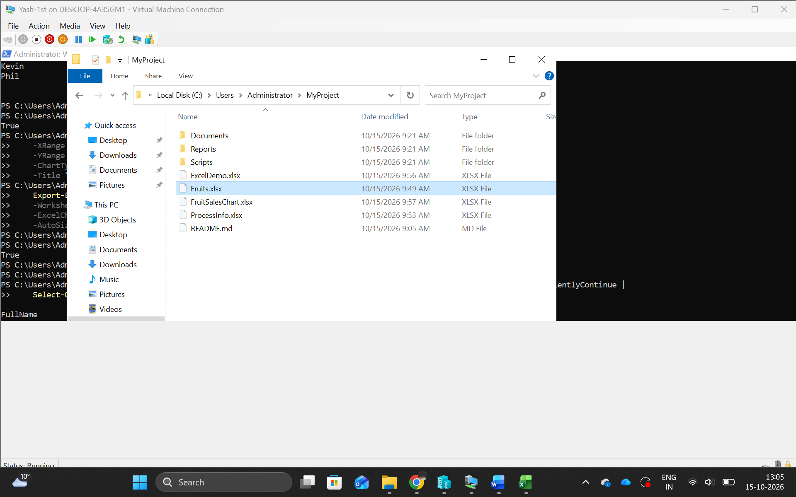
I successfully generated FruitSalesChart.xlsx using PowerShell on Windows Server. I verified that the workbook existed in my project folder using Test-Path and confirmed its location. The ImportExcel module allowed me to create the workbook without Microsoft Excel installed.
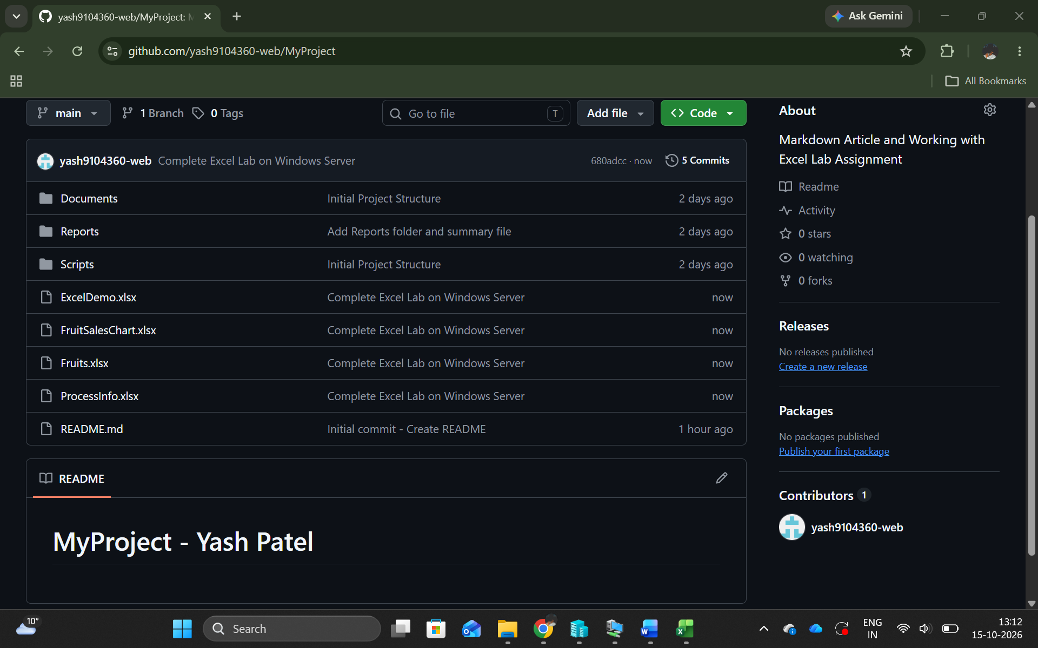
I used Git Bash on Windows Server to add and commit my completed Excel Lab files. I pushed the files to my existing GitHub repository and verified that they appeared online. This allowed me to store and track my Excel Lab work using Git.
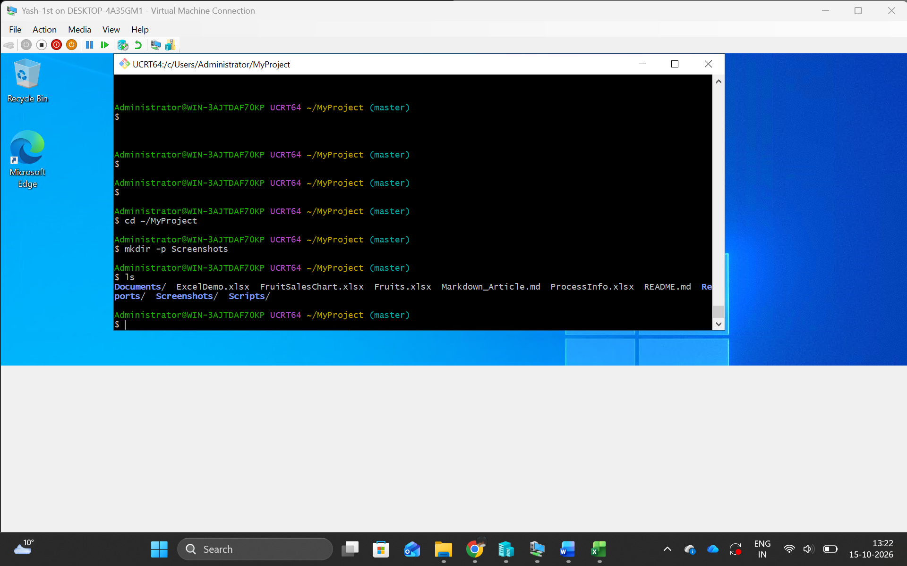
I organized my Windows Server lab documentation by placing the Word report in the Reports folder and screenshots in a separate Screenshots folder. The report includes the Git, GitHub, Markdown, and PowerShell Excel Lab activities with their outputs and explanations.

