Pigeon Pea Crop Disease VLM Captioning
Results Report — Stage 1 (Qwen2.5-VL-7B-Instruct Caption Generation)

1. Experimental Results Summary
Metric | Value
Total images | 3,155
Successful captions | 3,155
Failed | 0
Success rate | 100%
Average time per image | 2.53 seconds
Total processing time | 133.25 minutes
GPU | NVIDIA GeForce RTX 4090
Model | Qwen2.5-VL-7B-Instruct
max-image-dim | 768
max-new-tokens | 128
Table 1.1: Stage 1 execution statistics, as reported for the captioning run.
A GPU memory contention issue was encountered during the run: another root-owned process was occupying approximately 21 GB of VRAM. Caption generation completed successfully, with the 100% success rate above, once sufficient GPU memory became available.

2. Dataset Class Distribution
Class Label | Number of Images | Share of Dataset
Healthy | 572 | 18.1%
Phytopththora_blight | 466 | 14.8%
Pod_borer | 871 | 27.6%
Root_rot | 300 | 9.5%
Webbed_leaves | 376 | 11.9%
Wilt | 570 | 18.1%
Total | 3,155 | 100%
Table 2.1: Class-wise image distribution, derived from captions.jsonl (n = 3,155).

3. Caption Quality Analysis
Statistic | Value
Number of captions analyzed | 3,155
Average caption length | ≈ 78 words
Minimum caption length | 47 words
Maximum caption length | 108 words
Table 3.1: Caption length statistics derived from captions.jsonl (word counts).
Generated captions consistently describe plant morphology (trifoliate leaf structure, midribs, lateral veins, petioles, stems, pods) and note the presence or absence of visible symptoms such as discoloration, wilting, curling, drooping, spots, or pest presence.

4. Sample Captions by Class
The following tables show multiple representative captions per class, generated by Qwen2.5-VL-7B-Instruct in zero-shot mode, together with the corresponding source image where the image file was available in the uploaded dataset archives. Captions are quoted verbatim from captions.jsonl.

Healthy (5 of 572 images shown)
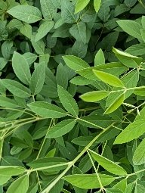 | Healthy/1_h_1694111400_1694159048.jpg  The image shows a close-up view of pigeon pea leaves, displaying a dense cluster of trifoliate leaves with prominent midribs and lateral veins. The leaves appear healthy, with a uniform green color and no visible signs of discoloration, spots, or damage. The leaflets are evenly spaced along the petioles, and there is no indication of wilting, drooping, or curling. The background consists of more foliage, suggesting a lush, green environment typical of a healthy pigeon pea plant.
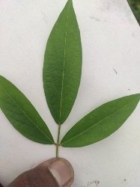 | Healthy/1_h_1692469800_1692520620.jpg  The image shows a single leaf of a pigeon pea plant. The leaf is trifoliate, with three distinct leaflets attached to a central petiole. The leaflets are broad and ovate, with smooth margins and a prominent midrib running down the center. Lateral veins are visible branching off from the midrib on each leaflet. The leaf surface appears healthy and uniformly green, with no visible signs of discoloration, spots, or damage. The background is plain white, suggesting the leaf was placed against a neutral backdrop for observation.
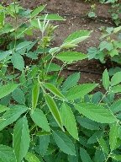 | Healthy/1_h_1694197800_1694254487.jpg  The image shows a pigeon pea plant with trifoliate leaves displaying a healthy green color. The leaflets are arranged in a pinnate pattern, with prominent midribs and lateral veins visible on the leaf surfaces. Petioles connect the leaflets to the stem, which appears robust and unblemished. The plant's nodes and internodes are also visible, indicating a well-developed structure. The background consists of dense green foliage, suggesting a healthy growth environment. No signs of wilting, drooping, or other abnormalities are present.
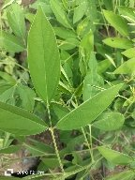 | Healthy/1_h_1692210600_1692260685.jpg  The image shows a pigeon pea plant with trifoliate leaves displaying a range of green shades. The leaflets appear healthy without visible signs of discoloration, spots, or damage. The midribs and lateral veins are prominent, and the petioles connect the leaflets to the stem. The stems are upright, and the nodes and internodes are clearly visible. The background consists of dense green foliage, indicating a healthy environment. No abnormalities such as wilting, drooping, or curling are evident on the leaves.
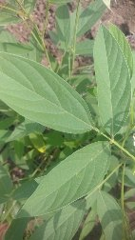 | Healthy/1_h_1692210600_1692264726.jpg  The image shows a close-up view of pigeon pea leaves. The leaves are trifoliate, with three leaflets each. The leaflets have prominent midribs and lateral veins, and the leaf surfaces appear smooth. The petioles are visible, connecting the leaflets to the stem. The stems are green and have nodes where the leaves attach. There are no visible signs of wilting, drooping, or curling, and the leaves do not show any discoloration or spots. The background consists of more greenery, indicating a healthy growth environment.
Representative Healthy captions generated by Qwen2.5-VL-7B-Instruct, quoted verbatim from captions.jsonl.

Phytopththora_blight (5 of 466 images shown)
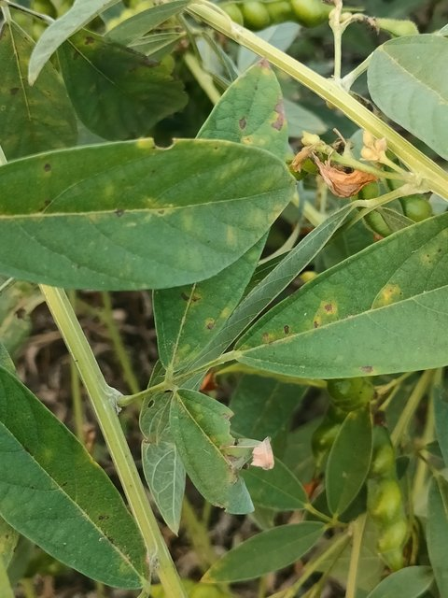 | Phytopththora_blight/IMG20260104165950.jpg  The image shows a pigeon pea plant with trifoliate leaves exhibiting various symptoms. Some leaves have brown discoloration concentrated along the veins, while others appear healthy and green. The stems are visible, showing no apparent abnormalities. Pod development is present, with some pods appearing green and unripe. The overall plant structure appears intact, with no significant wilting or drooping observed. The distribution of symptoms is scattered across the visible leaves, suggesting potential stress or environmental factors affecting the plant.
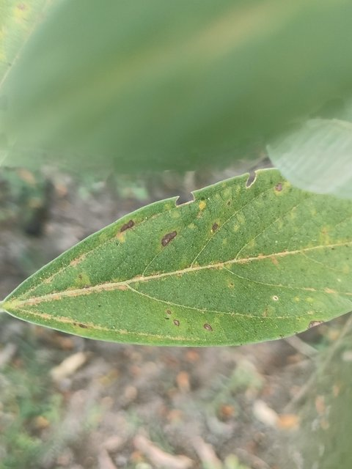 | Phytopththora_blight/IMG20260104170006.jpg  The image shows a single leaf of a pigeon pea plant. The leaf exhibits several small, scattered brown spots and patches across its surface, indicating some form of discoloration or damage. These spots are primarily concentrated towards the center of the leaf, with a few more dispersed along the veins. The leaf appears otherwise healthy, with no significant wilting, curling, or drying evident. The background is blurred, suggesting a natural outdoor setting with some vegetation.
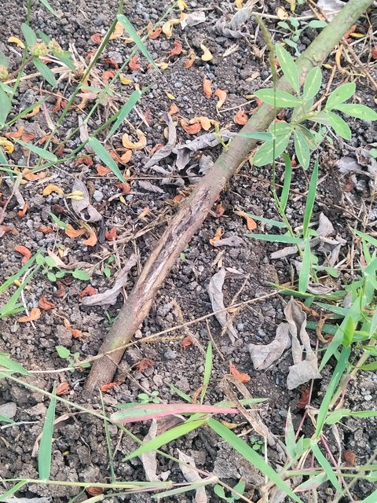 | Phytopththora_blight/IMG20260104170108.jpg  The image shows a section of a pigeon pea plant lying on the ground. The stem appears to have a longitudinal split or crack running along its length, exposing the inner bark. The surrounding soil is dry and contains scattered dried leaves and small debris. The plant's leaves are trifoliate, with some showing signs of wilting and discoloration, particularly around the edges. The overall condition suggests possible mechanical damage or stress, but no specific disease symptoms are evident.
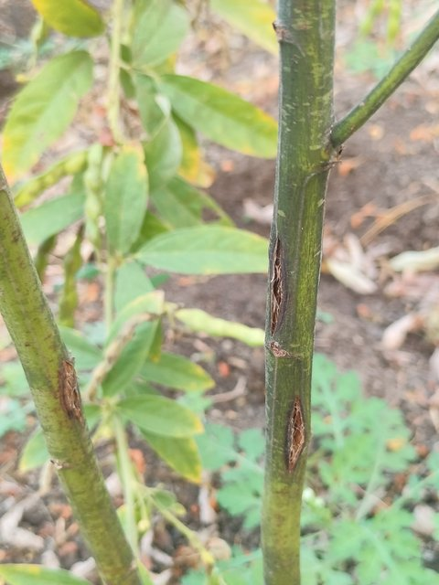 | Phytopththora_blight/IMG20260104170026.jpg  The image shows a section of a pigeon pea plant stem with visible lesions along the internodes. The lesions appear as elongated, dark brown markings, possibly indicating mechanical damage or disease. The stem is green with some minor blemishes, and the background includes other plant parts and soil, suggesting a natural outdoor setting. The leaves are healthy-looking, with no apparent abnormalities.
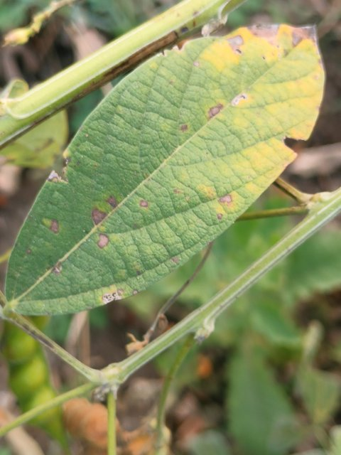 | Phytopththora_blight/IMG20260104165724.jpg  The image shows a pigeon pea leaf with visible signs of discoloration and spotting. The leaf exhibits a mix of green and yellow hues, with some areas appearing lighter and others darker, indicating possible nutrient deficiency or stress. There are scattered brown spots across the leaf surface, suggesting potential pest activity or environmental stress. The leaf structure appears intact, with no significant wilting or curling. The background includes parts of the plant's stem and other leaves, which appear healthy. The overall condition suggests the plant might be under some form of stress, but specific causes cannot be determined from the image alone.
Representative Phytopththora_blight captions generated by Qwen2.5-VL-7B-Instruct, quoted verbatim from captions.jsonl.

Pod_borer (5 of 871 images shown)
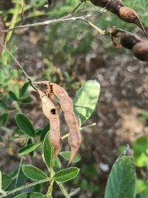 | Pod_borer/1_h_1707244200_1707282838.jpg  The image shows a pigeon pea plant with visible leaflets and petioles. The leaves exhibit some brown discoloration, particularly on the edges, suggesting possible stress or damage. The pods appear intact, with no visible signs of damage or infection. The background consists of soil and vegetation, indicating a natural outdoor setting. The overall morphology of the plant appears healthy, with no significant abnormalities other than the minor discoloration on the leaves.
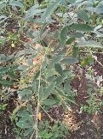 | Pod_borer/1_h_1702233000_1702285558.jpg  The image shows a pigeon pea plant with trifoliate leaves exhibiting slight curling at the tips. The leaflets appear healthy, with no visible spots, lesions, or discoloration. The stems are upright, and there are no signs of wilting or drooping. The background consists of soil and other vegetation, indicating a natural outdoor setting. No insects or other abnormalities are apparent on the plant.
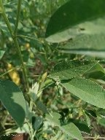 | Pod_borer/1_h_1699209000_1699256023.jpg  The image shows a close-up view of a pigeon pea plant. The trifoliate leaves exhibit a mix of green and yellow hues, indicating potential nutrient deficiency or stress. The leaflets appear slightly curled, and there are no visible signs of wilting or drooping. The midribs and lateral veins are prominent, and the petioles are attached to the stem, which appears healthy without any noticeable damage. The background consists of green foliage, suggesting a natural outdoor setting. No specific symptoms such as spots, lesions, or discoloration are evident on the leaves.
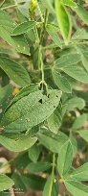 | Pod_borer/1_h_1701455400_1701513903.jpg  The image shows a pigeon pea plant with trifoliate leaves exhibiting some visible damage. The leaflets have small holes and appear slightly curled, particularly on the edges. The leaf surfaces show minor discoloration, with some areas appearing lighter than others. The spatial distribution of the damage is scattered across multiple leaves, indicating potential insect feeding or mechanical damage. The background consists of dense foliage, suggesting the plant is growing in a natural setting.
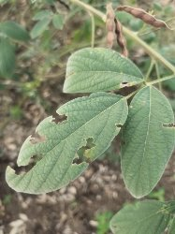 | Pod_borer/1_h_1702578600_1702635282.jpg  The image shows a close-up of pigeon pea leaves with visible signs of damage. The leaves exhibit holes and missing tissue, particularly on the lower left leaflet. The damage appears scattered across multiple leaflets, with some showing more extensive loss of tissue than others. The leaf surfaces appear generally healthy, with no significant discoloration or wilting. The spatial distribution of the damage suggests it could be due to insect feeding or mechanical damage. The background consists of additional leaves and stems, indicating the plant is in a natural setting.
Representative Pod_borer captions generated by Qwen2.5-VL-7B-Instruct, quoted verbatim from captions.jsonl.

Root_rot (5 of 300 images shown)
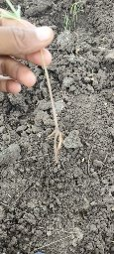 | Root_rot/5_h_1691692200_1691742079.jpg  The image shows a close-up view of a pigeon pea plant stem. The stem appears to have a small, light-colored growth or protrusion near the base, which could be a developing node or a minor swelling. The soil in the background is dry and compacted, indicating possible drought conditions. No visible signs of disease, pests, or physical damage are apparent on the stem or surrounding soil. The overall condition of the plant seems stable at this stage.
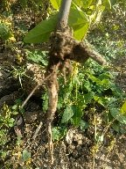 | Root_rot/5_h_1705343400_1705400003.jpg  The image shows a pigeon pea plant with visible roots extending into the soil. The roots appear tangled and somewhat thick, suggesting they might be well-developed. The surrounding soil looks dry and compacted, with some scattered debris. The plant's leaves are not fully visible, but their presence can be inferred from the stem structure. No obvious signs of disease, such as discoloration or wilting, are apparent on the visible parts of the plant. The overall condition appears stable, with no immediate signs of distress.
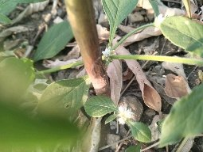 | Root_rot/5_h_1698431400_1698491435.jpg  The image shows a close-up view of a pigeon pea plant. The visible leaves are trifoliate, with distinct leaflets and midribs. The leaf surfaces appear healthy, with no noticeable discoloration or damage. The stems are slender and green, with nodes and internodes visible. A small white flower bud is present at the base of one leaflet. The background consists of dry, brown leaves and soil, indicating a natural outdoor setting. No signs of wilting, drooping, or other abnormalities are evident on the plant.
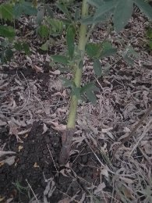 | Root_rot/4_h_1705516200_1705581602.jpg  The image shows a pigeon pea plant with a single visible stem. The stem appears healthy, with a smooth surface and no visible signs of damage or disease. The surrounding soil and ground cover consist of dry, brown debris, indicating a natural outdoor environment. No leaves, flowers, or pods are visible in the frame, focusing attention solely on the stem. The overall condition of the stem suggests the plant is in good health at this stage.
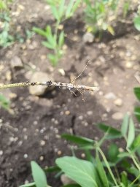 | Root_rot/5_h_1693333800_1693384596.jpg  The image shows a close-up of a pigeon pea plant stem with a small insect perched on it. The stem appears healthy, with no visible signs of discoloration, wilting, or damage. The insect is positioned near the top of the stem, and its body is partially obscured by the stem's structure. The background consists of soil and some green foliage, indicating a natural outdoor setting. The focus is primarily on the interaction between the stem and the insect, with no other significant abnormalities observed.
Representative Root_rot captions generated by Qwen2.5-VL-7B-Instruct, quoted verbatim from captions.jsonl.

Webbed_leaves (5 of 376 images shown)
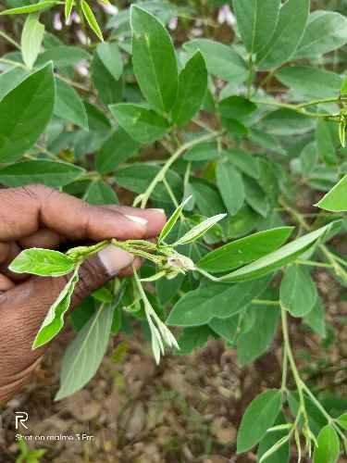 | Webbed_leaves/46_1_11545_3_5.jpg  The image shows a hand holding a pigeon pea plant displaying a cluster of trifoliate leaves. The leaves exhibit slight curling at the tips, with some showing a light brown discoloration along the edges. The petioles appear healthy, and the background consists of additional green leaves, indicating a healthy plant environment. No other abnormalities or pests are visibly present on the plant.
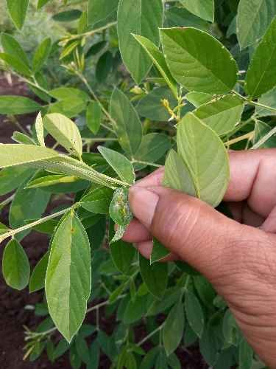 | Webbed_leaves/44_3_1409_3_8.jpg  A hand holds a pigeon pea leaf displaying a small, curled, and discolored area near the petiole. The leaflet appears slightly wilted, with a lighter green coloration compared to surrounding healthy leaves. The leaf surface shows no significant spots or lesions, and the overall structure of the leaf remains intact. The background consists of a dense cluster of similar leaves, indicating a healthy plant environment.
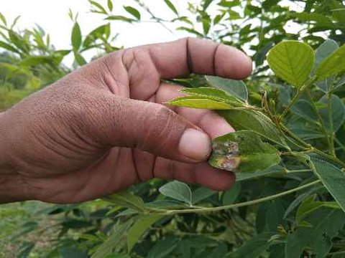 | Webbed_leaves/15_3_4519_3_3.jpg  A hand holds a pigeon pea leaf displaying a small, irregularly shaped brown spot on one of the leaflets. The spot appears to be localized and does not seem to affect the overall structure of the leaflet. The surrounding leaflets appear healthy and green, with no other visible abnormalities. The background shows more of the plant's foliage, which is lush and green, indicating a healthy environment.
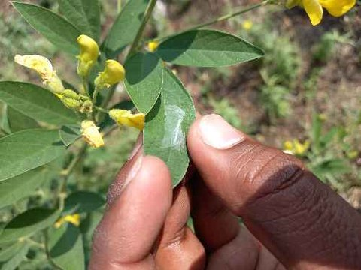 | Webbed_leaves/28_1_5537_3_1.jpg  The image shows a close-up of a pigeon pea plant with trifoliate leaves. The leaves have a smooth texture and are a vibrant green color. The leaflets are broad and slightly pointed at the tips. The midribs are prominent, running down the center of each leaflet, while lateral veins branch out symmetrically on either side. The petioles connecting the leaflets to the stem are short and sturdy. The background includes additional green foliage, suggesting a healthy environment. No visible signs of disease, damage, or abnormality are present on the leaves shown.
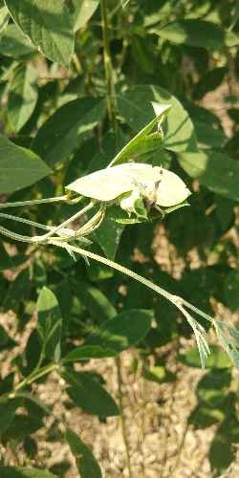 | Webbed_leaves/17_1_4490_3_6.jpg  The image shows a pigeon pea plant with trifoliate leaves displaying a light green color. The leaflets appear slightly curled at the tips, and there is a noticeable web-like structure on one of the leaves, suggesting the presence of an insect or mite. The background consists of more green foliage, indicating a healthy plant environment. No significant discoloration, wilting, or other abnormalities are evident in the visible parts of the plant.
Representative Webbed_leaves captions generated by Qwen2.5-VL-7B-Instruct, quoted verbatim from captions.jsonl.

Wilt (5 of 570 images shown)
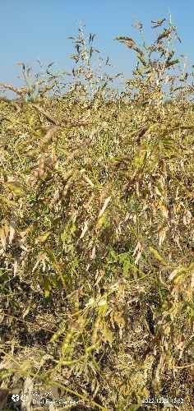 | Wilt/102_3_1363_10_4.jpg  The image shows a field of pigeon pea plants with mature pods. The pods are mostly dry and brown, indicating ripening or maturity. The leaves appear healthy, with no visible signs of discoloration, wilting, or damage. The plants are densely packed, and the background consists of a clear blue sky, suggesting a sunny day. The overall appearance suggests a healthy crop at the end of the growing season.  ⚠ Ground truth: Wilt — caption states the crop appears healthy. See Limitations.
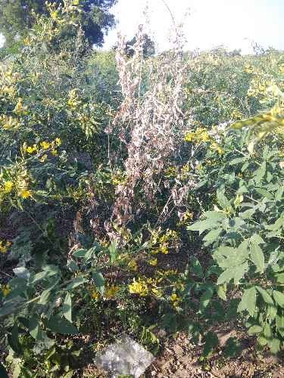 | Wilt/96_1_10226_10_5.jpg  The image shows a pigeon pea plant with a mix of healthy and unhealthy-looking foliage. The healthy leaves are green and appear normal, while some leaves exhibit brown discoloration and wilting, particularly on the upper parts of the plant. The stems show signs of drying, with some appearing lighter in color compared to others. The overall distribution of the symptoms suggests a possible stress condition affecting the upper portions of the plant. The background consists of a field with other vegetation, indicating the plant's growth environment.
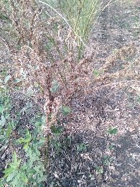 | Wilt/6_h_1703874600_1703914826.jpg  The image shows a pigeon pea plant with visible leaflets and stems. The leaves appear to have some discoloration, with brownish areas concentrated on the edges, suggesting possible nutrient deficiency or environmental stress. The plant's overall structure appears intact, with no significant wilting or drooping observed. The background consists of dry soil and scattered debris, indicating a natural outdoor setting.
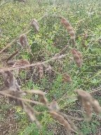 | Wilt/3_h_1704479400_1704525159.jpg  The image shows pigeon pea plants with visible mature pods, some of which appear dried and browned at the tips. The leaves are trifoliate, with leaflets showing signs of drying and browning, particularly along the edges. The stems are slender and green, with nodes and internodes clearly visible. The background consists of a mix of grasses and other vegetation, indicating a natural field setting. No significant abnormalities such as spots, lesions, or wilting are apparent on the leaves or stems.
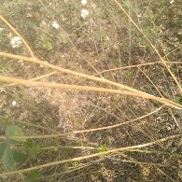 | Wilt/4_h_1704652200_1704692473.jpg  The image shows a close-up view of pigeon pea plant stems and leaves. The stems appear thin and elongated, with a light brown coloration. The leaves are trifoliate, with leaflets that have a slightly curled appearance, giving them a somewhat drooping look. The leaf surfaces seem smooth, and there are no visible signs of discoloration, spots, or wilting. The background consists of dry grass and other vegetation, indicating a natural outdoor setting. No specific abnormalities or damage are evident on the visible parts of the plant.
Representative Wilt captions generated by Qwen2.5-VL-7B-Instruct, quoted verbatim from captions.jsonl.

5. Limitations — Class/Caption Mismatch
As highlighted above, some generated captions do not match the ground-truth class label. The Wilt-class example marked in red is captioned as visually healthy (“...The leaves appear healthy, with no visible signs of discoloration, wilting, or damage...The overall appearance suggests a healthy crop...”) despite its ground-truth label being Wilt. This occurs because Stage 1 captions were generated without providing the ground-truth label to the model — the model reasoned purely from visual appearance, which can disagree with expert-assigned ground truth for subtle or partially visible symptoms.
- No formal caption-quality metric (e.g., BLEU, METEOR, CIDEr) or expert human evaluation has been computed at this stage.
- The captioning system has not been validated as a disease-diagnosis tool; captions are descriptive text outputs only.
- This class–caption mismatch is the motivation for the planned Stage 2 (LoRA/QLoRA fine-tuning with ground-truth label conditioning), which is not yet implemented.

