Project Completion Report

Project Title
AI-Driven Crop Disease Detection Using Image Processing and Computer Vision Techniques
Submitted by
Yadnika Pashte and Yashodhan Rajapkar (CHANAKYA Fellows)
Mentor: Dr. Sushopti Gawade, Professor
Vidyalankar Institute of Technology, Mumbai
CHANAKYA Fellowship Programme, TIH Foundation for IoT and IoE, IIT Bombay
Yadnika Pashte: yadnika.pashte@vit.edu.in | 7058868221
Yashodhan Rajapkar: yashodhan.rajapkar@vit.edu.in | 9769503670
Dr. Sushopti Gawade: sushoptiekrishimitra@gmail.com | 8369323410
Date of Submission: 09 / 10 / 2026




Contents
Cover Sheet 3
Part A - Summary Report 4
1. Project Objectives 4
2. Deliverables 6
a) Nature of Output: 7
b) Performance specifications: 7
c) Details of engineering designs/ drawings and prototype 8
3. Specific Benefits/Outcome (Please give details) 9
a) Patents filed during the Review Period 9
b) Paper publication/submission in Journal/Symposia/Conferences during the Review Period 9
c) Journal Details with Impact Factors 9
d) Details of the Project Staff working on the project 9
e) Manpower trained (Give details) 10
f) Awareness, training camps, etc. organized 10
g) Summary of significant S&T Achievements 10
h) Project Budget (Final) 11
Part B – Comprehensive Report 12
Annexure A – Sugarcane results (Table 3.1.1 of the Handover Report) 18
Annexure B – Pigeon Pea results (Table 3.2.1 of the Handover Report) 18
Annexure C – Grapes results (Table 3.3.1 of the Handover Report) 20
Annexure D – Mustard results (Table 3.4.1 of the Handover Report) 21
Annexure E – Classification reports and confusion matrices 22
Annexure F – Result figures (from the submitted paper) 28
Annexure G – Copy of submitted paper 29

Cover Sheet

Sr. No. | Name | Details
3 | Project Grant Number | TIH-IoT/2025-11/HRD/CHANAKYA/SL/CFP/TIHI-153341
4 | Project Title | AI-Driven Crop Disease Detection Using Image Processing and Computer Vision Techniques
3 | Principal Investigator (PI)
 | Name | Dr. Sushopti Gawade, Professor, Vidyalankar Institute of Technology (sushoptiekrishimitra@gmail.com, 8369323410)
 | Organization | Vidyalankar Institute of Technology, Mumbai; CHANAKYA Fellowship Programme, TIH Foundation for IoT and IoE, IIT Bombay
7 | Co-Principal Investigators (co-PI) :1
 | Name | Nil – no Co-Principal Investigator
 | Organization | Not applicable
8 | Collaborating Organizations :1
 | Name | PoCRA (Project on Climate Resilient Agriculture, Government of Maharashtra) – source of the curated crop-disease datasets; TIH IIT Bombay – TIH Mentor / POC: Susmita Banerjee
 | Team Members | Yadnika Pashte (yadnika.pashte@vit.edu.in, 7058868221) and Yashodhan Rajapkar (yashodhan.rajapkar@vit.edu.in, 9769503670) – CHANAKYA Fellows; Project No. 153341
 | Activities/Tasks Assigned | Yadnika Pashte and Yashodhan Rajapkar: all work (model training, cross-domain PoCRA→NPSS evaluation and documentation for Sugarcane, Pigeon Pea, Grapes and Mustard) was carried out jointly, with no formal work split. Where attributed: Pigeon Pea model training – Yashodhan Rajapkar; Sugarcane model training – Yadnika Pashte; all remaining work done together. PoCRA team: provision of curated, annotated datasets.
5 | Date of Project Commencement | 1 December 2025
 | Approved Date of Project Completion | 30 September 2026 (end of fellowship duration)
6 | Actual Date of Project Completion | 30 September 2026

Part A - Summary Report

Project Objectives
Sr. No. | Objective as per the approved Project | Fully Achieved/Partially Achieved | Reason for Partial  Achievement
1 | Develop automated, image-based disease-classification models for four crops – Sugarcane, Pigeon Pea, Grapes and Mustard – in support of the MahaVISTAAR AI-based agricultural advisory platform. | Fully achieved | – Sugarcane (23 configurations), Pigeon Pea (29, plus an earlier baseline series), Grapes (8) and Mustard (1 finalised baseline model) were completed.
2 | Evaluate how well PoCRA-trained models generalise to independently collected NPSS field imagery (cross-domain evaluation). | Partially achieved | NPSS evaluation completed for Sugarcane (355 validated images) and Pigeon Pea (366 validated images). Grapes was evaluated on only 42 NPSS images (indicative, not statistically robust). Mustard NPSS evaluation not performed. Pigeon Pea Exp 10, 11 and 16 (ShuffleNet, LiteMDC) not evaluated on NPSS.
3 | Identify which training interventions narrow the internal-to-field accuracy gap, and test whether internal accuracy predicts field accuracy. | Fully achieved | – Findings: class-weighted loss (Sugarcane) and SAM (Pigeon Pea); Pearson r = -0.74 (p < 0.001) for Sugarcane and r = 0.14 (p = 0.51) for Pigeon Pea. The gap itself remains open (best field accuracy 66.48% Sugarcane, 71.31% Pigeon Pea).
4 | Document methodology, results and reproducibility artifacts so that future researchers can reproduce or benchmark the work. | Partially achieved | Dataset, split, checkpoint, code and environment artifacts are recorded only at directory level on VDI-22; file-level split files, random seeds and code commit hashes are not recorded. No classification-report/confusion-matrix artifacts were generated for Grapes; Mustard preprocessing and optimiser settings were not recorded separately.
5 | Design and implement a robust data-processing pipeline for ingesting, cleaning and structuring agricultural field data, with a baseline model (Milestones 1–2, Dec 2025 – Jan 2026). | Fully achieved | –
6 | Integrate the curated PoCRA dataset and train independent crop-specific models for Pigeon Pea and Mustard (Milestone 3, Feb 2026); test the application functionally, including regression, edge-case and usability checks (Milestone 4, Feb 2026); learn GitHub collaboration and Docker fundamentals (Milestone 5, Mar 2026). | Fully achieved | – All reported Completed on their target dates (April 2026 review). Multiple critical and non-critical application bugs were found and resolved during testing.
7 | Integrate the trained models into the application for an end-to-end prediction workflow and real-world farmer access. | Partially achieved | Application testing was completed; end-to-end integration of the final models and pilot deployment for real-world field testing are planned next steps.
8 | Audit the currently deployed models on NPSS field data for additional crops (June 2026) and build the NPSS data-extraction tooling. | Fully achieved | – NPSS datasets were extracted for nine crops, deployed models were evaluated crop-wise (e.g. Cotton 26.11%, Soybean 36.82% overall accuracy) and reports prepared; extraction script pushed to GitHub (Part B, item 5.6).
Note: Objectives are taken from Section 1 of the Handover Report, the June 2026 task sheet and the April 2026 review presentation (objectives and milestones). The formal approved-project objective text was not among the supplied documents; PI to verify wording.

Deliverables
Sr. No. | Deliverables as per the approved Project | Fully/Partially/Not Achieved | Reason for Partial/ Non Achievement
1 | Sugarcane 7-class leaf-disease classification models (23 experiment configurations; PoCRA-trained, NPSS-evaluated). Best field result: CSPDarkNet53 + Dropout/BN Freeze + Class Weights, 66.48% NPSS accuracy. | Fully achieved | –
2 | Pigeon Pea 7-class leaf/plant disease classification models (29 consolidated configurations plus the earlier CROP06_EXP001–EXP0010 baseline series). Best field result: ConvNeXt-Base + Augmentation + SAM, 71.31% NPSS accuracy. | Fully achieved | Exp 10, 11 and 16 were not evaluated on NPSS.
3 | Grapes 4-class leaf-disease classification models (8 configurations). Best field result: DINOv2 + Augmentation + SAM, 78.57% NPSS accuracy (42 images). | Fully achieved | NPSS sample of 42 images is small; result is indicative only.
4 | Mustard 7-class leaf/pest disease classification model (ResNet50 baseline), 97.02% internal test accuracy. | Partially achieved | NPSS cross-domain evaluation not performed; no earlier-iteration history retained.
5 | Cross-domain (PoCRA→NPSS) evaluation and internal-vs-field correlation analysis for Sugarcane and Pigeon Pea. | Fully achieved | –
6 | CHANAKYA Fellowship Crop Research Documentation (Handover) Report v1.0, 15 September 2026, including the consolidated artifact index. | Fully achieved | Artifact index is at directory level on VDI-22 only (no file-level split/seed/commit references).
7 | Research paper “From Lab to Field: Diagnosing the Internal-to-Field Accuracy Gap in Sugarcane and Pigeon Pea Disease Classification”, submitted to IEEE PerCom 2027. | Fully achieved (submitted) | Review in progress.
8 | June 2026 deliverables: NPSS data-extraction script (GitHub: PoCRA_Test_Scripts, extraction-branch, pull request raised); NPSS datasets extracted for Cotton, Soybean, Chickpea, Cucumber, Onion, Grapes, Sugarcane, Maize and Papaya (shared OneDrive); crop-wise accuracy reports for the deployed models. | Fully achieved | –

Nature of Output:
Software / trained machine-learning models: image-classification model checkpoints, training and evaluation code, evaluation artifacts and documentation for four crops (Sugarcane, Pigeon Pea, Grapes, Mustard), together with a cross-domain evaluation study and a conference paper. No hardware, equipment or pilot-scale demonstration was produced. All artifacts are held on VDI-22 (D:\pocra_image_dev\ for Sugarcane, Pigeon Pea and Grapes; D:\test\mustard\ for Mustard).

Performance specifications:
Table A1 – Headline performance by crop (full per-experiment results in Annexures A–D).
Crop | PoCRA training data | NPSS field-evaluation set | Best field-accuracy configuration | Internal test acc. (%) | Field (NPSS) acc. (%)
Sugarcane | ~10,500 RGB leaf images; 7 classes | 355 expert-validated images; 4 shared classes (1,195-image non-validated split also available) | CSPDarkNet53 + Dropout/BN Freeze + Class Weights (Exp 40) | 88.07 | 66.48
Pigeon Pea | ~3,400 RGB leaf/plant images; 7 classes | 366 validated images; 4 shared classes | ConvNeXt-Base + Augmentation + SAM (Exp 12) | 91.89 | 71.31
Grapes | ~17,000 images; 4 classes | 42 validated images; 3 shared classes | DINOv2 + Augmentation + SAM (Exp 7) | 99.13 | 78.57 (indicative; 42 images)
Mustard | PoCRA-curated dataset; 7 classes; 1,310 test images | Not performed | ResNet50 (single finalised model) | 97.02 | Not evaluated

Per-class classification reports and confusion matrices for the headline models are in Annexure D (Mustard) and Annexure E (Sugarcane and Pigeon Pea). Metrics: overall accuracy on the held-out PoCRA validation/test split (internal) and overall accuracy on the NPSS dataset (field). Macro-averaged precision/recall/F1 for headline configurations: Sugarcane Exp 40 – P 0.9157, R 0.8783, F1 0.8819; Sugarcane Exp 41 (DINOv2 + Aug. + Class Weights, 57.46% NPSS) – P 0.9758, R 0.9688, F1 0.9715; Pigeon Pea Exp 12 – P 0.9096, R 0.9133, F1 0.9101; Pigeon Pea Exp 7 – P 0.9055, R 0.9247, F1 0.9118; Mustard macro F1 ≈ 0.967.

Details of engineering designs/ drawings and prototype image
The deliverables are software/model artifacts; no hardware prototype exists. Fig. A1 shows the system architecture: preprocessing, two-phase transfer learning, the optimisation/regularisation interventions compared, and the dual internal-vs-field evaluation protocol (Fig. 1 of the submitted paper).
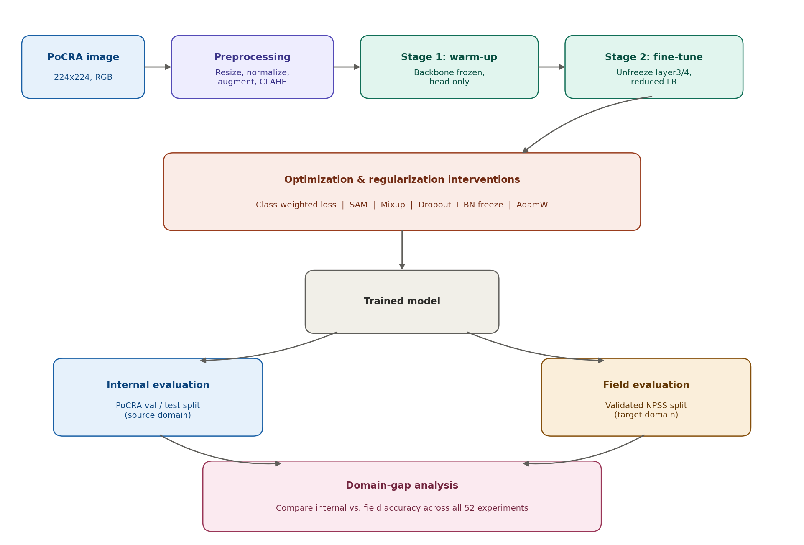
Fig. A1 – System architecture and evaluation protocol. Result figures are in Annexure F; confusion matrices and classification reports in Annexures D and E.

Specific Benefits/Outcomes

Patents filed during the Review Period
Sr. No | Title | Inventors | Date of Filing
1 | Nil – no patent was filed during the project period | Not applicable | Not applicable
No patents were filed during the project (1 December 2025 – 30 September 2026). IP of the models and the dataset belongs to TIH IIT Bombay.

Paper publication/submission in Journal/Symposia/Conferences during the Review Period
Title of the paper | Journal/Symposium/Conference | Date of conference | Authors
From Lab to Field: Diagnosing the Internal-to-Field Accuracy Gap in Sugarcane and Pigeon Pea Disease Classification  (Status: submitted; review in progress) | IEEE PerCom 2027 (IEEE conference) | Conference: 8–12 March 2027, Goa, India  Status: Submitted; review in progress | Yadnika Pashte, Yashodhan Rajapkar, Dr. Sushopti Gawade, Susmita Banerjee, Prajwal Rameshrao Asole
The paper reports 52 transfer-learning experiments (23 Sugarcane, 29 Pigeon Pea), trained on PoCRA and tested on NPSS.

Journal Details with Impact Factors
Sr. No. | Article Sci Name | Article Sci If | Article Sci Citation | Article Scopus Name | Article Scopus If
1 | Not applicable – conference submission; no journal publication | Not applicable | Not applicable | Not applicable | Not applicable
attach Copies of the Papers as annexure.

Details of the Project Staff working on the project
Sr. No. | Name | Designation | Qualification | Date of joining
1 | Yadnika Pashte | CHANAKYA Fellow (final-year B.Tech student, Vidyalankar Institute of Technology) | B.Tech (final year) | 1 December 2025
2 | Yashodhan Rajapkar | CHANAKYA Fellow (final-year B.Tech student, Vidyalankar Institute of Technology) | B.Tech (final year) | 1 December 2025
3 | Dr. Sushopti Gawade | Institute Mentor; Professor, Vidyalankar Institute of Technology | Professor | 1 December 2025

Manpower trained
 | Name | Date of joining
Research Scientists/ Research Associates | Yadnika Pashte and Yashodhan Rajapkar (CHANAKYA Fellows) – trained in ML pipeline design, agricultural data preprocessing and model evaluation (per Milestones Review Report) | 1 December 2025
No. of Ph.D. (s) produced | Nil | Not applicable
Other Technical Personnel trained | Nil | Not applicable

Awareness, training camps, etc. organized
No camps were organised by the project. Team members attended the AI4Agri Conference 2026, gaining exposure to current advances in AI-driven agriculture through interaction with researchers and industry experts. The team also gained practical experience in ML pipeline design, agricultural data pre-processing, model evaluation, GitHub collaboration and Docker fundamentals.

Summary of significant S&T Achievements

- Built and evaluated 60 transfer-learning experiment configurations across three crops (Sugarcane 23, Pigeon Pea 29, Grapes 8) plus one finalised Mustard model, each trained on PoCRA data and (except Mustard) tested on independently collected NPSS field imagery.
- Quantified a severe internal-to-field gap: Sugarcane baselines reached 85–97% internal accuracy but only 24–39% NPSS accuracy.
- Showed that internal validation accuracy is not a reliable predictor of field accuracy: significantly negatively correlated for Sugarcane (Pearson r = -0.74, Spearman ρ = -0.73, both p < 0.001) and statistically uncorrelated for Pigeon Pea (Pearson r = 0.14, p = 0.51; Spearman ρ = 0.05, p = 0.82).
- Sugarcane: class-weighted loss was the most effective lever (+21 to +30 NPSS points for 7–10 points of internal accuracy); best result CSPDarkNet53 + Dropout/BN Freeze + Class Weights, 66.48% NPSS (88.07% internal test); best foundation-model result DINOv2 + Aug. + Class Weights, 57.46% NPSS.
- Pigeon Pea: SAM was the effective lever (under 2 points of internal accuracy for more than 4 points of NPSS accuracy on ConvNeXt-Base); best result ConvNeXt-Base + Augmentation + SAM, 71.31% NPSS (91.89% internal test). CLAHE configurations reached up to 99.01% internal test accuracy but not the best NPSS accuracy.
- Grapes: DINOv2 + Augmentation + SAM reached 78.57% NPSS accuracy (99.21% validation), the highest field accuracy recorded in the study, on only 42 NPSS images (indicative).
- Mustard: crop-specific ResNet50 model on a PoCRA-curated dataset reached 97.02% internal test accuracy (1,271 of 1,310 test images correct; macro F1 ≈ 0.967); NPSS evaluation outstanding.
- Data-processing pipeline: designed and deployed an end-to-end pipeline for ingesting, cleaning, normalising and structuring raw agricultural field data, with a baseline model for benchmarking; project environment, version control and compute set-up completed (Dec 2025 – Jan 2026).
- Application testing (Feb 2026): functional verification, regression testing, edge-case analysis and UI usability assessment; multiple critical and non-critical bugs identified and resolved.
- PoCRA collaboration: secured formally annotated, curated datasets, improving annotation quality, label consistency and training reliability; independent crop-specific Pigeon Pea and Mustard models gave measurable accuracy gains over the baseline model.
- Attended the AI4Agri Conference 2026; gained hands-on experience in GitHub collaboration and Docker fundamentals (Mar 2026).
- June 2026 deployed-model audit: wrote and pushed (with pull request) an NPSS data-extraction script; extracted NPSS datasets for nine crops; evaluated deployed models on NPSS crop-wise – Cotton 26.11% and Soybean 36.82% (deployed ResNet-50) overall accuracy – and prepared per-class accuracy and misclassification reports (also Sugarcane, Grapes, Chickpea, Onion, Sorghum, Tomato, Mango).
- Crop-specific (rather than single generalised) modelling was reported to give measurably better domain-specific accuracy (Milestones Review Report).
- Prepared the consolidated Crop Research Documentation (Handover) Report v1.0 and submitted the research paper “From Lab to Field…” to IEEE PerCom 2027.

Project Budget
Sr. No. | Budget Head | Funds Sanctioned | Expenditure | % of Total
1 | Manpower | ₹2,00,000  (fellowship paid by TIH) | ₹2,00,000 | 83.33%
2 | Consumables | Nil | Nil | 0%
3 | Contingencies | ₹10,000  (reserved for research-paper publication, IEEE PerCom 2027) | Nil so far (to be utilised for the publication) | 4.17%
4 | Travel | ₹30,000  (fuel, cab and travel allowance of both fellows) | ₹30,000 | 12.50%
5 | Others, if any | Nil | Nil | 0%
6 | Overhead expenses | Nil | Nil | 0%
7 | Equipment | Nil | Nil | 0%
 | Total | ₹2,40,000 | ₹2,30,000 (fellowship ₹2,00,000 + travel ₹30,000) | 100%
Total sanctioned and disbursed from TIH: ₹2,40,000. Contingency of ₹40,000 is the combined allocation for both fellows: ₹30,000 has been used for travel (bills total ₹30,034.94; the ₹34.94 excess is not claimed) and the remaining ₹10,000 is reserved for the research-paper publication (IEEE PerCom 2027), not yet incurred. Details in the Utilization Certificate and Statement of Expenditure.

Part B – Comprehensive Report

- Project Title
AI-Driven Crop Disease Detection Using Image Processing and Computer Vision Techniques (CHANAKYA Project No. 153341; Grant No. TIH-IoT/2025-11/HRD/CHANAKYA/SL/CFP/TIHI-153341)
- Product/Process as an outcome of the Project, identify Beneficiaries
Product / process. (i) Trained, crop-specific deep-learning image-classification models for Sugarcane, Pigeon Pea, Grapes and Mustard disease detection, built to support the MahaVISTAAR AI-based agricultural advisory platform; (ii) a cross-domain evaluation process – train on controlled PoCRA imagery, test on independently collected NPSS field imagery, and compare internal with field accuracy; (iii) a reproducibility record (datasets, splits, checkpoints, code and results) for future researchers.
Beneficiaries. Smallholder farmers in Maharashtra (through the MahaVISTAAR advisory platform, which needs scalable image-based diagnosis in place of manual field inspection); TIH IIT Bombay and the PoCRA programme (Government of Maharashtra); and future researchers/fellows who can use the documented experiments as a benchmark.
- Scientific Description of the Product/Process, give Specifications/Standards for the same
Each model is a supervised image classifier: an ImageNet-pretrained backbone fine-tuned on crop-specific PoCRA images (224×224 input, ImageNet normalisation, 80% / 10% / 10% train/validation/test split) and assessed on held-out PoCRA data and on NPSS.
Table B1 – Specifications and headline results.
Crop | PoCRA training data | NPSS field-evaluation set | Best field-accuracy configuration | Internal test acc. (%) | Field (NPSS) acc. (%)
Sugarcane | ~10,500 RGB leaf images; 7 classes | 355 expert-validated images; 4 shared classes (1,195-image non-validated split also available) | CSPDarkNet53 + Dropout/BN Freeze + Class Weights (Exp 40) | 88.07 | 66.48
Pigeon Pea | ~3,400 RGB leaf/plant images; 7 classes | 366 validated images; 4 shared classes | ConvNeXt-Base + Augmentation + SAM (Exp 12) | 91.89 | 71.31
Grapes | ~17,000 images; 4 classes | 42 validated images; 3 shared classes | DINOv2 + Augmentation + SAM (Exp 7) | 99.13 | 78.57 (indicative; 42 images)
Mustard | PoCRA-curated dataset; 7 classes; 1,310 test images | Not performed | ResNet50 (single finalised model) | 97.02 | Not evaluated

- Sugarcane classes (7): Healthy, Mosaic, Red Rot, Redrot Rust, Rust, Unknown, Yellow Leaf Disease.
- Pigeon Pea classes (7): Healthy, Phytophthora Blight, Pod Borer, Root Rot, Unknown, Webbed Leaves, Wilt.
- Grapes: 4 training classes; 3 classes shared with NPSS.
- Mustard classes (7): Alternaria_Blight, Aphid, Healthy, Pea_Leaf_Miner, Powdery_Mildew, Unknown, White_Rust_Leaf.
- Architectures evaluated: ResNet18/34/50, VGG16/19, DenseNet201, EfficientNet-B0/B7, MobileNetV2, ShuffleNet, LiteMDC, ConvNeXt-Base, CSPDarkNet53, Swin Transformer and DINOv2 (self-supervised foundation model, head-only fine-tuning).
- Evaluation standard: internal accuracy = validation/test accuracy on the held-out PoCRA split; field accuracy = overall accuracy on NPSS (4 of 7 classes shared for Sugarcane and Pigeon Pea; 3 for Grapes). Per-class precision/recall/F1 are available in the classification-report artifacts on VDI-22 (not generated for Grapes).

- Methodology adopted for Development of the Product/Process
Data. Training used PoCRA (Project on Climate Resilient Agriculture, Government of Maharashtra) image collections: Sugarcane (~10,500 images, 7 classes), Pigeon Pea (~3,400 images, 7 classes), Grapes (~17,000 images, 4 classes) and a PoCRA-curated Mustard dataset (7 classes). Each was split 80% / 10% / 10%. For field-domain testing, Sugarcane (355 expert-validated images), Pigeon Pea (366 validated images) and Grapes (42 validated images) were evaluated on the independently collected NPSS dataset, sharing 4, 4 and 3 classes with PoCRA respectively. Pipeline. Images were resized to 224×224 and normalised with ImageNet statistics. On-the-fly augmentation included flip, rotation, colour jitter, Gaussian blur, shear, translation, random erasing and perspective transforms; CLAHE was added for one Pigeon Pea group (Exp 22–29). ImageNet-pretrained backbones were fine-tuned in two phases: Stage 1 trains only the classification head with a frozen backbone (Adam, learning rate 0.001, 30–50 epochs, early-stopping patience 5–7); Stage 2 unfreezes upper layers (typically layer3/layer4) and trains jointly at learning rate 0.0001. Experiments. Interventions were added step by step: reduced learning rate/AdamW, augmentation, class-weighted cross-entropy, dropout with batch-norm freezing, Mixup, Sharpness-Aware Minimisation (SAM), CLAHE, and newer backbones (ConvNeXt-Base, CSPDarkNet53, Swin Transformer, DINOv2). In total 23 Sugarcane, 29 Pigeon Pea and 8 Grapes configurations were run, plus one finalised ResNet50 Mustard model. Evaluation. Internal accuracy on the held-out PoCRA split was compared with NPSS field accuracy; Pearson and Spearman correlations between the two were computed for Sugarcane and Pigeon Pea, and macro precision/recall/F1 reported for headline configurations.
- Scientific /Technological Formulation giving underlying Basis
5.1 Underlying basis. Supervised transfer learning: ImageNet-pretrained backbones are fine-tuned on crop-specific PoCRA images through a two-phase schedule (frozen-backbone head training, then partial unfreezing at a reduced learning rate). Models trained on controlled PoCRA imagery are then tested on NPSS to measure how far internal accuracy carries over to unconstrained field photography. The 7-class (PoCRA) vs 4-class (NPSS) label mismatch is a structural source of domain shift for every configuration; the PoCRA “Unknown” class in particular has no NPSS counterpart. Interventions target specific failure modes: class-weighted cross-entropy for class imbalance (Focal Loss was also evaluated); SAM to seek flatter loss minima; dropout before the fully connected head with frozen batch-norm statistics in Stage 2 to recover internal accuracy lost when class weighting is introduced; Mixup and augmentation (including perceptual-hash near-duplicate removal and NPSS-style text-overlay augmentation) as regularisers; and CLAHE pre-processing for Pigeon Pea Exp 22–29.
5.2 Sugarcane (23 configurations).
- Baseline sweep (v1, 15 June 2026; 9 architectures plus MobileNetV2): internal accuracy 85–97%, NPSS accuracy only 24–39%, confirming a severe domain gap. MobileNetV2 reached 23.77% on the non-validated NPSS split and was excluded from further tuning.
- Class-weighted loss gave the largest NPSS jump (ResNet50 65.07%, ResNet34 65.63%; +21 to +30 points over the matched unweighted configuration) at a cost of roughly 7–10 points of internal accuracy.
- Best result: CSPDarkNet53 + Dropout/BN Freeze + Class Weights (Exp 40), 66.48% NPSS, 88.07% internal test accuracy; macro P 0.9157, R 0.8783, F1 0.8819. Best foundation model: DINOv2 + Aug. + Class Weights (Exp 41), 57.46% NPSS, 96.37% internal test accuracy; macro P 0.9758, R 0.9688, F1 0.9715. ConvNeXt-Base + Class Weights (Exp 39): 54.65%.
- Regularisation-only interventions (dropout/BN-freeze, Mixup, SAM without class weighting; Exp 17–37) kept internal accuracy high (e.g. ConvNeXt-Base + SAM 97.28% test) but NPSS accuracy stayed between 35.77% and 47.61%. ResNet50 + Mixup regressed to 36.34% vs 45.07% for dropout-only.
- Internal validation and NPSS accuracy are significantly negatively correlated across the 23 configurations (Pearson r = -0.74, Spearman ρ = -0.73, both p < 0.001). CSPDarkNet53’s cross-stage partial connections are hypothesised to give more spatially localised, background-invariant features.
5.3 Pigeon Pea (29 configurations plus pre-curation series).
- Exploratory series (CROP06_EXP001–EXP0010, January–February 2026, raw PoCRA pipeline, internal validation only): ResNet50, MobileNetV2 and ResNet34 baselines reached 71–90% validation accuracy; the best, EXP0010 (ResNet50 two-phase fine-tuning), reached 92% with macro P/R/F1 all 0.92 and became Exp 2 of the consolidated study.
- Consolidated study (26 July – 6 August 2026): baselines gave 55.74% (ResNet34) and 65.57% (ResNet50) NPSS accuracy. Best result: ConvNeXt-Base + Augmentation + SAM (Exp 12), 71.31% NPSS, 91.89% internal test accuracy; macro P 0.9096, R 0.9133, F1 0.9101. ConvNeXt-Base + Dropout/BN-Freeze (Exp 7): 66.94% NPSS; macro P 0.9055, R 0.9247, F1 0.9118. The highest internal validation accuracy (Exp 2, 92.03%) is not the best field model.
- SAM on ConvNeXt-Base cost under two points of internal accuracy for a gain of more than four points of NPSS accuracy. The CLAHE group (Exp 22–29) gave the highest internal test accuracies (up to 99.01%, Swin Transformer and DINOv2) but NPSS accuracy of 49.73% and 57.38% respectively.
- Internal validation and NPSS accuracy are statistically uncorrelated across the 26 evaluated configurations (Pearson r = 0.14, p = 0.51; Spearman ρ = 0.05, p = 0.82). DenseNet201 + SAM and CSPDarkNet53 both reached 62.02% NPSS despite internal accuracies of 90.63% and 76.58%, suggesting a dataset-imposed ceiling around 61–67%. VGG19 overfitted more than VGG16 (25.41% vs 57.38% NPSS). Root Rot and Webbed Leaves are the most persistently confused classes.
5.4 Grapes (8 configurations).
- The same two-phase pipeline and preprocessing as Sugarcane/Pigeon Pea is inferred from the labelling convention of the source spreadsheet; no separate Grapes-specific methodology document exists.
- DINOv2 + Augmentation + SAM (Exp 7): 78.57% NPSS, 99.21% validation, 99.13% test; DINOv2 + Augmentation (Exp 6): 71.43% NPSS. ConvNeXt-Base: 69.07% NPSS, and 64.29% with SAM (matching the ResNet50 baseline, 64.29%, for which no internal accuracy was recorded).
- The NPSS set has only 42 images, so these figures are indicative and should be confirmed on a larger validated sample.
5.5 Mustard (1 finalised model).
- ResNet50 trained on a formally curated, annotated PoCRA Mustard dataset as an independent crop-specific model. Overall test accuracy 97.02% (1,271 of 1,310 images; computed from the supplied confusion matrix), macro F1 ≈ 0.967. Alternaria_Blight has the lowest recall (0.867): 12 of 98 images were misclassified as White_Rust_Leaf. Exact preprocessing, epochs, learning rate and optimiser settings were not recorded separately; no NPSS evaluation has been performed. Per-class classification report and confusion matrix: Annexure D.
5.6 June 2026 deployed-model audit on NPSS (Yadnika Pashte).
- Extraction tooling: NPSS data-extraction script pushed to GitHub (PoCRA_Test_Scripts, extraction-branch) with a pull request (4 June). NPSS datasets extracted and uploaded to the shared OneDrive: Cotton (4 June); Chickpea and Soybean (5 June); Cucumber, Onion, Grapes, Sugarcane and Maize (8 June); Papaya downloaded (2 June).
- Deployed-model evaluation (batch prediction, per-class and misclassification analysis, observations and recommendations per crop): Cotton – 26.11% overall accuracy; Soybean (deployed ResNet-50) – 36.82%; Sugarcane, Grapes and Chickpea reports prepared 9 June (their overall accuracies are in the reports, not in the task sheet); threshold-based testing of the deployed Cotton model, and evaluation on Onion, Sorghum, Tomato and Mango NPSS datasets (10 June).
- Sugarcane improvement (15–19 June): ResNet50, ResNet34 and MobileNetV2 trained and evaluated on NPSS at confidence thresholds of 0.00% and 70.00%; successive strategies followed (longer training/lower learning rate, stronger augmentation, class-weighted loss, dropout + BN freeze + class-aware ColorJitter, Mixup + SAM, then EfficientNet-B7, DenseNet201, ConvNeXt-Base). The task sheet records 72.80% (ResNet50) and 72.38% (ResNet34) after adding class weights on 17 June (evaluation split not stated there; the validated-split figures in Annexure A are 65.07% and 65.63%). ConvNeXt reached about 97% internal test accuracy while NPSS evaluation showed marked domain shift, particularly for the Healthy and Mosaic classes. These runs fed the v1–v6 experiment series.
5.7 Additional findings reported in the paper. (i) Sugarcane baselines fell from 95.55–96.73% internal to 31.55–38.87% field accuracy, a gap of roughly 57–65 points; augmentation alone lifted field accuracy only into the low-to-high forties. (ii) The best cross-domain results (66.48% Sugarcane, 71.31% Pigeon Pea) remain well below internal accuracy and are not yet good enough for unsupervised deployment without human checking. (iii) Five of eight Pigeon Pea configurations sit in a narrow 61–67% NPSS band regardless of architecture, pointing to a dataset-imposed ceiling (~3,400 images, minority class of 300) that likely needs explicit domain adaptation or more labelled field data. (iv) Limitations: 7-class vs 4-class label mismatch; imbalanced training sets (Sugarcane 488–1,988 images per class, Pigeon Pea 300–870); small validated NPSS splits (355 and 366 images), so 1–2 point differences should not be over-read; a single external dataset; each configuration run once, with no confidence intervals; latency, model size and on-device footprint not assessed. Result figures are in Annexure F.
5.8 Cross-crop conclusion. Internal validation accuracy was not a trustworthy predictor of field accuracy for either fully evaluated crop. The effective domain-gap lever differed by crop (class weighting for Sugarcane; SAM for Pigeon Pea). ConvNeXt-Base and DINOv2 generalised most consistently across crops once paired with the right intervention. Controlled-condition accuracy still exceeds field accuracy for every crop. Full per-experiment values are in Annexures A–D.
- Further Work required, if any, to get full Benefits or enhance Utilization.
- Perform NPSS cross-domain evaluation for Mustard and expand the Grapes NPSS validated sample beyond 42 images, so both crops can be assessed on the same internal-vs-field basis as Sugarcane and Pigeon Pea.
- Pursue explicit domain adaptation (correlation alignment, adversarial domain-invariant feature learning, Deep CORAL – planned next steps in the fellowship’s progress reporting) rather than relying on class weighting and augmentation as indirect proxies.
- Pair class-weighted loss with ConvNeXt-Base, Swin Transformer and DINOv2 for Sugarcane, where these were tested only unweighted (DINOv2 was run with class weights).
- Evaluate Test-Time Augmentation, few-shot fine-tuning and pseudo-label self-training for Pigeon Pea; evaluate ShuffleNet and LiteMDC (Exp 10, 11, 16) on NPSS.
- Integrate the trained models into the application for an end-to-end prediction workflow; run a pilot deployment and test under real-world field scenarios; implement monitoring of prediction accuracy and system performance.
- Run repeated trials with confidence intervals for close results (e.g. the identical 62.02% NPSS accuracy of two Pigeon Pea configurations), as each configuration was run once.
- Record, for every future experiment, the exact dataset path, split file, random seed, model checkpoint, code commit hash and environment file; current artifacts are recorded only at directory level on VDI-22.
- Recommendations for Utilization of the Product/Process. Give Concrete Steps.
1. Select deployment models on NPSS field accuracy, not internal accuracy. Candidate models: Sugarcane – CSPDarkNet53 + Dropout/BN Freeze + Class Weights (Exp 40); Pigeon Pea – ConvNeXt-Base + Augmentation + SAM (Exp 12).
2. Treat Grapes and Mustard as provisional. Use Grapes DINOv2 + Augmentation + SAM (Exp 7) only after validation on a larger NPSS sample; run NPSS evaluation for Mustard before field use, since its 97.02% is internal only and should not be assumed to carry over.
3. Integrate the selected models into the MahaVISTAAR production application, followed by application-level testing under real-world scenarios and monitoring of prediction accuracy.
4. Communicate expected field performance. Best recorded field accuracies are 66.48% (Sugarcane) and 71.31% (Pigeon Pea), well below internal accuracy; deployment should reflect this.
5. Retrieve artifacts from VDI-22 (D:\pocra_image_dev\ and D:\test\mustard\) and adopt the artifact-recording standard in item 6 for all future experiments.
6. Fund domain-adaptation follow-up work (item 6) targeting the PoCRA-to-NPSS distribution shift directly.

Signature of PI

Name of PI : Dr. Sushopti Gawade (Principal Investigator)

Signature of Co-PI

Name of Co-PI : Not applicable (no Co-Principal Investigator)

Annexure A – Sugarcane results
Training: PoCRA SC_dataset_v1 (~10,500 images, 7 classes). Field: NPSS expert-validated split (355 images, 4 classes). A MobileNetV2 baseline (23.77% on the non-validated split) is not on the same basis and is excluded.
Exp | Model | Technique | Val. Acc. (%) | Test Acc. (%) | Field (NPSS) Acc. (%)
Baseline | EfficientNet-B0 | Baseline pipeline | 96.73 | — | 35.77
2 | ResNet50 | Baseline pipeline | 95.55 | 96.37 | 38.87
4 | ResNet34 | Baseline pipeline | 96.16 | 96.83 | 31.55
7 | ResNet50 | Reduced LR + AdamW + longer patience | 96.16 | 95.77 | 25.63
9 | ResNet50 | + Augmentation | 94.47 | 94.11 | 41.13
11 | ResNet34 | + Augmentation | 91.55 | 94.26 | 48.17
13 | ResNet50 | + Aug. + Class Weights | 86.64 | 86.86 | 65.07
15 | ResNet34 | + Aug. + Class Weights | 84.33 | 86.10 | 65.63
17 | ResNet50 | + Aug. + Dropout + BN Freeze | 93.70 | 94.56 | 45.07
19 | ResNet34 | + Aug. + Dropout + BN Freeze | 89.55 | 90.63 | 47.61
21 | ResNet50 | + Dropout/BN Frz. + Mixup | 95.39 | 95.92 | 36.34
23 | ResNet34 | + Dropout/BN Frz. + Mixup | 93.24 | 95.92 | 47.04
25 | ResNet50 | + Dropout/BN Frz. + SAM | 94.62 | 96.53 | 43.94
28 | EfficientNet-B7 | + Dropout/BN Frz. | 89.86 | 89.12 | 40.00
30 | EfficientNet-B7 | + Dropout/BN Frz. + SAM | 94.01 | 92.75 | 44.51
32 | DenseNet201 | + Dropout/BN Frz. + SAM | 96.16 | 96.83 | 35.77
34 | ConvNeXt-Base | + Dropout/BN Frz. | 95.24 | 97.13 | 44.51
36 | ConvNeXt-Base | + Dropout/BN Frz. + SAM | 95.55 | 97.28 | 47.32
37 | CSPDarkNet53 | + Dropout/BN Frz. | 91.86 | 93.81 | 44.79
38 | Swin Transformer | + Augmentation | 94.93 | 96.37 | 43.38
39 | ConvNeXt-Base | + Dropout/BN Frz. + Class Weights | 94.93 | 96.83 | 54.65
40 | CSPDarkNet53 | + Dropout/BN Frz. + Class Weights | 87.56 | 88.07 | 66.48
41 | DINOv2 | + Aug. + Class Weights | 95.24 | 96.37 | 57.46

Annexure B – Pigeon Pea results
Training: PoCRA PP_dataset_v1 (~3,400 images, 7 classes). Field: NPSS validated split (366 images, 4 classes).
Exp | Model | Technique | Val. Acc. (%) | Test Acc. (%) | Field (NPSS) Acc. (%)
1 | ResNet34 | Baseline pipeline | 90.66 | 88.95 | 55.74
2 | ResNet50 | Two-phase fine-tuning, patience 7 | 92.03 | 88.41 | 65.57
3 | VGG16 | + Augmentation | 84.02 | 81.08 | 57.38
4 | VGG19 | + Augmentation | 76.03 | 74.86 | 25.41
5 | DenseNet201 | + Dropout/BN Frz. + SAM | 90.63 | 90.54 | 62.02
6 | CSPDarkNet53 | + Dropout/BN Frz. | 76.58 | 77.03 | 62.02
7 | ConvNeXt-Base | + Dropout/BN Frz. | 91.18 | 91.89 | 66.94
8 | EfficientNet-B0 | + Augmentation | 81.82 | 82.70 | 61.48
9 | ResNet18 | + Augmentation | 81.82 | 84.86 | 60.93
10 | ShuffleNet | + Augmentation | 82.92 | 82.16 | Not evaluated on NPSS
11 | LiteMDC | + Augmentation | 82.92 | 65.01 | Not evaluated on NPSS
12 | ConvNeXt-Base | + Augmentation + SAM | 89.26 | 91.89 | 71.31
13 | CSPDarkNet53 | + Augmentation + SAM | 80.72 | 78.65 | 52.46
14 | DenseNet201 | + Augmentation + SAM | 86.23 | 86.49 | 62.02
15 | EfficientNet-B0 | + Augmentation + SAM | 82.92 | 83.24 | 67.21
16 | LiteMDC | + Augmentation + SAM | 48.48 | 49.19 | Not evaluated on NPSS
17 | MobileNetV2 | + Augmentation + SAM | 77.69 | 75.68 | 63.66
18 | ResNet18 | + Augmentation + SAM | 75.76 | 75.95 | 64.75
19 | ShuffleNet | + Augmentation + SAM | 69.97 | 70.27 | 50.82
20 | VGG16 | + Augmentation + SAM | 74.38 | 74.59 | 52.19
21 | VGG19 | + Augmentation + SAM | 79.06 | 79.19 | 53.01
22 | Swin Transformer | + Augmentation + CLAHE | 98.56 | 99.01 | 49.73
23 | DINOv2 | + Augmentation + CLAHE | 98.42 | 99.01 | 57.38
24 | ConvNeXt-Base | + Augmentation + CLAHE | 95.11 | 97.16 | 48.36
25 | DenseNet201 | + Augmentation + CLAHE | 90.94 | 93.04 | 58.20
26 | VGG19 | + Augmentation + CLAHE | 89.64 | 91.48 | 47.81
27 | ResNet50 | + Augmentation + CLAHE | 88.63 | 90.48 | 57.10
28 | EfficientNet-B7 | + Augmentation + CLAHE | 87.34 | 90.06 | 64.21
29 | VGG16 | + Augmentation + CLAHE | 87.77 | 89.77 | 45.63

Annexure C – Grapes results
Training: PoCRA Grapes (~17,000 images, 4 classes). Field: 42 validated NPSS images, 3 shared classes – indicative only. Baseline internal accuracy was not recorded.
Exp | Model | Technique | Val. Acc. (%) | Test Acc. (%) | NPSS Acc. (%)
Baseline | ResNet50 | PoCRA Codebase | — | — | 64.29
1 | ConvNeXt-Base | + Aug. + Dropout + BN Freeze | 98.34 | 98.78 | 69.07
2 | ConvNeXt-Base | + Aug. + Dropout + BN Freeze + SAM | 98.78 | 98.87 | 64.29
3 | DenseNet201 | + Aug. + Dropout + BN Freeze | 97.99 | 98.78 | 52.38
4 | VGG16 | + Augmentation | 97.12 | 97.57 | 47.62
5 | Swin Transformer | + Augmentation | 98.25 | 98.17 | 61.90
6 | DINOv2 | + Augmentation | 99.04 | 99.04 | 71.43
7 | DINOv2 | + Augmentation + SAM | 99.21 | 99.13 | 78.57

Annexure D – Mustard results
ResNet50; 7 classes; internal PoCRA-curated test set only (1,310 images). Overall accuracy 97.02% (1,271 correct), macro F1 ≈ 0.967 (computed from the confusion matrix).
Class | Precision | Recall | F1-score | Support
Alternaria_Blight | 0.9341 | 0.8673 | 0.8995 | 98
Aphid | 0.9770 | 0.9907 | 0.9838 | 429
Healthy | 1.0000 | 0.9750 | 0.9873 | 40
Pea_Leaf_Miner | 1.0000 | 0.9865 | 0.9932 | 74
Powdery_Mildew | 0.9771 | 0.9884 | 0.9828 | 173
Unknown | 0.9780 | 0.9468 | 0.9622 | 94
White_Rust_Leaf | 0.9581 | 0.9677 | 0.9629 | 402
Accuracy |  |  | 0.9702 | 1310
Macro avg | 0.9749 | 0.9603 | 0.9674 | 1310
Weighted avg | 0.9701 | 0.9702 | 0.9700 | 1310

Confusion matrix (test set):
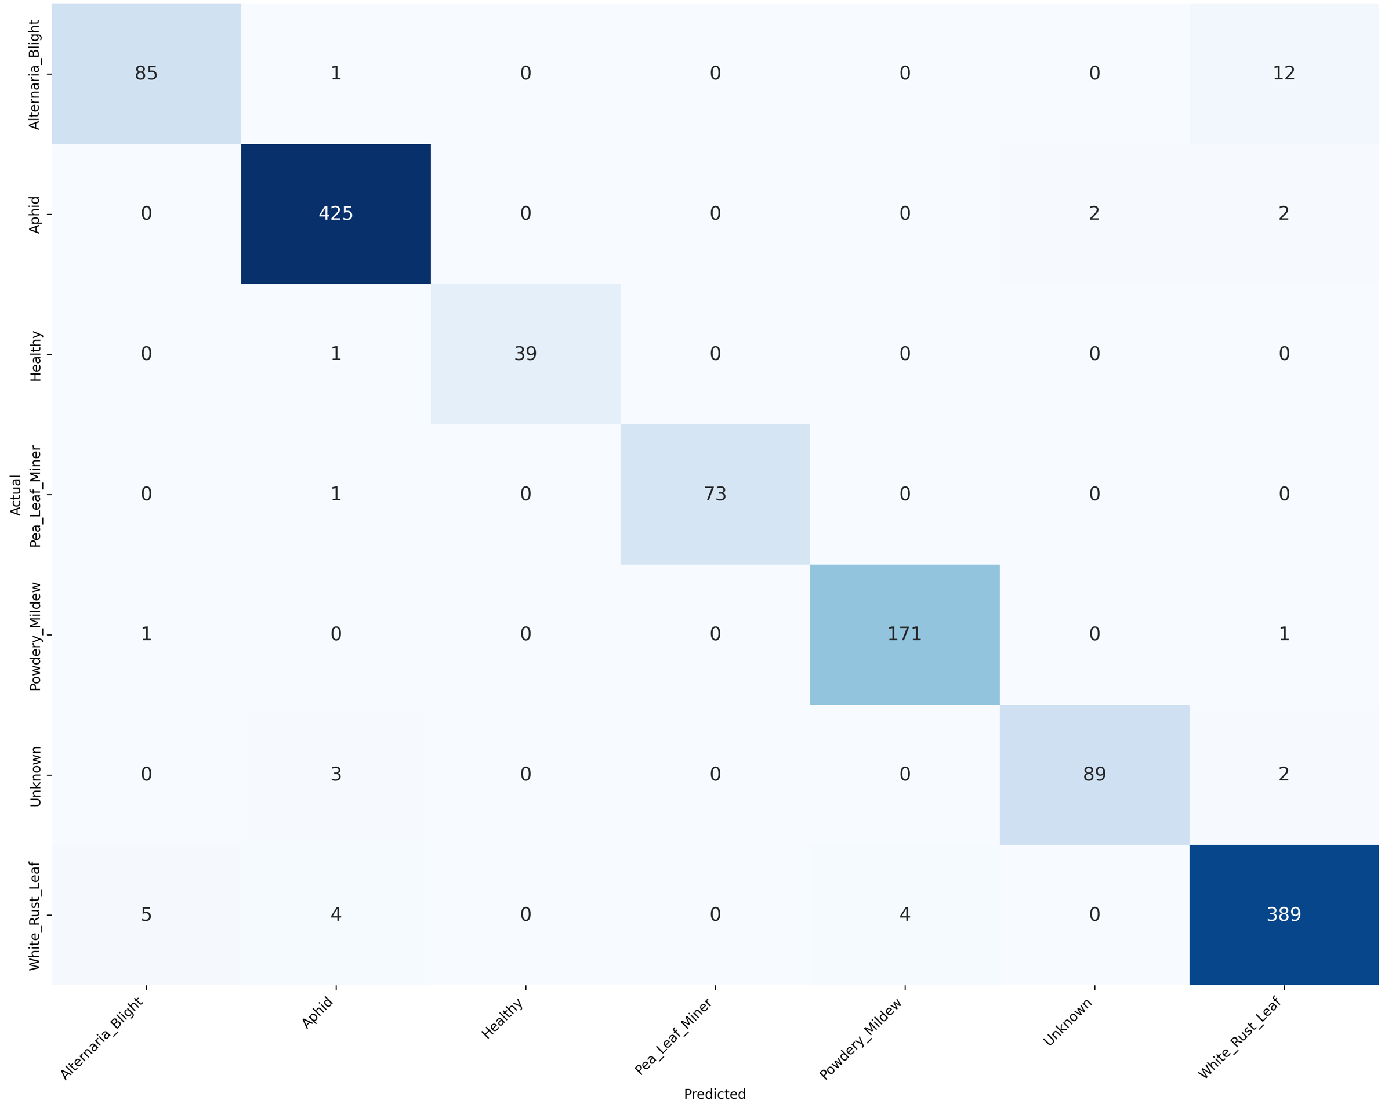
Alternaria_Blight is the weakest class (recall 0.8673): 12 of 98 images were predicted as White_Rust_Leaf. Aphid (425 of 429) and Healthy (39 of 40) are almost perfectly classified.

Annexure E – Classification reports and confusion matrices
Test-set matrices (rows = actual, columns = predicted). Mustard: Annexure D.
E1. Sugarcane – Exp 40: CSPDarkNet53 + Dropout/BN Freeze + Class Weights (best field model, 66.48% NPSS)
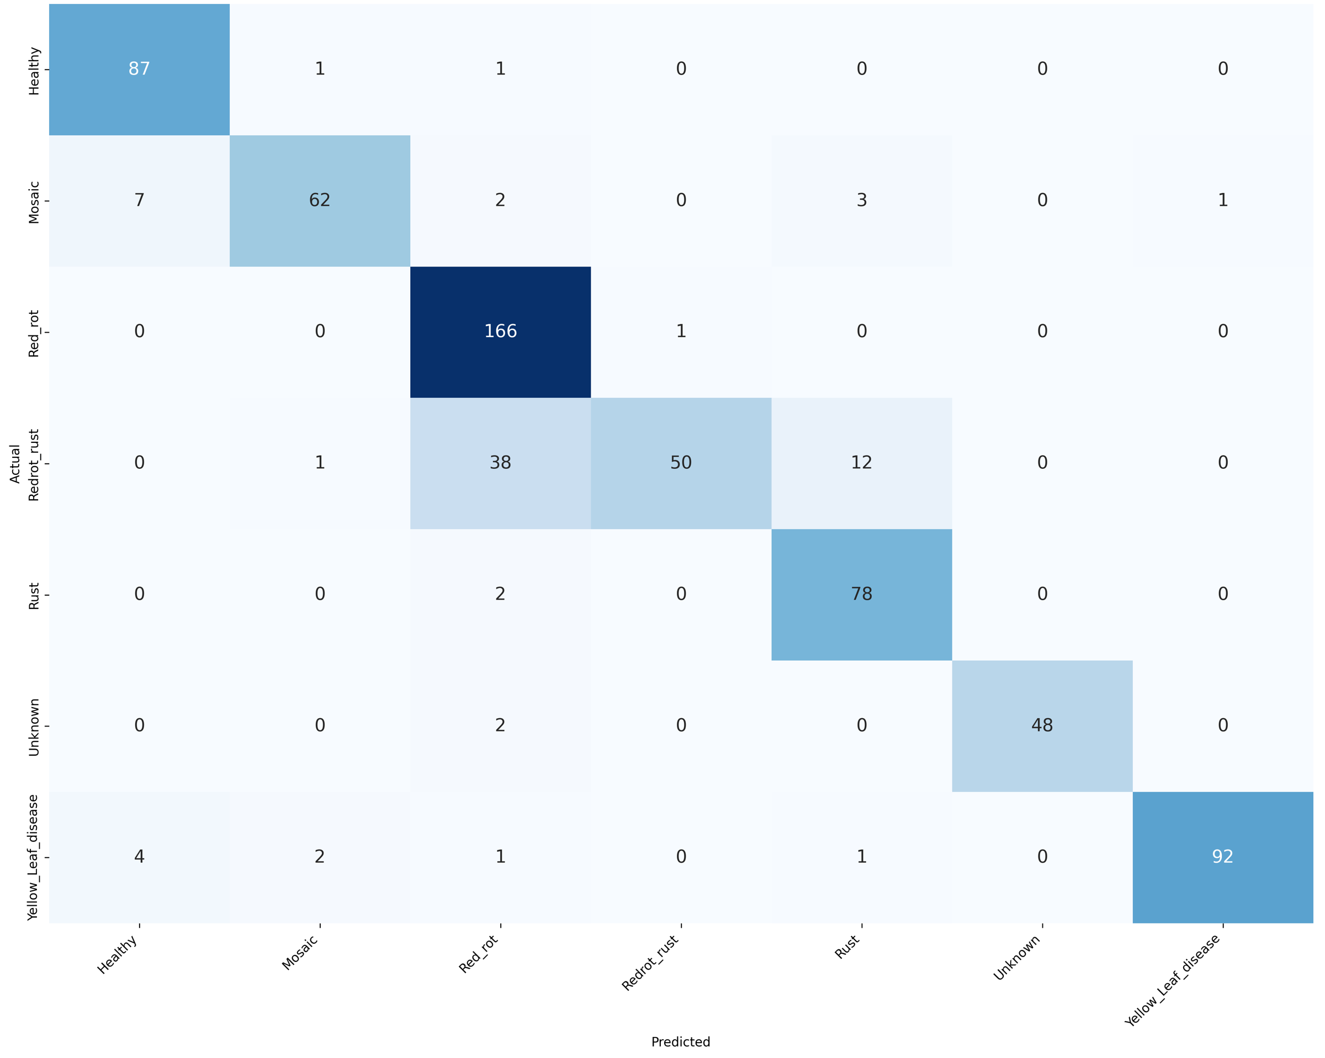
Class | Precision | Recall | F1-score | Support
Healthy | 0.8878 | 0.9775 | 0.9305 | 89
Mosaic | 0.9394 | 0.8267 | 0.8794 | 75
Red_rot | 0.7830 | 0.9940 | 0.8760 | 167
Redrot_rust | 0.9804 | 0.4950 | 0.6579 | 101
Rust | 0.8298 | 0.9750 | 0.8966 | 80
Unknown | 1.0000 | 0.9600 | 0.9796 | 50
Yellow_Leaf_disease | 0.9892 | 0.9200 | 0.9534 | 100
Accuracy |  |  | 0.8807 | 662
Macro avg | 0.9157 | 0.8783 | 0.8819 | 662
Weighted avg | 0.8981 | 0.8807 | 0.8724 | 662

Redrot_rust is the weakest class (recall 0.4950, F1 0.6579; 38 of 101 images predicted as Red_rot). Red_rot has recall 0.9940 but precision 0.7830. Test accuracy 88.07%.
E2. Sugarcane – Exp 41: DINOv2 + Augmentation + Class Weights (best foundation model, 57.46% NPSS)
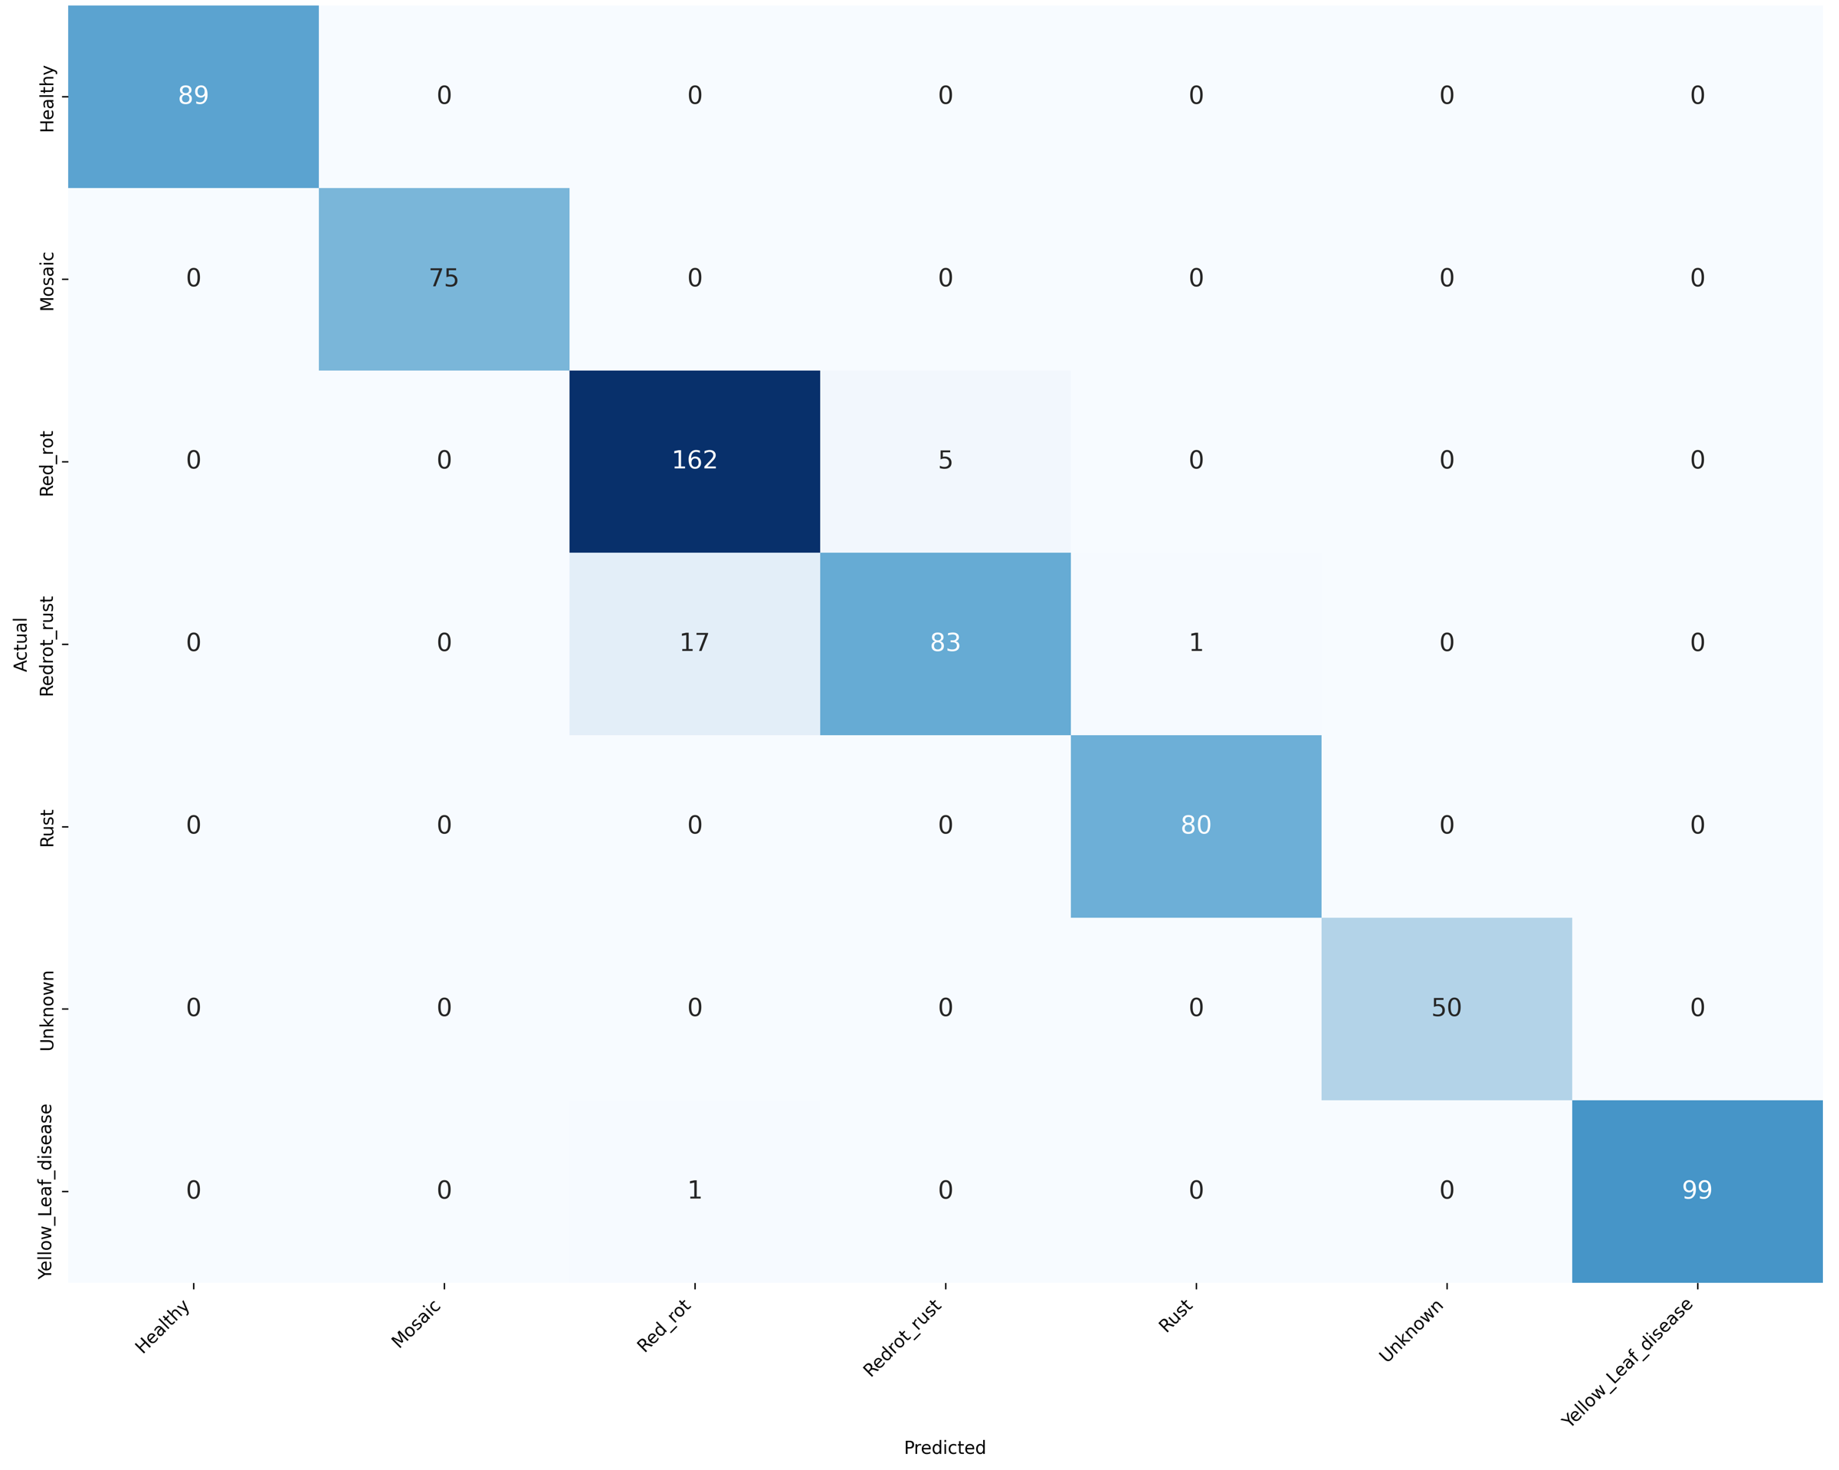
Class | Precision | Recall | F1-score | Support
Healthy | 1.0000 | 1.0000 | 1.0000 | 89
Mosaic | 1.0000 | 1.0000 | 1.0000 | 75
Red_rot | 0.9000 | 0.9701 | 0.9337 | 167
Redrot_rust | 0.9432 | 0.8218 | 0.8783 | 101
Rust | 0.9877 | 1.0000 | 0.9938 | 80
Unknown | 1.0000 | 1.0000 | 1.0000 | 50
Yellow_Leaf_disease | 1.0000 | 0.9900 | 0.9950 | 100
Accuracy |  |  | 0.9637 | 662
Macro avg | 0.9758 | 0.9688 | 0.9715 | 662
Weighted avg | 0.9646 | 0.9637 | 0.9632 | 662

Test accuracy 96.37%, macro F1 0.9715; the lowest per-class F1 is Redrot_rust.
E3. Pigeon Pea – Exp 12: ConvNeXt-Base + Augmentation + SAM (best field model, 71.31% NPSS)
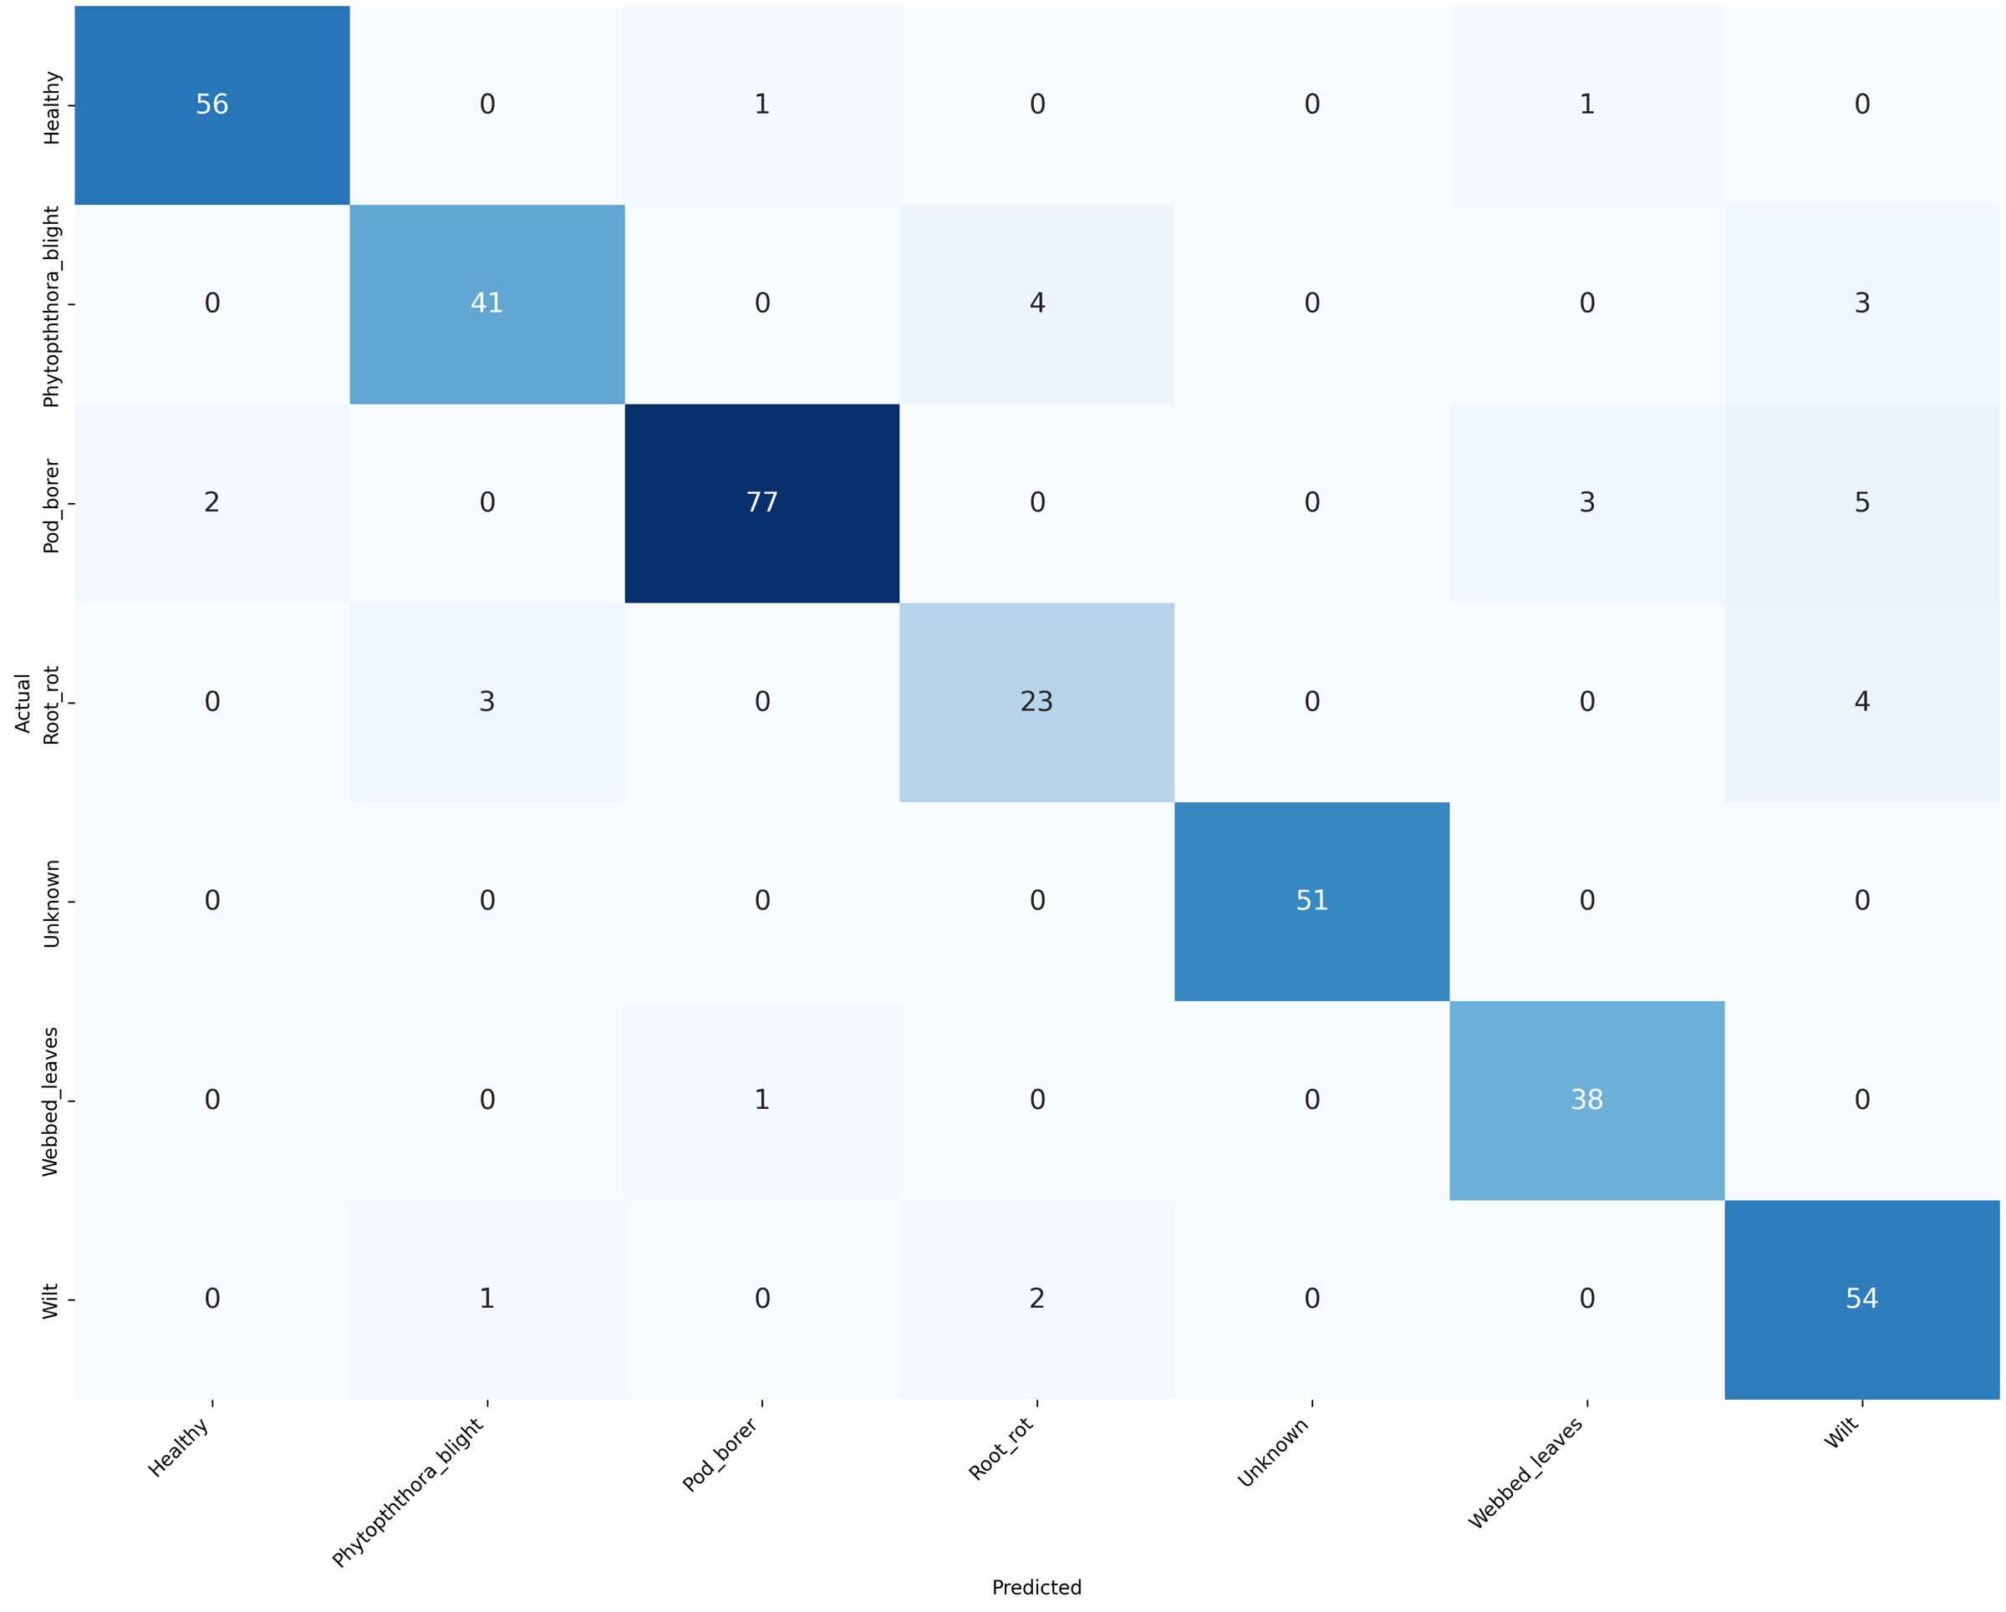
Class | Precision | Recall | F1-score | Support
Healthy | 0.9655 | 0.9655 | 0.9655 | 58
Phytopththora_blight | 0.9111 | 0.8542 | 0.8817 | 48
Pod_borer | 0.9747 | 0.8851 | 0.9277 | 87
Root_rot | 0.7931 | 0.7667 | 0.7797 | 30
Unknown | 1.0000 | 1.0000 | 1.0000 | 51
Webbed_leaves | 0.9048 | 0.9744 | 0.9383 | 39
Wilt | 0.8182 | 0.9474 | 0.8780 | 57
Accuracy |  |  | 0.9189 | 370
Macro avg | 0.9096 | 0.9133 | 0.9101 | 370
Weighted avg | 0.9223 | 0.9189 | 0.9191 | 370

Root_rot is the weakest class (23 of 30 correct; F1 0.7797); Unknown is classified perfectly (51 of 51). Test accuracy 91.89%, macro F1 0.9101.
E4. Pigeon Pea – Exp 7: ConvNeXt-Base + Dropout/BN Freeze (66.94% NPSS)
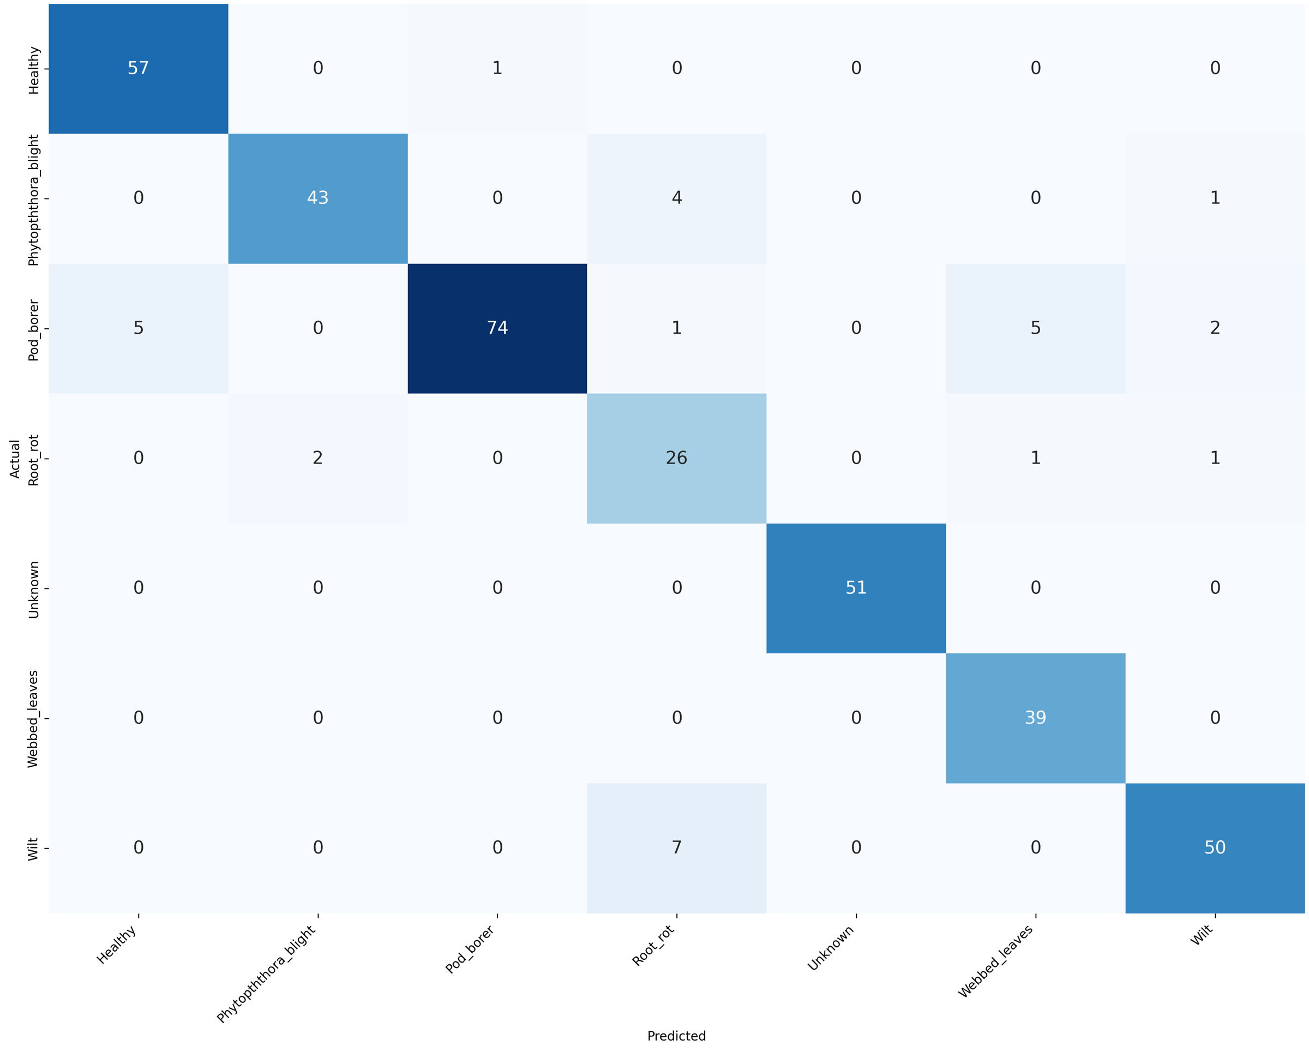
Class | Precision | Recall | F1-score | Support
Healthy | 0.9194 | 0.9828 | 0.9500 | 58
Phytopththora_blight | 0.9556 | 0.8958 | 0.9247 | 48
Pod_borer | 0.9867 | 0.8506 | 0.9136 | 87
Root_rot | 0.6842 | 0.8667 | 0.7647 | 30
Unknown | 1.0000 | 1.0000 | 1.0000 | 51
Webbed_leaves | 0.8667 | 1.0000 | 0.9286 | 39
Wilt | 0.9259 | 0.8772 | 0.9009 | 57
Accuracy |  |  | 0.9189 | 370
Macro avg | 0.9055 | 0.9247 | 0.9118 | 370
Weighted avg | 0.9274 | 0.9189 | 0.9202 | 370

Test accuracy 91.89%, macro P/R/F1 0.9055 / 0.9247 / 0.9118.
E5. Pigeon Pea – Exp 22: Swin Transformer + Augmentation + CLAHE (highest internal accuracy, 49.73% NPSS)
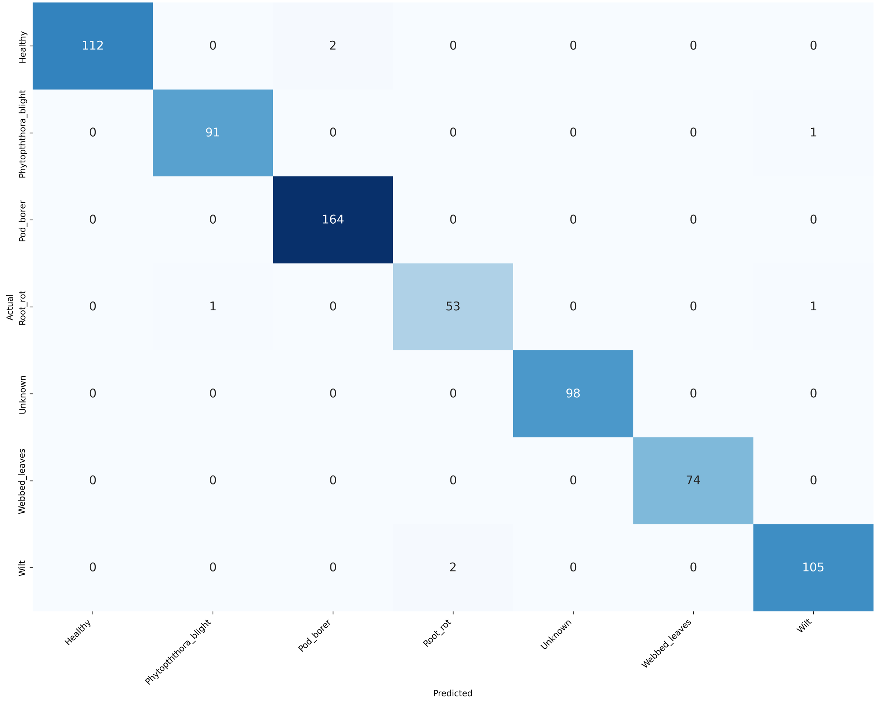
Class | Precision | Recall | F1-score | Support
Healthy | 1.0000 | 0.9825 | 0.9912 | 114
Phytopththora_blight | 0.9891 | 0.9891 | 0.9891 | 92
Pod_borer | 0.9880 | 1.0000 | 0.9939 | 164
Root_rot | 0.9636 | 0.9636 | 0.9636 | 55
Unknown | 1.0000 | 1.0000 | 1.0000 | 98
Webbed_leaves | 1.0000 | 1.0000 | 1.0000 | 74
Wilt | 0.9813 | 0.9813 | 0.9813 | 107
Accuracy |  |  | 0.9901 | 704
Macro avg | 0.9889 | 0.9881 | 0.9885 | 704
Weighted avg | 0.9901 | 0.9901 | 0.9901 | 704

Test accuracy 99.01%, macro F1 0.9885 – near-perfect internally, yet only 49.73% on NPSS field images.
E6. Pigeon Pea – ResNet50: baseline vs two-phase training (early iteration, April 2026 review)
Aspect | Baseline (resnet50.pth) | Final (resnet50_4.pth)
Training strategy | Single phase; backbone frozen, FC layer only | Two phase: frozen, then backbone unfrozen
Learning rate | Single LR throughout | Phase 2 uses a lower LR
Test accuracy | 86.52% | 88.41% (+1.89)
Macro precision / recall / F1 | 0.8375 / 0.8500 / 0.8413 | 0.8643 / 0.8575 / 0.8595

Class | Baseline P / R / F1 | Final P / R / F1
Healthy | 0.818 / 0.931 / 0.871 | 0.900 / 0.931 / 0.915
Phytopththora_blight | 0.886 / 0.813 / 0.848 | 0.870 / 0.833 / 0.851
Pod_borer | 0.926 / 0.862 / 0.893 | 0.868 / 0.908 / 0.888
Root_rot | 0.513 / 0.667 / 0.580 | 0.656 / 0.700 / 0.677
Unknown | 1.000 / 1.000 / 1.000 | 1.000 / 1.000 / 1.000
Webbed_leaves | 0.923 / 0.923 / 0.923 | 0.875 / 0.718 / 0.789
Wilt | 0.796 / 0.754 / 0.775 | 0.881 / 0.912 / 0.897

Source: April 2026 review presentation. The final model corresponds to Exp 2 of the consolidated Pigeon Pea study (test accuracy 88.41%).

Annexure F – Result figures
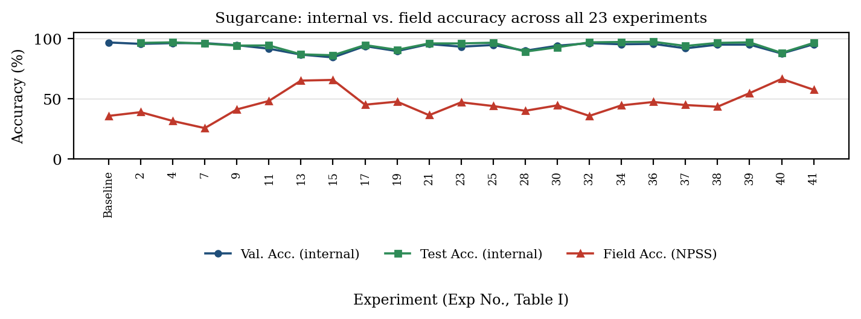
Fig. F1 – Sugarcane: validation, test and field (NPSS) accuracy for all 23 experiments.
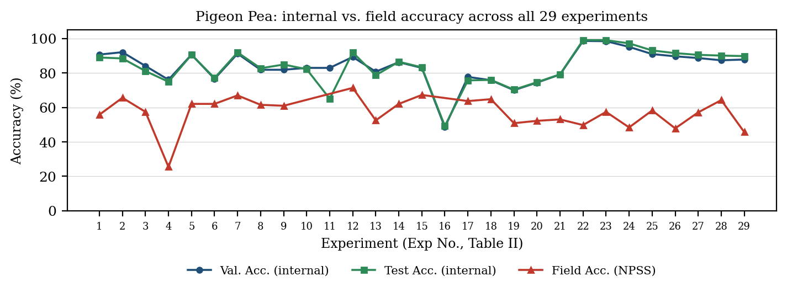
Fig. F2 – Pigeon Pea: validation, test and field (NPSS) accuracy for all 29 experiments.
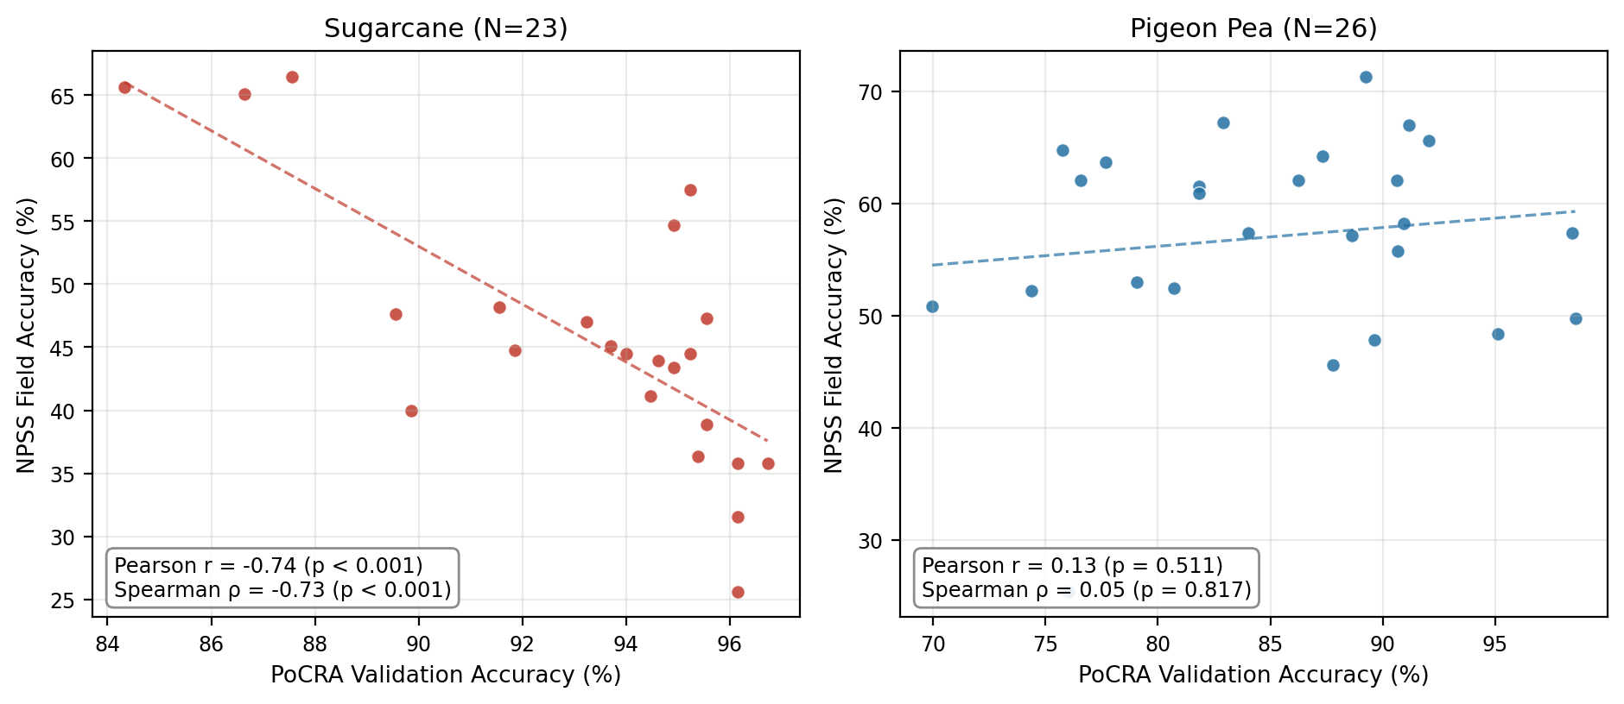
Fig. F3 – PoCRA validation accuracy vs NPSS field accuracy (Sugarcane N=23; Pigeon Pea N=26). Sugarcane: Pearson r = -0.74, Spearman ρ = -0.73 (p < 0.001); Pigeon Pea: Spearman ρ = 0.05 (p = 0.82); Pearson r = 0.14 in the text of the paper (printed as 0.13 on the figure panel).
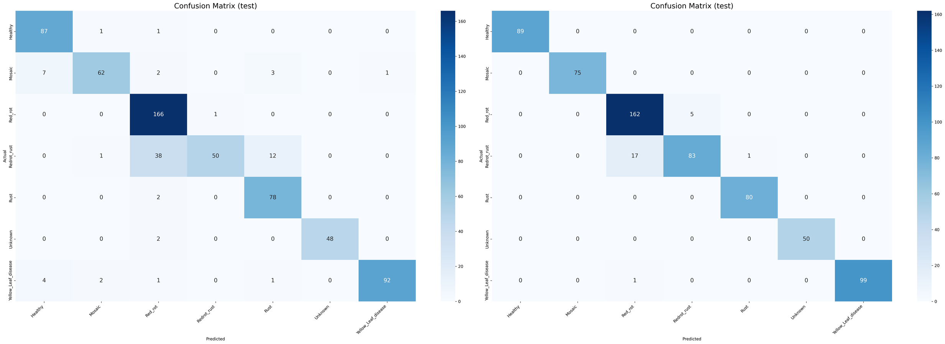
Fig. F4 – Sugarcane confusion matrices (internal test split): CSPDarkNet53 + Dropout/BN Freeze + Class Weights (Exp 40, left) and DINOv2 + Aug. + Class Weights (Exp 41, right).
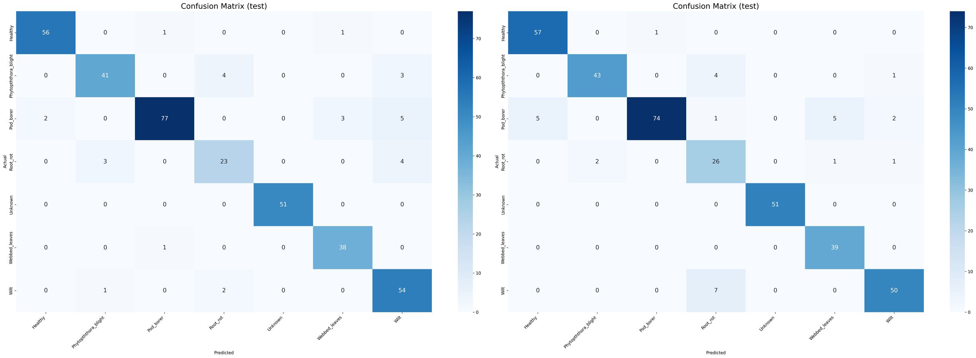
Fig. F5 – Pigeon Pea confusion matrices (internal test split): ConvNeXt-Base + Aug. + SAM (Exp 12, left) and ConvNeXt-Base + Dropout/BN Freeze (Exp 7, right).

Annexure G – Copy of submitted paper
“From Lab to Field: Diagnosing the Internal-to-Field Accuracy Gap in Sugarcane and Pigeon Pea Disease Classification” (IEEE PerCom 2027). A copy of the submitted manuscript is enclosed with this report.

