Final Report



Title: Sign Language Recognition

As a Field work for Course

AI/ML(CSR311) and NLP(CSR322)

By

Sr. No. | Registration No | Name of Students | Roll No
1 | 12304877 | Shivam Kumar | 20
2 | 12307816 | Yash Bhardwaj | 07

Submitted To Aalekh Kumar Rai and Aravind V Anil
Lovely Professional University
Jalandhar, Punjab, India.

Real-Time Sign Language
Recognition System
Using Computer Vision & Deep Learning

Report Type | CA2 Project Report
Domain | Computer Vision & Natural Language Processing
Technology | MediaPipe, PyTorch, OpenCV, N-gram NLP Model
System | Real-Time ASL Alphabet Recognition
Performance | ~85% Classification Accuracy

GitHub Link: - https://github.com/yash9939/Sign-Language-Recognition
Dataset Link: - Link

1. Abstract
This paper presents a real-time Sign Language Recognition system that converts hand gestures into textual output using a combination of Computer Vision and Deep Learning techniques. The system leverages MediaPipe for efficient hand landmark detection and a fully connected neural network for classification of American Sign Language (ASL) alphabets.
Unlike traditional image-based approaches, this system uses landmark-based features, significantly reducing computational complexity while improving real-time performance. Additionally, an NLP-based n-gram model is integrated to enhance usability by predicting meaningful words from partial letter sequences.
The system achieves approximately 85% classification accuracy and demonstrates robustness in real-time environments, making it a viable solution for assistive communication technologies.

2. Introduction
Communication plays a vital role in human interaction. However, individuals with hearing or speech impairments rely on sign language, which is not universally understood — creating a significant communication barrier between signing and non-signing communities.
Recent advancements in Artificial Intelligence, particularly in Computer Vision and Natural Language Processing, have enabled the development of systems that can interpret visual gestures and convert them into meaningful textual outputs.
This project focuses on designing a real-time system that achieves three primary goals:
- Detects hand gestures using a standard webcam
- Classifies detected gestures into ASL alphabet characters
- Converts character sequences into words using NLP-based prediction

3. Problem Statement
Despite the widespread use of sign language among the deaf and hard-of-hearing community, several critical challenges remain unaddressed:
- Lack of awareness and understanding of sign language among the general population
- Absence of affordable, real-time translation systems accessible to everyday users
- High cost of existing proprietary assistive technologies
- Limited cross-platform support for gesture recognition tools

Therefore, there is a pressing need for a low-cost, real-time, AI-based solution that can bridge this communication gap and provide accessible assistive technology to those who need it most.

4. System Architecture

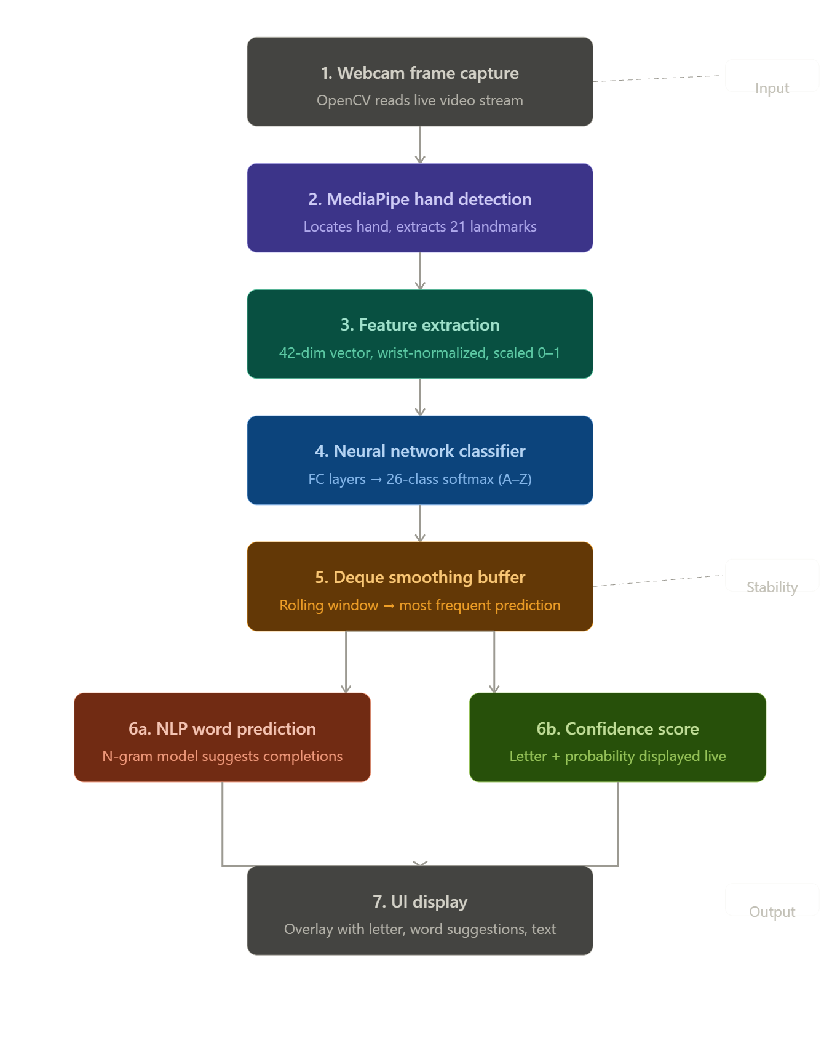
4.1 Pipeline Overview
The system follows a linear, real-time processing pipeline. Each video frame captured from the webcam undergoes sequential processing through detection, feature extraction, classification, and output generation stages.
- Frame Capture: Webcam stream captured using OpenCV
- Hand Detection: MediaPipe detects hand presence and extracts 21 landmarks
- Feature Extraction: Landmark coordinates normalized relative to wrist position
- Classification: Neural network predicts the ASL alphabet from feature vector
- Smoothing: Deque buffer reduces flickering and stabilizes predictions
- NLP Integration: N-gram model suggests words from predicted letter sequences
- Output Display: Results rendered on live video feed with confidence scores

5. Dataset & Preprocessing
5.1 Dataset Description
The dataset used in this project is a custom-built landmark dataset, collected specifically to train the classification model on ASL hand gestures.
5.2 Feature Structure
Each data sample is represented using 21 hand landmarks, each with an (x, y) coordinate pair — resulting in a 42-dimensional feature vector per sample.

Property | Value | Notes
Landmarks per sample | 21 | Full hand skeleton
Coordinates per landmark | (x, y) | 2D spatial position
Feature vector length | 42 | 21 × 2 coordinates
Normalization | Relative to wrist | Scale-invariant
Value range | 0.0 – 1.0 | Min-max scaled

5.3 Preprocessing Steps
- Extract (x, y) landmark coordinates from each MediaPipe output
- Normalize all coordinates relative to the wrist (landmark 0)
- Scale values to a 0–1 range using min-max normalization
- Convert final feature arrays into PyTorch tensors for model input
5.4 Advantages of Landmark-Based Approach
- Significantly reduced data size compared to raw image storage
- Faster computation and lower memory footprint
- Inherent robustness against background noise and lighting variation

6. Model Architecture
The classification model is a fully connected (dense) neural network, designed for efficient inference on low-dimensional landmark feature vectors.

Layer | Details | Purpose
Input Layer | 42 neurons | Receives normalized landmark features
Hidden Layer 1 | 256 neurons + BN | ReLU activation, Batch Normalization
Dropout 1 | p = 0.4 | Prevents overfitting
Hidden Layer 2 | 128 neurons + BN | ReLU activation, Batch Normalization
Dropout 2 | p = 0.3 | Additional regularization
Output Layer | 26 neurons | Softmax — one per ASL alphabet

6.1 Key Design Decisions
- Batch Normalization: Accelerates training and improves gradient stability
- Dropout Layers: Reduce overfitting and improve generalization
- ReLU Activation: Introduces non-linearity for complex decision boundaries

7. Training Process
7.1 Hyperparameters

Parameter | Value
Loss Function | CrossEntropyLoss
Optimizer | Adam
Learning Rate | Default (1e-3)
Training Epochs | ~70
Batch Size | Standard mini-batch

7.2 Training Observations
- Training loss decreased gradually and consistently across epochs
- Validation accuracy improved steadily, indicating effective generalization
- The model converged efficiently without signs of significant overfitting
- Final training accuracy reached approximately 85%

8. Real-Time Prediction Pipeline
The real-time pipeline is optimized to provide low-latency predictions while maintaining stable output. The following steps execute for every captured frame:
- Webcam frame captured via OpenCV
- MediaPipe processes the frame to detect and locate the hand
- 21 landmark coordinates extracted and normalized
- Feature vector passed to the trained neural network
- Model outputs a probability distribution over 26 ASL classes
- Predicted class stored in a deque buffer (smoothing window)
- Most frequent prediction in buffer displayed on screen with confidence score
8.1 Smoothing Mechanism
A rolling deque buffer is used to smooth predictions over a configurable number of frames. This approach eliminates flickering caused by momentary misclassifications and significantly improves the perceived stability of the output.

9. NLP Integration
To improve practical usability, an n-gram language model is integrated into the system to provide intelligent word prediction from partial letter sequences.
9.1 Functionality
- Accepts a sequence of predicted letters as input
- Queries a pre-built n-gram frequency dictionary
- Returns the top-N most probable word completions
9.2 Example
Input Sequence | Suggested Words
"BO" | "BOY, BODY, BOOK, BOTH, BOLD"

9.3 Features
- Real-time word suggestions shown as user signs letters
- Auto-complete functionality to speed up communication
- Significantly reduces the number of gestures required to convey a word

10. User Interface
The user interface is designed for clarity, responsiveness, and ease of use, overlaying prediction results directly on the live webcam feed.
10.1 UI Features
- Real-time video display with hand landmark overlay
- Current letter prediction prominently displayed
- Confidence score shown as a percentage and progress bar
- Running text string showing the word being formed
- Top word suggestions displayed below the prediction
10.2 Design Principles
- Transparent semi-opaque overlay to avoid obstructing the video feed
- High-contrast color scheme for readability in varying lighting
- Highlighted word suggestions for easy selection
- Minimal clutter to reduce cognitive load during use

11. Results & Analysis

Metric | Value
Overall Classification Accuracy | ~85%
Real-Time Inference Speed | Live (webcam frame rate)
Number of Classes | 26 (A–Z ASL alphabets)
Performance in Normal Lighting | High — stable predictions
Performance in Poor Lighting | Reduced — some misclassification
Similar Gesture Confusion Rate | Moderate — primary error source

11.1 Key Observations
- System performs reliably under standard indoor lighting conditions
- Some confusion observed between visually similar gestures (e.g., M/N, R/U)
- Smoothing buffer effectively eliminates transient prediction errors
- NLP word suggestions further compensate for occasional misclassifications

12. Challenges Faced
- Similar gesture ambiguity: Certain ASL letters share nearly identical hand shapes, making classification difficult
- Limited dataset size: Collecting sufficient labeled landmark data for all 26 classes is time-intensive
- Lighting sensitivity: MediaPipe hand detection degrades under low-light or high-glare conditions
- Model misclassification: Edge cases near decision boundaries between similar classes
- Latency management: Balancing smoothing buffer size against prediction responsiveness

13. Future Work
The following enhancements are planned to extend the system's capabilities and improve performance:
- CNN-Based Image Model: Implement a convolutional neural network using raw image inputs for higher accuracy
- Text-to-Speech Output: Integrate TTS to provide audio output alongside text predictions
- Expanded Dataset: Collect a larger, more diverse dataset to improve model generalization
- Mobile Deployment: Port the system to Android/iOS using TensorFlow Lite or ONNX
- Grammar Correction: Integrate a language model to auto-correct and form grammatically correct sentences
- Full Word/Sentence Support: Extend beyond alphabets to recognize complete word-level signs

14. Conclusion
This project successfully demonstrates a real-time Sign Language Recognition system that effectively bridges the communication gap for individuals with hearing and speech impairments. By combining MediaPipe's efficient hand landmark detection with a fully connected neural network classifier, the system achieves approximately 85% accuracy in identifying ASL alphabets from live webcam input.
The integration of an NLP-based n-gram language model for word prediction further enhances the system's practical usability, reducing the cognitive and physical effort required to communicate. The transparent UI design and real-time responsiveness make the system suitable for everyday assistive communication scenarios.
This work provides a strong foundation for future development, including CNN-based approaches, speech output, and mobile deployment — paving the way for a fully accessible, scalable, and cost-effective sign language translation platform.

15. References
- Google LLC. MediaPipe Hands: On-device Real-time Hand Tracking. Google AI. https://google.github.io/mediapipe/
- PyTorch Development Team. PyTorch Documentation. Meta AI Research. https://pytorch.org/docs/
- OpenCV Team. OpenCV Documentation. https://docs.opencv.org/
- Jurafsky, D. & Martin, J. H. Speech and Language Processing (3rd ed.). Stanford University. Chapter on N-gram Language Models.
- Ioffe, S. & Szegedy, C. (2015). Batch Normalization: Accelerating Deep Network Training by Reducing Internal Covariate Shift. ICML.

