

**Gokhale Institute of Politics and Economics**

**M.Sc. Semester IV (2020-2022)**

**Specialization: International Business Economics and Finance Subject: Economics of Multinational Enterprises Subject Code: IBEF-A-16**

**Assignment II**

**Topic: Determinants of inward Foreign Direct Investment in Netherlands**

**Submitted to Dr Pooja Thakur**

**Name: Yash Mehra**

**Registration No: IBEF2050**

**TABLE OF CONTENTS**

|  |  |  |
| --- | --- | --- |
| **S.No.** | **Contents** | **Page no.** |
| 1. | Introduction | 3-4 |
| 2. | Literature Review | 5-6 |
| 3. | Data sources and methodology | 7-10 |
| 4. | Results and analysis | 11-15 |
| 5. | Conclusions | 16 |
| 6. | References | 17 |

**INTRODUCTION**

The Netherlands consistently ranks among the world’s most competitive industrialized economies. It offers an attractive business and investment climate and remains a welcoming location for business investment from the United States and elsewhere.

Strengths of the Dutch economy include the Netherlands’ stable political and macroeconomic climate, a highly developed financial sector, strategic location, well-educated and productive labor force, and high-quality physical and communications infrastructure. Investors in the Netherlands take advantage of its highly competitive logistics, anchored by the largest seaport and fourth-largest airport in Europe. In telecommunications, the Netherlands has one of the highest internet penetrations in the European Union (EU) at 96 percent and hosts one of the largest data transport hubs in the world, the Amsterdam Internet Exchange.

The Netherlands is among the largest recipients and sources of foreign direct investment (FDI) in the world and one of the largest historical recipients of direct investment from the United States. This can be attributed to the Netherlands’ competitive economy, historically business-friendly tax climate, and many investment treaties containing investor protections. The Dutch economy has significant foreign direct investment in a wide range of sectors including logistics, information technology, and manufacturing. Dutch tax policy continues to evolve in response to EU attempts to harmonize tax policy across member states.

Prior to the coronavirus crisis, the Netherlands Bureau for Economic Policy Analysis (CPB) forecast stable but low growth for the coming years, with annual GDP growth at around 1.5 percent. The CPB has now revised its projection downward, with various scenarios of economic decline and recovery depending on the duration of coronavirus-related mitigation measures. In late March, the CPB calculated four scenarios, all of which anticipate a recession, and the Netherlands is bracing itself for an across-the-board economic decline, the full ramifications of which are not yet captured in CPB models.

The Netherlands is a top destination for U.S. FDI abroad, holding just under $900 billion out of a total of $6 trillion total outbound U.S. investment – about 16 percent. For the Netherlands, inbound FDI from the United States represents 17 percent of total inbound FDI. Dutch investors contribute $367 billion FDI to the United States of the $4 trillion total inbound FDI– about 10 percent. For the Netherlands, outbound FDI to the United States represents 16 percent of all Dutch direct investment abroad.

**Openness To, and Restrictions Upon, Foreign Investment: Policies Towards Foreign Direct Investment**

The Netherlands is the seventeenth-largest economy in the world and the fifth largest in the European Union, with a gross domestic product (GDP) of over $910 billion (€812 billion).  According to the International Monetary Fund (IMF), the Netherlands is consistently among the three largest source and recipient economies for foreign direct investment (FDI) in the world, although the Netherlands is not the ultimate destination for the majority of this investment.  The government of the Netherlands maintains liberal policies toward FDI, has established itself as a platform for third-country investment with some 145 investment agreements in force, and adheres to the Organization for Economic Cooperation and Development (OECD) Codes of Liberalization and Declaration on International Investment, including a National Treatment commitment and adherence to relevant guidelines.

The Netherlands is the recipient of eight percent of all FDI inflow into the EU.  Of all EU member states, it is the top recipient of U.S. FDI, at over 16 percent of all U.S. FDI abroad as of 2017.  The Netherlands has become a key export platform and pan-regional distribution hub for U.S. firms.  Roughly 60 percent of total U.S. foreign-affiliate sales in the Netherlands are exports, with the bulk of them going to other EU members.

In 2014, foreign-owned companies made inward direct investment worth $15.8 billion (14.2 billion euros) – just over 30 percent of total corporate investment in durable goods in the Netherlands.  Foreign investors provide 19 percent of Dutch employment in the private sector (860,200 jobs).  U.S. firms contribute the most among foreign firms to employment, responsible for 214,000 jobs.  In its 2017 investment report, the UN Conference on Trade and Development (UNCTAD) identified the Netherlands as the world’s fifth largest destination of global FDI inflows and the third largest source of FDI outflows.

**LITERATURE REVIEW**

In the past decades, there has been an increase in the inflow and outflow of FDI amongst countries. Since the world crisis in 2008, global FDI has been increasing step by step. Developing countries are being more open to FDI, giving developed countries the opportunity to invest in these countries. There are also developed countries who invest in other developed countries and in this case, acting like both host and home countries to FDI. Jansen & Stokman (2004), share the same opinion highlighting that developed countries in most cases act as a host to FDI in their own country and also participate in FDI projects in other countries. Yu & Walsh (2010) state that looking at the literature and the research that has been done, it is not clear that the factors attracting FDI in rich countries and developing countries are the same.

1. ***Determinants of Foreign Direct Investment- Yu & Walsh (2010)***
   1. **Labor Cost and Productivity Growth**- Noorbakhsh et al. (2001) point out that with the new technological advantages in the world, FDI shifted towards more capital-, knowledge-, and skill-intensive industries. Countries with a well-educated workforce have increased their chances of attracting more FDI since this has become more attractive to MNCs compared to low labor costs. According to Chakrabarti (2011) of all the determinants of FDI, wage as an indicator of labor cost has been the most controversial. There is no unanimity amongst the studies exploring the role of wage in effecting FDI. Some say higher wages decrease the inflow of FDI, while others found no significant effect or a positive relationship between the two. He further explains that when there’s not that big of a difference in the cost of labor in the home and host country, the skills of the labor force will be the one to have an impact on the location of FDI. Noorbakhsh et al. (2001) explain that in the case of developing countries, the cost of labor is regarded as an important determinant for labor-intensive and efficiency-seeking FDI since labor in developing countries cost less than in developed countries.
   2. **Market Size and Growth Potential**- For the efficient utilization of resources and exploitation of economies, a large market is needed and as the market-size grows, FDI will start to increase thereafter with its further expansion. Faster growing markets create better opportunities for firms to acquire more profits than market who grow slowly or don’t grow at all (Chakrabarti, 2011). Zhang & Daly (2011) also share the opinion that the larger the size of the market, the more FDI the host country will attract and thus giving foreign investors more opportunities in the market.
   3. **Trade Openness-** A country can attract more horizontal FDI if they decrease their openness since firms can escape trade barriers through building production sites abroad (Xu and Sylwester 2016). As noted by Demirhan & Masca (2008), it is the type of investment that decides how big of an impact openness can have on FDI. This means that foreign firms aiming to serve local markets may set up branches or affiliates in the host country if it is too difficult to import their products to that country. Export-oriented firms, on the other hand, may want to invest in economies that are more open since trade protection indicate higher transaction costs associated with those exports. According to Noorbakhsh et al. (2001), open economies whether small or not show more confidence and encourage foreign investments. According to Das (2013), the openness of countries influences FDI positively. By expanding their trade activities countries give domestic firms the opportunity to gain knowledge about foreign countries and their markets. They get to learn various skills related to organizing foreign operations and also to advertise their products on an international level. He further explains that a high degree of trade openness exposes countries to foreign markets.
   4. **Exchange Rate Valuation-** According to Yu & Walsh (2010), countries with a weak real exchange rate attract more vertical FDI, because this can be an advantage to firms as low prices in host markets are used to buy facilities and obtain more home-country profits on goods that are sent to third markets. Das (2013) points out that a strong currency favors outward investment since it gives investors the ability to buy more. If the home country currency appreciates, the capital requirements of foreign investors in domestic currency are in this case lower which makes it easier for these investors to raise capital than in the case of a depreciating currency.
2. ***FDI and Human Capital in the Netherlands- By OCED***

Foreign-owned firms in the Netherlands export almost twice more than domestically owned firms. The export intensity of these foreign-owned firms is also above the OECD average (OECD. 2017). This is due to the reform plans of avoiding double taxation of corporate profits and by making sure that Dutch businesses can compete on an equal footing abroad. Also important is the ease of doing business in the Netherlands. MNE’s don’t have to

wait too long to start their business. Being an attractive location for MNEs attracts a high number of FDI. With a high inflow of FDI and a very skilled population, the country gets to benefit by placing its labor force in these MNEs and getting the chance to acquire important skills, know-how, and the newest technology.All of this causes the Netherlands to be a country with key specific factors such as high savings rates with an increasing share of foreign investment and the presence of large multinationals with both positive net exports and outgoing FDI.

According to the Lisbon Counsel Policy brief by Ederer (2006), human capital utilization has been increasing for the past two decades in the EU. Three countries have performed greatly by rising from the bottom all the way to the top. One of these countries is the Netherlands. Compared to other European countries it is very clear to see that the Netherlands has a very active workforce. It is way higher than in other big countries like Germany and Spain. In terms of employment, as of 2016, at least 75% of people aged 15 to 64 in the Netherlands have a paid job. This is above the OECD employment average of 67%. In the case of men and women, at least 80% of Dutch men are in paid work, compared with 70% of women. The most important requirements for finding a job in the Netherlands, are good education and skills. At least 77% of all Dutch adults aged 25-64 have completed upper secondary education, this is also higher than the OECD average of 74%. Comparing men and women, the number of men that have successfully completed high school is 78% and for women that number is 76%. Looking at the quality of the Dutch education system, it is also clear that compared to other OECD countries, the Dutch score very high on the OECD Programme for International Student Assessment (PISA). In terms of the quality of the education system, the average student scored 508 in reading literacy, maths, and science. This score is also higher than the OECD average of 486. With scores higher than all the OECD averages Netherlands can be seen as one of the strongest OECD countries in students' skills (OECD Economic Surveys: Netherlands 2018).

**DATA SOURCES AND METHODOLOGY**

We used Microsoft Excel for our analysis, this study employs the FDI, GDP, Trade (% of GDP), Gross fixed capital formation (% of GDP), Total natural resources rents (% of GDP), Research and development expenditure (% of GDP), Charges for the use of intellectual property, payments (BoP, current US$) from the year 2000-2020 (20 years period).

All variable were transformed to Natural Log.

**Market Seeking**

Market-seeking investment is one of the types of foreign direct investment, it occurs when companies internationalize to a particular country because they want to supply this particular market with goods or services to grow in that market, and to be competitive within the industry as well as to provide opportunities to achieve production economies of scale. To benefit from the production economies of scale requires a sizable population and the ability of the market to support the expected demand on which the investment is based.

**FDI~GDP+Trade**

GDP(Current US$)

Trade(% of GDP)

**Resource Seeking**

It is a strategy in which the main aim of the company is that of acquiring in foreign markets particular types of resources that are not available in the home country, or that are available abroad at a lower cost.

**FDI~GFCG+TNRR**

Gross Fixed Capital Formation(% of GDP)

Total Natural Resource Rent(%of GDP)

**Efficiency Seeking**

Another major motive for internationalisation is efficiency seeking, i.e. the quest for the improvement of the overall cost efficiency of the MNC. The foreign subsidiary in this case is often part of an internationally configured network of production activities. The intention is to exploit specific location advantages for specific activities and design a production network that rationalises the production processes.

**FDI~ Research and Development+ Charges for the use of intellectual property, payments**

Research and Development(% of GDP)

Charges for the use of intellectual property, payments (BoP, current US$)

**GDP (current US$)**

GDP at purchaser's prices is the sum of gross value added by all resident producers in the economy plus any product taxes and minus any subsidies not included in the value of the products. It is calculated without making deductions for depreciation of fabricated assets or for depletion and degradation of natural resources. Data are in current U.S. dollars. Dollar figures for GDP are converted from domestic currencies using single year official exchange rates. For a few countries where the official exchange rate does not reflect the rate effectively applied to actual foreign exchange transactions, an alternative conversion factor is used.

**Trade (% of GDP)**

Trade is the sum of exports and imports of goods and services measured as a share of gross domestic product.

**Gross fixed capital formation (% of GDP)**

Gross fixed capital formation (formerly gross domestic fixed investment) includes land improvements (fences, ditches, drains, and so on); plant, machinery, and equipment purchases; and the construction of roads, railways, and the like, including schools, offices, hospitals, private residential dwellings, and commercial and industrial buildings. According to the 1993 SNA, net acquisitions of valuables are also considered capital formation.

**Total natural resources rents (% of GDP)**

Total natural resources rents are the sum of oil rents, natural gas rents, coal rents (hard and soft), mineral rents, and forest rents.

**Research and development expenditure (% of GDP)**

Gross domestic expenditures on research and development (R&D), expressed as a percent of GDP. They include both capital and current expenditures in the four main sectors: Business enterprise, Government, Higher education and Private non-profit. R&D covers basic research, applied research, and experimental development.

**Charges for the use of intellectual property, payments (BoP, current US$)**

Charges for the use of intellectual property are payments and receipts between residents and nonresidents for the authorized use of proprietary rights (such as patents, trademarks, copyrights, industrial processes and designs including trade secrets, and franchises) and for the use, through licensing agreements, of produced originals or prototypes (such as copyrights on books and manuscripts, computer software, cinematographic works, and sound recordings) and related rights (such as for live performances and television, cable, or satellite broadcast). Data are in current U.S. dollars.

**Multiple Regression Analysis**

It is an extension of simple linear regression analysis, used to assess the association between two or more independent variables and a single continuous dependent variable. The multiple linear regression equation is as follows:

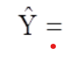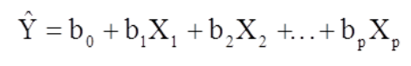,

where is the predicted or expected value of the dependent variable, X1 through Xp are p distinct independent or predictor variables, b0 is the value of Y when all of the independent variables (X1 through Xp) are equal to zero, and b1 through bp are the estimated regression coefficients. Each regression coefficient represents the change in Y relative to a one unit change in the respective independent variable. In the multiple regression situation, b1, for example, is the change in Y relative to a one unit change in X1, holding all other independent variables constant (i.e., when the remaining independent variables are held at the same value or are fixed). Again, statistical tests can be performed to assess whether each regression coefficient is significantly different from zero

**RESULTS AND ANALYSIS**

1. Regression Analysis for Market Seeking

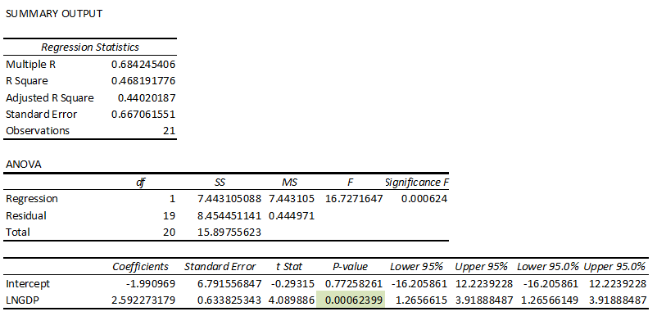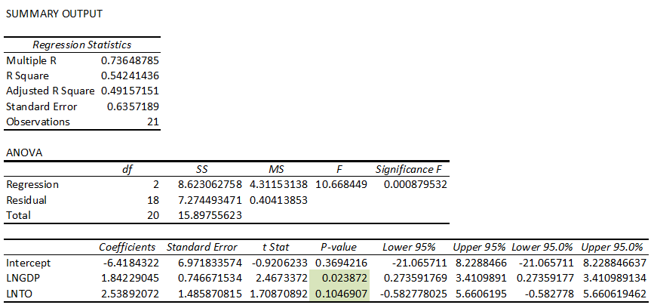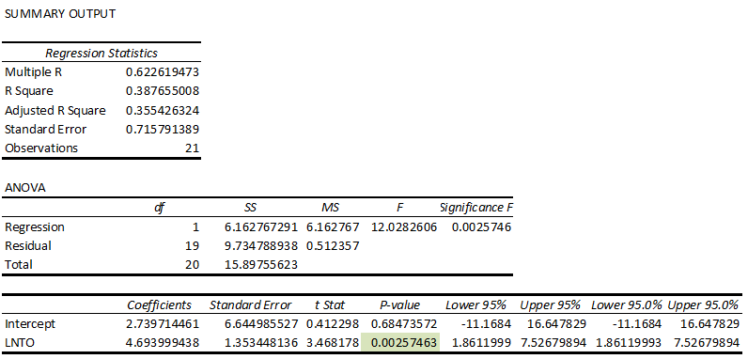

We are regressing GDP and Trade openness on FDI, we find a insignificant R-squared  
value, also LNGDP and LNTO are statistically insignificant value. The significance of F value is greater than 0.05 thus this regression equation is insignificant.

The p-value of LNTO is greater than 0.05 thus that tells us LNTO as a variable is irrevelant for us though LNGDP is less than 0.05 and thus LNGDP is significant.

1. Regression Analysis for Resource Seeking

Regression of Gross fixed capital formation (% of GDP) on GDP

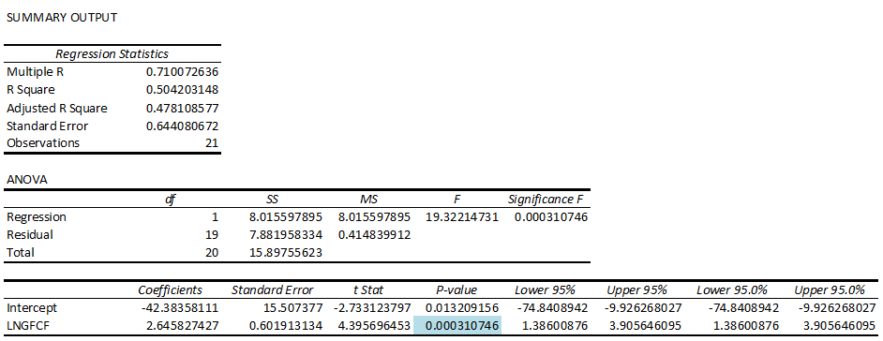

We run a Gross Fixed Capital formation on FDI and found a low R-squared value,it  
can be problematic if we need correct precise prediction but we can try by adding  
more variable and check for the result. LNGFCF is statistically significant as its p  
value is less than 0.05. The significance of F value is less than 0.05 thus this regression equation is significant.

1. Regression of Total natural resources rents (% of GDP)

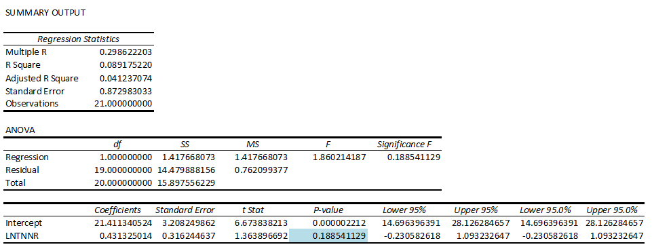

We run a regression of Total Natural resource rent on FDI and found a low Rsquared value, it can be problematic if we need correct precise prediction but we can  
try by adding more variable and check for the result. Also, LNTNRR is statistically  
insignificant as its p value is great than 0.05. The significance of F value is great than 0.05 thus this regression equation is also insignificant.

1. Regression of Gross fixed capital formation (% of GDP) and Total naturalresources rents (% of GDP) on FDI

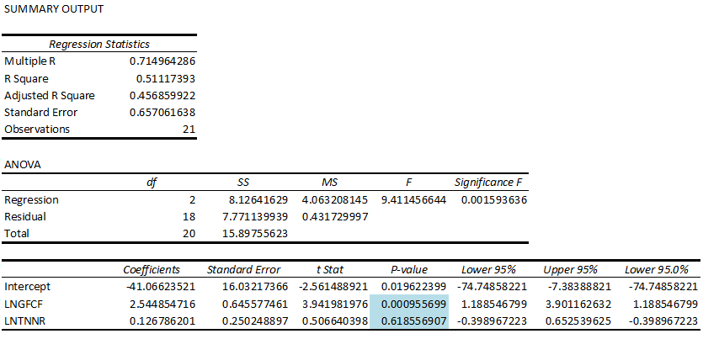

Here we run regression of GFCG and TNRR on FDI and found out that this time we  
have a higher R- squared value as compared to, when we were regressing  
individually, here the LNGFCF is statistically significant as in the previous case but  
LNTNRR is statistically insignificant. Also, high F-value shows the regression is insignificant.

1. Regression analysis for Efficiency seeking

Regression of Logistics performance index: Overall (1=low to 5=high) on FDI

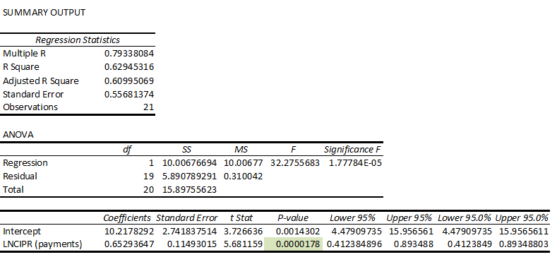

We run a regression of Logistic performance on FDI and the p-value is less than  
0.05 which mean that it is statistically significant.

1. Regression of Research and development expenditure (% of GDP) on FDI

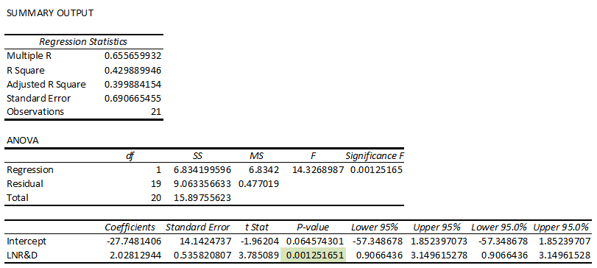

We run a regression of R&D on FDI and the p-value is less than  
0.05 which mean that it is statistically significant.

1. Regression of Research and development expenditure (% of GDP) andLogistics performance index: Overall (1=low to 5=high) on FDI

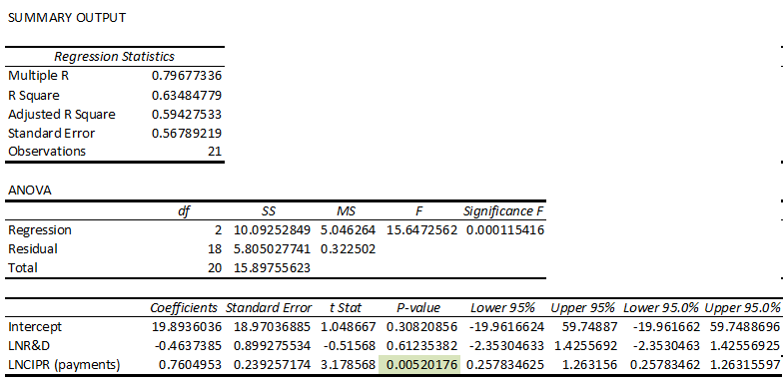

We run a regression of Logistic performance and R&D on FDI and the p value is  
greater than 0.05 for logistic performance which mean that it is statistically insignificant while its significant in case of R&D as p-value is less than 0.05.

**CONCLUSIONS**

This study tried to analyse various factors, determinants to the inflow of FDI in the country of Netherlands for the period of 2001 to 2020. The study analysed the determinants under the heading of market seeking, resource seeking and efficiency seeking FDI inflow.

Under the market seeking inflows size of the market and trade openness of the country were the factors that were considered. As per the results of the regression analysis both the factors were statistically insignificant to the FDI inflows. Thus, we can conclude that as the GDP grows, and the international trade thrives for the country FDI will continue to flow in.

Under the resource seeking only gross fixed capital formation was considered, and in the regression analysis we found that it’s a insignificant determinant for resource seeking FDI inflows.

Finally, under the efficiency seeking, performance of a country in logistic performance index and spending on R&D was considered. There factors of R&D were found to be statistically significant while logistics performance index was found insignificant.

Growth of any country depends upon investments, increasing assets and infrastructure. Foreign Direct investment in an economy shows that there is a good trend of investment which ultimately results in increasing the GDP and growth of the country as we have found in our research that increasing trend of FDI also increases the GDP of the country.The Netherlands is a leading example for other small economies who want to attract foreign investment. As one of the largest recipients of world FDI, the Netherlands has provento be a favoured location for foreign investors from all corners of the globe. Overall, the Netherlands appears to be an attractive location for establishments by foreign firms. However, the historical success in attracting FDI should not be taken for granted. Monitoring and handling the problems in doing business in the Netherlands is a necessary condition for continued inflows of FDI. Although most foreign firms have indicated expansion plans in the Dutch market, their difficulties in getting qualified personnel may limit their possibilities.

Thus, for the country of Netherlands it needs to continue to lay emphasis on growing as an economy to continue to receive FDI inflows. Only Macro factors that can hamper its inflows like slow economic growth in Europe, Low Interest Rate and High Inflation.

**REFERENCES**

* <https://data.worldbank.org/indicator>
* <https://www.state.gov/reports/2020-investment-climate-statements/netherlands/#:~:text=The%20Netherlands%20is%20a%20top,percent%20of%20total%20inbound%20FDI>.
* <https://www.worldbank.org/en/home>
* <https://www.imf.org/en/Home>