**Assignment No. 04**

**Problem Statement :** Write a program to simulate inter process communication mechanism using pipes and redirection.

**Code :**

#include<stdio.h>

#include<unistd.h>

#include<sys/types.h>

#include<sys/stat.h>

#include<fcntl.h>

int main(int argc, char* argv[]) {

    if(argc != 3) {

        printf("You can not enter more or less than 3 arguments.\n");

        return 0;

    }

    int fd[2];

    int fork_val;

    char* file_1 = argv[1];

    char* file_2 = argv[2];

    int src_file;

    int dest_file;

    src_file = open(file_1, O_RDONLY);

    if(src_file == -1) {

        printf("Unable to open source file!!!\n");

        return 1;

    } else {

        dup2(src_file, STDIN_FILENO);

        close(src_file);

    }

    pipe(fd);

    fork_val = fork();

    if(fork_val > 0) {

        dup2(fd[1], STDOUT_FILENO);

        close(fd[0]);

        close(fd[1]);

        execl("/usr/bin/sort", "sort", NULL);

        perror("execl failed for sort");

    }

    else if(fork_val == 0) {

        dup2(fd[0], STDIN_FILENO);

        dest_file = open(file_2, O_WRONLY | O_CREAT | O_TRUNC, 0644);

        if(dest_file == -1) {

            printf("Unable to open destination file!!!\n");

            return 1;

        } else {

            dup2(dest_file, STDOUT_FILENO);

            close(dest_file);

            close(fd[0]);

            close(fd[1]);

            execl("/usr/bin/uniq", "uniq", NULL);

            perror("execl failed for uniq");

        }

    } else {

        perror("Fork failed!!!");

        return 1;

    }

    return 0;

}

**Complilation :**

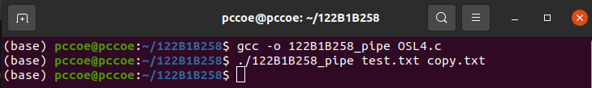

**Output :**

