**Assignment No. 05**

**Problem Statement :** Write a program using pthreads to demonstrate the reader writer synchronization problem. Implement appropriate synchronization. Show the different results with and without synchronization.

1. **Without Synchronization…**

**Code :**

#include <pthread.h>

#include <stdio.h>

#include <stdlib.h>

#include <unistd.h>

int total_amount = 2500;

void *add_money(void *x) {

int cash = 700;

total_amount += cash;

printf("Writer %d credited Rs- %d. New balance: Rs- %d\n", *((int *)x), cash, total_amount);

}

void *deduct_money(void *x) {

int cash = 400;

total_amount -= cash;

printf("Writer %d debited Rs- %d. New balance: Rs- %d\n", *((int *)x), cash, total_amount);

}

void *show_balance(void *x) {

printf("Reader %d checked balance: Rs- %d\n", *((int *)x), total_amount);

}

int main() {

pthread_t readers[6], writers[3];

char actions[] = {'D', 'C', 'D'};

int ids[6] = {1, 2, 3, 4, 5, 6};

for(int i = 0; i < 3; i++) {

pthread_create(&readers[i], NULL, show_balance, &ids[i]);

}

for(int i = 0; i < 3; i++) {

if(actions[i] == 'C')

pthread_create(&writers[i], NULL, add_money, &ids[i]);

else

pthread_create(&writers[i], NULL, deduct_money, &ids[i]);

}

for(int i = 3; i < 6; i++) {

pthread_create(&readers[i], NULL, show_balance, &ids[i]);

}

for(int i = 0; i < 3; i++) {

pthread_join(readers[i], NULL);

}

for(int i = 0; i < 3; i++) {

pthread_join(writers[i], NULL);

}

for(int i = 3; i < 6; i++) {

pthread_join(readers[i], NULL);

}

return 0;

}

**Output :**

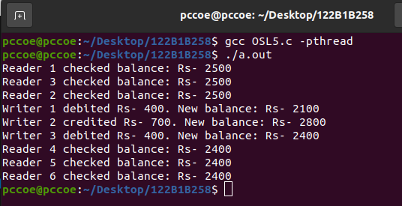

1. **With Synchronization…**

**Code :**

#include <pthread.h>

#include <semaphore.h>

#include <stdio.h>

sem_t resource;

pthread_mutex_t lock;

int total_amount = 2500;

int active_readers = 0;

void *add_money(void *x) {

int cash = 750;

sem_wait(&resource);

total_amount += cash;

printf("Writer %d credited Rs- %d. New balance: Rs- %d\n", *((int *)x), cash, total_amount);

sem_post(&resource);

}

void *deduct_money(void *x) {

int cash = 250;

sem_wait(&resource);

total_amount -= cash;

printf("Writer %d debited Rs- %d. New balance: Rs- %d\n", *((int *)x), cash, total_amount);

sem_post(&resource);

}

void *show_balance(void *x) {

pthread_mutex_lock(&lock);

active_readers++;

if (active_readers == 1) {

sem_wait(&resource);

}

pthread_mutex_unlock(&lock);

printf("Reader %d checked balance: Rs- %d\n", *((int *)x), total_amount);

pthread_mutex_lock(&lock);

active_readers--;

if (active_readers == 0) {

sem_post(&resource);

}

pthread_mutex_unlock(&lock);

}

int main() {

pthread_t readers[6], writers[3];

char actions[] = {'D', 'C', 'D'};

pthread_mutex_init(&lock, NULL);

sem_init(&resource, 0, 1);

int ids[6] = {1, 2, 3, 4, 5, 6};

for (int i = 0; i < 3; i++) {

pthread_create(&readers[i], NULL, show_balance, &ids[i]);

}

for (int i = 0; i < 3; i++) {

if (actions[i] == 'C')

pthread_create(&writers[i], NULL, add_money, &ids[i]);

else

pthread_create(&writers[i], NULL, deduct_money, &ids[i]);

}

for (int i = 3; i < 6; i++) {

pthread_create(&readers[i], NULL, show_balance, &ids[i]);

}

for (int i = 0; i < 3; i++) {

pthread_join(readers[i], NULL);

}

for (int i = 0; i < 3; i++) {

pthread_join(writers[i], NULL);

}

for (int i = 3; i < 6; i++) {

pthread_join(readers[i], NULL);

}

pthread_mutex_destroy(&lock);

sem_destroy(&resource);

return 0;

}

**Output :**

