Assignment 3: Object Tracking
Satyanarayana, Ahmad, Varghese
Electrical and Computer Engineering, Colorado State University
Fort Collins, Colorado

Abstract — Object tracking in computer vision is the task of finding and tracking a given object in a video sequence. It is one of the hardest challenges for computer vision systems today. Humans find this task extremely trivial and can recognize and track objects even if they are rotated, translated, scaled or partially obstructed from view. Many approaches have been applied to object tracking. The task is to be able to recognize the object and track it in a video sequence. Some of the challenges posed by this particular task include recognizing the object when looking at it from a different perspective and pose, recognizing the object when it is partially occluded and tracking the object while it is in motion. We propose a technique to track objects in video sequences.
Index Terms — Background Segmentation, Mixture of Gaussians, ViBe, Object Tracking, MOSSE

Introduction
The objective of this assignment is to track motion using background and foreground detection methods and then track the object or objects in the given video frame by tracking the foreground regions from frame to frame. We have successfully implemented this using three different methods. The first method used is a basic segmentation method. The second method is the Mixture of Gaussians and ViBe is the third implementation of background and foreground segmentation. Object Tracking has been achieved using an implementation of MOSSE.
In the basic background segmentation method, each frame is converted to a grayscale image and a gaussian blur is applied to it followed by which the difference of each frame is taken against the background model which was initialized from the first frame. This is used to segment between the background and foreground models. In the Mixture of Gaussians method, each pixel is modeled as a mixture of gaussians and then these Gaussian distributions are then evaluated to determine whether the pixels are part of the background or foreground. The ViBe method of background subtraction stores a set of values taken in the past at the same location or in the neighborhood for each pixel. These set of values are then compared to the current pixel value to determine whether it is a part of the background or not and adapts the background model by randomly choosing which values to substitute from the background model. The object tracking is achieved through MOSSE filter which produces stable correlation filters when initialized using a single frame.
In this report, following are the major stages of computation used to detect and track objects:
- The video is read in by the program and a background segmentation method is applied to each frame to detect motion
- Once the background segmentation has been completed, MOSSE is applied to track the detected objects.

Initialization
We, first read in the video and convert each frame to a grayscale image. In order to detect moving objects in the video from frame to frame we need a background and foreground segmentation method. Here we use three different methods for segmentation.
In the first method, which is the basic background segmentation method, each frame is converted to grayscale and a gaussian blur is applied to it. Here, the current frame is subtracted from the background model and a threshold value is applied to obtain a foreground model. This method of background and foreground segmentation is relatively easier to implement compared to the Mixture of Gaussians and ViBe methods described below. A visual representation of the basic background segmentation method is given in Figure 1.

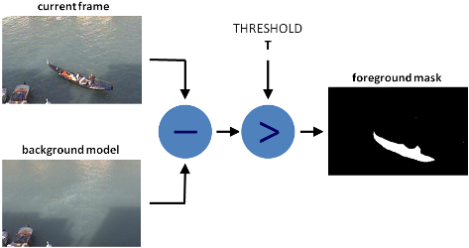
Figure 1: Basic Background Segmentation

The second method used is the Mixture of Gaussians method (Stauffer and Grimson). In this method, rather than explicitly modeling the values of all the pixels as one particular type of distribution, the pixels are modeled as a mixture of gaussians. These pixels are then classified as background based on their variance and persistence. Pixel values that do not fit the background distributions are considered foreground until there is a gaussian that includes them with sufficient, consisting evidence supporting it.
The third method used is ViBe (Barnich and Droogenbroeck). In this method, for each pixel, as set of values taken in the past at the same location or in the same neighborhood. This set of pixel values is then compared to the current pixel value to determine whether the pixel belongs to the background and adapts the model by randomly choosing which values are to be substituted in the background model. Pixels found to be a part of the background, its values are propagated into the background model of its neighboring pixels.
Once the frames in the video have been processed to classify the background and foreground, we now need to keep track of the objects moving in and out of the frames. The tracking algorithm needs to be robust to variations in lighting, scale and non-rigid deformations. To track the objects, we have used an implementation of MOSSE filter (Bolme, Beveridge, Draper, and Liu).

Background Segmentation
Background subtraction, also known as foreground detection, is a technique in the fields of image processing and computer vision wherein an image's foreground is extracted for further processing. The rationale for the approach is that of detecting the moving objects from the difference between the current frame and a reference frame, often called "background image", or "background model". Background modeling consists of two main steps:

1. Background Initialization
2. Background Update

In the first step, an initial model of the background is computed, while in the second step that model is updated to adapt to possible changes in the scene.
In the basic background segmentation model, the first frame of the video is initialized as the background model. Once the initialization process has been completed every frame followed by the initial frame is subtracted from the background model and thresholding is carried out. The pixel values greater than the threshold value are assigned as foreground pixels. This process is used to differentiate between the background and the foreground. The basic Background segmentation method, though faster than the Mixture of Gaussians method and ViBe in terms of computation speed, does not offer the reliability and robustness offered by the former and latter methods. The output of this method is shown in Figure 2.

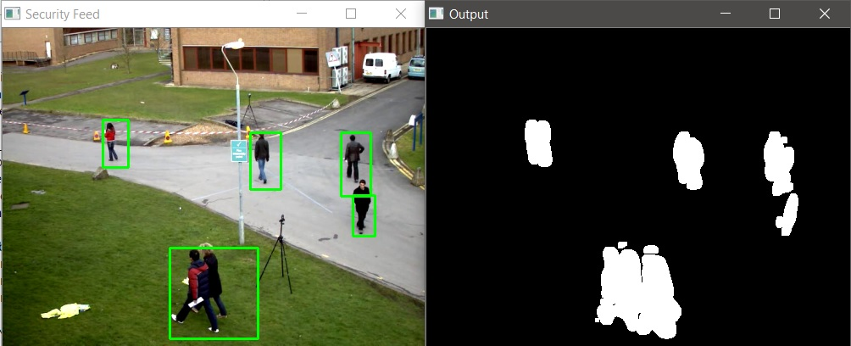
Figure 2: Output of the basic background segmentation process

A Mixture of Gaussians method approaches by modeling each pixel as a mixture of Gaussians and uses an on-line approximation to update the model. In this technique, it is assumed that every pixel's intensity values in the video can be modeled using a Gaussian mixture model. A simple heuristic determines which intensities are most probably of the background. Then the pixels which do not match to these are called the foreground pixels. Foreground pixels are grouped using 2D connected component analysis. We have applied the Mixture of Gaussians method through the OpenCV library in Python (MOG2). It is also a Gaussian Mixture-based Background/Foreground Segmentation Algorithm. It is based on two papers by Z. Zivkovic, "Improved adaptive Gaussian mixture model for background subtraction. However, the major problem with the Mixture of Gaussians method is the slow removal of ghosts formed in the model. This can lead to errors during detection of objects. The ghosts formed are marked with red circles as shown in Figure 3.

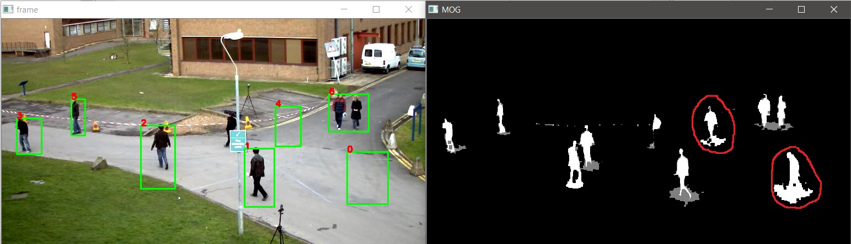
Figure 3: Ghosts formed in the model in the MOG method

The ViBe method of background segmentation though less intensive computationally, compared to the Mixture of Gaussians method, requires a GPU to process a video at an acceptable rate. The following parameters are crucial for the ViBe background segmentation method.
R – radius of sphere used to compare current pixel values to previous pixel sample (20 is the default value mentioned by the authors)
∅ - The time subsampling factor. It is used to determine the probability of a background pixel value updating the background model (16 is the default value mentioned by the authors)
N – Number of samples stored in each pixel model (20 is the default value mentioned by the authors)
# - Threshold value of pixels to be present in the circle of radius R needed to classify a new pixel value as background
Despite the ViBe method being able to eliminate ghosts significantly faster than the Mixture of Gaussians method, the slow processing of the video due to the absence of an external GPU forced us to abandon the implementation of this method with the MOSSE tracker. The output of the ViBe method is as shown in Figure 4.

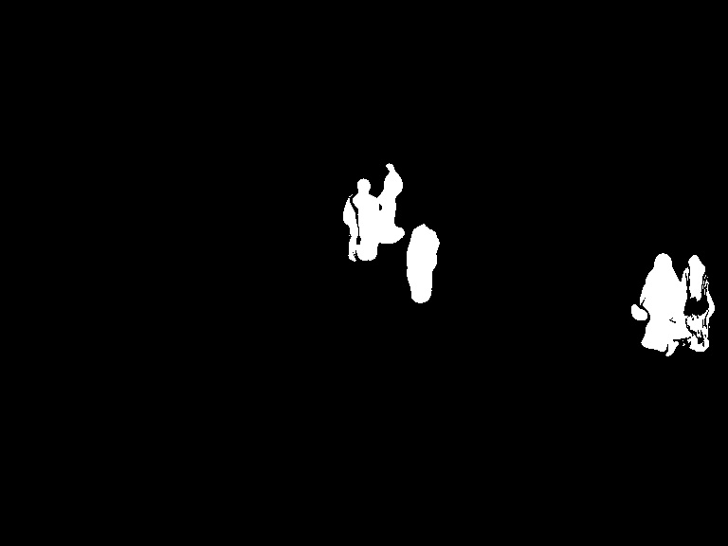
Figure 4: Output of ViBe

Tracking Method
Tracking is easier than detection and less intensive computationally. The features we were looking for in the tracker that we wanted to implement are robustness, trained with online learning, and simplicity of modeling. The tracking method used here is the MOSSE filter method. Here the targets are initialized in a frame and tracked in subsequent frames. The target is selected based on a tracking window centered on the object in the first frame. The target is then tracked by correlating the filter over a search window.
In our implementation of the MOSSE filter tracking system, we have tried two different methods. The first method uses the basic background segmentation method to differentiate between the background and foreground pixels and then the MOSSE tracker is initialized to track the various objects in the frame. In the second method, the Mixture of Gaussians is used to detect objects which is followed by implementing the MOSSE tracker to track the objects through the various frames.
Due to our implementation of the ViBe background subtraction method being slow, we did not use it along with the MOSSE filter to detect and track objects.

Evaluation
Evaluation of the system is based on 2 main parameters:
- Peak to Side Lobe Ratio (PSR) Ratio
- Computation/Time Analysis

Peak to Side Lobe (PSR) Ratio
The performance of the MOSSE filter is evaluated by the sharpness of the correlation filter output, mathematically represented by the Peak to Side Lobe Ratio (PSR). Figure 5 represents the top view of correlation output plot, where PSR ratio is mathematically computed as follows:
PSR= (peak-mean) / σ

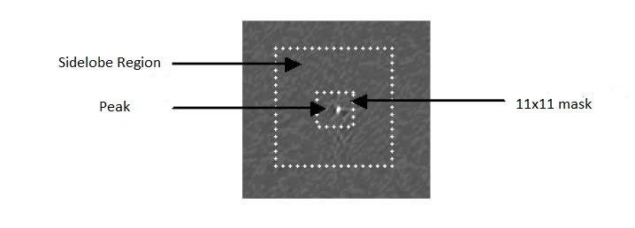
Figure 5: Computing Peak to Side Lobe Ratio (PSR) Value

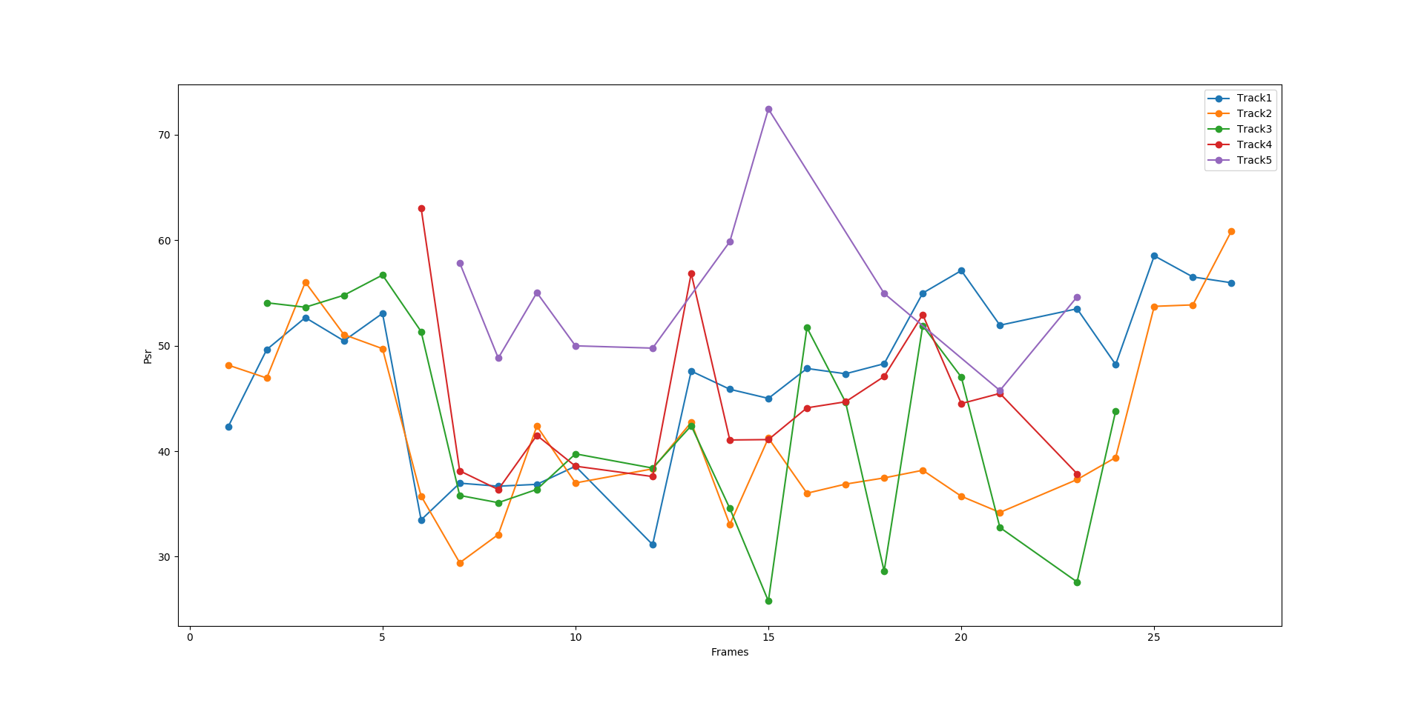
Figure 6: Graph depicting the variation of PSR as a function of frames for various tracks of object detected using Background Subtraction and MOSSE filter.

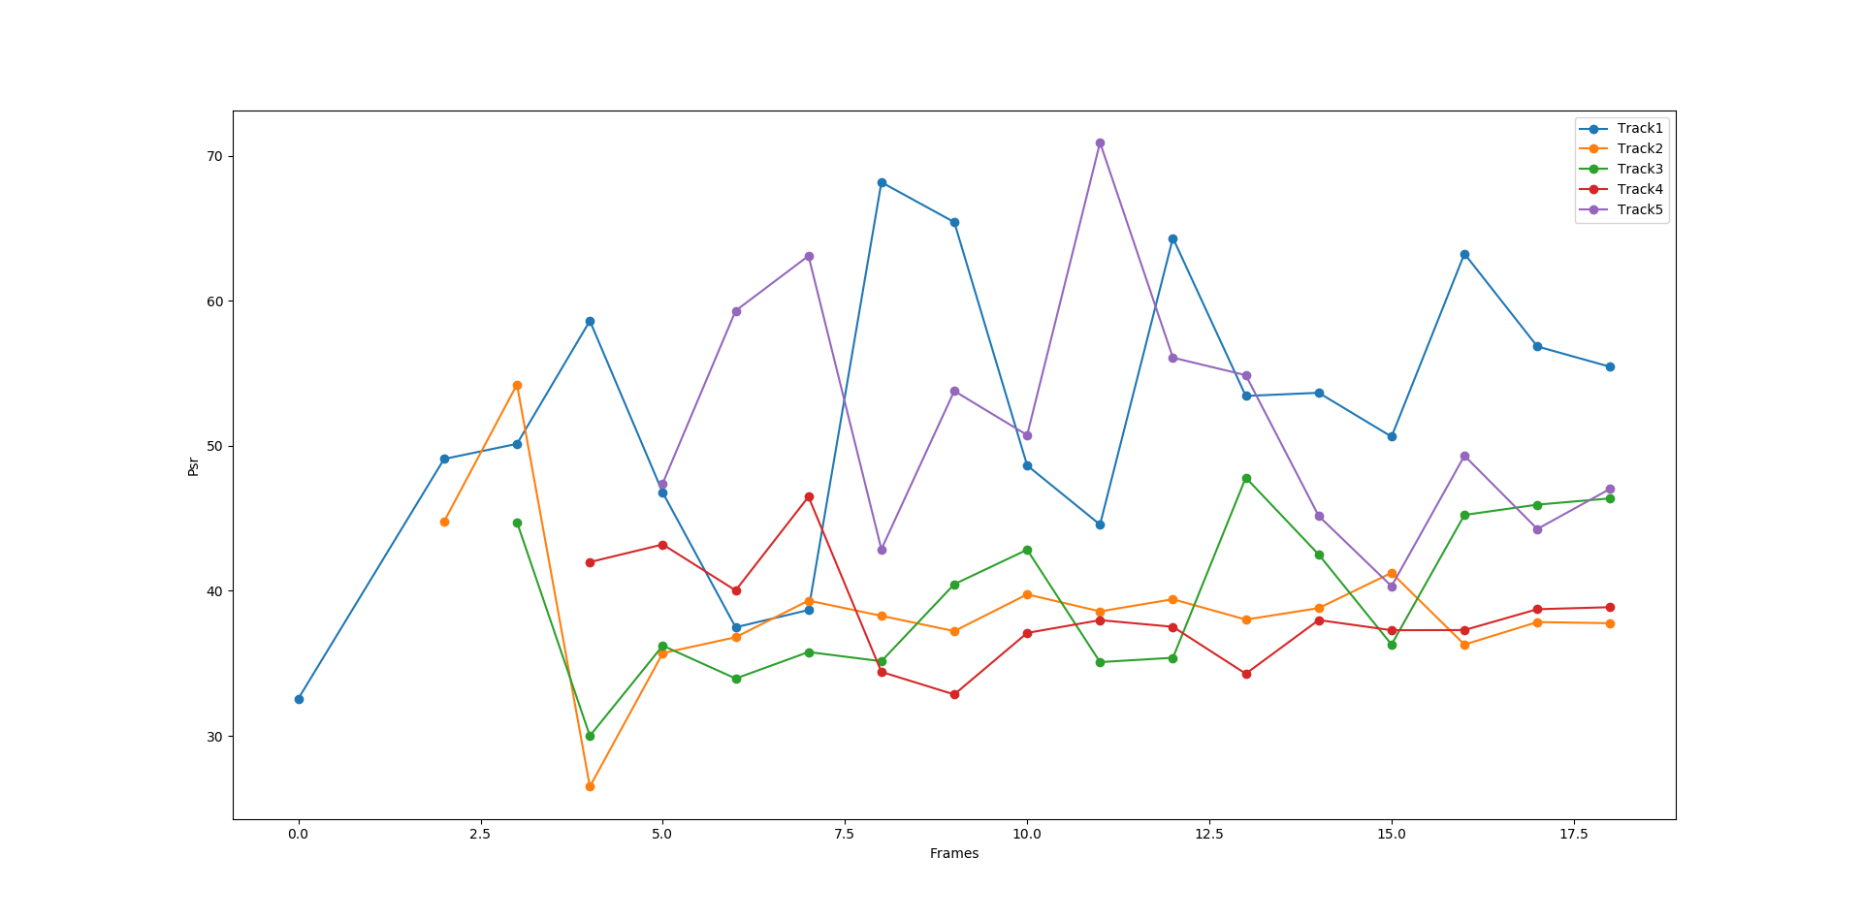
Figure 7: Graph depicting the variation of PSR as a function of frames for various tracks of object detected using Mixture of Gaussian (MOG) and MOSSE filter.

Two systems were developed for this assignment, the first system used Background Subtraction for segmentation and MOSSE filter for tracking while the second used Mixture of Gaussian (MOG) for segmentation and MOSSE filter for tracking. For evaluation, a common video was subject to both the systems. A graph representing the variation of PSR as a function of frame for all the tracks detected by the system was plotted. Figure 6 shows the graph for a system of Basic Background Subtraction and MOSSE filter (system 1) while Figure 7 shows the graph for a system of MOG and MOSSE filter (system 2). It can be visually analyzed that the PSR ratio of the tracks in system 2 is higher than that of system 1 indicating the better tracking of object in system 2. Additionally, we also observed that by using Mixture of Gaussian (MOG) as the background segmentation model, tracking may begin from the first frame.

Computation/Time Analysis
Computation or Time Analysis is the measure of the number of frames processed by the program in given time. This parameter is dependent on the operating system and all values provided in the table below were obtained on an i7 6th generation Quad-Core processor.

Description | Time (in frames/second)
MOG | 47.5815411969
Basic Background Subtraction | 21.3120426702
Basic Background Subtraction + MOSSE Filter | 3.50328115438
MOG + MOSSE Filter | 2.3273285767

Table 1. Computation/Time Analysis

Observation
BACKGROUND SUBTRACTION METHOD
Tracking | Advantages | Disadvantages
MOG with Mosse | Highest frame rate  Very Fast when combined with MOSSE | Ghost lasts for longer period of time  False tracking is prominent.
Background Subtraction  with  Mosse | Ghost is not prominent  Slower as compared to MOG-Moose | Fails when contrast of moving object is similar to that of the background  Eradication of ghosts is efficient but it’s a tradeoff between efficient tracking and ghost
Mosse with background subtraction and contour refresh | Faster than other methods | Tracking is poor

Conclusion
In conclusion, we can see that our implementation of a basic background segmentation model for object detection coupled with the MOSSE filter for tracking is not significantly faster than the second implementation which uses Mixture of Gaussians for foreground detection along with MOSSE filter for tracking despite the basic background segmentation being faster than the Mixture of Gaussians method.

References
For papers published in translation journals, please give the English citation first, followed by the original foreign-language citation [6].
- Zivkovic, Zoran. "Improved adaptive Gaussian mixture model for background subtraction." Pattern Recognition, 2004. ICPR 2004. Proceedings of the 17th International Conference on. Vol. 2. IEEE, 2004.
- .
- I. S. Jacobs and C. P. Bean, “Fine particles, thin films and exchange anisotropy,” in Magnetism, vol. III, G. T. Rado and H. Suhl, Eds. New York: Academic, 1963, pp. 271–350.
- K. Elissa, “Title of paper if known,” unpublished.
- R. Nicole, “Title of paper with only first word capitalized,” J. Name Stand. Abbrev., in press.
- Y. Yorozu, M. Hirano, K. Oka, and Y. Tagawa, “Electron spectroscopy studies on magneto-optical media and plastic substrate interface,” IEEE Transl. J. Magn. Japan, vol. 2, pp. 740–741, August 1987 [Digests 9th Annual Conf. Magnetics Japan, p. 301, 1982].
- M. Young, The Technical Writer's Handbook. Mill Valley, CA: University Science, 1989.

