**3.1 – DESIGN ASPECTS**

1. **USE CASES-:**

**USER REGISTRATION-:**

ACTOR-: New User

GOAL-: To help new user to get registered

DESCRIPTION-: It will help all the new user to register themselves in the software for the ease usage of the software.

**USER LOGIN-:**

ACTOR-: Already registered user

GOAL-: To help registered user to log into their account

DESCRIPTION-: It will help the registered user to log into their account safely and securely.

**BROWSE LOCATION-:**

ACTOR-: Registered user

GOAL-: To help users to browse location

DESCRIPTION-: It will help users to browse the location for locating charger.

**BOOKING-:**

ACTOR-: Registered user

GOAL-: To help users to book the spot of socket

DESCRIPTION-: It will help to book the socket for desired time.

**VIEW PROFILE-:**

ACTOR-: Registered user

GOAL-: To view and update profile

DESCRIPTION-: It will help user to view their profile as well as update it.

1. **USER STORIES-:**
   1. As an EV driver, I want to register on Locate a Socket so that I can access its featured (For New Users)
   2. As an EV driver, I want to log into my account to access the software and do booking.
   3. As an EV driver, I want to locate the nearest available charging station so that I can charge it conveniently.
   4. As an EV driver, I want to know the type of socket available to check the compatibility.
   5. As an EV driver, I want to view the current status of the power socket like its available or occupied.
   6. As an EV driver, I want to be able to navigate to the booked charging station using Maps.
   7. As an EV driver, I want to see additional features like locating nearby rest rooms or restaurants to plan my stay.
2. **USER REQUIREMENTS-:**
   1. REAL-TIME DATA-: The application should provide real-time data about which socket is available.
   2. SOCKET INFORMATION-: Display information regarding the type of socket.
   3. LOCATION-BASED SERVICES-: Using map locating near-by charging sockets.
   4. NOTIFICATION SYSTEM-: Give a notification alert to the user when preferred charging socket or location is available.
   5. SECURITY-: Implementing security to protect user data and transactions.
   6. FEEDBACK-: Allow users to give feedback of the user experience to improve service quality.
3. **DESIGN SPECIFICATION-:**
   1. USER REGISTRATION FLOW-: Design should include a form for user input like name, address, phone number, Gmail etc.

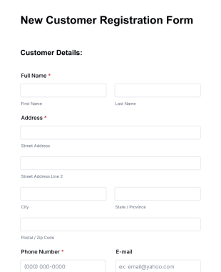

* 1. USER LOGIN-: It should have input fields for logging in like phone number/ Email and password.

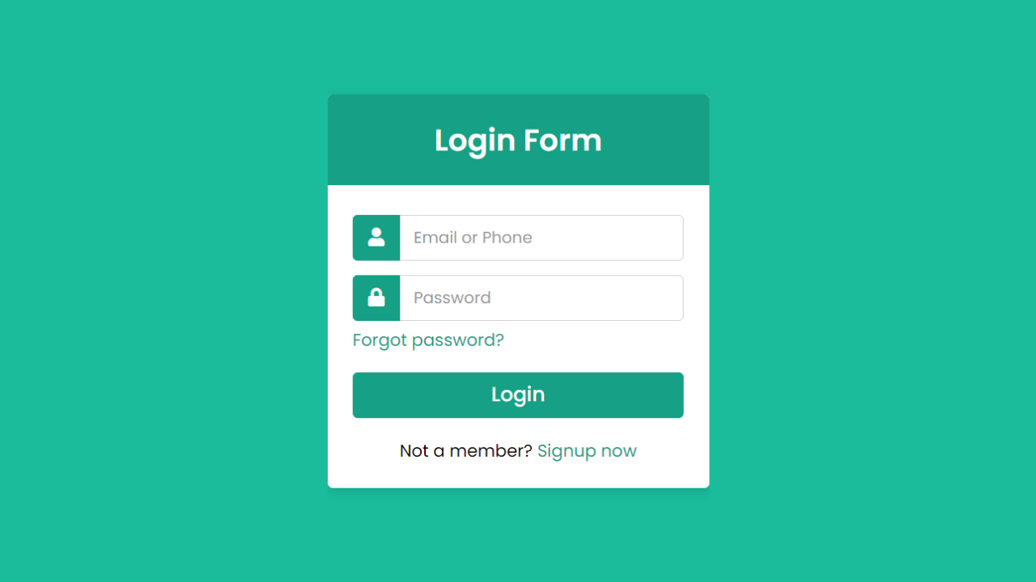

* 1. SEARCH BAR-: Design should have a search bar where user can search the location for the charging socket. We can also see the nearby restaurants, guest-room etc.

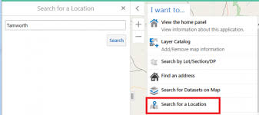

* 1. EDIT PROFILE-: Design should have the option to edit the user profile where user can update their personal information.

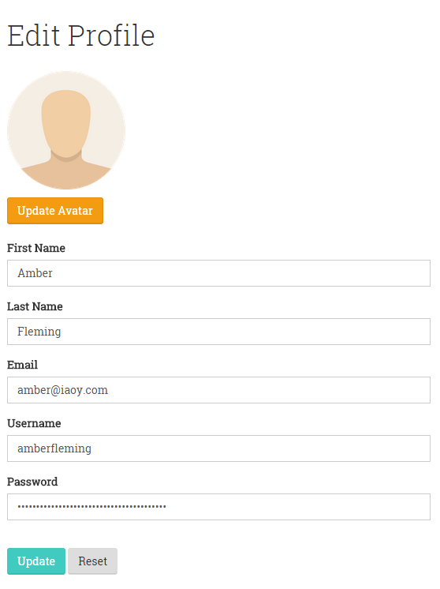

* 1. FEEDBACK-: Design should have the feedback form where users can give feedback about their user experience.

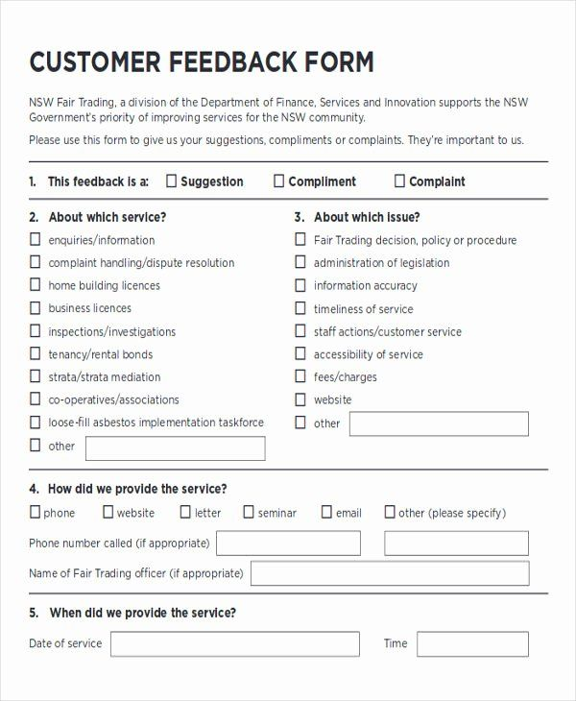

**REFERENCE**

All the images are taken from google images just to give an example. Software ‘Locate a Socket’ will have all this pages. These are just an example to demonstrate how our software will contain all these features.