CS 634 - Data Mining (Midterm Project Report)

Yash Shah (yns5@njit.edu)
Prof. Yasser Abduallah
Date: Oct 18, 2025

Table of Content

1. Introduction
2. Dataset Creation
3. Implementation of Brute Force Algorithm
4. Apriori and FP-Growth
5. Output with multiple parameters
6. Github Repository
7. How to Run the Code
8. Conclusion
9. Github Repository Structure

Introduction
The purpose of this project was to analyze transactional data and identify frequent itemsets using different data mining algorithms. Association rule mining was implemented to uncover patterns and relationships between items frequently bought together. This report presents the process of dataset creation, implementation of the brute force approach, and the use of Apriori and FP-Growth algorithms for efficient pattern discovery.

Dataset Creation
To simulate real-world market basket data, a synthetic dataset of transactions was generated by me. Each transaction represents a customer purchased items, which contains a combination of items such as milk, bread, eggs, butter, cheese, and vegetables. The dataset was created manually to ensure logical and diverse transactions, for example, customers buying bread often also purchased butter, while milk frequently appeared with cereal.
The final dataset consisted of at least 20 transactions and 5 items in it with varying item combinations, saved in CSV format for easy import and processing.

Implementation of Brute Force Algorithm
1. Method
The brute force algorithm was implemented as the baseline approach to discover frequent itemsets. This method evaluates all possible combinations of items across transactions and counts their occurrences to determine support values.
Although it guarantees accurate results, it is computationally expensive since the number of combinations increases exponentially with the number of items. The algorithm was used on a smaller subset of the dataset to demonstrate its functionality and to serve as a comparison for the optimized algorithms.
2. Test Run:
Dicks
Choose dataset by number (1-5): 5
Enter min support (e.g., 0.2 or 20): 0.2
Enter min confidence (e.g., 0.6 or 60): 0.5

Output:
Found 16 frequent itemsets and 8 association rules.
=== Brute-force Results ===
Frequent Itemsets:
{Air Pump} (support=0.40)
{Baseball Glove} (support=0.20)
{Basketball} (support=0.30)
{Fitness Tracker} (support=0.25)
{Gym Shorts} (support=0.25)
{Running Shoes} (support=0.20)
{Soccer Ball} (support=0.25)
{Sports Towel} (support=0.35)
{Tennis Balls} (support=0.25)
{Tennis Racket} (support=0.25)
{Water Bottle} (support=0.50)
{Air Pump, Basketball} (support=0.20)
{Air Pump, Water Bottle} (support=0.20)
{Baseball Glove, Gym Shorts} (support=0.20)
{Sports Towel, Water Bottle} (support=0.20)
{Tennis Balls, Tennis Racket} (support=0.25)

Association Rules:
Tennis Balls → Tennis Racket (confidence=1.00)
Tennis Racket → Tennis Balls (confidence=1.00)
Baseball Glove → Gym Shorts (confidence=1.00)
Gym Shorts → Baseball Glove (confidence=0.80)
Basketball → Air Pump (confidence=0.67)
Sports Towel → Water Bottle (confidence=0.57)
Air Pump → Basketball (confidence=0.50)
Air Pump → Water Bottle (confidence=0.50)

Apriori and FP-Growth
For Apriori
Used Python mlxtend.frequent_patterns.apriori
Results:
Same frequent itemsets as brute force.

For FP-Growth
Used Python mlxtend.frequent_patterns.fpgrowth
Results:
Same frequent itemsets as brute force.

Timing comparison with itemsets:
Brute-force: 16 itemsets, 8 rules, 0.00s
Apriori: 16 itemsets, 8 rules, 0.01s
FP-Growth: 16 itemsets, 8 rules, 0.01s

Output with multiple parameters

For Dicks Sporting Goods dataset:
Support = 0.2, Confidence = 0.6
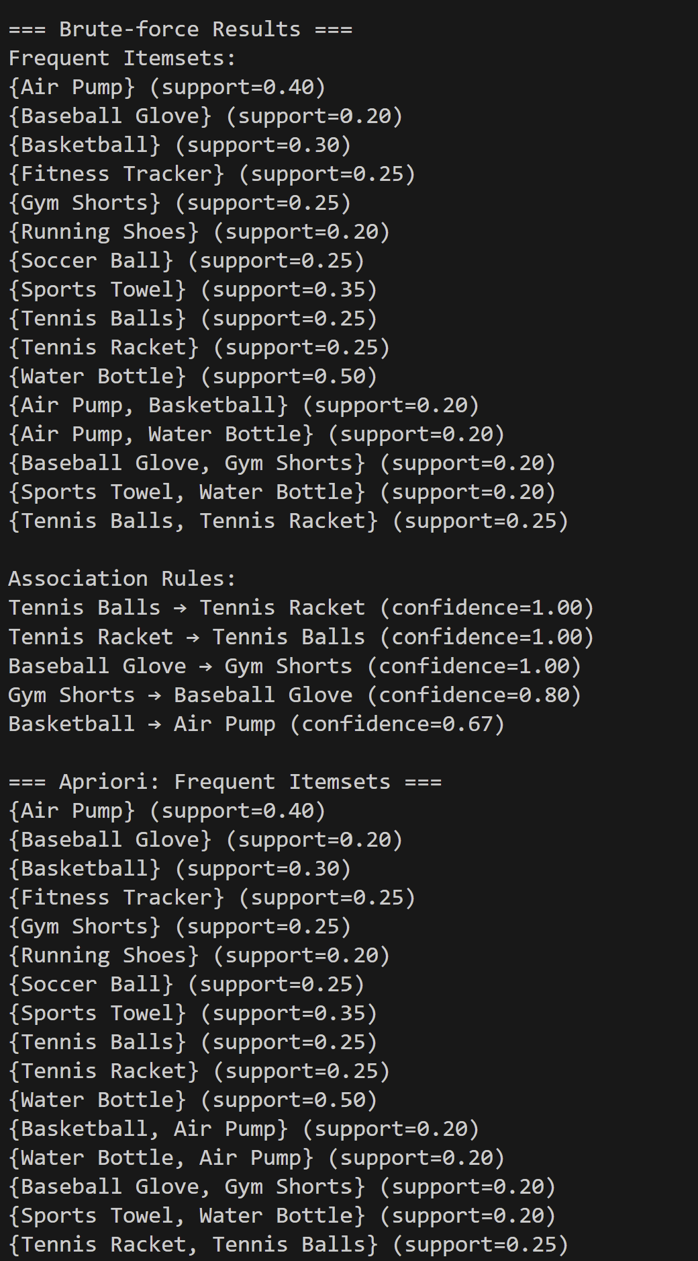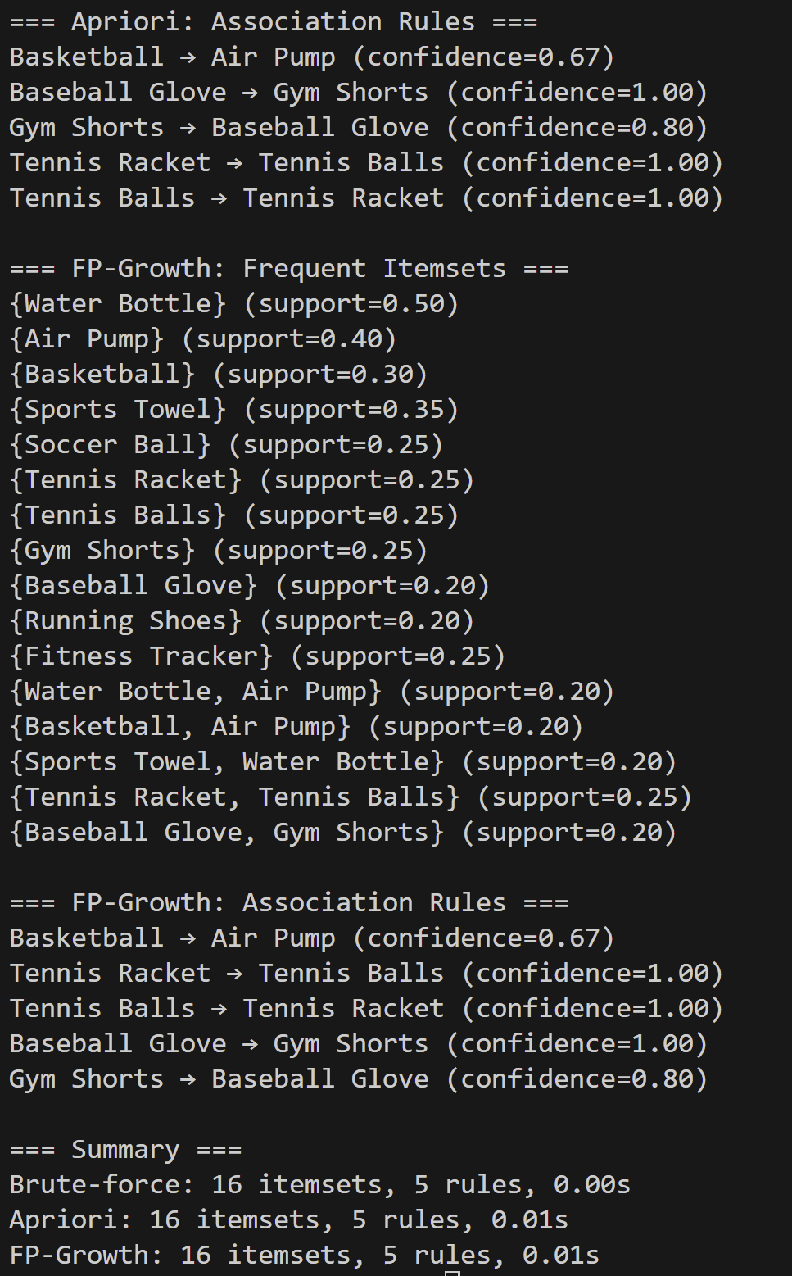

Support = 0.3, Confidence = 0.6
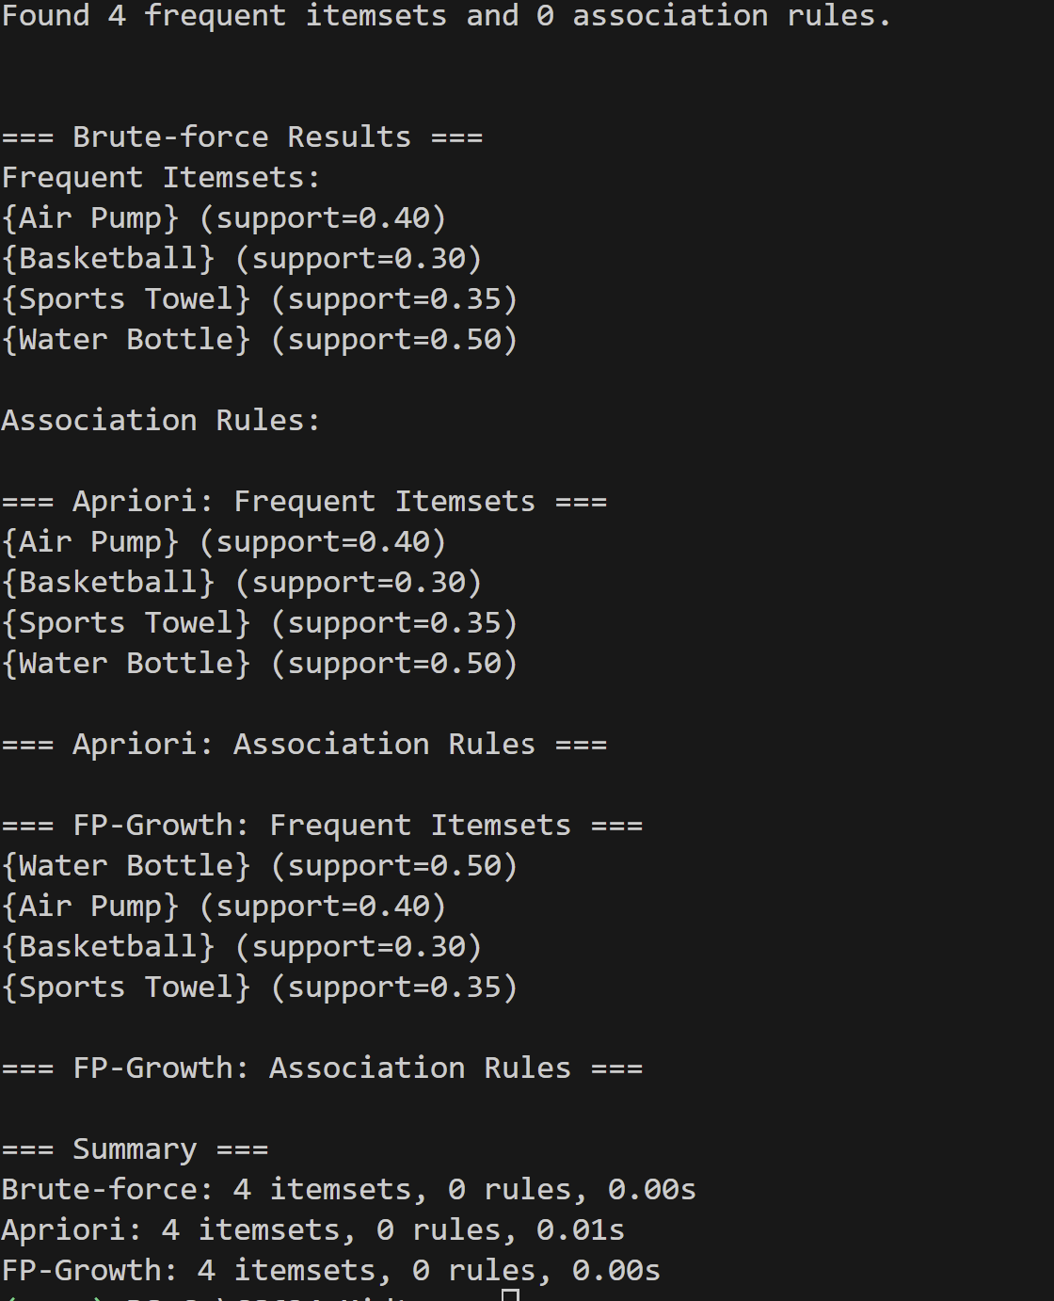
Support = 0.23, Confidence = 0.7
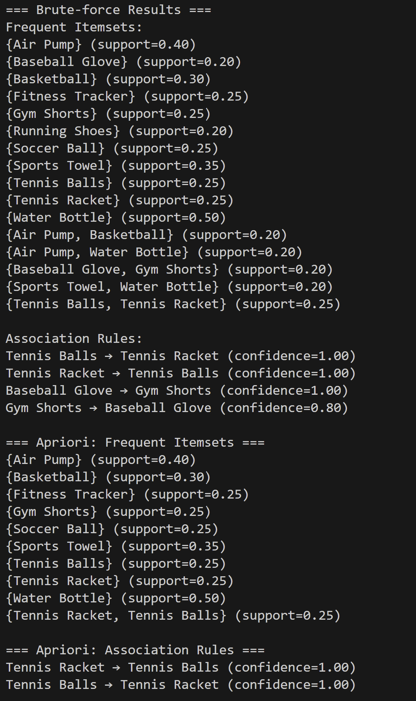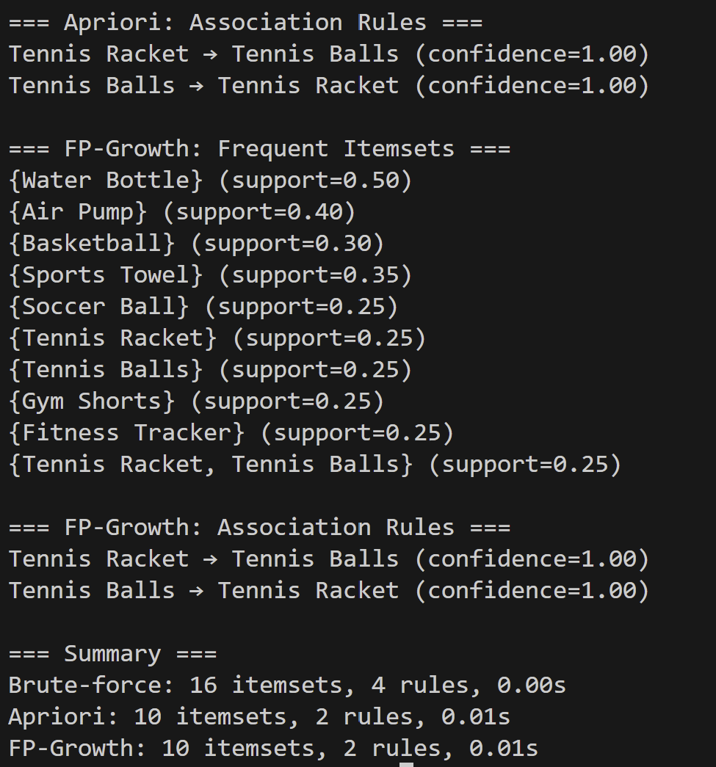

Github Repository
Code and dataset uploaded here. It is my personal github account.

Link: https://github.com/yashah9/Shah_Yash_MidtermProj

How to Run Code

In VsCode
1. In your project folder, open a terminal and run:

python -m venv venv
venv\Scripts\activate # for Windows

pip install pandas mlxtend jupyter

2. To run standalone code:

python .\src\brute_force.py
python .\src\apriori_algo.py
python .\src\fpgrowth_algo.py

python association_rules.py (# this is all code together)

3. To run Jupyter notebook:

jupyter notebook .\Yash_Shah_Midterm.ipynb

Conclusion
In this study, I implemented and compared three algorithms which are Brute Force, Apriori, and FP-Growth for mining frequent itemsets and generating association rules from a few retail transaction dataset. All three methods produced consistent results in terms of the discovered frequent itemsets and association rules when applied under the same minimum support and confidence thresholds.
The Brute Force algorithm serves as a baseline, exhaustively checking all possible item combinations. While it guarantees correctness, its computational inefficiency makes it impractical for larger datasets. Both Apriori and FP-Growth improve upon this by using more efficient strategies to prune the search space and reduce computation time.
The Apriori algorithm iteratively generates candidate sets and prunes infrequent ones based on the Apriori property. It performed efficiently for the moderate-sized dataset used in this experiment but may face scalability issues as dataset size increases.
In contrast, FP-Growth avoids candidate generation altogether by compressing transactions into a tree structure, resulting in faster performance and lower memory usage, especially for larger datasets.
Overall, all three algorithms identified similar high-confidence rules such as:
- Tennis Balls → Tennis Racket (confidence = 1.00)
- Baseball Glove → Gym Shorts (confidence = 1.00)
These findings indicate strong associations among items commonly purchased together.

Github Structure

shah_yash_midtermproj/
│
├── data2/ # Datasets (CSV files, small size)
│ ├── amazon_transactions.csv
│ ├── bestbuy_transactions.csv
│ ├── adidas_transactions.csv
│ ├── shoprite_transactions.csv
│ └── dicks_sporting_transactions.csv
│
│
├── src/ # Python source code
│ ├── brute_force.py
│ ├── apriori_algo.py
│ ├── utils.py
│ └── fpgrowth_algo.py
│
├── report/ # Final report
│ └── midterm_report.pdf
│
├── screenshots/ # Program output screenshots
│ ├── apriori.png
│ ├── brute.png
│ ├── fpgrowth.png
│ └── timing.png
│
├── association_rules.py # every standalone algorithm to run altogether
│
├──Yash_Shah_Midterm.ipynb # jupyter notebook to run
│
├── requirements.txt # Python dependencies
├── README.md # Instructions for running project

