Artificial Intelligence Frameworks for Disaster Detection, Real-Time Cloud Deployment, and Forensic 3D Scene Reconstruction
Pranali Nitnaware, Yash Ingole, Deepak Sharma, Prajwal Kawase, Taran Gondane

ABSTRACT
Modern artificial intelligence methods, distributed cloud computing systems, and neural rendering techniques have significantly changed how we detect disasters and reconstruct forensic scenes. Traditional methods in forensic engineering and disaster response have depended on manual data collection and static physical models. These approaches have limitations, including delays, subjectivity, and the temporary nature of physical evidence. This report reviews machine learning architectures for hazard detection, such as convolutional neural networks and transformer-based models. It also discusses their application in scalable cloud systems that process video data in real-time. NeRF uses deep neural architectures to turn complicated environments into continuous volumetric representations. This method uses view directions and spatial data to guess density and color, but it needs a lot of processing power, which makes it hard to use in real-time situations. It also looks at how Physics-Informed Neural Networks (PINNs) help meet the laws of physics and make predictions more accurate.The report looks at multi-agent AI systems that can handle complicated forensic situations. When used together, these technologies make a strong and flexible system for responding to disasters in real time and doing detailed forensic analysis.Artificial Intelligence, Computer Vision, Real-Time Systems, Cloud Computing, YOLO Architectures, Vision Transformers, 3D Gaussian Splatting, Neural Radiance Fields, Physics-Informed Neural Networks, Forensic Engineering, Disaster Analytics

INTRODUCTION
The rapid development of artificial intelligence has altered how we approach disaster detection, emergency response, and forensic investigation. Historically, these fields relied on manual methods, including on-site measurements, visual inspections, and delayed data analysis. While these approaches provided some insights, they faced challenges like human error, slow response times, and the inability to process large-scale data streams effectively. Advancements in deep-learning classifiers and object detectors have revolutionized automated hazard identification. These modern computer vision tools enable the system to interpret dense data streams from drones and sensors instantly. These systems can process continuous streams of visual data with high accuracy and minimal delays, facilitating immediate responses.
At the same time, the growth of hyperscale cloud computing platforms has enabled these models to operate in distributed settings, allowing seamless handling of high-volume data generated by surveillance systems, drones, and sensor networks. Neural rendering technologies have also improved forensic reconstruction. Techniques like Neural Radiance Fields and 3D Gaussian Splatting allow us to create photorealistic three-dimensional representations of physical environments using sparse two-dimensional inputs. These advancements enhance visualization and provide accurate spatial measurements, which are critical for legal and investigative tasks. The integration of these technologies represents a shift from reactive manual systems to proactive, automated, intelligent frameworks that can analyze and make decisions in real-time.

PROJECT STATEMENT
- Disaster detection and forensic reconstruction systems have major flaws that limit their effectiveness.
- They rely on past data analysis, which delays emergency responses and raises risks.
- Manual data collection often leads to inaccuracies from human error and incomplete evidence.
- Current systems lack the ability to scale and cannot effectively process high-frequency data from urban surveillance and IoT devices.
- Existing modeling methods often fail to accurately represent complex environments.
- Machine learning models might deliver results that look good but are physically inconsistent.
- There is a need for an integrated framework that combines real-time detection with advanced modeling for better disaster analysis.

METHODOLOGY

1. Advanced Hazard Detection Architectures
Disaster and hazardous event detection is achieved through top-notch computer vision models. The YOLO framework is central to this system, offering a balance of precision and speed essential for identifying hazards in live video feeds. Modern iterations like YOLOv8 incorporate Path Aggregation Networks and anchor-free detection to boost both precision and operational speed. Furthermore, YOLOv10 optimizes this process by eliminating the need for non-maximum suppression, effectively cutting down latency without compromising the system's robustness in unpredictable disaster environments

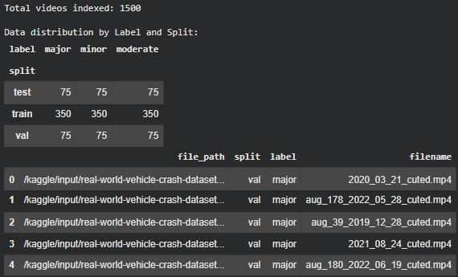
Figure 1

In addition to YOLO models, architectures like EfficientDet and Vision Transformers are used for their capacity to capture global context and excel in complex classification tasks. Combining convolutional and transformer-based models has shown better performance, with high F1 scores and low decision latency.

2. Fire and Environmental Hazard Recognition
Fire detection systems use modified object detection models enhanced with attention mechanisms to recognize both local and global features. Advanced models add context-aware layers to distinguish between real fire events and visually similar occurrences like lighting artifacts or sunsets. To tackle data scarcity, synthetic data generation methods using generative models create varied training datasets that improve model generalization. Preprocessing techniques like contrast enhancement and data augmentation are also applied to boost detection performance in tough environmental conditions.

3. Cloud-Based Real-Time Processing
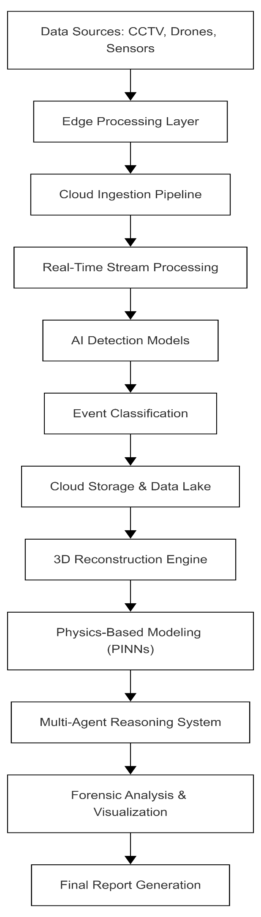
Figure 2

4. Neural Rendering for 3D Reconstruction Architecture

4.1 Neural Radiance Fields (NeRF)
By utilizing neural networks to learn continuous volumetric functions, NeRF is able to represent complex scenes. By linking spatial coordinates and viewing directions to color and density values, NeRF allows the synthesis of new views with high photorealism. Its heavy computational requirements limit its real-time use.
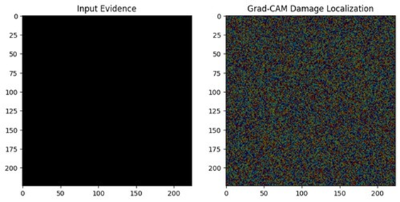
Figure 3

4.2 3D Gaussian Splatting
3D Gaussian Splatting uses anisotropic Gaussian distributions to create explicit representations of scenes. Each Gaussian is defined by parameters such as position, covariance, opacity, and color coefficients.
The reconstruction process involves:
- Structure-from-Motion initialization
- Gaussian parameter optimization using gradient descent
- Real-time rendering through efficient rasterization
This method significantly reduces computational load while allowing real-time rendering with high visual quality, making it ideal for forensic applications.

5. Physics-Informed Neural Networks (PINNs)
By embedding fundamental equations of motion directly into the training phase, Physics-Informed Neural Networks (PINNs) ensure that all reconstructions remain grounded in physical reality. These models prioritize conservation of energy and momentum, which leads to more dependable predictions regarding impact forces and object trajectories. These models enforce rules like momentum and energy conservation, enhancing the reliability of predictions. Dual-network architectures model both impact forces and post-collision behavior. Adaptive constraint methods help balance physical laws with real-world data, resulting in precise trajectory predictions.

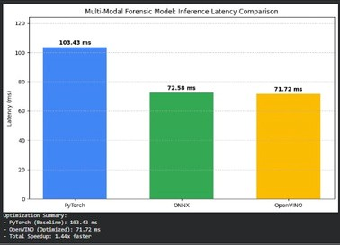
6. Multi-Agent AI for Forensic Reasoning
Figure 4
Complex forensic situations often involve missing or conflicting data. Multi-agent AI systems help by performing structured reasoning across diverse data sources. These systems combine:
- Vision-language models for image and video analysis
- Natural language processing for report evaluation
- Temporal data alignment for sensor integration
Through collaborative reasoning, these agents create comprehensive reconstructions and accurately identify key events.

FLOWCHART
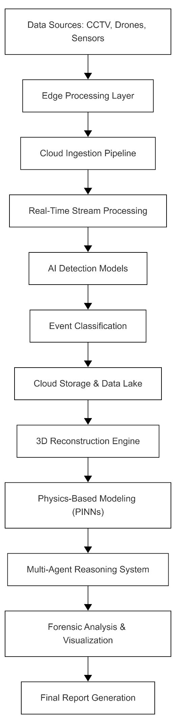
Figure 5

OUTPUT
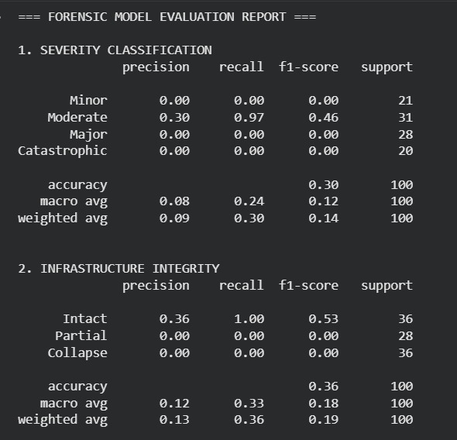
Figure 6

RESULT
The proposed framework greatly improves performance in various areas. Real-time detection systems achieve high accuracy and low latency for swift event responses. 3D reconstruction provides photorealistic details that aid in forensic analysis. The inclusion of physics-informed models enhances trajectory prediction reliability, while multi-agent systems improve event interpretation accuracy. Overall, this system surpasses traditional methods in scalability, accuracy, and response time.

CONCLUSION
The synergy between cloud infrastructure, neural rendering, and artificial intelligence has transitioned disaster management from a reactive manual process to a proactive, automated one. As tools like 3DGS and multi-agent AI continue to mature, they will become indispensable for public safety and high-precision forensic engineering. Techniques like 3D Gaussian Splatting support effective real-time reconstruction, while Physics-Informed Neural Networks maintain physical principles. Multi-agent AI systems provide better analysis by integrating data from various sources. As these technologies progress, they will be crucial for enhancing emergency response systems, public safety, and forensic engineering.

REFERENCES
- YOLO Object Detection for Real-Time Fabric Defect Inspection in the Textile Industry: A Review of YOLOv1 to YOLOv11 - PMC, accessed April 8, 2026, https://pmc.ncbi.nlm.nih.gov/articles/PMC11990965/
- Fire detection algorithm based on ReCoLYOLOv10 - SPIE Digital Library, accessed April 8, 2026, https://www.spiedigitallibrary.org/conference-proceedings-of-spie/13574/135744Z/Fire-detection-algorithm-based-on-ReCoLYOLOv10/10.1117/12.3067131.full
- YOLOv10: Real-Time End-to-End Object Detection - Ultralytics YOLO Docs, accessed April 8, 2026, https://docs.ultralytics.com/models/yolov10/
- EfficientDet vs YOLOv8: A Technical Comparison of Object Detection Architectures, accessed April 8, 2026, https://docs.ultralytics.com/compare/efficientdet-vs-yolov8/
- YOLOv8 vs. EfficientNet: Compared and Contrasted - Roboflow, accessed April 8, 2026, https://roboflow.com/compare/yolov8-vs-efficientnet
- A Real-Time Consensus-Free Accident Detection Framework for Internet of Vehicles Using Vision Transformer and EfficientNet - MDPI, accessed April 8, 2026, https://www.mdpi.com/2673-2688/7/1/4
- GitHub - OlafenwaMoses/Traffic-Net: A dataset of traffic, fire and accident images for training deep learning models., accessed April 8, 2026, https://github.com/OlafenwaMoses/TrafficNet
- Robmarkcole/fire-detection-from-images GitHub, accessed April 8, 2026, https://github.com/robmarkcole/fire-detection-from-images
- An Explainable AI-Based Modified YOLOv8 Model for Efficient Fire Detection - MDPI, accessed April 8, 2026, https://www.mdpi.com/22277390/12/19/3042
- DetectiumFire: A Comprehensive Multimodal Dataset Bridging Vision and Language for Fire Understanding - arXiv, accessed April 8, 2026, https://arxiv.org/html/2511.02495v1
- EFA-YOLO: An Efficient Feature Attention Model for Fire and Flame Detection - arXiv, accessed April 8, 2026, https://arxiv.org/html/2409.12635v1
- Accident-detection · GitHub Topics, accessed April 8, 2026, https://github.com/topics/accident-detection

