**Batch:B-1 Roll No.:16010122105**

**Experiment No. 02**

|  |
| --- |
| **TITLE:** **Develop and demonstrate the usage of inline, internal and external style sheet using CSS** |

**AIM:** To demonstrate usage of CSS

**______________________________________________________________________**

**Expected Outcome of Experiment:** Use CSS to prepare the layout of web pages.

**______________________________________________________________________**

**Books/ Journals/ Websites referred:**

1. .

**_____________________________________________________________________**

Importance of CSS in designing of a website is to be explained. Explain various ways to use CSS. Also explain how to change background colour of page, adding and editing border types, adding navigation bars, usage of various types of 2D and 3D transformation.

**Description of the CSS style code with its effect at output**:

**Code: Html code**

<!DOCTYPE html>

<html lang="en">

<head>

    <meta charset="UTF-8">

    <meta name="viewport" content="width=device-width, initial-scale=1.0">

    <title>Movie Management System - Login</title>

    <link rel = "stylesheet" href = "style1.css">

    <style>

        h1 {

            color: #333;

            margin-bottom: 20px;

        }

        label {

            display: block;

            text-align: left;

            margin-bottom: 8px;

            color: #555;

        }

        input {

            width: 100%;

            padding: 10px;

            margin-bottom: 15px;

            box-sizing: border-box;

            border: 1px solid #ddd;

            border-radius: 4px;

        }

        button {

            background-color: #007BFF;

            color: #fff;

            padding: 10px;

            border: none;

            border-radius: 4px;

            cursor: pointer;

            width: 100%;

        }

        button:hover {

            background-color: #0056b3;

        }

        .footer {

            margin-top: 20px;

            color: #777;

        }

        header{

            text-align: center;

            margin: 20px 0;

            position: absolute;

            top: 0;

            left: 50%;

            transform: translateX(-50%);

            width: 100%;

        }

    </style>

</head>

<body>

    <header>

        <h1>Movie Management System</h1>

        <p id = "menu" style = "color: whitesmoke">Membership | Lists | Ratings</p>

    </header>

    <div id="login-container">

        <form>

            <label for="username">Username:</label>

            <input type="text" id="username" name="username" required>

            <label for="password">Password:</label>

            <input type="password" id="password" name="password" required>

            <button type="button">Login</button>

        </form>

        <p class="footer">Don't have an account? <a href="#">Sign up here</a>.</p>

    </div>

</body>

</html>

**CSS code:**

body {

    font-family: 'Arial', sans-serif;

    background: url('wall1.jpg') center center fixed;

    background-size: cover;

    display: flex;

    align-items: center;

    justify-content: center;

    height: 100vh;

    margin: 0;

}

#login-container {

    background-color: rgba(255, 255, 255, 0.9);

    width: 300px;

    padding: 20px;

    border-radius: 8px;

    box-shadow: 0 0 10px rgba(0, 0, 0, 0.1);

    text-align: center;

}

#login-container img {

    max-width: 100%;

    height: auto;

    margin-bottom: 20px;

    border-radius: 8px;

}

**Output:**

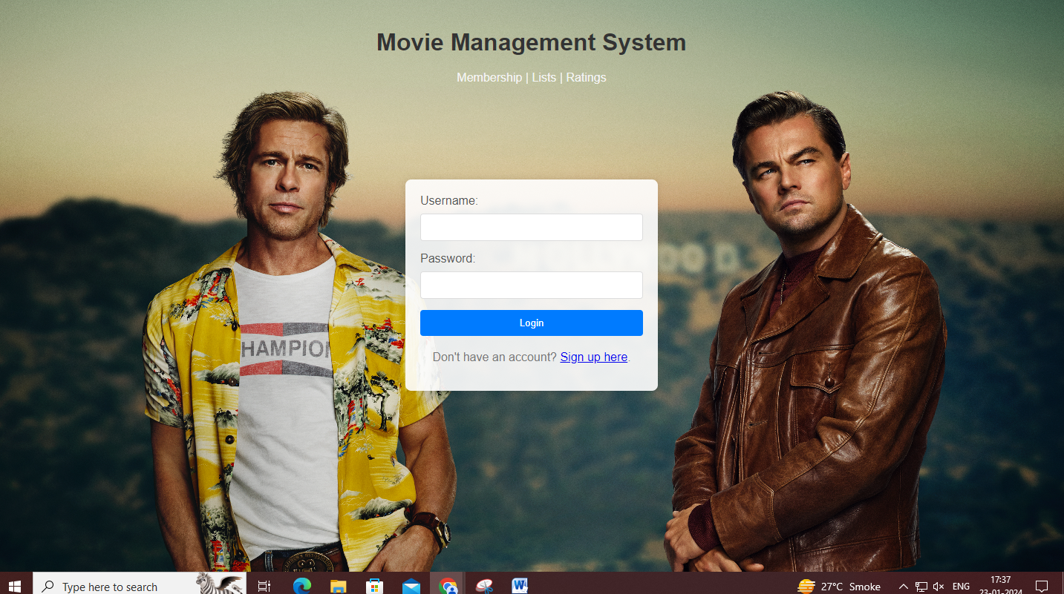

**Post Lab Objective with Ans (Min 5):**

* **What is the Box model in CSS? ...**

**Ans**: The CSS box model is a container that contains multiple properties including borders, margin, padding, and the content itself. It is used to create the design and layout of web pages.

* **What are the advantages of using CSS? ...**

**Ans:**

* Consistency and Global Styling.
* Easier to Maintain and Efficient Updates.
* Time-Saving and Faster Loading Times.
* Enhanced Design Options and Responsive Design.
* SEO-Friendly. ...
* Accessibility and Print-Friendly Pages.
* Platform Independence and Device Compatibility.
* CSS Minification and Page Load Efficiency
* **What are the limitations of CSS?**

**Ans:**

* Browser Compatibility. CSS may render differently in various web browsers, leading to inconsistencies in the visual presentation. ...
* Learning Curve.
* Lack of Security.
* Limited Layout Control.
* Performance Impact.
* Overriding Styles.
* **What are the different types of Selectors in CSS?**

**Ans:**

* Element Type Selectors.
* Descendant Selectors.
* Class selectors.
* Id Selectors.
* Child Selectors.
* Adjacent sibling selectors.
* Pseudo Selectors.
* Universal Selectors