

**“Building real world song Recommendation using Python”**

***A***

***Project Report***

*submitted in partial fulfillment of the*

*requirements for the award of the degree of*

**BACHELOR OF TECHNOLOGY**

**in**

**COMPUTER SCIENCE & ENGINEERING**

**by**

|  |  |
| --- | --- |
| **Name** | **Roll No.** |
| **Syed Saif Rizvi**  **Tejas Bhatia** | **R164217057**  **R164217058** |
| **Vidhi Mittal** | **R164217059** |
| **Yash Sharma** | **R164217062** |

***under the guidance of***

**Dr. Susheela Dahiya**

**Assistant Professor, Department of Computer Application**

**CANDIDATE’S DECLARATION**

I/We hereby certify that the project work entitled **“Building Real world song Recommendation using Python”** in partial fulfillment of the requirements for the award of the Degree of BACHELOR OF TECHNOLOGY in COMPUTER SCIENCE AND ENGINEERING with specialization in INTERNET OF THINGS& SMART CITIES and submitted to the Department of Systemics at School of Computer Science, University of Petroleum & Energy Studies, Dehradun, is an authentic record of my/ our work carried out during a period from **August**, **2020** to **December**, **2020** under the supervision of **Dr. Susheela Dahiya, Assistant Professor, Department Of Computer Application.**

The matter presented in this project has not been submitted by me/ us for the award of any other degree of this or any other University.

**(Syed Saif Rizvi, R164217057**

**Tejas Bhatia, R164217058**

**Vidhi Mittal, R164217059**

**Yash Sharma, R164217062)**

This is to certify that the above statement made by the candidate is correct to the best of my knowledge.

Date: 05/11/2020

**Dr. Neelu J. Ahuja**  **Dr. Susheela Dahiya**

Head of the Department Assistant Professor

Department of Systemics Project Guide

**ACKNOWLEDGEMENT**

We wish to express our deep gratitude to our guide **Dr. Susheela Dahiya**, for all advice, encouragement and constant support he has given us throughout our project work. This work would not have been possible without his support and valuable suggestions.

We sincerely thank to our respected Program Head of the Department, **Dr. Neelu J. Ahuja**, for his great support in doing our project.

We are also grateful to **Dr. Manish Prateek, Dean SoCS**, UPES for giving us the necessary facilities to carry out our project work successfully.

We would like to thank all our **friends** for their help and constructive criticism during our project work. Finally, we have no words to express our sincere gratitude to our **parents** who have shown us this world and for every support they have given us.

|  |  |  |  |  |
| --- | --- | --- | --- | --- |
| **Name** | **Syed Saif Rizvi** | **Tejas Bhatia** | **Vidhi Mittal** | **Yash Sharma** |
| **Roll No.** | **R164217057** | **R164217058** | **R164217059** | **R164217062** |

**ABSTRACT**

A recommendation engine application that provides a person recommended songs on the basis of their listening history. On the faculty end, it gives the ability of continuous evaluation and provide the feedback to the project.

This app will contain a short description explaining the functionality of that particular project in their respective language.

Our project aims to ease the recommendation system and selection process and automate the whole process through an App. This will result in a user getting better experience and wider array of songs which he/she may like to choose from.

**TABLE OF CONTENTS**

**S.no. Contents Page No.**

1. **Introduction** 07

**2. System Analysis**

* Existing System 08
* Proposed System 08

1. **Literature Review 09-10**
2. **Objective 11**

1. **Methodology 12**
2. **Algorithm 13**
3. **Diagrams 14-15**
4. **Conclusion 16**
5. **References 17**

**LIST OF FIGURES**

**S.No. Figure Page No**

1. Fig.1 Use Case UML Diagram 14

04 Fig. 2 Data Flow Diagram 15

**INTRODUCTION**

Rapid development of mobile devices and internet has made possible for us to access different music resources freely. The number of songs available exceeds the listening capacity of single individual. People sometimes feel difficult to choose from millions of songs. Moreover, we need an efficient way to manage songs and help us to discover music by giving quality recommendation. Thus, there is a strong need of a good recommendation system.

In this project, we have designed, implemented and analyzed a song recommendation system.The project is aimed to keep track and analyze the songs in order to provide them a managed and classified recommendation of their taste. It can be achieved by implementing Jupyter Framework and Development Operations (DevOps). It is integrated as a Web App and hosted on local host.

We will be developing a web-application solution to our problem. Web App would provide a Graphical User Interface(GUI) to the user to interact with the application deployed on Local Host. Jupyter Framework is a tool designed to make it easier to create, deploy, and run applications by using Python. Jupyter is fast and easy to access.

Our project aims to ease the recommendation system and selection process and automate the whole process through an Web App. This will result in a user getting better experience and wider array of songs which he/she may like to choose from.

Our aim would be to digitalize the project evaluation process. Automation of the process and evaluation of all the reports is done using the given parameters provided by the university.

**SYSTEM ANALYSIS**

**EXISTING SYSTEM:**

n the current system we need to keep a number of playlist according to our taste and different genres. After listening to a song we have to search the next song which matches our taste of listening and which didn’t spoil our mood because of not getting the correct song or listening to a song which doesn’t matches our taste.

**PROPOSED SYSTEM:**

Existing system has encountered with many limitations. The suggested system hits the restrictions found in the existing system. In our proposed system we have the provision which automatically suggests you songs which are of same taste and genre which you are currently listening. This improves the pleasure of listening and makes your work easy to find the next song and automatically creates a temporary playlist for you.

# LITERATURE REVIEW

[1]The proposition issue in the music region has additional challenges as person & music perception depends upon various parameters and constraints. In a research it was found that songs acumen is impacted by the setting of the customer. They found that music preference mainly differs on the basis of age differences, locations and languages .These parameters further can be classified into sub age groups, countries, states, regional languages and many more. It was reported that artists of similar sounds does not necessarily have the similar music and taste of listeners may differ. [2]Music can be near or undeniable to the extent in every way that really matters any property that can be used to depict music, for instance, sort, melody, beat, arrive starting and instrumentation, which makes it possible to answer the subject of similarity between two skilled workers from different perspectives. In a research it was found that most of the music listeners are in the age between 16 to 45 years of age and that was further divided into sub - groups: i. Broad taste: People whose melodic learning are exceptionally broad .They contributed 7 percent of total division. ii. Enthusiasts: There is lot of people in this world who believes that music is life and they are crazy for music. Indeed, music is the most relaxing thing in this world. They include 21 percent of this division. iii. Casual music listeners: People who casually listen to music in their free time include 32 percent of this division. iv. Indifferent: They have different mindset about music and including 40 percents of this age group. As per a research every person requires unique set of suggestions. Academics is exceptionally urgent and are along these lines the most troublesome audience members to give suggestions to. They require unsafe and shrewd proposals rather than famous ones. Lovers then again value a harmony between fascinating, obscure, and commonplace proposals. Casuals and indifferent, who speak to 72% of the populace, don't require confused proposals and famous standard music that they can without much of a stretch relate to would accommodate their melodic needs. In this way, it is critical for a recommender framework to have the capacity to recognize the kind of client and act as needs be. 8 The objective was to enhance suggestion precision by including more sound information from numerous melodies. For this purpose, songs from similar collection and similar artists were analysed to find the correlation and was named as “collection effect”. As of late, be that as it may, inquire about on recommenders utilizing communitarian separating has picked up a greater prominence in the music space. The main music recommender framework utilizing community oriented. It utilised a compelled person connection for computing similarity effect which corresponds to total like content. Then again, slithered client related to an enormous account of robotized tunes that drove web looks of blueprints to somebody's gifted specialists. [3]They utilized system sifting techniques on the information to diagram proposals. Then they utilized substance based and synergistic sifting approaches unreservedly to support music subject to music and client social gatherings. The music packs contained melodies the client was beginning late enchanted by and client bunches set clients with comparative interests. They accomplished higher precision with the substance-based framework, yet the synergistic secluding system gave all the moreover dumbfounding suggestions. Sanchez-Moreno et al. (2016) proposed a total separating method that utilized listening coefficients as an approach to manage area the decrease sheep issue of synergistic sifting. In order to distinguish between clients, the listening clients conduct with respect to specialists they tune into which is utilized to describe the clients dependent on the exceptionalness of their inclinations. The proposed strategy fundamentally surpassed more customary community oriented sifting technique.

# OBJECTIVES

This project aim in developing a song recommendation system for users in any application. We can analyze the preferences of a user, and on that basis, offer suitable recommendations for various subjects-books, songs, or various online shopping products

In this project we create an analytical recommendation system which interacts with user and they will be able to get excellent suggestions.

We create this project by using Python and Anaconda, and a data set of songs, available online.

# METHODOLOGY

Functional Requirement:

The functional requirement specification of the project are mainly categorized as user requirements, security requirements, and device requirement each of which are explained in detail below:

User Requirement: User ought to have account on framework and client must have somewhere around one song listened to investigate the identity for the music suggestion.

Non-functional Requirement :

1. Performance: The framework will have a speedy, exact and dependable outcomes.
2. Capacity and Scalability: The framework will have the capacity to store identity registered by the framework into the database.
3. Availability: The framework will be accessible to client whenever at whatever point there is an Internet association.
4. Flexibility and Portability: System will be available whenever from any areas

**ALGORITHM**

Step 1 : Install python, install anaconda

Step 2 : Import song data set from millionsongdataset.com

Step 3: Reading the songs metadata file into a dataframe

Step 4: Another data sets triplets file which tells us the listen count of our user for a specific song

Step 5: Combine these 2 data sets on song id column

Step 6: We can apply different filters on how to recommend song-most listened song ,most popular artist

Step 7: Generate cross tab(pivot table)-for songs and users

Step 8: Compress pivot table using svd transformation(which describes relationship between songs and users in some other form such as genre) into a matrix

**Use Case Diagram**

The use case diagram for the proposed system describes the system in terms of system Actors, Use cases, and their associations.

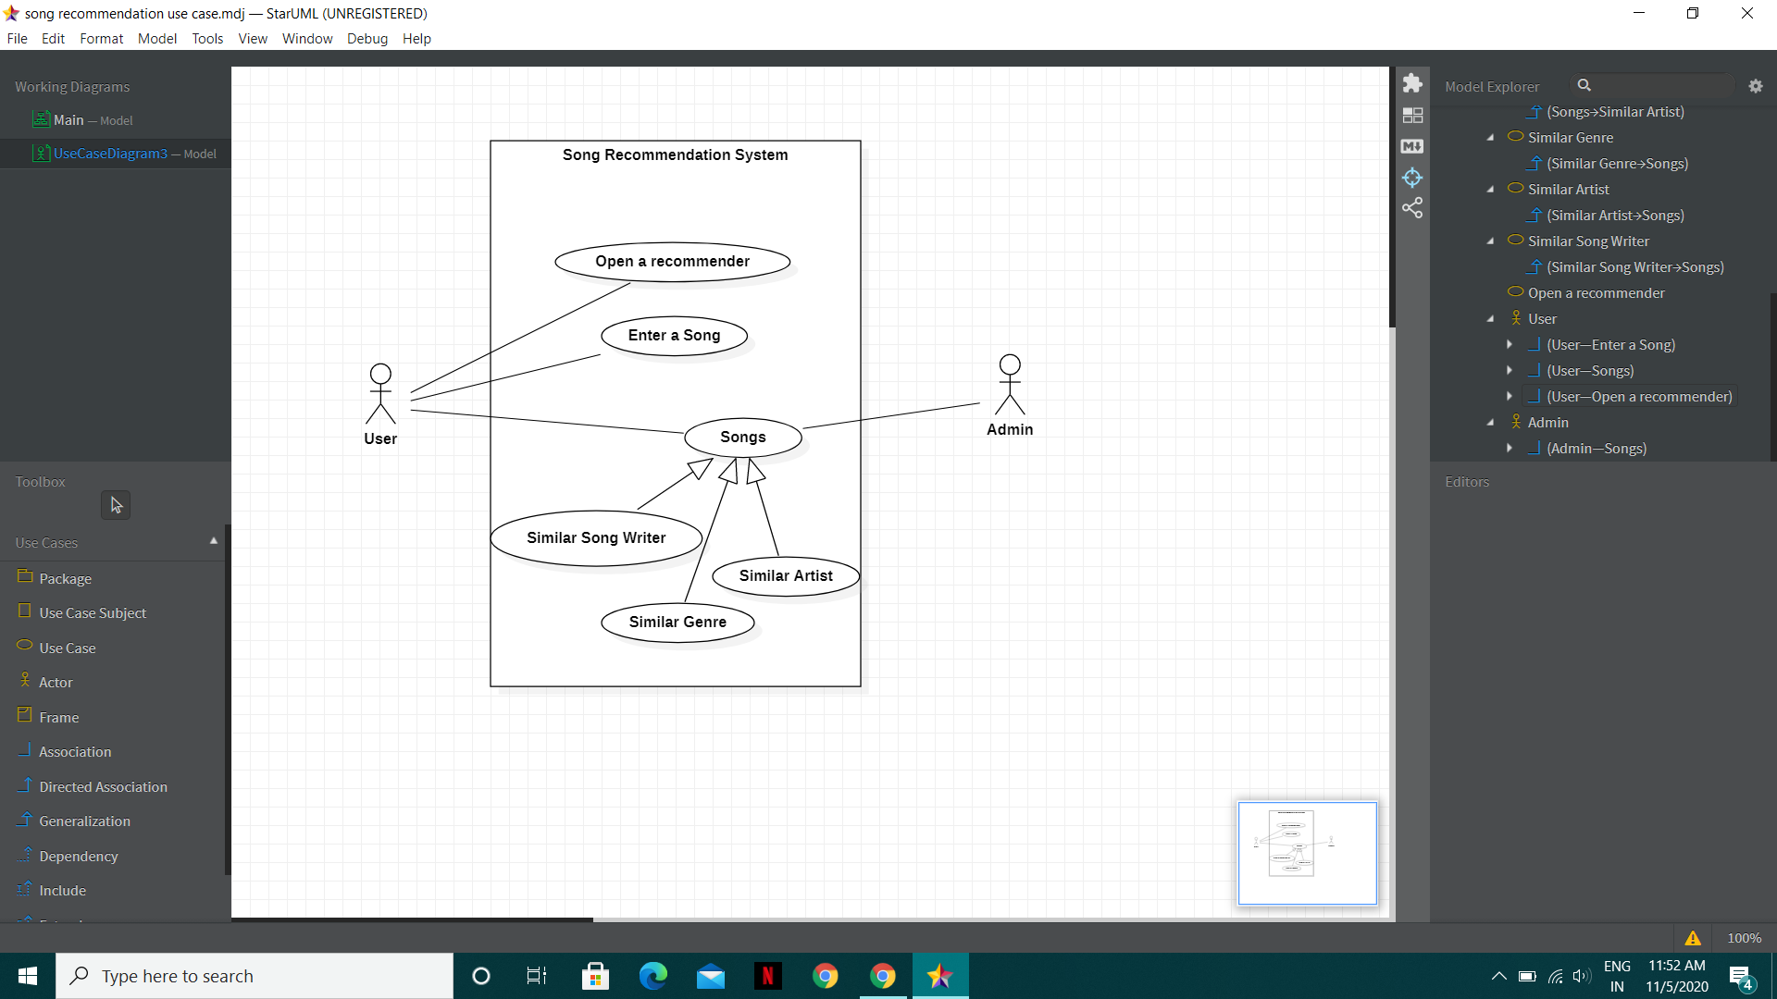

**Fig. 1 Use Case Diagram**

**Data Flow Diagram**

Fig. 2 shows the data flow diagram. Based on end user necessities as well as the thorough investigation on current system we have suggested a system that satisfies user requirements.

# C:\Users\hp\Pictures\Screenshots\Screenshot (12).png

# Fig.2 Data flow diagram

# Conclusion

Music recommender system is a system which learns from the user’s past listening history and recommends them songs which they would probably like to hear in future. We have implemented various algorithms to try to build an effective recommender system. Our work has given us a keen insight into recommendation systems for music. Our results have shown how we can use song metadata as well as data from users histories to provide the best set of songs to recommend. Furthermore, we observed the low precision results from both our own work and those from related work, which forced us to think about ways to improve overall precision. Ultimately, we devised a novel method to provide a recommendation system aimed to maximize precision of our song recommendations.

# 

# REFERENCES

[1] McFee, B., BertinMahieux,T., Ellis, D. P., Lanckriet, G. R. (2012, April). The million song dataset challenge. In Proceedings of the 21st international conference companion on World Wide Web (pp. 909916).ACM.

[2] Aiolli, F. (2012). A preliminary study on a recommender system for the million songs dataset challenge. PREFERENCE LEARNING: PROBLEMS AND APPLICATIONS IN AI

[3] Koren, Yehuda. ”Recommender system utilizing collaborative filtering combining explicit and implicit feedback with both neighborhood and latent factor models.”

## 

## Report verified by

**Project Guide HOD**

**(Department of Systemics)**

Dr. Susheela Dahiya Dr. Neelu J. Ahuja