SAI VIDYA INSTITUTE OF TECHNOLOGY
(Affiliated to Visvesvaraya Technological University, Belagavi | Recognized by Govt. of Karnataka | Approved by AICTE, New Delhi)
Rajanukunte, Bengaluru- 560 064

DEPARTMENT NAME
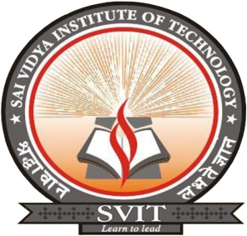

CERTIFICATE

Certified that the Internship / Professional Practice work (15CS84) entitled “Software development using python ” is carried out at “K-AKA Technology, Bengaluru” by YOUR NAME (YOUR USN ), a bonafide student of SAI VIDYA INSTITUTE OF TECHNOLOGY, Bengaluru, in partial fulfillment for the award of Bachelor of Engineering in BRANCH NAME of VISVESVARAYA TECHNOLOGICAL UNIVERSITY, Belagavi during the year 2020-21. It is certified that all corrections/suggestions indicated for internal assessment have been incorporated in the report deposited in the departmental library. The Internship / Professional Practice report has been approved as it satisfies the academic requirements in respect of Internship / Professional Practice work prescribed for the said degree.

HOD NAME  HOD  Dept. of NAME, SVIT |  | Dr. H S Ramesh Babu  Principal

Internship / Professional Practice Marks Allotment
Report (25) | Seminar (25) | Total (50) | Signature of Guide

Examiners Name: Signature with Date

1. _____________________ ___________________

2. _____________________ ____________________

