Derivative option Greek analysis and prediction using volatility and time series data

# Option Greek analysis

1. Linear Regression without Greek parameters
2. Heston model
3. Linear Regression with Greek parameters
4. Random forest
5. Support Vector Regression
6. K-Nearest Neighbors
7. GARCH and ARCH Models

Common training: Trained on calculating Greek parameters using above black Scholes formula on 2022 BANKNIFTY data of CE

Training was done 2931 and tested on 731 which was split in 80:20 train test ration

Metrics used for measurement are MSE and Accuracy,

MSE is MSE = (1/n) * Σ(y_true - y_pred)^2

## 1. Linear regression

Mean Absolute Error: 276.91269972548025

Mean Squared Error: 299200.2375505358

Root Mean Squared Error: 546.9919903897459

R-squared: 0.21003128157209716

## 3. Linear Regression with Greek parameters

* Obtaining sigma value using black scholes method
  + Explain the formula
* Second obtaining gamma, theta, vega, and delta using
  + 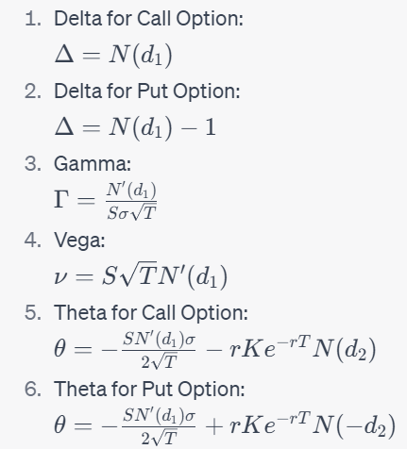

Where,

N(x) is s the cumulative distribution function of the standard normal distribution.

N'(x) is the probability density function of the standard normal distribution.

d_1 and d_2 are the variables used in the Black-Scholes model and are defined as follows:

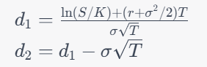

where:

S is the current stock price

K is the strike price of the option

r is the risk-free interest rate

sigma is the standard deviation of the stock's returns

T is the time to maturity of the option.

* Next will be training a linear regression model with Greek derivatives as input and option value as output
  + Training done Bank nifty data for call options of 2022 year
  + 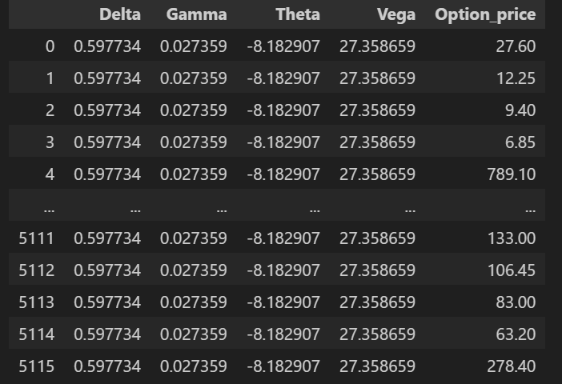
* Mean Absolute Error: 151.00825902124623
* Mean Squared Error: 269334.3344713395
* Root Mean Squared Error: 518.9743100302167
* R-squared: 0.42211642017180273Model accuracy is 53%

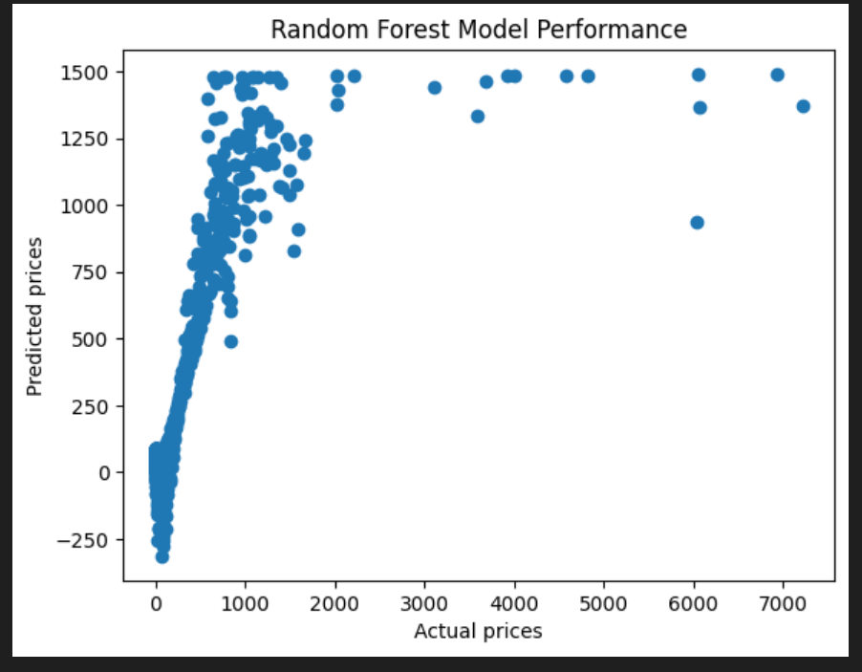

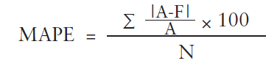

* Testing
* 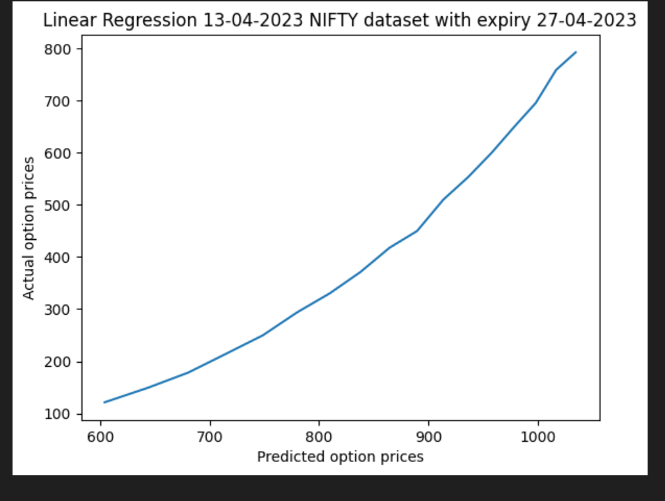

MAPE: 144% error

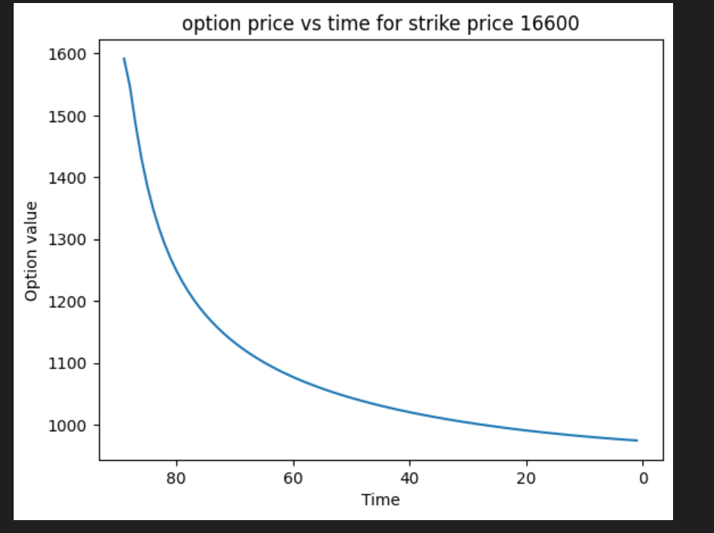

Inference the option price reduces with time

MAE is 416.126

## 4. Random forest

Trained on calculating Greek parameters using above black Scholes formula on 2022 BANKNIFTY data of CE

Training was done 2931 and tested on 731 which was split in 80:20 train test ration

Mean Absolute Error: 22.108270916427703

Mean Squared Error: 47542.48408455925

Root Mean Squared Error: 218.04239056788762

R-squared: 0.773250572298023

Model accuracy was 72%

Model evaluation graph

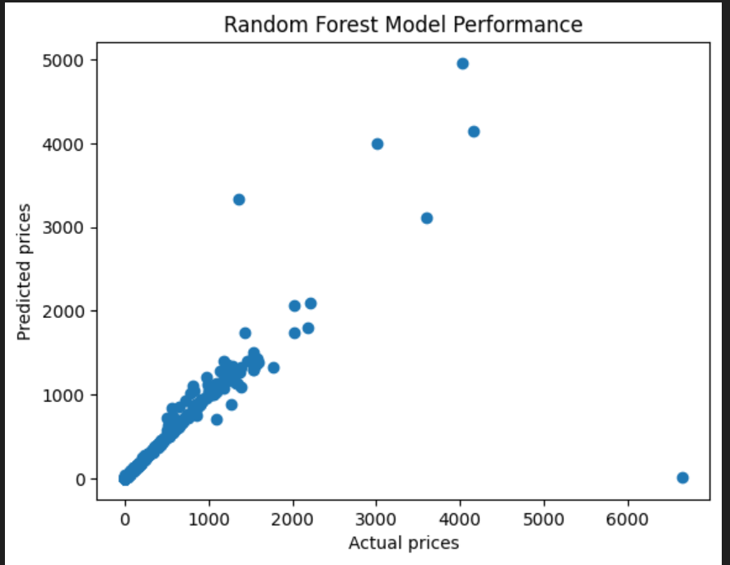

Output after testing on

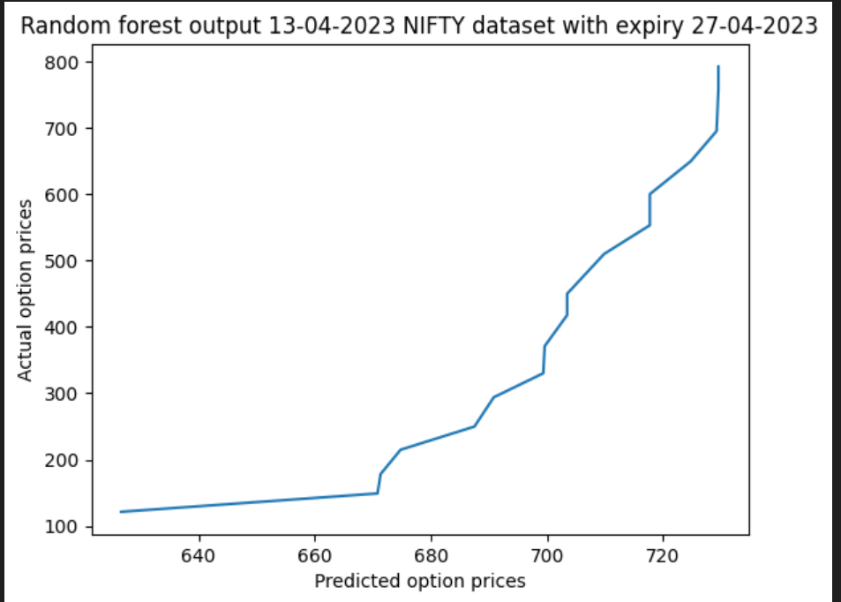

MAE is 278.53673529411725

## 5. Support Vector Regression

Kernel: Linear

Training:

Mean Absolute Error: 185.53400656806832

Mean Squared Error: 356997.49715131836

Root Mean Squared Error: 597.4926753955385

R-squared: 0.1197382619872861

Testing:

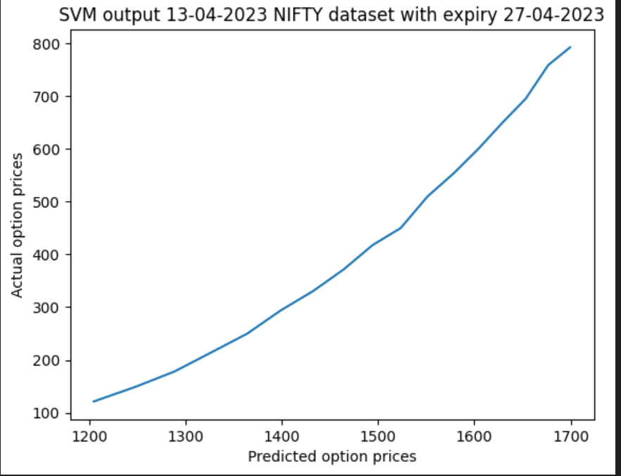

MSA: 1047.46

## 6. K-Nearest Neighbors

Training:

Mean Absolute Error: 119.4023888888889

Mean Squared Error: 163476.50881648148

Root Mean Squared Error: 404.322283353863

R-squared: 0.5969100149908002

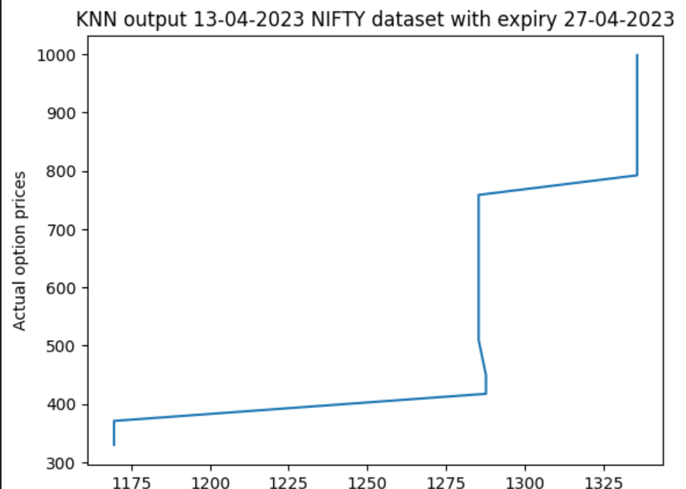

MAE: 600.1725

## 7.GARCH and ARCH Models