Derivative option Greek analysis and prediction using volatility and time series data

There are several Greek parameters used in derivative option Greek analysis, including:

Delta: Delta measures the sensitivity of the option price to changes in the underlying asset's price. It represents the change in the option's value for every $1 change in the underlying asset's price.

Gamma: Gamma measures the rate of change of delta concerning changes in the underlying asset's price. It represents the rate of change in delta for every $1 change in the underlying asset's price.

Theta: Theta measures the sensitivity of the option price to changes in time. It represents the change in the option's value for every day that passes.

Vega: Vega measures the sensitivity of the option price to changes in the implied volatility of the underlying asset. It represents the change in the option's value for every 1% change in the implied volatility of the underlying asset.

Rho: Rho measures the sensitivity of the option price to changes in interest rates. It represents the change in the option's value for every 1% change in interest rates.

Option price prediction using IV

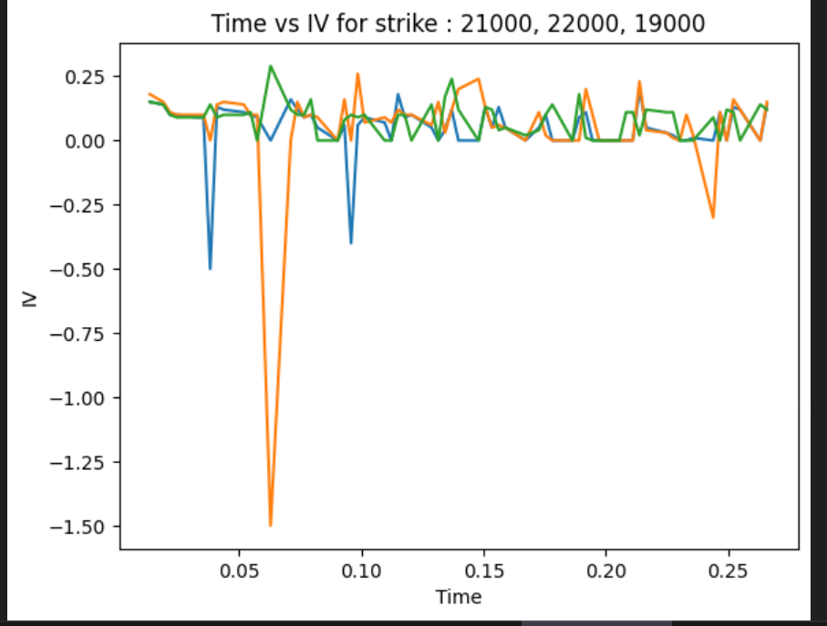

Time vs IV for strike 21000 (22-dec-22, 29-mar-2023), 22000(22-dec-22, 29-mar-2023), 19000(22-dec-22, 29-mar-2023)

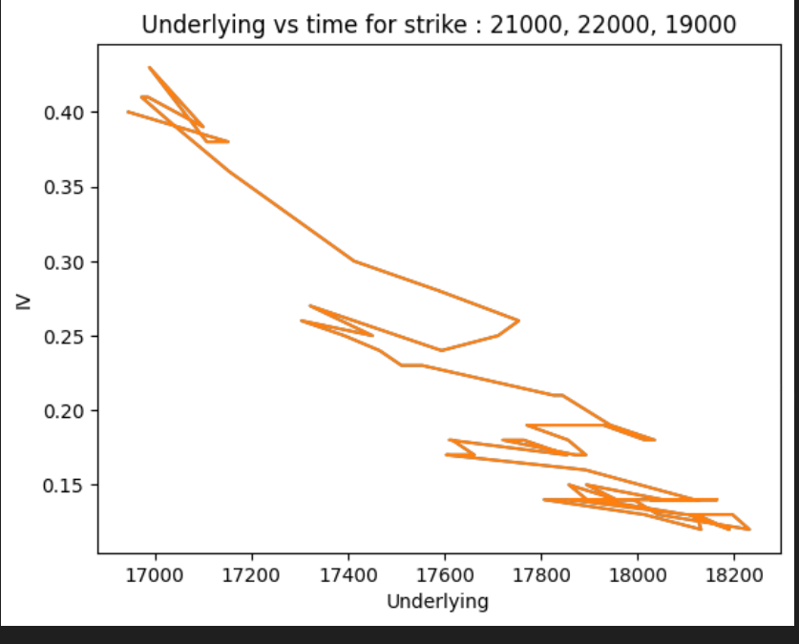

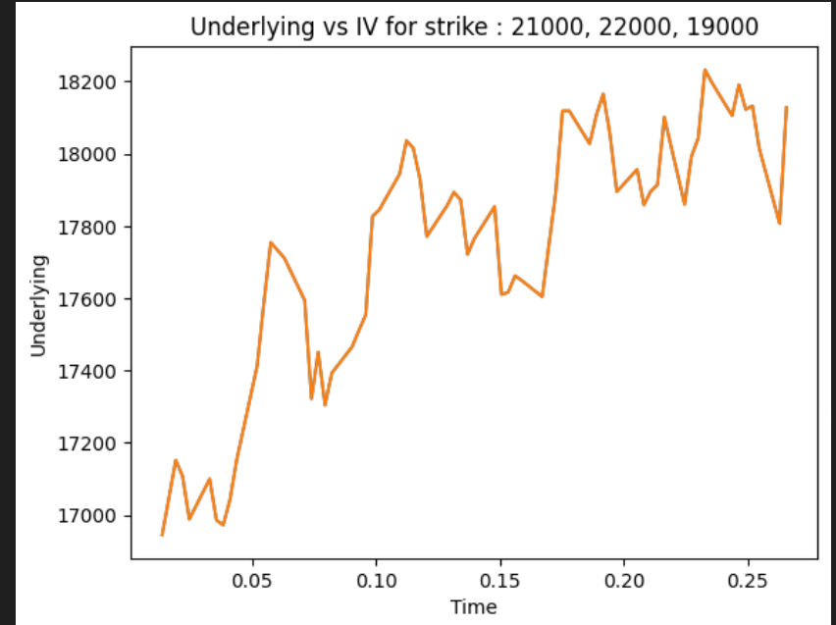

# 1] MLR with strike price, stock price as input and option value as output

Trained with NIFTY dataset from last year.

Tested for NIFTY 50: 25/03/2023 expiry : 25/03/2023 with underlying asset price : 16945.5

Inference: There is negative value appearing as option value after strike price became less than 18500

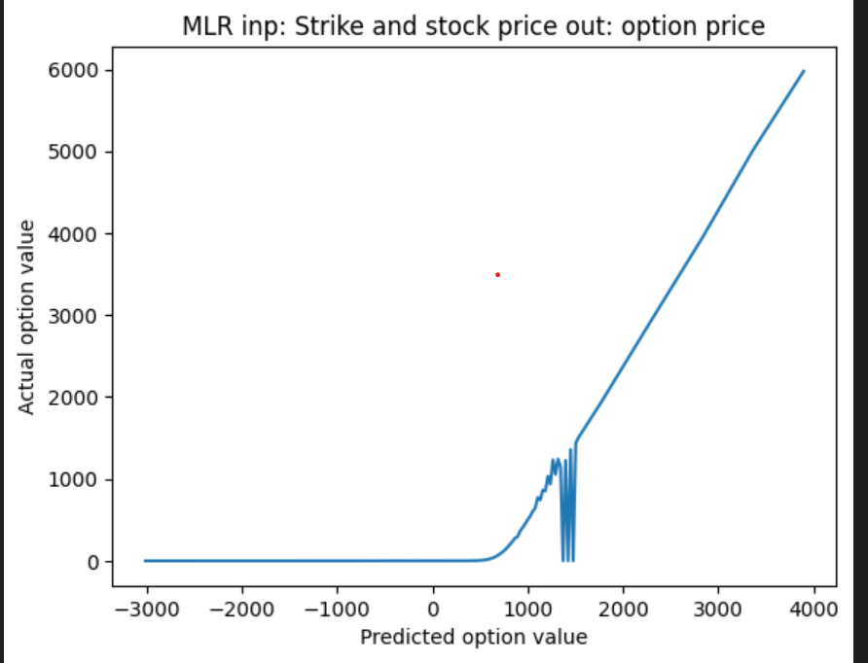

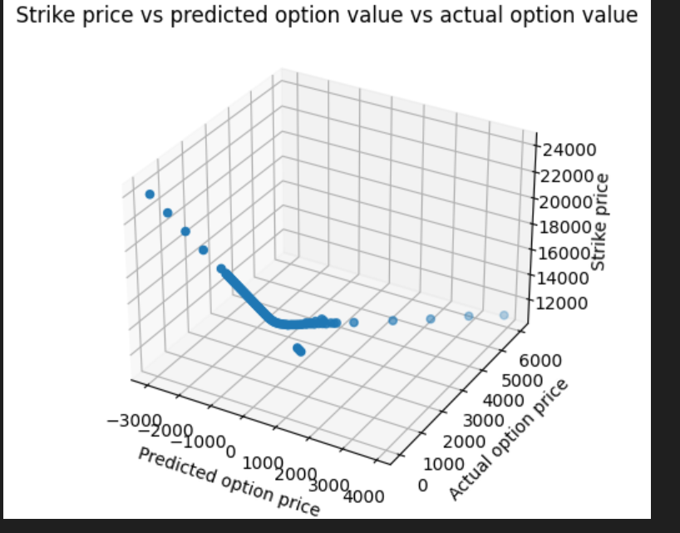

Failure of Black scholes stochastic approach

Among the most used derivatives are options. Their huge popularity can be attributed to the work of Black and Scholes (1973) who proposed a stochastic model for calculating their market value. After almost 50 years since publishing, the model is still extensively used by practitioners all over the world. Despite its success, the model fails to capture empirical phenomena like a leptokurtic distribution of returns (not a normal one) or the existence of a volatility smile that suggests that volatility is not constant as the model assumes.

2] Support vector regression

Git: https://github.com/fromslow/Pricing_Option_using_SVM/blob/main/Finance_Engineering_Pricing_Option_using_SVM.ipynb

As a financial engineering class assignment, I used SVM to price option data.

First, we artificially created option data and used SVM to price it.

Even with actual option data, I tried pricing using SVM. However, since volatility is unknown in actual option data, implied volatility was estimated using the newton raphson method and then SVM was used.

* **Hyperplane:**This is basically a separating line between two data classes in SVM. But in Support Vector Regression, this is the line that will be used to predict the continuous output

Note: IV in nse is internsic value and not implied volatality

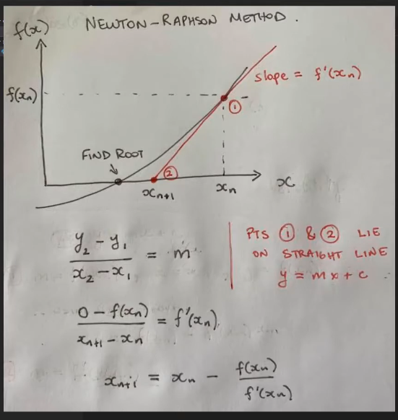

Use for doc

<https://www.codearmo.com/blog/implied-volatility-european-call-python>

3] LR – linear regression

First trained a model to predict IV using strike price, stock price, and option price from bank_50_option_365_CE from nse website which has nifty 50 option values of the year 2022

For the above data Strike vs IV is

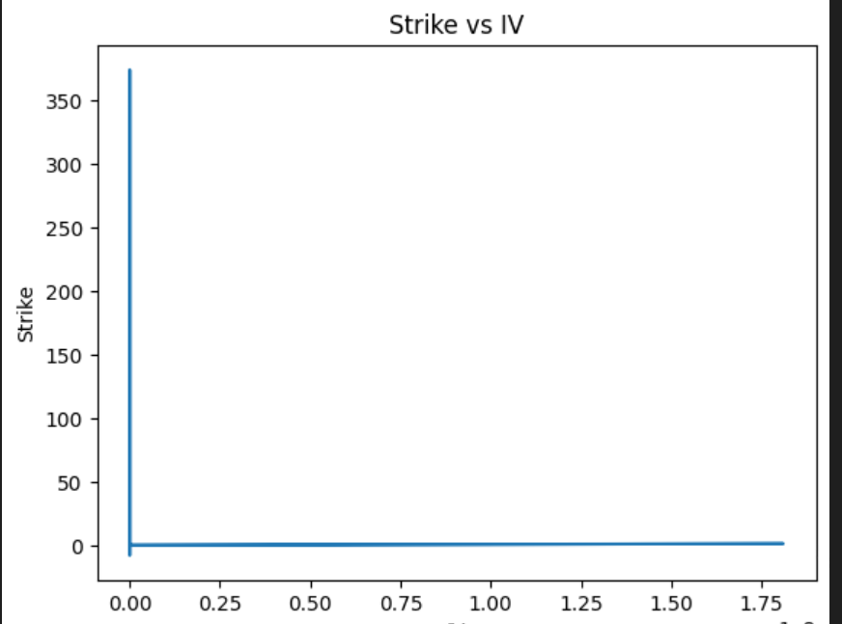

Then, predicted the IVs for the day 28-03-2023 nse nifty data

Second trained another model to predict option price using strike price, stock price and predicted IV

The graph obtained by comparing the actual option price and predicted option price is as follows

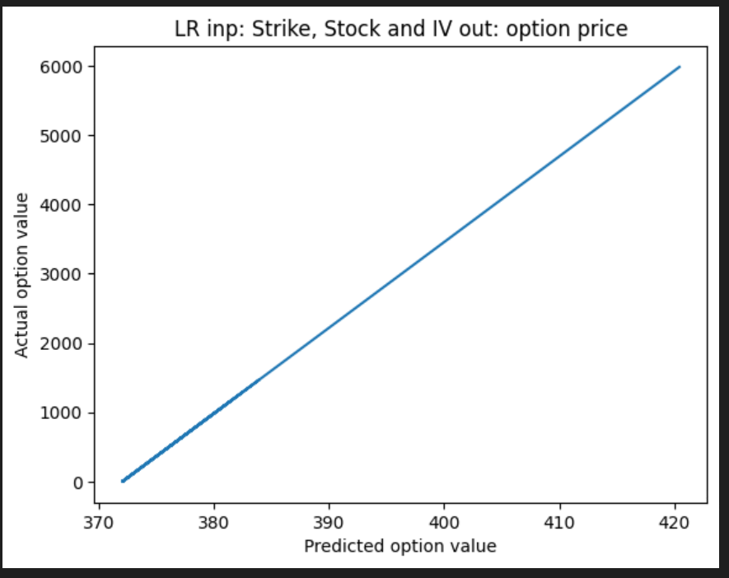

LR with strike, stock and time to predict IV

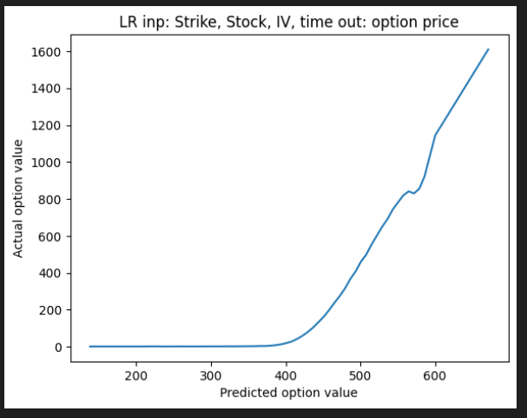

First trained a model to predict IV using strike price, stock price, and Time from bank_50_option_365_CE from nse website which has nifty 50 option values of the year 2022

Second trained a LR model with the help of predicted iv from above, with strike, stock and time

And tested on 29-03-2023 nfity data

Mean Absolute error is

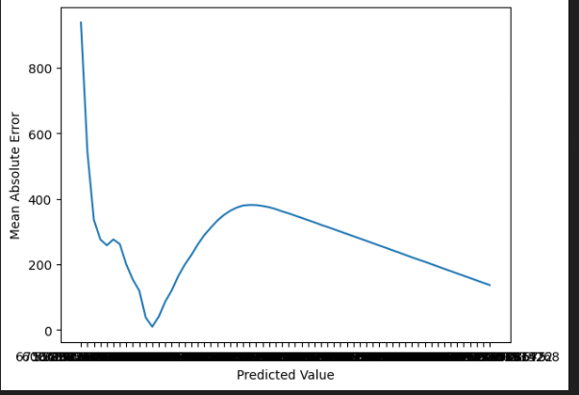

IV vs time for strike price of 16600

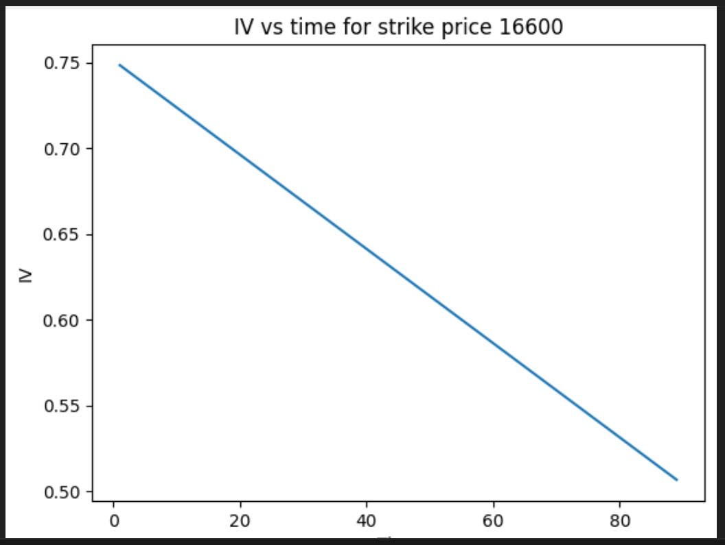

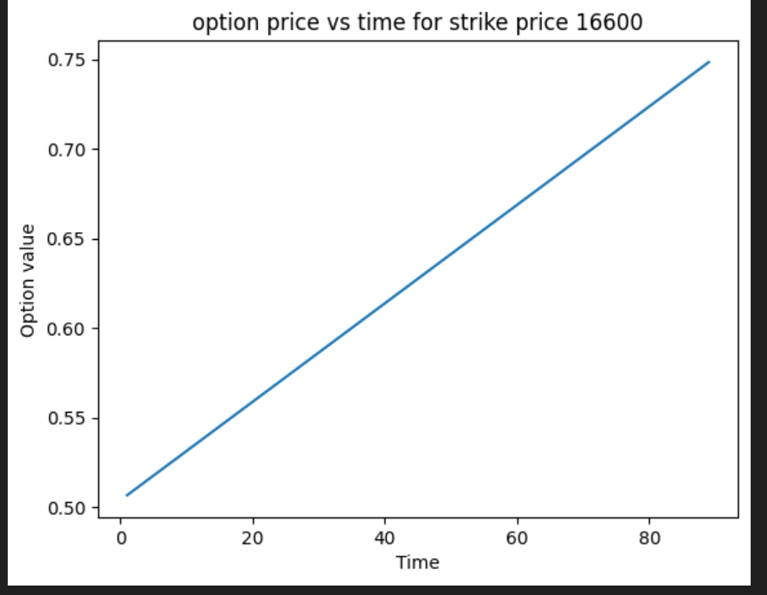

Option value for strike price 16660,

It reduces when time reaches zero

5] Binomial tree model

5] Neural network for regression

6] GARCH

7] Heston model

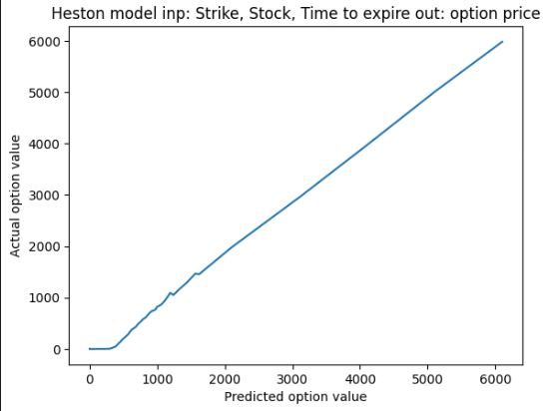

Tested on 30-03-2023 NIFTY dataset

With:

In: Strike price, stock price and Time to expiry

Out: option value

Explain from the Heston.ipynb