Auravance
Business problem and how the system works
Written from the running code in auravance-backend and auravance-frontend. Date: 22 October 2026.

1. Why this document exists
This is an onboarding brief. Section 2 is the plant problem Auravance is built to solve. Section 3 onwards is how the software actually works today, including what is still a production target. It is not a resume substitute and it does not claim a product-wide 30% detection-accuracy improvement.

2. The business problem
A process plant keeps value flowing through rotating and fluid equipment: pumps, air compressors, motors, drives, conveyors, cooling loops. When one of those assets fails without warning, the line stops. Production is lost, overtime and rush parts are expensive, and in some cases a bearing or seal failure is also a safety event. The economic question is not “can we buy a sensor?” — most plants already have temperature, vibration, pressure, and current readings. The question is whether anyone can turn those readings into a decision before the machine is already down.

2.1 Unplanned downtime is the expensive failure mode
Run-to-failure is simple until it is not. A compressor air leak, a pump seal, or a motor bearing can look healthy on a shift checklist and then degrade in hours or days. The plant pays three times: lost throughput while the line is idle, premium repair cost because the job was not scheduled, and secondary damage because the first fault was allowed to run. Reliability teams already know this. What they lack is a consistent, asset-level signal that something has changed now, that failure is likely in the next shift or two, and roughly how many operating hours remain.

2.2 Calendar maintenance wastes work or still misses the failure
The usual alternative is time-based preventive maintenance: rebuild the pump every N hours, grease the motor on a Friday, swap filters on a calendar. That policy over-services healthy machines (parts and labour spent too early) and still misses sudden faults such as a compressor leak that does not follow the calendar. Condition-based and predictive maintenance exist as ideas in most reliability programs. They fail in practice when the data is siloed in a historian, the model is a spreadsheet only one engineer trusts, or the “alert” is a raw threshold that cries wolf until operators ignore it.

2.3 Sensor data without a decision layer
Four channels are enough to see many industrial faults if they are watched together: temperature, vibration, pressure, and current. Individually they are noisy. A current spike may be a load change. A temperature rise may be ambient. Vibration may be a passing truck. The business need is a layer that:
- Ingests live readings from many assets without a custom dashboard per machine.
- Flags abnormal behaviour against that asset’s own recent history and type (pump vs compressor vs motor).
- Separates “this looks odd” (anomaly) from “this looks like a failure forming” (probability and remaining useful life).
- Does not go silent if a model file fails to load — operators still need a conservative reading.

2.4 Root cause is slow, tribal, and hard to audit
When a high-risk label appears, the next cost is diagnosis time. The answer often lives in a vendor PDF, a site SOP, or a senior technician’s memory. Junior staff search folders; senior staff get pulled off the floor. Wrong first action — opening the wrong housing, changing oil instead of finding a leak — extends the outage. The business need is explainable diagnostics: likely causes and recommended actions that cite the manuals, tied to the same asset and sensor that just scored high-risk, with a fallback when the language model is unavailable.

2.5 Work still has to happen in the CMMS sense of the word
A prediction that nobody can turn into a work order, a schedule, a defect record, or a vendor/equipment master is a science project. Plants already live in master data (plants, equipment, sensors, vendors) and execution records (schedules, work orders, defects). Auravance therefore includes those surfaces so a reliability engineer can move from “compressor-17 is high-risk, pressure is the dominant signal” to a tracked job. Auto-opening work orders from alerts is a later production step; the demo keeps prediction and execution adjacent but not auto-wired.

2.6 Who feels the pain
Role | What hurts today | What they need from Auravance
Reliability / process engineer | Cannot see plant health in one console; models live in notebooks | Live scores per asset, history charts, honest model status
Maintenance technician | Alarm floods; RCA depends on who is on shift | Dominant signal, grounded causes and actions, not a black-box score
Planner / supervisor | Emergency work wrecks the weekly schedule | 72-hour failure probability and remaining useful life to pull work forward
Plant / IT admin | Another silo, unclear who may ingest vs who may view | User roles, ingest key separate from dashboard login, deployable demo

3. What Auravance is
Auravance is a full-stack predictive maintenance platform for industrial equipment. The React console is the operator surface. The FastAPI service is the ingest, scoring, storage, and diagnostics engine. Together they give a plant a single place to watch assets, score incoming telemetry, raise alerts, and ask for root-cause guidance over equipment manuals.
The intended product capability — the north star used as a build goal, not as a description of every line of code — is:
- Built a full-stack AI platform (React, FastAPI) for real-time equipment monitoring and failure prediction using XGBoost and LSTM, improving detection accuracy by 30%.
- Engineered scalable event-driven IoT ingestion pipelines using MQTT and Python for high-frequency sensor telemetry with low latency and high reliability.
- Designed scalable ETL and event-driven MQTT pipelines processing 1M+ sensor records/day, enabling predictive maintenance, anomaly detection, and RUL insights with sub-minute latency.
- Built a RAG-based root cause analysis system over equipment manuals to generate explainable diagnostics and maintenance recommendations.
Locally, the first three bullets are partially met: React + FastAPI monitoring is live; XGBoost and LSTM serve when artifacts load; MQTT exists as a local producer into the same ingest service; RAG over manuals is live with an OpenAI or playbook fallback. Timescale-scale ETL, an external plant MQTT cluster, and a product-wide 30% accuracy claim are not shipped. Section 8 states the line clearly.

4. How a user moves through the product
A reliability engineer signs in to the React console. The app loads plants, equipment, and assets, then polls the selected machine: last 24 telemetry points, latest prediction, and open alerts. Monitoring shows the four public channels, an anomaly label, 72-hour failure probability, estimated remaining useful life, and the dominant signal. If replay is feeding the plant, the original dataset’s ground truth (NORMAL, BROKEN, AIR_LEAK, FAILED, and similar) sits next to the model so the demo is honest.
Root Cause Analysis is a deliberate action, not something that runs on every incoming reading. The technician submits the asset plus a symptom summary. The backend attaches the latest score, retrieves manual chunks, and returns likely causes and recommended actions. Master data and execution modules are CRUD against the same database: plants, vendors, equipment, schedules, work orders, defects. Admins manage users. The dashboard never posts ingest; live data comes from the simulator, the replay script, or MQTT.
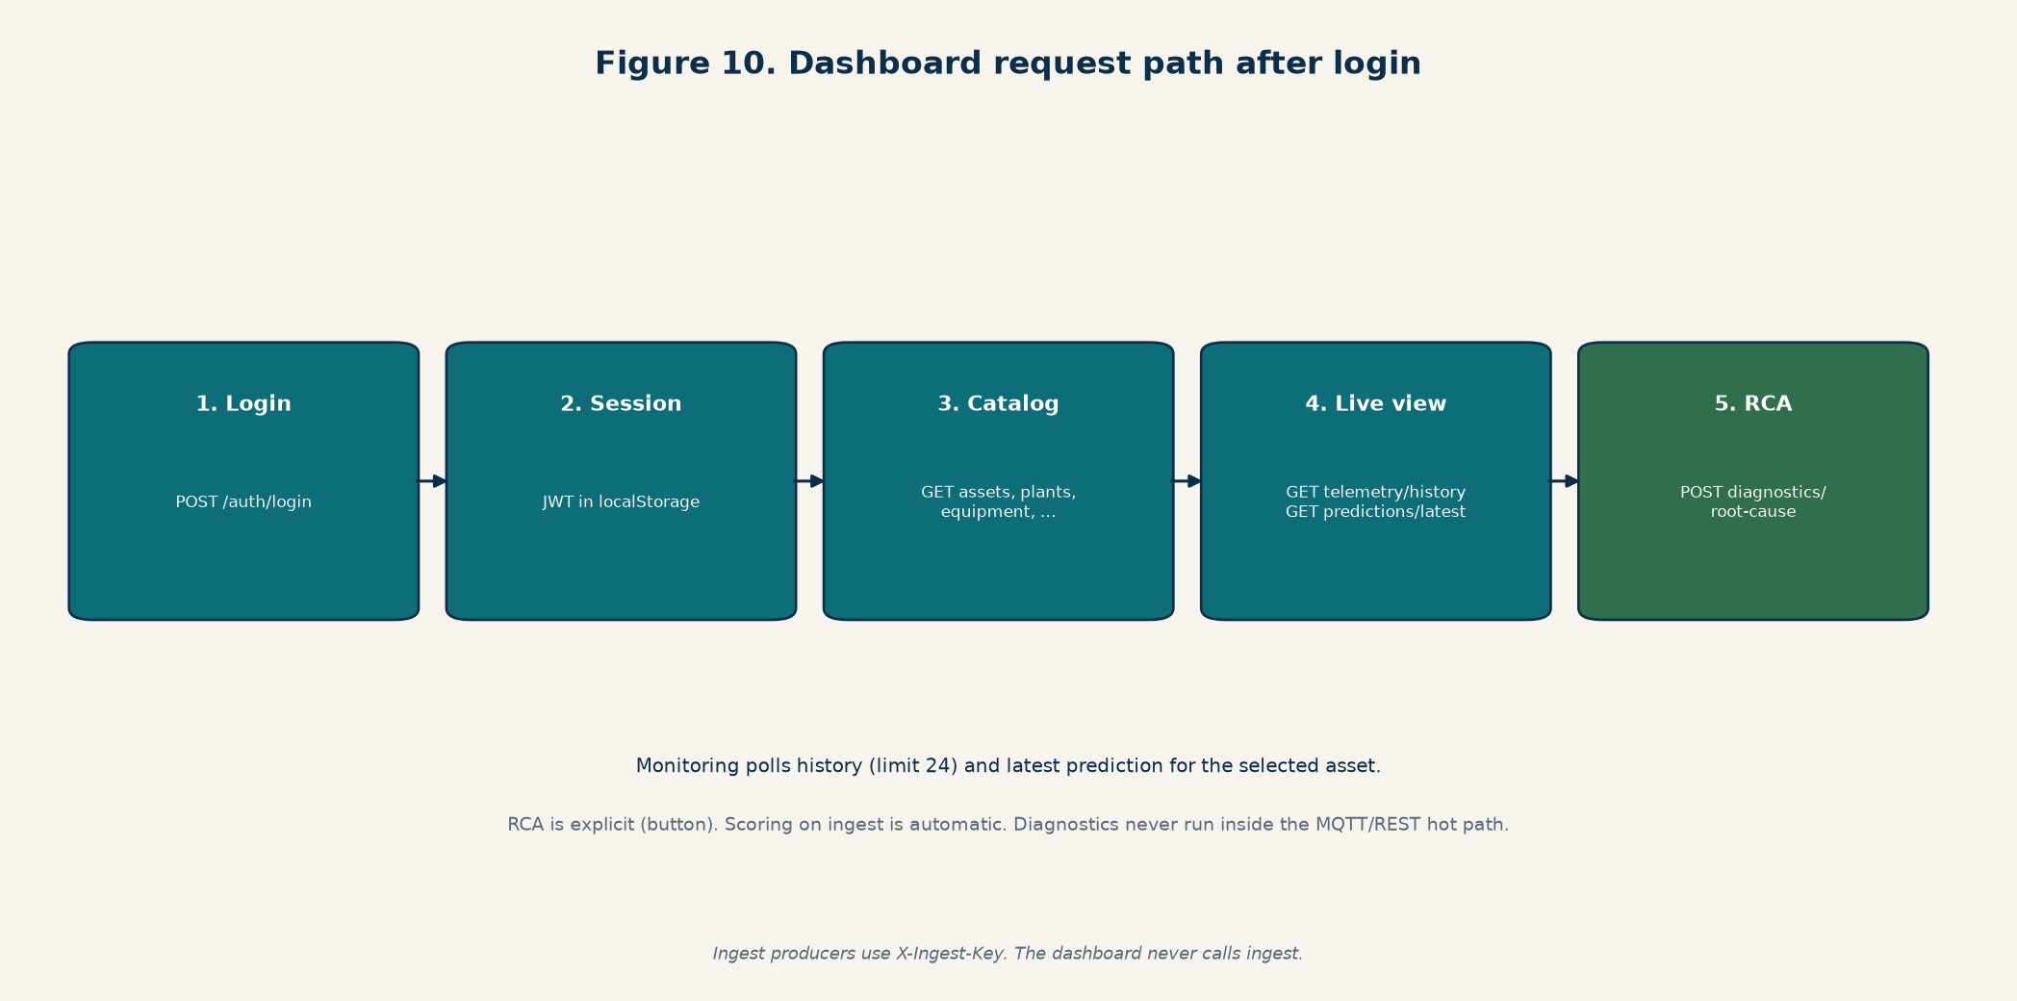
Figure 1. After login the console loads catalogs, then polls live scores. RCA is an explicit POST.
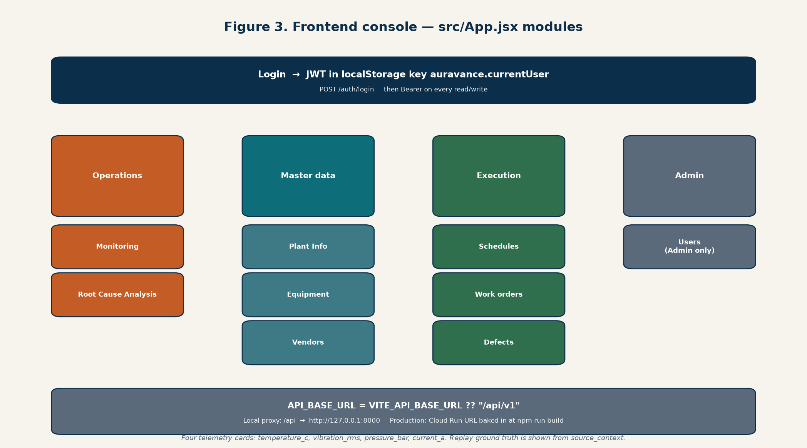
Figure 2. Console modules: Operations, Master Data, Execution, Admin.

5. How the system works technically

5.1 Two repositories, one HTTP contract
auravance-frontend is a React 18 + Vite single-page app (localhost:5173 in development, with a proxy from /api to the API). auravance-backend is FastAPI on /api/v1 (localhost:8000). The frontend never embeds models. The backend never serves React sources. Production bakes VITE_API_BASE_URL at npm run build so the SPA calls Cloud Run directly.
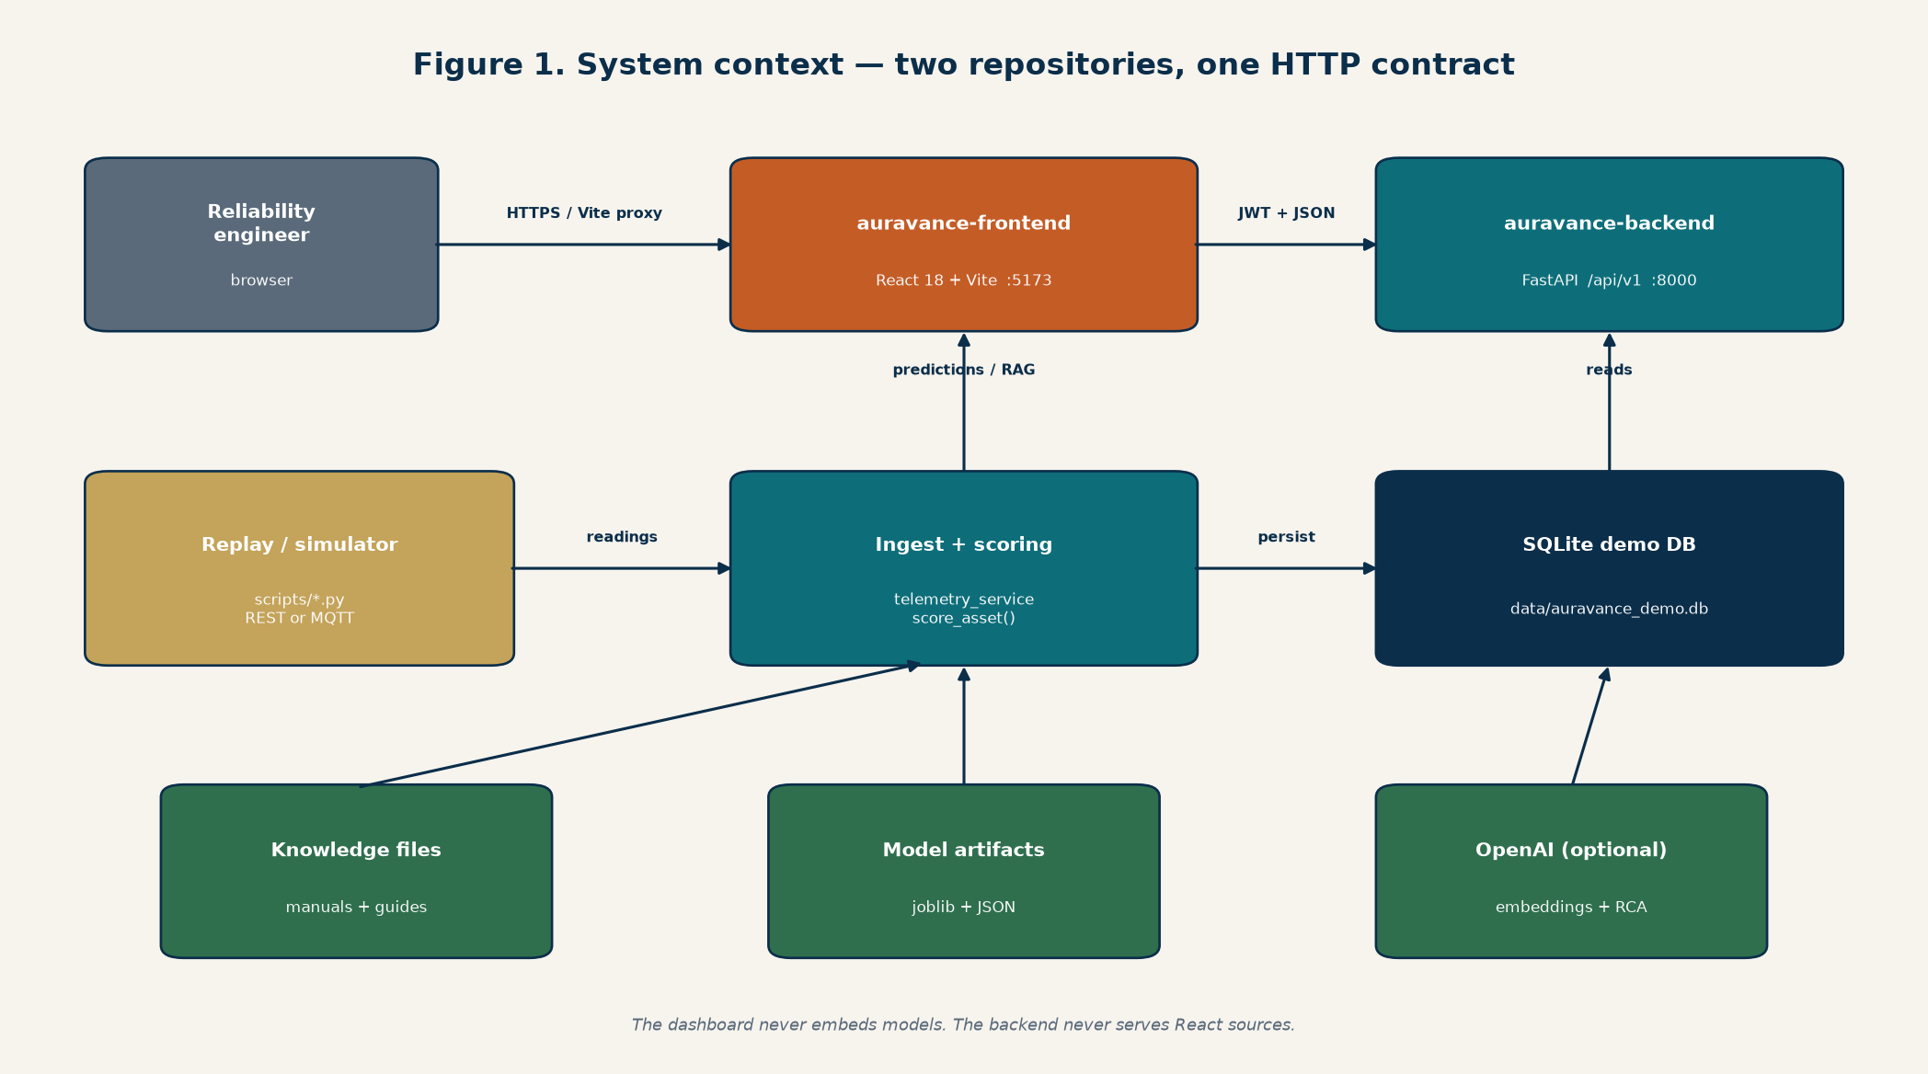
Figure 3. Operators, replay scripts, FastAPI, SQLite, artifacts, and optional OpenAI.

5.2 End-to-end data path
On a laptop the story is: a producer emits readings → FastAPI validates the asset and the four-channel payload → SQLite stores the row → scoring runs on the last eight points and may open an alert → the dashboard later asks for history (24 points) and a prediction on the last twelve points. RAG runs only when someone requests it.
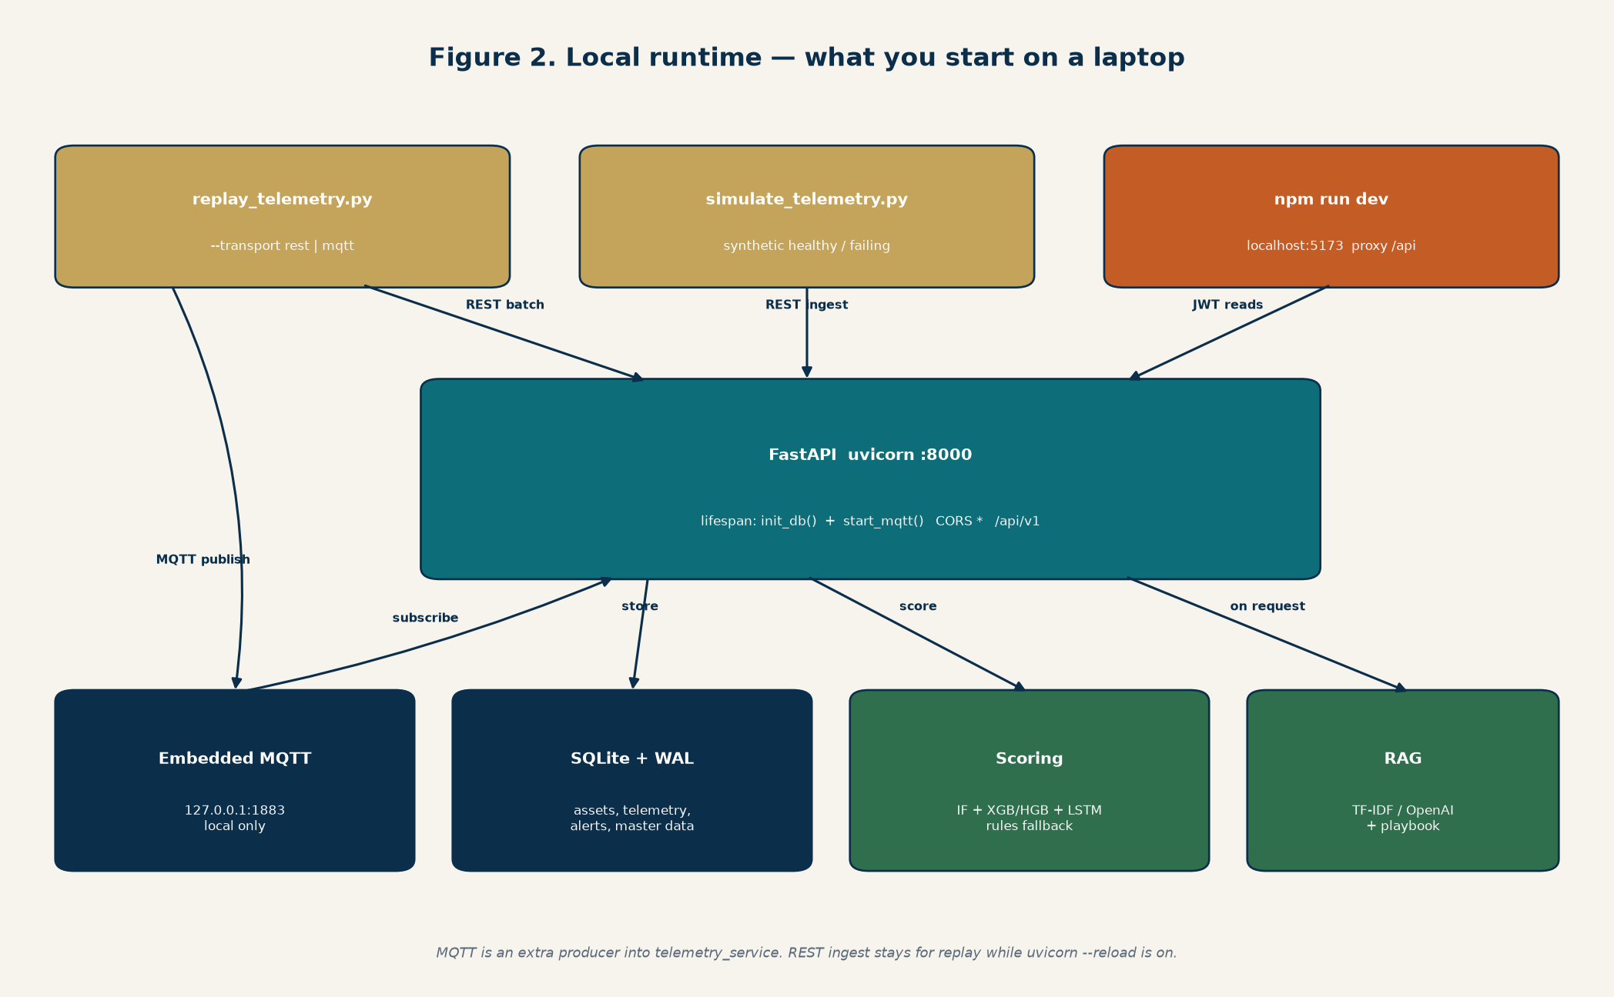
Figure 4. Local processes: uvicorn :8000, Vite :5173, SQLite, optional MQTT on 1883.

5.3 Ingestion
Every producer must finish in telemetry_service. That is the rule that keeps REST and MQTT honest: decode, map to the public payload, persist, score, maybe alert. Nothing bypasses scoring to write a “prediction” of its own.
{ "timestamp": "...Z", "asset_id": "compressor-17", "metrics": { "temperature_c": 84.2, "vibration_rms": 0.63, "pressure_bar": 5.2, "current_a": 11.7 }, "source": "api", "source_context": {} }
- REST: POST /api/v1/telemetry/ingest and /ingest/batch (1–500 readings). Unknown asset IDs fail the whole batch (404).
- MQTT (local): topic plants/{plant_id}/lines/{line_id}/assets/{asset_id}/telemetry. Default is an embedded MQTT 3.1.1 broker (QoS 0) plus a paho-mqtt subscriber. This is a stand-in, not a plant broker cluster.
- Replay: scripts/replay_telemetry.py streams committed public-dataset clips as if the machines were live. source_context carries original timestamp, raw values, ground truth, units, and dataset id.
- Simulator: scripts/simulate_telemetry.py posts synthetic healthy/failing readings.
- Alert cooldown: AURAVANCE_ALERT_COOLDOWN_SECONDS (default 300) unless severity rises.
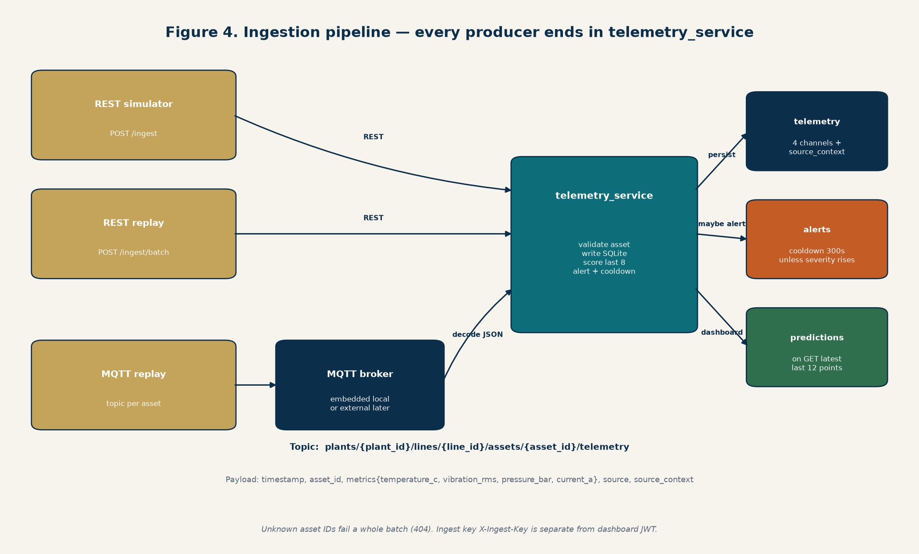
Figure 5. REST and MQTT are producers. Persistence, scoring, and cooldown live in telemetry_service.

5.4 The four channels and three equipment profiles
The public wire format is fixed at four metrics so the dashboard, SQLite columns, and all three model profiles stay in lockstep. Expanding a fifth channel is a cross-repo change, not a local tweak.
Asset types | Profile | Training / replay source | Failure character
pump, cooling-system | pump | Kaggle pump-sensor (1 min) | Mixed; 72-hour forecast is weak
compressor | compressor | MetroPT-3 air compressor (5 min) | Sudden air leaks; leak-in-progress is learnable
motor, drive, conveyor | motor | NASA/IMS bearing run-to-failure (10 min RMS) | Gradual bearing degradation

5.5 Storage
The demo store is SQLite at data/auravance_demo.db (WAL mode so the API thread and MQTT subscriber can share it). init_db() creates tables and seeds demo plants, assets, users, vendors, equipment, schedules, work orders, and defects. Schema changes belong in app/core/db.py together with seed data. This is not TimescaleDB and not pgvector. Cloud Run has no volume in the current Terraform, so the file inside a container is ephemeral after a new revision.
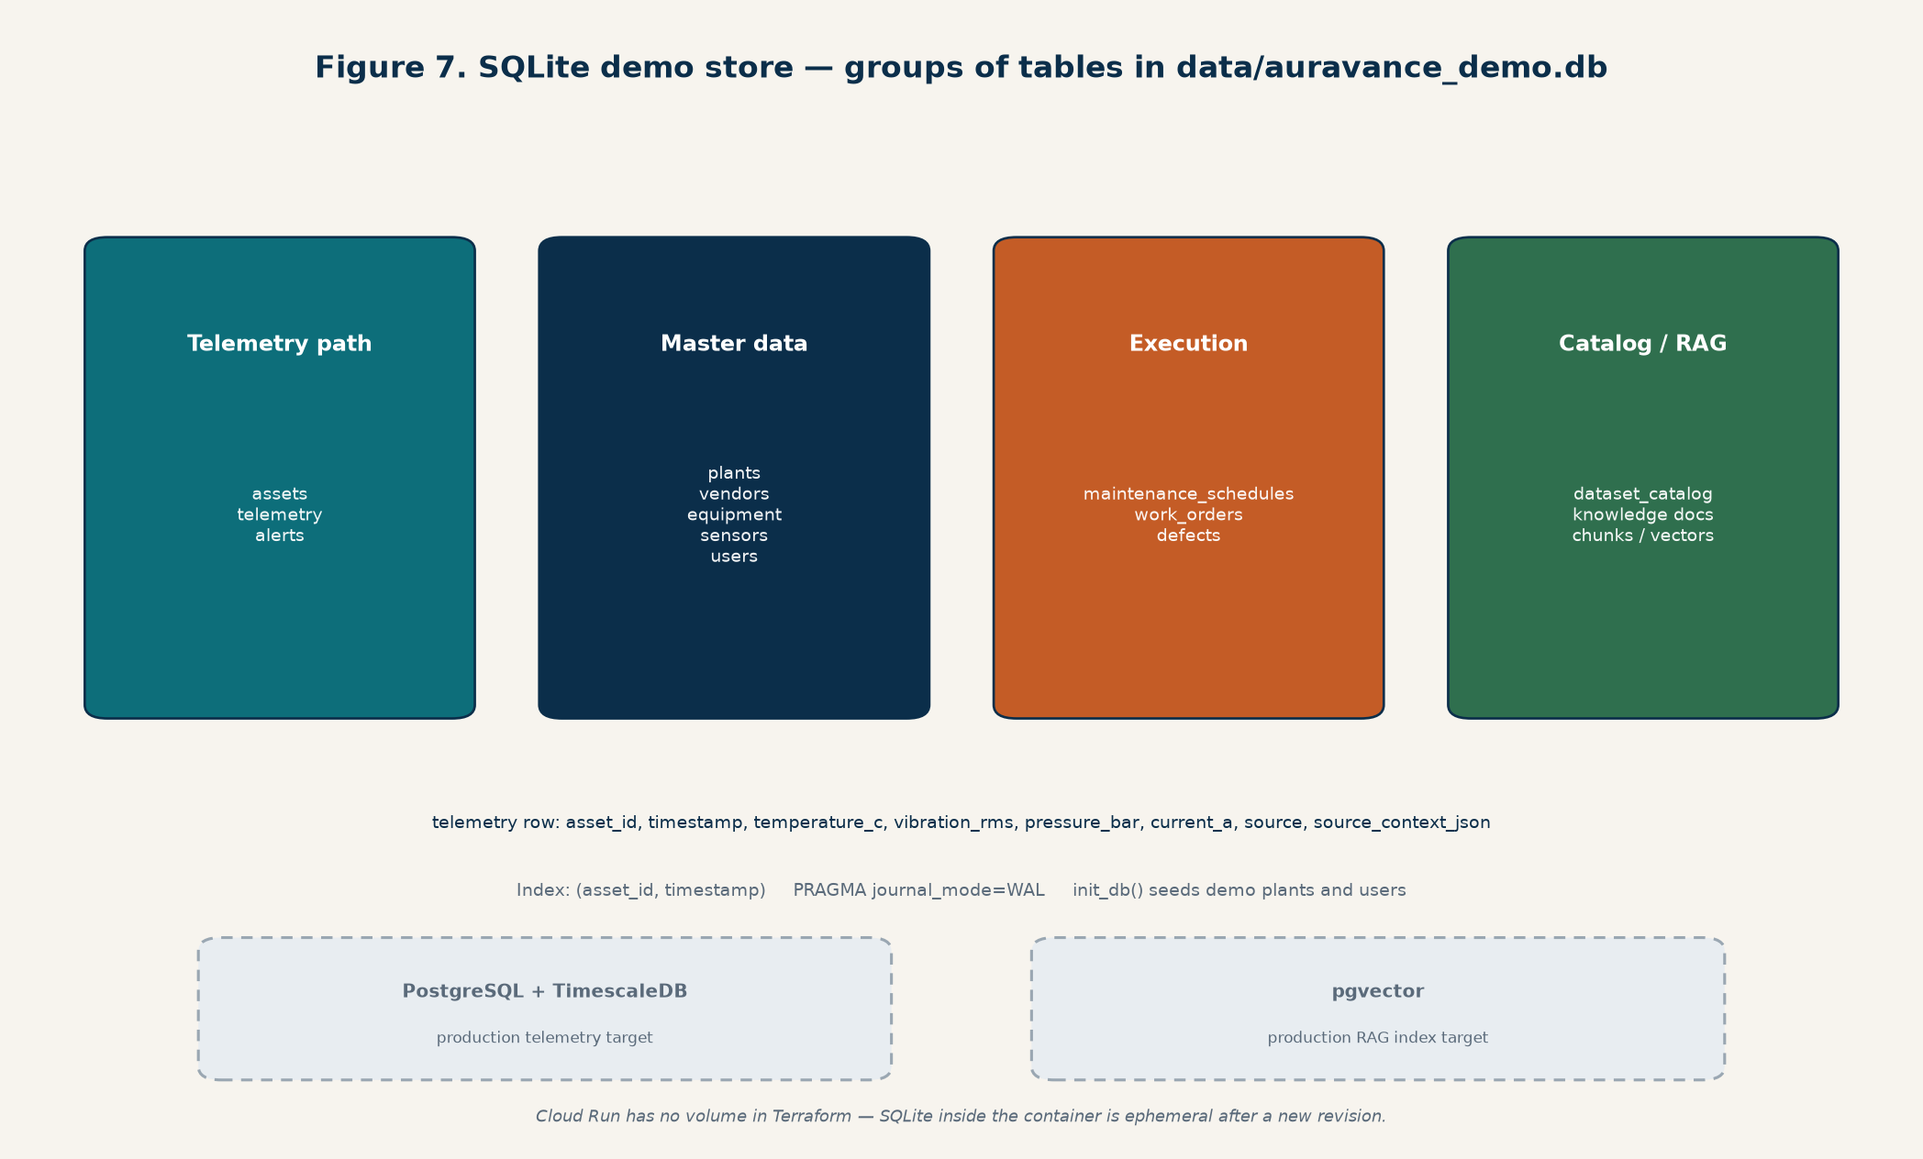
Figure 6. Implemented SQLite groups. Dashed boxes are the production storage target.

5.6 Scoring: anomaly, failure, remaining useful life
Three questions stay separate on purpose. Mixing them is how demo platforms lie.
- Anomaly — “does this look unlike healthy operation?” Isolation Forest on healthy data, else a rules mix of normalized channels and trend.
- Failure — “is this failing now, or likely within 72 hours?” LSTM sequence (window 12) if history and artifact are present; else XGBoost tabular; else HistGradientBoosting; else rules.
- RUL — “about how many hours until the next failure?” XGBoost if present, else HistGradientBoosting, else a value derived from failure probability (capped). Do not reuse a classification score as RUL except the documented compressor sudden-failure wrappers.
score_asset() in app/services/scoring.py picks the profile from asset type, loads artifacts (joblib dict, artifact_schema_version: 1), and always has a rules fallback so a missing or unloadable model does not take the API down. fallback_active is visible on GET /predictions/models/status. Replay honesty: if source_context.dataset matches a training fold and the timestamp is in a held-out window, the API serves the stored +heldout-N estimator instead of the full-fit model that already saw that failure.
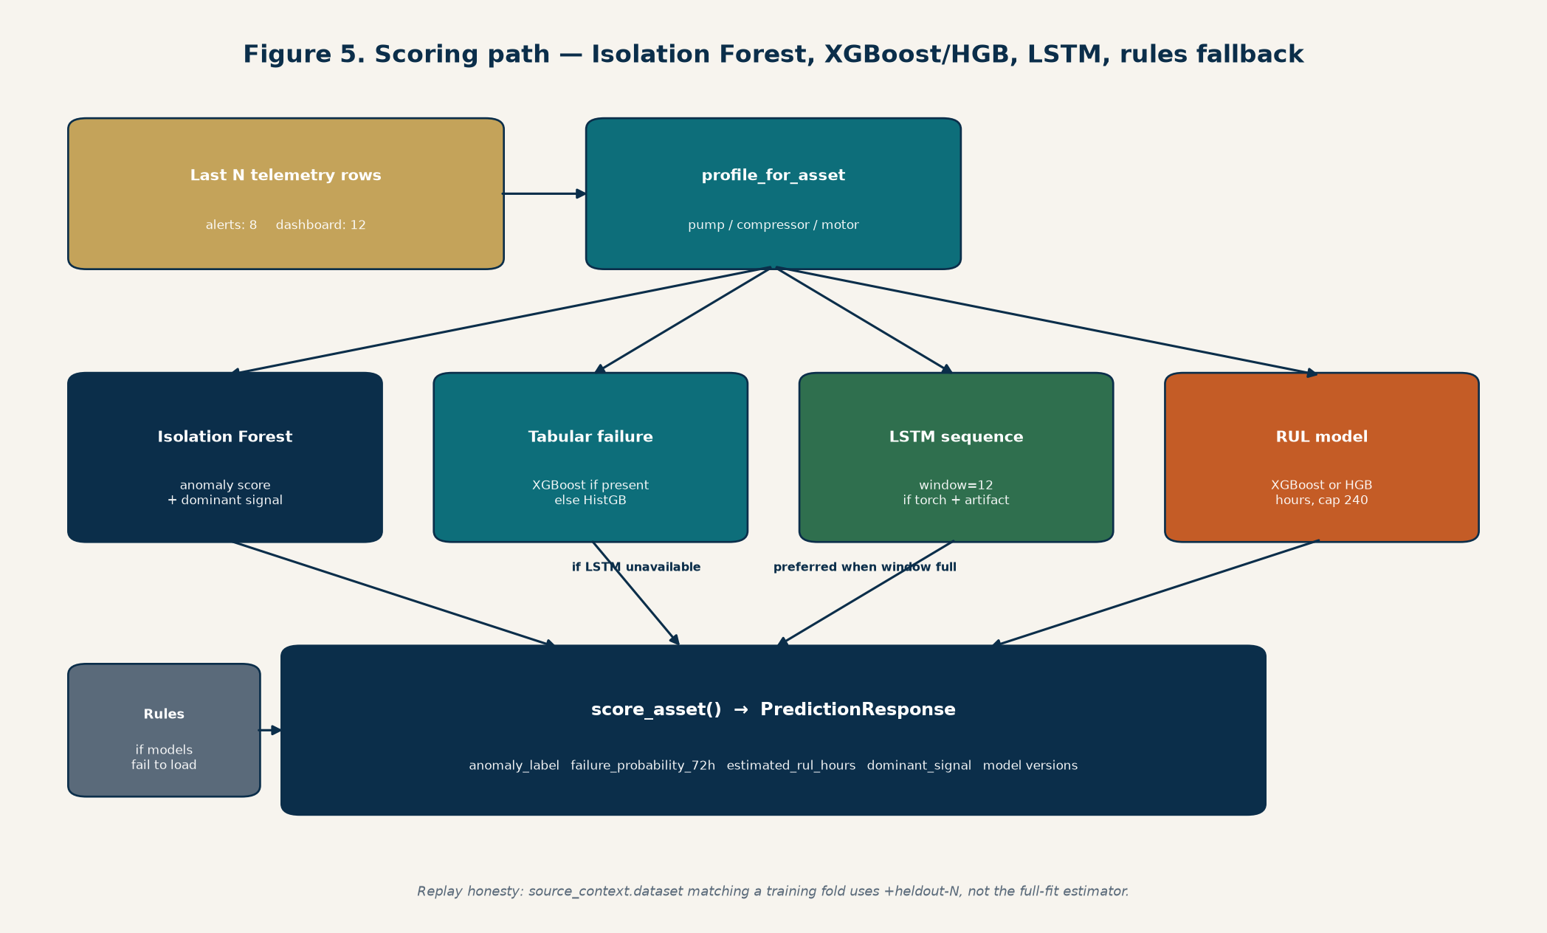
Figure 7. Isolation Forest, LSTM then XGBoost/HGB, RUL model, rules if artifacts fail to load.
Measured detection delta versus the rules scorer on replay clips lives in artifacts/models/detection_delta.json. Pump tabular ROC-AUC is high against a weak anonymized-channel rules baseline; compressor is about +20% versus a stronger rules baseline; motor snapshots after downsampling are too sparse for a 30% claim (and tabular AUC there is not a win). Do not quote a product-wide 30% improvement.

5.7 RAG diagnostics
POST /diagnostics/root-cause takes asset_id, a symptom summary, and optional alert ids. The service loads the latest prediction, maps dominant_signal onto a local issue playbook, retrieves about five knowledge chunks (OpenAI embeddings when OPENAI_API_KEY is set, otherwise TF-IDF over SQLite), then calls the OpenAI Responses API with a JSON schema at low temperature. If the key or the API is down, it extracts cause and action sentences from the chunks plus the playbook. Status reports openai_api_key_loaded as a boolean only — the key is never echoed. Index the corpus with python scripts/prepare_knowledge.py over knowledge/raw PDFs and knowledge/*.md guides.
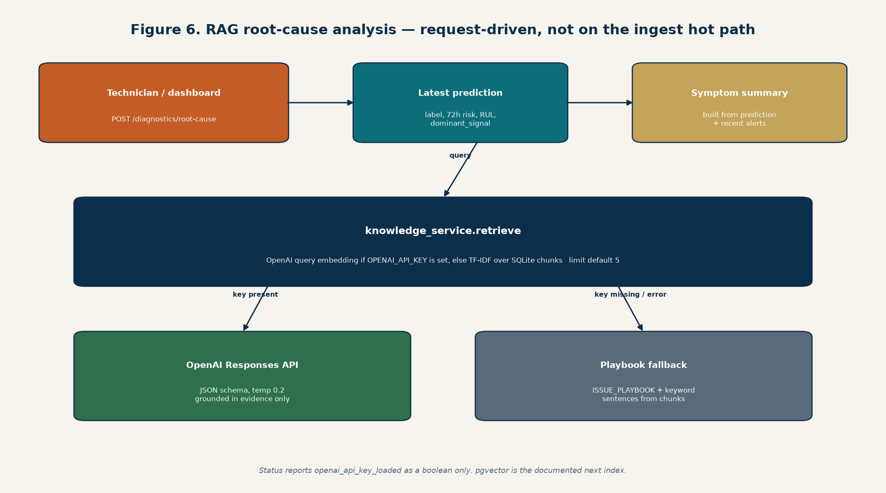
Figure 8. RCA is request-driven. Retrieval and generation both have a local fallback.

5.8 Auth: dashboard login is not ingest
- People: POST /auth/login returns a JWT. Subsequent console calls send Authorization: Bearer. Demo admin is seeded in SQLite (see README / .env.example).
- Machines: X-Ingest-Key on ingest routes when AURAVANCE_INGEST_API_KEY is set. Unset keeps ingest open for local development.
- A dashboard JWT cannot replace the ingest key, and the ingest key cannot log into the console.

5.9 Contracts the frontend depends on
Additive fields are acceptable. Renaming or removing these requires a lockstep change in auravance-frontend.
Contract | Must stay stable
Telemetry ingest | Four metric keys; source_context preserved on replay
Prediction latest | anomaly_score/label, failure_probability_72h, estimated_rul_hours, dominant_signal, model versions
RAG root-cause | likely_causes, recommended_actions, grounded_summary, evidence_snippets, generation_mode
Auth | POST /auth/login → access_token; Bearer thereafter

6. Demo plant vs a real plant
A real plant would publish from PLCs and IoT gateways into an MQTT cluster, land time-series in TimescaleDB, and keep RAG vectors in pgvector. This repo’s demo substitutes replay of public run-to-failure datasets so the scoring path, alerts, and dashboard can be exercised without factory hardware. Each registered asset gets the dataset that matches its type; assets that share a dataset start at offset positions so the plant is not all “healthy” or all “failed” at once. Timestamps on the wire are “now”; the original time and ground truth travel in source_context.
That substitution is why MQTT in this tree is an extra local producer, not proof of 1M+ records/day. High-volume ETL is still offline scripts (prepare_datasets.py, prepare_metropt.py, prepare_ims.py, build_replay_dataset.py) plus SQLite inserts.

7. Deploy shape (demo, not production HA)
Docker: python:3.11-slim, pip install -e ., uvicorn on $PORT. The image does not include the optional torch extra or a durable data/ volume. Terraform under terraform/ creates Artifact Registry, Secret Manager (openai-api-key), Cloud Run v2 (min 0, max 2, 1 vCPU / 512Mi), and a Firebase Hosting site resource. You still build and push the image, set VITE_API_BASE_URL, npm run build, and firebase deploy. Health check {backend_url}/api/v1/health. terraform.tfvars stays gitignored. This layout is a free-tier portfolio deploy: no Cloud SQL, no MQTT broker, no Redis, no CI.
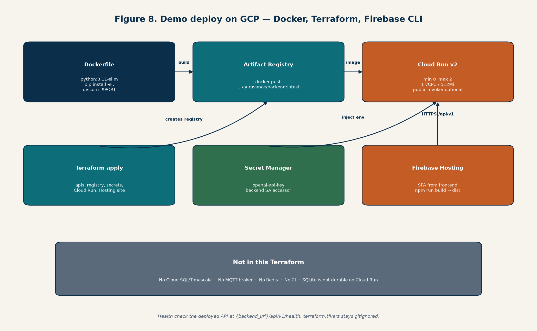
Figure 9. Docker image to Artifact Registry to Cloud Run; SPA on Firebase Hosting.

8. Implemented today versus production target
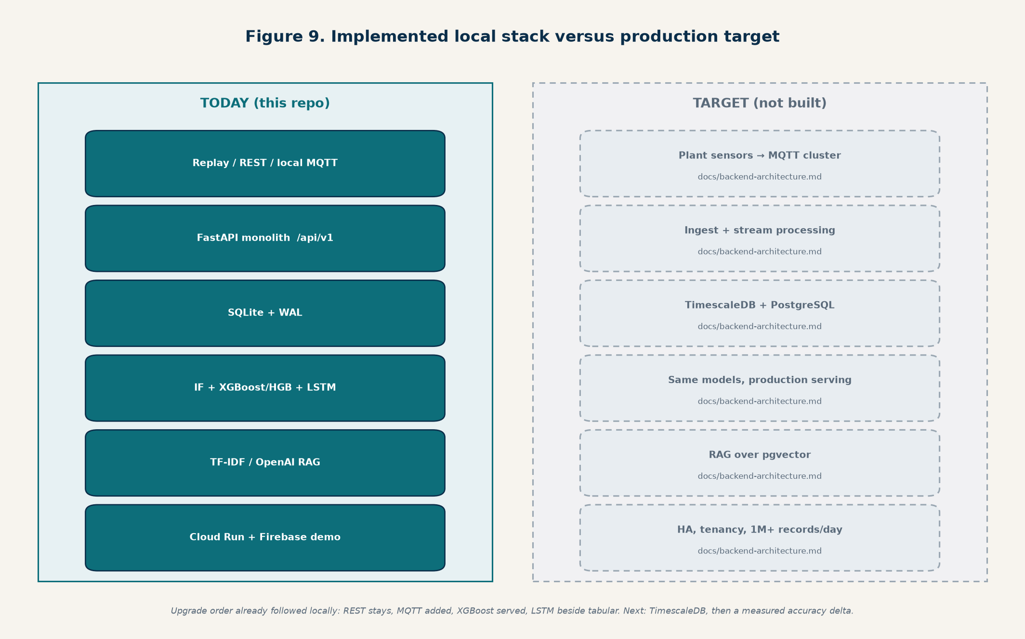
Figure 10. Solid boxes are in these repos. Dashed boxes remain the documented target.
Need | In the repos today | Still a target
Watch the plant | React console + FastAPI /api/v1 | Hardened auth, tenancy, push (WebSocket/SSE)
Get data in | REST ingest + local MQTT subscriber / embedded broker | External MQTT cluster, 1M+ records/day
Keep history | SQLite WAL demo DB | PostgreSQL + TimescaleDB
Score risk | Isolation Forest; XGBoost or HGB; LSTM beside tabular; rules fallback | Same algorithms, production serving and monitoring
Explain the fault | OpenAI or TF-IDF retrieval + playbook fallback | pgvector index, stronger evidence
Prove 30% better detection | evaluate_detection_delta.py vs rules; mixed by profile | A published, product-wide measured delta

9. How to see it run
From auravance-backend: create a Python 3.12 venv, pip install -e ".[sequence]", copy .env.example to .env, then uvicorn app.main:app --reload --host 127.0.0.1 --port 8000. From auravance-frontend: npm run dev (Vite :5173). Optionally python scripts/replay_telemetry.py to stream the demo plant. Open the console, sign in with the seeded demo admin, and use Monitoring then Root Cause Analysis. uvicorn --reload restarts the process and drops the embedded MQTT broker; REST replay is more reliable while developing. Tests: pytest tests/.

10. Related documents
- docs/Auravance-Architecture.docx — illustrated architecture (ingest, SQLite, scoring, RAG, Docker, Terraform)
- docs/demo-backend-architecture.md — local stack
- docs/backend-architecture.md — production target
- README.md — run, train, replay
- auravance-frontend/README.md — Vite proxy and production API URL
End of document. Generated from the repository layout as of 22 October 2026.

MQTT here is another way to push the same four-channel telemetry into the API. It does not score, store, or talk to the dashboard. After a message is decoded, it calls the same telemetry_service.ingest() that REST uses.
REST is still the default for local replay. MQTT is the IoT-shaped producer so a plant sensor, gateway, or replay_telemetry.py --transport mqtt can publish instead of POST /telemetry/ingest.

Why it matters
Industrial devices rarely speak HTTP well. They publish small messages to a broker on a topic, and many consumers can subscribe without the device knowing who is listening. That is the north-star ingest story: PLCs/gateways → MQTT → ingest → score → alerts.
In this repo that story is started, not finished:
Role | What this code does | What it is not
Transport | Event-driven publish/subscribe for telemetry | A 1M+/day plant pipeline
Broker | In-process MQTT 3.1.1, QoS 0, default 127.0.0.1:1883 | Mosquitto, HiveMQ, or Cloud IoT
Subscriber | FastAPI process, one client auravance-ingest | A separate ingest microservice
Reliability | Best-effort QoS 0; REST still works if MQTT fails to start | Durable queues, retained messages, QoS 1/2
If MQTT is down, REST ingest, scoring, and the dashboard keep working. GET /api/v1/telemetry/ingest/status reports that.

How a reading flows
replay / gateway
PUBLISH plants/{plant}/lines/{line}/assets/{asset}/telemetry
↓
embedded broker (or an external one if you point env at it)
↓
paho subscriber in FastAPI (filter: plants/+/lines/+/assets/+/telemetry)
↓
decode JSON → TelemetryIngestRequest (asset_id from the topic)
↓
telemetry_service.ingest() → SQLite, score last 8, maybe alert
↓
dashboard later GETs history / predictions over HTTP + JWT
Topic example: plants/plant-local/lines/line-1/assets/compressor-17/telemetry
Payload is the same public contract as REST: timestamp, metrics.{temperature_c, vibration_rms, pressure_bar, current_a}, optional source_context. The topic’s asset_id wins. If the JSON names a different asset, that is only recorded in source_context.

How it is implemented
On API startup, lifespan starts MQTT after SQLite init:
main.pyLn 34–43
@asynccontextmanager
async def lifespan(_: FastAPI):
if sys.platform == "win32":
_ignore_windows_connection_reset(asyncio.get_running_loop())
init_db()
start_mqtt()
try:
yield
finally:
stop_mqtt()
Three modules:
- app/ingestion/mqtt_protocol.py — topic parse/build and JSON → TelemetryIngestRequest. Sets source to "mqtt" and stamps plant_id, line_id, mqtt_topic into source_context.
- app/ingestion/mqtt_broker.py — tiny in-process broker so tests and replay do not need Mosquitto. TCP server, MQTT 3.1.1 packets: CONNECT, SUBSCRIBE, PUBLISH, PING, DISCONNECT. Forwards QoS 0 publishes to matching subscribers (+ and # filters). Not a production broker.
- app/ingestion/mqtt.py — the real ingest path. If AURAVANCE_MQTT_EMBEDDED is true (default), start the embedded broker, then connect a paho-mqtt 3.1.1 client, subscribe, and on each message call handle_mqtt_message → telemetry_service.ingest. Username/password fall back to the ingest key when AURAVANCE_INGEST_API_KEY is set.
mqtt.pyLn 54–58
def handle_mqtt_message(topic: str, payload: bytes | str | dict) -> None:
from app.services.telemetry import telemetry_service
reading = decode_telemetry_message(topic, payload)
telemetry_service.ingest(reading)
Defaults in app/core/config.py:
- AURAVANCE_MQTT_ENABLED=true
- AURAVANCE_MQTT_EMBEDDED=true
- host 127.0.0.1, port 1883
- subscribe filter plants/+/lines/+/assets/+/telemetry
To use a real broker later: set AURAVANCE_MQTT_EMBEDDED=false and point host/port at Mosquitto (or similar). The subscriber contract stays the same.
Publisher in this repo: python scripts/replay_telemetry.py --transport mqtt still uses REST only to discover assets (GET /telemetry/ingest/targets), then publishes one JSON message per asset per tick. Default replay transport remains REST.
Status: GET /api/v1/telemetry/ingest/status (ingest-key gated) returns enabled/connected, embedded vs not, topic, and accepted/rejected counts.
Tests: tests/test_mqtt_ingest.py publishes through the embedded broker and asserts a row lands in SQLite with source=mqtt.

Practical catch: uvicorn --reload kills the process and therefore the embedded broker. MQTT replay then drops until the subscriber is back. REST replay is the reliable local path while you are editing code.
MQTT’s significance is the ingest contract for real devices. What is implemented is that contract on a laptop: subscribe, normalize, same scoring path as REST — not a plant-scale MQTT cluster.

