Auravance
Industrial Predictive Intelligence Platform
Full-stack architecture: backend, frontend, ingestion, storage, models, RAG, Docker, and Terraform.
This document describes what the repositories actually implement, and separately what remains a production target.
Repositories: auravance-backend (FastAPI) and auravance-frontend (React 18 + Vite). Date: 21 October 2026.

List of figures
- Figure 1. System context — two repositories, one HTTP contract
- Figure 2. Local runtime — laptop processes and data stores
- Figure 3. Frontend console modules
- Figure 4. Ingestion pipeline (REST and MQTT)
- Figure 5. Scoring path (Isolation Forest, XGBoost/HGB, LSTM, rules)
- Figure 6. RAG root-cause analysis
- Figure 7. SQLite demo store
- Figure 8. GCP demo deploy (Docker, Terraform, Firebase)
- Figure 9. Implemented stack versus production target
- Figure 10. Dashboard request path after login

1. Purpose of this document
Auravance is split across two git repositories. The backend owns telemetry ingest, scoring, alerts, master data, and RAG diagnostics. The frontend is a single-page React console that calls the backend over HTTP. Local development uses SQLite and a Vite proxy. GCP demo deploy uses Cloud Run and Firebase Hosting.
Resume-style capability statements are treated as the product north star. They are the build goal. They are not copied into this document as a description of the current tree unless matching code exists.

2. Product north star (target capability)
Use this wording only as the target. Do not treat it as a description of the current tree unless the matching implementation exists.
- Built a full-stack AI platform (React, FastAPI) for real-time equipment monitoring and failure prediction using XGBoost and LSTM, improving detection accuracy by 30%.
- Engineered scalable event-driven IoT ingestion pipelines using MQTT and Python for high-frequency sensor telemetry with low latency and high reliability.
- Designed scalable ETL and event-driven MQTT pipelines processing 1M+ sensor records/day, enabling predictive maintenance, anomaly detection, and RUL insights with sub-minute latency.
- Built a RAG-based root cause analysis system over equipment manuals to generate explainable diagnostics and maintenance recommendations.

3. Implemented today versus still pending
Capability | In the repos today | Still pending
Full-stack monitoring | FastAPI /api/v1; React dashboard in auravance-frontend | Production hardening (auth tenancy, HA, observability)
Failure / RUL models | Isolation Forest anomalies; XGBoost tabular if artifacts exist else HistGradientBoosting; LSTM sequence beside tabular; rules fallback | Production model serving, drift monitors, scheduled retraining
MQTT IoT ingest | REST ingest plus a local MQTT subscriber (embedded broker by default) on plants/{plant_id}/lines/{line_id}/assets/{asset_id}/telemetry | External production MQTT cluster
ETL / volume | Offline scripts over Kaggle pump, MetroPT-3, NASA/IMS; SQLite demo DB; MQTT/REST event path into telemetry_service | 1M+ records/day, sub-minute latency at plant scale, TimescaleDB
RAG diagnostics | OpenAI embeddings + TF-IDF over manuals/guides; playbook fallback | pgvector index
Accuracy claim | Leave-one-failure-out metrics in model JSON; scripts/evaluate_detection_delta.py vs rules | A product-wide measured 30% detection-accuracy claim
Deploy | Dockerfile + Terraform for Cloud Run, Artifact Registry, Secret Manager, Firebase Hosting site | Stateful DB, managed MQTT, production secrets/tenancy

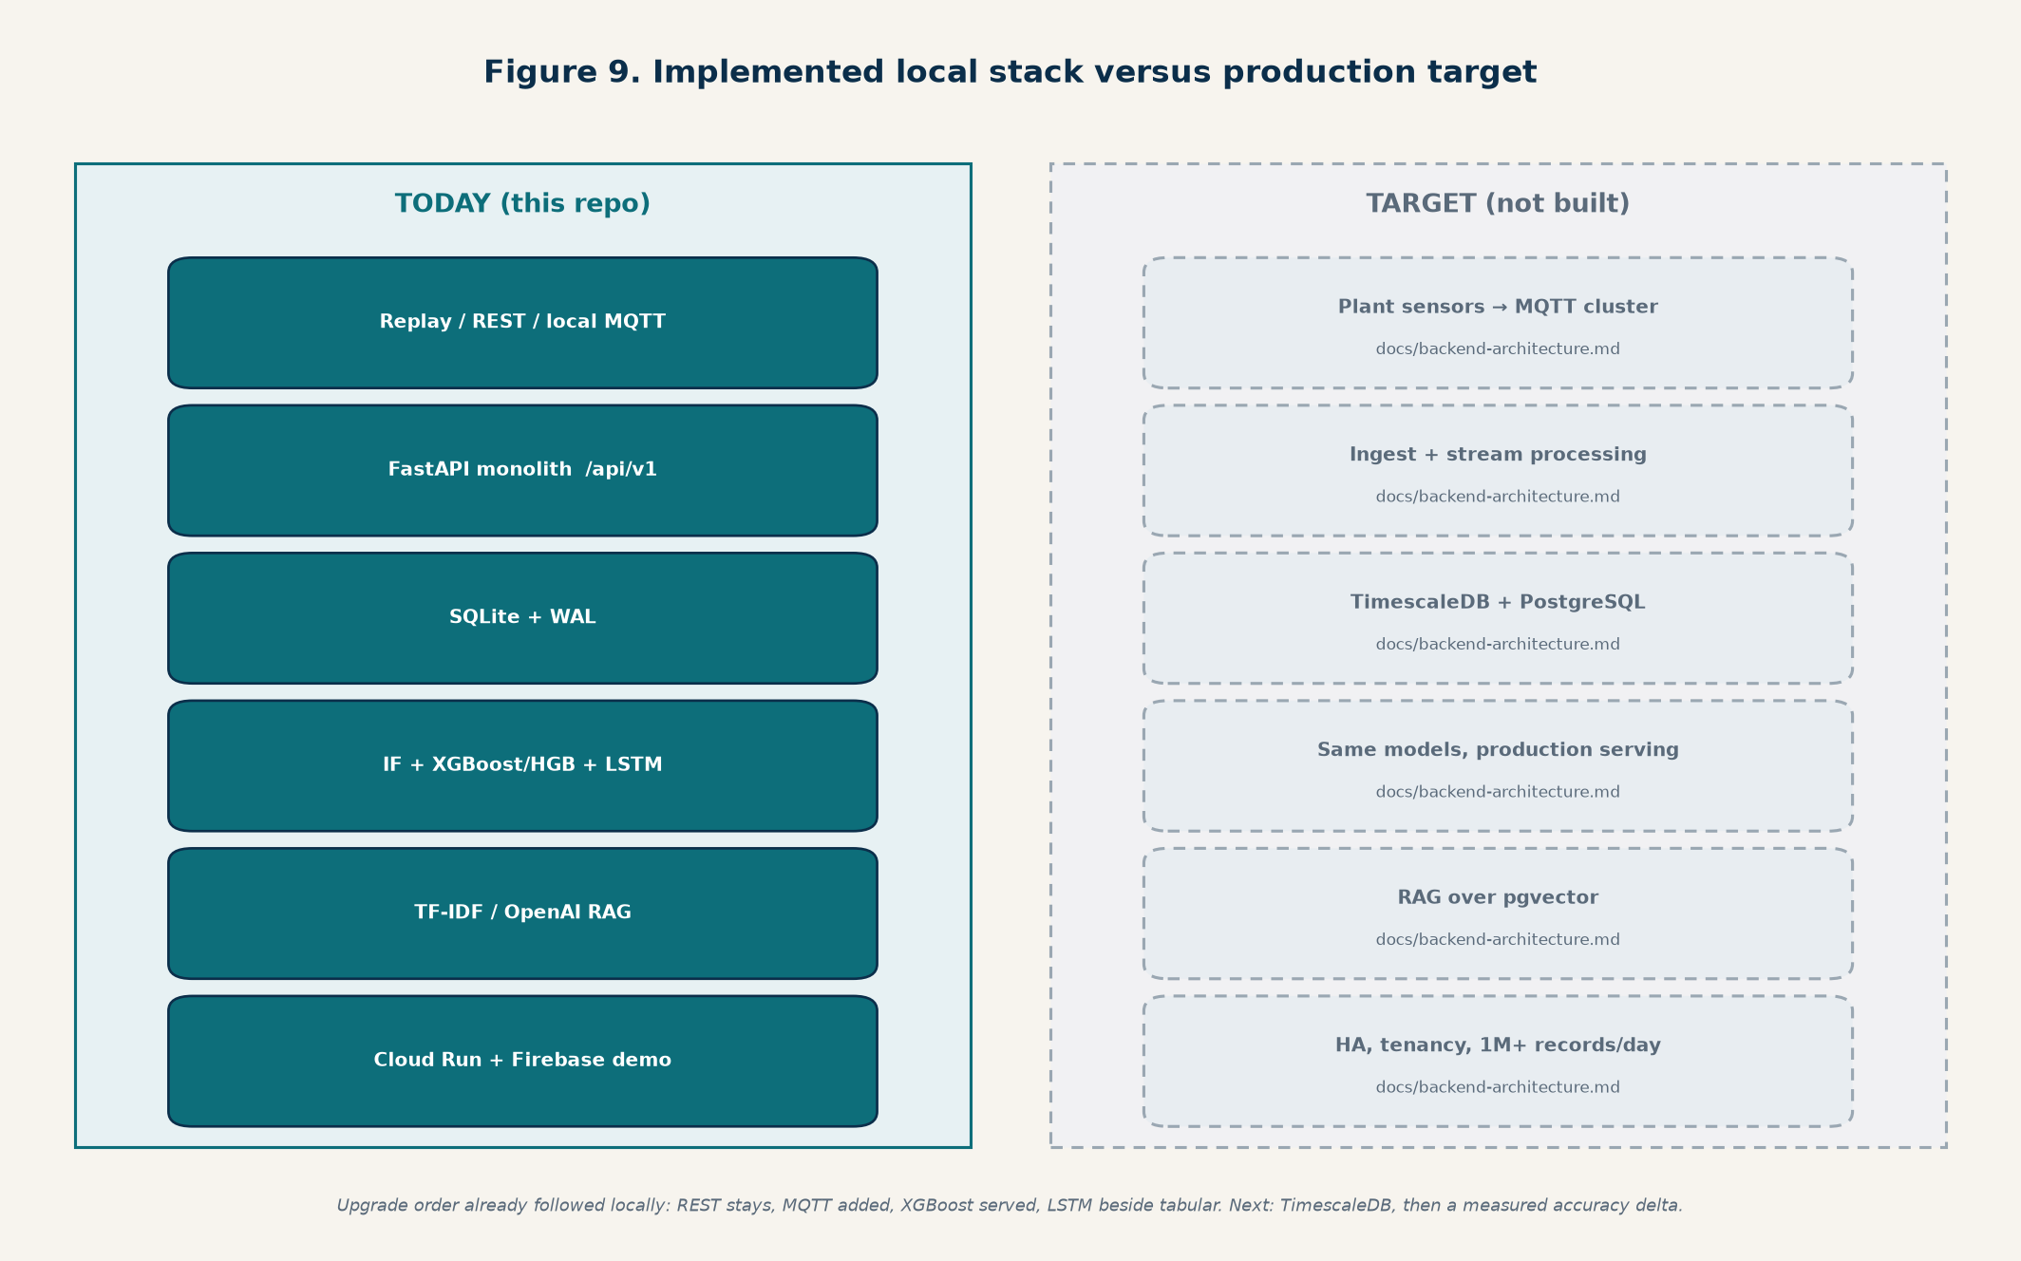
Figure 9. Solid boxes are implemented in these repos. Dashed boxes are the production target in docs/backend-architecture.md.

4. System context and repositories
The product is two sibling repositories. The frontend never embeds backend source. The backend never re-creates the React app.
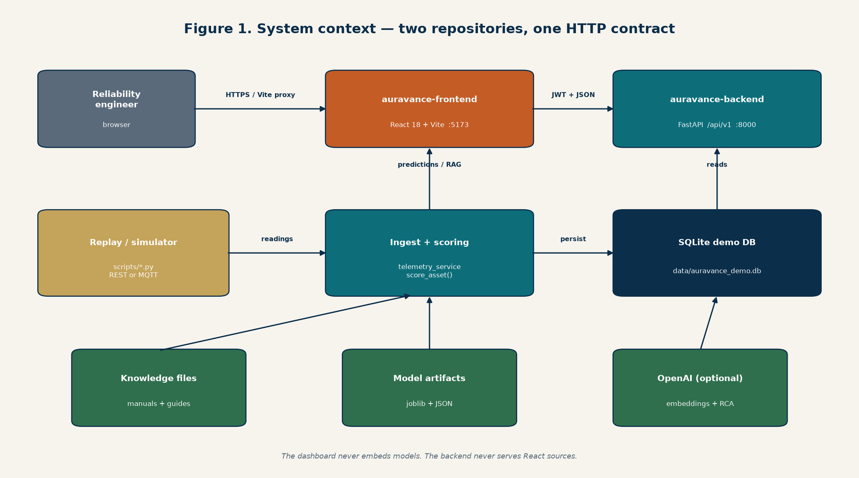
Figure 1. Operators use the React console. Replay scripts and optional MQTT feed the FastAPI process. SQLite, model artifacts, and knowledge files stay on the backend.
Repository | Role | Primary stack
auravance-backend | API, ingest, SQLite, models, RAG, Terraform, Docker | Python 3.11+, FastAPI, scikit-learn, XGBoost, optional PyTorch
auravance-frontend | Operator console | React 18, Vite 5, single src/App.jsx + styles.css

4.1 Backend layout
- app/main.py — FastAPI app, CORS, lifespan (SQLite init, MQTT start/stop)
- app/api/routes/ — REST surface under /api/v1
- app/models/schemas.py — Pydantic contracts (change these first)
- app/services/ — telemetry, scoring, anomaly, prognostics, sequence LSTM, RAG, alerts, master data, auth
- app/ingestion/ — replay helpers, MQTT protocol, embedded broker, subscriber
- app/core/ — settings, SQLite, JWT and ingest-key security
- scripts/ — ETL, training, replay, simulator, knowledge index
- artifacts/models/ — joblib artifacts + JSON sidecars
- knowledge/ — markdown guides and processed PDF chunks
- terraform/ — Cloud Run + Firebase Hosting site + secrets

4.2 Frontend layout
- src/App.jsx — login, nav, Monitoring, Root Cause Analysis, master data, execution, admin
- src/styles.css — console styling
- vite.config.js — dev server on 5173, proxy /api → http://127.0.0.1:8000
- VITE_API_BASE_URL — optional; local default is /api/v1 through the proxy
- Session key localStorage: auravance.currentUser

5. Runtime architecture (what runs locally)
Local topology: replay or simulator produces telemetry → REST ingest and/or MQTT → FastAPI telemetry_service persists to SQLite and scores the asset → alerts with cooldown → the React dashboard reads assets, telemetry history, predictions, alerts, and RAG over /api/v1.
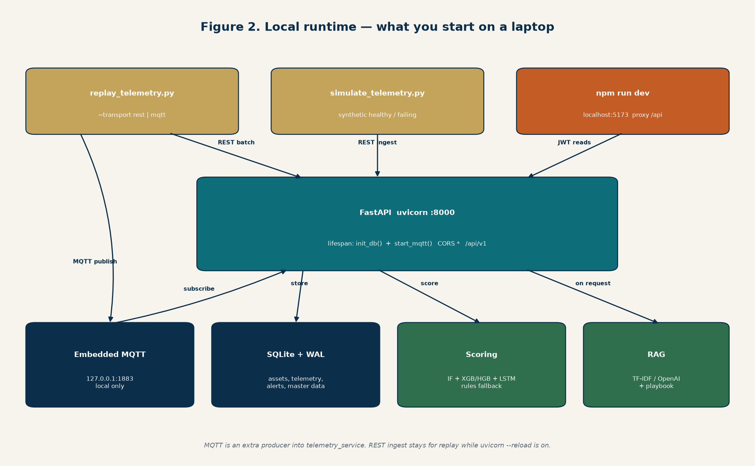
Figure 2. What runs on a laptop: uvicorn :8000, Vite :5173, SQLite, optional embedded MQTT on 1883.
simulate_telemetry.py / replay_telemetry.py
| REST POST /api/v1/telemetry/ingest[/batch]
| or MQTT plants/{plant}/lines/{line}/assets/{asset}/telemetry
v
FastAPI (app/main.py)
|-- SQLite data/auravance_demo.db
|-- score_asset() Isolation Forest + XGBoost/HGB + LSTM (+ rules fallback)
|-- alerts (cooldown, default 300s)
+-- rag_service.root_cause() knowledge chunks + OpenAI or playbook
^
auravance-frontend src/App.jsx (Vite proxy /api → :8000)

6. Frontend application
The dashboard is a React 18 single-page app. There is no client-side router library; navigation is module state in App.jsx. After JWT login, the console loads assets, plants, vendors, equipment, schedules, work orders, defects, users (admin), diagnostics status, then polls telemetry history and the latest prediction for the selected asset.
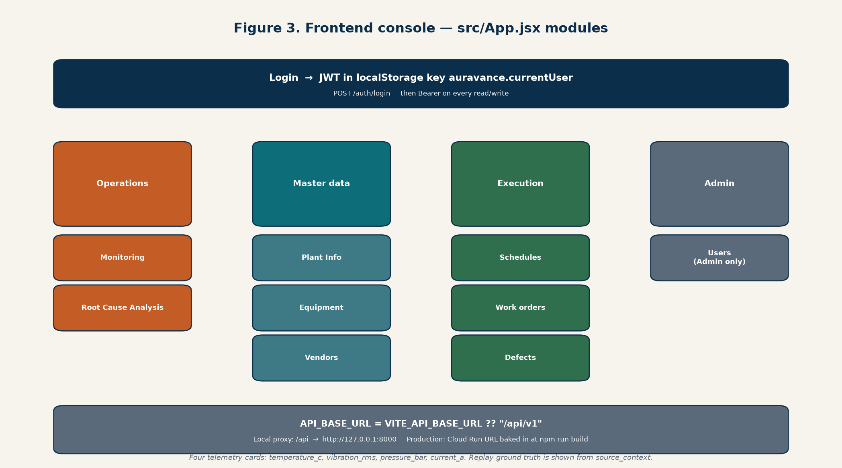
Figure 3. Console modules after login. Operations read live telemetry and predictions; master data and execution are CRUD against SQLite.

6.1 Navigation groups
Group | Modules | Backend calls
Operations | Monitoring; Root Cause Analysis | telemetry history, predictions, alerts; POST /diagnostics/root-cause
Master Data | Plant Info; Equipment Master; Vendor Management | CRUD /plants, /equipment, /vendors
Execution | Maintenance Schedules; Work Order Mgmt; Defects View | CRUD /maintenance-schedules, /work-orders, /defects
Admin | User Mgmt (Admin role only) | /users

6.2 Monitoring and prediction UI
Monitoring shows the four public sensor channels (temperature_c, vibration_rms, pressure_bar, current_a), trend charts from the last 24 history points, anomaly label, 72-hour failure probability, estimated RUL hours, dominant signal, and alerts. Replay ground truth in source_context (NORMAL, BROKEN, RECOVERING, AIR_LEAK, FAILED) is shown next to model output when present.

6.3 How the frontend reaches the API
- Local: fetch('/api/v1/...') → Vite proxy → http://127.0.0.1:8000/api/v1/...
- Deployed: VITE_API_BASE_URL=https://<cloud-run-host>/api/v1 baked in at npm run build
- Auth header: Authorization: Bearer <JWT> after POST /auth/login
- CORS on the API allows any origin (demo); cookies are not used
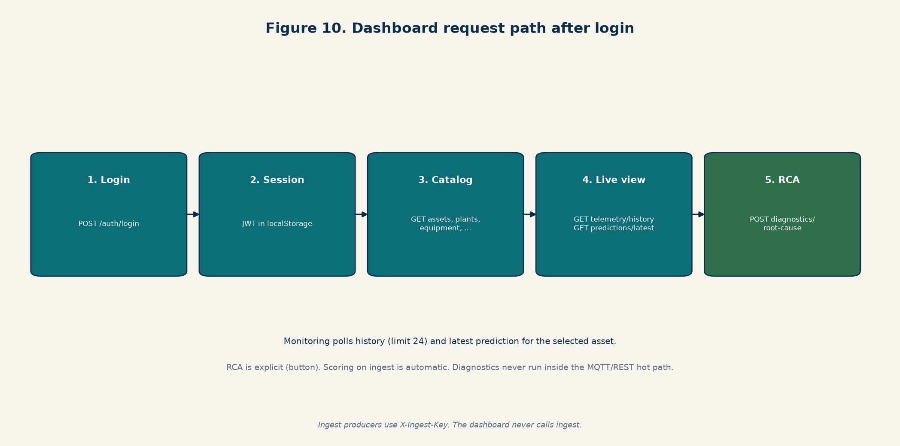
Figure 10. After login the SPA loads catalogs, then polls history and the latest prediction. RCA is an explicit POST, not part of ingest.

7. Backend application
FastAPI exposes a versioned HTTP API at /api/v1. Lifespan initializes SQLite (DDL + demo seed) and starts the MQTT subscriber if AURAVANCE_MQTT_ENABLED is true. Model load failures must not crash the process: score_asset falls back to rules and status endpoints report fallback_active.

7.1 REST surface
Area | Routes
Health | GET /health (mounted at /api/v1/health)
Auth | POST /auth/login, GET /auth/me
Assets | GET/POST /assets
Master data | /plants, /vendors, /equipment, /sensors, /users, /maintenance-schedules, /work-orders, /defects
Telemetry | POST /telemetry/ingest, POST /telemetry/ingest/batch, GET /telemetry/ingest/targets, GET /telemetry/ingest/status, latest/history
Predictions | GET /predictions/assets/{asset_id}/latest, GET /predictions/models/status
Diagnostics | GET /diagnostics/status, POST /diagnostics/root-cause, GET /diagnostics/retrieve
Knowledge | /knowledge/documents, /knowledge/search
Alerts | GET /alerts
Datasets | GET /datasets

7.2 Authentication split
- Dashboard reads/writes: JWT Bearer from POST /auth/login. Demo admin is seeded in SQLite.
- Ingest: X-Ingest-Key when AURAVANCE_INGEST_API_KEY is set. Unset keeps ingest open for local development.
- These are different controls. A dashboard JWT cannot replace the ingest key, and vice versa.

8. Ingestion pipelines

8.1 Live ingest contract
Every producer — REST simulator, REST replay, MQTT subscriber — must end in telemetry_service. Scoring and alerting are not bypassed. The public payload is:
{ "timestamp": "2026-05-15T14:22:31Z", "asset_id": "compressor-17", "metrics": { "temperature_c": 84.2, "vibration_rms": 0.63, "pressure_bar": 5.2, "current_a": 11.7 }, "source": "api", "source_context": {} }
- Four channels only on the wire. Expanding them requires the frontend and all three model profiles together.
- Batch: {"readings":[...]} min 1, max 500. Unknown asset IDs fail the whole batch (404).
- Replay fills source_context with original timestamp, raw values, ground-truth status, units, and dataset id.
- On ingest, the last 8 points are scored for alerts. Cooldown AURAVANCE_ALERT_COOLDOWN_SECONDS (default 300) unless severity changes.
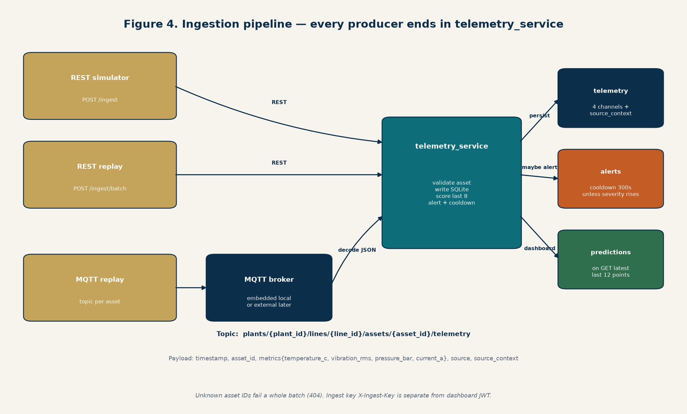
Figure 4. REST and MQTT are producers. Scoring, SQLite writes, and alert cooldown all happen inside telemetry_service.

8.2 REST ingest
POST /api/v1/telemetry/ingest and /ingest/batch are the original and still-supported path. scripts/simulate_telemetry.py posts synthetic readings. scripts/replay_telemetry.py (--transport rest, default) posts one batch per tick for every registered asset.

8.3 MQTT ingest (local)
MQTT is an additional producer into the same service. Default local settings start an embedded MQTT 3.1.1 broker (QoS 0) and a paho-mqtt subscriber. Topic:
plants/{plant_id}/lines/{line_id}/assets/{asset_id}/telemetry
- Subscriber: app/ingestion/mqtt.py — decode JSON, map topic asset_id, call telemetry_service.ingest
- Status: GET /telemetry/ingest/status (ingest-key gated)
- Replay: python scripts/replay_telemetry.py --transport mqtt
- uvicorn --reload restarts the process and drops the embedded broker; REST replay is more reliable while developing
- Production still needs an external broker. The in-process broker is a local stand-in, not a plant MQTT cluster

8.4 Offline ETL and replay datasets
High-volume plant ETL is not a streaming job in this repo. Offline scripts prepare public datasets used for training and for honest live replay.
Profile | Asset types | Source dataset | Sampling | Failure character
pump | pump, cooling-system | Kaggle pump-sensor (replay file committed; full CSV gitignored) | 1 min | Mixed; 72h forecast weak
compressor | compressor | MetroPT-3 air compressor, 4 air leaks | 5 min | Sudden; leak-in-progress is learnable, 72h is not
motor | motor, drive, conveyor | NASA/IMS bearing run-to-failure | 10 min vibration RMS | Gradual degradation

- scripts/prepare_datasets.py, prepare_metropt.py, prepare_ims.py, build_replay_dataset.py
- Replay files in data/replay/ are what local demo streaming uses
- GET /datasets lists the catalog stored in SQLite
- This is not a 1M+ records/day pipeline. That remains a TimescaleDB-era target.

9. Databases and storage

9.1 SQLite demo store (implemented)
AURAVANCE_DEMO_DB_PATH defaults to data/auravance_demo.db. init_db() creates tables and seeds demo plants, assets, vendors, equipment, users, schedules, work orders, and defects. Schema changes belong in app/core/db.py together with seed data. WAL mode is enabled for concurrent API + MQTT threads.
Table group | Tables | Purpose
Telemetry path | assets, telemetry, alerts | Live readings and scored warnings
Master data | plants, vendors, equipment, sensors, users | Dashboard CRUD
Execution | maintenance_schedules, work_orders, defects | Seeded workflows; not auto-opened from alerts
Catalog / RAG | dataset_catalog, knowledge documents/chunks/vectors | Dataset registry and retrieval index

Telemetry columns: asset_id, timestamp, temperature_c, vibration_rms, pressure_bar, current_a, source, source_context_json. Index: (asset_id, timestamp).
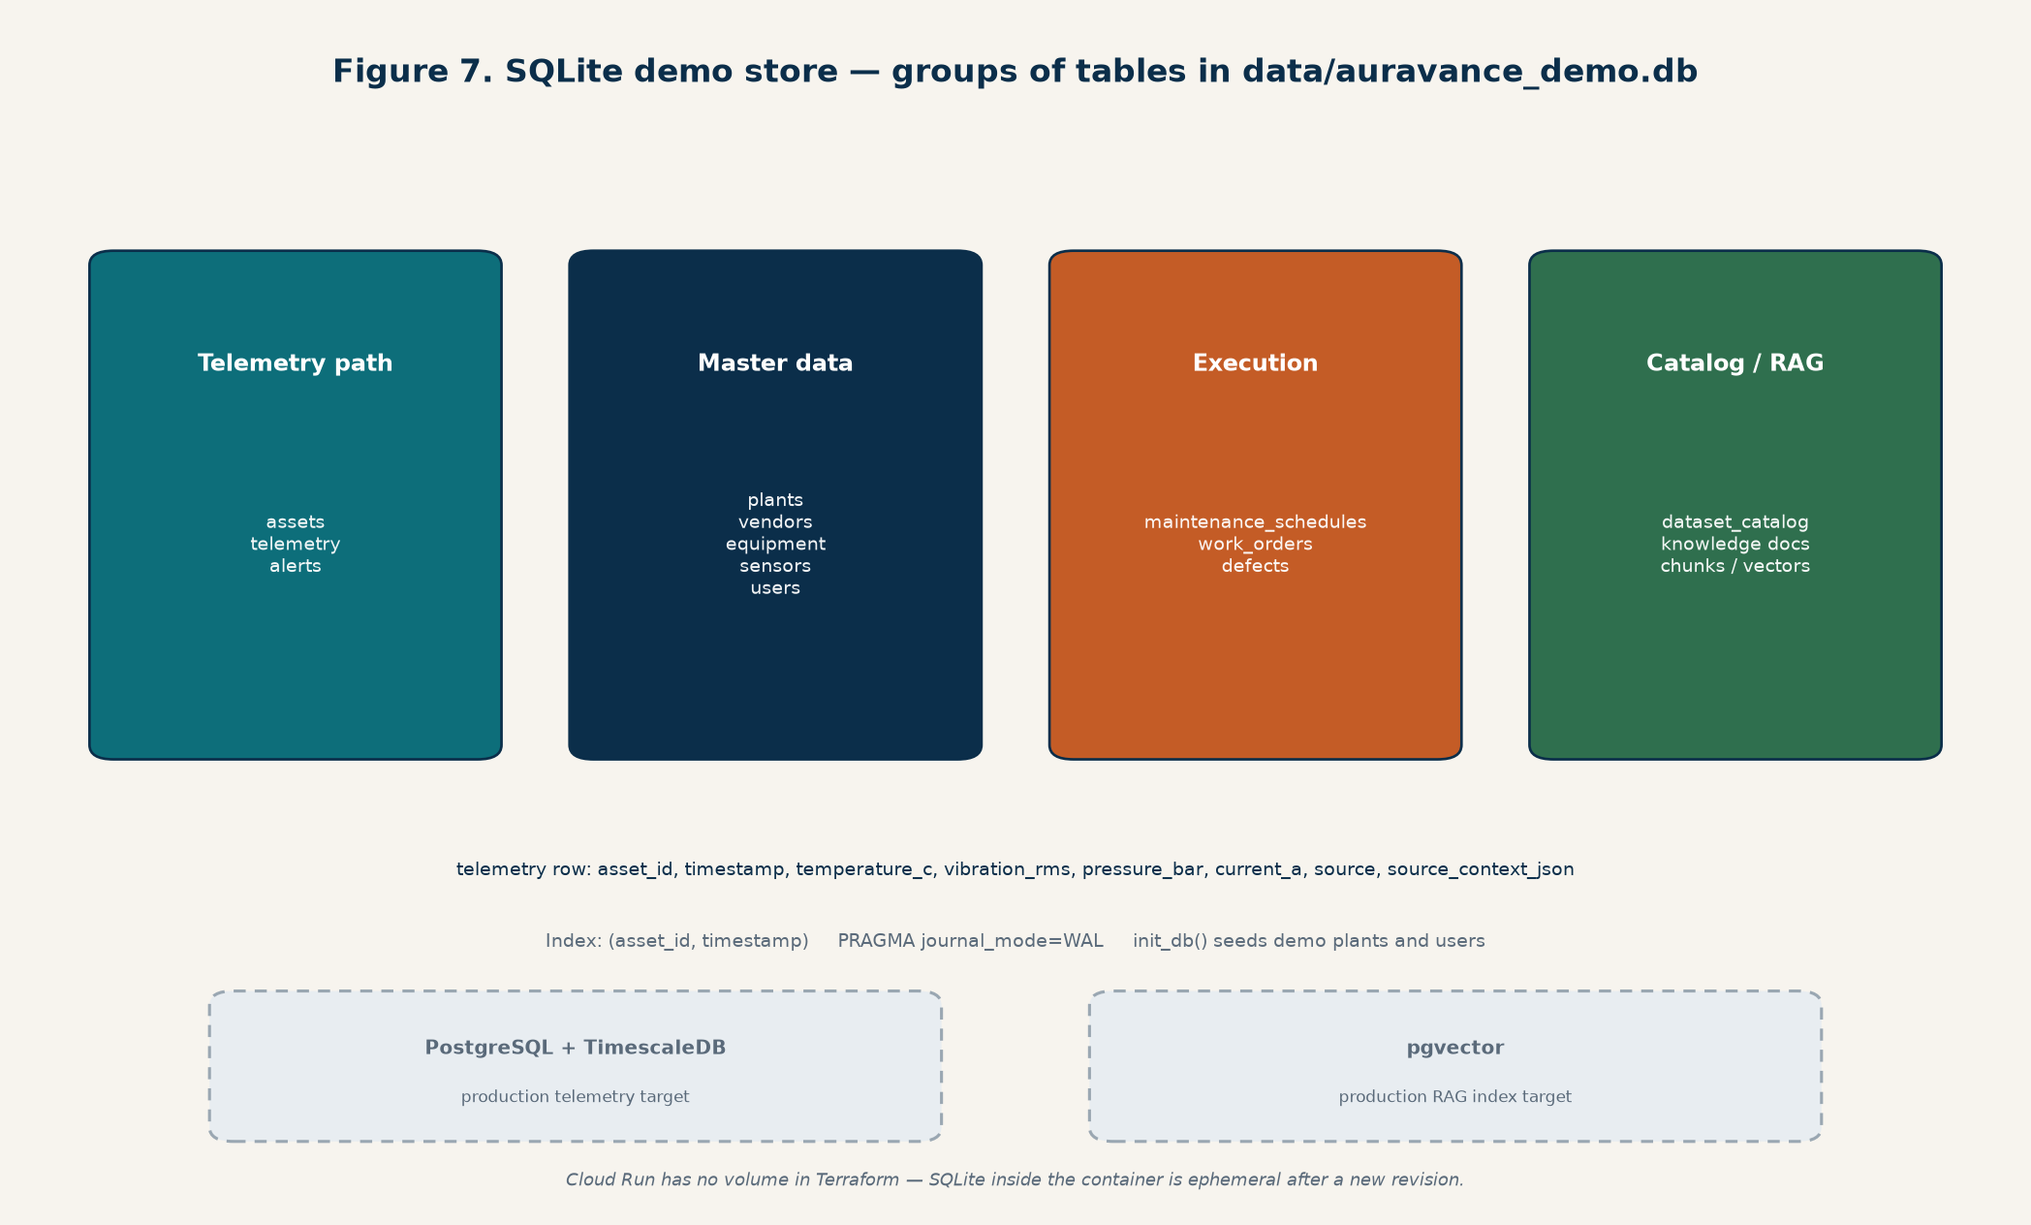
Figure 7. Implemented tables in SQLite. Dashed boxes are the TimescaleDB / pgvector cutover, which is not in this repo.

9.2 What SQLite is not
- Not TimescaleDB. No hypertables, no continuous aggregates, no retention policies.
- Not pgvector. Embeddings live as JSON/blobs in SQLite when OPENAI_API_KEY is set during indexing.
- Not durable on Cloud Run. The container filesystem is ephemeral; a new revision starts from an empty seeded DB unless a volume is added (not in Terraform today).

9.3 Production storage target
docs/backend-architecture.md specifies PostgreSQL + TimescaleDB for telemetry and metadata, and pgvector for RAG. That cutover is not implemented. Object storage for manuals and model artifacts is also a target (S3-compatible), while today artifacts and knowledge are copied into the image.

10. Machine learning and scoring
Three tasks stay separate: anomaly (unsupervised Isolation Forest on healthy operation), failure (P(failing now or within 72h)), and RUL (hours until next failure, capped). Do not reuse a classification score as RUL except the documented compressor sudden-failure wrappers.

10.1 Serving path
- score_asset in app/services/scoring.py
- Profile from asset type: pump / compressor / motor (cooling-system → pump; drive/conveyor → motor)
- Anomaly: Isolation Forest if loaded, else rules mix of normalized channels + trend
- Failure: LSTM if history length ≥ window (12) and artifact loaded; else XGBoost if present; else HGB; else rules
- RUL: XGBoost if present, else HGB, else derived from failure probability
- Predictions use last 12 points; ingest alerts use last 8
- Honest replay: if source_context.dataset matches fold_dataset and the timestamp is in a held-out window, serve +heldout-N
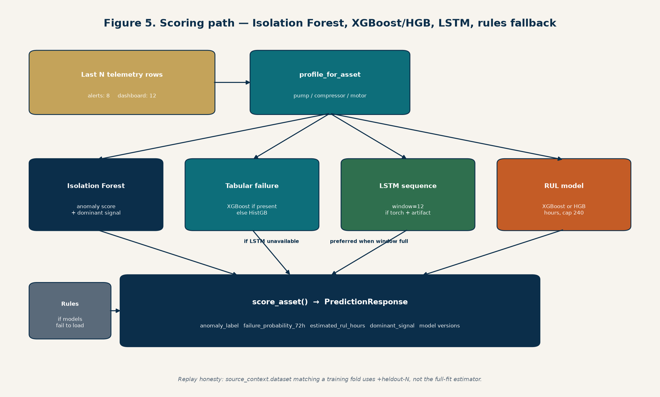
Figure 5. Isolation Forest for anomaly, LSTM then XGBoost/HGB for failure, XGBoost/HGB for RUL, rules if artifacts fail to load.

10.2 Artifacts
joblib dict, artifact_schema_version: 1, plus a sibling .json with the estimator stripped. GET /predictions/models/status reads metadata (algorithm, metrics, fallback_active) per profile, including sequence/LSTM status.

10.3 Accuracy honesty
Published leave-one-failure-out numbers live in artifact JSON (pump failure AUC ~0.66 on the full HGB training set; compressor leak-now is strong and 72h forecast is not; motor bearings degrade). scripts/evaluate_detection_delta.py compares models to the rules scorer on replay. Pump beats a weak rules baseline by a large relative margin on that clip-based detection task; compressor is about +20%; motor snapshots are too sparse for a 30% claim. Do not state a product-wide 30% detection-accuracy improvement.

11. RAG diagnostics
POST /diagnostics/root-cause takes asset_id, symptom_summary, and optional alert ids. The service loads the latest prediction, maps dominant_signal to playbook terms, retrieves knowledge chunks (OpenAI embeddings when the key is present, else TF-IDF), then calls the OpenAI Responses API with a JSON schema. If the key or API is down, it extracts cause/action sentences from chunks plus the playbook.
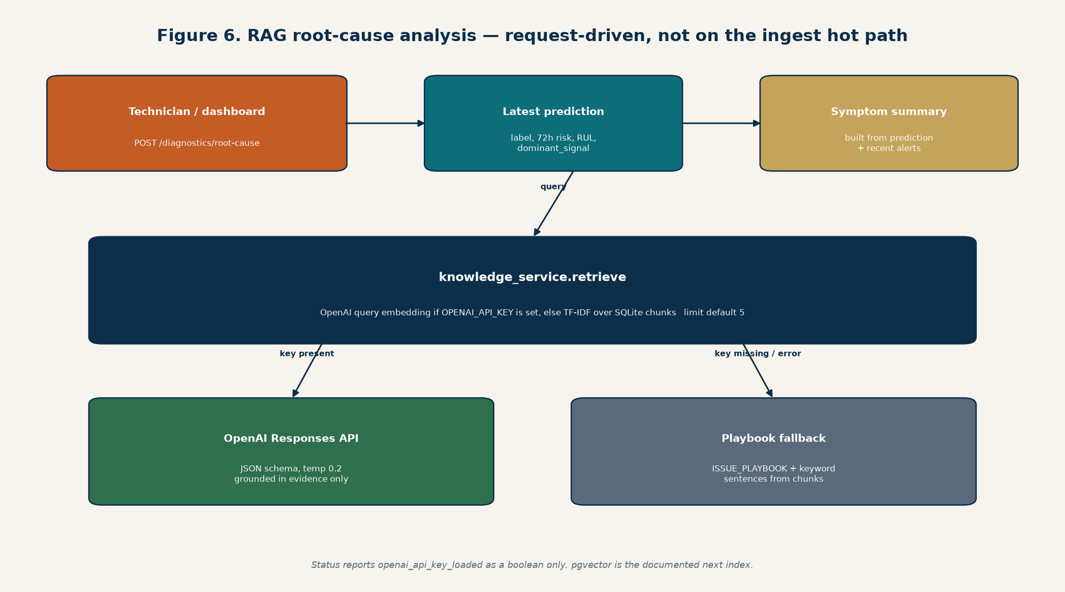
Figure 6. RCA is request-driven. Retrieval uses OpenAI embeddings or TF-IDF; generation uses the Responses API or the local playbook.
- Index: python scripts/prepare_knowledge.py over knowledge/raw PDFs and knowledge/*.md
- Return fields: grounded_summary, likely_causes, recommended_actions, confidence, generation_mode, generation_model, evidence_snippets
- Status reports openai_api_key_loaded as a boolean only — the key is never echoed
- Diagnostics are request-driven, not on the ingest hot path
- pgvector is the documented next index, with the same retrieve() signature

12. Local development process
Python 3.11 or 3.12 is required. Python 3.14 may not have XGBoost/PyTorch wheels.
Backend:
py -3.12 -m venv .venv
.venv/Scripts/python.exe -m pip install -e ".[sequence]"
.venv/Scripts/python.exe -m uvicorn app.main:app --reload --host 127.0.0.1 --port 8000
Frontend (sibling repo):
npm install && npm run dev # http://localhost:5173
Optional live replay:
.venv/Scripts/python.exe scripts/replay_telemetry.py --transport rest
Copy .env.example to .env for OPENAI_API_KEY, ingest key, MQTT flags, and auth secret. Never commit .env.

13. Docker
auravance-backend/Dockerfile builds a python:3.11-slim image. It installs build-essential, copies pyproject.toml, app/, artifacts/, and knowledge/, then pip install --no-cache-dir -e . The default extra does not include PyTorch, so Cloud Run serves Isolation Forest + XGBoost/HGB and LSTM falls back unless the image is built with the sequence extra.
- CMD: uvicorn app.main:app --host 0.0.0.0 --port ${PORT} (Cloud Run injects PORT; Dockerfile default 8080)
- data/, scripts/, and the SQLite file are not copied — replay ETL is a local/dev concern
- Model artifacts in artifacts/models are baked into the image
- There is no docker-compose for Postgres or Mosquitto in this tree
docker build -t us-central1-docker.pkg.dev/<project>/auravance/backend:latest .
docker push us-central1-docker.pkg.dev/<project>/auravance/backend:latest

14. Terraform and GCP demo deploy
terraform/ is a free-tier portfolio deploy, not the MQTT/Timescale production design. Estimated cost at demo traffic is intended to stay inside GCP Always Free limits (Cloud Run scale-to-zero, 2M requests/month class).
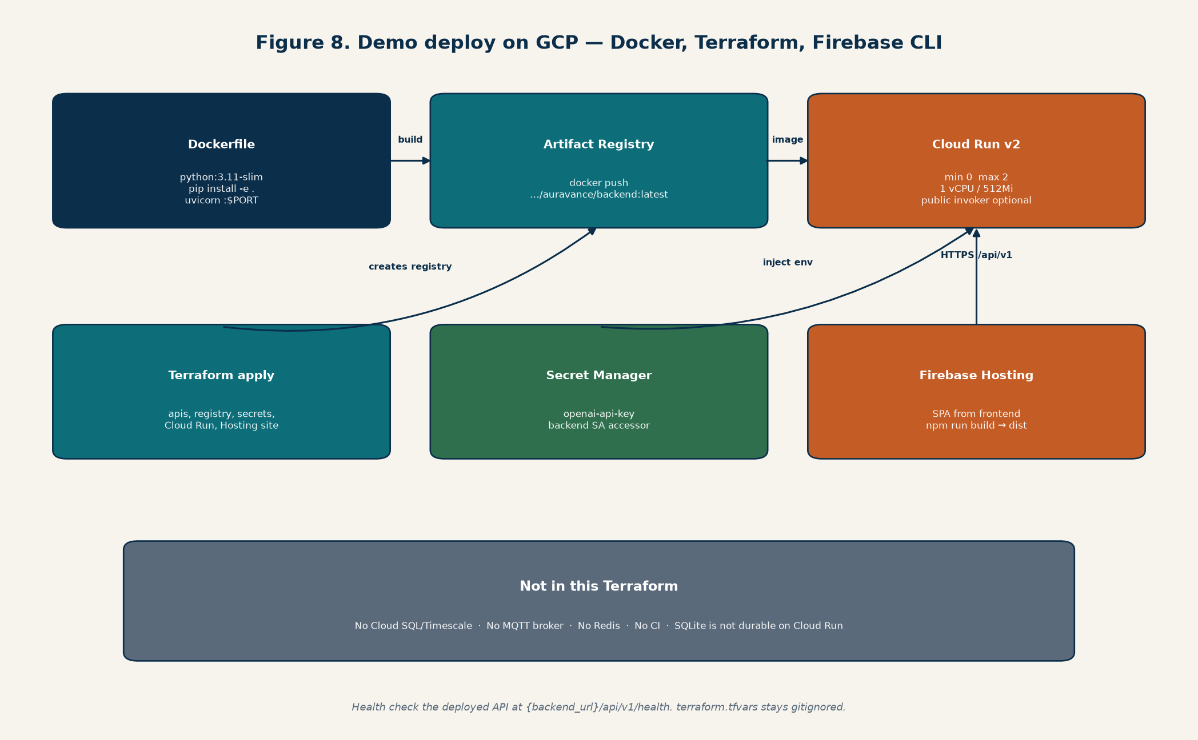
Figure 8. Docker image → Artifact Registry → Cloud Run. Terraform creates the site resource; firebase deploy uploads the SPA.

14.1 Resources
File | What it creates
apis.tf | Enables run, artifactregistry, secretmanager, firebase, firebasehosting APIs
artifact_registry.tf | Docker repo auravance in the chosen region
secrets.tf | Secret Manager openai-api-key; dedicated Cloud Run service account with secretAccessor
cloud_run.tf | Cloud Run v2 service, 1 vCPU / 512Mi, min instances 0, max 2, port 8080, public invoker optional
firebase_hosting.tf | Firebase project + Hosting site resource; it does not upload the SPA files
variables.tf | project_id, region (us-central1), backend_image, openai_api_key (sensitive), allow_unauthenticated

14.2 Deploy sequence
- 1. Create/select a GCP project and enable billing (required even for free tier).
- 2. Build and push the backend image to Artifact Registry (or apply the registry resource first).
- 3. terraform init && terraform apply with terraform.tfvars (gitignored). Never commit terraform.tfvars.
- 4. terraform output backend_url
- 5. In auravance-frontend: set VITE_API_BASE_URL to that URL plus /api/v1, npm run build.
- 6. firebase init hosting (public dir dist) and firebase deploy --only hosting.
- 7. Health check GET {backend_url}/api/v1/health — not /health at the container root.

14.3 What Terraform does not provision
- No Cloud SQL / TimescaleDB
- No Memorystore, no MQTT broker (HiveMQ, Mosquitto, Cloud IoT)
- No load balancer beyond Cloud Run URL
- No CI pipeline; image build and firebase deploy are manual CLI steps
- SQLite inside Cloud Run is ephemeral — demo data resets when the instance is replaced

15. Security notes
- Secrets from environment / .env / Secret Manager only. Do not commit .env or terraform.tfvars.
- JWT secret AURAVANCE_AUTH_SECRET_KEY must be changed off the demo default before any shared deploy.
- Ingest key is optional locally and should be set in any network-exposed API.
- Cloud Run allow_unauthenticated defaults true for a portfolio demo; that is not a plant-network posture.
- RAG status exposes openai_api_key_loaded as boolean only.
- Password hashes are stored in SQLite users.password_hash.

16. Production target architecture (not built)
The longer-term backend design in docs/backend-architecture.md is: industrial sensors/PLCs → MQTT broker → ingestion service → stream processing → TimescaleDB and a feature store → XGBoost/LSTM/Isolation Forest inference → alerts and maintenance workflows → RAG over pgvector. The FastAPI gateway remains the dashboard API. Extra production pieces named there and not present in code: Celery/Dramatiq, Redis/RabbitMQ, WebSocket or SSE push, S3-compatible object storage, Kubernetes, and auto work-order generation from alerts.
Documented upgrade order: keep REST ingest; add external MQTT into telemetry_service; serve XGBoost behind artifact schema v1 (done locally); add LSTM beside tabular (done locally); move telemetry to TimescaleDB when volume needs it; measure detection accuracy against the rules baseline before claiming 30%.

17. HTTP contracts to keep stable
The frontend depends on these staying compatible. Additive fields are acceptable; renaming or removing prediction/telemetry/RAG fields requires a lockstep change in auravance-frontend.
Contract | Stability rule
Telemetry ingest | Four metrics keys; source_context preserved
Prediction latest | anomaly_score/label, failure_probability_72h, estimated_rul_hours, dominant_signal, model versions
RAG root-cause | likely_causes, recommended_actions, grounded_summary, evidence_snippets, generation_mode
Auth | POST /auth/login returns access_token; subsequent calls use Bearer

18. Related files
- auravance-backend/docs/Auravance-Architecture.docx — this illustrated write-up
- auravance-backend/docs/architecture-diagrams/ — PNG sources for the figures
- auravance-backend/docs/demo-backend-architecture.md — local stack
- auravance-backend/docs/backend-architecture.md — production target
- auravance-backend/terraform/README-DEPLOY.md — GCP steps
- auravance-backend/README.md — run, train, replay
- auravance-frontend/README.md — Vite proxy and production API URL
End of document. This architecture write-up is generated from the repository layout as of 21 October 2026 and is intended for engineering onboarding, not as a resume substitute.

