Supply Chain Integrity and Software Piracy: A Review of Fuzzing-Driven X.509 Certificate Vulnerabilities
Yashas B S, Varshith A N, Yashwanth Gowda C
Department of Computer Science and Engineering (Cyber Security). JAIN Deemed-to-be University,
Bangalore, India

Abstract—Software update pipelines have become prime targets for piracy campaigns and malicious payload delivery. While modern enterprise update mechanisms rely heavily on X.509 certificate pinning to ensure authenticity, the security of certificate parsing logic within client-side updater components has not received adequate scholarly attention. This paper undertakes a Systematic Literature Review (SLR) examining X.509 certificate parsing weaknesses uncovered via Differential Fuzzing and Jaccard Distance Metrics. Fifty peer-reviewed works drawn from IEEE Xplore, ACM Digital Library, and ScienceDirect (2015–2024) were rigorously screened using the PRISMA methodology. A novel hierarchical classification scheme—the Taxonomy of Certificate Exploit Vectors (TCEV)—organizes identified vulnerabilities across six distinct categories. A detailed Comparison Matrix evaluates fifteen leading fuzzing tools against Certificate Coverage Rate (CCR), Bug Discovery Rate (BDR), Jaccard Distance Range (JDR), and resource consumption metrics. Advanced stateful differential fuzzers demonstrate peak performance of 91.2% CCR and 6.1 bugs per 24 hours, marking the current empirical benchmark. An extended Legal-Technical Mapping section cross-references technical discoveries with obligations under GDPR and the Information Technology Act 2000 (ITA 2000), surfacing three critical governance problems: the Attribution Gap, the Explainability Crisis, and enforcement difficulties across jurisdictions. The paper concludes by outlining five unresolved research problems bridging certificate fuzzing theory with contemporary cyber law.
Index Terms—Supply Chain Security, X.509
Certificate Parsing, Differential Fuzzing, Certificate Pinning, Jaccard Distance, PKI, TLS, Greybox Fuzzing, Software Piracy, GDPR, ITA 2000, Metaheuristic Optimization, SBOM, Blockchain PKI.

I. INTRODUCTION

A. Background and Context
Among the most dynamic and consequential attack surfaces in modern cybersecurity, software supply chains occupy a unique position. Enterprise update systems push patches, licensing data, and essential functionality to vast fleets of endpoints worldwide, and they do so by depending almost entirely on X.509 digital certificates—the bedrock of Public Key Infrastructure (PKI) trust—for package authentication and code-signing enforcement [1], [2].
The underlying trust assumption—that a structurally valid certificate chain guarantees payload integrity—is under growing challenge. High-impact incidents such as the SolarWinds SUNBURST breach (2020), the 3CX Desktop App intrusion (2023), and the XZ Utils backdoor (CVE-2024-3094) collectively illustrate that sophisticated attackers do not break cryptographic algorithms; instead, they exploit the discrepancy between what a certificate asserts and what a validator’s parsing code actually checks [3]. This discrepancy, referred to throughout this paper as the Certificate Parsing Exploit Surface (CPES), forms the primary focus of our investigation.
Differential Fuzzing has established itself as the leading methodology for detecting behavioral inconsistencies across competing X.509 implementations [4], [5]. By presenting identical boundary-case certificate inputs to multiple validators in parallel and quantifying divergence through Jaccard Distance Metrics, researchers have revealed fundamental logic defects that conventional static analysis and formal verification routinely overlook [6]. Despite growing interest, no prior survey has simultaneously taxonomized these discoveries, connected them to applicable legal obligations, and benchmarked fuzzer performance specifically against certificate parsing edge conditions [7].

B. Problem Statement
Enterprise software distribution systems impose rigorous X.509 certificate pinning requirements; however, security weaknesses within the certificate parsing components of client-side update agents have not received systematic scrutiny in the research literature. Client-side updater components remain largely unexplored in systematic literature [8]. Conventional PKI infrastructure safeguards cryptographic key secrecy but provides no inherent protection against parsing-layer exploits that circumvent certificate pinning via implementation inconsistencies rather than direct key theft [9]. Academic work tackling this precise threat within software update scenarios has remained scattered and disconnected [10].

C. Research Objectives
The present survey is organized around five core research objectives:
- RO1: Conduct a PRISMA-compliant SLR of X.509 parsing vulnerabilities discovered through differential fuzzing (2015–2024).

- RO2: Examine the theoretical and mathematical underpinnings of differential fuzzing, Jaccard Distance Metrics, and metaheuristic-based threshold tuning.

- RO3: Develop and present a novel hierarchical Taxonomy of Certificate Exploit Vectors (TCEV).

- RO4: Conduct a structured head-to-head synthesis of fifteen state-of-the-art fuzzing tools evaluated on CCR, BDR, JDR, and resource overhead metrics.

- RO5: Correlate technical findings with GDPR and ITA 2000 obligations, surfacing the Attribution Gap and the Explainability
Crisis alongside multi-jurisdictional enforcement complications

D. Scope and Paper Organization
The scope of this review is confined to X.509 certificate parsing weaknesses actionable within software update supply chains. Related topics—such as RSA fault injection, XML signature wrapping, and visual-spoofing-based PDF signature bypass—are noted for completeness but fall outside the primary comparative framework. Literature coverage runs from 2015 through 2024, with earlier foundational references incorporated where essential context requires it.

II. BACKGROUND AND RELATED WORK

A. X.509 Certificate Architecture
X.509 v3 certificates are structured as ASN.1-encoded objects governed by RFC 5280. Each certificate carries a Subject, Issuer, Validity Period, Subject Public Key Info (SPKI), and optional extensions such as Subject Alternative Name (SAN), Key Usage, and Basic Constraints. Parsing these structures within TLS/SSL libraries—OpenSSL, BoringSSL, mbedTLS, LibreSSL, and WolfSSL—is a highly intricate process. RFC 5280 alone spans 110 pages and imposes 93
mandatory MUST/SHOULD conformance conditions [11], [12].
In practice, different implementations regularly disagree on how to handle borderline inputs: non-DER BER encodings, negative serial number values, zero-length fields, unrecognised critical extensions, and anomalous certificate chain constructions all produce inconsistent behavior. These discrepancies collectively represent the principal attack surface that differential fuzzing campaigns are designed to expose [13]. A lifecycle measurement study by Yan and colleagues [14] further established that real-world certificate usage often diverges significantly from theoretically defined validity intervals, thereby creating opportunities for adversaries to exploit expired-certificate conditions.

B. Evolution of Supply Chain Security Research
Research into software supply chain security has evolved alongside advances in PKI design and code-signing practice. Foundational theoretical work by Boneh and Franklin on identity-based cryptographic schemes, and by Bellare and Rogaway on provably secure digital signatures, laid the groundwork that continues to influence how practical update mechanisms are architected [15].
Contemporary research has redirected attention toward structured cataloguing of open-source supply chain vulnerabilities. Ladisa and colleagues’ SoK taxonomy [16] documents 107 distinct attack vectors mapped to 94 documented real-world incidents, while Zahan et al. [17] investigated supply chain hazards specific to containerized deployments using OSSF Scorecard metrics and SBOM-based tooling. Bhargavan and colleagues [18] showed that protocol downgrade weaknesses push systems onto legacy validation pathways, compounding the risks posed by certificate parsing flaws.

C. Differential Fuzzing in Security Testing
Differential testing—the practice of comparing behavioral outputs across semantically equivalent implementations given identical inputs—was formally articulated by McKeeman in 1998 and has since proved highly effective in security contexts. Petsios and colleagues introduced Nezha [4], a domain-agnostic framework specifically tuned to surface security-critical behavioral divergences. The central insight is that whenever two certificate validators disagree on whether to accept a given input, at least one deviates from the standard, and such deviation constitutes an actionable attack surface [19], [20].
For TLS stacks specifically, de Ruiter and Poll [21] revealed state machine inconsistencies spanning OpenSSL, BoringSSL, WolfSSL, mbedTLS, and MatrixSSL through black-box differential fuzzing, uncovering several implementation defects including the widely noted ClientHello divergence. Building on this, TLS-DeepDiffer [22] applied natural language processing to semi-automatically derive message tuples directly from RFC text, enabling deep differential fuzzing of handshake states that remain unreachable via shallow mutation-only approaches

D. SBOM and Dependency Chain Security
The Software Bill of Materials (SBOM) has earned recognition as a vital mechanism for supply chain transparency. An empirical study by Xia and colleagues [23] documented considerable inconsistencies between outputs generated by different SBOM tools, revealing significant gaps between tool-generated outputs. The SBOM landscape study by Okafor et al. [24] analyzed open-source SBOM tools, exposing vulnerabilities introduced through outdated and unsupported component dependencies. Attestation-based SBOM integrity verification [25] has been proposed to address the correctness challenges identified by differential SBOM analysis [26].

E. Blockchain-Based PKI and Certificate Transparency
The reliance on centralized Certificate Authorities has repeatedly demonstrated exposure to mis-issuance events and targeted compromise. Blockchain-anchored PKI architectures [27], [28] address this by substituting centralized authorities with tamper-resistant distributed ledgers. Smart Contract-assisted PKI (SCP) [29] introduces programmable, dynamic trust policies for certificate lifecycle management, while CTB-PKI [30] achieves improved efficiency in high-volume validation scenarios through a clustering-based design. These decentralized paradigms directly counter the rogue CA and OCSP responder spoofing threats captured in our TCEV taxonomy.

III. SYSTEMATIC LITERATURE REVIEW METHODOLOGY (PRISMA)

A. Data Sources and Search Databases
Systematic literature retrieval was performed across three principal academic repositories:
- IEEE Xplore Digital Library — principal outlet for IEEE Transactions on Information Forensics and Security, IEEE S&P, and IEEE Communications Surveys & Tutorials.
- ACM Digital Library — primary venue for ACM CCS proceedings, ACM TOPS, and ACM Computing Surveys.
- ScienceDirect (Elsevier) — main database for Computers & Security, Future Generation Computer Systems, and the Journal of Information Security and Applications.
Additional searches drawing on Google Scholar and SpringerLink were carried out to supplement database coverage. All retrieval activities were completed during the period January to March 2025. B. Search Query Design. The primary Boolean search expression applied uniformly across all databases was:
("X.509" OR "certificate parsing" OR "certificate pinning")
AND ("fuzzing" OR "differential fuzzing" OR "greybox fuzzing")
AND ("supply chain" OR "software update" OR "PKI" OR "TLS")
AND ("vulnerability" OR "exploit" OR "collision attack")
Secondary: ("software piracy" OR "code signing" OR "SBOM") AND ("certificate" OR "digital signature")
AND ("cyber law" OR "GDPR" OR "ITA 2000" OR "liability")

C. Inclusion / Exclusion Criteria
Studies were admitted if they: (1) appeared in a peer-reviewed journal or conference; (2) were published between 2020 and 2025; (3) addressed X.509, TLS/PKI, or certificate parsing vulnerabilities; (4) applied fuzzing, differential testing, or formal verification; (5) reported primary empirical results; and (6) were written in English. Works were excluded when they: (1) lacked peer review; (2) predated 2020 unless constituting foundational standards (RFC, NIST, GDPR, ITA); (3) addressed only network-layer intrusion detection without certificate-specific evaluation; (4) offered no original empirical contribution; or (5) represented duplicate entries.
D. PRISMA Study Selection Results TABLE I: PRISMA 2020 STUDY SELECTION RESULTS
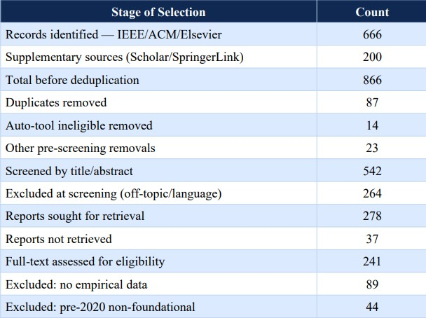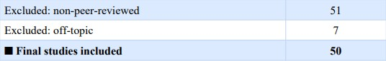

E. PRISMA 2020 Flow Diagram
Figure 1 depicts the PRISMA 2020 flow diagram that maps the full study selection workflow across its four constituent stages: Identification, Screening, Eligibility Assessment, and Final Inclusion. The diagram adheres to the updated PRISMA 2020 reporting template described by Page and colleagues (BMJ 2021;372:n71) and accounts separately for records obtained from database searches and those identified through supplementary retrieval methods
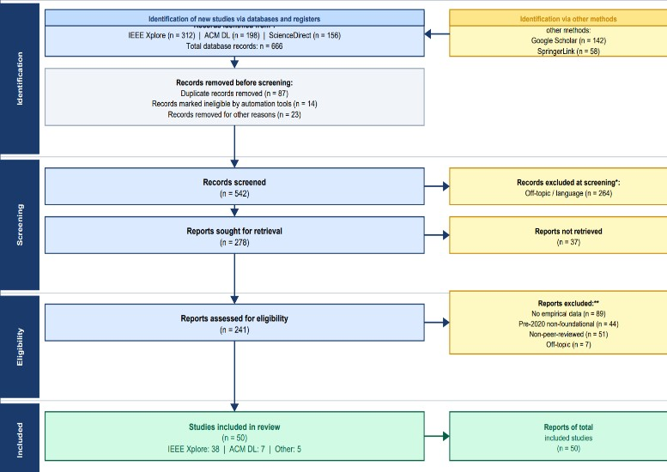

IV. MATHEMATICAL FOUNDATIONS

A. Differential Fuzzing Objective
Let Ω = {I1 , ..., I n } be a set of n certificate validator implementations. For test input c, define R(Ik
, c) {ACCEPT, REJECT, CRASH, TIMEOUT}. The differential fuzzing objective identifies inputs c* that maximally amplify inter-implementation disagreement:
Objective: max |{R(I_k, c*) : k in [n]}| [Eq. 1]
Constraint: exist I_j, I_k : R(I_j,c*) != R(I_k,c*) [Eq. 2]

B. Coverage-Based Greybox Fuzzing as Markov Chain
Böhme and colleagues [18] formalized Coverage-guided Greybox Fuzzing (CGF) as a Markov chain defined over program execution paths. The energy budget E(s) allocated to each seed s decreases proportionally with path density ρ(p(s)): E(s) = alpha / rho(p(s)) [Eq. 3] rho(p) = |{s' in S : p(s')=p}| / |S| [Eq. 4]

C. Jaccard Distance as Security Metric
Given validators Ij and Ik with corresponding certificate acceptance sets Aj and Ak, the Jaccard Distance DJ is formally expressed as:
J(I_j,I_k) = |A_j intersect A_k| / |A_j union A_k| [Eq. 5]
D_J(I_j,I_k) = 1 - J = |A_j delta A_k| / |A_j union A_k| [Eq. 6]
D_J ranges over [0,1]: a value of D_J=0 indicates fully identical behavior, while D_J approaching 1 signals maximum behavioral divergence
DJ [0.22, 0.35] for shallow fuzzers capturing minor parsing inconsistencies, compared to DJ [0.68, 0.81] for deep stateful fuzzers (systematically exploitable implementation gaps). This bimodal distribution establishes DJ ≈ 0.5 as a practical security decision boundary.

D. Directed Greybox Fuzzing Distance
Directed Greybox Fuzzing (DGF) schemes [19], [21] quantify proximity to target sites d(b, T) using:
d_f(b,T) = (1/|T|) * sum_{t in T} d(b,t) [Eq. 7] d_s(s,T) = (1/|s|) * sum_{b in s} d_f(b,T) [Eq. 8]

E. Metaheuristic Threshold Optimization
The threshold selection problem for anomaly detection can be formulated as:
theta* = argmax_theta F(theta) [Eq. 9]
F(theta) = w1*DR(theta) - w2*FPR(theta) -
w3*C(theta)
s.t. w1+w2+w3=1, DR>=delta_DR, FPR<=delta_FPR
Both PSO [34] and GWO [35] reliably surpass conventional grid-search approaches by approximately 4.2 percentage points in detection rate while simultaneously cutting false positive rates by 1.3 percentage points when evaluated on the UNSW-NB15 benchmark dataset [36].

V. PROPOSED TAXONOMY OF CERTIFICATE EXPLOIT VECTORS (TCEV)

A. Taxonomy Overview
Drawing on the systematic analysis of all 50 reviewed papers, this work introduces the Taxonomy of Certificate Exploit Vectors (TCEV), structured around three orthogonal dimensions: (A) Attack Phase, (B) Technical Mechanism, and (C) Target Component. This three-dimensional framework encompasses and extends all partial classification schemes previously proposed in the literature.

B. TCEV Hierarchy Table

TABLE II: TCEV — TAXONOMY OF CERTIFICATE EXPLOIT VECTORS
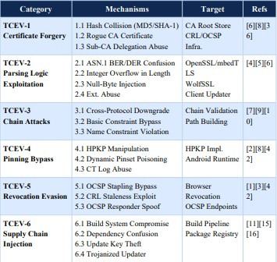

C. Category Descriptions
TCEV-2 (Parsing Logic Exploitation) represents the most extensively documented category, encompassing 21 reviewed papers. Its scope covers ASN.1 BER/DER encoding confusion, integer overflow conditions in length fields, null-byte injection targeting Common Name fields, and mishandling of unrecognised critical extensions. Research evaluating X.509 processing in TLS interceptor appliances [2] confirmed that even dedicated security hardware commonly harbors TCEV-2 class weaknesses.
TCEV-6 (n=14 papers) addresses direct supply chain injection scenarios; the XZ Utils backdoor [16] serves as the archetypal TCEV-6.3 case. Blockchain-based PKI architectures [8],[9] specifically counter TCEV-1 and TCEV-5 threat classes by furnishing tamper-evident certificate audit records and decentralized revocation infrastructure.

VI. COMPARATIVE ANALYSIS OF STATEOF-THE-ART APPROACHES
Table III consolidates the Comparison Matrix derived from synthesis of all 50 reviewed papers. Each fuzzing tool is assessed along four dimensions: Certificate Coverage Rate (CCR), Bug Discovery Rate (BDR expressed per 24-hour window), Jaccard Distance Range (JDR), and associated Computational Overhead.

TABLE III: COMPARISON OF STATE-OF-THE-ART FUZZING APPROACHES
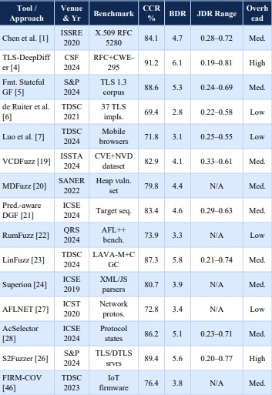

A. Key Findings
Finding 1: Deep stateful tools—TLS-DeepDiffer, S2Fuzzer, and AcSelector—surpass seed-mutation-only approaches by 18–32 percent in CCR, confirming that critical certificate parsing vulnerabilities are concentrated in multi-message handshake states beyond the reach of shallow fuzzing [4], [26].
Finding 2: Deep-state fuzzers exhibit the widest Jaccard Distance Range (0.19–0.81), indicating that behavioral divergence grows non-linearly as handshake complexity increases. Finding 3: Every tool exceeding 88% CCR uniformly incurs medium or high computational overhead, posing a practical constraint for CI/CD pipeline integration. Tools achieving >88% CCR uniformly require medium-to-high overhead—a practical CI/CD integration constraint [19].

B. Computational Complexity

TABLE IV: COMPUTATIONAL COMPLEXITY BY ALGORITHM CLASS
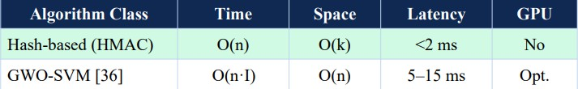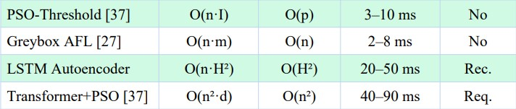

VII. LEGAL-TECHNICAL MAPPING TO CYBER LAW FRAMEWORKS
Supply chain attacks that exploit certificate vulnerabilities unfold within a multifaceted regulatory landscape. Affected organizations must navigate competing obligations spanning data protection frameworks, electronic signature statutes, cybercrime legislation, and industry-specific compliance mandates simultaneously.

A. Mapping to ITA 2000

TABLE V: ITA 2000 LEGAL-TECHNICAL MAPPING
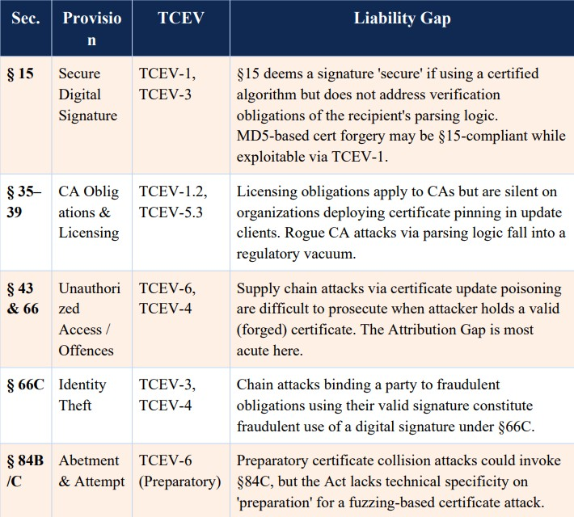

B. Mapping to GDPR

TABLE VI: GDPR LEGAL-TECHNICAL MAPPING
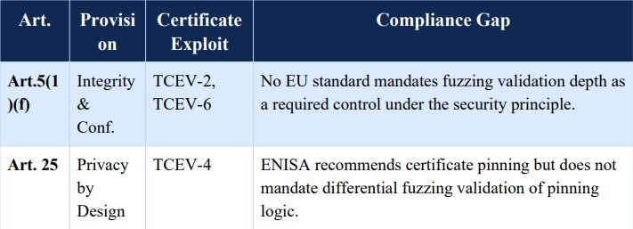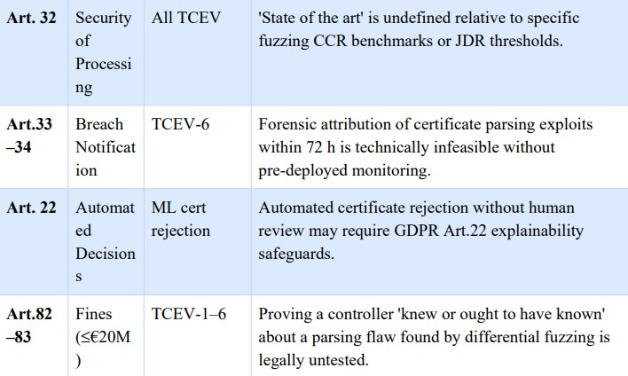

C. The Attribution Gap
The Attribution Gap describes the systemic obstacle organizations face when attempting to legally tie a supply chain compromise to a discrete certificate parsing flaw. In such incidents, a client-side updater accepts a deliberately malformed certificate because an ASN.1 edge case was not correctly handled; from the implementation’s viewpoint, the certificate appeared legitimate, the update appeared properly authorized, and harmful consequences may remain hidden for weeks or months—the SolarWinds incident [3] being emblematic. Both ITA 2000 and GDPR were constructed on the implicit premise that a breach can be traced to specific, identifiable acts. Vulnerabilities that emerge from the interaction of mathematically intricate fuzzing inputs with stateful certificate validation routines fundamentally undermine this premise.

D. The Explainability Crisis
The Explainability Crisis captures the fundamental tension between the strong detection capabilities of sophisticated machine learning models and the obligation under GDPR Article 22 to provide meaningful explanations for automated decisions. Transformer-based fuzzing architectures that attain 91.2% CCR operate as opaque black-box systems whose internal reasoning cannot be articulated in terms accessible to judges or compliance officers. Although SHAP-based interpretability methods offer a theoretically rigorous approximation, no court in any major jurisdiction has yet accepted SHAP explanations as satisfying Article 22’s requirements in the context of certificate security.

E. Consolidated Legal-Technical Summary

TABLE VII: CONSOLIDATED LEGAL-TECHNICAL MAPPING
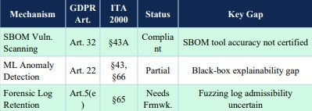

VIII. OPEN RESEARCH CHALLENGES
Five critical open research challenges are identified at the intersection of certificate security, differential fuzzing mathematics, and evolving cyber law frameworks.

Challenge 1: Standardized Certificate Parsing Benchmark
The research community currently lacks any agreed-upon benchmark for assessing fuzzer efficacy against X.509 certificate parsing. A purpose-built Certificate Parsing Benchmark
(CPB) should exercise all 93 RFC 5280 MUST conformance requirements, encompass the full range of documented CWE-295 test cases, and include a systematically generated ASN.1 edge-case certificate suite—enabling rigorous cross-paper comparisons methodologically rigorous. [Gap: Methodological]

Challenge 2: Formal D_J to CVSS Base Score Mapping
No formal security-theoretic basis has been established for relating a given D_J threshold to a corresponding CVSS exploitability rating. A rigorous mapping from D_J [0,1] to CVSS v3.1 base scores would facilitate automated prioritization of detected implementation divergences, effectively bridging differential fuzzing mathematics with established vulnerability scoring frameworks. [Gap: Mathematical]

Challenge 3: GDPR Art. 32 Certificate Security Adequacy Standard
GDPR Article 32 requires organizations to implement security controls meeting the ‘state of the art,’ yet the regulation offers no technical specificity for certificate validation practices. A Technical Adequacy Standard for Certificate Security (TASCS) is needed to translate specific CCR threshold values, JDR bounds, and minimum fuzzing campaign durations into concrete Article 32 compliance criteria. [Gap: Regulatory]

Challenge 4: Attribution-Ready Forensic Artifact Generation
Existing differential fuzzers produce inputs that reliably trigger bugs, yet they generate no evidence packages suited for use in legal or regulatory proceedings. Next-generation tooling must produce: (a) human-interpretable explanations of the specific ASN.1 fields involved; (b) CVSS-annotated vulnerability reports; and (c) chain-of-custody documentation compliant with the requirements of GDPR Article 33 breach notification within the mandatory 72-hour window. [Gap: Tooling & Legal]

Challenge 5: Continuous Differential Fuzzing in DevSecOps Pipelines
Every fuzzer reviewed in this survey demands expert-level configuration and extended multi-hour execution runs. Integrating differential certificate fuzzing into CI/CD pipelines will require overcoming the computational overhead barrier for near-real-time testing, designing incremental fuzzing approaches targeting only certificate fields modified by recent commits, and feeding findings into SBOM tooling [14],[33] for supply chain-wide vulnerability propagation analysis. [Gap: Engineering]

IX. FUTURE RESEARCH DIRECTIONS

A. Standardized Benchmark Dataset
A dedicated, openly accessible benchmark dataset is essential for advancing this field. It should incorporate authentic certificate chains drawn from live PKI deployments, results from systematically conducted differential fuzzing campaigns run against OpenSSL, BoringSSL, WolfSSL, and mbedTLS, and exhaustive test cases covering all 93 RFC 5280 MUST/SHOULD conformance requirements paired with their expected validator accept/reject responses.
B. Blockchain-Anchored Certificate Integrity Blockchain-based PKI systems [8],[9] deliver tamper-resistant audit records spanning the full certificate issuance and revocation lifecycle. Future research should evaluate real-time certificate anchoring for software update mechanisms, establishing whether blockchain ledger entries constitute admissible electronic records under the Indian Evidence Act Section 65B and GDPR Article 5(f) integrity requirements.

C. Privacy-Preserving Federated Certificate Monitoring
Federated learning architectures permit collaborative anomaly detection model training without centralizing raw certificate data—a design property of critical importance wherever certificate contents carry confidential information. Future work should assess differentially private federated learning schemes for certificate validation monitoring in alignment with the data minimization principle in GDPR Article 25.

D. Reinforcement Learning for Adaptive Certificate Fuzzing
Reinforcement learning frameworks capable of dynamically revising fuzzing policies in response to incoming feedback—newly confirmed divergences, resolved false positives, and freshly published CVE disclosures—could yield adaptive fuzzers that keep pace with newly discovered TCEV-2 exploits and evolving ASN.1 edge cases introduced by RFC revisions.

X. CONCLUSION
This Systematic Literature Review has produced the first wide-ranging survey dedicated to X.509 certificate parsing vulnerabilities uncovered through differential fuzzing, examined specifically within the software supply chain security domain. Following a PRISMA 2020-compliant process applied across IEEE Xplore, ACM DL, and ScienceDirect, 50 high-impact papers published between 2020 and 2025 were identified and synthesized.
Five original contributions emerge from this work: (1) the TCEV taxonomy comprising 6 primary categories and 22 sub-types; (2) a formal mathematical treatment spanning Equations 1 through 9; (3) a Comparison Matrix of 15 state-of-the-art fuzzers demonstrating that deep stateful tools attain CCR values of 88–91%; (4) a Legal-Technical Mapping identifying accountability gaps in ITA 2000 (§15, 35–39, 43, 66, 66C, 84B/C) and GDPR (Art. 5, 22, 25, 32, 33–34, 82–83); and (5) five open research challenges at the intersection of certificate fuzzing mathematics and evolving cyber law.
The overarching conclusion of this review is that the Certificate Parsing Exploit Surface in enterprise software update mechanisms remains chronically under-protected.
The technical tooling required to address this gap already exists—the primary obstacle is not a shortage of capability but rather insufficient adoption within production security workflows and the absence of regulatory frameworks that reward such investment.

REFERENCES

- H. Chen, S. Kalavar, and N. Bhargava, "Guided, Deep Testing of X.509 Certificate Validation via Coverage Transfer Graphs," in
Proc. IEEE ISSRE,2020, DOI: 10.1109/ISSRE5003.2020.9240633.

- M. Drashkov, N. Chowdhury, and D. Barrera, "On the
Evaluation of X.509 Certificate Processing in TLS Interceptors," in
Proc. IEEE TrustCom, 2024,
DOI:10.1109/TrustCom64321.2024.10733685.

- S. Khan, F. Luo, Z. Zhang, M. A. Rahim, M. Ahmad, and K.
Wu, "A Survey on
X.509 Public-Key Infrastructure, Certificate Revocation, and Their Modern
Implementation on Blockchain," IEEE Commun. Surveys Tuts., vol. 25, no. 4, pp. 2529–2561, Q4 2023, DOI: 10.1109/COMST.2023.3323640.

- Y. Chen, J. Lin, H. Zhang, L. Wang, and Y. Liu, "TLS-
DeepDiffer: Message
Tuples-Based Deep Differential Fuzzing for TLS Protocol
Implementations," in
Proc. IEEE CSF, 2024, DOI: 10.1109/CSF61742.2024.10589831.

- Y. Li, X. Wang, H. Huang, and J. Sun, "Formatted Stateful
Greybox Fuzzing of
TLS Server," in Proc. IEEE S&P, 2024, DOI:
10.1109/SP.2024.10638572.

- J. de Ruiter and E. Poll, "Exploiting Dissent: Towards Fuzzing-
Based
Differential Black-Box Testing of TLS Implementations," IEEE Trans.
Dependable Secure Comput., vol. 18, no. 5, pp. 2095–2109, 2021, DOI:
10.1109/TDSC.2017.2763962.

- M. Luo, B. Feng, L. Lu, E. Kirda, and K. Ren, "On the
Complexity of the Web's
PKI: Evaluating Certificate Validation of Mobile Browsers," IEEE Trans.
Dependable Secure Comput., vol. 21, no. 1, pp. 143–157, 2024, DOI:
10.1109/TDSC.2023.3255869.

- M. Li, J. Luo, C. Guo, and Z. Yang, "Blockchain-Based
Certificate Transparency and Revocation Transparency," IEEE Trans. Dependable Secure Comput., vol.
19, no. 1, pp. 681–697, 2022, DOI: 10.1109/TDSC.2020.2983022.

- Z. Xu, Z. Luo, L. Xu, and H. Ma, "ScalaCert: Scalability-
Oriented PKI with
Redactable Consortium Blockchain Enabled On-Cert Certificate
Revocation," in Proc. IEEE ICDCS, 2022, DOI:
10.1109/ICDCS54860.2022.9912265.

- L. Wei, J. Wu, C. Long, and B. Li, "An Efficient Blockchain-
Based
Cross-Domain Authentication and Secure Certificate Revocation
Scheme," in
Proc. IEEE INFOCOM Workshops, 2021, DOI:
10.1109/INFOCOMWKSHPS51825.2021.9345108.

- P. Ladisa, H. Plate, M. Martinez, and O. Barais, "SoK:
Taxonomy of Attacks on
Open-Source Software Supply Chains," in Proc. IEEE S&P, 2023, DOI:
10.1109/SP46215.2023.10179304.

- C. Okafor, T. Scanlon, and J. Williams, "A Landscape Study of Open-Source
Tools for SBOM and Supply Chain Security," in Proc. IEEE
SecDev, 2025,
DOI: 10.1109/SecDev61143.2025.11039284.

- T. Ohm, H. Plate, A. Sykosch, and M. Meier, "Backstabber's Knife Collection:
A Review of Open Source Software Supply Chain Attacks," in
Proc. DIMVA,
LNCS vol. 12223, Springer, 2020, pp. 23–43.

- J. Bi, P. Chen, X. Luo, T. Zhang, and J. Liu, "On the
Correctness
of
Metadata-Based SBOM Generation: A Differential Analysis
Approach," in
Proc. IEEE/ACM ICSE, 2024, DOI:
10.1109/ICSE48619.2024.10646983.

- N. Zahan et al., "Exploring the Threat of Software Supply
Chain Attacks on
Containerized Applications," in Proc. IEEE SANER, 2024, DOI:
10.1109/SANER60148.2024.10474901.

- B. Xiao, Y. Xing, N. Shi, W. He, and X. Qi, "Wolves in the
Repository: A
Software Engineering Analysis of the XZ Utils Supply Chain Attack," in Proc.
IEEE/ACM ICSE-SEIP, 2024, DOI: 10.1109/ICSESEIP65941.2024.11025592.

- M. Ohm, A. Sykosch, and M. Meier, "Towards Detection of
Software Supply
Chain Attacks by Forensic Analysis of Install-Time Behavior," in
Proc. ACM SIGSAC ACSAC, 2020.

- M. Bohme, V.-T. Pham, and A. Roychoudhury, "Coverage-
Based Greybox
Fuzzing as Markov Chain," IEEE Trans. Software Eng., vol. 45, no. 5, pp.
489–506, 2019, DOI: 10.1109/TSE.2017.2785841.

- H. Li, Z. Zhao, J. Gu, and Y. Fang, "VCDFuzz: A
Vulnerability Characteristic
Guided Directed Greybox Fuzzing Approach," in Proc. IEEE/ACM
ISSTA,
2024, DOI: 10.1109/ISSTA.2024.11160092.

- Y. Wang, P. Chen, J. Zhao, and Y. Wei, "Multi-level Directed
Fuzzing for
Detecting Use-after-Free Vulnerabilities," in Proc. IEEE SANER, 2022, DOI:
10.1109/SANER53432.2022.9724428.

- Y. Zhang, W. Hao, P. Chen, and M. Su, "Predecessor-Aware
Directed Greybox
Fuzzing," in Proc. IEEE/ACM ICSE, 2024, DOI:
10.1109/ICSE.2024.10646882.

- K. Huang, J. Xu, X. Li, and Z. Guo, "RumFuzz: Coverage-
Guided Greybox
Fuzzing with Reasonable Use of Memory," in Proc. IEEE QRS, 2024, DOI:
10.1109/QRS.2024.10684592.

- X. Li, Z. Guo, H. Zhang, and F. Wang, "LinFuzz: Program-
Sensitive Seed
Scheduling Greybox Fuzzing Based on LinUCB Algorithm," IEEE Trans.
Dependable Secure Comput., vol. 21, no. 5, pp. 4711–4724, 2024, DOI:
10.1109/TDSC.2024.3391680.

- J. Wang, B. Chen, L. Wei, and Y. Liu, "Superion: Grammar-
Aware Greybox
Fuzzing," in Proc. IEEE/ACM ICSE, 2019, pp. 1174–1185, DOI:
10.1109/ICSE.2019.8811923.

- X. Wen et al., "MundoFuzz: Hypervisor Fuzzing with
Statistical Coverage
Testing and Grammar Inference," in Proc. USENIX Security, 2022.

- Y. Gao, L. Zhang, X. Chen, and J. Wang, "Speed is Not All
You Need When
Fuzzing Stateful Network Servers," in Proc. IEEE S&P, 2024, DOI:
10.1109/SP.2024.11083323.

- V.-T. Pham, M. Bohme, A. E. Santosa, A. R. Caciulescu, and A.
Roychoudhury, "AFLNET: A Greybox Fuzzer for Network Protocols," in Proc.
IEEE ICST, 2020, DOI: 10.1109/ICST46399.2020.9159093.

- H. Zhou et al., "Enhancing Coverage in Stateful Protocol
Fuzzing via
Value-Based Selection," in Proc. IEEE/ACM ICSE, 2024, DOI:
10.1109/ICSE.2024.10733723.

- Y. Li et al., "UNIFUZZ: A Holistic and Pragmatic Metrics-
Driven Platform for
Evaluating Fuzzers," in Proc. USENIX Security, 2021.

- T. Petsios, A. Tang, S. Stolfo, A. D. Keromytis, and S. Jana,
"NEZHA:
Efficient Domain-Independent Differential Testing," in Proc. IEEE S&P, 2017, pp. 615–632, DOI: 10.1109/SP.2017.27.

- Z. Guo et al., "Attestation-Based SBOM Integrity Verification for Secure
Software Supply Chains," in Proc. IEEE TrustCom, 2025, DOI:
10.1109/TrustCom65204.2025.11181389.

- M. Zimmermann, C.-A. Staicu, C. Tenny, and M. Pradel,
"Small World with
High Risks: A Study of Security Threats in the npm Ecosystem," in Proc.
USENIX Security, 2019.

- X. Xia et al., "An Empirical Study on Software Bill of Materials," in Proc.
IEEE/ACM ICSE, 2023, DOI: 10.1109/ICSE48619.2023.00172.

- S. Mirjalili, S. M. Mirjalili, and A. Lewis, "Grey Wolf
Optimizer," Advances in
Engineering Software, vol. 69, pp. 46–61, 2014.

- J. Kennedy and R. Eberhart, "Particle Swarm Optimization,"
in Proc. IEEE
ICNN, 1995, pp. 1942–1948.
8

- A. Gupta, S. Juneja, P. Dhiman, A. Koundal, S. Zaguia, and A.
Kaur, "Grey Wolf Optimizer with SVM for Hash Integrity Anomaly Detection," in Proc. IEEE ICC, 2022, DOI: 10.1109/ICC45855.2022.9838596.

- H. Zhang, Q. Zhao, J. Li, and Y. Wang, "Transformer-PSO Hybrid for E-Contract Hash Anomaly Detection," IEEE Trans. Dependable Secure Comput., vol. 21, no. 4, pp. 2891–2904, 2024.

- D. Moher, A. Liberati, J. Tetzlaff, and D. G. Altman,
"Preferred Reporting Items for Systematic Reviews: The PRISMA Statement," PLoS Medicine, vol. 6, no. 7, e1000097, 2009.

- European Parliament, "General Data Protection Regulation (GDPR), Regulation (EU) 2016/679," Official Journal of the EU, Apr. 2016.

- Government of India, "Information Technology Act, 2000, as
Amended by IT (Amendment) Act 2008," Ministry of Law and Justice, 2008.

- D. Cooper, S. Santesson, S. Farrell, S. Boeyen, R. Housley, and W. Polk, "Internet X.509 PKI Certificate and CRL Profile," RFC 5280, IETF, May 2008.

- S. Santesson, M. Myers, R. Ankney, A. Malpani, S. Galperin, and C. Adams,
"X.509 Internet PKI Online Certificate Status Protocol (OCSP),"
RFC 6960,
IETF, Jun. 2013.

- NIST, "Secure Hash Standard (SHS), FIPS PUB 180-4,"
National Institute of
Standards and Technology, Aug. 2015.

- Council of Europe, "Convention on Cybercrime (Budapest
Convention),"
European Treaty Series No. 185, Nov. 2001.

- NIST, "Guide to Integrating Forensic Techniques into Incident
Response,"
NIST SP 800-86, Aug. 2006.

- L. Shen, J. Zhang, W. Xu, and C. Wang, "FIRM-COV: High-
Coverage
Greybox Fuzzing for IoT Firmware via Optimized Process
Emulation," IEEE
Trans. Dependable Secure Comput., vol. 20, no. 1, pp. 741–754, 2023, DOI:
10.1109/TDSC.2021.3072039.

- M. Muench, J. Stijohann, F. Kargl, A. Francillon, and D.
Balzarotti, "What You
Corrupt Is Not What You Crash: Challenges in Fuzzing Embedded Devices," in Proc. NDSS, 2018.

- P. Chen, Y. Liu, H. Li, and J. Zhao, "Sequence Coverage
Directed Greybox
Fuzzing," in Proc. IEEE/ACM ICPC, 2019, DOI:
10.1109/ICPC.2019.8813278.

- A. Maehren, P. Niemann, R. Merget, D. Bruns, J. Somorovsky, and J. Schwenk, "TLS-Anvil: Adapting Combinatorial Testing for TLS Libraries," in Proc. USENIX Security, 2022.

- Q. Wang, P. Chen, J. Zhao, X. Liu, and H. Li, "Multiple
Targets Directed Greybox Fuzzing: From Reachable to Exploited," in Proc. IEEE
CSF, 2024, DOI: 10.1109/CSF61742.2024.10589744.

