Week 2 - System Design & Architecture
Name | Type | Information | Timings
Main gate | Entrance | The primary entry and exit point for the campus. | 24/7 (restricted access after 7:30 pm)
Café | Facility | Serves coffee, snacks, and light meals. A common student meeting point. | 7:30 am to 5 pm*
Auditorium | Building | Main hall for university events, seminars, and performances. | Varies by event schedule
Library | Building | Contains the main collection of books, journals, and provides quiet study areas. | 9 am to 5 pm
Academic block B | Academic building | Engineering block. | 9 am to 5 pm
Food court | Facility | The main dining area for hosteller students. | 7:30 am to 9:30 pm
Laundry | Facility | Laundry services for hosteller students | 9:30 am to 6 pm
Faculty hostel | Residence | Accommodation facilities designated for university faculty members. | 5:30 am to 10 pm*
Hostel | Residence | The main accommodation and residential building for students. | 5:30 am to 10 pm
Sports complex | Sports venue | The central hub for all sports facilities | 6 am to 7:30 pm*
Football ground | Sports area | Football play area for practice,matches etc. | 6 am to 7:30 pm*
Cricket pitch | Sports area | Cricket play area for practice,matches etc | 6 am to 7:30 pm*
Basketball court | Sports area | Outdoor court for basketball games and practice | 6 am to 7:30 pm*
Volleyball court | Sports area | Outdoor court fro volleyball games and practice | 6 am to 7:30 pm*
Tennis court | Sports area | Outdoor court for tennis matches and practice | 6 am to 7:30 pm*
Admin block | Admin building | The main administrative block of the college regarding, enquires ,admissions ,finances etc | 9 am – 5 pm

*the timings are taken approximately, it may vary little bit.

Navigation/pathfinding of the campus
n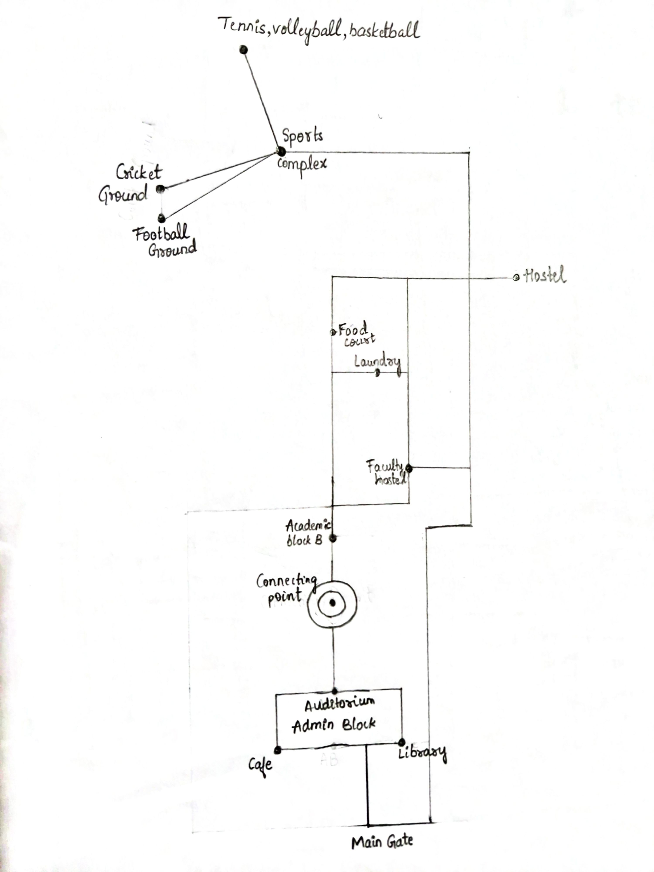

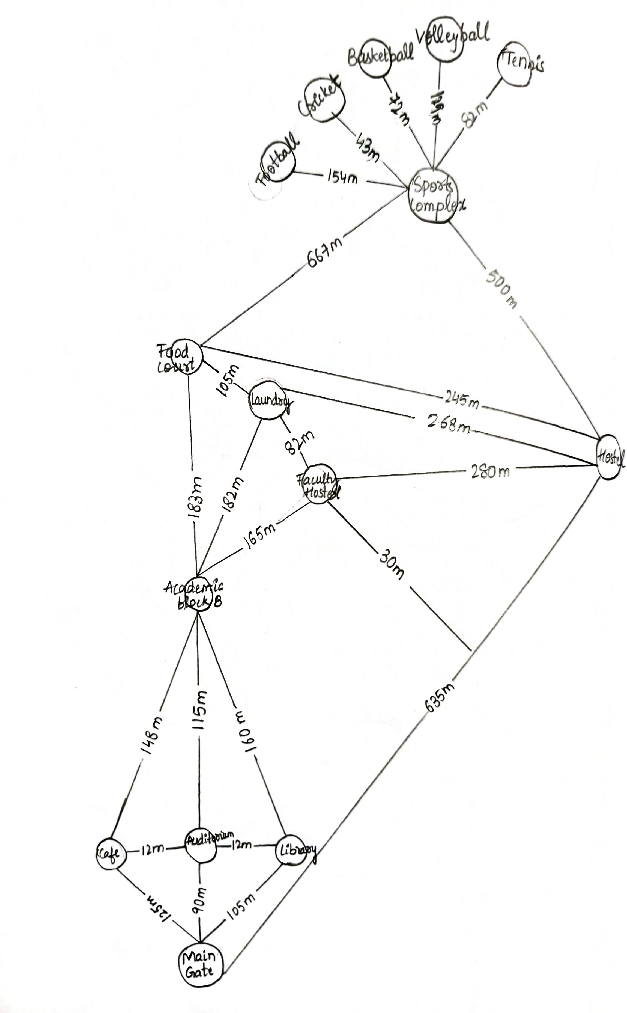
state space graph presentation of the campus
FAQs from the chatbot
Timings : What are the Library hours?, When does the Cafe close?,What are the timings for the Sports Complex?,When is the Food Court open?,What time does the Admin Block open?,What is the hostel in-time?,When can I use the laundry services? Etc
Location & Services: Where can I pay my fees?, What is in Academic Block B?, Where can I find the librarian?, Where can I do my laundry?, What services are in the Admin Block? etc
General Information : How do I use the navigator?, Are there any events scheduled today?, How do I connect to the campus Wi-Fi? Etc
there are many possibilities of questions which could be asked, listed out few of them.

Reference:
Google earth pro – to check the distance between two locations.
https://earth.google.com/web/@13.2236927,77.75757808,902.23141937a,611.9175951d,30.00000399y,341.47914767h,0t,0r/data=CgRCAggBOgMKATBCAggBSg0I____________ARAA

Pdfs and ppts of the introduction to AI and ML course.

