Introduction
Settlement at Greenroom is not purely a calculation problem; it is a trust and decision-making problem. Mariana often reviews settlements late at night and must mentally connect fragmented signals across status badges, artist notes, and manual comments under time pressure. I intentionally focused on the pre-signoff moment because it represents the highest-leverage opportunity to prevent avoidable disputes. Instead of redesigning the entire settlement workflow, I built an AI Settlement Review assistant that proactively surfaces risk signals, explains why a settlement may require attention, and recommends clear next steps.

Why this slice and not others
I intentionally focused on the pre-signoff settlement review moment because it represented the highest leverage point to reduce avoidable disputes. Rather than redesigning the full settlement workflow, I focused on helping Mariana interpret messy signals that already existed in the system. I prioritized depth over breadth and validated the concept around one high-signal disputed case before expanding into broader workflows.

- Original settlement page
Problem: Users can see status labels and notes, but the system does not explain why a settlement may be risky.
- Shows disputed workflow
- No AI guidance
- Mariana manually interprets everything
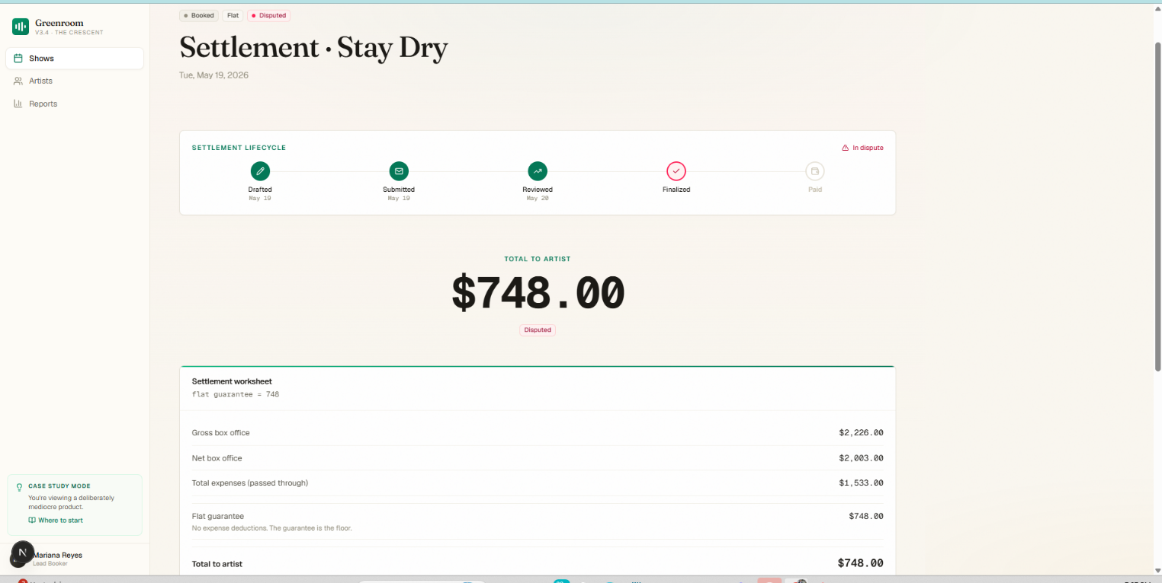

2. Original sign-off notes
The original experience required Mariana to manually interpret disconnected signals without guidance.
- Artist note: "ok wire monday"
- Mariana note: "Backline charge waived"
- No explanation for why status is disputed
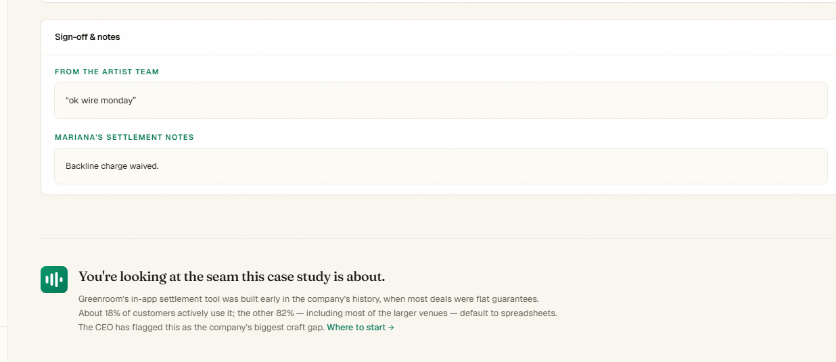

3. AI Settlement Review added
To address this gap, I introduced an AI review layer that proactively surfaces hidden risk signals and explains the reasoning behind them.
- Risk surfaced
- Reasons explained
- Next action suggested

Why I built this:
Settlement pages often contain disconnected information across status badges, artist notes, and manual comments. In disputed cases, Mariana currently has to mentally piece together risk signals at 2am. I added an AI Settlement Review panel that proactively explains why a settlement may be risky and recommends next actions, reducing cognitive load and helping prevent avoidable disputes.
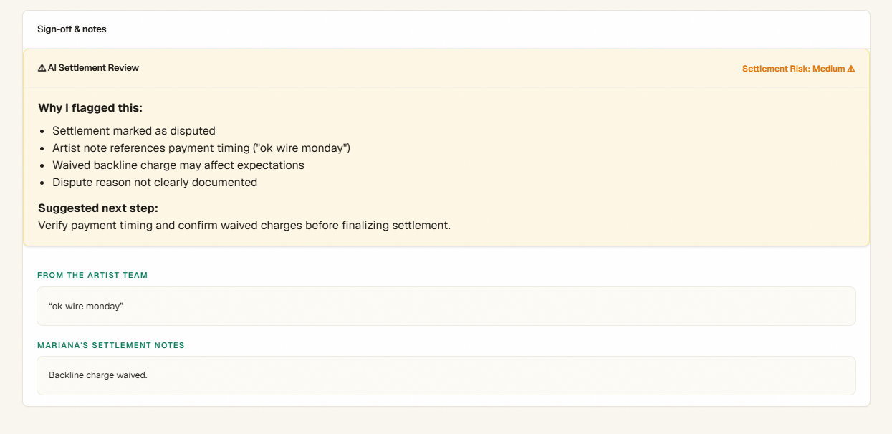

AI-assisted workflow
To move faster while preserving product judgment, I used AI as a collaborative teammate throughout the build process rather than as a replacement for decision-making. AI accelerated implementation and exploration, while I retained ownership of scope, prioritization, and tradeoffs.
Examples of AI usage:
- Used AI to quickly understand and navigate the Greenroom codebase structure.
- Used AI during implementation to identify where settlement sign-off components lived in the React/Next.js flow.
- Iterated on multiple versions of risk explanations and recommendation messaging.
- Used AI support during debugging, Git setup, and local environment configuration.
- Used AI to accelerate coding and content generation while retaining control over product decisions and feature scope.
- Human judgment determined which workflow to solve, why this slice mattered, and what features were intentionally excluded.

Design decisions & implementation changes
- Added a color-coded AI review card to visually separate high-attention items from standard notes.
- Used amber/yellow risk styling to indicate caution without creating panic.
- Added a visible Settlement Risk: Medium label for fast scanning at 2am.
- Grouped signals under Why I flagged this to explain reasoning instead of only surfacing alerts.
- Added Suggested next step to make the output actionable rather than informational.
- Designed the AI assistant to augment Mariana’s judgment instead of replacing it.

What I intentionally cut:
- Full settlement calculator redesign
- Predictive revenue modeling
- Agent chatbot workflow
- End-to-end dispute resolution redesign
I intentionally focused only on the pre-signoff moment because it represented the highest-leverage opportunity to reduce confusion and prevent avoidable disputes.

Limitations:
The current prototype was designed and demonstrated around a single disputed settlement scenario. I intentionally started with one high-signal case to validate the workflow before expanding broadly. In a production version, I would test across multiple settlement patterns such as disputed status with positive sign-off, payment timing ambiguity, waived expenses, and historical repeat disputes to refine AI confidence and reduce false positives.

Next steps:
- Historical pattern detection across prior settlements
- Dynamic AI risk scoring
- Similar-settlement matching
- Learning from prior dispute outcomes
This version creates a narrow and defensible first step while leaving room for future iterations.

