THE ICFAI FOUNDATION FOR HIGHER EDUCATION, HYDERABAD
FACULTY OF SCIENCE AND TECHNOLOGY
A FINAL PROJECT REPORT ON
Blockchain-Based Academic Record Management and Verification System
A Web3 Student Information System with Zero-Gas Credential Verification
Submitted in partial fulfilment of the requirements for the award of the degree of
BACHELOR OF TECHNOLOGY
SPECIAL PROJECT (SP301)
Submitted by
Kasala Yashas Reddy (24STUCHH010288)
Kurri Bhavesh Kumar (24STUCHH010966)
Vegesna Sujit Varma (24STUCHH010891)
Mantena Laxmi Kishore Varma (24STUCHH010060)

Under the guidance of
Dr. D. Krishna Madhuri
Department of Computer Science and Engineering
October 2026

Declaration
We hereby declare that the project report entitled “Blockchain-Based Academic Record Management and Verification System” submitted to the Faculty of Science and Technology, ICFAI Foundation for Higher Education, Hyderabad, in partial fulfilment of the requirements for the award of the degree of Bachelor of Technology, is a record of original work carried out by us under the guidance of Dr. D. Krishna Madhuri.
The system described in this report was designed, implemented and evaluated by the authors. All external sources of information, standards, libraries and research publications that informed the design are acknowledged in the references. The measurements reported in Chapter 6 were produced by the measurement scripts contained in the project repository, and the raw values are retained in the repository so that the results can be reproduced.
This work has not been submitted, either in part or in full, for the award of any other degree or diploma at this or any other institution.

Signature: ______________________  Kasala Yashas Reddy  24STUCHH010288 | Signature: ______________________  Kurri Bhavesh Kumar  24STUCHH010966

Signature: ______________________  Vegesna Sujit Varma  24STUCHH010891 | Signature: ______________________  Mantena Laxmi Kishore Varma  24STUCHH010060

Place: Hyderabad
Date:

Certificate
This is to certify that the project report entitled “Blockchain-Based Academic Record Management and Verification System” is a bonafide record of the special project work carried out by Kasala Yashas Reddy (24STUCHH010288), Kurri Bhavesh Kumar (24STUCHH010966), Vegesna Sujit Varma (24STUCHH010891) and Mantena Laxmi Kishore Varma (24STUCHH010060), students of the Faculty of Science and Technology, ICFAI Foundation for Higher Education, Hyderabad, during the academic year 2026–27, under my supervision and guidance.
The work presented in this report is original and has been evaluated through the test suites and measurement scripts described in Chapters 5 and 6. It has not been submitted elsewhere for the award of any degree or diploma.

Project Guide: ______________________
Dr. D. Krishna Madhuri
Head of Department: ______________________
Department of Computer Science and Engineering

Acknowledgement
We express our sincere gratitude to our project guide, Dr. D. Krishna Madhuri, for her continuous guidance, careful review of our design decisions and her insistence that every claim in this report be backed by a measurement or a test result. Her feedback shaped both the architecture and the way we evaluated it.
We thank the faculty and staff of the Department of Computer Science and Engineering, Faculty of Science and Technology, ICFAI Foundation for Higher Education, Hyderabad, for the laboratory facilities and the academic environment that made this work possible. We are grateful to our classmates who acted as test users for the issuer and verification screens, and who reported several usability problems during the demonstrations.
Finally, we thank our families for their patience and support during the many long evenings that this project required. Any errors that remain in the implementation or in this report are ours alone.

Abstract
Academic credentials are still largely issued and verified through paper documents and centralised institutional databases. Verification therefore depends on direct contact between the verifier and the issuing institution, is slow, and gives a verifier no independent way to tell whether a presented transcript has been altered. This report presents the design, implementation and evaluation of a blockchain-based academic record management and verification system that keeps the institution's operational data off-chain and anchors only cryptographic evidence on an Ethereum-compatible ledger.
The implemented system is a full-stack student information system. Academic data — students, programmes, courses, enrolments and grades — live in a MySQL 8 database, which remains the mutable source of truth. When a registrar issues a transcript, the backend compiles a canonical, key-sorted JSON document from the live grade data, computes its SHA-256 digest (or the digest of an uploaded PDF), encrypts the stored document with AES-256-GCM, and anchors the digest, storage reference and issuer identity in an AcademicRecordManager smart contract. A record is marked ACTIVE only after the anchoring transaction is mined, so a failed transaction can never be presented as an issued credential. Corrections publish the corrected record and retire its predecessor in a single atomic transaction, and revocations update the on-chain status while preserving the audit trail.
Verification is deliberately treated as an integrated, zero-cost feature rather than a separate product. A verifier supplies a record identifier, a shared link or the document itself; the system reads the anchored evidence with a read-only eth_call that consumes no gas and requires no wallet, cross-checks the ledger against the database, and reports the database status, the ledger status, an explicit consistency flag and the issuer's signature check. Unknown identifiers return 404 and an unreachable chain is reported as unavailable, never as tampering. Identity is wallet-based: users sign a login challenge with MetaMask (or another EVM wallet) and the API issues a stateless twelve-hour session token, while the contract independently enforces its own issuer whitelist.
The system was evaluated with fourteen contract unit tests, a fifty-two assertion end-to-end API suite, a ten assertion chain-service round trip, a twenty-three mutation tamper suite, and a seven assertion chain-outage test, all of which passed. Public verification required 45–69 ms (mean 54.7 ms, n = 10) at zero gas; issuance required a mean of 304 ms and 101,548 gas; a revocation cost 53,179 gas and a correction 150,684 gas; a pre-signed batch measured 194.2 transactions per second against a 20 tx/s acceptance target. The report also states the limits of the prototype: the deployment is a local Hardhat network, Sepolia and IPFS pinning are configured but were not exercised, the credential signature is a wallet signature over the record digest rather than a W3C Data Integrity proof, and the trust model still assumes a single administrative authority.

Table of Contents
Open in Word and update this field to generate the table of contents with page numbers.

List of Figures
Open in Word and update this field to list the figures with page numbers.

List of Tables
Open in Word and update this field to list the tables with page numbers.

1. Introduction

1.1 Background and motivation
A degree certificate, a transcript or a mark sheet is the interface between years of study and the opportunities that follow it. Employers, admissions committees, scholarship bodies, immigration authorities and professional councils all need to answer the same question: is this document genuine, and does it still represent the institution's position? In most institutions that question is answered by a centralised database that only the institution can query, or by a paper document carrying a seal and a signature that must be verified manually.
That arrangement has three structural weaknesses. First, verification is a service the issuer must perform: an employer who receives a transcript from a candidate has to contact the university, wait for a response, and trust the channel through which the reply arrives. Second, the artefact and the record can diverge. Once a transcript leaves the registrar's office it is a file, and a file can be edited; nothing on the paper or in the PDF lets a third party detect that the grade point average printed on it was changed after issuance. Third, the lifecycle of a credential is invisible. A degree that has been revoked after a disciplinary finding, or a transcript that has been superseded after a correction, looks identical to a valid one when it is presented months later.
Public blockchains offer a property that centralised databases do not: an append-only ledger whose contents any participant can independently re-derive and check. If a digest of a credential is written to such a ledger at the moment of issuance, then a verifier who recomputes the digest of the presented document can determine whether the bytes are the bytes the institution anchored, without contacting the institution and without trusting the intermediary that delivered the file. The ledger also provides a natural place to record status changes, so revocation becomes a public, timestamped fact rather than an internal database row.
Blockchain does not, however, make a credential true, and it is important to be precise about what it does provide. It cannot validate the grade that a faculty member entered, it cannot make personal data disappear once written, and it cannot by itself give a verifier a machine-readable credential that interoperates with another institution's system. The literature review in Chapter 2 shows that the systems which have survived contact with real institutions treat the ledger as one component of a larger credential architecture, alongside digital signatures, identity, off-chain storage, status management and standardised data models. This project adopts that position: the blockchain is the anchoring and audit layer of a conventional student information system, not a replacement for it.

1.2 Problem definition
The project addresses the following concrete problems in academic record management:
- Certificate forgery. Academic documents circulate as PDFs and scanned images that can be edited with ordinary tools. A verifier holding only the document has no independent means of establishing that its contents match what the institution issued.
- Slow, issuer-dependent verification. Confirming a credential usually requires a request to the registrar, manual lookup and a reply. The delay is measured in days and the process does not scale during admission or recruitment cycles.
- Undetectable post-issuance modification. In a centralised store, a change to a grade or a status leaves no externally checkable evidence. Even where audit tables exist, they are visible only to the institution.
- Incomplete credential lifecycle. Revocation, correction and supersession are poorly represented. A verifier cannot easily distinguish a credential that was never valid from one that was valid and has since been revoked.
- Single point of failure and availability. Verification stops when the institution's system is unavailable, and long-term availability depends on the institution continuing to operate the same database.
- Weak student control. Graduates depend on the institution to send transcripts on their behalf and have no portable, self-serviceable proof of their own academic record.

1.3 Objectives
The objectives of the project, restated here so that Chapter 6 can trace results back to them, are:
- O1 — Manage academic records end to end. Implement issuance, retrieval, correction, revocation and transcript compilation as first-class operations of a student information system, driven by real programme, course, enrolment and grade data.
- O2 — Make unauthorised modification detectable. Anchor a cryptographic digest of the exact issued bytes on-chain and recompute it during verification, so that any change to the document is detectable by a third party.
- O3 — Enable verification without the issuer and without cost. Provide a public, wallet-free verification path that answers in well under a second and consumes no gas.
- O4 — Preserve the credential lifecycle. Represent Active, Revoked and Superseded states on-chain, link a superseded record to its replacement, and keep the transition atomic.
- O5 — Give students portable access. Let a student view and download their own credentials, and share a link or QR code that a verifier can resolve directly.
- O6 — Enforce authorisation independently of the API. Use role-based access control in the application and an issuer whitelist in the contract, so that a compromised or bypassed API still cannot write to the ledger.
- O7 — Fail honestly. Distinguish “not found”, “tampered”, “revoked” and “service unavailable” in both the API and the user interface, and never report an outage as tampering or a failed transaction as an issued credential.
- O8 — Produce reproducible evidence. Automate the functional, adversarial and performance evaluation so that every number quoted in this report can be regenerated from the repository.

1.4 Scope of the delivered system
The scope was fixed after the midterm review and is summarised below. Items in the right-hand column are deliberately excluded and are revisited in Section 7.4.

In scope (implemented and exercised) | Out of scope (not implemented)
Wallet-based sign-in and role-based access for ADMIN, ISSUER, STUDENT and VERIFIER | Federated identity, institutional SSO and DID-based issuer identity
Programme, course, enrolment and grade management with weighted GPA computation | Integration with commercial student information systems or LMS platforms
Credential issuance from live academic data or an uploaded PDF, with canonical JSON | W3C Verifiable Credential issuance with Data Integrity proofs
SHA-256 digest anchoring and AES-256-GCM encryption of stored documents | On-chain storage of personal data or full credential documents
Active / Revoked / Superseded lifecycle with atomic supersession | Multi-institution consortium governance and cross-institution credit transfer
Zero-gas public verification by identifier or by document hash | Zero-knowledge selective disclosure of individual claims
QR codes and shareable verification links | Camera-based QR scanning and a native mobile application
Local Hardhat deployment with Sepolia configuration present | A funded public testnet or mainnet deployment with measured public-network cost
Table 1.1. Scope of the implemented system.

1.5 Contributions of the work
- A working hybrid architecture in which academic data stays in a relational database and the ledger stores only a digest, a storage reference, an issuer address and a status, with a documented rule for exactly which bytes are hashed.
- An issuance protocol that couples the database and the ledger correctly: a record is created as DRAFT, anchored, and only promoted to ACTIVE after the receipt is confirmed, with an explicit retry path for failures.
- A verification procedure that cross-checks two independent sources and reports a consistency flag, so that tampering with the database behind the ledger's back is visible rather than silently trusted.
- An adversarial evaluation, including a twenty-three mutation tamper suite and an automated chain-outage test, and a measured performance characterisation of the anchoring path.
- A usable interface for registrars and students, including QR-based sharing, with the verification page accessible without a wallet or an account.

1.6 Limitations of the delivered system
The prototype is honest about what it does not do. These limitations are developed further in Section 7.3.
- All measurements were taken on a local Hardhat node with automining; they characterise the implementation, not a public network, where block times and fees dominate.
- Sepolia deployment and Pinata pinning are configured in the codebase but were not exercised because no funded testnet key or pinning credential was available during the project.
- The issuer credential signature is an EIP-191 wallet signature over the record digest. It is not a W3C Data Integrity proof, and the credential JSON is W3C-VC-shaped rather than conformant.
- The trust model is single-institution: the contract administrator, which is also the server signer in the default configuration, controls the issuer whitelist.
- QR codes are generated and resolve to the verification page, but camera-based scanning is not implemented; a verifier types or follows the link.
- The system anchors what the institution asserts. It cannot detect an incorrect grade entered before issuance, which is a governance problem rather than a cryptographic one.

1.7 Organisation of the report
Chapter 2 reviews the research literature and the standards landscape, and derives the design requirements used later. Chapter 3 analyses the existing process, states the requirements and records the feasibility and environment decisions. Chapter 4 presents the architecture, data model, data-flow and UML design. Chapter 5 describes the implementation of the contract, the API, the storage layer and the client. Chapter 6 reports the testing strategy and the measured results, including the threats to their validity. Chapter 7 concludes and sets out the work that should follow. Appendices list the REST interface, the commands needed to reproduce the evidence, and the abbreviations used throughout.

2. Literature Review

2.1 Review approach
The review was conducted to answer a narrow question: which architectural choices in a blockchain-based academic credential system are supported by evidence, and which are assertions that the literature does not support? Peer-reviewed studies, standards documents and the documentation of deployed open-source systems were considered. Marketing material and unverifiable claims were excluded. The anchor study is the systematic review by Rustemi et al., which applied a PRISMA protocol to 1,744 publications between 2018 and 2022 and retained 34 primary studies on blockchain-based academic certificate verification [1]. That review is useful precisely because it is deflationary: it finds evidence of benefit in reliability, efficiency and independence from a central authority, but concludes that the field is not mature and that non-technical factors dominate adoption.
Three standards documents frame the analysis: the W3C Verifiable Credentials Data Model 2.0, published as a Recommendation in May 2025 [2]; the Open Badges 3.0 specification from 1EdTech, which profiles verifiable credentials for achievement claims [12]; and the European Commission's report on blockchain in education, which sets out the policy and ecosystem view [3][9]. The distinction the literature insists on, and which this project adopts, is that a blockchain is an anchoring technology, while a credential format is a data and cryptographic model. A system needs both, and one does not substitute for the other.

2.2 How academic credentials are verified today
Conventional verification relies on a database lookup performed by the issuing institution, on paper artefacts carrying seals and signatures, or on e-mail exchanges between registrars. Each of these depends on the issuing institution remaining reachable and cooperative, and each places the verifier in the position of trusting whatever channel delivered the response. The cost is not only delay: because the verifier cannot check anything independently, verification effort is concentrated at the issuer, which is exactly where capacity is scarcest during admission cycles. The systematic review identifies this dependency as the central inefficiency that blockchain-based proposals attempt to remove [1][3].
A second, subtler problem is that verification answers the wrong question. A registrar's confirmation typically establishes that a credential was issued, not that the document in the verifier's hands is the document that was issued. Where systems do bind the artefact to the record, they do so with a digital signature whose verification requires the issuer's public key and a signature format the verifier must implement. Blockchain anchoring simplifies the trust distribution problem — the digest is published, so anyone who can hash a file can check it — but it does not remove the need for signatures or for a defined serialisation of the signed bytes.

2.3 Thematic findings

2.3.1 Immutability does not establish truth
The most consistently repeated caution in the literature is that a ledger records assertions, not facts. If an authorised issuer anchors an incorrect grade, the ledger preserves the error with perfect fidelity. Blockcerts documentation makes the same point from the opposite direction: a verifiable credential proves that a claim was made by an issuer and has not been altered since, not that the claim is correct [4][5]. Any design must therefore treat issuer authorisation and data-entry governance as part of the security boundary. In this project the boundary is explicit: the digest proves integrity after issuance, and the database plus institutional process remain responsible for correctness at issuance.

2.3.2 Personal data should not be written to a public ledger
Academic records contain names, identifiers, grades and sometimes sensitive personal circumstances. Because public ledger entries are replicated and effectively permanent, writing such data on-chain conflicts with data-protection expectations and with the right to erasure. The design consensus is to store the credential off-chain and anchor a commitment — a hash, an identifier, a status — on-chain. ZKBAR-V extends this idea with a dual-blockchain design, IPFS storage, decentralised identifiers and zero-knowledge proofs, so that a verifier can establish a property of a record without receiving the record [6]. The cost is computational complexity and a considerably larger trust surface, which is why this project stops at the commitment and leaves zero-knowledge disclosure to future work.

2.3.3 The credential lifecycle is the hard part
Issuance is the easy case. A production credential system must also answer whether a credential is currently valid, must support correction when a grade is revised, and must survive key rotation. W3C Verifiable Credentials 2.0 devotes explicit machinery to credential status, and Blockcerts defines revocation and status handling for its certificates [2][5]. The lesson for this project is that status must be a first-class on-chain field rather than an inference from the presence of a hash, and that a correction should not merely delete the old record: it must leave a link from the superseded credential to its replacement, so that a verifier holding an older copy can discover what happened to it.

2.3.4 Interoperability requires standards, not clever schemas
Early blockchain credential projects defined their own JSON schemas and their own signature formats, which made them difficult to consume outside the issuing platform. The current consensus is towards W3C Verifiable Credentials, Decentralised Identifiers, the Data Integrity proof suites and Open Badges 3.0 [2][12]. EduCTX shows the same issue at the level of academic data: its contribution is a shared representation of ECTS credits across institutions, which only has value if institutions agree on the representation [7]. Interoperability is therefore a governance problem supported by standards, not a feature that a single implementation can deliver on its own.

2.3.5 Scale, cost and governance
Public networks impose fees, variable confirmation latency and external capacity constraints. Permissioned and consortium networks offer predictable throughput and institutional control, at the cost of membership and arbitration agreements that the literature identifies as unresolved [1][7]. There is no evidence in the reviewed work for a universally best consensus mechanism for academic credentials. The practical consequence for a prototype is to keep the on-chain footprint minimal — one write per issuance, one write per lifecycle change, and reads that cost nothing — so that the design remains viable whether it is later deployed to a Layer 2 network or to a consortium chain.

2.3.6 Usability and adoption
A credential that a graduate cannot easily hold, or that an employer cannot check without training, fails regardless of its cryptography. Rustemi et al. list staff training, cost of maintenance, diploma generation and the migration of existing certificates among the practical obstacles [1]. Open Badges 3.0 emphasises machine verifiability and portability for the same reason [12]. This project therefore treats verification as a public web page that requires no account, no wallet and no installation, and treats the registrar interface as the primary product rather than an afterthought.

2.4 Prior systems and standards
Blockcerts is the most mature open ecosystem for blockchain-anchored credentials, originally developed at the MIT Media Lab with Learning Machine. It combines signed credential documents with blockchain anchoring and a recipient-controlled wallet model, and has moved towards alignment with W3C Verifiable Credentials, Data Integrity and DIDs [4][5]. Its enduring lesson is the separation of concerns: the blockchain provides verification evidence, while the credential itself lives with the recipient. Its difficulties — key management, issuer identification, revocation and interoperability — are the same difficulties this project confronts in reduced form.
EduCTX by Turkanović et al. generalises the problem from certificate authenticity to academic credit representation, using an Ark-based blockchain in which institutions are peers and ECTX tokens represent ECTS credits [7]. It demonstrates that shared academic records are feasible, and that the hard problems migrate to governance and identity once issuance is solved. The Lifelong Learning Passport of Gräther et al. extends the horizon to a learner's whole life, combining blockchain, smart contracts and storage so that credentials from many institutions can travel with the learner [8]; it makes clear that a credential ecosystem needs consistent data models and status handling to be more than a collection of isolated certificates.
ZKBAR-V is the most privacy-forward design reviewed. It combines two blockchains, IPFS, decentralised identifiers and zero-knowledge proofs so that verification can establish claims without disclosing the underlying record [6]. It is technically impressive and computationally expensive, and it illustrates the trade-off this project declines to take: selective disclosure is valuable, but it multiplies the components that must be correct before the system can be trusted.
Recent Ethereum + IPFS implementations reported in 2025 follow the pattern this project adopts: store the document off-chain, hash it, and anchor the hash, keeping the cost of the ledger proportional to the number of credentials rather than their size [10][11]. Their shared weakness is also instructive: anchoring a hash does not by itself solve identity, revocation, privacy, interoperability or the availability of the off-chain object.
Two standards complete the picture. W3C Verifiable Credentials 2.0 defines a data model, a proof mechanism and a status mechanism for machine-verifiable credentials [2]; it is not a blockchain specification, and a system may implement it with or without a ledger. Open Badges 3.0 profiles that model for achievement credentials and is widely used in education [12]. This project borrows their vocabulary — issuer, holder, verifier, credential subject, proof, status — while implementing a deliberately simpler signature scheme, and it does not claim conformance.

System / standard | Core architecture | Main contribution | Principal limitation
Blockcerts [4][5] | Signed credential documents plus blockchain anchoring | Recipient-controlled, independently verifiable credentials | Key management, revocation and adoption requirements
EduCTX [7] | Ark-based permissioned blockchain with institutional peers | Shared representation of ECTS credits across institutions | Credits rather than full credential lifecycle and privacy
Lifelong Learning Passport [8] | Blockchain, smart contracts and storage | Portable record of achievements across a lifetime | Needs ecosystem-wide standards and governance
ZKBAR-V [6] | Dual blockchain, IPFS, DIDs and zero-knowledge proofs | Privacy-preserving verification with minimal disclosure | High cryptographic and operational complexity
Ethereum + IPFS studies [10][11] | Smart contracts with IPFS-hosted documents | Low on-chain footprint with tamper-evident verification | Identity, status and governance remain out of scope
W3C VC 2.0 [2] | Standard data, proof and status model | Interoperable, machine-verifiable credentials | Not a ledger and not an implementation
Open Badges 3.0 [12] | VC-conformant achievement credential profile | Standardised educational achievement claims | Requires issuer adoption and identity infrastructure
Table 2.1. Comparison of prior systems and standards, synthesised from the cited work.

2.5 From research gaps to design requirements
The gaps identified in Section 2.3 were converted into the requirements that shaped the architecture. The mapping is recorded explicitly so that the design can be judged against the literature rather than against convenience.

Gap in the literature | Design response in this project | Where it is realised
Immutability mistaken for correctness | Anchor integrity only; keep correctness inside institutional process and expose the issuer explicitly | Sections 4.8, 5.7; issuer signature check
Personal data on a public ledger | Store transcripts off-chain; anchor digest, storage reference and status only | Sections 4.4, 5.6; academic_records schema
Credential lifecycle and revocation | First-class Active / Revoked / Superseded states with a replacement link and atomic supersession | Sections 4.5, 5.2; supersedeRecord
Interoperability | VC-shaped credential JSON with a documented canonicalisation rule, leaving a path to full VC conformance | Sections 4.6, 5.4
Cost and scale of anchoring | One write per issuance or lifecycle change; all verification through a zero-gas view call | Sections 4.5, 6.9
Usability and adoption | Public verification page requiring no wallet or account; QR and link sharing; registrar-centric interface | Sections 5.9, 6.7
Failure semantics and trust in reporting | Explicit distinction between not found, tampered, revoked and unavailable, tested by an outage suite | Sections 4.9, 6.6
Table 2.2. Traceability from reviewed gaps to implemented design responses.

2.6 Summary
The literature supports a hybrid, standards-aware architecture: credentials stored off-chain under access control, a cryptographic commitment anchored on a ledger, an explicit status model, and a verification procedure that any third party can perform without the issuer's cooperation. It also warns, repeatedly, that blockchain alone solves none of identity, interoperability, governance or usability. The system described in the following chapters is a deliberate implementation of the defensible core of that position, with the remaining problems named rather than hidden.

3. System Analysis and Requirements

3.1 Analysis of the existing process
The existing process at most institutions is a chain of custody rather than a system. Grades accumulate in departmental spreadsheets and are consolidated into a student information system; a transcript is generated on request, printed or exported as a PDF, stamped and signed; and a copy is filed. Verification is a separate workflow triggered by an external request, handled by staff who look up the student record and reply in writing.
Modelling that workflow exposes four failure surfaces. The artefact leaves the controlled environment at the moment of printing, so the institution no longer knows what version a verifier holds. The verification response is only as trustworthy as the channel that carried it. Corrections require locating and withdrawing every copy already issued, which in practice does not happen. And because the verification workflow is staffed, its latency and availability are tied to office hours. None of these are cryptographic problems, but each of them is a problem that a correctly designed anchoring layer can make observable.
It is equally important to record what must not change. Registrars need to correct grades and re-issue transcripts; students change names; programmes are revised; and access to a transcript must remain controlled. A design that makes records permanently unmodifiable would be unusable. The architecture therefore separates mutable academic data from immutable evidence, and models change as a new record linked to its predecessor rather than as an edit.

3.2 The proposed system
The proposed system is a student information system in which academic record management is the product and verification is one integrated feature. It has three layers. A React single-page application provides dashboards for administrators, issuers and students, and a public verification page. A Node.js/Express API owns the business logic: it authenticates wallets, compiles transcripts, computes digests, encrypts and stores documents, coordinates transactions and cross-checks results. A MySQL 8 database holds the mutable academic data, while an Ethereum-compatible smart contract holds the immutable evidence.
The design rule that governs every decision is stated once and applied everywhere: MySQL stores the mutable academic data; the chain stores only the immutable evidence — the SHA-256 digest, the storage reference, the issuer address, the issuance time and the lifecycle status. No name, grade, programme or decryption key is written on-chain. Verification is a view function, so external verifiers pay nothing and never connect a wallet.
Four further principles follow from the literature. Issuance is transactional: a record is persisted as DRAFT, anchored, and promoted to ACTIVE only after the receipt is confirmed, so a failed transaction cannot be presented as an issued credential. Verification is corroborative: the ledger answer is compared with the database and the two must agree on both status and digest. Failures are differentiated: unknown, tampered, revoked and unavailable are distinct outcomes. And authorisation is duplicated: the API enforces roles, and the contract enforces an issuer whitelist that the API cannot override.

3.3 Actors and responsibilities

Actor | Responsibilities | Application role | Ledger rights
Registrar / faculty issuer | Maintain academic data, issue credentials, revoke or correct records | ISSUER | Whitelisted issuer: may issue, revoke and supersede
Administrator | Manage users, programmes and courses; whitelist issuer wallets; inspect activity | ADMIN | Contract admin: may manage the issuer whitelist and transfer admin
Student / holder | View and download own credentials, share links and QR codes, raise corrections offline | STUDENT | None (read-only through the public interface)
Verifier / public | Check a credential by identifier, link or document hash; no account required | Anonymous (VERIFIER role exists for institutional accounts) | None (read-only eth_call)
System signer | Anchors transactions when the browser wallet is not whitelisted; server-side fallback | Service account | Whitelisted issuer in the default local deployment
Table 3.1. Actors, responsibilities and privileges.

3.4 Functional requirements
Requirements were written to be testable, and each is exercised by at least one of the suites described in Chapter 6.

ID | Requirement | Verification
FR-01 | Users authenticate by signing a challenge with an EVM wallet; no password is stored | API suite, authentication group
FR-02 | An unknown but valid wallet is auto-provisioned as a STUDENT | API suite
FR-03 | Only ADMIN and ISSUER roles may issue, revoke or correct records | API suite (403 checks), contract tests
FR-04 | Administrators maintain programmes, courses, enrolments and grades | API suite, manual UI checks
FR-05 | GPA is computed from completed enrolments using weighted grade points | API suite, transcript assertions
FR-06 | A credential can be issued from live academic data or from an uploaded PDF | API suite, tamper suite
FR-07 | Credential identifiers are unique in both the database and the ledger | Contract tests, API suite
FR-08 | The digest is SHA-256 over the exact finalised bytes; canonical JSON is key-sorted | API suite, tamper suite
FR-09 | Stored documents are encrypted at rest with AES-256-GCM | API suite (ciphertext on disk)
FR-10 | A record is ACTIVE only after the anchoring transaction is confirmed | API suite, contract tests
FR-11 | A failed anchoring transaction leaves a DRAFT record and an audit entry, retryable | Chain-outage and failure-path tests
FR-12 | Revocation updates both the database and the ledger | API suite, contract tests
FR-13 | Correction publishes a new record and supersedes the old one in one transaction | API suite, contract tests
FR-14 | Any party can verify by credential identifier without authentication | API suite (public lookup)
FR-15 | Any party can verify by document hash, detecting any modification | Tamper suite (23 mutations)
FR-16 | Verification reports database status, ledger status and a consistency flag | API suite, tamper suite
FR-17 | Students see and download only their own credentials | API suite (scoping assertions)
FR-18 | The verification page is reachable from a QR code or shareable link | Manual UI checks
Table 3.2. Functional requirements and the evidence that each is met.

3.5 Non-functional requirements

Attribute | Requirement | Outcome in the prototype
Performance | Verification must complete in well under a second on a local node | Mean 54.7 ms, maximum 69 ms over ten trials (Section 6.9)
Cost | Verification must not consume gas or require a wallet | Read-only verifyRecord view function; gas cost 0
Reliability | A ledger outage must not be reported as tampering | Chain-outage suite passes 7/7 assertions (Section 6.6)
Integrity | Any modification of an issued document must be detectable | 23/23 mutations rejected; database tamper flagged (Section 6.5)
Security | Roles enforced in the application and independently in the contract | API 401/403 tests; contract RBAC tests
Confidentiality | Documents protected at rest and in transit | AES-256-GCM with per-record IV and authentication tag
Auditability | Every state change recorded with actor and transaction reference | audit_logs table with eleven recorded action types
Usability | Verification requires no account, wallet or installation | Public /verify/:credId page with QR and link sharing
Portability | Clear separation of standard and project-specific behaviour | Environment-driven configuration; no secrets in the repository
Maintainability | Module boundaries aligned with responsibilities | Contract, chain service, credential service, storage, routes
Table 3.3. Non-functional requirements and measured outcomes.

3.6 Feasibility analysis
Technical feasibility. Every component used is mature and open source: Solidity 0.8.24 with Hardhat for the contract, Node.js with Express and ethers v6 for the backend, React with Vite for the client, and MySQL 8 for storage. The only element that cannot be exercised without external credentials is IPFS pinning, which is therefore optional in the configuration.
Economic feasibility. On a local network the marginal cost of anchoring is zero. On a public network the design limits cost to one transaction per issuance and one per lifecycle change, with verification free. At the measured 101,548 gas per issuance, the cost of a cohort of a thousand credentials can be estimated directly from the network's gas price, and it scales linearly with the number of credentials rather than with their size.
Operational feasibility. The system runs on a developer workstation with MySQL and a local node. A registrar needs only a browser and a wallet; a verifier needs only a browser. The single operational obligation that differs from a conventional system is custody of the signing key and the document encryption key, which is discussed as a risk in Section 4.8.
Legal and ethical feasibility. The design deliberately keeps personal data off-chain, which reduces the tension between immutability and data-protection obligations. It does not eliminate that tension: a digest anchored for a revoked credential remains on the ledger, and linkability of records issued to the same student is possible. Both points are recorded as open issues in Section 7.3 rather than presented as solved.

3.7 Development and deployment environment
The midterm proposal listed PostgreSQL and a purely W3C-oriented credential format as planned technologies. During implementation these were changed, and the changes are recorded here rather than quietly absorbed: MySQL 8 was used because the schema, foreign keys and JSON column behaviour were already validated in the department's laboratory environment, and the credential is a W3C-VC-shaped JSON document with a project-specific signature scheme, because implementing a conformant Data Integrity proof suite was judged out of scope for the available time. No standards conformance is claimed anywhere in this report.

Component | Technology and version | Role
Front end | React 18.3, Vite 5.4, React Router 6.28, qrcode 1.5 | Dashboards, student portal, public verification page
Backend | Node.js 26 (requires 18+), Express 4.21, ethers 6.13, mysql2 3.11 | REST API, transcript compilation, hashing, chain coordination
Database | MySQL 8.0, InnoDB, utf8mb4 | Users, programmes, courses, enrolments, records, audit log
Smart contract | Solidity 0.8.24, optimizer enabled (200 runs), Hardhat 2.26 | Issuance, lifecycle, RBAC, zero-gas verification
Ledger | Local Hardhat node on port 8546, chain ID 31338; Sepolia configured | Immutable evidence and events
Storage | Local encrypted uploads; IPFS via Pinata optional | Credential documents off-chain
Cryptography | SHA-256, secp256k1 wallet signatures, AES-256-GCM | Digest, issuer signature, encryption at rest
Tooling | Hardhat test runner, Mocha/Chai, custom Node test scripts, Git | Unit, integration, adversarial and performance testing
Table 3.4. Implemented technology stack.

3.8 Assumptions and constraints
- The issuing institution is honest at the point of issuance; the threat model protects against modification and unauthorised issuance after that point, not against a registrar entering a wrong grade.
- A verifier can obtain the exact bytes of the credential. Verification by digest is only meaningful if the verifier hashes the same byte sequence the issuer hashed, which is why the hashing rule is documented and the canonicalisation procedure is shared.
- The EVM node is reachable from the API host. If it is not, the system degrades to database-only reporting and says so explicitly.
- Wallet custody is the user's responsibility. Loss of an issuer wallet is a revocation event handled by the administrator, not a recoverable password reset.
- The prototype targets a single institution. Multiple institutions would require independent administrators and a governance agreement, which the contract structure anticipates but does not implement.

4. System Design

4.1 Architectural overview
The system is organised into three tiers and two data planes. The client tier is a React single-page application with five views; the application tier is an Express REST API that owns all business logic; the trust tier is an EVM smart contract. The two data planes are deliberately separated: a relational database holds mutable academic data and access metadata, while the ledger holds immutable evidence. Figure 4.1 shows the arrangement, including the two write paths (server-signed and wallet-signed) and the single read path used by verification.
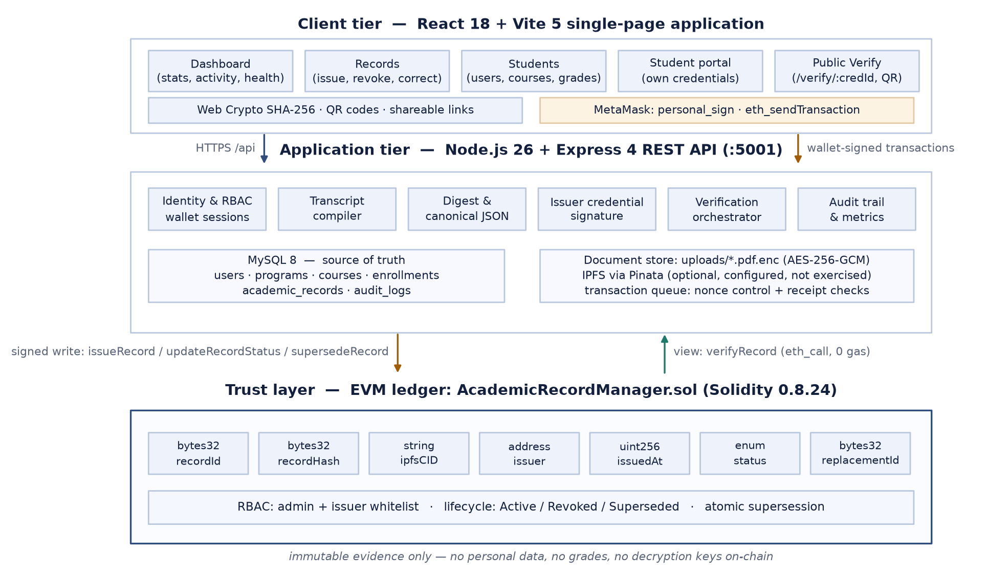
Figure 4.1. Three-tier hybrid architecture. Academic data remains in MySQL; only the digest, storage reference, issuer, timestamp and status are anchored on-chain.
Three properties of this arrangement matter. First, no personal data crosses into the trust tier, so the immutability of the ledger does not conflict with the mutability of academic records. Second, verification is a read: the contract exposes verifyRecord as a view function, so the cost of a verification is the cost of an eth_call, which is zero, and the verifier never needs a wallet. Third, the ledger is not on the critical path of ordinary academic work: grades, enrolments and programme changes are database operations, and the chain is touched only when a credential is issued or its lifecycle changes.

4.2 Context-level data flow
Figure 4.2 shows the system as a single process with four external entities. The issuer supplies academic data and lifecycle instructions and receives credentials and transaction receipts. The student supplies access and sharing requests and receives credential files, QR links and status. The verifier supplies an identifier or a document and receives a verdict. The ledger and storage infrastructure receive commitments and return anchored evidence.
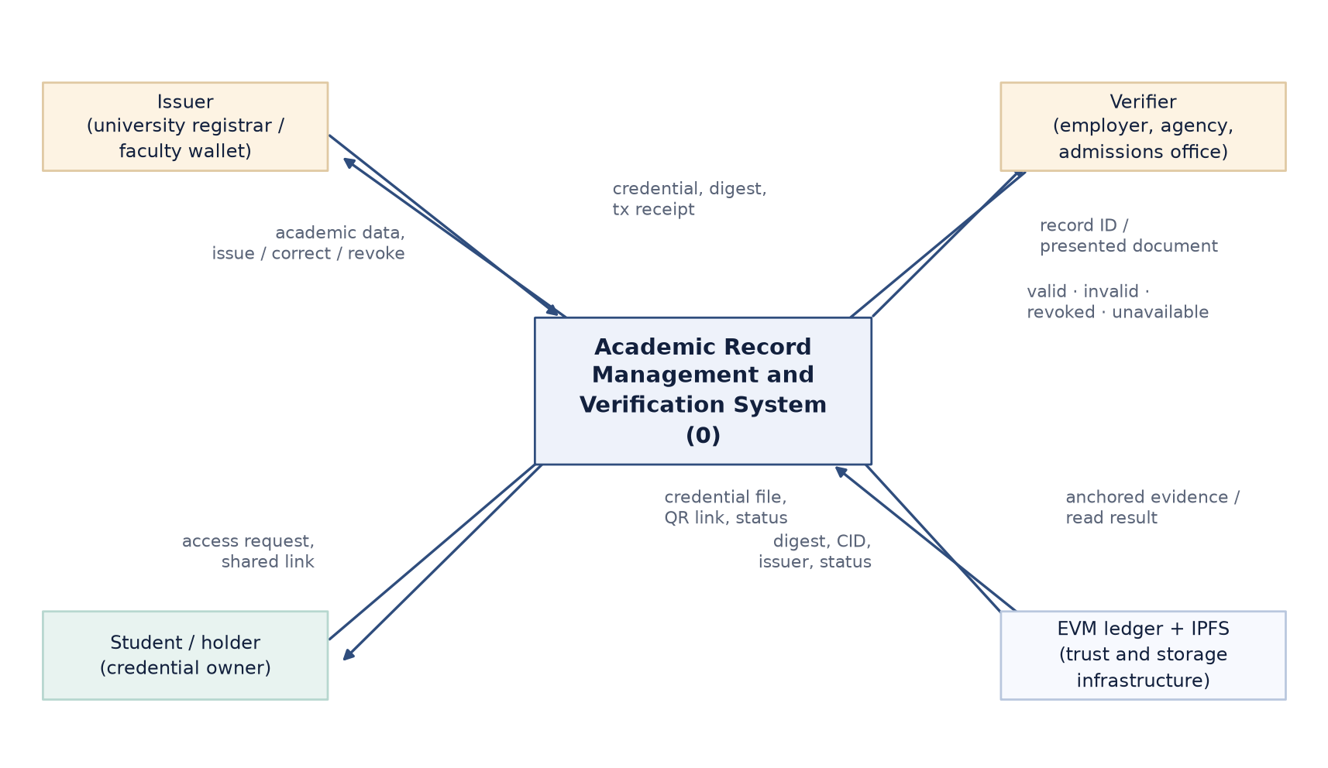
Figure 4.2. Context-level data flow diagram: external actors and the information exchanged with the system.

4.3 Level-1 data flow
Figure 4.3 decomposes the system into five processes and three data stores. Process 1 authenticates a wallet and establishes a session; process 2 compiles, hashes, signs and encrypts a credential and anchors it; process 3 serves a holder's credentials and sharing artefacts; process 4 performs public verification; process 5 maintains academic data and executes lifecycle operations. The stores are the MySQL database (D1), the encrypted document store with optional IPFS objects (D2), and the on-chain registry (D3).
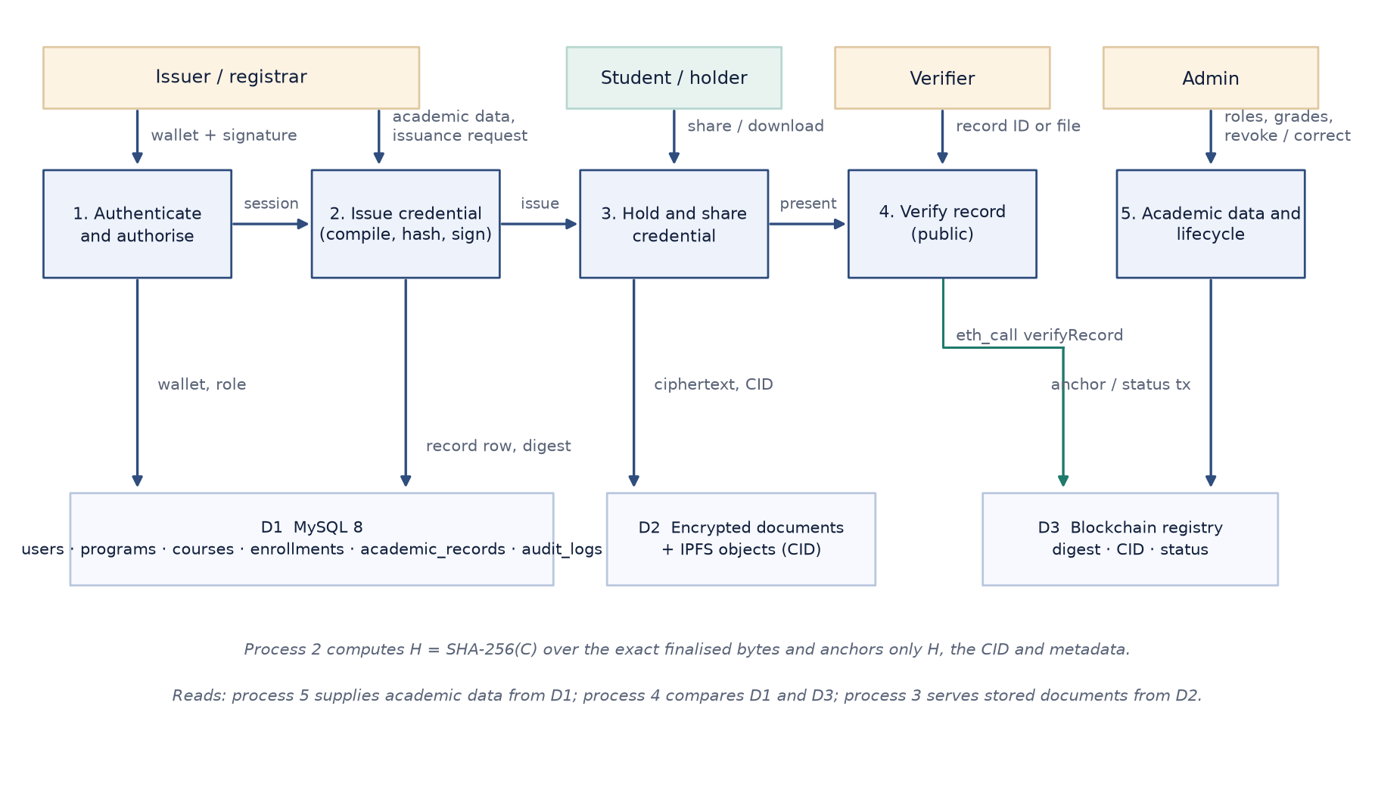
Figure 4.3. Level-1 data flow diagram: processes, data stores and the principal flows between them.
Process 2 is where the integrity rule is enforced: it computes H = SHA-256(C) over the exact finalised bytes C — the uploaded PDF when one is supplied, otherwise the canonical JSON — and anchors H together with a storage reference and status. Process 4 recomputes the digest only when content is presented, and otherwise reports the anchored status. Process 5 is the only writer of lifecycle transitions, and it does so through the contract rather than by editing the database alone.

4.4 Data model
Figure 4.4 shows the relational model, which has six tables. programs and courses describe the academic catalogue, users holds identities and roles keyed by wallet address, enrollments records a grade per student per course per term, academic_records stores the finalised credential and its anchored digest, and audit_logs records actions with the wallet that performed them. Foreign keys use ON DELETE CASCADE for student-owned rows and ON DELETE SET NULL for reference rows, so that removing a student removes their records while removing a programme does not.
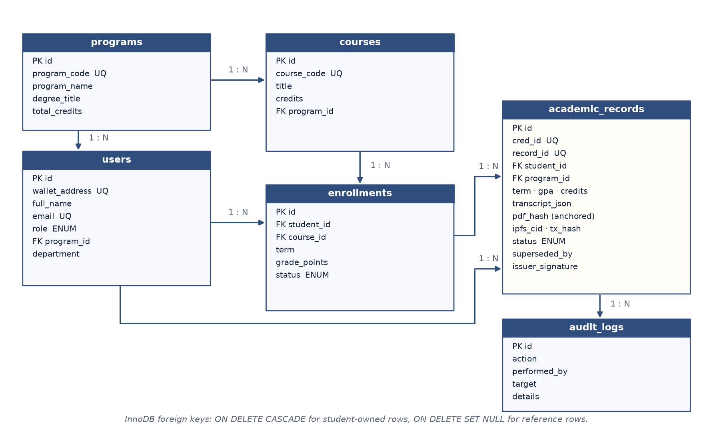
Figure 4.4. Entity–relationship model of the MySQL schema, with primary keys, unique keys and foreign keys.
Two details of academic_records deserve comment. transcript_json stores the exact canonical document that was hashed, which makes it possible to re-derive the digest and to show a holder what was signed. pdf_hash stores the anchored SHA-256 digest as 0x-prefixed hex, matching the contract's bytes32 field. The record_id column holds keccak256(credId), i.e. the 32-byte key used by the contract, so that a human identifier such as CRED-2026-037 can be mapped deterministically to a ledger key.

Table | Purpose | Key columns
programs | Degree programmes and credit requirements | program_code (UQ), degree_title, total_credits
users | Identities and role assignment | wallet_address (UQ), email (UQ), role ENUM, program_id (FK)
courses | Course catalogue | course_code (UQ), credits, program_id (FK)
enrollments | Per-term enrolment and grade | student_id (FK), course_id (FK), term, grade, grade_points, status
academic_records | Finalised credential and anchored evidence | cred_id (UQ), record_id (UQ), transcript_json, pdf_hash, ipfs_cid, tx_hash, status, superseded_by, issuer_signature
audit_logs | Append-only activity trail | action, performed_by, target, details, created_at
Table 4.1. Relational schema summary.

4.5 On-chain data model and contract interface
The contract stores one struct per credential, keyed by a 32-byte identifier. The struct contains the digest, the storage reference, the issuing wallet, the issuance timestamp, the status enumeration and a replacement identifier. Status is an enum with three values — Active, Revoked and Superseded — which makes invalid transitions expressible as preconditions rather than conventions.

Member | Type | Meaning
recordId (key) | bytes32 | keccak256 of the human credential identifier
recordHash | bytes32 | SHA-256 digest of the exact finalised credential bytes
ipfsCID | string | Content identifier of the stored document (may be empty)
issuer | address | Wallet that signed the anchoring transaction
issueTimestamp | uint256 | Block timestamp at anchoring
status | enum | Active, Revoked or Superseded
replacementId | bytes32 | Identifier of the successor record when superseded
Table 4.2. On-chain credential record.

Function | Access | Behaviour
issueRecord(id, hash, cid) | Only issuer or admin | Creates an Active record; rejects an identifier that already exists
updateRecordStatus(id, status, replacement) | Only issuer or admin | Changes the status of an Active record; rejects any other prior state
supersedeRecord(oldId, newId, newHash, newCid) | Only issuer or admin | Creates the corrected record and retires the old one in one transaction
verifyRecord(id) | Anyone (view, zero gas) | Returns the full record; reverts for an unknown identifier
recordExists(id) | Anyone (view) | Non-reverting existence probe used by the interface and the API
setIssuer(address, enabled) | Only admin | Grants or revokes issuance rights
transferAdmin(address) | Only admin | Transfers administrative control
Table 4.3. Contract interface (abridged).

4.6 Credential representation and the hashing rule
A credential is a JSON document compiled from live academic data at the moment of issuance. It carries the credential identifier, a schema reference, the credential type, the student's identity and wallet, the programme and degree, the term, the completed courses with credits and grades, the computed GPA and the total credits earned. Students are identified by internal identifier and wallet address rather than by e-mail, so that the document does not leak contact details that the verifier does not need.
Because JSON object ordering is not significant but byte order is, the document is serialised with keys sorted recursively before hashing. The resulting string is the canonical form; both issuance and verification use the same procedure, and the browser uses the same rule. Where a PDF is supplied, the PDF's exact bytes are hashed instead and the canonical JSON is retained as the descriptive record. This addresses a subtle failure mode that the literature does not always make explicit: a structured transcript and its rendered PDF are different representations and must never be treated as the same hash input.
// Canonical JSON: object keys are sorted recursively, so any client that
// rebuilds the same document derives the same digest.
function canonicalJSON(value) {
const sort = (v) => {
if (Array.isArray(v)) return v.map(sort);
if (v && typeof v === 'object') {
return Object.keys(v).sort().reduce((acc, k) => {
acc[k] = sort(v[k]);
return acc;
}, {});
}
return v;
};
return JSON.stringify(sort(value));
}
const canonical = canonicalJSON(transcript);
const documentBytes = pdfBase64
? Buffer.from(pdfBase64, 'base64') // exact issued bytes
: Buffer.from(canonical, 'utf8'); // canonical JSON fallback
const digest = sha256Hex(documentBytes);
const chainId = recordIdOf(credId); // keccak256(credId)
Read literally, the rule is: H = SHA-256(C), where C is the exact finalised credential file; the identifier used on-chain is keccak256(credId); and a rendered PDF and its JSON source are distinct artefacts with distinct digests. An identifier lookup alone therefore reports status and evidence but cannot authenticate the contents of a separately presented document; only a digest comparison can do that.

4.7 UML models

4.7.1 Use case view
Figure 4.5 shows the operations available to each actor. Issuers and administrators share the record-management use cases because both roles are permitted to issue; the distinction is that the administrator additionally manages the issuer whitelist. Students see only their own credentials and the sharing controls. Verification is available to everyone, including anonymous visitors, because it is a read-only query.
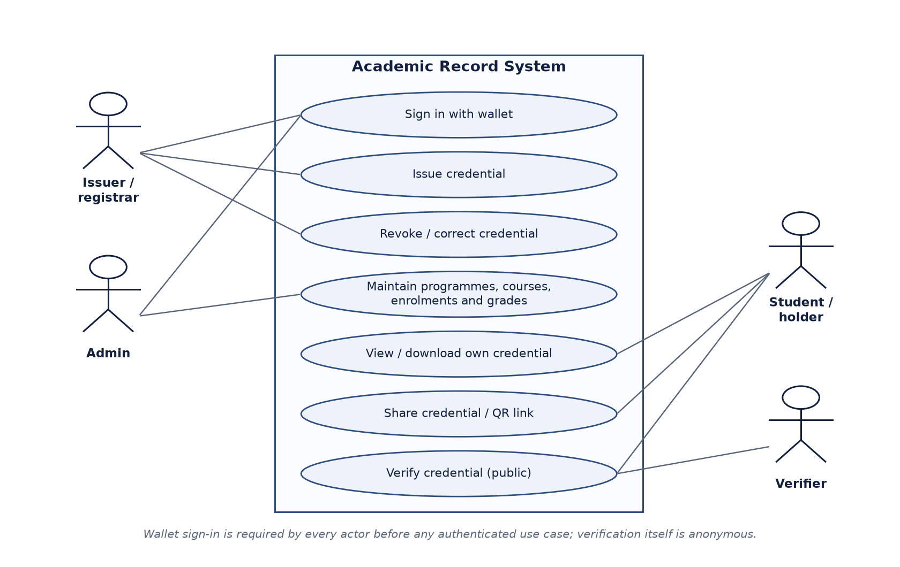
Figure 4.5. Use case diagram. Wallet sign-in precedes every authenticated use case; verification itself is anonymous.

4.7.2 Issuance sequence
The successful issuance path is shown in Figure 4.6. The issuer submits a student, a term and optionally a PDF. The API validates the session and the issuer role, loads completed enrolments, compiles the canonical document, hashes it, inserts a DRAFT row, optionally pins the document to IPFS, and sends the anchoring transaction. Only after the receipt arrives does it update the row to ACTIVE and audit the action. When the issuer's wallet is whitelisted on-chain, the transaction is returned to the browser unsigned instead, and the client confirms it afterwards.
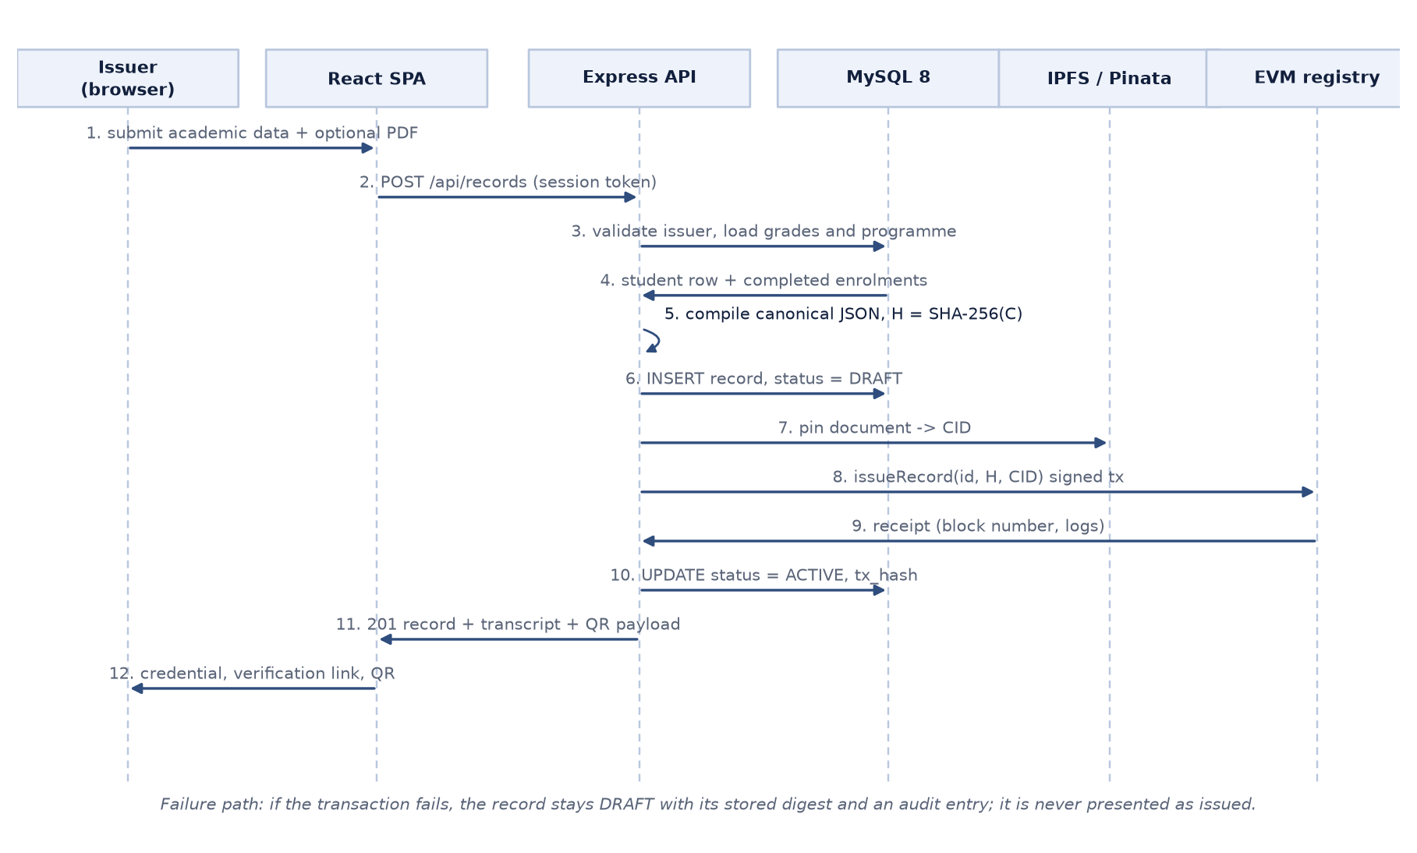
Figure 4.6. Sequence diagram for credential issuance, including the durable DRAFT state that protects against partial failure.
The failure path is part of the design rather than an afterthought. If validation, upload or signing fails, no record is created. If the transaction fails after the row is written, the record remains DRAFT with its digest and storage reference intact, an RECORD_ANCHOR_FAILED entry is written to the audit log, and the operator can retry anchoring without re-issuing the credential. A failed transaction can never be presented as an issued credential, which is the property the midterm acceptance criteria demanded.

4.7.3 Verification activity
Figure 4.7 shows the verification decision procedure. The system first establishes whether the identifier is known to either source; if neither the database nor the ledger knows it, the answer is 404. If content is presented, the digest is recomputed and compared with both stored digests. The status is then checked, followed by the issuer signature. A ledger failure suspends the decision and reports the service as unavailable rather than producing a negative verdict.
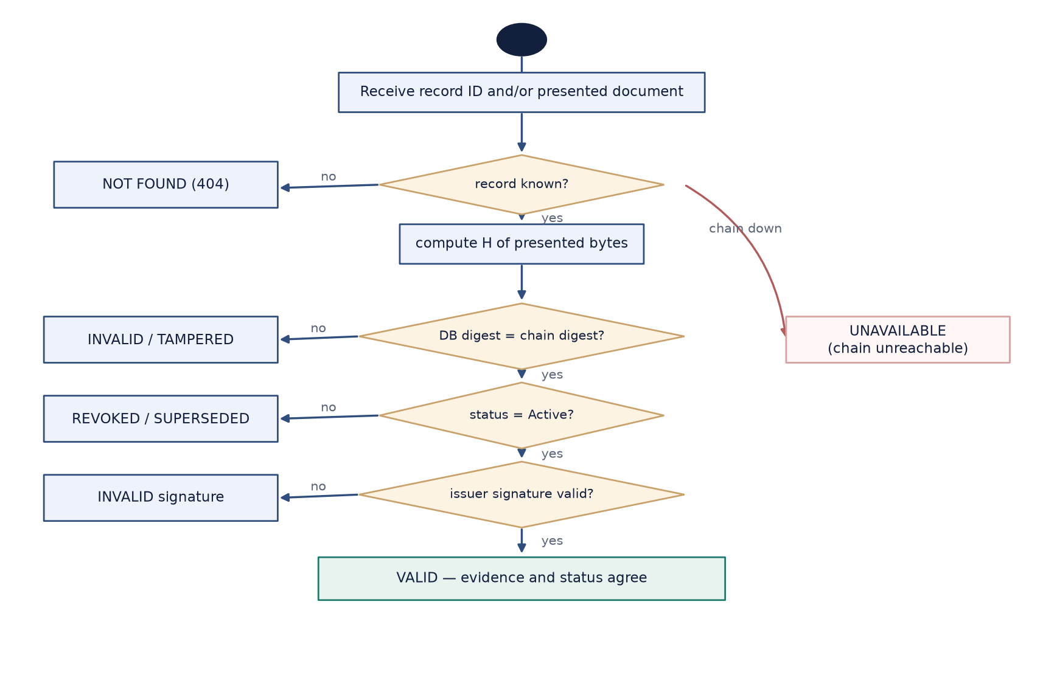
Figure 4.7. Activity diagram for verification, showing the distinct outcomes and the unavailability branch.

4.7.4 Lifecycle state machine
Figure 4.8 shows the state machine. Records move from DRAFT to ACTIVE on confirmation, and from ACTIVE to either REVOKED or SUPERSEDED. Supersession creates the successor record in the same transaction and links the predecessor to it, which is what allows a verifier holding an older copy to discover the correction. Transitions out of a terminal state are rejected by the contract, and an identifier can never be re-issued, so history cannot be rewritten.
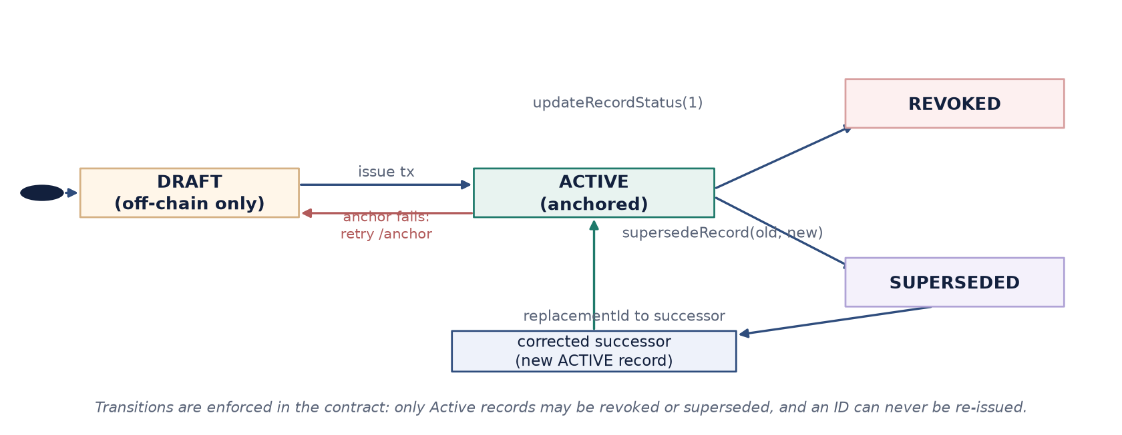
Figure 4.8. Credential lifecycle. Terminal states are enforced by contract preconditions.

4.8 Security design
The threat model assumes an attacker who can read the public interface, present forged documents, attempt to call the API with a wallet they control, and — in the strongest case tested — modify the database directly. It does not assume an attacker who controls the contract administrator's key, because that key is the root of trust.

Threat | Mitigation | Evidence
Forged or edited credential document | SHA-256 digest anchored at issuance and recomputed at verification | 23/23 mutations rejected
Unauthorised issuance | Role check in the API and an independent issuer whitelist in the contract | Contract RBAC tests; API 403 tests
Database modified behind the ledger | Verification compares database digest and status with the ledger and reports a consistency flag | Tamper suite database case
Session forgery | Token carries the wallet signature of the login message; the signature is re-verified on every request | API authentication tests
Replay of an old session | Twelve-hour expiry embedded in the signed message and checked on use | API authentication tests
Document theft from disk | AES-256-GCM encryption at rest with a key held outside the database | Ciphertext-on-disk assertion
Transaction substitution during client signing | Receipt is checked for status, emitting contract and expected record identifier | API client-signing tests
Nonce races under concurrent issuance | Serialised write queue with explicit pending nonce and bounded retries | Throughput and issuance tests
Table 4.4. Threat model and mitigations.

4.9 Failure semantics
One of the design decisions that most affects trustworthiness is the vocabulary of failure. A verifier who is told “invalid” because the RPC endpoint was down will wrongly reject a genuine credential; a verifier who is told “valid” because the database row exists has learned nothing about the ledger. The API therefore returns distinct, documented outcomes, and the interface renders each with different language and colour.

Outcome | Trigger | HTTP status | Reported to the verifier
Not found | Identifier unknown to database and ledger | 404 | No academic record exists for this identifier
Valid | Digest matches and status is Active | 200 | Evidence and status agree; issuer signature verified
Tampered | Presented digest differs from the anchored digest | 200 | Integrity check failed; content does not match the anchored record
Revoked / superseded | Anchored status is not Active | 200 | Credential is no longer valid; successor shown when present
Inconsistent | Database and ledger disagree | 200 | Sources disagree; treat as unverified and investigate
Unavailable | Ledger unreachable | 200 with chainAvailable: false | Cannot verify right now; this is not evidence of tampering
Table 4.5. Verification outcomes and their meaning.

4.10 Key design decisions

Decision | Alternative considered | Rationale
Anchor a digest, not the document | Store the PDF or JSON on-chain | Keeps personal data off the ledger and makes cost independent of document size
Keep MySQL as the source of truth | Make the ledger the primary store | Academic data is mutable; a ledger cannot support corrections without destroying history
Model correction as supersession | Edit the record in place | Preserves the audit trail and lets a verifier holding an old copy discover the change
Expose verification as a view function | A write that records the verification | Zero gas, no wallet, no incentive to gate access, and no personal data in the query
Require confirmation before ACTIVE | Optimistic update on submission | Prevents a failed transaction from appearing as an issued credential
Cross-check two sources | Trust the ledger alone | Detects database tampering and exposes disagreement instead of hiding it
Support wallet signing with a server fallback | Server signing only | Demonstrates that the issuer's own key can author the transaction while keeping the demo usable without a whitelisted wallet
Table 4.6. Principal design decisions and trade-offs.

5. Implementation

5.1 Repository structure
The repository is an npm workspace with three areas: the contract and its Hardhat configuration at the root, a backend workspace for the API, and a client workspace for the React application. Test and measurement scripts live in scripts/, and their outputs are committed under docs/ so that results can be inspected without re-running the system.

Path | Contents
contracts/AcademicRecordManager.sol | State registry with RBAC, lifecycle and verification
scripts/deploy.js, role-wallets.js | Deployment, role wallet funding and issuer whitelisting
scripts/smoke-chain.js, smoke-api.js | Chain-layer and end-to-end assertion suites
scripts/tamper-suite.js, chain-outage.js | Adversarial mutation suite and failure-path test
scripts/measure.js | Latency, gas and throughput measurement to docs/measurements.json
backend/server.js | Express application, health and activity endpoints, error handling
backend/chain.js | Provider, ABI, hashing, canonical JSON, transaction queue, client-tx confirmation
backend/credential.js | Issuer signature creation and verification
backend/storage.js | AES-256-GCM document storage and retrieval
backend/middleware/auth.js | Stateless wallet-signature sessions and role guards
backend/routes/*.js | auth, users, academics, records, verify, ipfs and chain endpoints
backend/schema.sql, dbInit.js, seed.js | Schema creation, in-place upgrades and demo data
client/src/* | React application, API client, wallet helpers, pages and design system
docs/measurements.json | Raw measured values used in Chapter 6
Table 5.1. Repository structure and responsibilities.

5.2 Smart contract
The contract is intentionally small: 111 lines of Solidity with no inheritance, no external calls and no upgradeability. It owns a single administrator address, an issuer whitelist, and a mapping from identifier to record. Three modifiers encode the invariants: onlyAdmin for whitelist management, onlyIssuer for issuance and lifecycle changes, and existing for any operation on a record that must already be present.
struct AcademicRecord {
bytes32 recordHash; // SHA-256 of the canonical transcript / PDF
string ipfsCID; // off-chain storage reference
address issuer; // wallet that anchored the record
uint256 issueTimestamp; // block timestamp at anchoring
RecordStatus status; // Active | Revoked | Superseded
bytes32 replacementId; // successor id when superseded
}
function issueRecord(bytes32 _recordId, bytes32 _recordHash,
string calldata _ipfsCID) external onlyIssuer {
require(records[_recordId].issueTimestamp == 0,
"ARM: record id already exists");
records[_recordId] = AcademicRecord(_recordHash, _ipfsCID, msg.sender,
block.timestamp, RecordStatus.Active, bytes32(0));
emit RecordIssued(_recordId, _recordHash, _ipfsCID, msg.sender);
}
function supersedeRecord(bytes32 _oldId, bytes32 _newId, bytes32 _newHash,
string calldata _newIpfsCID)
external onlyIssuer existing(_oldId)
{
require(records[_oldId].status == RecordStatus.Active,
"ARM: old record is not active");
require(records[_newId].issueTimestamp == 0,
"ARM: new record id already exists");
records[_newId] = AcademicRecord(_newHash, _newIpfsCID, msg.sender,
block.timestamp, RecordStatus.Active, bytes32(0));
records[_oldId].status = RecordStatus.Superseded;
records[_oldId].replacementId = _newId;
emit RecordIssued(_newId, _newHash, _newIpfsCID, msg.sender);
emit RecordStatusUpdated(_oldId, RecordStatus.Superseded, _newId);
}
Two implementation notes are worth recording. First, updateRecordStatus requires the current status to be Active, which makes double revocation and revocation of a superseded record impossible rather than merely discouraged. Second, supersession is a single function rather than two calls from the backend, so there is no window in which the old record is retired but the corrected one does not yet exist. Both behaviours are covered by unit tests.

5.3 Backend modules
The API is deliberately thin at the routing layer and concentrates protocol behaviour in services. chain.js owns everything that touches the ledger, including the ABI, the digest and canonicalisation helpers, the transaction queue and the receipt checks used by the wallet-signing path. credential.js owns the issuer signature. storage.js owns encryption and retrieval of documents. middleware/auth.js owns session verification and role guards. Route modules translate HTTP into calls on these services and are responsible for status codes and error messages.
Transactions from the server signer are serialised through an explicit queue. Concurrent issuance requests would otherwise race for the same account nonce, and ethers caches RPC responses briefly, which can return a stale nonce. The queue fetches the pending nonce with a direct eth_getTransactionCount call, submits the transaction, and retries up to three times with a short backoff if the failure message indicates a nonce conflict. This is a small piece of engineering that materially affects reliability under load, and it is the reason the throughput measurement in Section 6.8 is meaningful rather than a measurement of colliding nonces.

5.4 Issuance pipeline
Issuance is the most intricate operation in the system because it spans both data planes and must remain correct when either one fails. The implementation proceeds in eight steps:
- Validate the session, the role, the student and the term, and check that a record marked for replacement is currently Active.
- Allocate a credential identifier of the form CRED-<year>-<sequence>, checking both the database and the ledger for collisions so that a restored database cannot re-issue an identifier that is already anchored.
- Compile the transcript from completed enrolments, including programme and degree mapping, weighted GPA and total credits.
- Canonicalise the document, or accept the uploaded PDF, and compute the SHA-256 digest.
- Encrypt and store the document, and optionally pin it to IPFS, recording the CID.
- Insert the record as DRAFT inside a database transaction, with the digest, canonical JSON, issuer wallet and — on the server path — an issuer signature over the identifier and digest.
- Anchor on-chain, either by signing with the server key or by returning an unsigned transaction request to the browser.
- On confirmation, update the row to ACTIVE with the transaction hash and issuance time, mark the predecessor superseded when applicable, and write an audit entry.
The split between steps 6 and 8 is what makes the failure semantics honest: the credential exists in a durable, non-public state before any transaction is attempted, and it becomes visible as issued only after the ledger has accepted it. If the process dies between the two steps, the record is still DRAFT and can be anchored later from the retry endpoint, which re-signs the credential if the original path did not.

5.5 Identity and sessions
Authentication is password-less. The client requests a challenge for its wallet address, signs the returned message with personal_sign, and posts the signature back. The API recovers the signer, compares it with the claimed address, checks the expiry embedded in the message, looks up the wallet and — if it has never been seen — creates a STUDENT account. The token returned to the client is the base64url encoding of {wallet, exp} concatenated with the signature itself, so no server secret is needed to validate it: the signature proves wallet ownership and the expiry is inside the signed payload.
// token = base64url({ wallet, exp }) + "." + signature
// message = "Academic Record System login\n"
// "wallet: <wallet>\nexp: <ISO timestamp>"
function verifyToken(token) {
const [payloadB64, signature] = token.split('.');
const { wallet, exp } = JSON.parse(b64urlDecode(payloadB64));
if (exp * 1000 < Date.now()) return null;
const recovered = ethers.verifyMessage(buildLoginMessage(wallet, exp), signature);
return recovered.toLowerCase() === wallet.toLowerCase() ? { wallet, exp } : null;
}
The trade-off is explicit: the design avoids a server-side session store and a shared signing secret, at the cost of tokens that cannot be revoked before expiry and that reveal the wallet address to anyone who sees them. For a twelve-hour academic workflow this was judged acceptable; a production deployment would add a revocation list or short-lived tokens with refresh.

5.6 Document protection
Documents are encrypted with AES-256-GCM under a 32-byte key supplied through the environment. Each file is written as iv(12 bytes) || authentication tag(16 bytes) || ciphertext, so decryption verifies integrity before returning bytes. The key is never stored in the database and never written to the ledger; if it is absent the system stores plaintext and says so in the documentation rather than silently pretending to encrypt. Legacy plaintext files written before encryption was enabled are still served, which keeps the migration painless at the cost of a small branch in the read path.

5.7 Verification pipeline
Verification is implemented as a single public endpoint with two entry points: by credential identifier, and by document hash. The second computes the identifier from the hash and delegates to the first, which keeps the decision logic in one place.
- Look up the record in MySQL by credential identifier or ledger key.
- Query the ledger with recordExists and, when present, fetch the record with verifyRecord. A failure here is captured as a chain error rather than a negative verdict.
- If neither source knows the identifier, return 404.
- Re-verify the issuer signature over AcademicRecord:<credId>:<digest> and record whether the signer matches the on-chain issuer.
- Compare statuses and digests between the two sources and compute a single consistency flag.
- Return the database status, ledger status, consistency, signature result, record summary and raw chain payload.
When content is presented, the client hashes it locally with the Web Crypto API and calls the hash endpoint. This is a deliberate design choice: the document never leaves the verifier's browser, and the comparison is between a digest the verifier computed and a digest anchored by the issuer. It also means that a verifier can check a document obtained from any source, which is the property that makes the system useful outside a single institution's portal.

5.8 Wallet-signed transactions
The default configuration signs anchoring transactions with a server key, which keeps the demonstration usable without wallet setup. The system also supports the stronger model in which the issuer's own wallet signs. A capability endpoint reports whether the connected wallet is whitelisted on-chain; if it is, the API returns an unsigned transaction request — target address, encoded calldata and chain identifier — and the browser submits it through the wallet. The client then posts the transaction hash, and the API verifies the receipt before promoting the record.
Receipt verification is not a formality. The API checks that the transaction was mined within thirty seconds, that it did not revert, that every log was emitted by the expected contract address, and that one of the logs carries the expected record identifier. It also requires the credential signature, when supplied, to come from the account that sent the transaction. Without these checks an attacker could submit a hash for an unrelated transaction and have the record promoted to ACTIVE.

5.9 Client application
The client is a five-page application with a shared design system, a wallet provider and a typed API helper. Routes that require a role are guarded; the verification page is not, because a verifier may be anonymous.

Page | Audience | Function
Dashboard | All signed-in users | Record counts by status, user and academic statistics, recent activity, system health
Records | ADMIN, ISSUER | Issue a credential from a student and term, optionally with a PDF; filter by status; revoke; issue a correction; copy verification links; show QR codes
Students | ADMIN, ISSUER | Register users, create programmes and courses, enrol students, post grades, manage the on-chain issuer whitelist
Student portal | STUDENT | Own credentials with status, transcript view, document download, QR and share link
Public verify | Everyone | Lookup by identifier, shared link or dropped document; renders valid, tampered, revoked, not-found and unavailable outcomes distinctly
Table 5.2. Client application pages.
Two implementation details connect the client to the integrity model. Hashing in the browser uses crypto.subtle.digest('SHA-256', bytes) and formats the result as 0x-prefixed hex, matching the backend exactly, so a digest computed locally can be compared with an anchored one without server involvement. And the verification page is driven by the route parameter, so a QR code or a shared link resolves directly to the result rather than to a search form.

5.10 Configuration and deployment
The system is configured entirely through environment variables, with an example file that contains placeholders only. Deployment proceeds in five steps: install dependencies, create and seed the database, start a local node and deploy the contract, copy the printed contract address and keys into .env, and start the API and client together. The local chain deliberately uses chain ID 31338 rather than Hardhat's default 31337, so that it does not collide with a wallet's built-in localhost network entry.

Variable | Purpose
PORT | API port (default 5000; the project uses 5001 locally)
RPC_URL | JSON-RPC endpoint of the EVM node
CONTRACT_ADDRESS | Deployed AcademicRecordManager address
SIGNER_PRIVATE_KEY | Server signing key and issuer identity for the fallback path
DOCUMENT_ENC_KEY | 32-byte hex key for AES-256-GCM document encryption
DB_HOST, DB_USER, DB_PASSWORD, DB_NAME | MySQL connection settings
PINATA_JWT, PINATA_GATEWAY | Optional IPFS pinning credentials and gateway
REGISTRATION_CODE | Optional invitation code for self-registration
Table 5.3. Environment configuration.

6. Testing and Results

6.1 Test strategy
Testing was organised in four layers, each targeting a different kind of failure. Unit tests exercise the contract's invariants in isolation. End-to-end API tests exercise the full stack against a running node, database and API, covering authorisation, issuance, verification, revocation and supersession. Adversarial tests attempt to defeat the integrity and failure semantics rather than merely confirm the happy path. Performance measurement characterises latency, gas and throughput under a documented configuration. The principle throughout was that a claim in this report must correspond to an assertion in a script that anyone can run.

Layer | Tooling | Scope | Result
Contract unit | Hardhat, Mocha, Chai | RBAC, issuance, duplicates, lifecycle, view functions | 14/14 passing
Chain service | Node script | Issue, verify, supersede and revoke round trip | 10/10 assertions
End-to-end API | Node script | Authentication, roles, issuance, verification, lifecycle, encryption, client signing, scoping | 52/52 assertions
Adversarial | Tamper suite and outage test | Document mutation, database tampering, dead RPC | 23/23 mutations rejected; 7/7 outage assertions
Build | Vite | Production client build | Successful
Performance | Measurement script | Verification, issuance, revocation, supersession, throughput | Recorded to docs/measurements.json
Table 6.1. Test layers and outcomes.

6.2 Test environment
All results in this chapter were produced on a single developer workstation running MySQL 8 and a local Hardhat node with automining, chain ID 31338, with the API on port 5001 and the client on port 5174. The measurement run is timestamped in the artefact (docs/measurements.json, 13 October 2026) and records the network description so that the numbers are not mistaken for public-network performance. Because automining mines a block per transaction, confirmation latency is at the optimistic end of what any real network can deliver; the numbers therefore describe implementation overhead, which is exactly what a prototype can control.

6.3 Contract unit tests
Fourteen tests cover the contract in five groups. They are ordinary assertions rather than property-based tests, which is a limitation, but they target the invariants that matter: who may write, what may be written once, and which transitions are legal.

Group | Tests | What is asserted
Deployment and RBAC | 4 | Deployer becomes admin and issuer; admin can whitelist and de-whitelist; non-admin cannot; admin transfer works
Issuance | 4 | All fields stored and event emitted; duplicate identifiers rejected; non-issuer rejected; whitelisted issuer accepted
Lifecycle | 4 | Revocation of an active record; rejection on non-active record; rejection for unknown record; atomic supersession links both records
Verification | 2 | verifyRecord reverts for unknown identifiers; recordExists probes without reverting
Table 6.2. Contract unit test coverage.

6.4 Chain service and end-to-end API tests
The chain-service script exercises the service layer directly: it issues a record, verifies it, supersedes it, verifies both sides of the link, revokes an active record and confirms that the state read back matches the state written. Ten assertions cover the round trip.
The end-to-end suite is the principal functional evidence. It authenticates with three role wallets, verifies that unauthenticated access is rejected with 401 and that a student is refused issuance with 403, loads academic data, issues a credential and checks both the database row and the ledger entry, checks the issuer signature, performs public verification with and without a document, downloads the stored PDF and compares it with the original while confirming that the file on disk is ciphertext, exercises the wallet-signed issuance path including the whitelisting step, then revokes and supersedes records and re-checks consistency after each change. Fifty-two assertions pass.

Area | Representative assertions
Health | API alive; MySQL connected; EVM node reachable; contract reachable
Authentication and RBAC | Each wallet resolves to its role; unauthenticated access returns 401; student issuance returns 403; unknown wallet is provisioned as STUDENT
Academic data | Student list and course catalogue load; statistics reflect the seeded data
Issuance | Record ACTIVE in MySQL; transaction anchored; transcript compiled from five completed courses; GPA computed above 3.0
Credential signature | Signature present, valid, and signed by the issuer wallet
Public verification | Lookup by identifier and ledger key; chain reports Active; database and chain agree; unknown identifier returns 404
Document verification | PDF record issued and verifiable by hash; a modified copy is not
Encrypted storage | Download equals the original; the file on disk differs from it
Client signing | Capability flips to client mode after whitelisting; wallet-signed transaction mines; confirmation promotes the record
Lifecycle | Revocation and supersession reflected in both sources; consistency preserved
Scoping | A student cannot read another student's record
Table 6.3. End-to-end API suite coverage.

6.5 Tamper suite
The tamper suite exists because a single flipped byte is a weak demonstration. It issues a deterministic multi-kilobyte PDF-like document as a control, confirms that the untouched document verifies, and then submits twenty-three mutated variants. Each variant is hashed and looked up through the public hash endpoint; anything other than a 404 with found: false fails the suite.

Mutation family | Count | Examples
Single-bit flips | 16 | One bit inverted at positions spread across the header, body and trailer of the document
Structural mutations | 6 | Truncation by one byte, extension by one byte, corrupted header, zeroed middle block, completely different file, empty file
Forged academic content | 1 | Transcript JSON edited (GPA raised, first grade changed) and re-hashed by the attacker
Database tampering | 1 scenario, 3 assertions | Digest overwritten directly in MySQL; verification reports the inconsistency while still showing both sources, and recovers when the original digest is restored
Table 6.4. Tamper suite composition.
All twenty-three mutations were rejected, and the database-tampering case behaved as designed: the response reported consistent: false while still returning the database status and the ledger status separately, so the mismatch was visible rather than resolved silently in favour of one source.

6.6 Chain-outage test
The outage test spawns a second API instance configured with an unreachable RPC endpoint and asserts three behaviours: health reports the database as available and the chain as unavailable with an explicit error; a known record is still described from the database with chainAvailable: false and without a positive consistency claim; and an unknown identifier still returns 404 rather than an error. Seven assertions pass. This is the test that protects the most important promise in the design — that an outage is never reported as tampering.

6.7 Functional behaviour observed in the interface
The production client build completes without errors. Manual checks covered the dashboard with live statistics and activity, issuance from live academic data and from a PDF, status filtering, revocation with confirmation, correction that creates a linked successor, the student portal with document download and QR code, and the public verification page for a valid identifier, a shared link, a dropped document, an unknown identifier and a revoked record. These checks are described as manual because they are not automated; they are the weakest evidence in this chapter and are recorded as such.

6.8 Performance measurement method
The measurement script authenticates as an issuer and performs each operation a fixed number of times, timing the full request from the client's perspective and reading gas from the transaction receipt. Verification is measured over ten trials of GET /api/verify/<id>; issuance over three trials because each issuance anchors a transaction; revocation and supersession once each, because each is a state change on a record created for the purpose. Throughput is measured differently: twenty pre-signed transactions are submitted as a batch and the wall-clock time to completion is recorded, which isolates submission overhead from wallet or UI latency. The configuration and raw values are committed, and the number of trials is reported alongside every figure so that the reader can judge the strength of each estimate.

6.9 Measured results

Operation | Trials | Minimum | Mean | Maximum | Gas
Public verification | 10 | 45 ms | 54.7 ms | 69 ms | 0
Issuance | 3 | 211 ms | 304 ms | 384 ms | 101,548
Revocation | 1 | — | 331 ms | — | 53,179
Correction (supersession) | 1 | — | 174 ms | — | 150,684
Issuance throughput | 20 (batch) | — | 194.2 tx/s | — | 101,560 per tx
Table 6.5. Measured latency and gas consumption on the local Hardhat node.
Figures 6.1, 6.2 and 6.3 present the same measurements graphically.
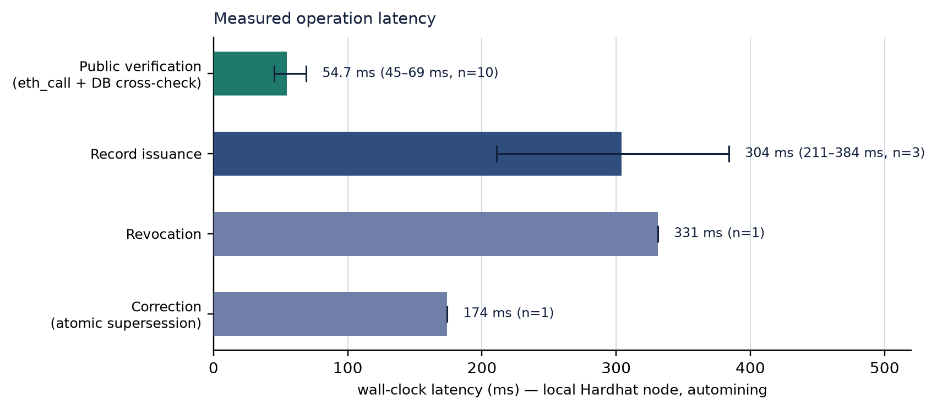
Figure 6.1. Latency by operation, with the observed range where more than one trial was performed.
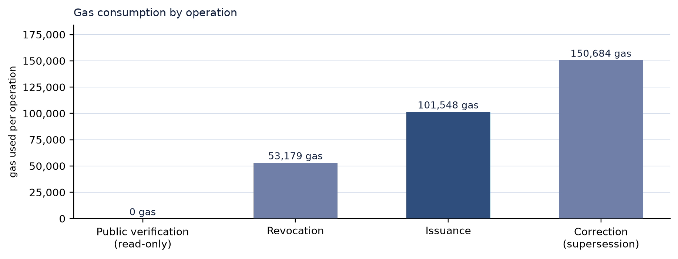
Figure 6.2. Gas consumed by each operation. Verification is a read-only call and consumes none.
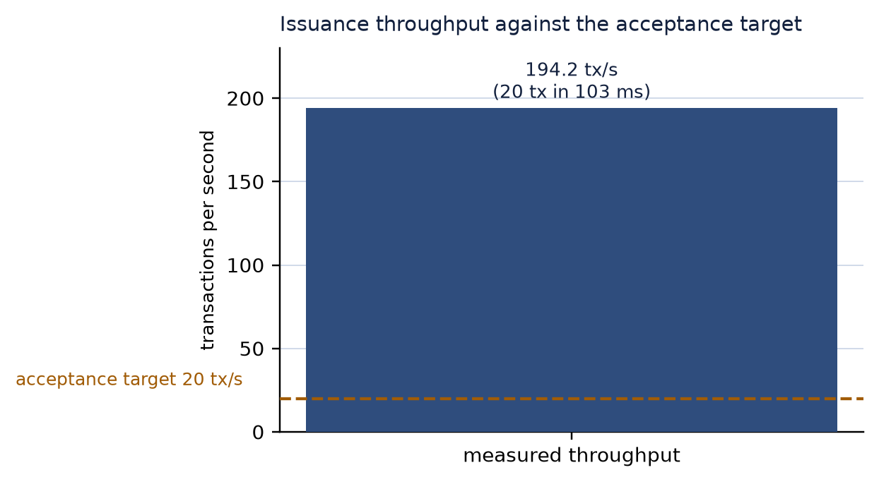
Figure 6.3. Issuance throughput against the twenty transactions per second acceptance target.
Three observations follow from the numbers. Verification, the operation a verifier actually performs, costs nothing and completes in tens of milliseconds, which is the central economic claim of the design. Issuance is dominated by transaction confirmation rather than by hashing, encryption or database work, so its cost is a network property more than an implementation property. And supersession is the most expensive operation at 150,684 gas because it writes a complete new record and updates the old one in a single transaction — a deliberate trade of gas for atomicity.

6.10 Discussion and threats to validity
The results support the claim that the implementation meets its objectives, with four qualifications that should be read as part of the result rather than as caveats added afterwards.
- Automining inflates latency performance. A block is produced per transaction, so confirmation is immediate. On a public network, issuance latency would be governed by block time and inclusion, not by this code. The measured issuance time should be read as protocol overhead plus local confirmation, not as a prediction.
- Sample sizes are small. Ten verification trials and three issuance trials support a statement about magnitude, not a precise distribution. Revocation and supersession were measured once each, so their means are single observations and are labelled as such in the table.
- The tamper suite is systematic but not exhaustive. Sixteen bit flips and six structural mutations across a deterministic document exercise the digest boundary thoroughly; they do not constitute a formal proof, and they say nothing about attacks on the issuer's key.
- Functional coverage is asserted by scripts, usability by observation. The API and contract behaviour is checked automatically; the interface was reviewed manually, and accessibility and cross-browser behaviour were not systematically evaluated.
Against the midterm acceptance criteria, the evidence is as follows. Successful issuance and verification are demonstrated end to end. Rejection of modified content is demonstrated across twenty-three mutations. Unauthorised writes are rejected by both the API and the contract, the latter independently of the API. Revocation and correction behave as specified, including the replacement link. Unavailable-service responses are distinct from negative verdicts, and the distinction is tested. Timed operations were repeated under a documented configuration with the number of trials reported, and the raw values are retained.

6.11 Requirements traceability

Objective | Evidence in this report
O1 — Manage academic records end to end | Sections 5.4, 5.9; API suite (issuance, lifecycle, academic data)
O2 — Detect unauthorised modification | Sections 4.6, 5.7; tamper suite 23/23; database-tamper case
O3 — Verify without the issuer and without cost | Sections 5.7, 6.9; 54.7 ms mean at 0 gas over ten trials
O4 — Preserve the lifecycle | Sections 4.5, 6.3; contract lifecycle tests; API supersession assertions
O5 — Give students portable access | Section 5.9; student portal, QR codes and shareable links
O6 — Enforce authorisation independently | Sections 4.8, 5.2; contract RBAC tests; API 401/403 assertions
O7 — Fail honestly | Sections 4.9, 6.6; outage suite 7/7; 404 semantics preserved
O8 — Produce reproducible evidence | Section 6.1 and Appendix B; committed scripts and measurements
Table 6.6. Traceability from objectives to evidence.

7. Conclusion and Future Work

7.1 Summary of the work
This project set out to determine whether a blockchain can make academic credentials independently verifiable without turning a university's record system into a public database. The answer delivered here is a qualified yes, and the qualifications are as informative as the answer. A ledger can hold a commitment that any third party can check, and can hold the status of that commitment, at a cost of one transaction per issuance and no cost at all for verification. It cannot hold the credential, cannot make the credential true, and cannot by itself make the credential portable or interoperable. Those properties come from the surrounding system: the database that supplies the data, the signature that binds the issuer to the digest, the storage layer that protects the document, the API that enforces roles, and the interface that makes verification a single click for someone who has never heard of a blockchain.
The implemented system is therefore best described as a student information system with an anchoring and audit layer attached, rather than as a blockchain application. Registrars issue, correct and revoke credentials; students hold and share them; verifiers check them anonymously. The blockchain is present exactly where its properties are needed and absent everywhere else, which is why the system remains usable when the chain is slow, and why verification still returns a meaningful, honest answer when the chain is down.

7.2 Conclusions against the objectives
Objectives O1 to O8 were met to the extent documented in Section 6.11. Records are managed end to end from live academic data. Modification is detectable through a digest comparison that requires no issuer involvement, and the tamper suite demonstrates it across twenty-three mutations. Verification is free and fast — a mean of 54.7 ms at zero gas — and requires neither an account nor a wallet. The lifecycle is modelled explicitly, with atomic supersession and a successor link that lets an older copy discover its replacement. Students can obtain and share their own credentials. Authorisation is enforced twice, once by the API and once by a contract whitelist that the API cannot override. Failures are distinguished, and the distinction is tested against a dead RPC endpoint. Every number in Chapter 6 can be regenerated from the repository.
Two objectives were met in a narrower sense than originally imagined. O6 is met at the level of a single institution: the contract administrator is the ultimate authority, and in the default configuration that administrator is also the server signer, so the independence of the two authorisation layers is architectural rather than organisational. O5 is met for viewing, downloading and sharing, but not for self-sovereign storage: the student holds a link, not a credential wallet.

7.3 Limitations
The limitations below are stated plainly because a report that hides them would be less useful than one that does not.
- Network. All measurements come from a local automining node. Sepolia configuration exists and the deployment script supports it, but no funded key was available, so public-network latency and cost are estimated rather than measured.
- Storage. IPFS pinning is implemented and configured but was not exercised, because no pinning credential was available. Stored documents are therefore held on the application server, encrypted, with the CID field left empty in that configuration.
- Standards. The credential is W3C-VC-shaped but not conformant. The issuer signature is an EIP-191 message signature over AcademicRecord:<credId>:<digest>, not a Data Integrity proof, and there is no DID document or status list. No interoperability claim is made.
- Trust model. The administrator controls the issuer whitelist. A compromised administrative key could whitelist an attacker, although it could not alter records already anchored. Multi-institution governance is not implemented.
- Privacy. Personal data is kept off-chain, but a digest on a public ledger is still a pseudonymous identifier, and repeated issuance to the same student is linkable by an observer who knows the pattern. Selective disclosure is not implemented.
- Usability. QR codes are generated and resolve to the verification page, but scanning requires a third-party application; there is no camera integration and no mobile application.
- Testing. Contract tests are example-based rather than property-based, performance samples are small, and interface verification was manual.

7.4 Future work
The next steps follow directly from the limitations and from the research gaps identified in Chapter 2. They are ordered by the value they would add to the system as it stands.
- W3C Verifiable Credentials and DIDs. Re-issue credentials as conformant VCs with Data Integrity proofs, a published issuer DID and a status list, so that a credential issued here can be consumed by systems built elsewhere.
- Public-network deployment and cost model. Deploy to Sepolia and then to a Layer 2 network, measure real confirmation latency and per-credential cost, and publish the cost model alongside the throughput results.
- Institutional governance. Replace the single administrator with a multisig or a consortium arrangement, separate the server signer from the administrative role, and define the procedure for onboarding and removing issuers.
- Zero-knowledge selective disclosure. Allow a student to prove properties — a degree was conferred, a GPA exceeds a threshold — without disclosing the transcript, following the direction of the ZKBAR-V work.
- Off-chain storage hardening. Pin encrypted credentials to IPFS with redundancy, monitor gateway availability, and move decryption keys into a dedicated key service.
- Registrar tooling. Batch issuance from a CSV extract, cohort statistics, degree audit checks before issuance, and connectors for existing student information systems.
- Verifier experience. Camera-based QR scanning, a mobile-friendly progressive web application with offline verification against cached proofs, and machine-readable verification endpoints for automated hiring pipelines.

7.5 Closing remarks
The most useful thing this project produced is not the contract or the API, but a precise account of where a blockchain helps and where it does not. It helps by making a commitment public, permanent and cheap to check, and by making the lifecycle of a credential observable to someone who does not work at the university. It does not help with data quality, identity, governance, privacy or interoperability, and a system that pretends otherwise will fail in production while passing its demonstrations. The implementation described here is small, but it is honest about that boundary: it anchors what the institution asserts, verifies it without asking the institution, refuses to call an outage a forgery, and leaves the remaining problems visible for the next iteration.

References
[1] Rustemi, A., Dalipi, F., Atanasovski, V., & Risteski, A. (2023). A systematic literature review on blockchain-based systems for academic certificate verification. IEEE Access, 11, 64679–64696. https://doi.org/10.1109/ACCESS.2023.3289598
[2] World Wide Web Consortium. (2025). Verifiable Credentials Data Model v2.0 (W3C Recommendation, 15 May 2025). https://www.w3.org/TR/vc-data-model-2.0/
[3] Grech, A., & Camilleri, A. F. (2017). Blockchain in education. European Commission Joint Research Centre, EUR 28778 EN. https://doi.org/10.2760/60649
[4] Blockcerts. (2026). The open standard for blockchain credentials: introduction, standards alignment, cert-issuer and verification documentation. https://www.blockcerts.org/
[5] Blockchain Certificates. (2026). Cert-issuer and Blockcerts technical documentation [GitHub repository]. https://github.com/blockchain-certificates/cert-issuer
[6] A zero-knowledge proof-enabled blockchain-based academic record verification system. (2025). Sensors, 25(11), 3450. https://doi.org/10.3390/s25113450
[7] Turkanović, M., Hölbl, M., Košič, K., Heričko, M., & Kamišalić, A. (2018). EduCTX: A blockchain-based higher education credit platform. IEEE Access, 6, 5112–5127. https://doi.org/10.1109/ACCESS.2018.2789929
[8] Gräther, W., Kolvenbach, S., Ruland, R., Schütte, J., Torres, C., & Wendland, F. (2018). Blockchain for education: Lifelong learning passport. Proceedings of the 1st ERCIM Blockchain Workshop. https://doi.org/10.18420/blockchain2018_07
[9] Grech, A., & Camilleri, A. F. (2017). Blockchain in education (JRC108255). Publications Office of the European Union.
[10] Academic certificate verification using blockchain technology. (2025). 2025 IEEE International Conference on Contemporary Computing and Communications (InC4). https://doi.org/10.1109/InC465408.2025.11256194
[11] Secure academic certificate authentication using blockchain technology. (2025). 9th International Conference on Computational System and Information Technology for Sustainable Solutions (CSITSS). https://doi.org/10.1109/CSITSS67709.2025.11294218
[12] 1EdTech Consortium. (2024–2026). Open Badges 3.0 specification and conformance documentation. https://www.1edtech.org/standards/open-badges
[13] Ethereum Foundation. (2026). Solidity documentation, version 0.8.24. https://docs.soliditylang.org/
[14] Hardhat. (2026). Hardhat documentation: networks, testing and deployment. https://hardhat.org/docs
[15] ethers.js. (2026). ethers v6 documentation. https://docs.ethers.org/v6/
[16] Oracle Corporation. (2026). MySQL 8.0 reference manual. https://dev.mysql.com/doc/refman/8.0/en/

Appendix A — REST API Reference

Method and path | Auth | Purpose
POST /api/auth/nonce | None | Return the login message to be signed by the wallet
POST /api/auth/verify | None | Verify the signature, provision unknown wallets, issue a token
GET /api/auth/me | Bearer | Return the current session's user and role
POST /api/auth/session | None | Introspect a token and report validity
GET /api/users | Bearer | List users, optionally filtered by role or query
POST /api/users | None (invite code) | Register a user with an explicit role
PATCH /api/users/:id | ADMIN | Update profile, role or department
GET /api/academics/programs, /courses | None | Read the academic catalogue
POST /api/academics/programs, /courses | ISSUER, ADMIN | Create catalogue entries
GET /api/academics/enrollments | Bearer | List enrolments by student or term
POST /api/academics/enrollments | ISSUER, ADMIN | Enrol a student in a course
POST /api/academics/enrollments/:id/grade | ISSUER, ADMIN | Post a grade and complete the enrolment
GET /api/records | Bearer | List records, scoped by role, filterable by status
GET /api/records/stats | Bearer | Aggregate counts for the dashboard
GET /api/records/:credId | Bearer (owner) | Record detail with transcript and signature check
GET /api/records/:credId/document | Bearer (owner) | Download the decrypted credential document
POST /api/records | ISSUER, ADMIN | Issue or supersede a record (server or client signing)
POST /api/records/:credId/confirm | ISSUER, ADMIN | Confirm a wallet-signed anchoring transaction
POST /api/records/:credId/anchor | ISSUER, ADMIN | Retry anchoring a DRAFT record
POST /api/records/:credId/status | ISSUER, ADMIN | Revoke a record (server or client signing)
GET /api/verify/:credId | None | Public verification by identifier or ledger key
GET /api/verify/hash/:pdfHash | None | Public verification by document digest
GET /api/verify | None | Recent public activity feed
POST /api/ipfs/pin | ISSUER, ADMIN | Pin an issuer-side asset to IPFS
GET /api/chain/capability | Bearer | Report whether the wallet may sign transactions itself
GET /api/chain/issuers | Bearer | List issuer wallets with their on-chain status
POST /api/chain/issuers | ADMIN | Whitelist or remove an issuer wallet on-chain
GET /api/health | None | API, database, node and contract reachability
Table A.1. REST endpoints implemented by the backend.

Appendix B — Reproducing the Evidence
The following sequence reproduces every result reported in Chapter 6 on a machine with Node.js 18 or later and MySQL 8 running locally. Commands are run from the repository root unless stated otherwise.
# 1. install workspace dependencies
npm install
# 2. create and seed the database (idempotent)
npm run db:init -w backend
npm run db:seed -w backend
# 3. start a local node and deploy the contract
npx hardhat node --port 8546
npm run deploy:local # prints CONTRACT_ADDRESS=...
# 4. configure the environment (see Section 5.10)
cp backend/.env.example .env # then set the contract address and keys
# 5. run the application
npm run dev # API :5001 and client :5174
# 6. reproduce the evidence
npx hardhat test # 14/14 contract unit tests
node scripts/smoke-chain.js # 10/10 chain-service assertions
node scripts/smoke-api.js # 52/52 end-to-end assertions
node scripts/tamper-suite.js # 23/23 mutations rejected
node scripts/chain-outage.js # 7/7 outage assertions
node scripts/measure.js # writes docs/measurements.json
npm run build -w client # production client build
The measurement script overwrites docs/measurements.json, so the committed file is the record of the run described in this report. The tamper and outage suites require a seeded database and a running node; the outage suite additionally starts its own API instance on a separate port with an intentionally unreachable RPC endpoint.

Appendix C — Abbreviations

Abbreviation | Expansion
ABI | Application Binary Interface
API | Application Programming Interface
CID | Content Identifier (IPFS)
DFD | Data Flow Diagram
DID | Decentralised Identifier
ECTS | European Credit Transfer and Accumulation System
EVM | Ethereum Virtual Machine
GPA | Grade Point Average
IPFS | InterPlanetary File System
JSON | JavaScript Object Notation
RBAC | Role-Based Access Control
REST | Representational State Transfer
RPC | Remote Procedure Call
SHA-256 | Secure Hash Algorithm, 256-bit
SIS | Student Information System
UML | Unified Modeling Language
VC | Verifiable Credential
ZKP | Zero-Knowledge Proof
Table C.1. Abbreviations used in this report.

