B0X-WingData
- Got the target ip addr.
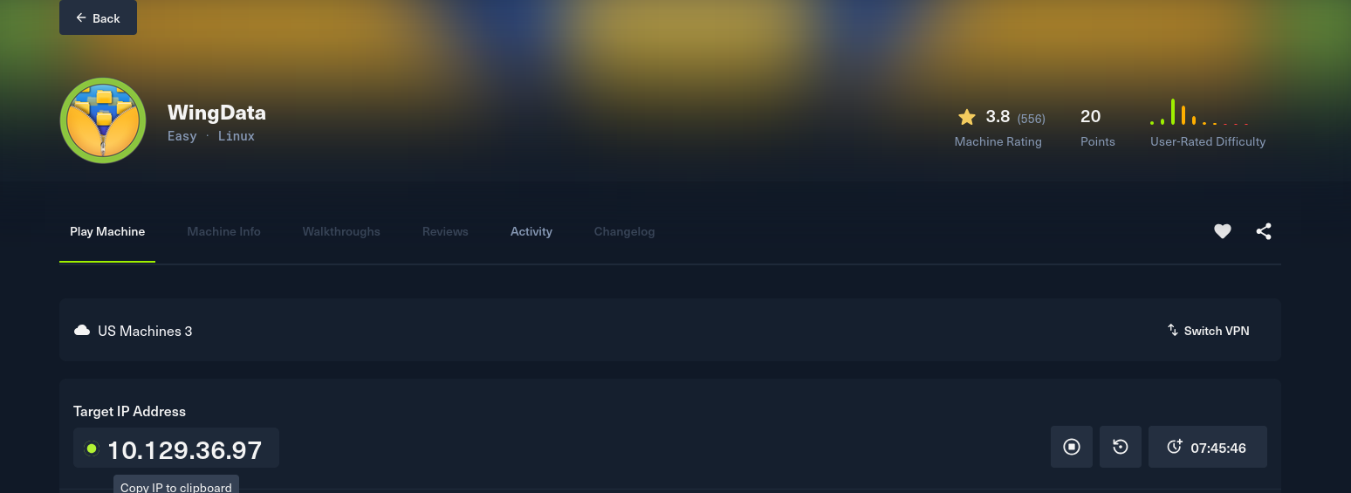
- Get the open ports using nmap scan.
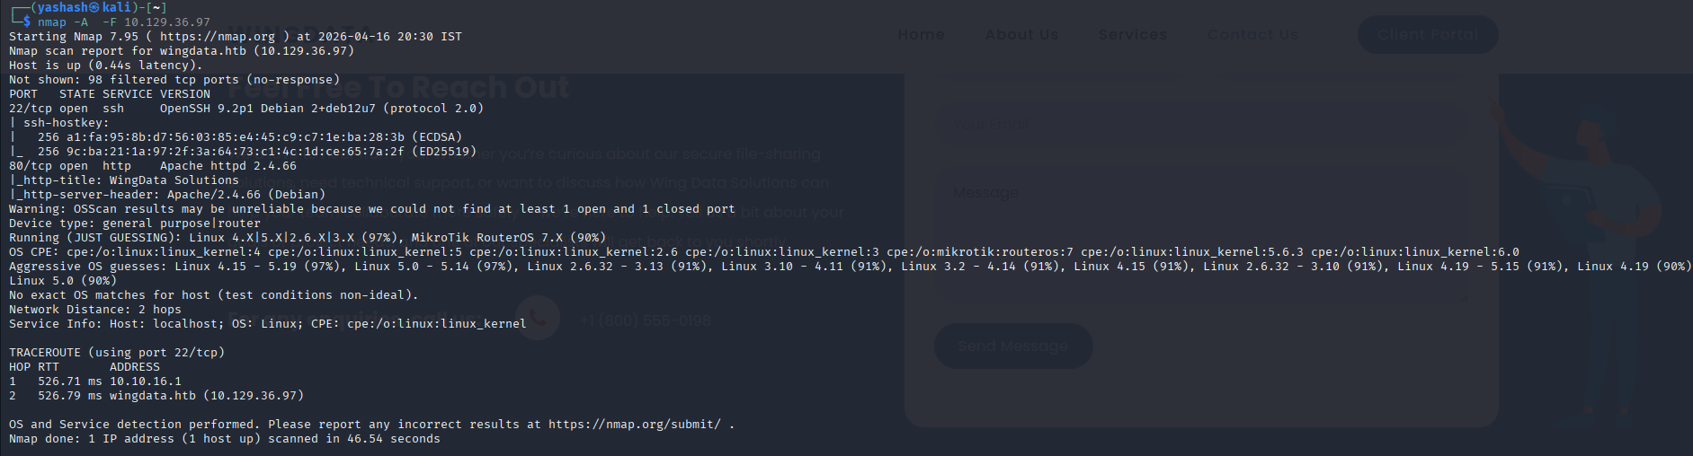
- There are two ports 80 and 22
- View the target ip addr in browser.
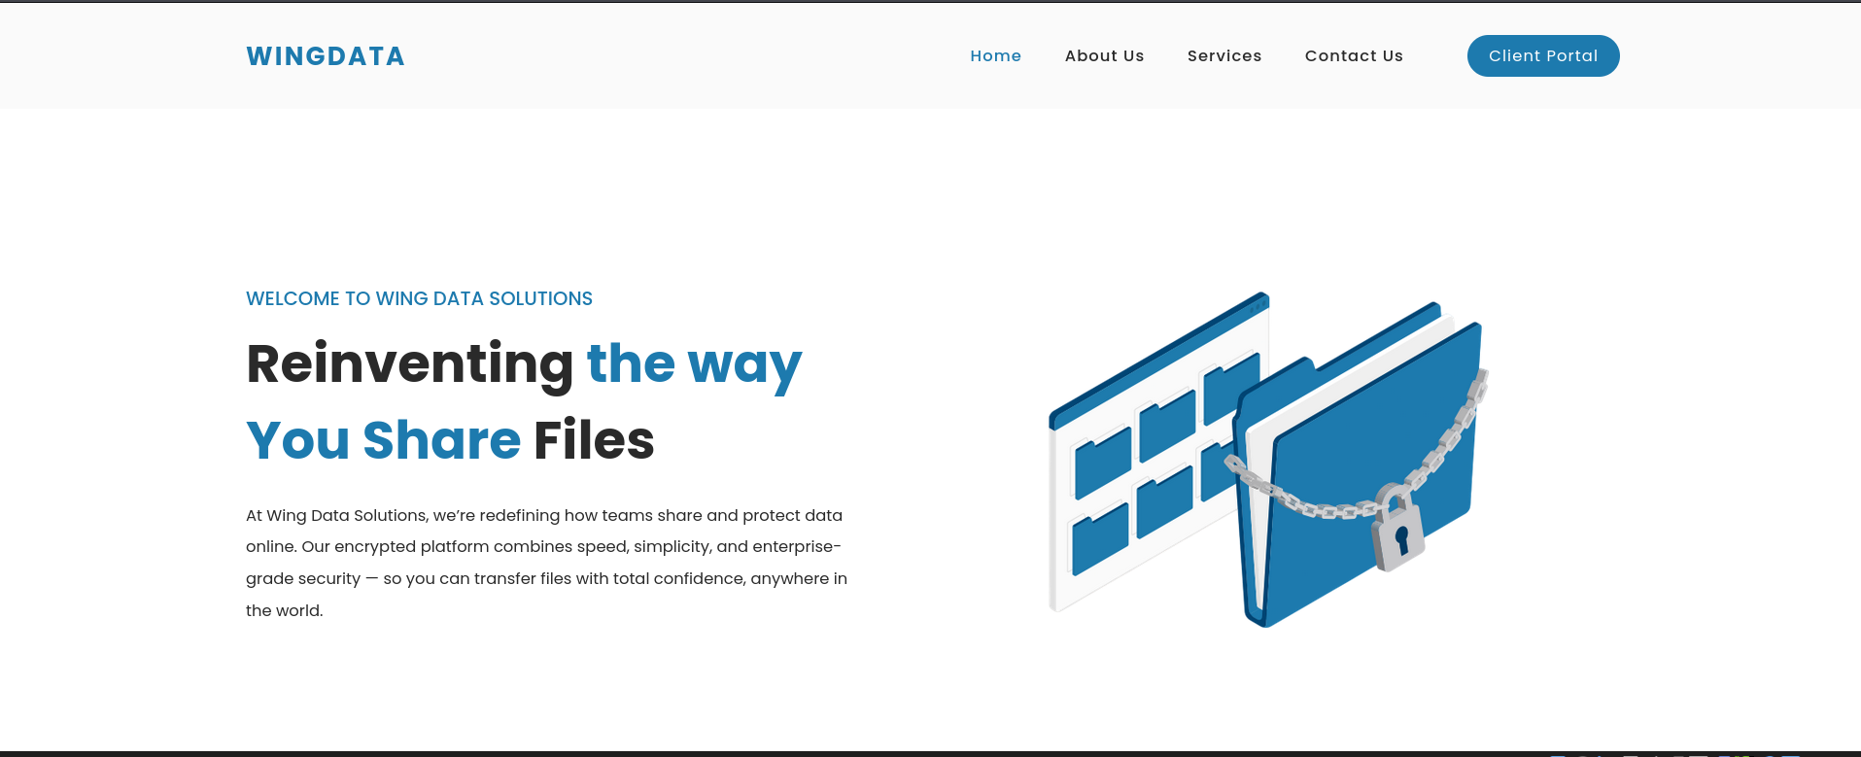
- Let’s do nikto scan to find dangerous files, outdated software, misconfigurations.
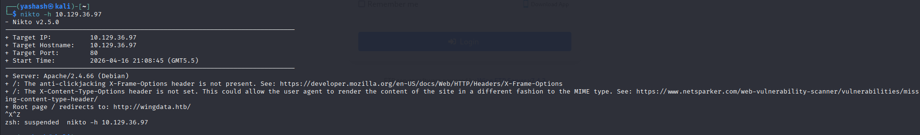
- There are no directories or endpoints present.
- Now let’s check the client portal
