BOX-Dina:1.0.1
- scan the target ip address and get the open ports and their services.
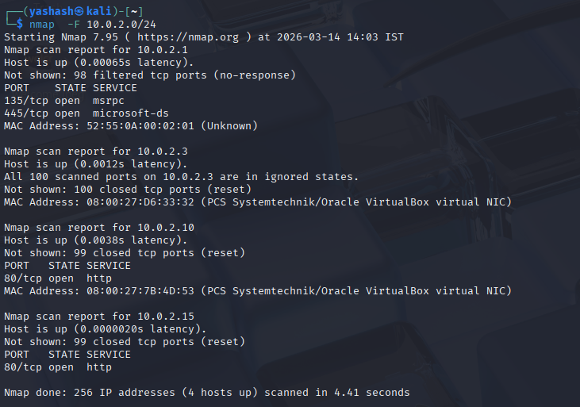
- search the ip address and view the web page.
- check the robots.txt file and get the endpoints if present
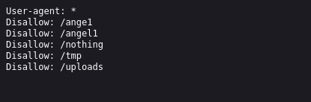
- when we explore page source of nothing ,then we got few secret passwords in that page.
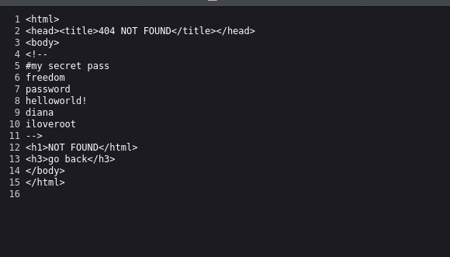
- now lets scan the target ip address to get more information by using a tool named nikto.
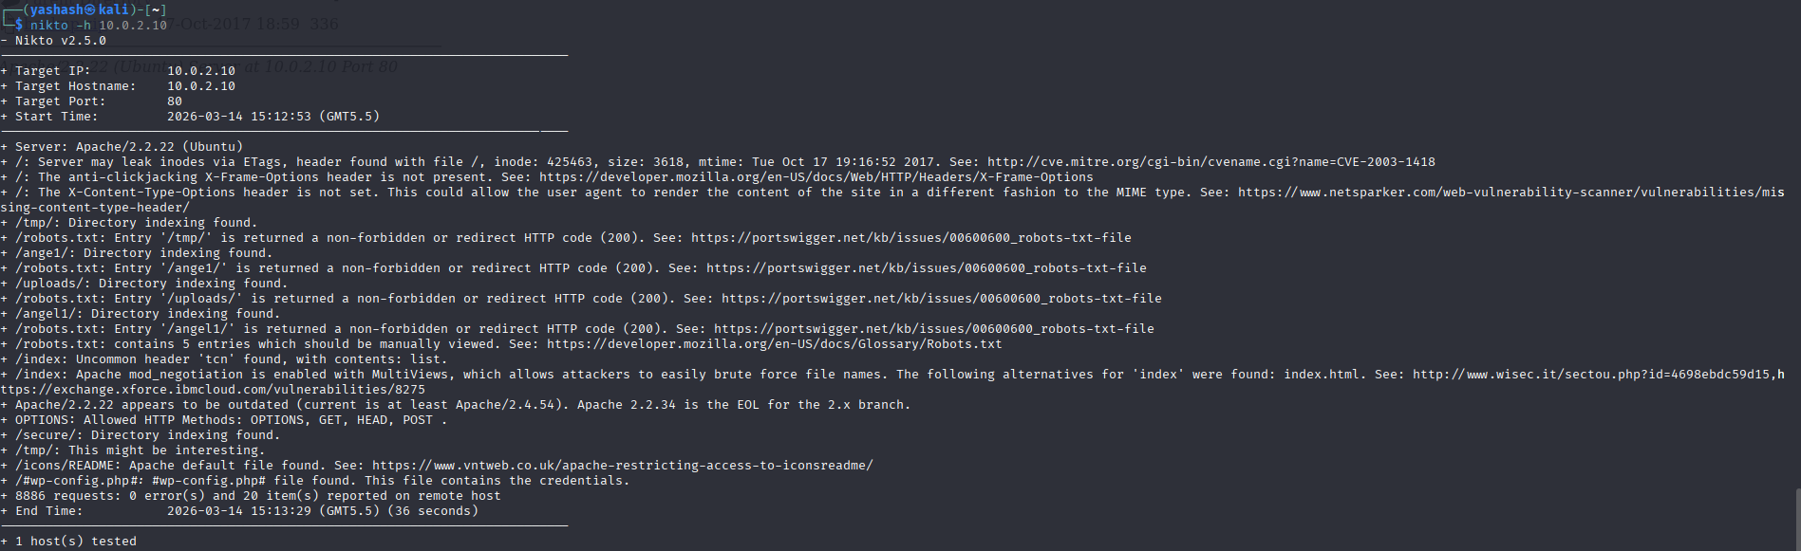
- found a directory name 'secure' in the scan.
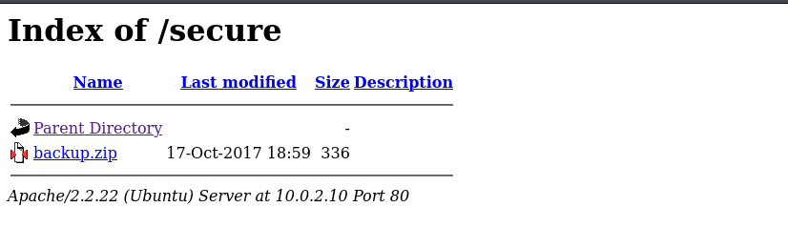
- when we follow the path, we found a zip file and after downloading, it asks us for password and we have a list of passwords already so try checking all the passwords and unzip it.
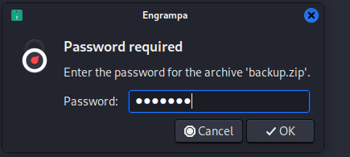
- now find the type of file, we observe that it is a text file. so read the content of that file.
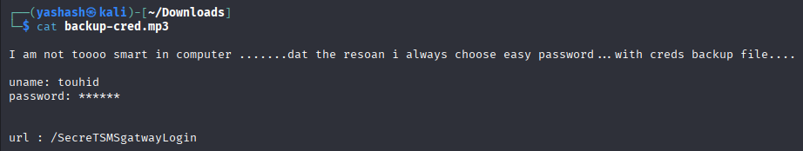
- we found a new path, follow the path and then it displays a login form containing username and password.
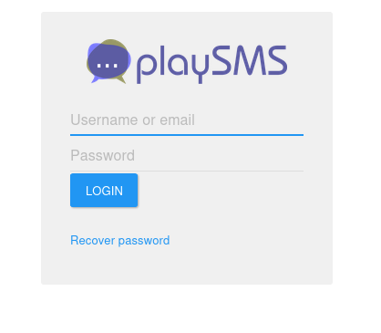
- the username is already given in the text file(user-touhid) and now try check the passwords that we got initially and get the access into it(pw=diana)
- after log in a new page is displayed.
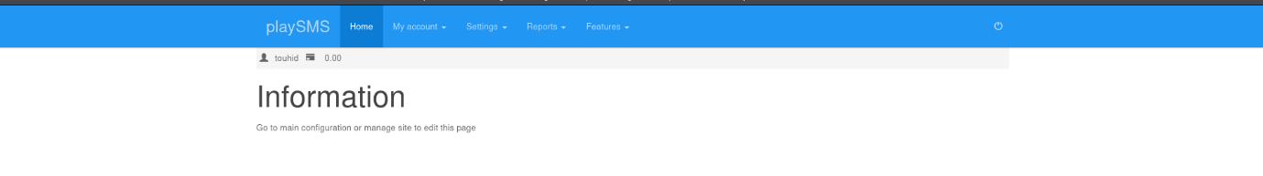
- now search for the vulnerabilities related to PlaySMS 1.4
- We found that PlaySMS 1.4 remote code execution using phonebook import function in import.php
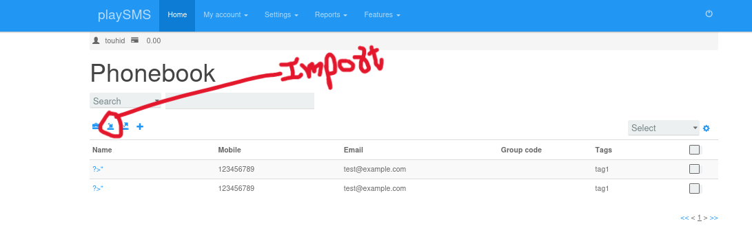aft
- To implement it we need to create a csv file.
- We observe that after creating a csv file and php code of printing hello world then after importing, it is displayed that only the output is only displayed in name field.
- Which means php code gets executed in the name field.
- Now lets connect it using reverse shell.
- Run [ nc -lvnp 4444 ] on ur terminal which listens to the port 4444.
- Now in the csv file we need to implement the php code in such a way it connects to our port and also telling it to execute a system shell.
CSV FILE:
- After running import, now check the terminal where you are listening.
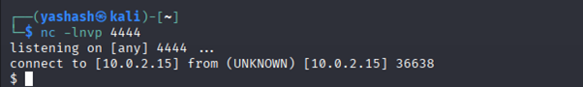
- Now search for the list of files.
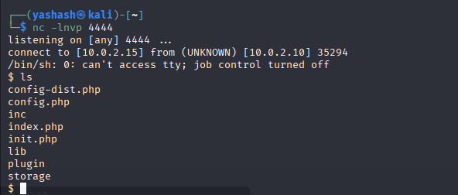
- Now check for the sudo privileges
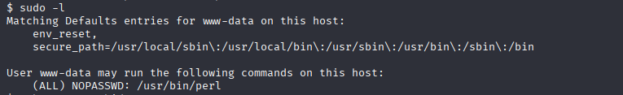
- From the above it says that we can use sudo only for the /usr/bin/perl.
- Perl is a high-level interpreted programming language and is used for system administration, web development, and network programming.
- Since we have the sudo access to run the perl, now we can connect to system shell using perl.

- Now list the files present in it.
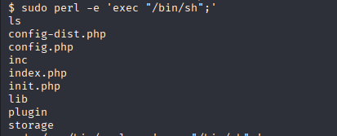
- Now check who u are by running ‘whoami’ it tells that u are root
- Now go to root directory and list the files and read the files that are present.
