ATTENDENCE MONITORING SYSTEM USING RFID
Version 1.1
Prepared by:
Harshitha J
Shritha Bharadwaj
Yashwaswini B V
Table of Contents
Table of Contents ii
1. Introduction 1
1.1 Purpose 1
1.2 Product Scope 1
1.3 References 1
2. Overall Description 2
2.1 Product Perspective 2
2.2 Product Functions 3
2.3 Operating Environment 3
2.4 Design and Implementation Constraints 3
3. External Interface Requirements 3
3.1 Hardware Interfaces 3
3.2 Software Interfaces 3
4. System Features 4
4.1 System Feature 1 4

Introduction

Purpose
The application of RFID to student attendance monitoring as developed and deployed in this study is capable of eliminating time wasted during manual collection of attendance and an opportunity for the educational administrators to capture face-to-face classroom statistics for allocation of appropriate attendance scores and for further managerial decisions.

1.2 Product Scope
In recent years, there have been rise in the number of applications based on Radio Frequency Identification (RFID) systems and have been successfully applied to different areas as diverse as transportation, health-care, agriculture, and hospitality industry to name a few. RFID technology facilitates automatic wireless identification using electronic passive and active tags with suitable readers. In this paper, an attempt is made to solve recurrent lecture attendance monitoring problem in developing countries using RFID technology.
The emergence of electronic paradigm for learning compared to traditional method and availability of almost all information on the information superhighway(Internet), nowadays have caused students to be less motivated to come to the lecture rooms than ever before. Laziness on the part of students, nonchalance to school work, extra social activities that have no importance in aiding the objectives of the institution and a lot more, may prevent students from attending lectures. lecturers and administrators in most developing countries have had to come up with ways to ensure a healthy participation from students, and make sure that the student-lecturer interactive relationship is kept intact.
RFID is an automated identification and data collection technology, that ensures more accurate and timely data entry. RFID combines radio frequency and microchip technologies to create a smart system that can be used to identify, monitor, secure and do object inventory. At their simplest, RFID systems use tiny chips called ―tags that contain and transmit some piece of identifying information to an RFID reader, a device that in turn can interface with computers

1.3 References
[1] Chitresh, S and Amit K (2010),”An efficient Automatic Attendance Using Fingerprint Verification Technique ”,International Journal on Computer Science and Engineering (IJCSE),Vol. 2 No. 2,pp 264-269.

[2] Nambiar A.N. (2009),” A supply chain perspective of RFID Systems”, World Academy of Science, Engineering and Technology Journal, Volume 6,pp1-5.

[3] Longe O.O.(2009),”Implementation of Student Attendance System using RFID Technology”, B. Tech Project Report, Ladoke Akintola University of Technology, Ogbomoso, Nigeria.

Overall Description

Product Perspective

1. RFID reader

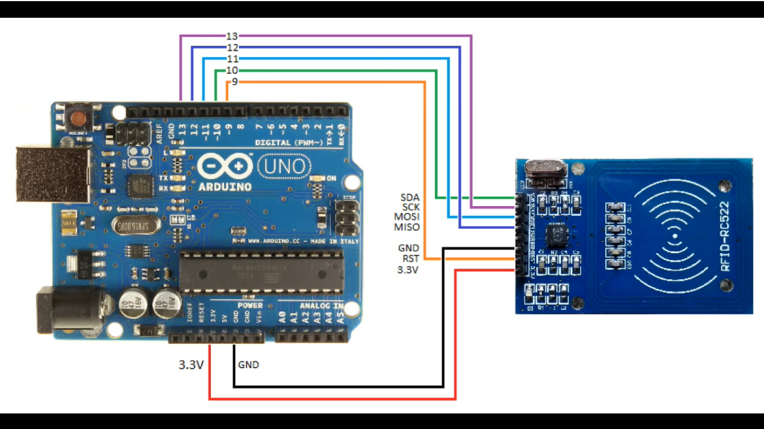
.
2.Wifi module
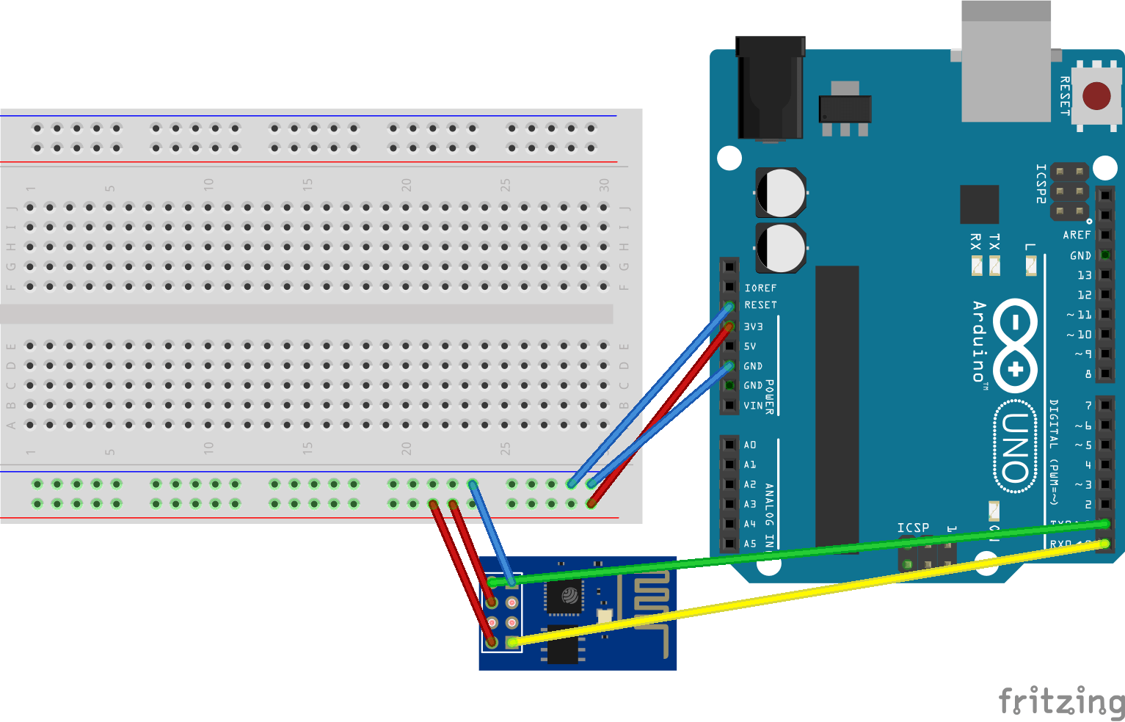

Product Functions

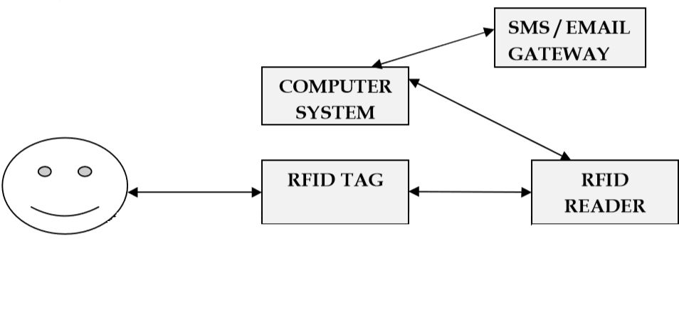

Operating Environment
- Operating System – Windows 10
- Arduino software
- Database interface

Design and Implementation Constraints
- Embedded c for arduino board.
- MYSQL for queries.
- Php for frontend.
- Arduino software

External Interface Requirements

Hardware Interfaces

1. Arduino uno board.
2. RFID reader.
3. RFID tags.
4. wi-fi module.
5. Connector.
6. Jumper wires.

Software Interfaces
- Xampp
- Arduino software

System Features
As the RFID technology evolves, more sophisticated applications will use the capability of RFID to receive, store and forward data to a remote sink source. RFID has many applications as can be imagined. we have utilized the versatility of RFID in implementing functional and automatic student course attendance recording system that allows students to simply fill their attendance just by swiping or moving their ID cards over the RFID reader which are located at the entrance of lecture halls with a considerable degree of success and acceptability of usage in our faculty. We hope that this system can shift the paradigm of students’ lecture attendance monitoring in face-face classroom and provide a new, accurate, and less cumbersome way of taking student attendance in thelectures.

System Feature 1
4.1.1 RFID reader
RFID systems can be classified by the type of tag and reader. A Passive Reader Active Tag (PRAT) system has a passive reader which only receives radio signals from active tags (battery operated, transmit only). The reception range of a PRAT system reader can be adjusted from 1–2,000 feet (0–600 m) allowing flexibility in applications such as asset protection and supervision.
An Active Reader Passive Tag (ARPT) system has an active reader, which transmits interrogator signals and also receives authentication replies from passive tags.
An Active Reader Active Tag (ARAT) system uses active tags awoken with an interrogator signal from the active reader. A variation of this system could also use a Battery-Assisted Passive (BAP) tag which acts like a passive tag but has a small battery to power the tag's return reporting signal
Fixed readers are set up to create a specific interrogation zone which can be tightly controlled. This allows a highly defined reading area for when tags go in and out of the interrogation zone. Mobile readers may be hand-held or mounted on carts or vehicles.

4.1.2 Wi-fi module
Wi-fi module sends the data from arduino board to respective destination which is given by the users such as database, website etc.

