Simulating Virtual Machine Allocation Policy in Cloud Using CloudSim
Version 1.0
Prepared by:
Harshitha J [1jt13is010]
Shritha Bharadwaj [1jt13is020]
Yashwaswini B V [1jt13is027]

Table of Contents
Table of Contents ii
1. Introduction 1
1.1 Purpose 1
1.2 Intended Audience and Reading Suggestions 1
1.3 Product Scope 1
1.4 References 1
2. Overall Description 2
2.1 Product Perspective 2
2.2 Product Functions 3
2.3 Operating Environment 3
2.4 Design and Implementation Constraints 3
3. Requirements 3
3.1 Hardware Interfaces 3
3.2 Software Interfaces 3
3.3 Functional Requirements 3
3.4 Non-Functional Requirements 3
4. System Features 4
4.1 System Feature 1 4
Appendix A: Glossary 4

Introduction

Purpose
Minimize the energy consumption made by the virtual machines migration by allocating the resources using resource allocation policies and load balance policies. Also utilize their resources and improves performance. The proposed model uses Hungarian algorithm and the result is verified by simulating this model using CloudSim.

Intended Audience and Reading Suggestions
The targeted audiences are researchers and students.

Product Scope
CloudSim is an open source simulation toolkit that provides modeling and simulation in cloud computing environment by providing way to model and to simulate various modeling policies in this environment. In cloud computing environment, all the resources are pooled in single place with shared memory architecture called Data Center. Broker has list of requested cloud application with high workload by cloud consumer, In order to deploy them, cloud computing uses virtualization as the focus element of this environment. Because cloud computing is worked on principal “pay as you used” and the virtualization is limited the actual physical hardware, Utilization of the cloud resources, allocation of virtual machines and proper load balance policy play major role in cloud computing environment. VM allocation algorithm allocates the virtual machines to the host of the data center which have amount of free processing elements (PE) close to the amount of PE’s required by virtual machine. The task allocation algorithm act as load balance policy and provides way to bind cloudlets (task) to virtual machines such that each task gets high speed of less execution time to complete the task. This algorithm provides fair distribution of cloudlets among the virtual machines. In these both algorithms are modeled and simulated in CloudSim toolkit and analyzed the output.

In future proposed policy can be implemented with consideration of various parameters like space in more dynamic fashion with respect to load generated in cloud environment

References
“Virtualization and Cloud Computing: Optimized Power, Cooling, and Management Maximizes Benefits Adaptive Management of Virtualized Resources in Cloud Computing Using Feedback Control”, First International Conference on Information Science and Engineering, (2010).

Overall Description

Product Perspective
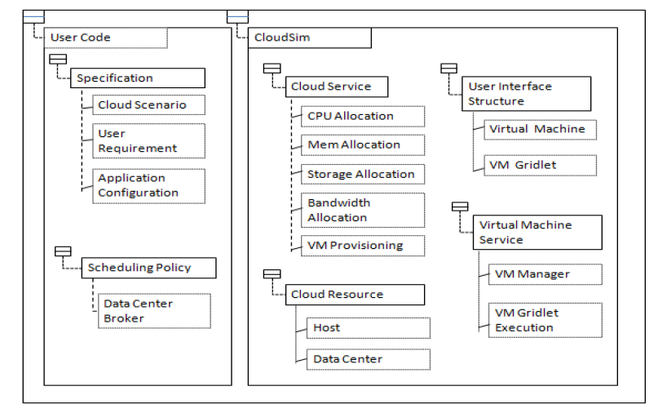

Product Functions

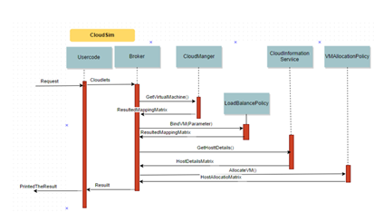

Operating Environment
- Operating System – Windows 10
- Cloud Simulator- Cloudsim 3.0
- Eclipse

Design and Implementation Constraints
Language requirements- Core JAVA(jdk 1.7 and higher)

External Interface Requirements

Hardware Interfaces
Monitor to view the variations in the simulations.

Software Interfaces
Operating System- Windows 10
Simulator – Cloudsim 3.0
IDE – Eclipse
JDK 1.7

Functional Requirements
- The proposed model, provide dynamic load balance policy based on different parameter like execution time, memory required and helps cloud computing environment to improve its performance by resources utilization.
- For load balancing with cost optimization, proposed model internally uses Hungarian algorithm.
- For modeling and simulation CloudSim is used, CloudSim is an extensible simulation toolkit that enables modeling and simulation of Cloud computing environments.

Non-Functional Requirements
- Proposed algorithm should be efficient in terms of both time and space.
- Algorithm should be scalable.

System Features
CloudSim: “An extensible simulation toolkit” that provide a way for modeling and simulation of Cloud computing environments. It enables to create virtual machine VMs and manages the virtual machines. It also provides way to simulate the data center. It provides the mapping and much other way for managing and utilizing the resources.
In CloudSim environment three major entities that perform most of the work are Broker, MIS (Management Information System) and Datacenter.

System Feature 1
4.1.1 Cloudlet
Cloud user gives request to cloud provider with their different configuration and requirements. Different configuration refers to Number of processing elements, amount of RAM, Space, number of instruction, file length etc. This all combines as task contained in cloudlet
4.1.2 Data Center
In cloud computing actual physical resources are available in single pool with shared memory. The Datacenter has actual resource. This entity contains list of host with different hardware configuration. Data centers registered them self to MIS for allowing the broker to access them. CloudSim provides services by using vitalization mechanism. It generates number of virtual machines and allocates them to job and simulates of a Data Center. In order to perform deploy requested application in terms of cloudlet with list of specification, broker map the cloudlet with virtual machines and requested to MIS for the knowing the information about actual physical hardware in data center in order to deploy of virtual machines in data center.

Appendix A: Glossary
VM-Virtual Machine
PE-Processing Element
DC-Data center

