**DBMS MINI PROJECT**

**Title: Hypermarket Chains DBMS**

Submitted By:

**Name: YASHAS B SHETTAR Name:-YUKTHA**

**SRN: PES1UG21CS730 SRN: PES1UG21CS939**

**Semester: 5th**

**Section: L**

**SHORT DESCRIPTION AND SCOPE OF THE PROJECT**

**DESCRIPTION:**

* The Project describes about the **Hypermarket chains management**.
* This project mainly focuses on how the many stores and distributors can sell various products of different categories. Simply to say, a superstore which is a chain of stores like DMART, BIG Bazaar, etc.
* The database consists of six entities such as **admin, distributor, store, sales, store orders, and stock.**
* The tables are populated with some values and many operations like **join, set, aggregate, functions, procedures, triggers and cursors** are performed on the data.
* A **front end of the database is created with CRUD functionalities** on each table of the database along with **a query box** that can execute and display any SQL query.

**SCOPE:**

* Hypermarket chains management involves management, creation and development of supermarkets.
* We can deploy it in all kinds of cities and use it for **efficient management** of a hypermarket to ensure all the products are sold at the earliest, with highest discount to the customers, using **deep discounting** models.
* We can closely monitor available stocks and ensure effective stock management, **faster delivery and connectivity** to all cities.
* Many operations can be performed on the database that give us **useful insights** which might go unnoticed to the naked eye. This can help the product user to **prepare, plan, and perfect the art of selling!**

**ER Diagram**

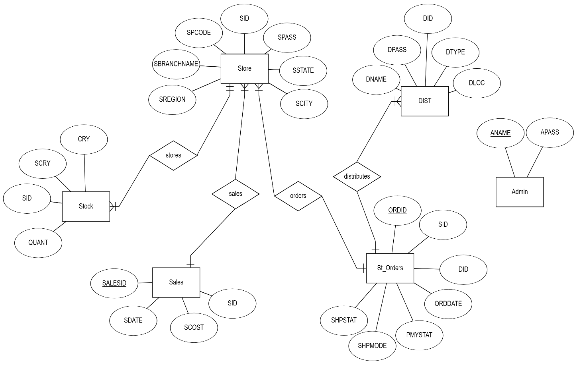

**Relational Schema**

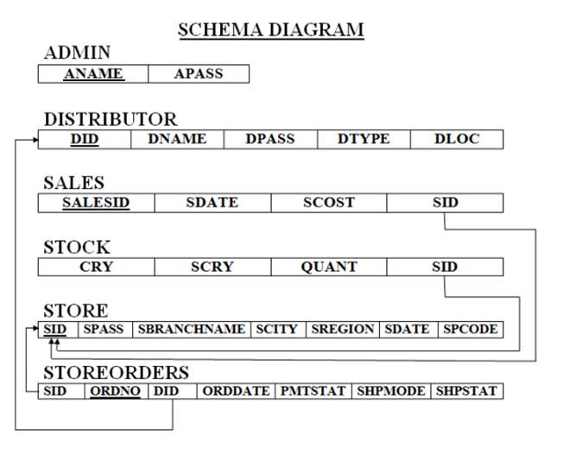

**DDL statements - Building the database**

**Table structure for table ‘admin’**

QUERY:

-- Table structure for table `admin`

CREATE TABLE `admin` (

  `ANAME` varchar(20) NOT NULL,

  `APASS` varchar(20) NOT NULL,

  PRIMARY KEY(ANAME)

) ENGINE=InnoDB DEFAULT CHARSET=latin1;

OUTPUT:

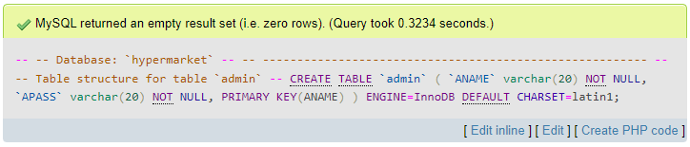

**Table structure for table ‘dist’**

QUERY:

-- Table structure for table `Dist`

CREATE TABLE `Dist` (

  `DID` int(11) NOT NULL,

  `DNAME` varchar(20) NOT NULL,

  `DPASS` varchar(20) NOT NULL DEFAULT 'admin',

  `DTYPE` varchar(20) NOT NULL,

  `DLOC` varchar(30) NOT NULL, PRIMARY KEY(DID)

) ENGINE=InnoDB DEFAULT CHARSET=latin1;

OUTPUT:

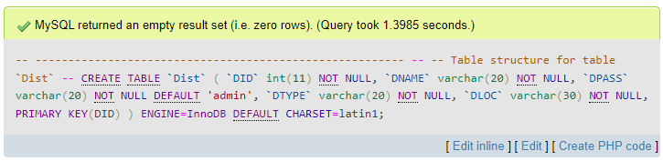

**Table structure for table `store`**

QUERY:

-- Table structure for table `store`

CREATE TABLE `store` (

  `SID` int(11) NOT NULL,

  `SPASS` varchar(20) NOT NULL DEFAULT 'admin',

  `SBRANCHNAME` varchar(20) NOT NULL,

  `SCITY` varchar(20) NOT NULL,

  `SREGION` varchar(20) NOT NULL,

  `SSTATE` varchar(20) NOT NULL,

  `SPCODE` int(11) NOT NULL,PRIMARY KEY(SID)

) ENGINE=InnoDB DEFAULT CHARSET=latin1;

OUTPUT:

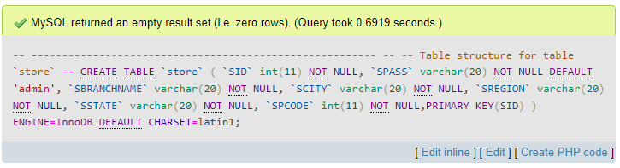

**Table structure for table `sales`**

QUERY:

-- Table structure for table `sales`

CREATE TABLE `sales` (

  `SALESID` int(11) NOT NULL,

  `SDATE` date NOT NULL,

  `SCOST` int(11) NOT NULL,

  `SID` int(11) NOT NULL,PRIMARY KEY(SALESID)

) ENGINE=InnoDB DEFAULT CHARSET=latin1;

alter table sales  add constraint sales_fk foreign key(SID) references store(SID) on delete CASCADE;

OUTPUT:

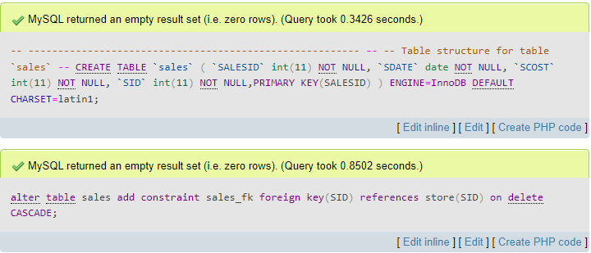

**Table structure for table `stock`**

QUERY:

-- Table structure for table `stock`

CREATE TABLE `stock` (

  `CRY` varchar(20) NOT NULL,

  `SCRY` varchar(20) NOT NULL,

  `QUANT` int(11) NOT NULL,

  `SID` int(11) NOT NULL

) ENGINE=InnoDB DEFAULT CHARSET=latin1;

alter table stock  add constraint stock_fk foreign key(SID) references store(SID) on delete CASCADE;

OUTPUT:

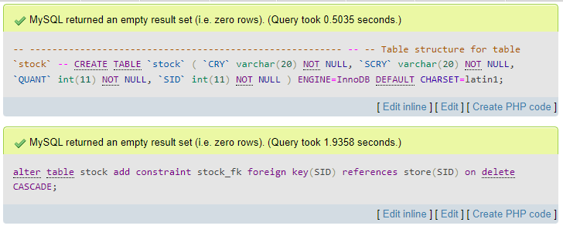**Table structure for table `st_orders`**

QUERY:

-- Table structure for table `st_orders`

CREATE TABLE `st_orders` (

  `SID` int(11) NOT NULL,

  `ORDID` int(11) NOT NULL,

  `DID` int(11) NOT NULL,

  `ORDDATE` date NOT NULL,

  `PMYSTAT` varchar(20) NOT NULL DEFAULT 'PENDING',

  `SHPMODE` varchar(20) NOT NULL DEFAULT 'Normal',

  `SHPSTAT` varchar(20) NOT NULL DEFAULT 'PENDING',

  PRIMARY KEY(ORDID)

) ENGINE=InnoDB DEFAULT CHARSET=latin1;

alter table st_orders  add constraint strodr1_fk foreign key(SID) references store(SID) on delete CASCADE;

alter table st_orders  add constraint strodr2_fk foreign key(DID) references Dist(DID) on delete CASCADE;

OUTPUT:

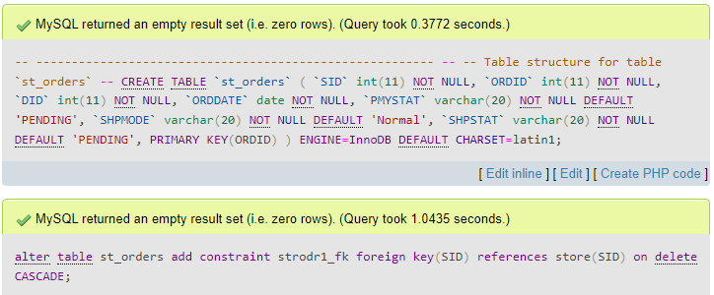

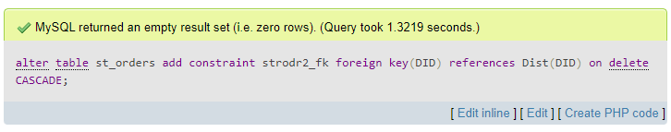

-------------Section Break (Next Page) -------------

**Populating the Database**

**INSERTIONS**

Dumping data for table `admin`

QUERY:

-- Dumping data for table `admin`

INSERT INTO `admin` (`ANAME`, `APASS`) VALUES

('555', 'admin'),('533', 'admin'),('544', 'admin')

,('511', 'admin'),('522', 'admin'),('588', 'admin')

,('500', 'admin'),('577', 'admin'),('566', 'admin');

OUTPUT:

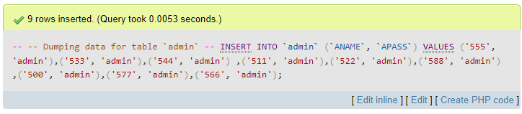

Dumping data for table `dist`

QUERY:

-- Dumping data for table `Dist`

INSERT INTO `Dist` (`DID`, `DNAME`, `DPASS`, `DTYPE`, `DLOC`) VALUES

(1000, 'Fritolay', 'admin', 'Electrical', 'Delhi'),

(1001, 'Pepsico', 'admin', 'CoolDrinks', 'Hyderabad'),

(1002, 'YogaBar', 'admin', 'Snacks', 'Bengaluru'),

(1003, 'Cello', 'admin', 'Stationery', 'Kolkata'),

(1004, 'Boat', 'admin', 'Earphones', 'Chennai'),

(1005, 'HP', 'admin', 'Computers', 'Jaipur'),

(1006, 'John Jacob', 'admin', 'Eyewear', 'Hyderabad'),

(1007, 'Unilever', 'admin', 'FMCG', 'Bengaluru'),

(1008, 'ITC', 'admin', 'FMCG', 'Chennai');

OUTPUT:

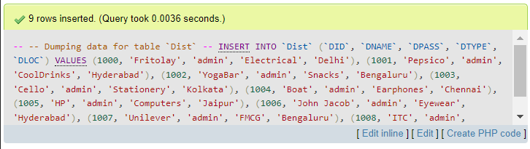

Dumping data for table `store`

QUERY:

-- Dumping data for table `store`

INSERT INTO `store` (`SID`, `SPASS`, `SBRANCHNAME`, `SCITY`, `SREGION`, `SSTATE`, `SPCODE`) VALUES

(100, 'admin', 'Ajmal Nagar', 'Delhi', 'North Delhi', 'Delhi', 131222),

(101, 'admin', 'Silk Point', 'Bidar', 'North Karnataka', 'Karnataka', 585401),

(102, 'admin', 'Banashankari', 'Bengaluru', 'South Karnataka', 'Karnataka', 585403),

(103, 'admin', 'Yeshawantpur', 'Bengaluru', 'South Karnataka', 'Karnataka', 585333),

(104, 'admin', 'VV nagar', 'Mysore', 'Central Karnataka', 'Karnataka', 585233),

(105, 'admin', 'Batra Nagar', 'Allahabad', 'North UP', 'UP', 485401),

(106, 'admin', 'Shanti Layout', 'Jaipur', 'South Rajasthan', 'Rajasthan', 385401),

(107, 'admin', 'Amar Colony', 'Kozhikode', 'North Kerala', 'Kerala', 457401),

(108, 'admin', 'Nippani', 'Gulbarga', 'North Karnataka', 'Karnataka', 595401),

(109, 'admin', 'Bhuvana Colony', 'Bengaluru', 'South Karnataka', 'Karnataka', 585567),

(110, 'admin', 'Ganesh Nagar', 'Shimla', 'North Kashmir', 'Kashmir', 591401),

(111, 'admin', 'Tulasi Layout', 'Shillong', 'North Meghalaya', 'Meghalaya', 185234);

OUTPUT:

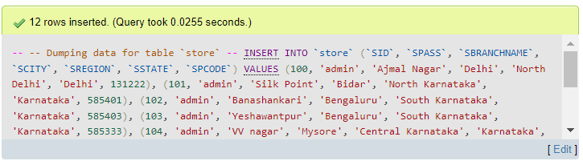

Dumping data for table `sales`

QUERY:

-- Dumping data for table `sales`

INSERT INTO `sales` (`SALESID`, `SDATE`, `SCOST`, `SID`) VALUES

(222, '2022-11-22', 40079, 100),

(223, '2022-11-22', 70000, 100),

(227, '2022-11-28', 59879, 102),

(228, '2022-11-25', 60000, 103),

(229, '2022-11-17', 70000, 104),

(230, '2022-11-27', 70000, 111),

(235, '2022-11-25', 70000, 110),

(240, '2022-11-23', 70000, 111),

(242, '2022-11-20', 70000, 105),

(244, '2022-11-24', 70000, 106),

(250, '2022-11-28', 70000, 108);

OUTPUT:

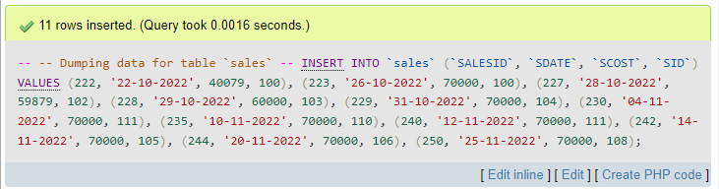

Dumping data for table `stock`

QUERY:

-- Dumping data for table `stock`

INSERT INTO `stock` (`CRY`, `SCRY`, `QUANT`, `SID`) VALUES

('Electrical', 'Mobiles', 30, 101),

('Snacks', 'Cereal', 300, 100),

('Electrical', 'Wires', 500, 100),

('Computers', 'Laptops', 10, 111),

('FMCG', 'Shampoo', 1000, 111),

('CoolDrinks', 'Pepsi', 2000, 107),

('Stationery', 'Pen', 5000, 106),

('Earphones', 'Bluetooth', 150, 108),

('Eyewear', 'Contact Lens', 170, 109),

('Earphones', 'Neck Band', 400, 104),

('Eyewear', 'Spectacles', 120, 103),

('FMCG', 'Cigarette', 1500, 102),

('FMCG', 'Soap', 3000, 105);

OUTPUT:

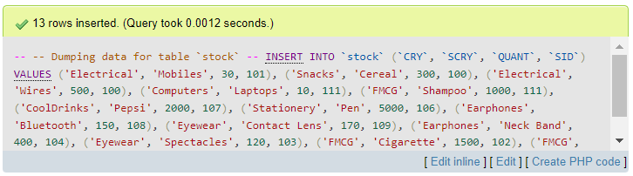

Dumping data for table `st_orders`

QUERY:

-- Dumping data for table `st_orders`

INSERT INTO `st_orders` (`SID`, `ORDID`, `DID`, `ORDDATE`, `PMYSTAT`, `SHPMODE`, `SHPSTAT`) VALUES

(100, 500, 1000, '2022-11-15', '', 'Premium', 'Delivered'),

(100, 501, 1001, '2022-11-28'  , 'PAID', 'Normal', 'PENDING'),

(101, 502, 1001,'2022-11-27' , 'PAID', 'Premium', 'Delivered'),

(102, 503, 1002,'2022-11-18' , 'PAID', 'Normal', 'PENDING'),

(103, 504, 1003, '2022-11-25', '', 'Normal', 'PENDING'),

(105, 505, 1004, '2022-11-22' , '', 'Normal', 'PENDING'),

(106, 506, 1005, '2022-11-26', '', 'Normal', 'PENDING'),

(105, 507, 1006, '2022-11-28', '', 'Normal', 'PENDING'),

(111, 508, 1008, '2022-11-28', '', 'Normal', 'PENDING');

OUTPUT:

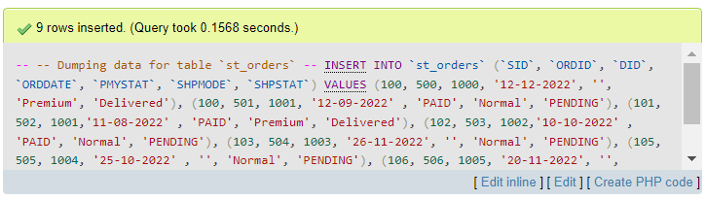

-------------Section Break (Next Page) -------------

**Join Queries**

Showcase at least 4 join queries

Write the query in English Language, Show the equivalent SQL statement and also a screenshot of the query and the results.

(Note: Store with SID 102 was deleted which resulted in deletion of a few other related entries. The following operations are performed on remaining data in database.)

1. **Natural Join:**

Retrieve all the branch name, city, specific category, quantity from store and stock

QUERY and OUTPUT:

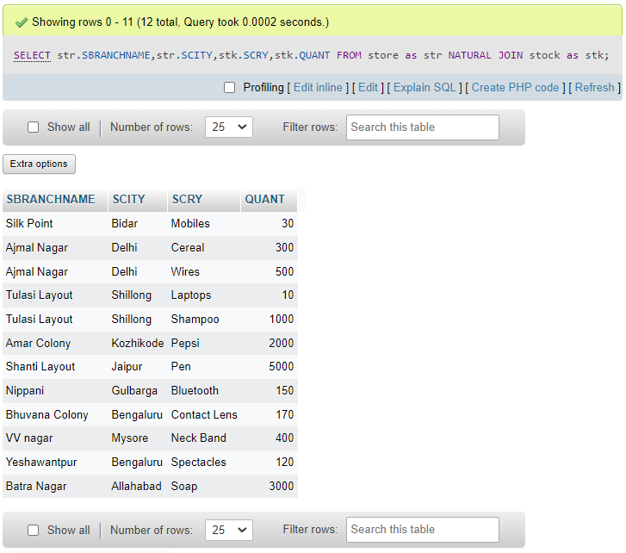

1. **Left Join:**

Retrieve all details from dist and only those which have matching DID from st_orders.

QUERY and OUTPUT:

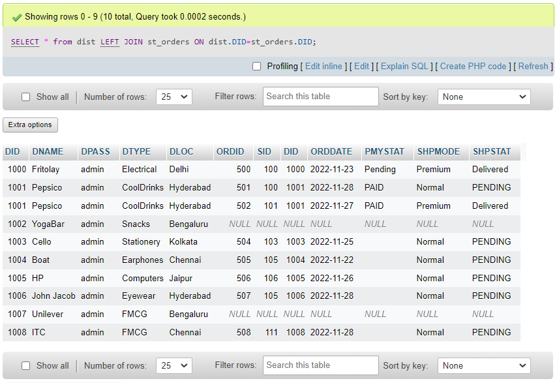

1. **Right Join:**

Retrieve the sales ID, date, cost from sales table and Branch name from store table while keeping all entries of sales and only matching ones from store, also order by sales date.

QUERY and OUTPUT:

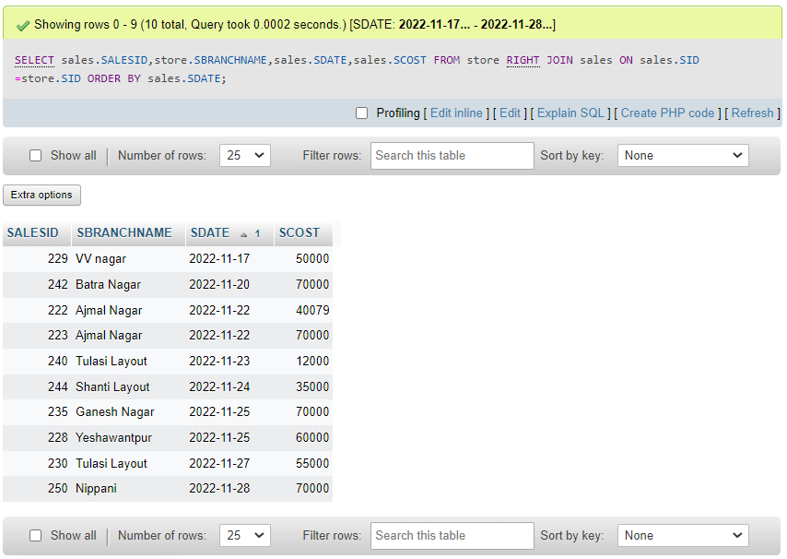

1. **Inner join:**

Retrieve dname, dtype, dloc from dist; orddate, shpstat from st_orders by inner join and order by dname.

QUERY and OUTPUT:

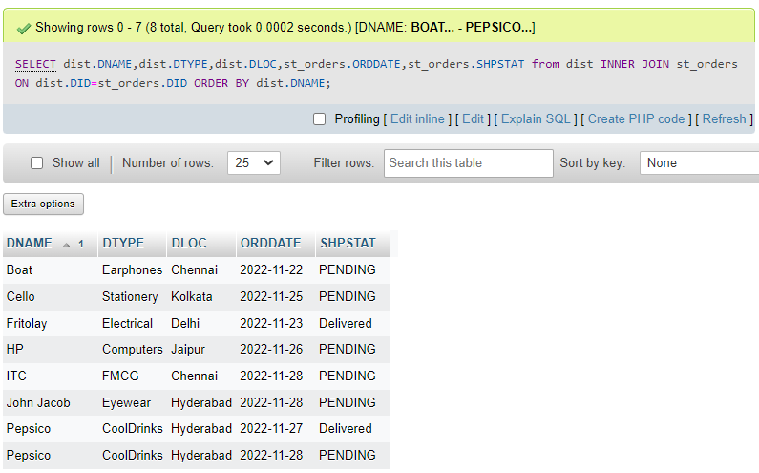

-------------Section Break (Next Page) -------------

**Aggregate Functions**

Showcase at least 4 Aggregate function queries

Write the query in English Language, Show the equivalent SQL statement and also a screenshot of the query and the results

1. Retrieve the **count** of number of sales greater than 50,000

QUERY and OUTPUT:

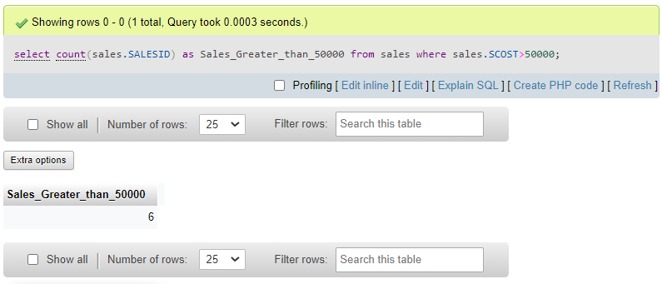

1. Display the Category, specific category and quantity of stock with **maximum** quantity.

QUERY and OUTPUT:

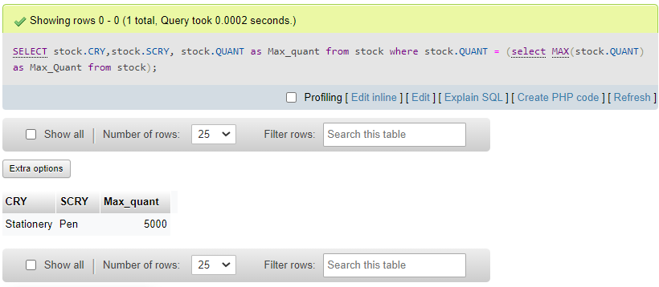

1. Retrieve **Sum** of sales made by store with SID=111.

QUERY and OUTPUT:

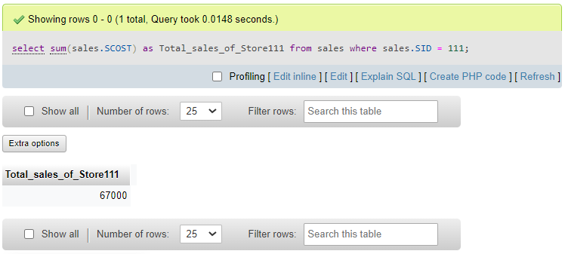

1. Display **Average** stocks in store with SID=100.

QUERY and OUTPUT:

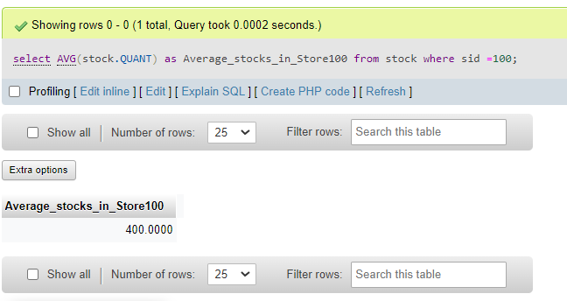

-------------Section Break (Next Page) -------------

**Set Operations**

Showcase at least 4 Set Operations queries

Write the query in English Language, Show the equivalent SQL statement and also a screenshot of the query and the results.

1. Perform **UNION** operation on SID of stock and st_orders.

QUERY and OUTPUT:

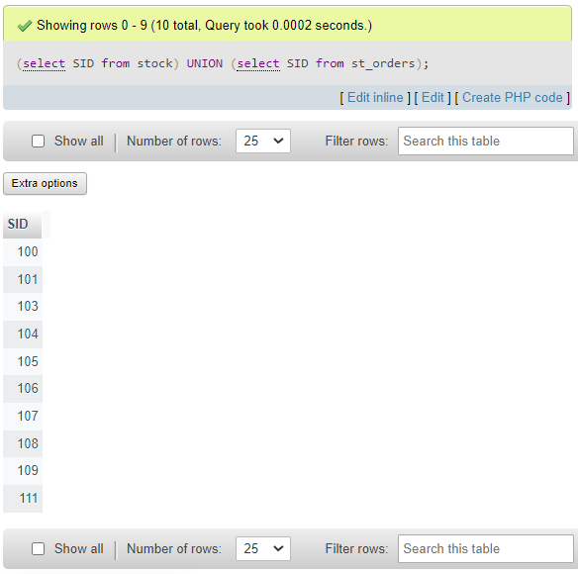

1. Perform **UNION ALL** operation on DID from dist and st_orders.

QUERY and OUTPUT:

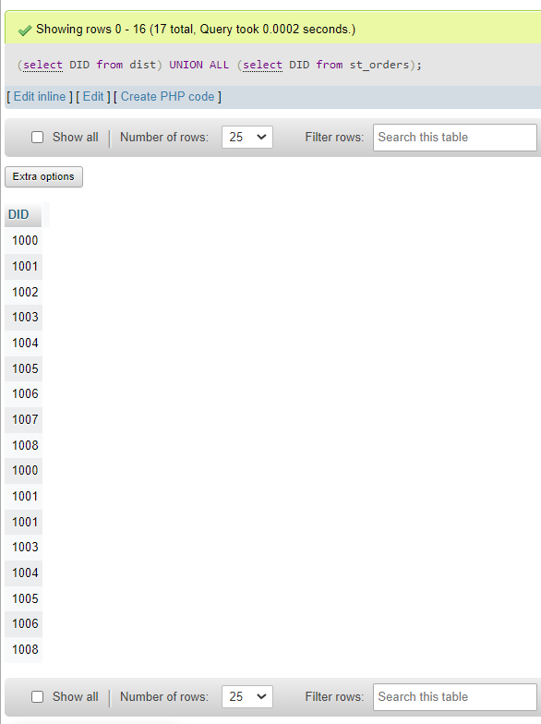

1. To find **INTERSECTION** of SIDs from sales table and store table where state is Karnataka.

QUERY and OUTPUT:

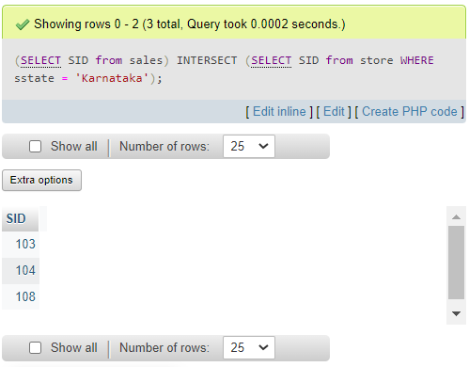

1. To find which stores have not had any sales (**MINUS** operation)

QUERY and OUTPUT:

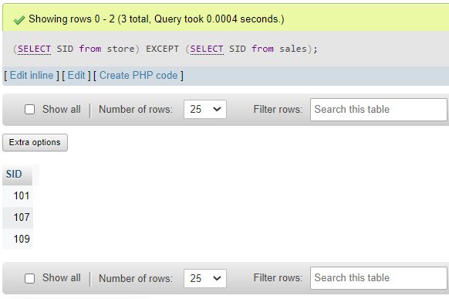

-------------Section Break (Next Page) -------------

**Functions and Procedures**

**Create a Function and Procedure. State the objective of the function / Procedure. Run and display the results**.

**FUNCTION:**

Function to show the connectivity of distributors.

**OBJECTIVE:**

We can say that a distributor has good connectivity if he distributes stocks in more than one warehouse in a single location. This is because he can connect to more stores or customers quickly through multiple warehouses.

**QUERY and OUTPUT:**

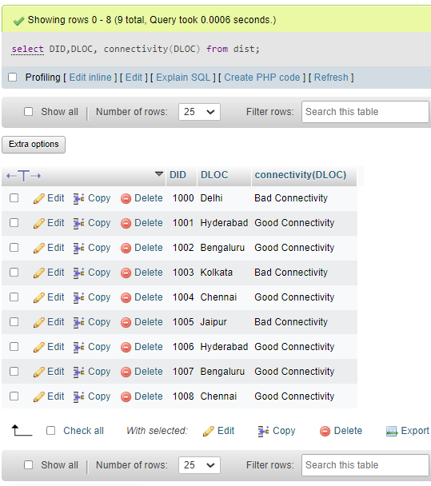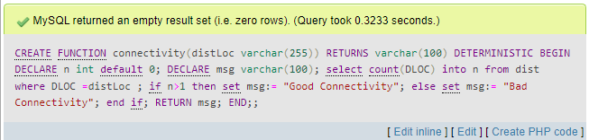

**PROCEDURE:**

Procedure to count the number of stores in each state.

QUERY and OUTPUT:

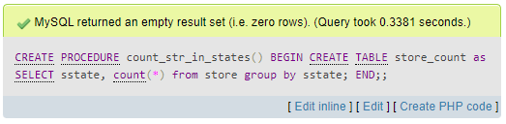

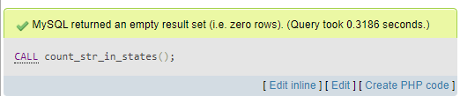

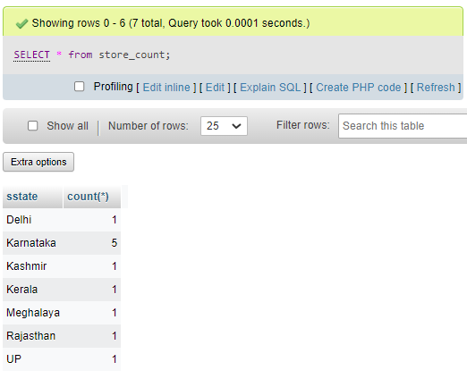

-------------Section Break (Next Page) -------------

**Triggers and Cursors**

**Create a Trigger and a Cursor. State the objective. Run and display the results.**

**TRIGGER:**

Write a trigger on stock for when category of exceeds 3, display an error message.

**OBJECTIVE:**

To show that each category in stock shouldn’t exceed 3 as we want to ensure many other categories are included in the stock to get larger customer base.

QUERY and OUTPUT:

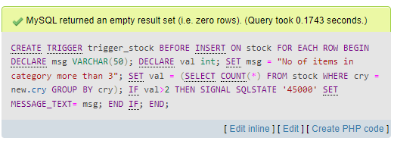

POSITIVE CASE:

QUERY and OUTPUT:

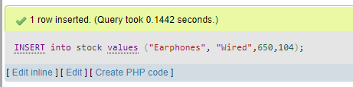

NEGATIVE CASE:

QUERY and OUTPUT:

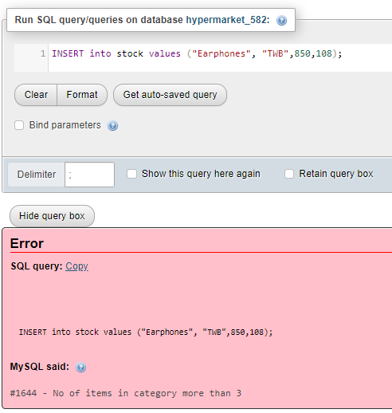

**CURSOR:**

Create a Cursor to display the distributors in Hyderabad.

**OBJECTIVE**

A cursor acts as a pointer, hence the cursor used below tries to display the Details of distributors in Hyderabad.

The cursor here is used within a procedure.

QUERY and OUTPUT:

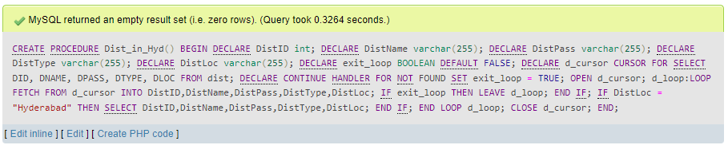

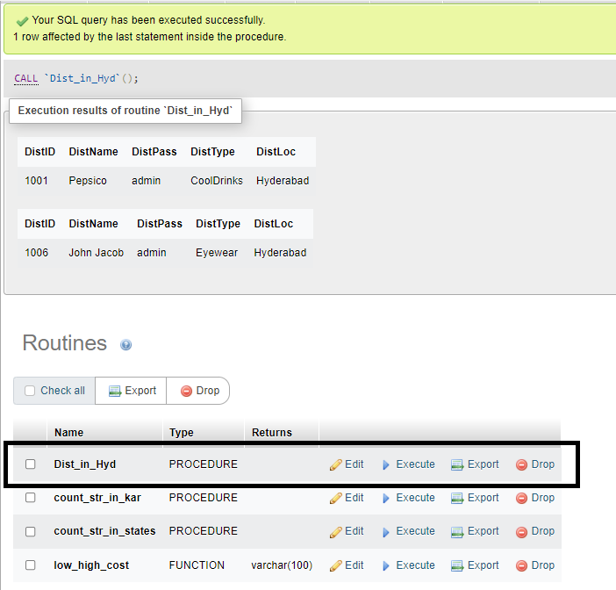

-------------Section Break (Next Page) -------------

**Developing a Frontend**

**The frontend should support**

**1. Addition, Modification and Deletion of records from any chosen table**

**2. There should be a window to accept and run any SQL statement and display the result**

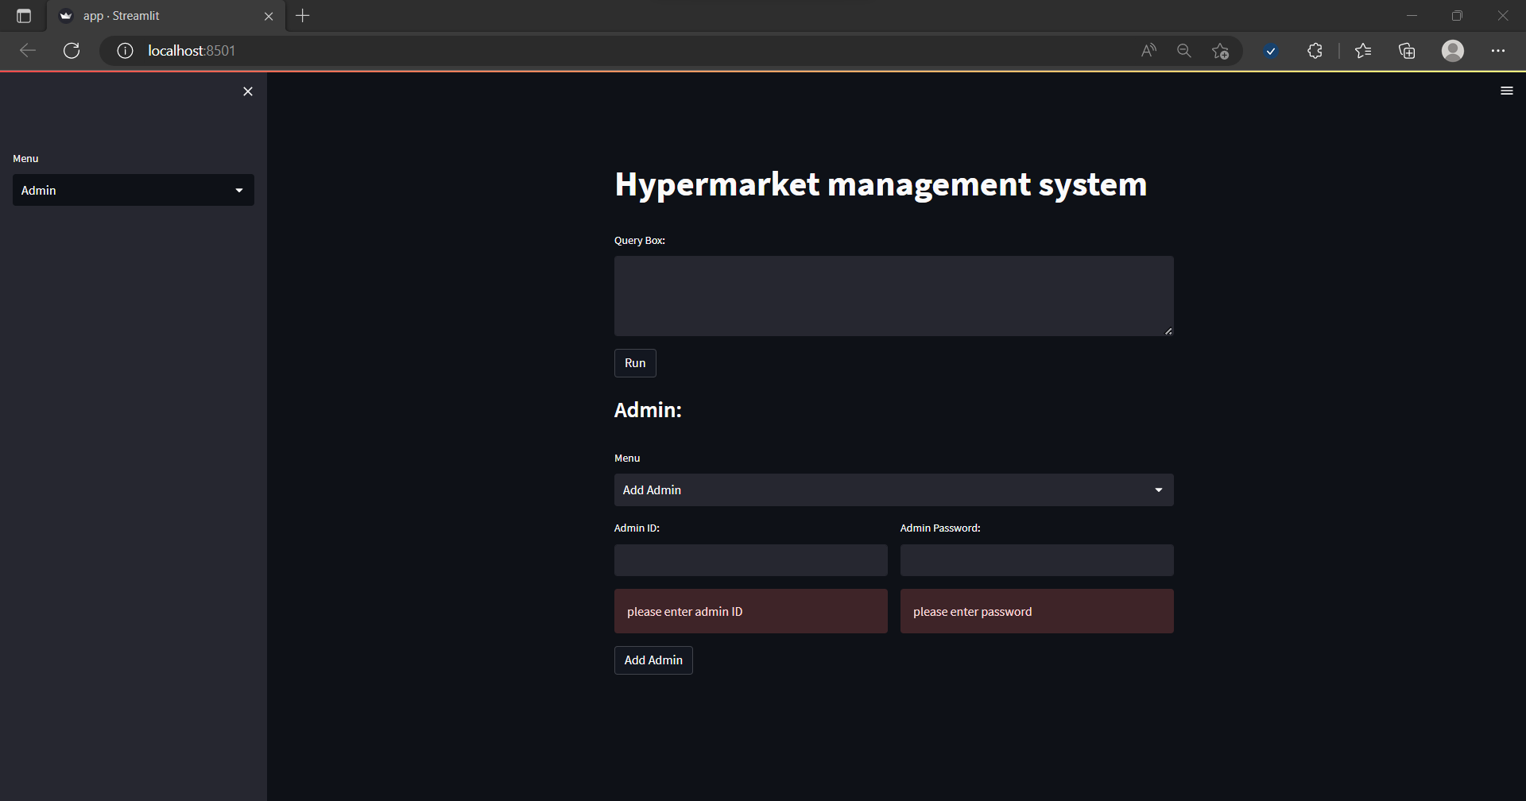**Overview:**

**Menu to choose which table to perform CRUD operations:**

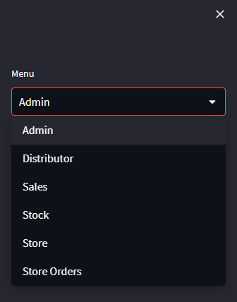

**Menu to choose which CRUD operation to perform on selected table:**

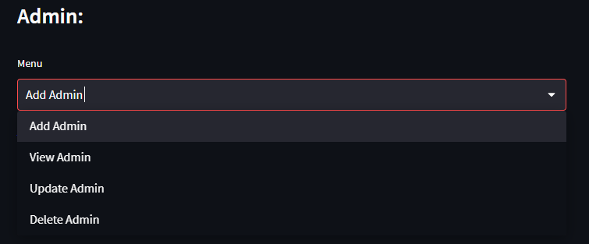

**Adding Admin:**

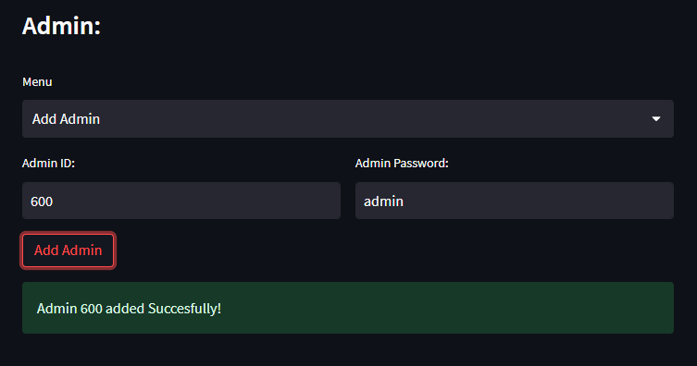

**Viewing admin:** (Note the newly added admin-600)

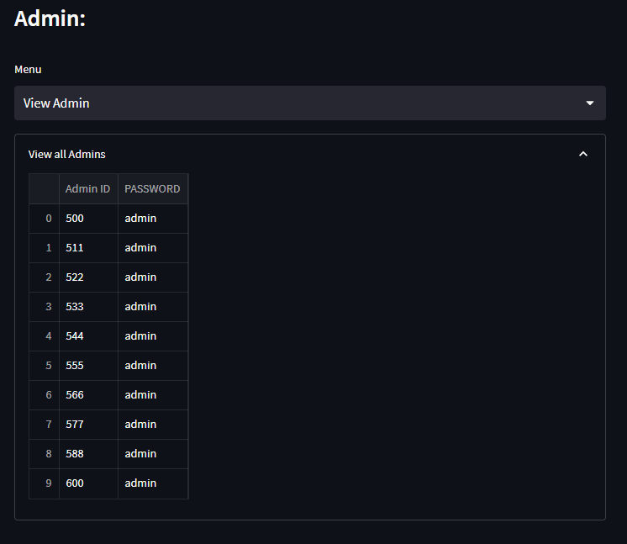

**Updating a stock:**

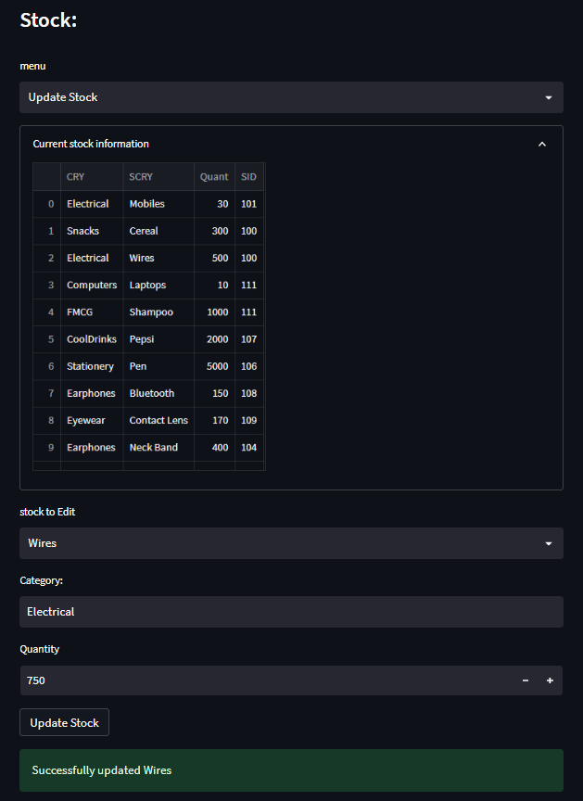

**Viewing the change:**

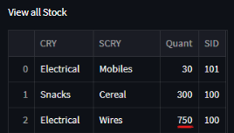

**Deleting an entry from sales table:**

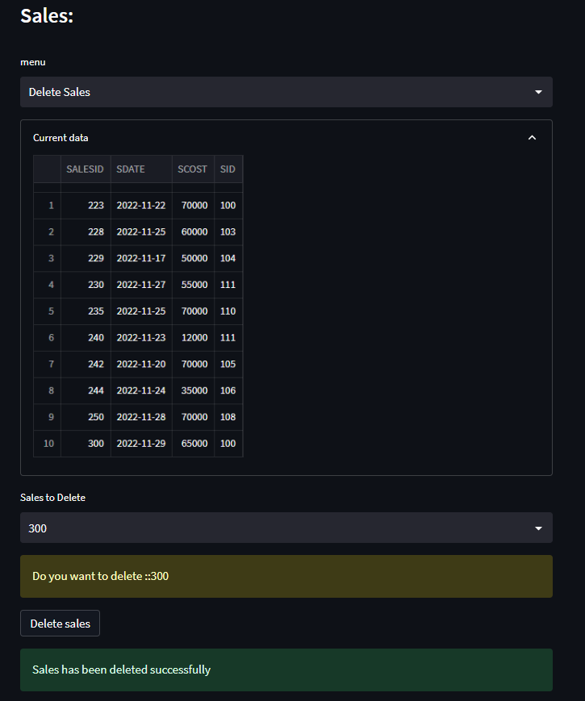

**In the same page you have an option to see the changes after deletion:**

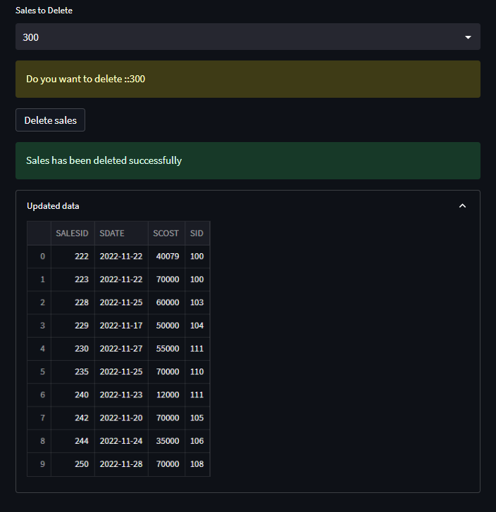

**Note: These functionalities are applicable and included in front end for all the tables that have been created in the database.**

**Query Box:**

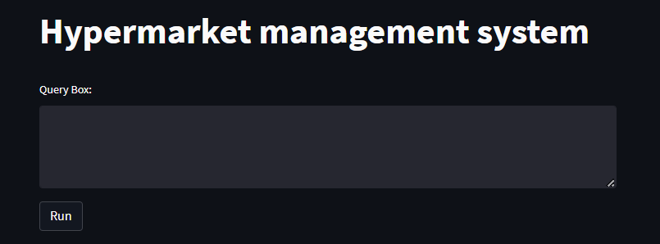

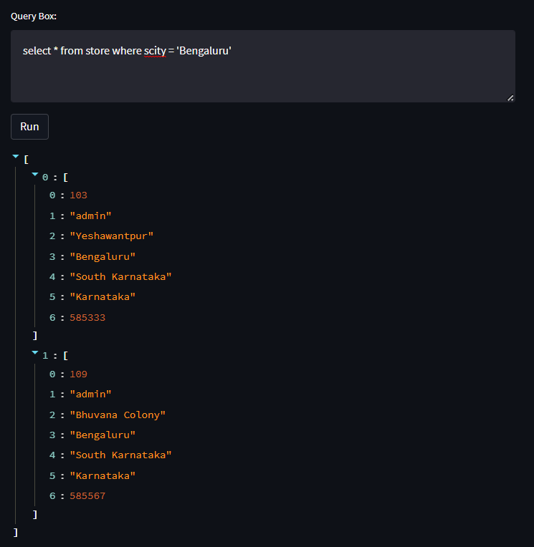

**-------------THANK YOU-------------**