BDA Lab Internal – 2

1. Linear Regression using Spark:

OUTPUT:

Displaying Data and Schema:

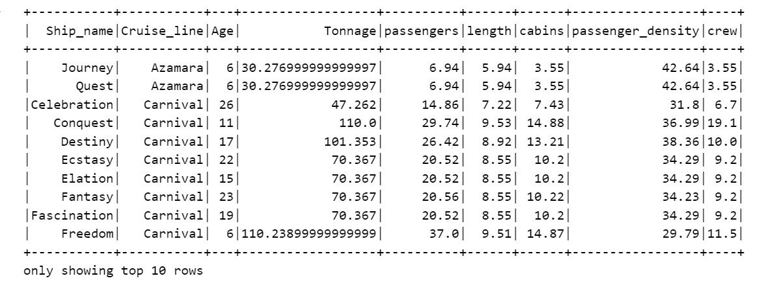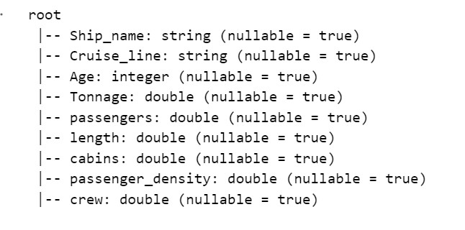

Preprocessing Data:

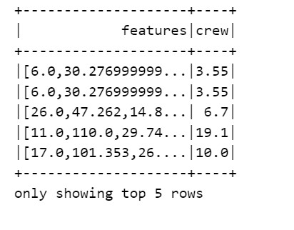

Rsquared error of the model after training:



Result with the testing Dataset:

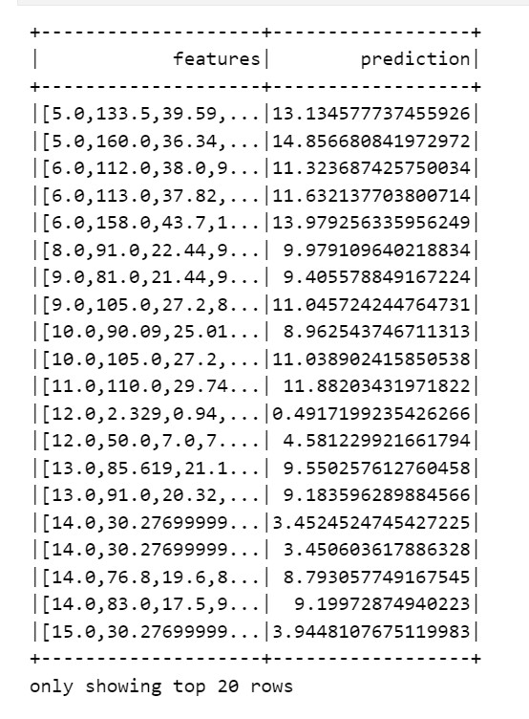

1. KMeans clustering using Spark:

OUTPUT:

Displaying Data and its Schema:

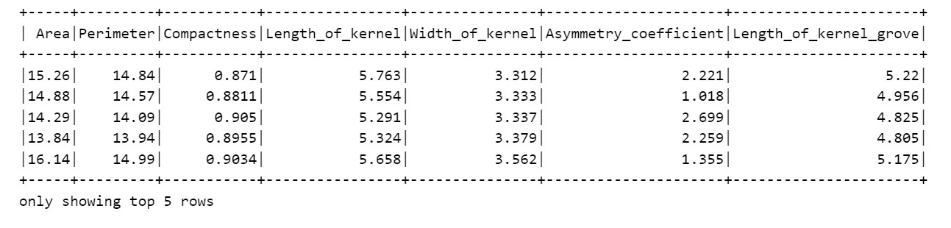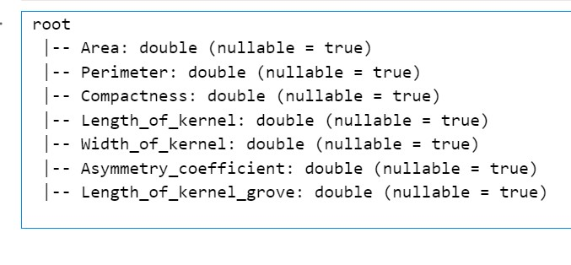

Preprocessed Data before and after scaling:

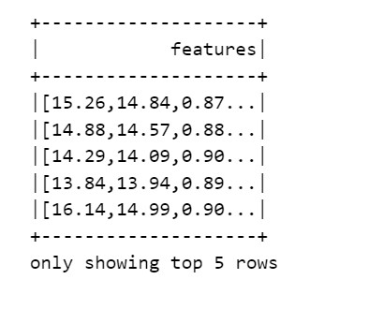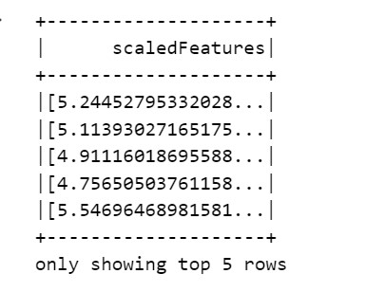

Silhouette Score graph for different k values:

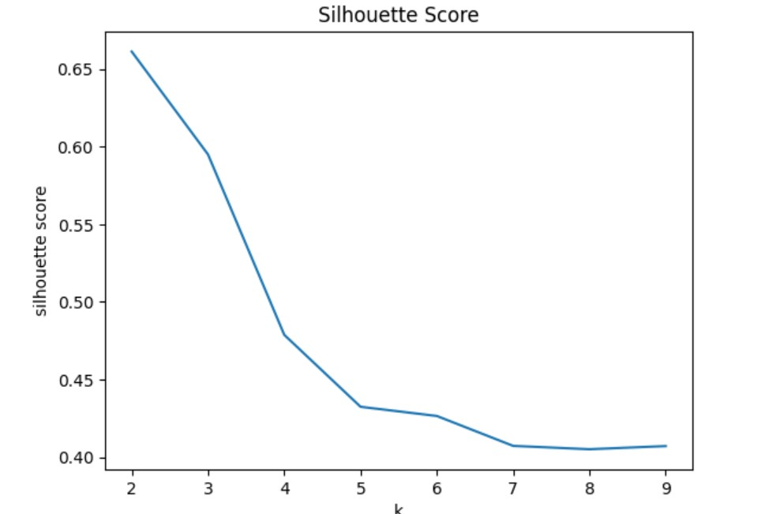

Displaying Cluster centers:

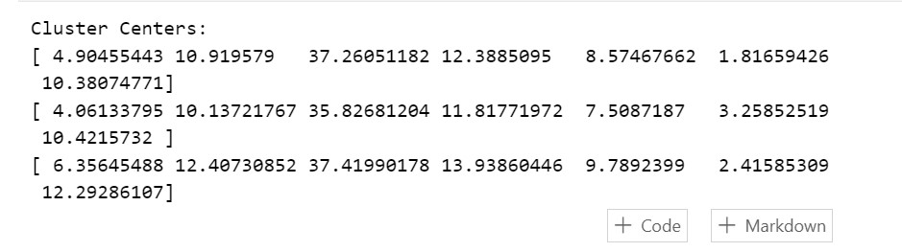

Displaying predictions for test data:

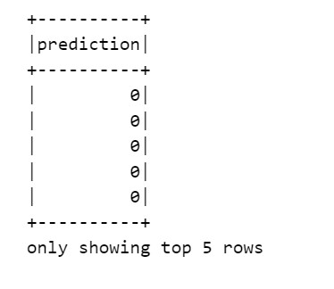

1. Dataset processing using Spark:

OUTPUT:

Printing Data:

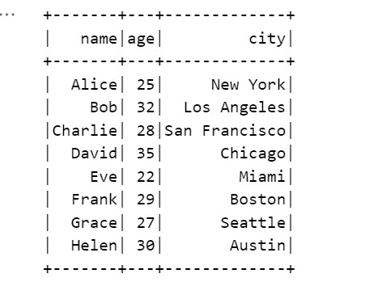

Displaying filtered data:

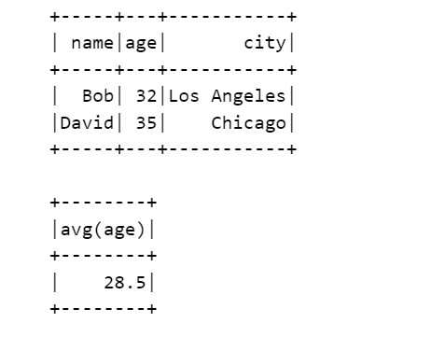

1. Data Visualization techniques:

OUTPUT:

Displaying data:

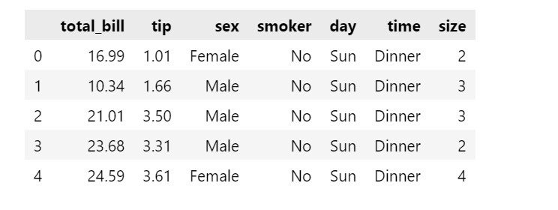

Scatter plot:

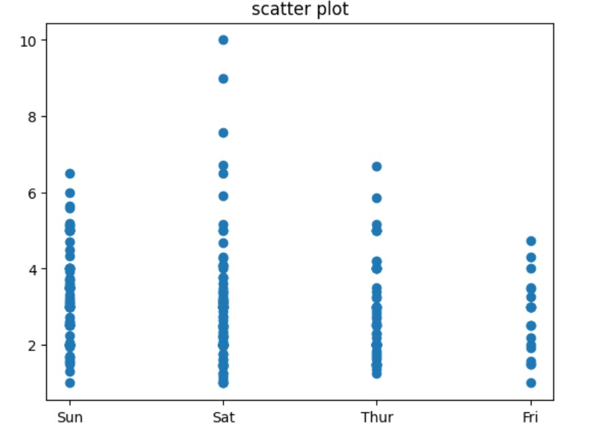

Bar chart:

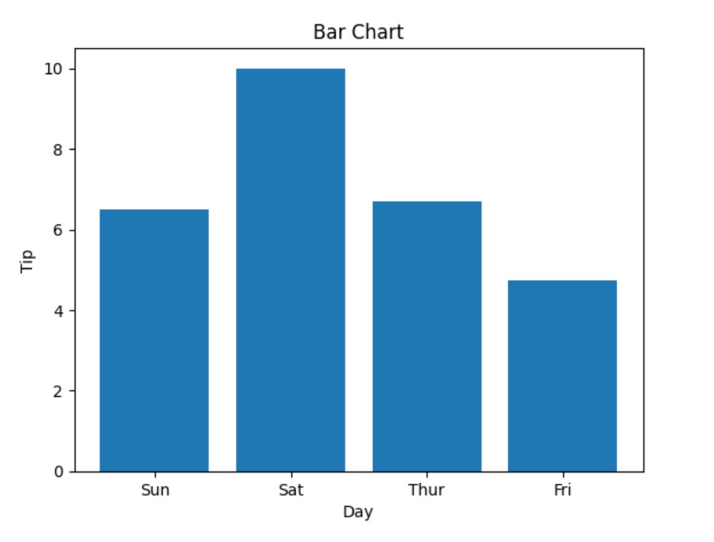

Histogram:

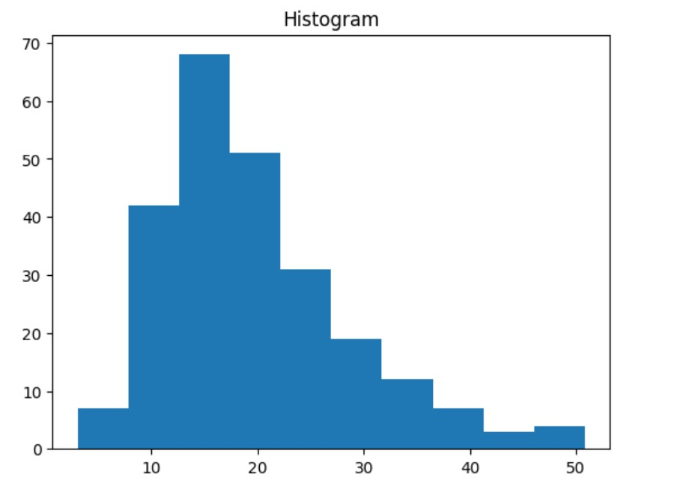

All plots together using seaborn:

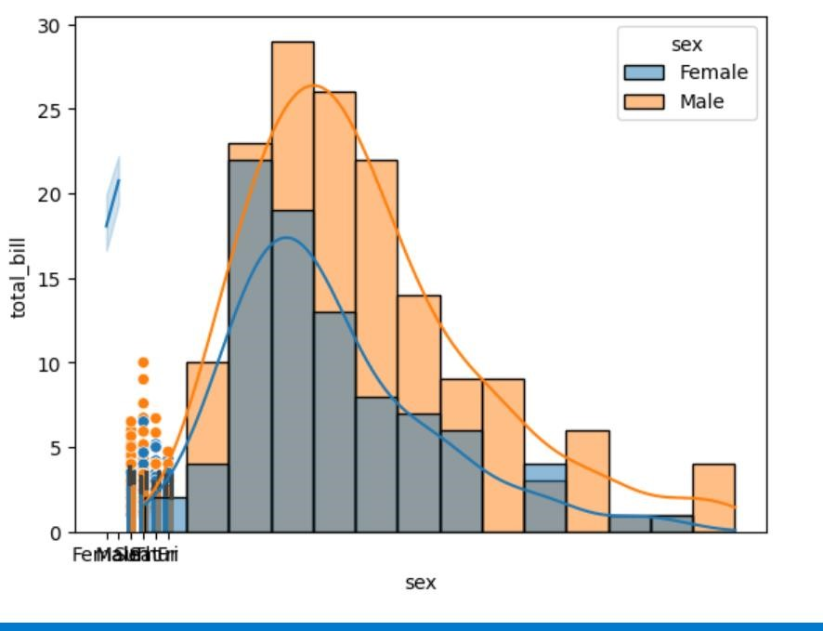

1. Word count using Mapreduce:

OUTPUT:

**Mapper.py :**

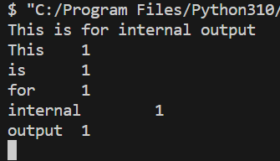

**Reducer.py :**

