**Software Engineering Lab (CSC17103)**

*Monsoon Semester (2020-21)*



***SRS- Student Feedback System***

*Submitted by*

HARIKRISHNA()

MOHIT YADAV()

SUYASH SRIVASTAVA(17JE003210)

YASHASVI GOUR(17JE002959)

Department of Computer Science and Engineering, Indian Institute of Technology(ISM) Dhanbad, 826004

Student Feedback System

**Client Name: Anuj Kumar**

**Client’s Email ID:** [**anuj-au@iitism.ac.in**](mailto:anuj-au@iitism.ac.in)

**Client’s Contact Number: +91 9199052296**

**Deadline: 15th November 2020**



Team:

Suyash Srivastava (Manager + Developer + Analyst)

Yashasvi Gour (Developer + Tester + Analyst)

HariKrishna (Developer+ Designer)

Mohit Yadav (Designer + Tester)

SYSTEM REQUIREMENT SPECIFICATION

(SRS)

**Table of Contents**

1. Introduction
   1. Purpose
   2. Scope of project
   3. Questions with the customer
   4. References
2. Overall Description
   1. System Environment
   2. Functional Requirements Specification
   3. User Characteristics
   4. Non functional Requirements(in brief)
   5. Requirement Specifications
   6. Functional Requirements
      1. Adjourn case
      2. Browse case
      3. Close case
      4. Create case
      5. Create user
      6. Delete user
      7. Query cases
      8. Update case
   7. Detailed Non Functional Requirements

4. Future Extensions

# Introduction

The Student Feedback System being developed for educational institute. This fully automated Feedback system connected with all sort of database about student and college details will be useful in taking the anonymous feedback of each course by students at the end of semester and let the professor and college administration improvise for upcoming semesters by analyzing these feedbacks.

#### PURPOSE

The purpose of this document is to present a detailed description of the Student Feedback System. The main purpose of this SRS is –

* + - It will explain the purpose and features of the system
    - The interfaces of the system, what the system will do the constraints under which it must operate and how the system will react to external stimuli.
    - For all testers to check the validation of the project.

This document is intended for both the stakeholders and the developers of the system.

#### SCOPE OF PROJECT

* This system allows the students to provide anonymous feedback to the courses provided in last semester.
* The feedback report is generated after which it is analyzed by Professor of the corresponding course and HOD of the department, Dean Academic and Director of the institute.
* Professor can view the number of students who have filled the feedback for his/her respective subject and the score and feedback given by the students.
* HOD can view the score and feedback of each professor of his department.
* Dean Academic and Director can view the score and feedback about any professor teaching in the institute.

#### Q&A with the Customer

As we had some doubts regarding the software building part so we planned to ask some question to customer regarding the requirements for this project, to assure its correctness.

Hence, this section contains all the questions we asked along with the answers provided by the customers. This was an important part of the development process as introduction of new feature and changes in upcoming stages would be difficult.

1. Will the feedback remain anonymous?

Answer: Yes it will remain anonymous.

1. Can a student fill the feedback more than once?

Answer: No, after receipt generation student should not fill the feedback again.

1. Can a student edit his/her submitted feedback once submitted?

Answer: No

1. Do student provide feedback of a course or of a professor?

Answer: Course

1. For which courses will a student be able to fill a feedback?

Answer: Only for those course which he/she had studied in his/her last semester.

1. Can a student avail his/her feedback receipt of previous semesters?

Answer: Preferred but not necessary.

1. Can a student view the details of the feedback of another student?

Answer: No, every student can access only his/her feedback no other.

1. Can a student skip a course, feedback question or comment section

Answer: All questions of each course are mandatory. Comment section can be optional.

1. Will Professor be able to see his feedback overall or for respective course?

Answer: Both, main page will have courses he taught and overall feedback, and clicking on each course will let him see feedback of each course separately.

1. What will be present in feedback sections?

Answer: Fixed questions with radio buttons for ratings and an extra comment section for each course.

#### References

The references for the above software are as follows:-

1. [www.google.co.in](http://www.google.co.in/)
2. [www.wikipedia.com](http://www.wikipedia.com/)
3. www.github.com
4. IEEE. Software Requirements Specification Std. 830-1993.
5. M. Tarare1, M.Manwani2, A. Paidlewar3, S. Maturkar4, P. Chaudhari5, J. V. Shiral6,” Feedback Management System for Evaluating And Generating Monthly Report”, International Journal of Emerging Technology and Advanced Engineering, Volume 4, Issue 3, March 2014.
6. J. Hatie, H. Timperley, "The power of feedback", J. Review of Educational Research, 87(1), pp. 81-112, 2007.
7. Software Engineering by Roger S. Pressman (Tata MC-GRAW hill, 5th edition).
8. Data Base Management System by Raghu Rama Krishnan (Tata MC-GRAW hill, 3rd edition).

# Overall description

### System environment

### 

### 

### 

* The main log-in screen of the Student Feedback System (SFS) will have options to log-in as student, Professor, HOD, Dean Academic or Director of the institute, by providing correct user name and password.
* If correct log-in details are entered, the SFS will show the home screen of the respective users from where they can access their respective details and functions.
* All Details will be fetched, pushed or updated in Database hosted on College Server via user friendly UI.
* These functions been enlisted later in this section.

### Functional requirements specification

* This section outlines the use cases for each of the active users separately.
* The Use cases of Students are completely different than that of others.
  + 1. Student Use Cases

**Use case: Access Main Page**

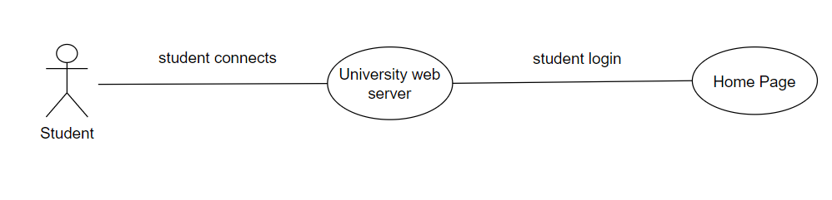

Brief Description

The University Web Server is waiting for a student to connect.

Initial step-by-step description

For this use case to be initiated, the student must be connected to the University Web Server.

1. The Student connects to the University Web Server.
2. The Student selects the Student login radio option and fills in correct login details.
3. The University Web Server passes the Student to the Home Page which contains student details and option to fill feedback.

**Use case: Select correct Session and Year**

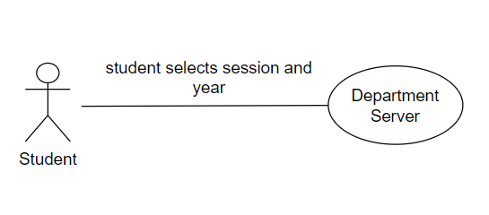

BriefDescription

Showing pending feedback forms for enrolled courses and generation of feedback receipt if already submitted.

Initial step-by-step description

For this use case to be initiated, the student must select fill feedback option.

1. Student need to select correct Year and Session to connect with department server.
2. If corresponding feedback is already submitted it should generate a feedback receipt else it should display the list of enrolled courses for which he/she needs to fill in feedback.
3. Student need to click on each course one by one and fill feedback form for each selected course. And finally click on submit option to generate feedback receipt.

**Use case: Filling form**

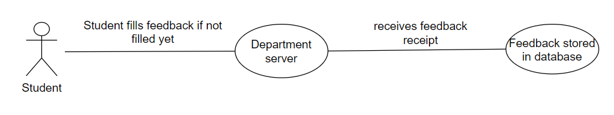

Brief Description

Answering all question of feedback and adding optional comment on each course.

Initial step-by-step description

For this use case to be initiated, the student must have selected a enrolled course whose feedback is still pending.

1. The Student need to select corresponding radio button as rating for each question asked.
2. The Student may add an optional comment for each course.
   * 1. Professor Use Cases

**Use case: Access Main Page**

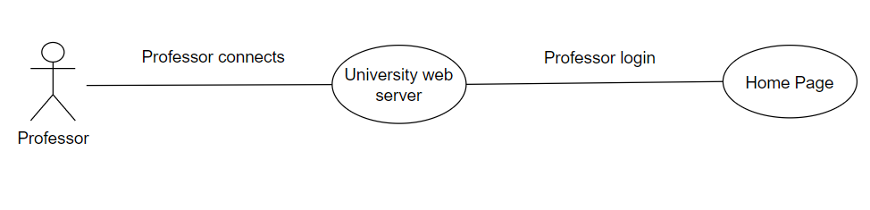

Brief Description

The University Web Server is waiting for a Professor to connect.

Initial step-by-step description

For this use case to be initiated, the Professor must be connected to the University Web Server.

1. The Professor connects to the University Web Server.
2. The Professor selects the Professor login radio option and fills in correct login details.
3. The University Web Server passes the Professor to the Home Page which contains Professor’s details and option to see feedback.

**Use case: Select correct Session and Year**

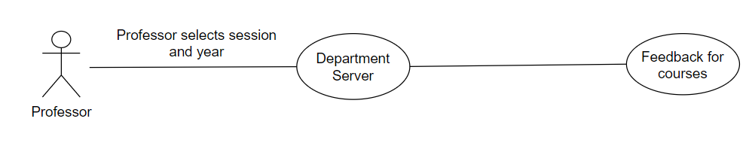

Brief Description

Showing till now filled feedback forms for courses taught by him and overall rating corresponding to each question.

Initial step-by-step description

For this use case to be initiated, the professor must select view feedbacks option.

1. Professor need to select correct Year and Session to connect with department server.
2. It should show his overall performance in that semester and list of courses he taught in that particular semester.
3. Professor can click on each course one by one and analyze feedback for each selected course.

**Use case: Viewing feedback responses course-wise**

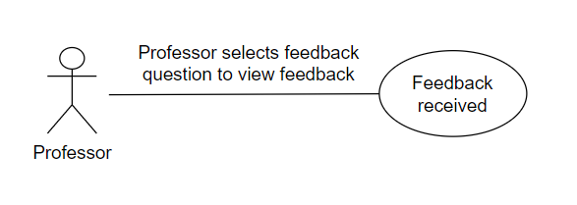

Brief Description

Showing no. of students enrolled in that particular course and no. of points one get on each corresponding question.

Initial step-by-step description

For this use case to be initiated, the professor must have selected a course from list provided.

1. The Professor can see need to select corresponding radio button for each question asked to view its ratings.
   * 1. HOD Use Cases

**Use case: Access Main Page**

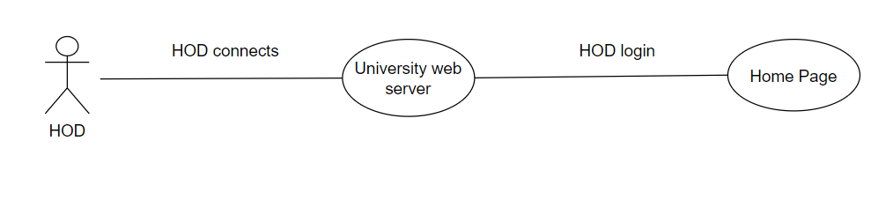

Brief Description

The University Web Server is waiting for a HOD to connect.

Initial step-by-step description

For this use case to be initiated, the HOD must be connected to the University Web Server.

1. The HOD connects to the University Web Server.
2. The HOD selects the HOD login radio option and fills in correct login details.
3. The University Web Server passes the HOD to the Home Page which contains Department’s details and option to view feedback.

**Use case: Select correct Session and Year**

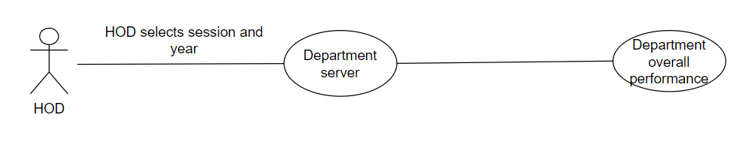

Brief Description

Displaying the courses offered by department in a particular semester and department’s overall rating corresponding to each question.

Initial step-by-step description

For this use case to be initiated, the HOD must select view feedbacks option.

1. HOD need to select correct Year and Session to connect with department server.
2. It should show department’s overall performance in that semester and list of courses offered by department in a particular semester.
3. HOD can click on each course one by one and analyze feedback for each selected course.

**Use case: Viewing feedback responses course-wise**

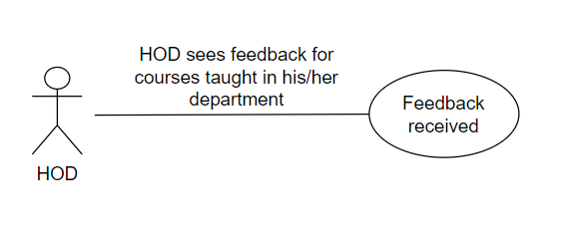

BriefDescription

Showing no. of students enrolled, professor who taught that particular course and no. of points one get on each corresponding question.

Initial step-by-step description

For this use case to be initiated, the HOD must have selected a course from list provided.

1. The Professor can see need to select corresponding radio button for each question asked to view its ratings.
   * 1. Admin Use Cases

**Use case: Access Main Page**

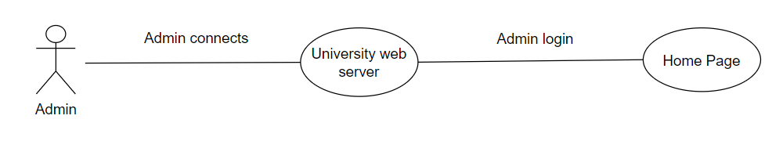

Brief Description

The University Web Server is waiting for a Professor to connect.

Initial step-by-step description

For this use case to be initiated, the Admin must be connected to the University Web Server.

1. The Admin connects to the University Web Server.
2. The Admin selects the Admin’s login radio option and fills in correct login details.
3. The University Web Server passes the Admin to the Home Page which contains Admin’s details and option to see feedback.

**Use case: Select correct Session and Year**

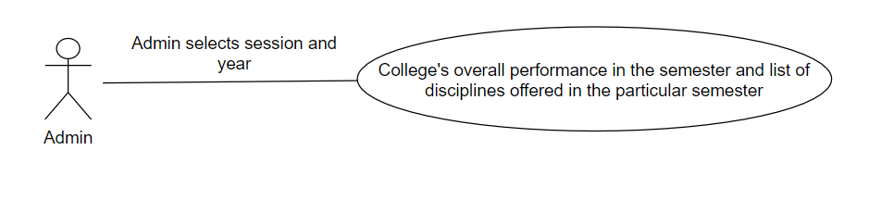

Brief Description

Showing till now filled feedback forms for disciplines offered by institute and overall rating corresponding to each question in a particular semester.

Initial step-by-step description

For this use case to be initiated, the Admin must select view feedbacks option.

1. Admin need to select correct Year and Session .
2. It should show college’s overall performance in that semester and list of disciplines offered by institute in that particular semester.
3. Admin can click on a discipline to view its details and analyze its feedback.

**Use case: Viewing feedback responses discipline-wise**

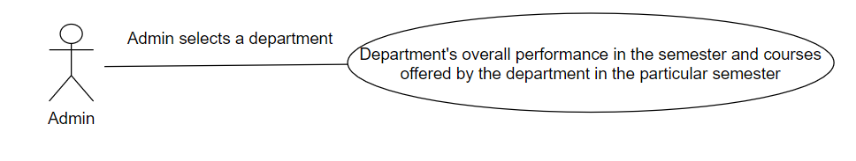

Brief Description

Showing no. of courses offered by that department and no. of points one get on each corresponding question.

Initial step-by-step description

For this use case to be initiated, the Admin must have selected a department from list provided.

(a) It should show department’s overall performance in that semester and list of courses offered by department in a particular semester.

1. Admin can click on each course one by one and analyze feedback for each selected course.

**Use case: Viewing feedback responses course-wise**

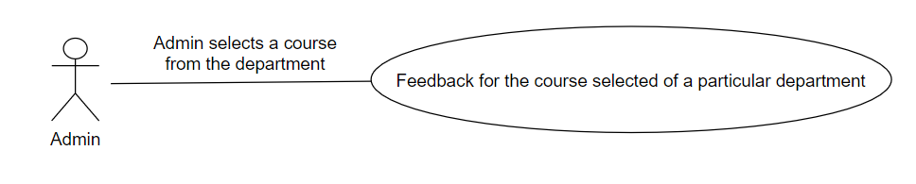

Brief Description

Showing no. of students enrolled, professor who taught that particular course and no. of points one get on each corresponding question.

Initial step-by-step description

For this use case to be initiated, the Admin must have selected a course from list provided.

1. The Admin can see need to select corresponding radio button for each question asked to view its ratings.

***2.3 User Characteristics***

* The Students, Professors, HOD and Admin are expected to be comfortable with using a basic Graphical User Interface consisting of windows, buttons, drop-down menus and input fields.
* They all must be connected with University’s intranet.

### 2.4. Non-functional requirements

There are requirements that are not functional in nature. Specifically, these are the constraints the system must work within.

The software must be compatible with both UNIX and Windows operating systems

# Requirement specifications

### Functional Requirements

#### Action Main Page

|  |  |
| --- | --- |
| **Use Case Name:** | Access Main Page |
| **Priority** | Essential |
| **Trigger** | None |
| **Precondition** | User logged in, currently on home screen |
| **Basic Path** | 1. It shows all the details of student, professor, Department, university if the user logged in as Student, Professor, HOD, and Admin respectively. 2. It should show the option to fill a feedback or analyze a feedback according to login type |

|  |  |
| --- | --- |
| **Alternate Path** | N/A |
| **Postcondition** | N/A |
| **Exception Path** | If there is a connection failure the user returns to Login Screen |

* + 1. **Select Correct Session and Year**

|  |  |
| --- | --- |
| **Use Case Name:** | Select correct Session and Year |
| **Priority** | Essential |
| **Trigger** | Button selection |
| **Precondition** | User logged in and have selected fill feedback or view feedback according to its login type. |
| **Basic Path** | 1. User selects Year and corresponding session. 2. In case of student    1. if for selected semester he had already filled the form, then it should display feedback receipt.    2. If not filled it should show the courses he was enrolled in that particular semester 3. In case of Professor   3.1 display course he taught in that semester and list of questions asked as feedback.  3.2 he can select each question and see his overall performance on it in that particular semester.  3.3 he can select a course to jump to view feedback course wise.   1. In case of HOD   3.1 display course his department had offered in that semester and list of questions asked as feedback.  3.2 he can select each question and see departments overall performance on it in that particular semester.  3.3 he can select a course to jump to view feedback course wise.   1. In case of Admin   3.1 display departments offered by the institute in that semester and list of questions asked as feedback.  3.2 he can select each question and see his overall performance on it in that particular semester.  3.3 he can select a department to jump to view feedbacks department wise. |
| **Alternate Path** | N/A |

|  |  |
| --- | --- |
| **Postcondition** | In case of student with already filled feedback he should get receipt else on feedback filling page.  In case of others they need to be a mentioned feedback analysis page |
| **Exception Path** | Connection error will lead to jumping back on login page |

* + 1. **Filling Form**

|  |  |
| --- | --- |
| **Use Case Name:** | Filling Form |
| **Priority** | Essential |
| **Trigger** | Radio button selection |
| **Precondition** | Student log in, and had selected a course from above mentioned list. |
| **Basic Path** | 1. Should be able to toggle between courses 2. For each course answering a set of questions by giving a ration using radio buttons. 3. Can add an optional comment for each course 4. Finally clicking on submit button for Receipt generation |
| **Alternate Path** | N/A |
| **Postcondition** | Generation of feedback form or error message if feedback was not filled completely. |
| **Exception Path** | If there is a connection failure the user returns to login page |

* + 1. **Viewing feedback Course wise**

|  |  |
| --- | --- |
| **Use Case Name:** | Viewing feedback Course wise |
| **Priority** | Essential |
| **Trigger** | Button selection |
| **Precondition** | HOD, Admin or Prof logged in, selected a course from above mentioned list. |
| **Basic Path** | 1. See total no. of students enrolled in that course and details of instructor. 2. Show overall performance of course by selecting each question |
| **Alternate Path** | N/A |
| **Postcondition** | User is on the course page. |
| **Exception Path** | If there is a connection failure the user returns to login page |

* + 1. **Viewing feedback Department wise**

|  |  |
| --- | --- |
| **Use Case Name:** | Viewing feedback department wis |
| **Priority** | Essential |

|  |  |
| --- | --- |
| **Trigger** | Button selection |
| **Precondition** | Admin logged in, currently on department list page. |
| **Basic Path** | 1. User can see list of courses offered by that department in that particular semester. 2. Can toggle on questions to see performance of Department 3. Can click on course to jump on view feedback as course status. |
| **Alternate Path** | N/A |
| **Postcondition** | User should be able to view department’s performance and jump to course page if a course is selected. |
| **Exception Path** | If there is a connection failure the user  returns to login screen |

* 1. ***Detailed non-functional requirements***

##### Logical structure of the data

The logical structure of the data has been represented in the diagram below

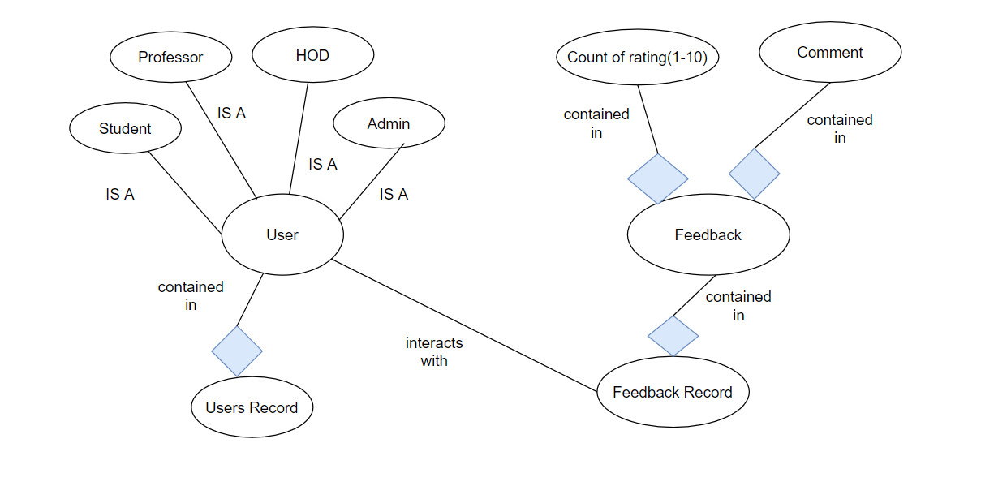*this representation might not resemble exactly with the Database, these are just for better understanding purpose

The descriptions of the various data entities are as follows:

##### User Data Entity

|  |  |  |  |
| --- | --- | --- | --- |
| **Data Item** | **Type** | **Description** | **Comment** |
| Username | Text | Username of the user | Assigned by Registrar |
| Password | Text | Password of the user | Assigned by Registrar initially |
| Type | Text | Type of the user | One of ‘Prof, ‘Student’, ‘HOD’, ‘Professor’ |

**Student Data Entity**

|  |  |  |  |
| --- | --- | --- | --- |
| **Data Item** | **Type** | **Description** | **Comment** |
| Adm. No. | Text | Admission Number | Unique |
| Name | Text | Full Name of Student |  |
| Department | Text | Branch of enrolled student |  |
| Start year | Integer | First year of student |  |
| Courses enrolled | List | List of courses enrolled |  |

**Professor Data Entity**

|  |  |  |  |
| --- | --- | --- | --- |
| **Data Item** | **Type** | **Description** | **Comment** |
| Emp. No. | Text | Employee Number | Unique |
| Name | Text | Full Name of Professor |  |
| Department | Text | Branch of enrolled Professor |  |

**HOD Data Entity**

|  |  |  |  |
| --- | --- | --- | --- |
| **Data Item** | **Type** | **Description** | **Comment** |
| Emp. No. | Text | Employee Number | Unique |
| Name | Text | Full Name of HOD |  |
| Department | Text | Branch of student |  |

**Admin Data Entity**

|  |  |  |  |
| --- | --- | --- | --- |
| **Data Item** | **Type** | **Description** | **Comment** |
| Emp. No. | Text | Employee Number | Unique |
| Name | Text | Full Name of Admin entity |  |
| Designation | Text | Director or Dean Academic |  |

**Department Data Entity**

|  |  |  |  |
| --- | --- | --- | --- |
| **Data Item** | **Type** | **Description** | **Comment** |
| Name | Text | Name of Department | Unique |
| Number of Students | Integer | Number of students enrolled in department |  |
| HOD | Text | Head of Department |  |

**Course Data Entity**

|  |  |  |  |
| --- | --- | --- | --- |
| **Data Item** | **Type** | **Description** | **Comment** |
| Course ID | Text | Self Explanatory |  |
| Name | Text | Name of Department |  |
| Number of Students | Integer | Number of students enrolled in department |  |
| HOD | Text | Head of Department |  |
| Year | Integer | Self Explanatory |  |
| Session | Text | ‘Monsoon’, ‘Winter’ or ‘Summer’ |  |
| Prof ID | Text | Instructor of that course in that particular sem. |  |

**Feedback Data Entity**

|  |  |  |  |
| --- | --- | --- | --- |
| **Data Item** | **Type** | **Description** | **Comment** |
| Year | Text | Self explanatory |  |
| Session | Text | Self explanatory |  |
| Department | Text | Self explanatory |  |
| Course ID | Date | Self explanatory |  |
| Question ID | Text | Self explanatory |  |
| Count of Rating(1-10) | Text | Self explanatory |  |
| Comment | Date | Self explanatory |  |

**Question Data Entity**

|  |  |  |  |
| --- | --- | --- | --- |
| **Data Item** | **Type** | **Description** | **Comment** |
| Question ID | Text | Name of Department | Unique |
| Question | Integer | Number of students enrolled in department |  |

# Future Extensions

# Following are the future plans one can work if the client feels satisfied with these the complete product in given deadlines.

# Analysis with the help of Graphs or pie charts

# Adding feedback for other college activities like fest, Examination section, Deans etc.