**Budget Management System**

By Pamu Yashasvi

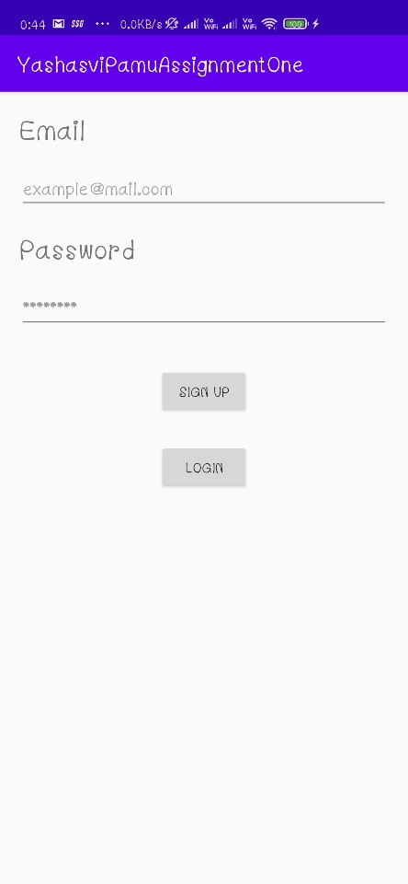This is the signup page of the application which when filled with valid details sends a verification link to the mail. After verification the credentials gets updated on firebase and then the user can click on the login button.

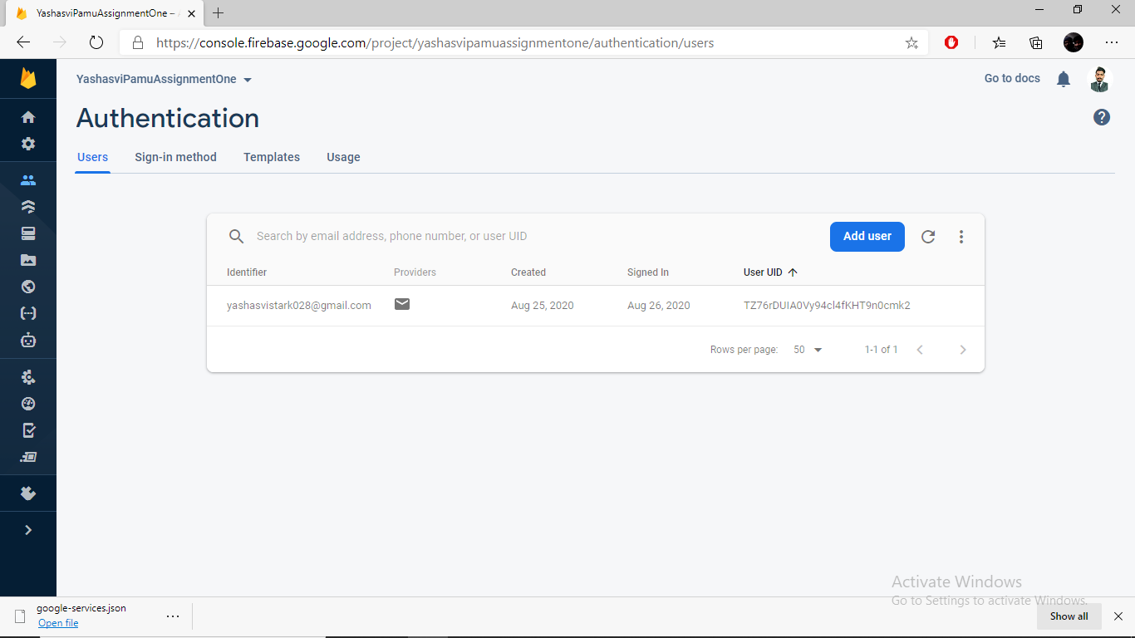

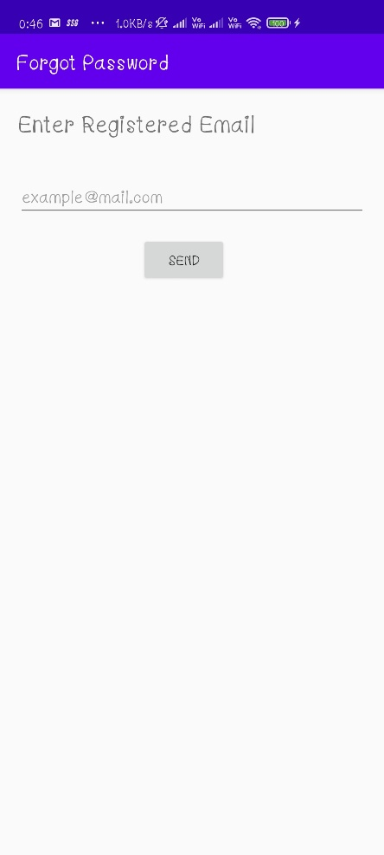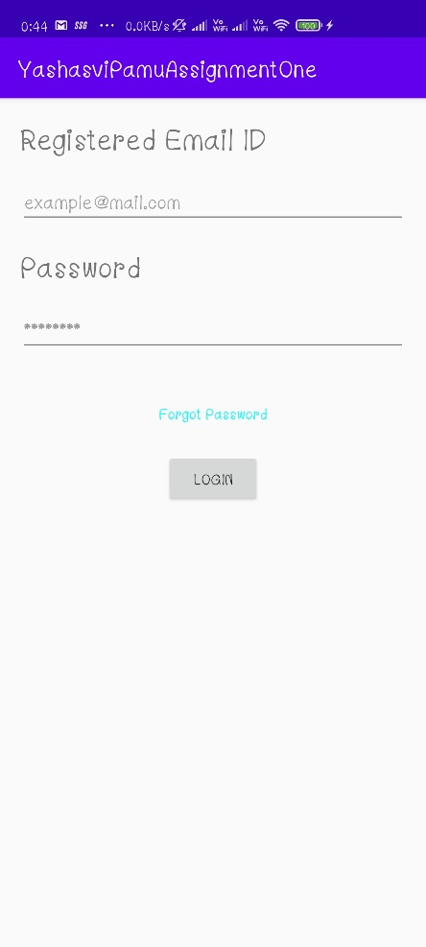This is the login page which consists of forgot password and login button which then authenticates the user and takes him/her to the welcome page.

The above page is forgot password page which when entered the registered mail id sends a password reset link.

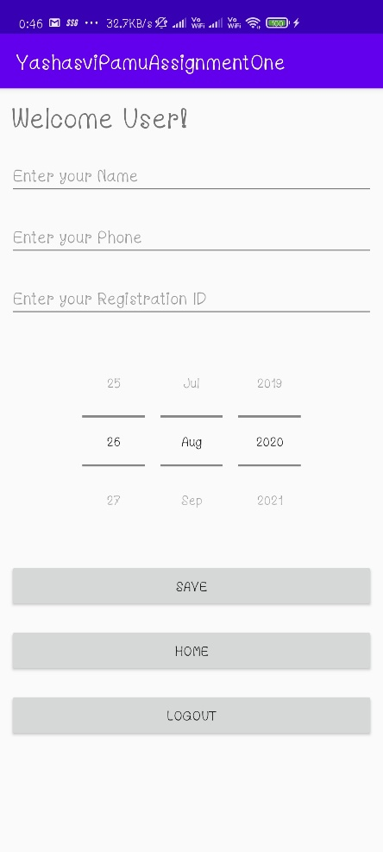

This here is the welcome page where user enters his/her details to save in the database. It doesn’t add the data if the phone number is less than 10 digits. After adding the data once it is stored and can fill the data again if they wish to modify it. Logout will log the user of their current session and takes him back to signup page. Home button takes user to the home activity of the BMS.

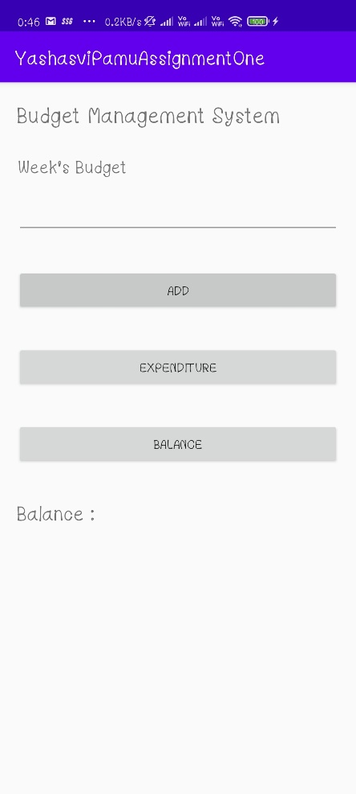This is the home screen of BMS. User can enter his week’s budget and click add to write it in the database. If the user wants to overwrite the previous budget he can just write it again and click add. Expenditure takes to expenditure activity and Balance gives the balance amount after deducting the expenses.

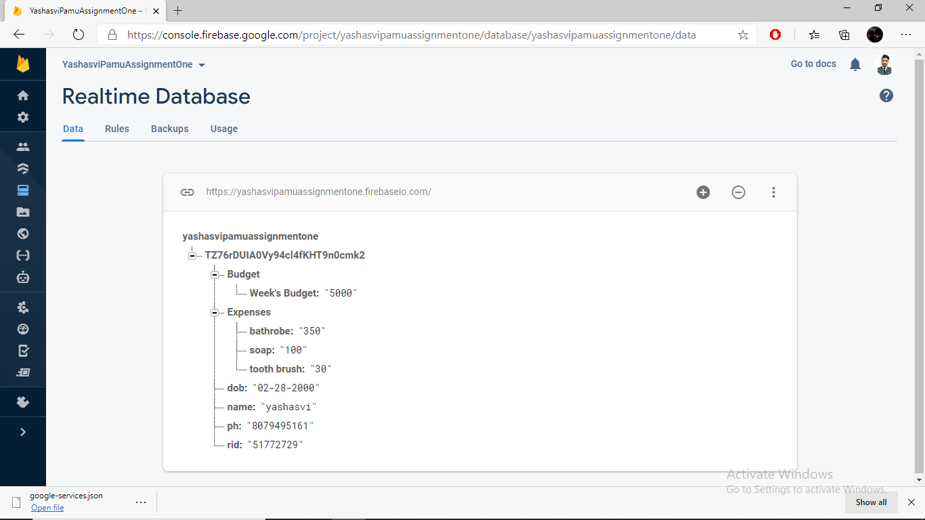

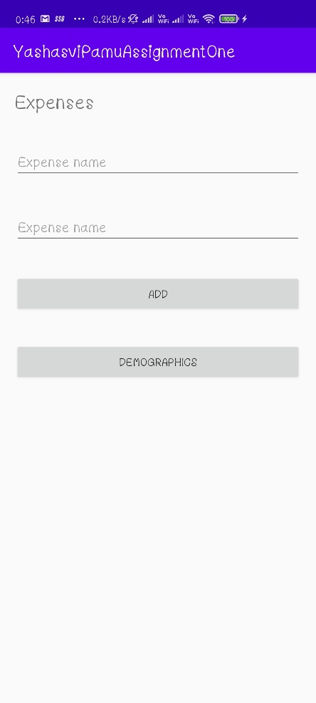The above image is the screenshot of the data after User enters the data of profile, Budget and Expenses.

This is the expenses page where user can add the expenses to the database. This activity consists of add button and demographics. Demographics will take user to a new activity where user can see his list of expenses.