Factory Optimisation Initiative
Executive Summary — Nassau Candy Distributor
Orders Analysed | Time Period | Factories | Products | Avg. Margin
10,194 | 2024–2025 | 5 | 15 | 66.5%

The Situation
Nassau Candy currently assigns each of its 15 products to one of five factories using fixed, historical rules — not data. As the business has grown, leadership has had no way to test whether these assignments are still the right ones, or to know how a change would affect shipping efficiency and profit before making it.
This project built a data-driven decision tool that analyses two full years of order history to answer one question: are our products being made in the right place?

What We Found
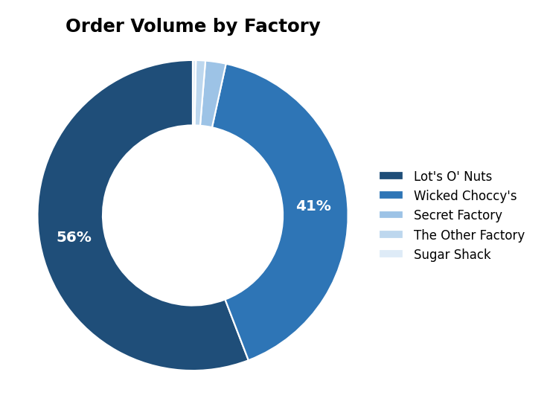  Two factories handle 96.6% of all orders. | 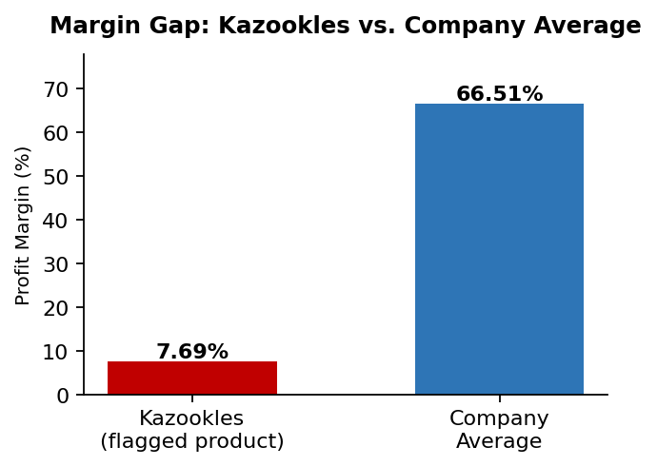  One product, Kazookles, sits far below the company's profit norm.
Three findings stand out:
- Heavy concentration. Two factories — Lot's O' Nuts and Wicked Choccy's — handle 96.6% of all order volume; the other three are lightly used.
- One product is the real problem, not a whole factory. “The Other Factory” initially looked underperforming, but this was driven almost entirely by one product, Kazookles (7.7% margin vs. 66.5% company average) — not the factory itself. Its other product, Hair Toffee, is healthy at 77.8%.
- Delivery timing follows the calendar, not the factory. Shipping speed is driven by seasonal demand patterns (e.g., holiday surges), not by which factory makes the product. We report this honestly rather than overstate what the data supports.

What We Recommend
Action | Why
Review Kazookles pricing/cost | Its margin (7.7%) is a pricing issue, not a shipping issue — moving factories will not fix it.
Reassign 4 products currently made at Sugar Shack | Both cost and shipping distance improve; low risk to make this change.
Leave high-performing products as-is | Several products (e.g., the core Wonka Bar chocolate line) are already well-placed; moving them would add risk for little gain.
Adopt the live dashboard | Lets your team test “what-if” factory changes before committing, going forward.

Tools Delivered
Alongside this summary, the project team has delivered a live, interactive dashboard where staff can select any product, compare factories side by side, and see which reassignments are recommended and why — no technical expertise required. A full technical research paper with complete methodology is available as a companion document.

