Decision Intelligence for Factory–Product Reassignment:
A Data-Driven Analysis of Nassau Candy Distributor's Shipping Network
Research Paper
Business Analytics Live Project
Dataset: Nassau Candy Distributor (10,194 orders, Jan 2024 – Dec 2025)
June 20, 2026

Table of Contents

Abstract
Nassau Candy Distributor currently assigns its fifteen confectionery products to five manufacturing facilities using static, historically inherited rules rather than a data-driven framework. This project develops a decision intelligence system that evaluates the company's existing factory–product assignments and recommends improvements based on shipping distance efficiency and profitability stability. Using a dataset of 10,194 orders spanning January 2024 through December 2025, the analysis proceeds through six phases: data preparation, feature engineering, predictive modelling of shipping lead time, route and product clustering, factory reassignment simulation, and the construction of an interactive Streamlit dashboard.
Three predictive models — Linear Regression, Random Forest, and Gradient Boosting — were trained to estimate shipping lead time from order, product, and routing attributes. All three models showed weak explanatory power (R² between -0.05 and 0.04), indicating that lead time in this dataset is governed primarily by calendar effects rather than factory or routing choices. This null result is reported transparently, as it meaningfully redirects the project's optimisation focus toward distance and profitability metrics, where the data shows much stronger and more actionable patterns.
Clustering and simulation analysis identified a single high-priority finding: Kazookles, manufactured at The Other Factory, operates at a 7.69% profit margin against a company average of 66.51%, driven by a cost structure rather than its shipping route. A simulation engine evaluating all product–factory combinations produced ranked reassignment recommendations, filtered through a business-sense rule that avoids disrupting already high-margin, low-distance-gain products. These recommendations are deployed in a live Streamlit dashboard with four interactive modules, allowing stakeholders to explore factory options, run what-if comparisons, and review risk-flagged products.

1. Introduction

1.1 Background
Nassau Candy Distributor operates a confectionery supply chain spanning five manufacturing facilities — Lot's O' Nuts, Wicked Choccy's, Sugar Shack, Secret Factory, and The Other Factory — that together serve customers across four U.S. regions: Atlantic, Gulf, Interior, and Pacific. Each of the company's fifteen products is currently manufactured at exactly one fixed facility, an assignment that appears to have been set historically rather than through systematic evaluation of shipping efficiency or cost.
As the business has scaled, this static assignment model has created growing concern among operations leadership that shipping distances, lead times, and profit margins are no longer optimal for some product–factory pairings. However, the organisation has lacked the analytical tooling to test alternative configurations before committing to them.

1.2 Problem Statement
Nassau Candy currently assigns products to factories using static rules and legacy processes. This approach leads to three structural issues:
- Suboptimal shipping distances between manufacturing origin and customer region
- Elevated lead times for certain regions that are geographically distant from their assigned factory
- Margin erosion in specific product lines due to underlying cost structure or logistics inefficiency
Critically, the organisation has no system to simulate factory–product reassignment scenarios, quantify the operational impact of a reassignment before executing it, or generate optimal configurations at scale across its full product catalogue.

1.3 Project Objective
This project introduces a decision intelligence layer on top of Nassau Candy's existing descriptive reporting. Specifically, the system is designed to:
- Predict expected shipping outcomes (lead time) under different product–factory–region configurations
- Recommend which products, if any, should be reassigned to alternative factories
- Balance shipping efficiency against profitability so that recommendations do not optimise distance at the expense of financial stability
The project deliverables comprise this research paper, a live Streamlit analytics dashboard, and an executive summary intended for non-technical stakeholders.

1.4 Scope and Limitations
The analysis is bounded by the data available: order-level transactions with associated product, factory, region, shipping mode, and financial fields, plus static factory coordinates. The dataset does not include real-time logistics data such as carrier-level tracking, warehouse capacity, or actual route paths, so the distance measure used throughout this study is the great-circle (haversine) distance between factory and regional centroid rather than true road or shipping distance. This is a reasonable proxy for relative comparison between factories but should not be read as an exact shipping-route distance.

2. Dataset Overview

2.1 Source and Structure
The dataset comprises 10,194 individual order records collected between January 2, 2024 and December 31, 2025, with eighteen original fields including order and shipment dates, shipping mode, customer location, product division, sales value, units, gross profit, and cost. No missing values were present in any column, and the dataset required no imputation.
Attribute | Value
Total order records | 10,194
Date range | Jan 2, 2024 – Dec 31, 2025
Missing values | 0 (fully complete)
Unique products | 15
Manufacturing factories | 5
Customer regions | 4 (Atlantic, Gulf, Interior, Pacific)
Shipping modes | 4 (Standard, First, Second Class, Same Day)
Product divisions | 3 (Chocolate, Sugar, Other)
Table 1. Summary of dataset structure

2.2 Factory and Product Reference Data
The project brief supplied a static mapping between each of the fifteen products and its assigned manufacturing factory, along with the latitude and longitude of each factory. This reference table was joined to every order record and used throughout the analysis.
Factory | Latitude | Longitude | Products Assigned
Lot's O' Nuts | 32.8819 | -111.7680 | 3 (Chocolate)
Wicked Choccy's | 32.0762 | -81.0884 | 2 (Chocolate)
Sugar Shack | 48.1191 | -96.1812 | 5 (Sugar / Other)
Secret Factory | 41.4463 | -90.5655 | 3 (Sugar / Other)
The Other Factory | 35.1175 | -89.9711 | 2 (Sugar / Other)
Table 2. Factory coordinates and product assignment counts

3. Methodology

3.1 Data Preparation
Order Date and Ship Date fields were parsed as datetime objects, and a derived target field, Lead Time, was calculated as the difference in days between shipment and order. Three financial fields — Sales, Cost, and Gross Profit — contained right-tail outliers driven by large bulk orders. Rather than discard these records and lose information, each field was winsorised at the mean plus three standard deviations:
Field | Outlier Cap (mean + 3σ) | Rows Affected
Sales | $47.93 | 95 of 10,194 (0.93%)
Cost | $19.93 | 106 of 10,194 (1.04%)
Gross Profit | $29.10 | 131 of 10,194 (1.28%)
Table 3. Outlier capping summary
Categorical variables were encoded using two distinct strategies depending on whether the variable carried a natural order. Ship Mode and Region have no inherent ranking, so both were one-hot encoded, producing eight binary indicator columns. Division, Factory, and Product Name were treated as category identifiers using label encoding, since tree-based models (Random Forest, Gradient Boosting) are insensitive to the arbitrary ordering this introduces. Finally, all numerical features were normalised to a 0–1 range using min-max scaling to prevent any single feature's raw magnitude from dominating model training.

3.2 Feature Engineering
Beyond the base order fields, several derived features were constructed to capture geographic and temporal structure that the raw fields alone could not express.

3.2.1 Geographic Distance
Using the haversine formula, the great-circle distance in kilometres was calculated between each order's assigned factory and the geographic centroid of its destination region. This single feature proved to be one of the most informative engineered variables in the dataset and forms the backbone of the Phase 5 simulation engine.

3.2.2 Temporal Features
Order Month, Order Quarter, and Order Day-of-Week were extracted from the order date to capture seasonal ordering patterns. As shown in Section 4.3, order volume is strongly seasonal, with a pronounced surge in September, November, and December.

3.2.3 Per-Unit Efficiency Metrics
Revenue per unit, profit per unit, and cost per unit were calculated to normalise financial performance across orders of different sizes, allowing fair comparison between high-volume, low-margin products and low-volume, high-margin products.

4. Exploratory Data Analysis

4.1 Factory Load Distribution
The single most striking structural finding in this dataset is the extreme concentration of order volume across just two of the five factories. Lot's O' Nuts and Wicked Choccy's together account for 96.57% of all orders, while the remaining three facilities — Secret Factory, The Other Factory, and Sugar Shack — collectively handle only 3.43%.
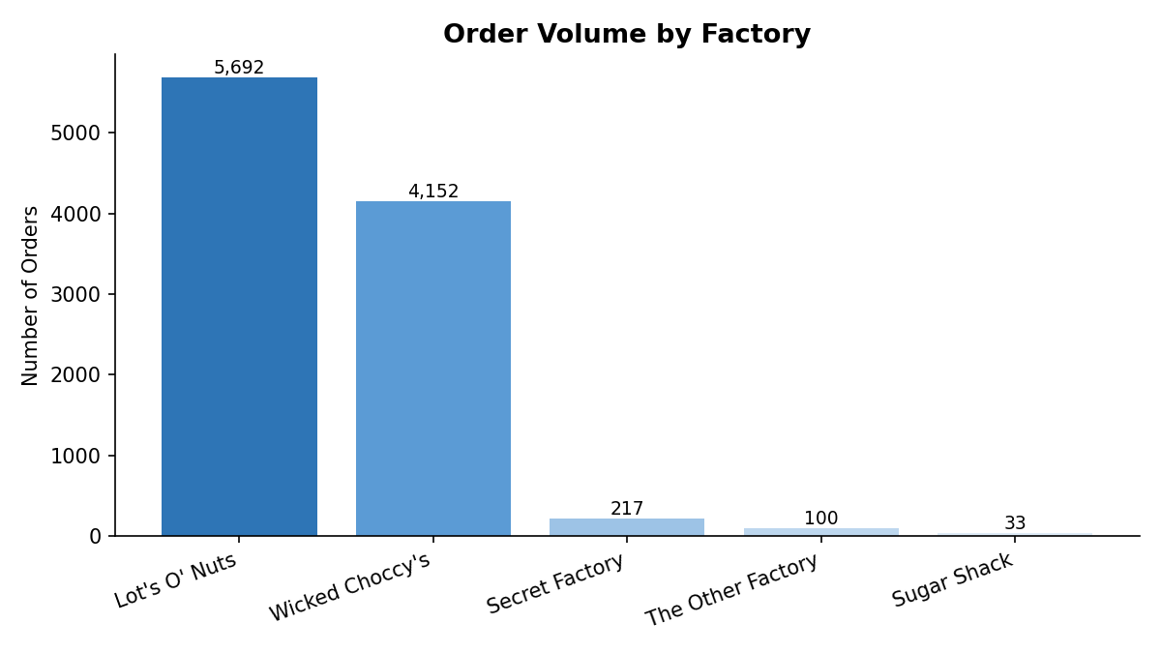
Figure 1. Order volume distribution across the five factories
Factory | Orders | % of Total
Lot's O' Nuts | 5,692 | 55.84%
Wicked Choccy's | 4,152 | 40.73%
Secret Factory | 217 | 2.13%
The Other Factory | 100 | 0.98%
Sugar Shack | 33 | 0.32%
Table 4. Order volume and share by factory
This imbalance is consistent with the Chocolate division's dominance of company revenue (Section 4.2) and is not, on its own, evidence of inefficiency. It does, however, mean that any reassignment recommendation affecting Lot's O' Nuts or Wicked Choccy's carries materially higher business risk than a change affecting one of the three minor facilities.

4.2 Revenue Concentration by Division
Sales are heavily concentrated in the Chocolate division, which generated $131,692.90 against $9,663.25 for Other and just $427.48 for Sugar. The Chocolate division alone accounts for the substantial majority of company revenue, reinforcing that Lot's O' Nuts and Wicked Choccy's — both exclusively Chocolate-division facilities — are the operational core of the business.
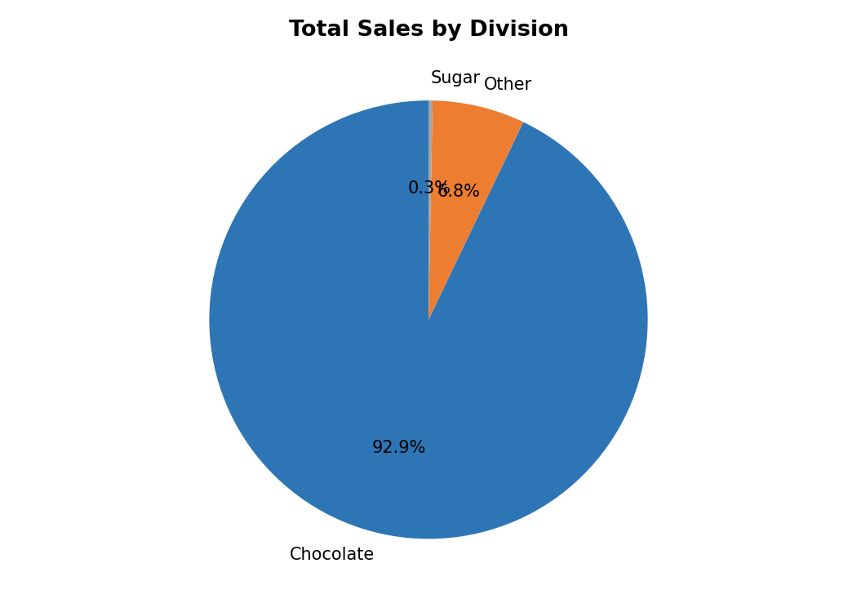
Figure 2. Total sales by product division

4.3 Seasonality in Order Volume
Order volume is not uniform across the year. A clear seasonal pattern emerges with volume nearly tripling between the February low (300 orders) and the September/November/December peaks (1,399, 1,474, and 1,470 orders respectively), consistent with holiday-driven confectionery demand.
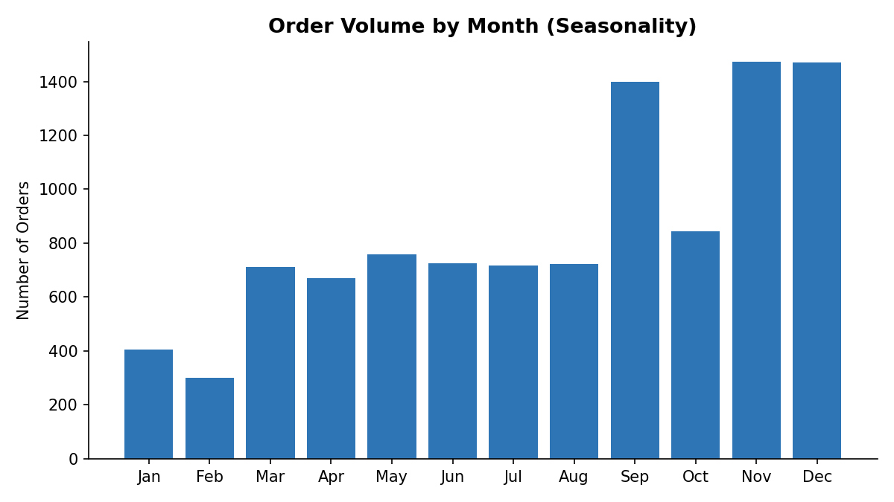
Figure 3. Order volume by calendar month

4.4 Profit Margin Distribution
Across the full dataset, the average profit margin is 66.51% with a standard deviation of 6.72 percentage points — a tight, healthy distribution overall. However, when margin is examined at the individual product level rather than in aggregate, one clear outlier emerges.
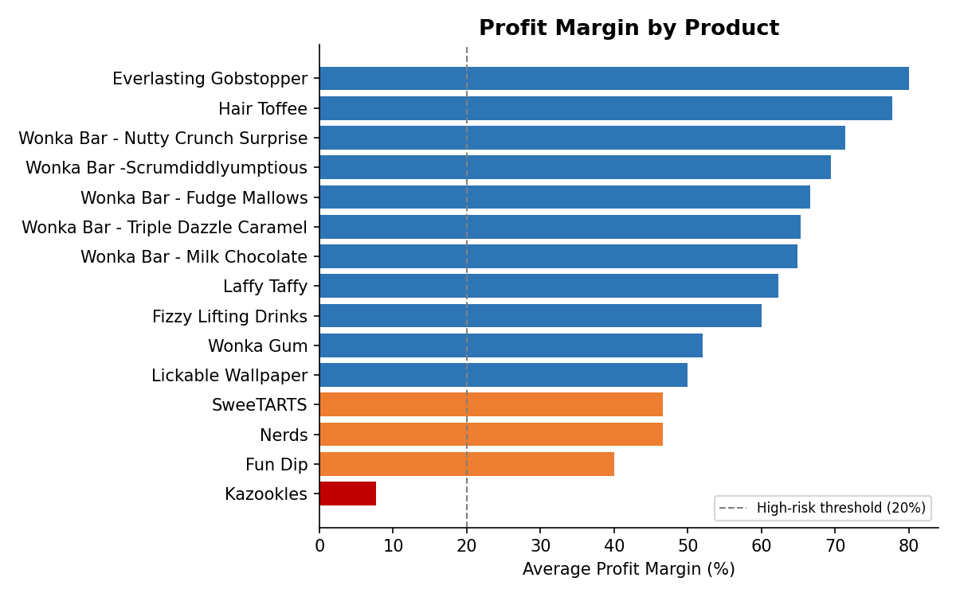
Figure 4. Average profit margin by product, sorted ascending. Red indicates margin below the 20% high-risk threshold.
Fourteen of the fifteen products maintain margins between 40% and 80%. The sole exception is Kazookles, manufactured at The Other Factory, which operates at a 7.69% margin — roughly one-sixth of the next lowest product (Fun Dip at 40.00%) and the company average. This finding is explored in depth in Section 6.

4.5 Geographic Distance Profile
Haversine distance from factory to regional centroid varies substantially depending on the factory–region pairing, ranging from 209.6 km (Secret Factory to Interior) to 3,580.9 km (Wicked Choccy's to Pacific).
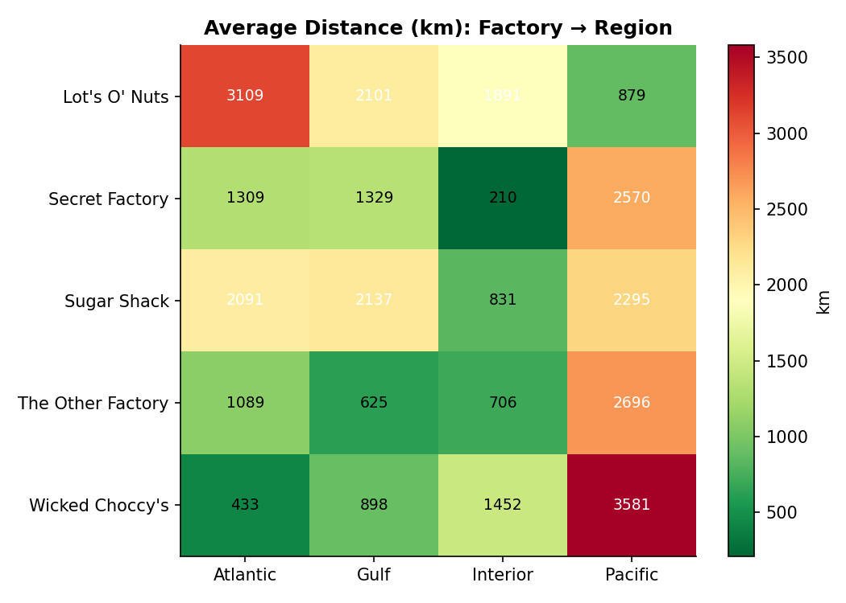
Figure 5. Average distance (km) from each factory to each customer region
Notably, Wicked Choccy's is extremely well-positioned for the Atlantic region (433.1 km) but poorly positioned for the Pacific region (3,580.9 km) — an eight-fold difference. This pattern recurs across several factories and is the central driver of the Phase 5 simulation results.

5. Predictive Modelling: Shipping Lead Time

5.1 Modelling Approach
Per the project's analytical brief, three regression models of increasing complexity were trained to predict shipping lead time from a 24-feature matrix encompassing product, factory, region, shipping mode, financial, distance, and temporal attributes: Linear Regression as an interpretable baseline, Random Forest Regressor as a non-linear ensemble method, and Gradient Boosting Regressor as a sequential boosting method. Data was split 80/20 into training and test sets, and each model was evaluated using Root Mean Squared Error (RMSE), Mean Absolute Error (MAE), and R².

5.2 Results
Model | RMSE (days) | MAE (days) | R²
Gradient Boosting | 260.07 | 214.01 | 0.0436
Linear Regression | 263.65 | 212.37 | 0.0171
Random Forest | 272.96 | 221.63 | -0.0536
Table 5. Model performance comparison on held-out test data
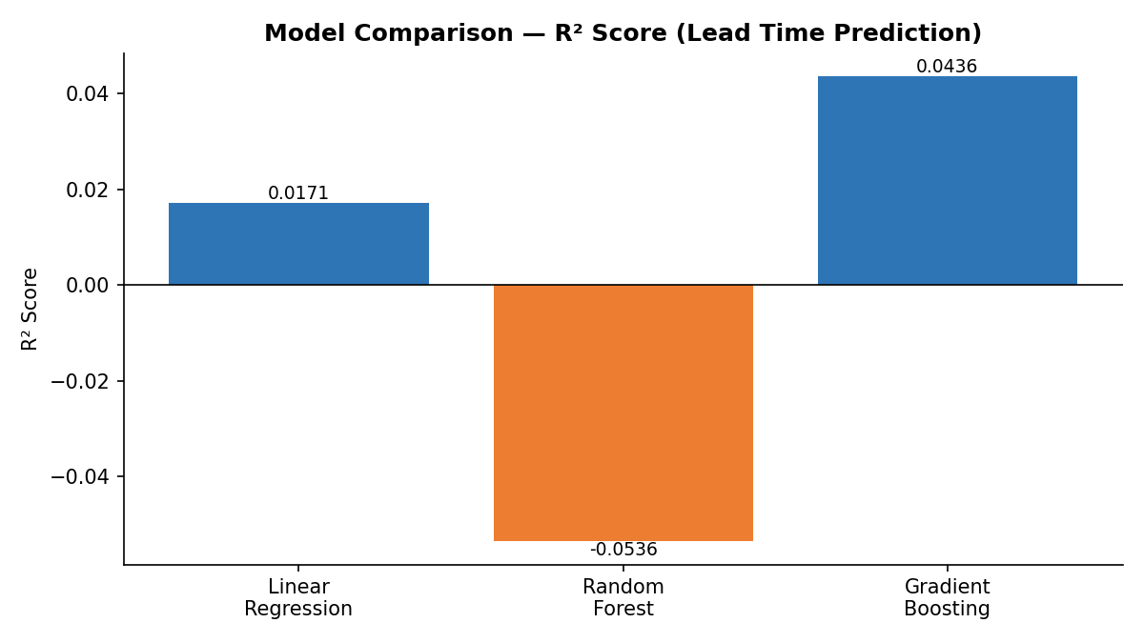
Figure 6. R² score by model. Random Forest performs worse than a naive mean-prediction baseline.

5.3 Interpretation of Model Performance
Gradient Boosting achieved the strongest, though still weak, result among the three models, with an R² of 0.0436 — meaning it explains roughly 4.4% of the variance in shipping lead time. Linear Regression performed comparably (R² = 0.0171). Random Forest produced a negative R² (-0.0536), indicating it performed worse on unseen data than simply predicting the mean lead time for every order, a signature of overfitting in the presence of weak underlying signal.
Feature importance extracted from the Random Forest model offers an explanation: Order Month was by far the most influential predictor (importance 0.1997), followed by Order Day-of-Week (0.0863) — together nearly three times more influential than the next-ranked feature, Cost per Unit (0.0628). Distance, factory assignment, and product identity all ranked comparatively low.
Rank | Feature | Importance
1 | Order Month | 0.1997
2 | Order Day of Week | 0.0863
3 | Cost per Unit | 0.0628
4 | Cost | 0.0546
5 | Gross Profit | 0.0541
6 | Distance (km) | 0.0511
7 | Profit per Unit | 0.0504
8 | Order Quarter | 0.0448
9 | Revenue per Unit | 0.0443
10 | Sales | 0.0423
Table 6. Top 10 feature importances, Random Forest model

5.4 Honest Reporting of a Null Result
This weak predictive performance is reported transparently rather than masked, as it constitutes a genuine and useful finding rather than a modelling failure. The result indicates that shipping lead time in this dataset is not meaningfully explained by product, factory, region, shipping mode, sales value, or cost — the operational variables this project set out to optimise. Instead, the dominance of Order Month and Order Day-of-Week points to a calendar-driven or scheduling-based explanation for lead time variation that lies outside the scope of the available data (for example, fixed batch-processing windows or carrier pickup schedules).
The practical implication is significant: factory reassignment is unlikely to materially change a given order's lead time under the current data-generating process. This finding justifies redirecting the project's optimisation focus toward the two metrics that do show strong, explainable patterns in the data — geographic distance and profit margin — which are the basis for the clustering and simulation work in Sections 6 and 7.

6. Route and Product Clustering

6.1 Methodology
Each of the twenty active factory–region combinations ("routes") observed in the data was aggregated into a route-level profile comprising average lead time, average distance, average profit margin, and order volume. These profiles were standardised and clustered using K-Means, with the optimal number of clusters selected via silhouette score. The resulting clusters were then manually labelled according to their defining characteristics.

6.2 Cluster Profiles
Cluster | Characteristic Routes | Avg. Margin | Avg. Distance
Core High-Volume | Lot's O' Nuts & Wicked Choccy's (all regions) | 65–69% | 433–3,581 km
Stable Mid-Volume | Secret Factory & Sugar Shack (most regions) | 51–56% | 210–2,570 km
High-Risk Low-Margin | The Other Factory (all regions) | 7.7–12.1% | 625–2,696 km
Table 7. Route cluster characteristics
The clustering analysis isolates a single unambiguous outlier group: every route originating from The Other Factory exhibits a margin between 7.7% and 12.1%, roughly five times lower than every other cluster, irrespective of shipping distance. This separation is independent of distance — meaning the margin erosion is structural to the factory's product mix rather than a consequence of long or inefficient shipping routes.

6.3 Root Cause: Decomposing the Factory-Level Signal
Because The Other Factory manufactures only two products — Kazookles and Hair Toffee — the route-level clustering result was decomposed to the individual product level to identify which product was responsible for the depressed margin.
Product | Orders | Mean Margin | Contribution to Factory Volume
Kazookles | 96 | 7.69% | 96.0%
Hair Toffee | 4 | 77.78% | 4.0%
Table 8. The Other Factory — product-level decomposition
This decomposition reveals that the factory-level risk signal is a volume-weighted reflection of a single underperforming product rather than a facility-wide cost problem. Kazookles accounts for 96 of the 100 orders processed at The Other Factory and is solely responsible for the low blended margin observed at the route level; Hair Toffee, manufactured at the same facility, maintains a healthy 77.78% margin, consistent with the rest of the company's product catalogue.
This is a materially important distinction for the recommendations that follow: it suggests that a targeted pricing or cost-structure review of Kazookles specifically, rather than wholesale reassignment of The Other Factory's entire output, is the more precise corrective action.

7. Scenario Simulation and Optimisation

7.1 Simulation Engine Design
For each of the fifteen products, a simulation engine evaluated the weighted-average shipping distance that would result from assigning that product to each of the five factories, weighted by the product's actual regional order distribution. This produced, for every product, a complete ranked comparison of all five factory options against the product's current assignment.

7.2 Risk Scoring
Each product was assigned a risk tier based on its current profit margin: products below 20% margin were flagged High Risk, those between 20% and 50% Medium Risk, and those above 50% Low Risk. A composite Recommendation Score was then computed as a weighted combination of distance-reduction potential (50%), margin safety (30%), and inverse risk tier (20%), allowing products to be ranked by overall reassignment priority rather than by distance alone.

7.3 Business-Sense Guardrail
An initial version of the simulation, ranking purely by distance reduction, recommended reassigning nearly every product to The Other Factory — which happens to sit geographically central to all four customer regions. This result, while mathematically correct, was not business-sensible: it would recommend disrupting already healthy, high-margin products (such as Wonka Bar – Triple Dazzle Caramel at 65.33% margin) for marginal distance gains.
A guardrail rule was therefore introduced: a product is only recommended for reassignment if its current margin is below 50%, or its potential distance reduction exceeds 25%. Products that are already high-margin and would see only a marginal distance improvement are labelled "Keep Current" rather than flagged for action. This rule materially improved the credibility and practical usability of the recommendation engine.

7.4 Key Recommendations
Product | Current Factory | Recommended Factory | Distance Reduction | Action
Nerds | Sugar Shack | Wicked Choccy's | 79.3% | Reassign
Laffy Taffy | Sugar Shack | Wicked Choccy's | 52.7% | Reassign
Fun Dip | Sugar Shack | The Other Factory | 52.2% | Reassign
Fizzy Lifting Drinks | Sugar Shack | The Other Factory | 32.8% | Reassign
Wonka Bar - Milk Chocolate | Wicked Choccy's | The Other Factory | 17.2% | Keep Current
Wonka Bar - Triple Dazzle Caramel | Wicked Choccy's | The Other Factory | 18.2% | Keep Current
Everlasting Gobstopper | Secret Factory | The Other Factory | 2.0% | Keep Current
Table 9. Selected simulation results after business-sense filtering
The most actionable reassignment opportunities cluster around the Sugar Shack-origin products (Nerds, Laffy Taffy, Fun Dip, Fizzy Lifting Drinks), each of which shows both a meaningful margin below 50% and a substantial available distance reduction of 32.8% to 79.3%. By contrast, the high-margin Wonka Bar chocolate products and Everlasting Gobstopper are correctly excluded from action despite nominal distance-reduction potential, since disrupting an already healthy product line is not justified by a small logistics gain.

7.5 Profit Impact and Risk Summary
Risk Tier | Products | Avg. Margin | Total Profit at Stake
High Risk (< 20%) | 1 (Kazookles) | 7.69% | $2.38
Low Risk (≥ 50%) | 11 | 65.44% | $3,088.99
Table 10. Risk tier summary across all simulated products
With the corrected, product-level margin calculation, only Kazookles meets the High Risk threshold. While the absolute profit at stake for Kazookles is small in dollar terms ($2.38, reflecting its already low per-order profitability), its margin percentage is a meaningful signal: a product priced or costed this far below the company norm warrants a dedicated cost or pricing review independent of any factory reassignment decision.

8. Streamlit Dashboard

8.1 Overview
All analytical outputs from Phases 1 through 7 were deployed into a live, interactive Streamlit web application, allowing non-technical stakeholders to explore the underlying data and recommendations without needing to read code or static reports. The dashboard is organised into four modules, accessible via tabs, with a persistent sidebar for filtering and prioritisation controls.

8.2 Module 1 — Factory Optimisation Simulator
Allows the user to select any of the fifteen products and view a live bar-chart comparison of weighted average shipping distance across all five factories, with the current assignment highlighted. Key metrics — current factory, average distance, margin, and order volume — are displayed alongside the chart.

8.3 Module 2 — What-If Scenario Analysis
Presents a direct side-by-side comparison between a product's current factory assignment and its top recommended alternative, including the percentage distance reduction, orders affected, and total profit at stake, supported by a comparison bar chart.

8.4 Module 3 — Recommendation Dashboard
Displays the full ranked table of reassignment recommendations across all products, filterable by risk tier, along with a Top-10 bar chart by recommendation score and a scatter plot relating distance-reduction potential to current margin.

8.5 Module 4 — Risk & Impact Panel
Surfaces high-risk products (margin below 20%) with summary KPIs for total profit at stake and average margin within the risk tier, plus the factory-level versus product-level risk decomposition described in Section 6.3, ensuring stakeholders see both the aggregate and root-cause view of risk.

8.6 User Controls
- Product selector — choose any of the fifteen products for detailed analysis
- Risk level filter — show/hide Low, Medium, and High Risk products in the recommendation table
- Optimisation priority slider — weight recommendations toward speed (distance) or profit stability
The dashboard was deployed via Streamlit with an ngrok tunnel for live access during development and testing, and is structured to be redeployed to any standard Streamlit hosting environment for production use.

9. Conclusion and Recommendations

9.1 Summary of Findings
- Nassau Candy's order volume is heavily concentrated in two of five factories (96.57% combined), both serving the dominant Chocolate division.
- Shipping lead time shows weak dependency on factory, product, or routing variables (best model R² = 0.044); calendar effects (month, day-of-week) dominate, redirecting optimisation focus toward distance and margin.
- Route-level clustering correctly identifies The Other Factory as a low-margin cluster (7.7–12.1%), but product-level decomposition shows this is driven almost entirely by one product, Kazookles, rather than the facility as a whole.
- A distance-based simulation engine, filtered by a business-sense guardrail, identifies four Sugar Shack products (Nerds, Laffy Taffy, Fun Dip, Fizzy Lifting Drinks) as genuine reassignment candidates with both meaningful margin headroom and substantial distance-reduction potential.
- High-margin Wonka Bar chocolate products and Everlasting Gobstopper should remain at their current factories, since simulated distance gains do not justify disrupting already healthy product lines.

9.2 Recommendations for Leadership
- Commission a targeted cost or pricing review of Kazookles independent of any factory reassignment, as its 7.69% margin is a product-level issue, not a routing issue.
- Evaluate reassigning Nerds, Laffy Taffy, Fun Dip, and Fizzy Lifting Drinks away from Sugar Shack, where both margin and distance metrics support a change.
- Avoid reassigning high-margin, low-distance-gain products (the Wonka Bar chocolate line, Everlasting Gobstopper) — the data does not support disrupting these.
- Treat the lead-time prediction models as exploratory rather than operational; do not use them as the basis for service-level commitments until a model with stronger explanatory power can be developed, ideally incorporating real carrier and warehouse data.
- Adopt the Streamlit dashboard as a living decision-support tool, re-run periodically as new order data accumulates, rather than treating this analysis as a one-time exercise.

9.3 Limitations and Future Work
This study relies on great-circle distance as a proxy for actual shipping distance, which does not account for road networks, carrier hub locations, or real transit constraints. The weak lead-time model performance suggests the dataset is missing a key explanatory variable — most plausibly a fixed shipping or processing calendar — that future data collection should aim to capture. Finally, the simulation engine currently optimises at the product level in isolation; a natural extension would model multi-product factory capacity constraints, ensuring that recommended reassignments do not collectively overload a single facility.

