**Web Based Case Study**

This Web Application allows user to give data in html form and then store and retrieve details from a csv file (students.csv).

It allows options as

1) Add new Student

2) Search with given ID

3) Display all Student records

**Approach**:

1. Index.html gives above options for user to choose.
2. Add new Student option takes user input in a html form and store them in a csv file (students.csv)
3. Search occurs by reading students.csv file with BufferedReader Class and matching id with specified String in search.java
4. To display all the records we run through the csv file and display them in html file.

**Students.csv**

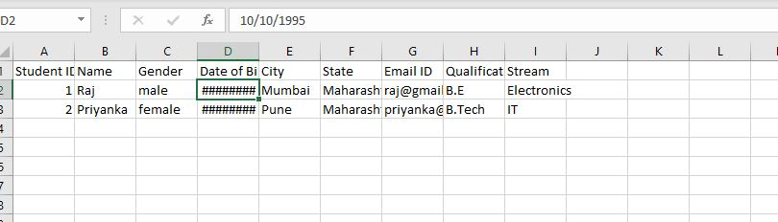

**OUTPUT:**

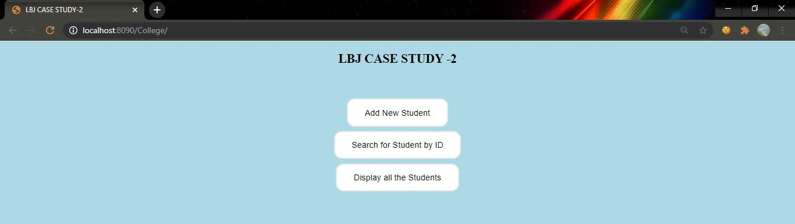

1. **Add new Student data –**

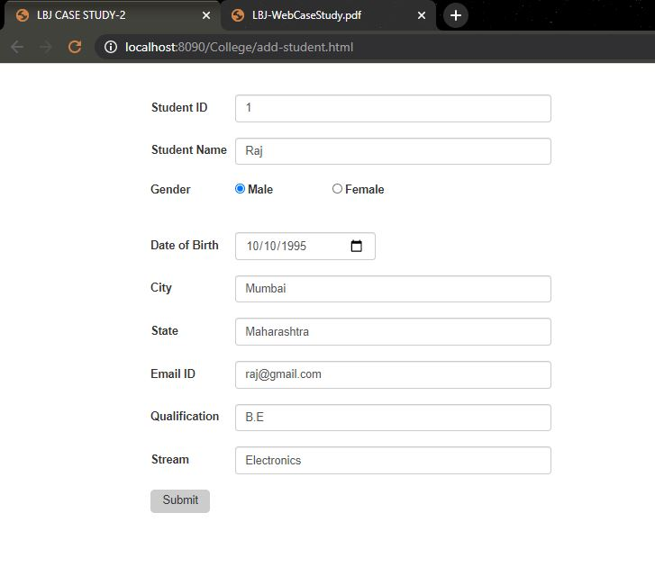

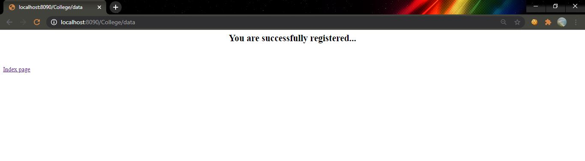

1. **search**

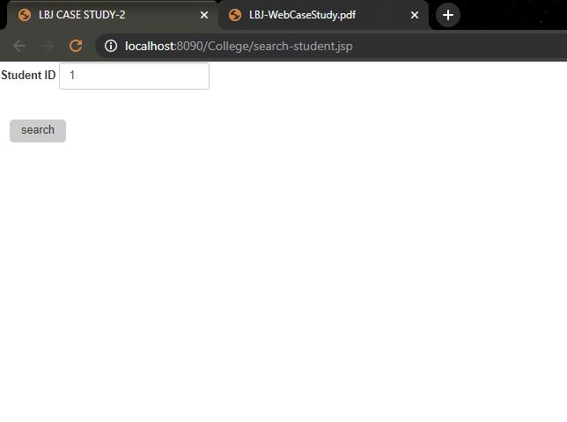

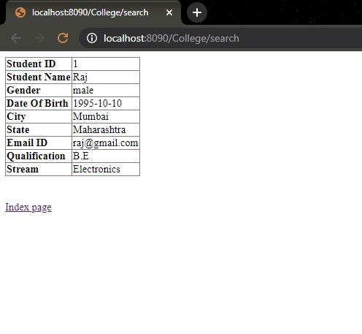

**I**f student ID Doesn’t exists-

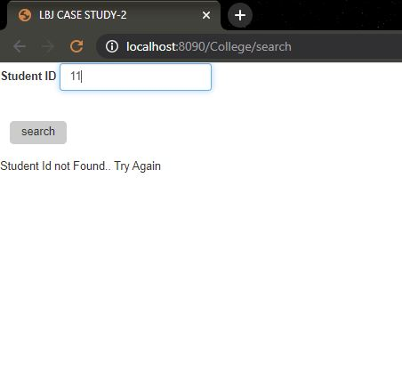

**3) Display all students Data**

