EWB AWS CLOUD LABS
AWS VPC PEERING
PROJECT IMPLEMENTATION REPORT

YASHASWINI C H
Amazon Web Services Internship
Project: AWS VPC Peering Lab
Region: Asia Pacific (Mumbai) — ap-south-1
Date: 21 October 2026

NETWORK DESIGN • ROUTING • SECURITY • CONNECTIVITY VALIDATION

1. Executive Summary
This report presents the implementation of an AWS VPC peering lab using two non-overlapping virtual private clouds in the same AWS account and Mumbai Region. The environment contains a public bastion host in VPC A and private application instances in VPC A and VPC B. A VPC peering connection links the two networks, while route tables and security groups control traffic paths and access.
The lab demonstrates core AWS networking concepts: VPC and subnet design, Internet Gateway routing, VPC peering, private addressing, security-group rules, EC2 deployment, and connectivity verification.

2. Objectives
- Create two VPCs with non-overlapping IPv4 CIDR ranges.
- Configure one public subnet and one private subnet in VPC A, plus a private subnet in VPC B.
- Attach an Internet Gateway to VPC A and configure the public route table.
- Establish VPC peering between VPC A and VPC B and configure routes in both directions.
- Apply security-group rules for restricted SSH access and ICMP connectivity checks.
- Validate network reachability and document the implementation with console and terminal evidence.

3. Architecture
The architecture below shows the lab topology, subnet boundaries, private IP assignments, Internet Gateway, and active VPC peering connection.
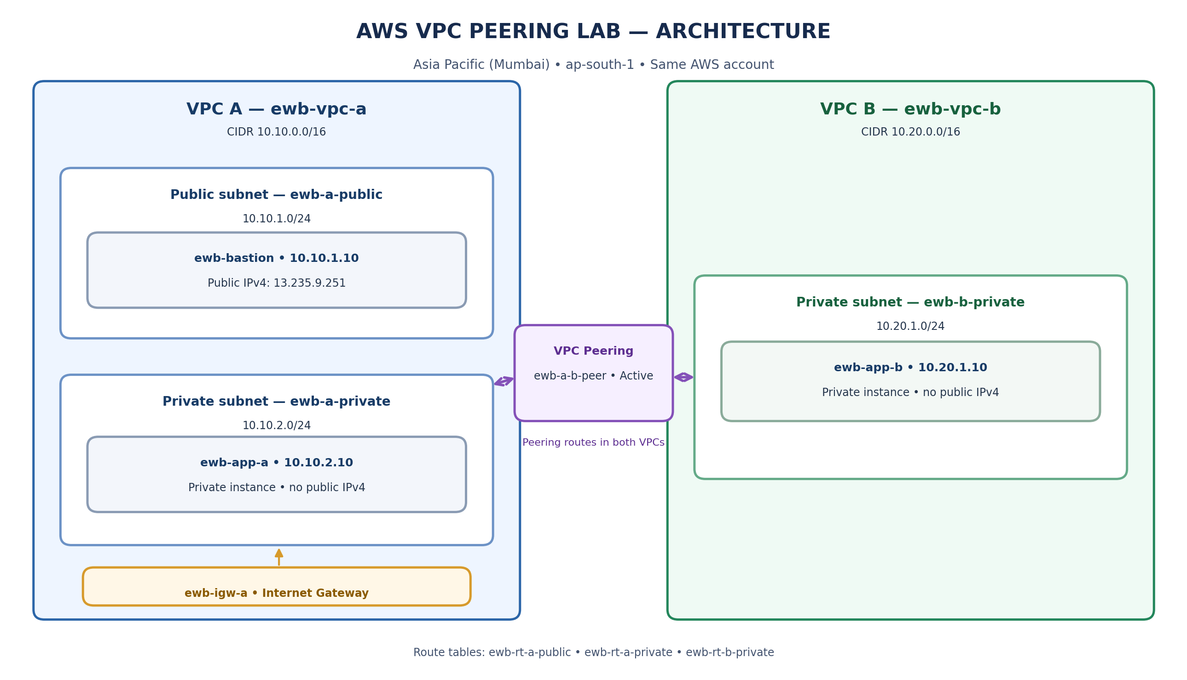

4. Resource Inventory and Address Plan
Resource | Name | CIDR / Private IP | Details
VPC | ewb-vpc-a | 10.10.0.0/16 | VPC A
Subnet | ewb-a-public | 10.10.1.0/24 | Public subnet; ap-south-1a
Subnet | ewb-a-private | 10.10.2.0/24 | Private subnet; ap-south-1a
EC2 | ewb-bastion | 10.10.1.10 | Public IPv4: 13.235.9.251
EC2 | ewb-app-a | 10.10.2.10 | Private instance; no public IPv4
VPC | ewb-vpc-b | 10.20.0.0/16 | VPC B
Subnet | ewb-b-private | 10.20.1.0/24 | Private subnet
EC2 | ewb-app-b | 10.20.1.10 | Private instance; no public IPv4
Internet Gateway | ewb-igw-a | — | Internet gateway for VPC A
VPC Peering | ewb-a-b-peer | pcx-00c80290671da9808 | Status: Active

5. Route Tables and Routing Design
Route table | Subnet association | Required routes
ewb-rt-a-public | ewb-a-public | 10.10.0.0/16 → local; 0.0.0.0/0 → ewb-igw-a; 10.20.0.0/16 → ewb-a-b-peer
ewb-rt-a-private | ewb-a-private | 10.10.0.0/16 → local; 10.20.0.0/16 → ewb-a-b-peer
ewb-rt-b-private | ewb-b-private | 10.20.0.0/16 → local; 10.10.0.0/16 → ewb-a-b-peer

VPC peering does not automatically add routes. The relevant route tables must explicitly direct traffic for the remote VPC CIDR to the peering connection.

6. Security Groups
Security group | Inbound rules | Purpose
ewb-sg-bastion | SSH/TCP 22 from the client public IPv4 /32 | Restricts administrative access to the bastion host.
ewb-sg-app-a | SSH/TCP 22 from 10.10.1.10/32; ICMP from 10.20.1.10/32 | Allows bastion SSH and the defined ICMP test source.
ewb-sg-app-b | SSH/TCP 22 from 10.10.1.10/32; ICMP from 10.10.2.10/32 | Allows bastion SSH and the defined ICMP test source.

Security groups are stateful. SSH should remain restricted to the intended source addresses; do not expose SSH to 0.0.0.0/0. Where possible, use the ICMP Echo Request rule required by the lab rather than a broader ICMP rule.

7. EC2 Instances and Key Pair
Instance | Private IP | Role | Expected public IPv4
ewb-bastion | 10.10.1.10 | Public access / jump host | 13.235.9.251
ewb-app-a | 10.10.2.10 | Private application host in VPC A | None
ewb-app-b | 10.20.1.10 | Private application host in VPC B | None

The instances use Amazon Linux 2023 and were shown in the console as Running with 3/3 status checks passed. The EC2 key pair is named ewb-lab. Its private PEM file is kept locally and must not be included in the report package or repository.

8. Validation Results
The project validation covered the VPC peering state, EC2 health, and private-network reachability. The following table summarizes the expected successful outcomes for the completed lab.
Validation | Expected result
VPC peering | ewb-a-b-peer is Active.
EC2 health | All three instances are Running and pass 3/3 status checks.
Private addressing | ewb-app-a and ewb-app-b have no public IPv4 addresses.
App-A → App-B ICMP | Four echo replies from 10.20.1.10; 0% packet loss.
App-B → App-A ICMP | Four echo replies from 10.10.2.10; 0% packet loss.
Controlled ICMP test | Ping fails while the specific inbound ICMP rule is removed and succeeds after the rule is restored.
Bastion access | SSH access is restricted to the client public IPv4 /32 and is used as the jump host for private instances.

9. Implementation Evidence
Selected console and terminal screenshots are organized in chronological order in the accompanying screenshots folder. They document the network inventory, gateway and route tables, peering, security groups, EC2 health, and connectivity tests.

VPC inventory — both lab VPCs
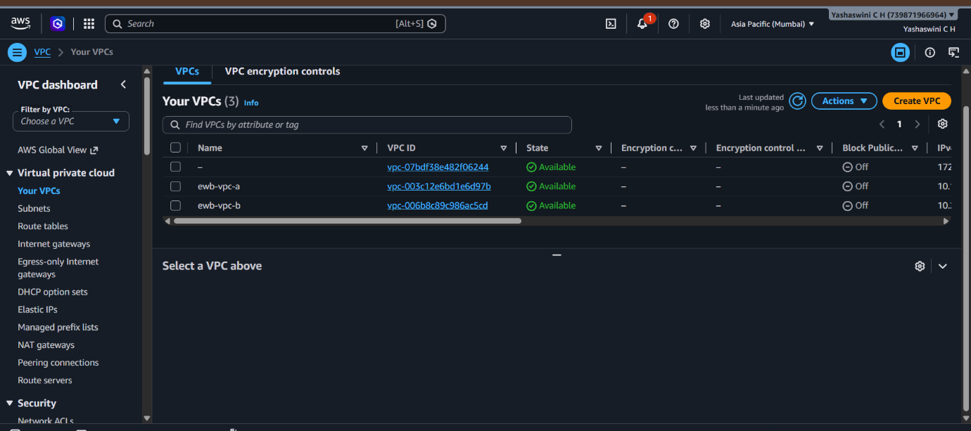

Internet Gateway configuration
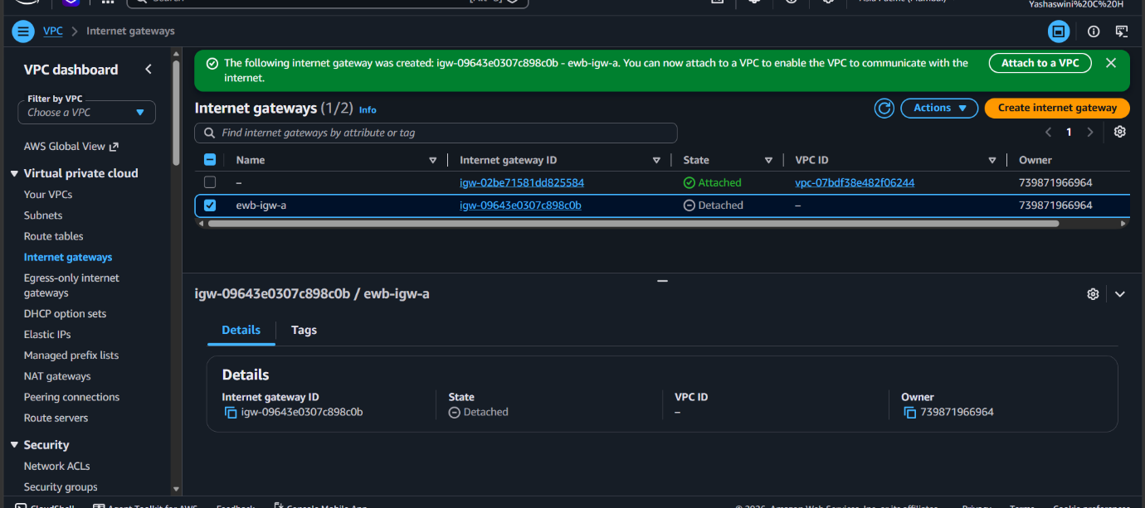

VPC A public route table
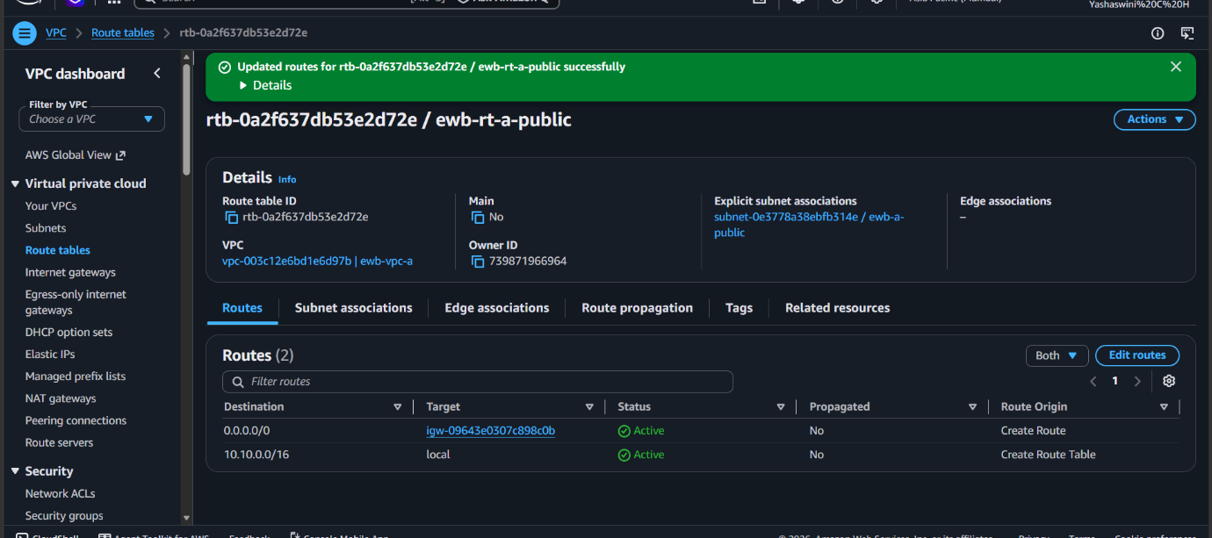

VPC A private route table
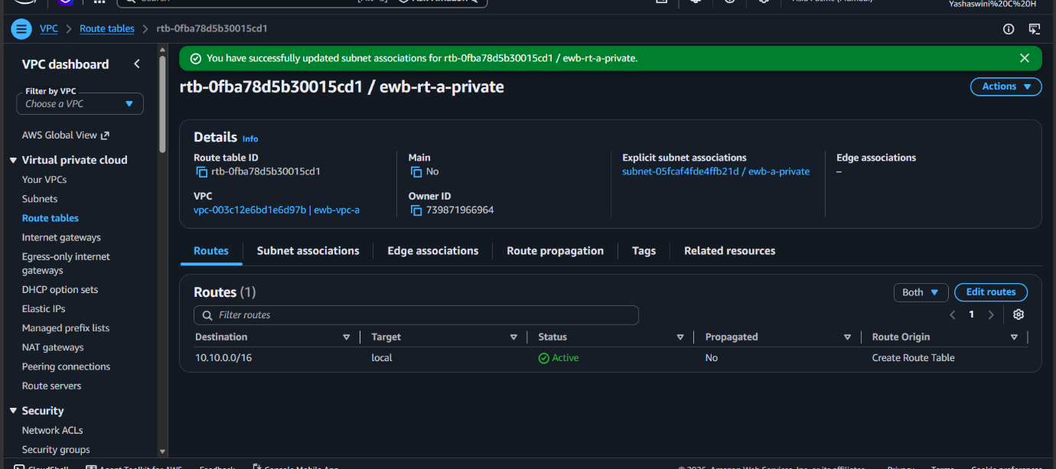

VPC B private route table
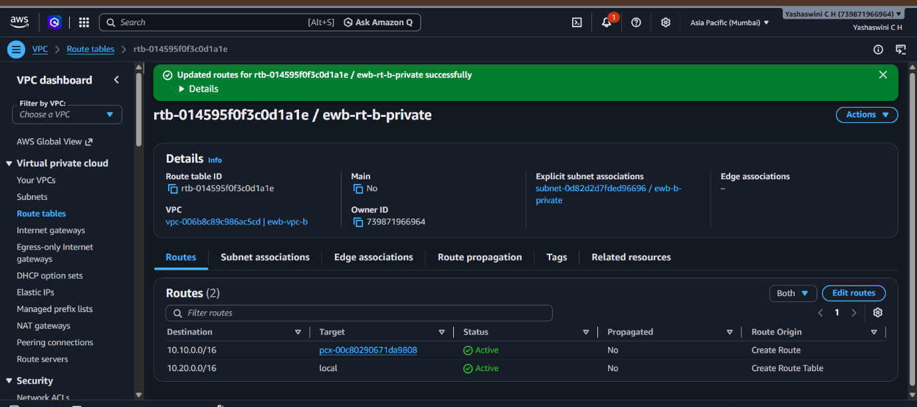

Active VPC peering connection
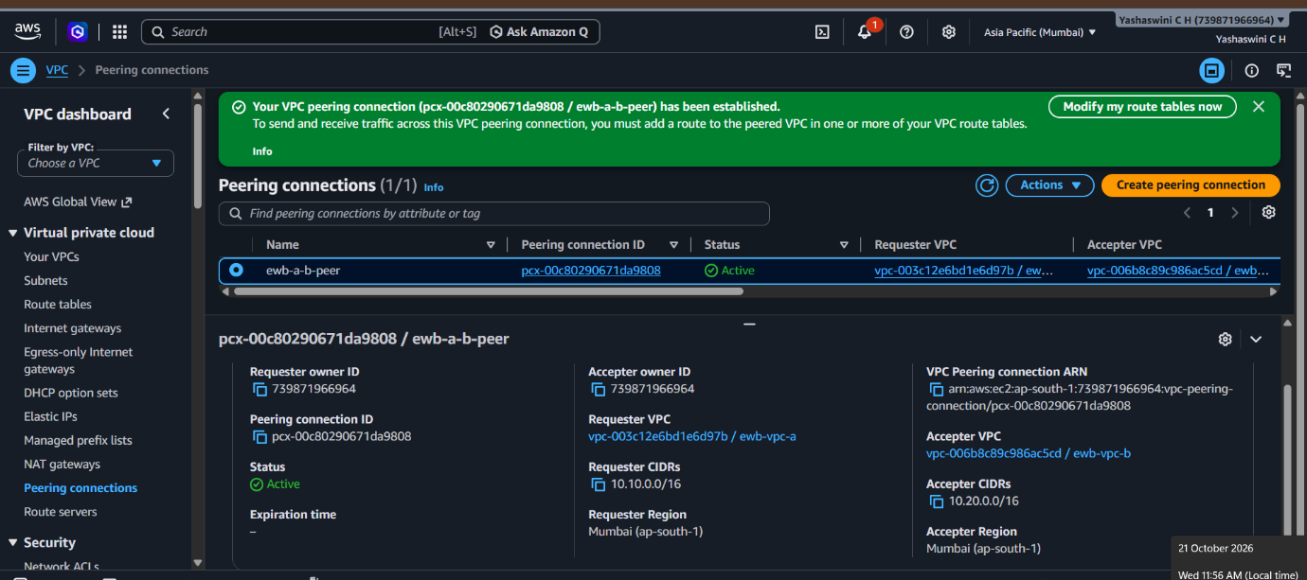

App-B security-group rules
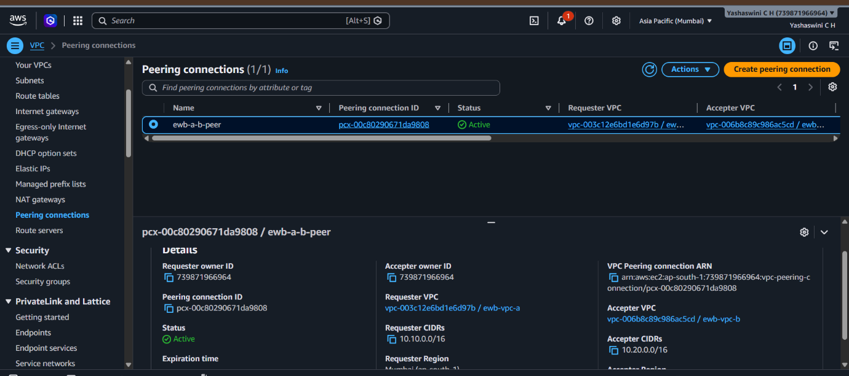

Bastion SSH restriction
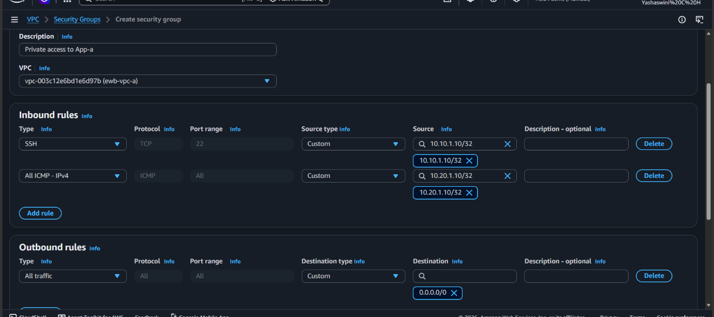

Subnet configuration
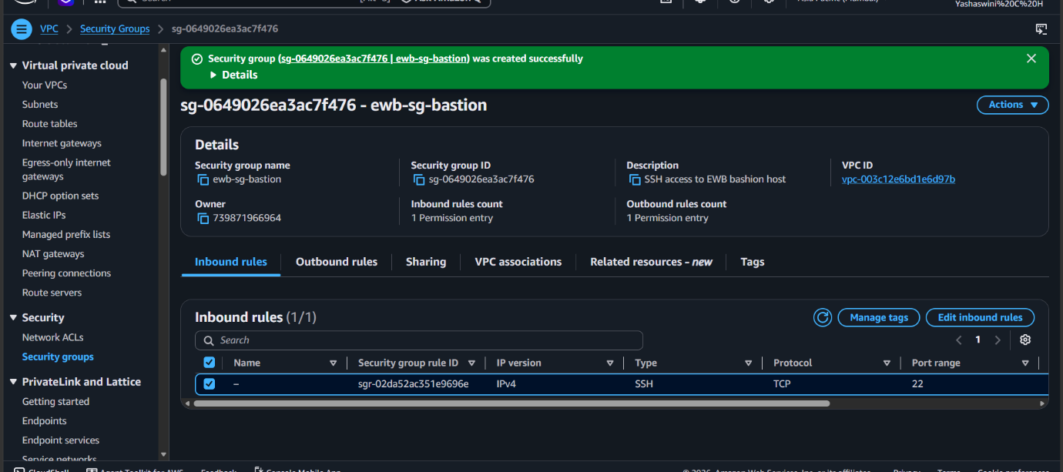

EC2 instance health
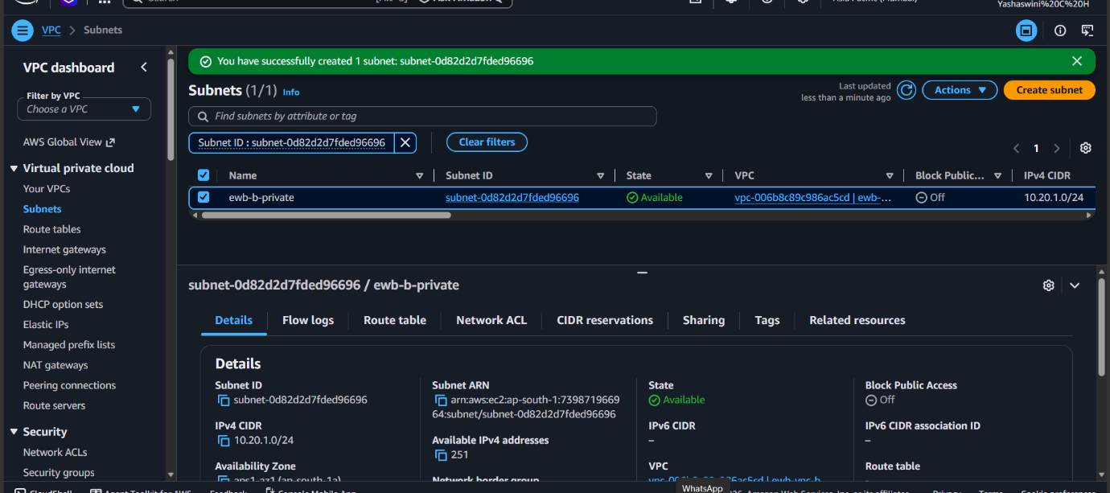

Terminal connectivity evidence — test 1
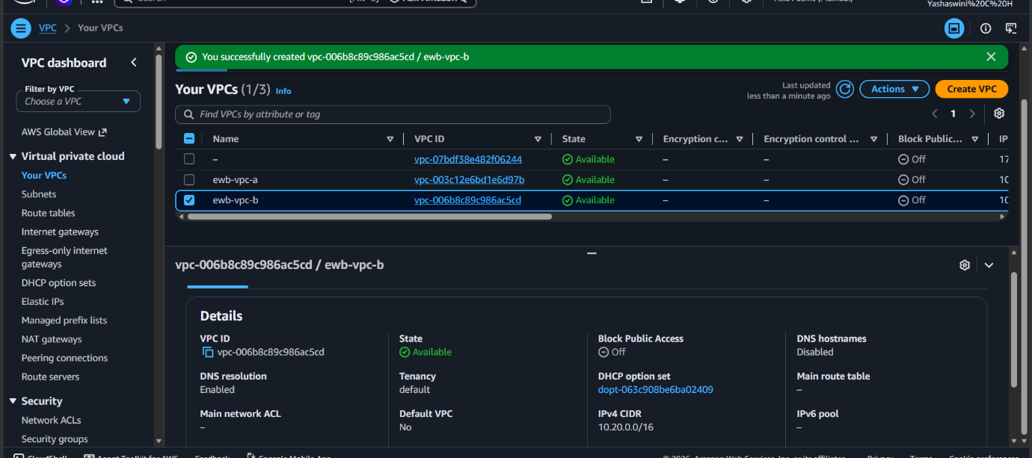

Terminal connectivity evidence — test 2
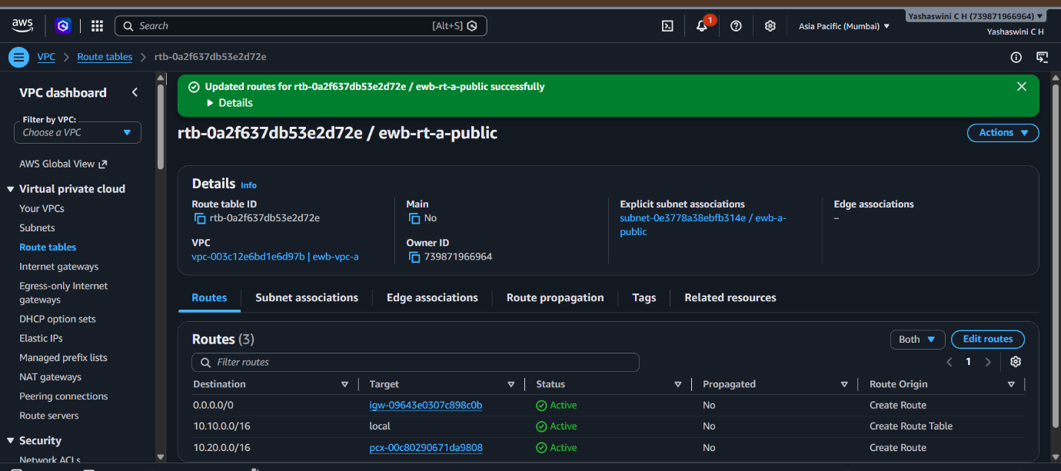

10. Cost, Security, and Cleanup
The AWS Billing console showed an active USD $100 credit with $100 remaining at the time of the captured billing screenshot. Credit eligibility and usage reporting can vary, so the balance should be checked in Billing and Cost Management before and after lab activity. EC2 runtime, EBS storage, public IPv4 usage, and data transfer may incur charges.
- After collecting required evidence, terminate the three EC2 instances.
- Verify lab EBS volumes are deleted and release any Elastic IP addresses if created.
- Delete the VPC peering connection and remove peering routes.
- Delete security groups after dependent network interfaces are removed.
- Delete subnets, custom route tables, the Internet Gateway, and both VPCs in dependency order.
- Recheck the AWS console and billing views for remaining resources and delayed usage updates.

11. Key Learnings
- VPC peering provides private IPv4 connectivity between VPCs without requiring an Internet Gateway for inter-VPC traffic.
- CIDR ranges must not overlap for a straightforward VPC peering design.
- Route tables on both sides must contain routes to the peer VPC CIDR.
- Security groups should follow least-privilege access and use narrowly scoped source addresses.
- A public subnet needs a route to an attached Internet Gateway, and a bastion host must have a valid public address and reachable TCP/22 path.
- Cost-aware cleanup is an essential part of short-lived cloud labs.

12. Conclusion
The AWS VPC Peering Lab brings together VPC design, subnet segmentation, routing, security-group configuration, EC2 deployment, and private connectivity verification. The architecture and evidence package provide a structured record of the implementation and its principal AWS networking concepts.

Additional Terminal Validation Evidence
The following terminal captures were supplied after the initial report package was prepared. They are included as direct evidence of the successful connectivity checks and the controlled ICMP failure test.

1. App-A to App-B: successful connectivity and controlled failure
From App-A (10.10.2.10), ping to App-B (10.20.1.10) first returned four replies with 0% packet loss. In the later test, the same ping returned 0 replies and 100% packet loss. This is consistent with the controlled-failure condition in which the relevant inbound ICMP rule on App-B is temporarily removed. The screenshot itself shows the sequence of results; the exact console rule-change action is documented separately.
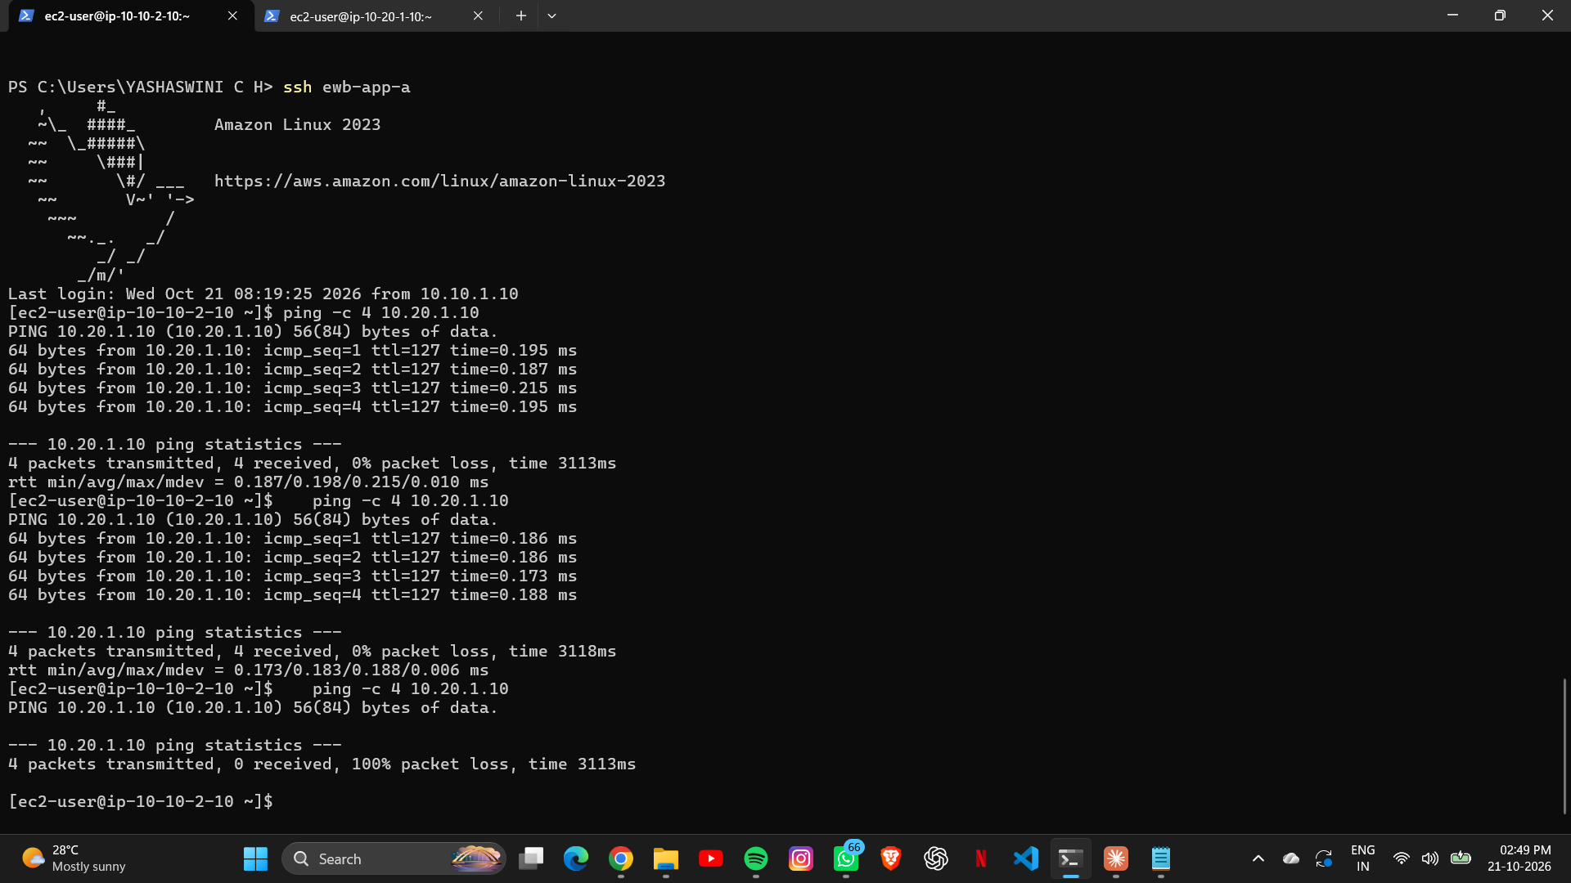
Figure: App-A → App-B ping succeeds (0% loss), then fails (100% loss) during the controlled ICMP test.

2. App-B to App-A: reverse connectivity
From App-B (10.20.1.10), ping to App-A (10.10.2.10) returned four replies with 0% packet loss. The terminal also shows repeated successful pings to its own private IP, confirming the target address and terminal context visible in the capture.
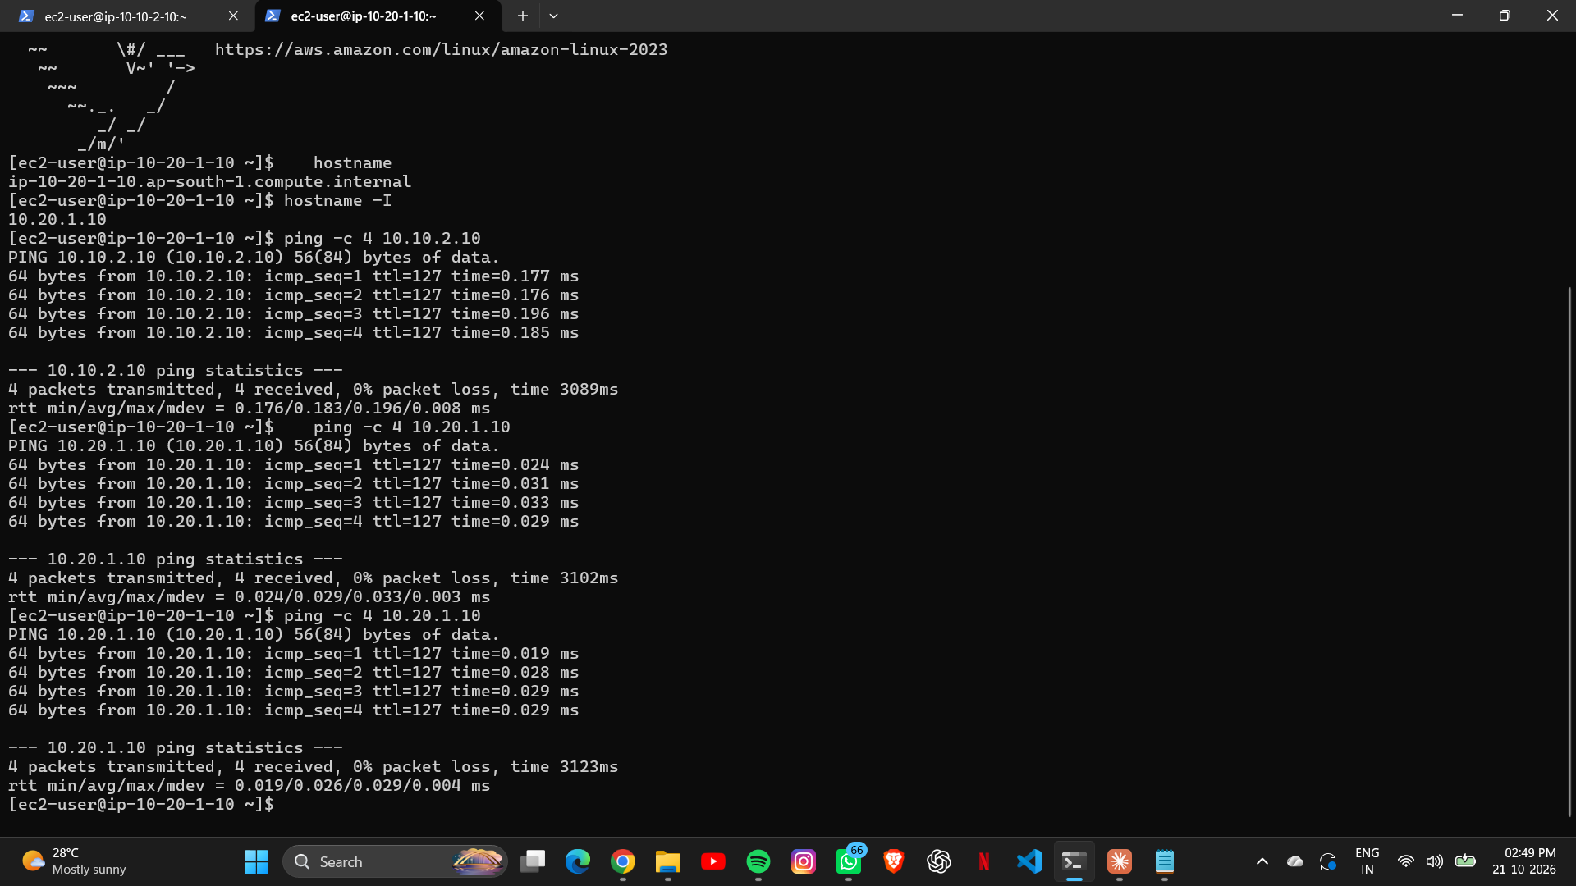
Figure: App-B → App-A reverse ping succeeds with 4 packets received and 0% packet loss.

