LoRa Pump Control
User Manual
SKU: P-0294 | UI v2.1 | FW RX-v3. | April 2026

1. Product Overview
LoRa Pump Control is a wireless remote relay system that lets you switch and monitor a 230 V AC pump load from a Windows PC — with no Wi-Fi or cellular network needed. A LoRa radio link connects the Local Transmitter (Tx, at your PC) to the Remote Receiver (Rx, at the field). The desktop software provides full control, scheduling, diagnostics, and event logging.

Component | Role | Connects To
Local Device (Tx) | Transmits commands from PC to field | PC via USB-A
Remote Device (Rx) | Receives commands, controls pump | 230V load + mains sense
LoRa Control UI | Windows desktop application | Tx device via COM port

2. Safety — Read Before Use
⛔ DANGER
This device interfaces with 230 V AC mains electricity. De-energise the circuit before making any wiring connections. Only qualified electricians should handle 230 V wiring.

⚠ WARNING
Never connect raw 230 V AC wires to the 230V SENSE port. It requires a conditioned signal from the purpose-built sense cable.

⚠ WARNING
Always attach the SMA antenna BEFORE powering on. Operating without an antenna permanently damages the LoRa radio module.

Rule | Detail
✔ Relay rating | Verify the relay current rating is sufficient for the connected load before wiring.
✔ Battery type | Use only the compatible Li-Ion battery on the Remote device.
✔ Environment | Do not expose either device to moisture, excessive heat, or corrosive environments.
✔ Enclosure | Do not open the enclosure while connected to mains or USB power.
✔ Regulations | Ensure LoRa radio operation complies with local regulations (IN865)
NOTE: Relay rating - Current at 230VAC/28V DC For 2 Form C is 5A.

3. Hardware Tour
All connectors and indicators are labelled directly on the enclosure. Identify every panel before making connections.

3.1 Remote Device (Rx) — Top Panel
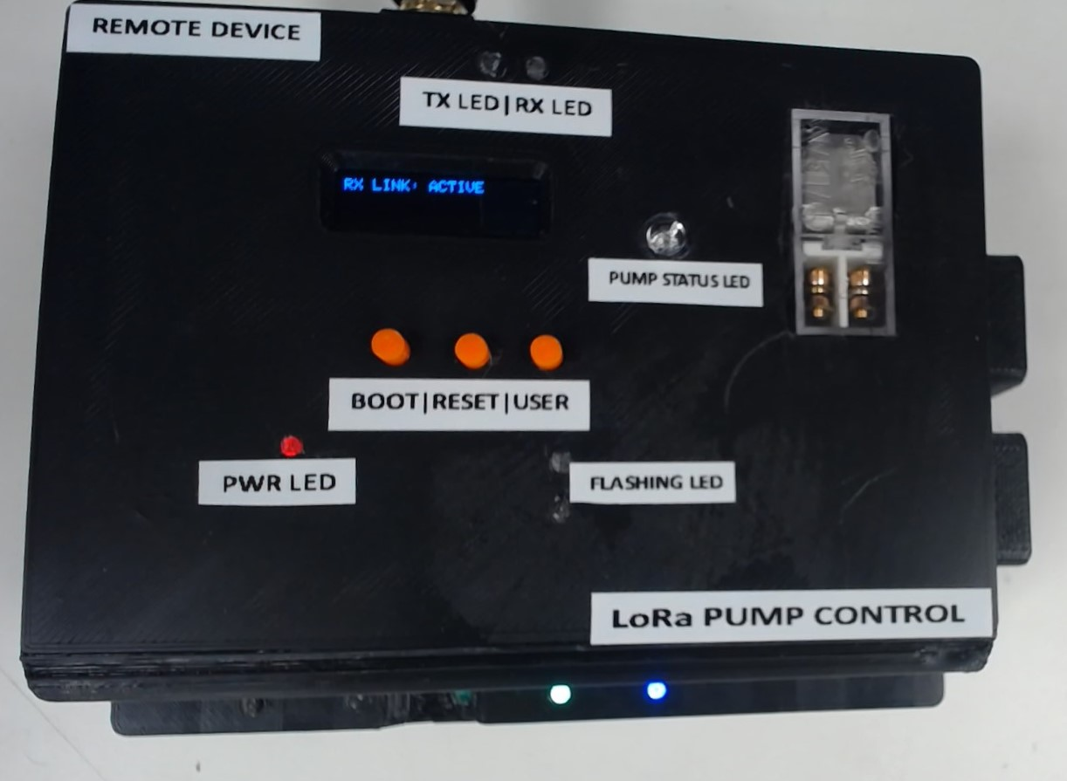
Fig. 1 — Rx Top Panel: OLED display, status LEDs, control buttons, and relay block

Component | Location | Description
OLED Display | Top-center | Shows RSSI, SNR, relay state, and mains status in real time.
PWR LED | Bottom-left (red) | Illuminates when the device has power.
TX LED | RX LED | Above OLED | Blink on every wireless packet transmitted or received.
PUMP STATUS LED | Next to pump block | White — illuminates when the relay is energised (pump ON).
FLASHING LED | Bottom-left | Active only during a firmware update.
BOOT | Orange button | Hold during reset to enter firmware flash mode.
RESET | Orange button | Resets the microcontroller.
USER | Orange button | User-configurable button.
PUMP Block | Top-left | 230 V AC relay — switches the pump load on command.

3.2 Remote Device (Rx) — Back & Side Panels
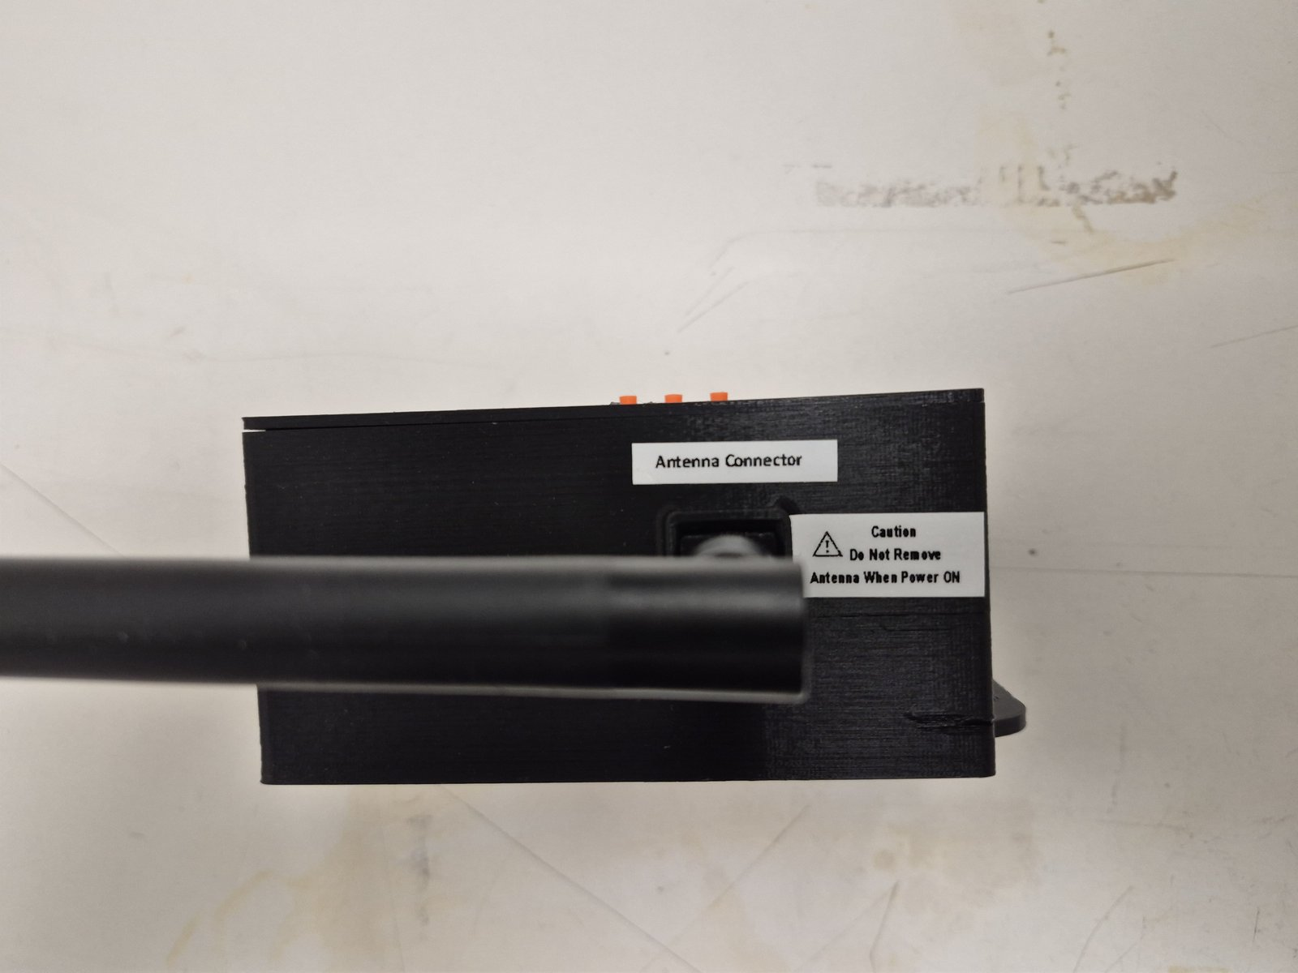  Fig. 2 — Back panel: SMA antenna connector | 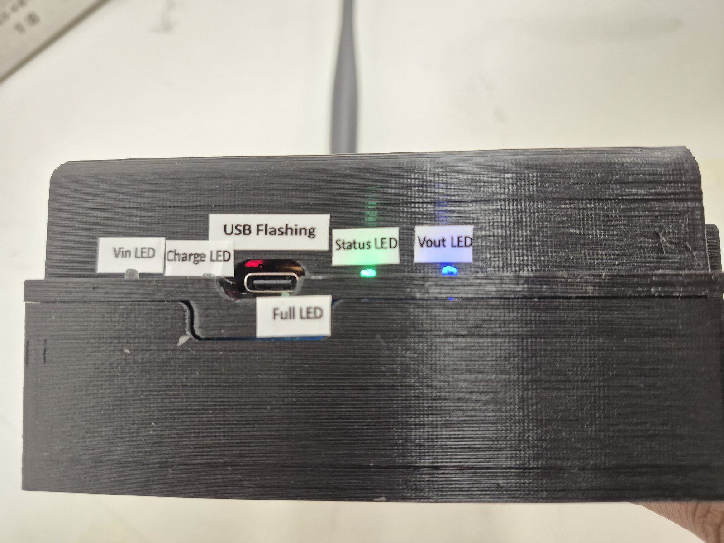  Fig. 3 — Front: Status LED of UPS + USB Flashing

Connector | Panel | Description
SMA Antenna Port | Back | Gold RF connector. Attach supplied LoRa antenna before power-on. REQUIRED.
Status LED’s | Front | TinyUPS LED’S status LED’s
USB Flashing | Front | Internal use only — firmware development. Do not connect during normal use.

3.3 Remote Device (Rx) — Right Panel (230V Connectors)
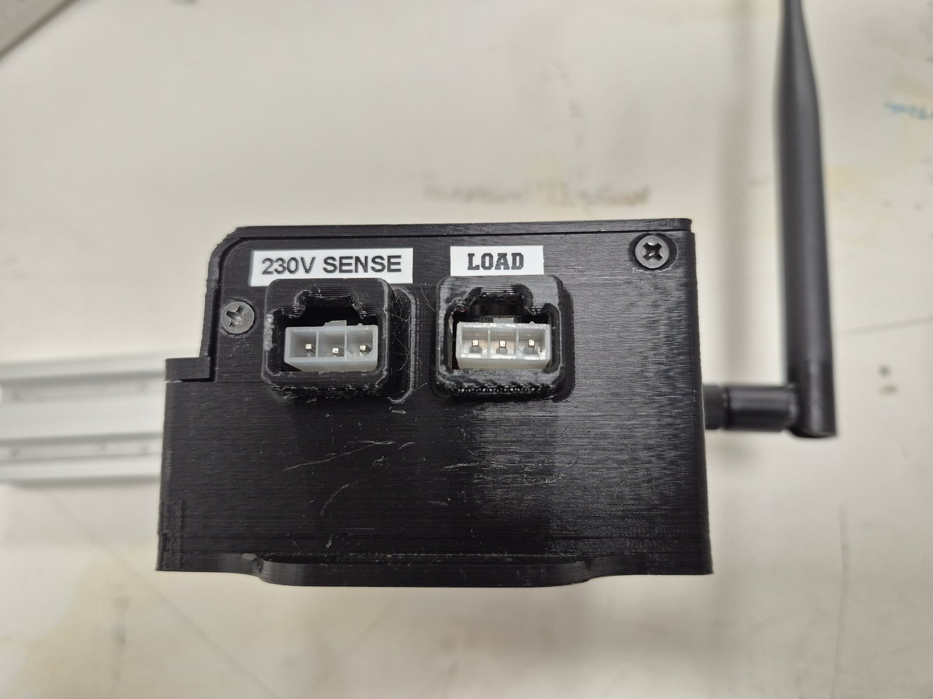
Fig. 4 — Rx Right Panel: 230V SENSE input (left) and LOAD output (right)

⚠ WARNING
230V SENSE accepts a low-voltage conditioned sense signal only — NOT raw 230V mains. Use the purpose-built sense cable supplied with the unit.

Connector | Description
230V SENSE (left) | Mains-sense input. Detects whether AC power is available at the remote site.
LOAD (right) | Relay-switched 230V AC output. Connect the pump or appliance to be controlled here.

3.4 Local Device (Tx) — Side Panel (USB & LEDs)
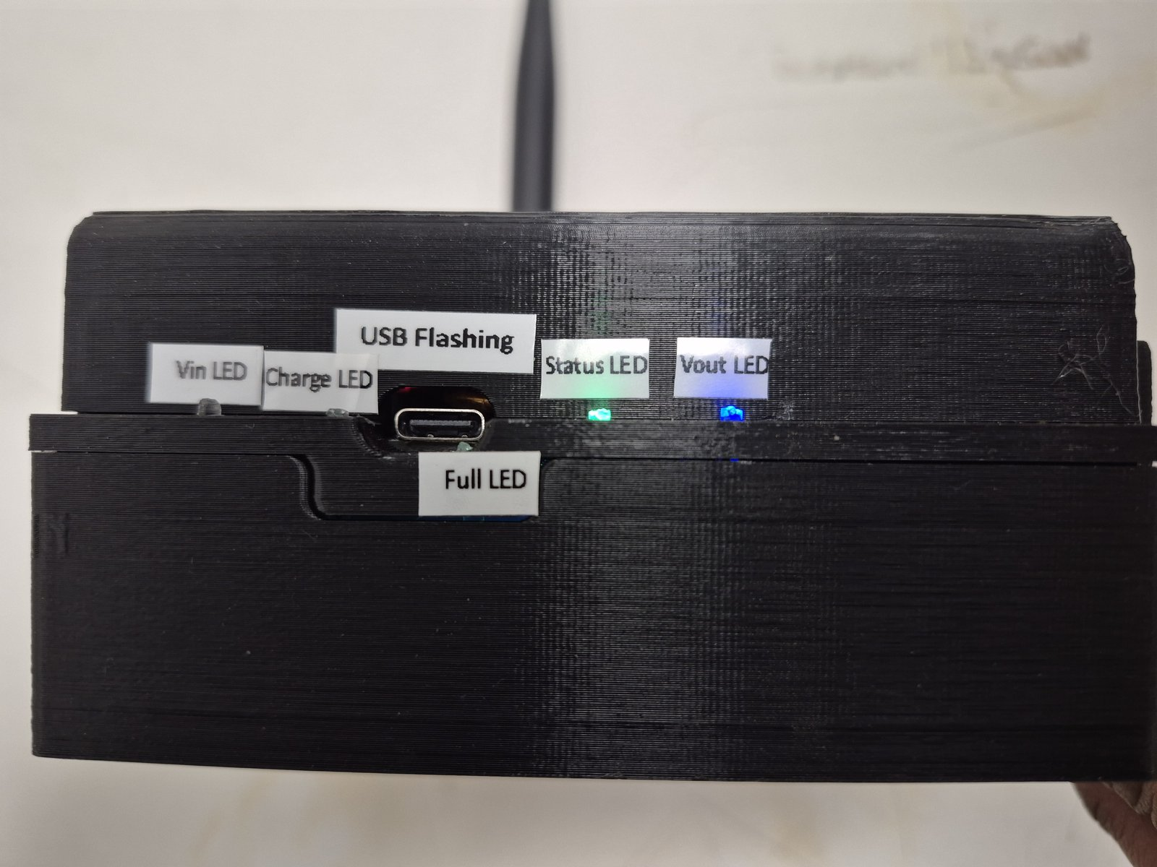  Fig. 5 — Tx side: USB port & LEDs (normal operation) | 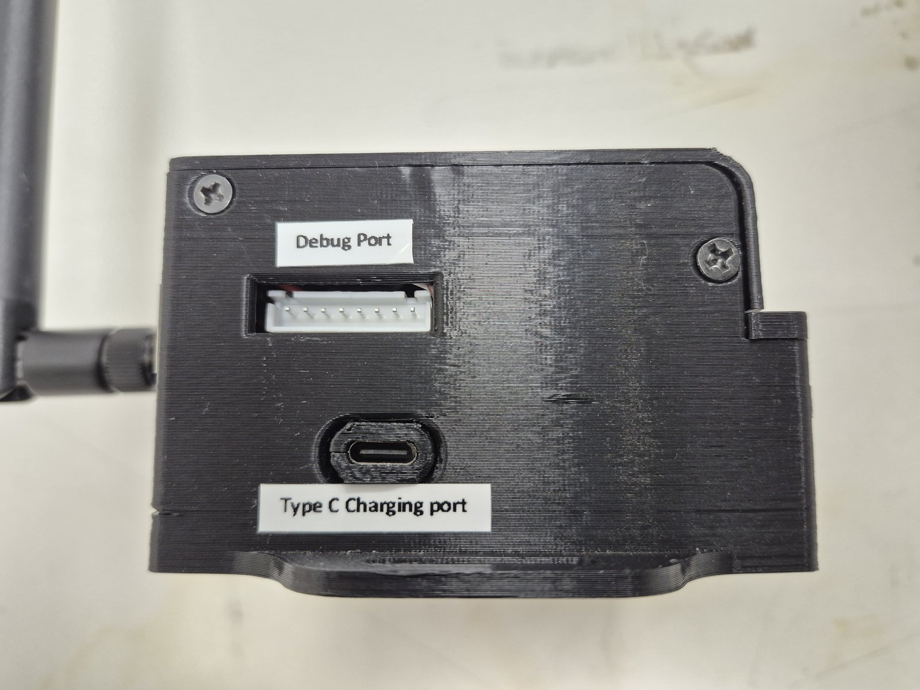  Fig. 6 — Tx side: Charge LED active (red)

Component | Description
Type C charging port | Primary power input (5V) . Connect this to your 5A dc Adapter.
Vin LED | Illuminates when input voltage is present.
Charge LED | Red — battery is currently charging.
Status LED (green) | Green — device operating normally.
Vout LED (blue) | Blue — output voltage active, device is communicating.
Full LED | Battery is fully charged.
Debug Port | For internal use only – Firmware flashing. Do Not Use.

4. First-Time Setup

4.1 Remote Device (Rx) — Hardware Setup
- Attach the LoRa antenna. Connect the supplied antenna firmly onto the SMA connector on the back panel. Do this BEFORE applying power.[DO NOT REMOVE THE ATTACHED ANTENNA].

Fig. 7 — Connect the LoRa antenna onto the SMA connector before powering on.
- Connect the LOAD cable. Wire the pump or appliance to the LOAD terminal on the right panel (relay-switched 230V AC output). Use a qualified electrician.
- Connect the SENSE cable. Plug the purpose-built sense cable into the 230V SENSE terminal on the right panel.

Fig. 8 — Right panel: 230V SENSE (top) for mains detection, LOAD (bottom) for pump output
- Apply USB-C power. Connect a 5V USB-C adapter to the type-c Charging port. The OLED illuminates within a few seconds showing RSSI and SNR values.

ℹ️ NOTE
The device begins transmitting LoRa packets immediately after power-on. It is ready to receive commands as soon as the OLED shows values.

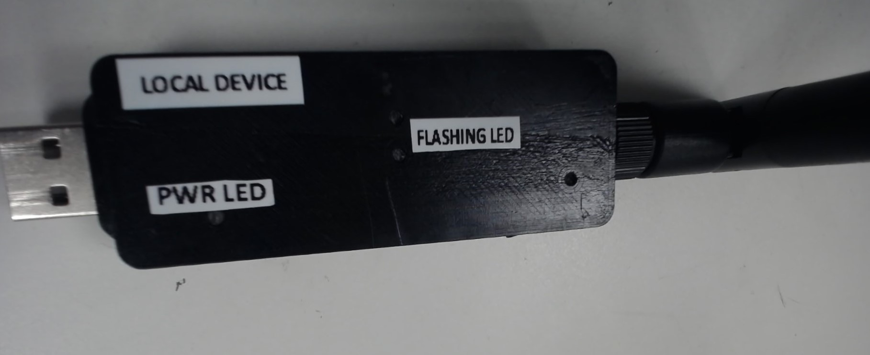

Fig. 9 — Connect the Tx device to your PC
- Connect the Tx to your PC .
- Check the LEDs. The Status LED (red) ,should illuminate, confirming power and normal operation.

4.3 Installing & Launching LoRa Control UI
- Locate the installer. "LoRa Pump Controller Setup.exe" on your USB drive or downloads folder.
- Run the installer. Double-click the file. If Windows SmartScreen appears, click More Info → Run Anyway.
- Follow the setup wizard. The application installs to Program Files and creates a desktop shortcut.
- Launch the application. Double-click the desktop shortcut.

ℹ️ NOTE
No internet connection is required. The installer is fully self-contained and can be transferred by USB drive.

5. Using the Control Software

5.1 Connecting to the Device (Dashboard)
When you first open the application, the status dot in the top navigation bar will be RED, indicating no connection. Follow these steps to connect:

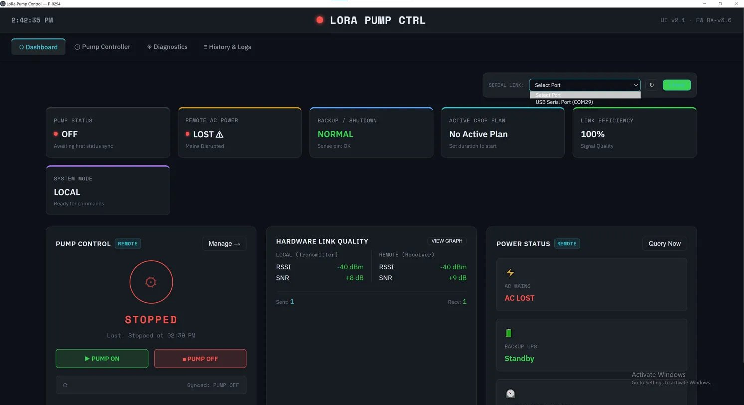
Fig. 10 — Dashboard on first launch: red dot = disconnected. Select your COM port from the SERIAL LINK dropdown

① | Look at the top-right area of the Dashboard. Find the SERIAL LINK dropdown.
② | Click the dropdown and select the port labelled USB Serial Port (e.g. COM29). If unsure, check Windows Device Manager → Ports.
③ | Click the green CONNECT button next to the dropdown.
④ | The status dot at the top centre changes from RED to GREEN. The dashboard comes alive with live data.

5.2 Dashboard Tab — Overview After Connection
Once connected, the Dashboard becomes the central command hub. It is divided into three rows:

Fig. 11 — Dashboard after connection: top status strip, status cards, and control panels

Top Status Strip (6 Mini-Cards)
A row of six quick-glance cards at the top shows the entire system state at a glance:

Card | What It Shows
1. PUMP STATUS | Green dot = ON running | Red dot = OFF stopped
2. REMOTE AC POWER | Whether mains electricity is available at the field site.
3. BACKUP / SHUTDOWN | Battery backup health — NORMAL or alert state.
4. ACTIVE CROP PLAN | Name of the currently active automation schedule (or "No Active Plan").
5. LINK EFFICIENCY | Wireless link quality as a percentage (100% = perfect signal).
6. SYSTEM MODE | LOCAL (you are in control) or REMOTE (a scheduled plan is running).

Pump Control Card (Bottom-Left)
This is where you manually start and stop the pump:

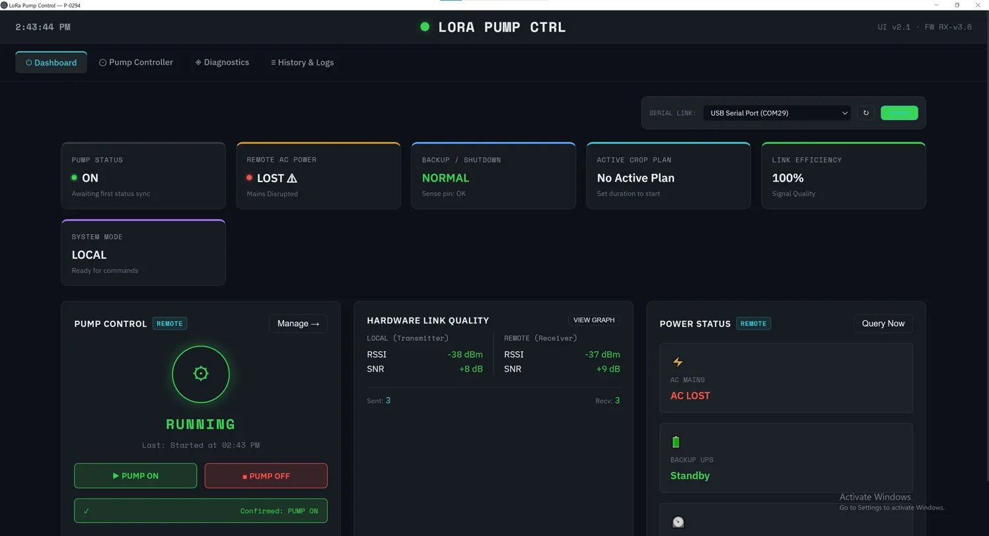
1
2
3
4
5
6
Fig. 12 — Pump Control card: animated green gear = RUNNING. Status bar shows command confirmation.

- The animated spinning gear changes colour: Green = RUNNING, Red/dim = STOPPED.
- Click PUMP ON to start the pump. Wait 1–3 seconds for the status bar to confirm.
- Click PUMP OFF to stop the pump. The status bar shows "Confirmed: PUMP OFF" in green.
- The yellow status bar below the buttons shows the current command state: Transmitting → Confirmed.

Hardware Link Quality Card (Bottom-Centre)
Displays live radio signal strength for both the Tx (local) and Rx (remote) units:

Value | Range | Colour | Meaning
RSSI | -30 to -60 dBm | Green | Excellent signal — ideal.
RSSI | -60 to -90 dBm | Amber | Good — reliable.
RSSI | -90 to -110 dBm | Amber/Red | Fair — consider repositioning.
RSSI | Below -110 dBm | Red | Poor — check antenna, reposition.
SNR | More than 0dB[+ve values] | Green | Clean signal, no noise issues.
SNR | Near 0 dB | Amber | Some noise — monitor.
Click VIEW GRAPH to open a live scrolling chart of signal strength over time.

Power Status Card (Bottom-Right)
Shows the physical power state at the remote site:

- AC MAINS — Green "STABLE" = mains power is present. Red "AC LOST" = power failure detected.
- BACKUP UPS — "Standby" = battery healthy and on standby. "Active" = running on battery backup.
- If AC power is lost, a red timer automatically starts counting up to show exactly how long the outage has lasted.
- Click QUERY NOW to force an immediate status refresh from the remote device.

5.3 Pump Controller Tab
The Pump Controller tab provides detailed manual pump control and automated crop scheduling. Click the "Pump Controller" tab in the navigation bar.

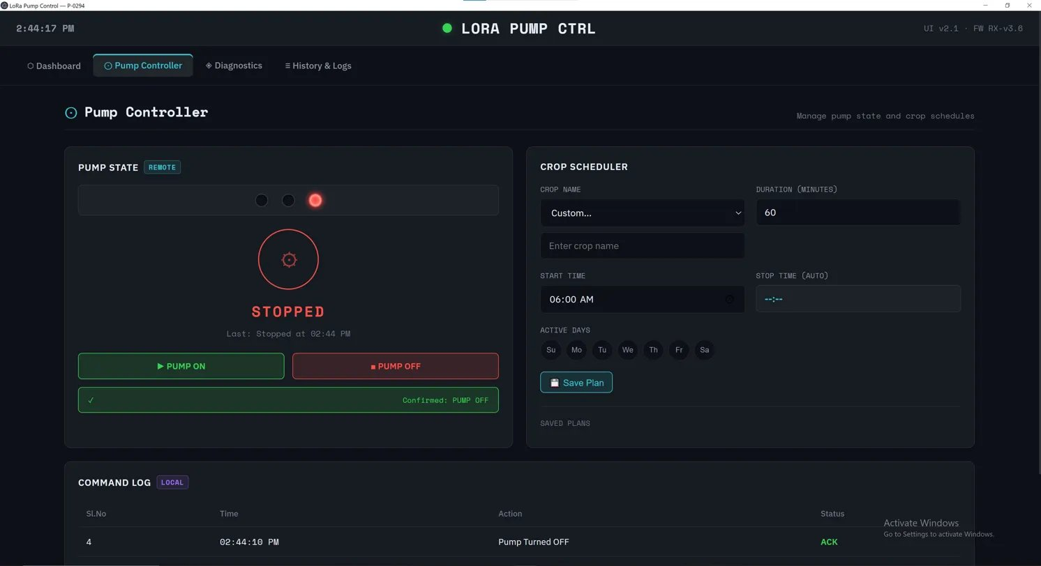
Fig. 13 — Pump Controller tab: LED status panel (left), Crop Scheduler (right), Command Log (bottom)

Pump State Panel (Left)
The three coloured circles at the top of this panel are simulated LEDs that mirror the physical lights on the remote hardware board:

LED Colour | State | Meaning
● Blue | Illuminated | System is in Scheduled/Automatic mode.
● Green | Illuminated | Pump is running.
● Red | Illuminated | Pump is stopped.
● Blue + Green | Both ON | Scheduled automation running.
● Blue + Red | Both OFF | Scheduled automation stopped.

The status bar below the ON/OFF buttons confirms the last sent command. "Confirmed: PUMP OFF" in green means the remote device acknowledged the command.

Crop Scheduler (Right Side)
Set up automated watering schedules that run without you being present:

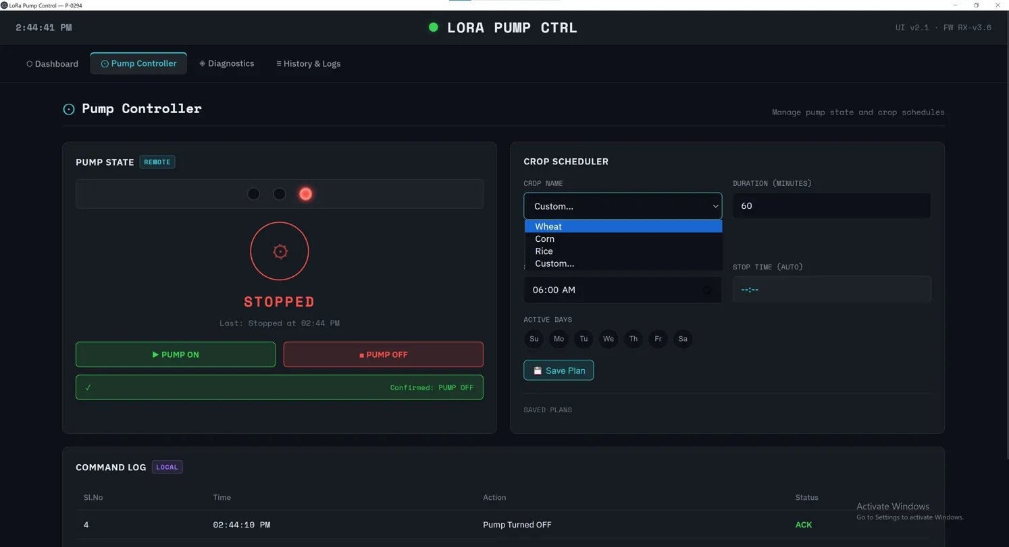
Fig. 14 — Crop Scheduler: select crop type, set duration, pick start time and active days, then Save Plan

- Select Crop Name. Choose from Wheat, Corn, Rice, or Custom. For Custom, type your crop name in the text field.
- Set Duration (Minutes). Enter how many minutes the pump should run each session (e.g., 60 for one hour).
- Set Start Time. Choose the time the pump should automatically turn ON each day.
The Stop Time (AUTO) is calculated automatically based on Start Time + Duration.
- Select Active Days. Click the day buttons (Su, Mo, Tu, We, Th, Fr, Sa) to toggle which days the schedule runs. Active days appear highlighted.
- Click Save Plan. The schedule is saved. The software monitors the clock and fires the pump ON and OFF at the exact scheduled times.

ℹ️ NOTE
The LoRa Control UI must be running on your PC at the scheduled time for the automation to trigger. The application does not run in the background when closed.

Command Log (Bottom)
A live-updating table tracking the last few actions in your current session. Each row shows the serial number, timestamp, action sent (e.g., "Pump Turned OFF"), and its status (ACK = acknowledged by remote device).

5.4 Diagnostics Tab
The Diagnostics tab lets you remotely test individual hardware components on the Rx device without physically visiting the field. Click the "Diagnostics" tab in the navigation bar.

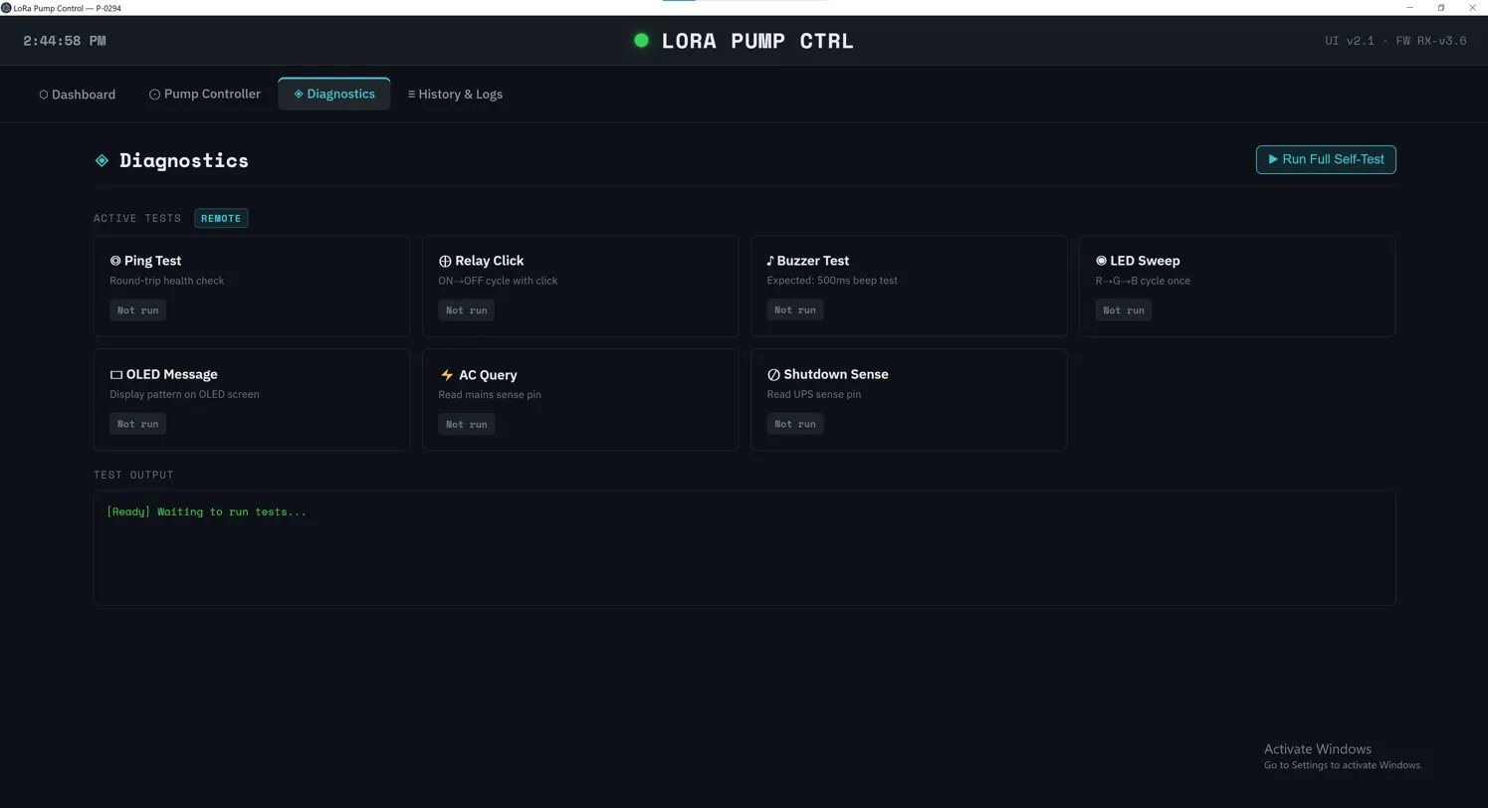
Fig. 15 — Diagnostics tab: 7 test buttons (left grid) and live test output console (bottom)

Available Tests

Test | What It Does
Ping Test | Sends a round-trip health check to the Rx device and measures response time in milliseconds.
Relay Click | Cycles the relay ON then OFF once — you should hear a physical "click" at the remote device.
Buzzer Test | Triggers a 500ms beep on the Rx buzzer — confirms audio indicator is functional.
LED Sweep | Cycles through Red → Green → Blue LEDs on the Rx device once.
OLED Message | Sends a test pattern to the OLED display — confirms screen is working.
AC Query | Reads the mains sense pin — confirms whether AC power is detected at the site.
Shutdown Sense | Reads the UPS sense pin — confirms whether battery backup is connected and healthy.

Click Run Full Self-Test (top-right button) to run all 7 tests sequentially in one pass.

Test Output Console
The scrolling terminal below the test grid shows timestamped raw data packets — exactly what was sent and what the Rx device replied. A green "PASS" or red "TIMEOUT/FAIL" appears after each test completes.

5.5 History & Logs Tab
The History & Logs tab maintains a permanent, chronological record of every system event. Data is saved to your PC's hard drive and survives application restarts.

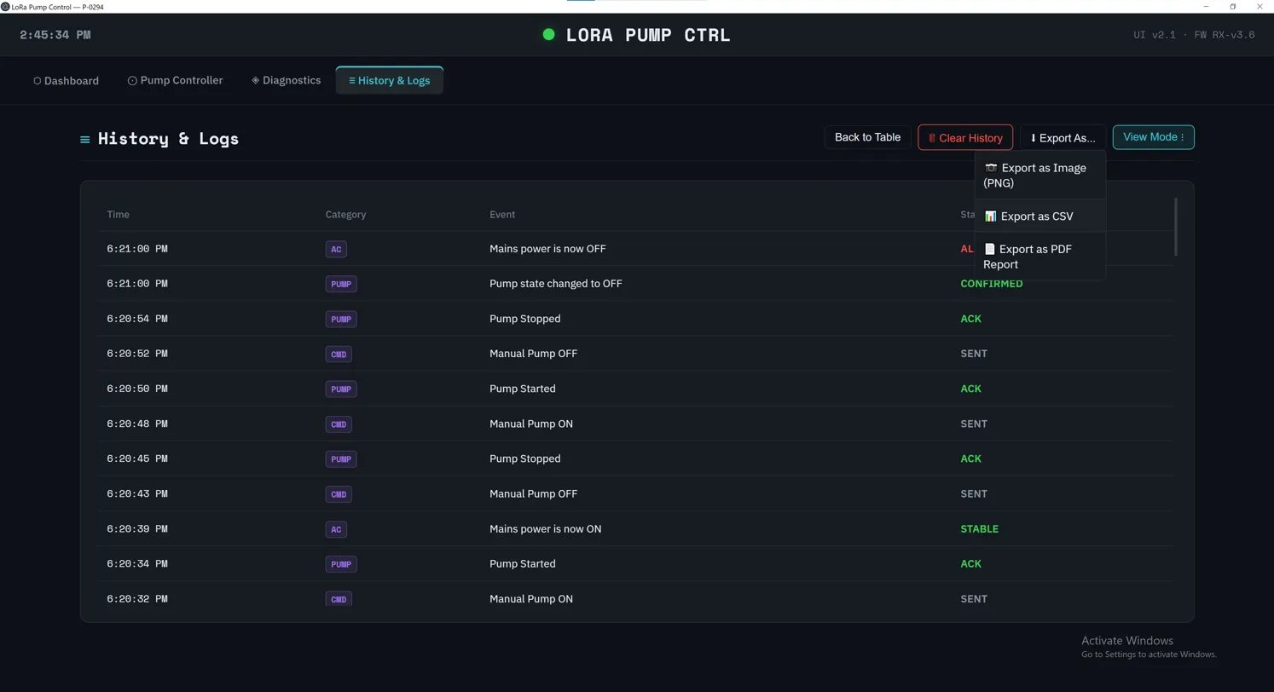
Fig. 16 — History & Logs: event table with Time, Category, Event, and Status columns. Export menu open.

Event Table
Each row in the table records: Time, Category (AC, PUMP, CMD), Event description, and Status (SENT, ACK, CONFIRMED, ALARM, STABLE). Events are colour-coded by status for quick scanning.

Status Label | Colour | Meaning
SENT | White | A command was sent to the remote device.
ACK | Green | The remote device acknowledged the command.
CONFIRMED | Green | The remote device confirmed the action was completed.
ALARM | Red/Orange | A critical event occurred (e.g., AC power lost).
STABLE | Green | A previously alarmed condition has returned to normal.

Export & Clear Controls
- Export As — opens a dropdown with three options: Export as Image (PNG), Export as CSV, Export as PDF Report.
- View Mode — toggle between the Table view and the 24-hour Gantt Chart timeline view.
- Back to Table — returns from the Gantt chart to the event table.
- Clear History — permanently deletes all recorded events from the log file.

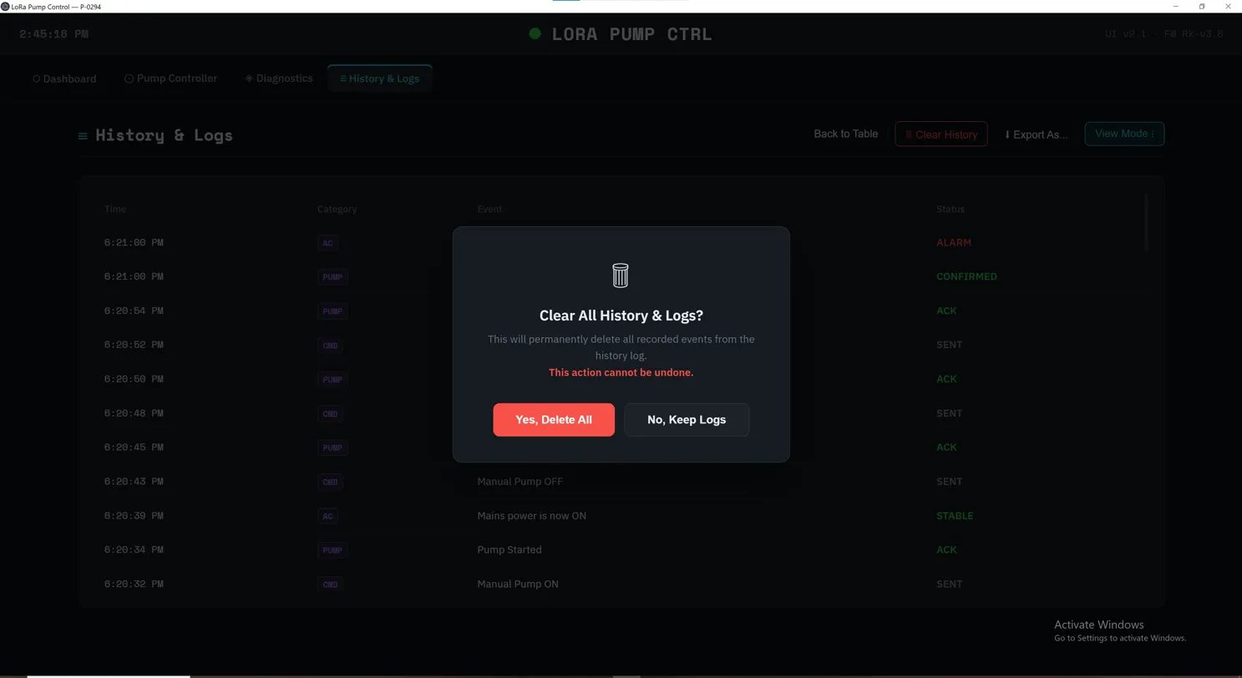
Fig. 18 — Clear History confirmation dialog: click "Yes, Delete All" to confirm, or "No, Keep Logs" to cancel

⚠ WARNING
Clearing history is permanent and cannot be undone. Export your logs as CSV or PDF before clearing if you need a backup record.

6. Status Indicators Reference


6.1 Status indicator LED in UI
Dot Colour | Meaning | Action
● Green | Connected — system online | Normal operation. All controls enabled.
● Red | Disconnected — no COM port link | Select correct COM port and click Connect.

6.2 Remote Device —Relay status LED
LED Combination | Meaning
Green only — ON | Relay energised. Pump/load is running.
Red only — ON | Relay off. Pump/load is stopped.
Blue + Green | Scheduled automation active and running.
Blue + Red | Scheduled automation ended.
Red flashing | Critical battery warning — running on very low battery.

6.3 Remote Device — LED Reference of UPS
LED | Colour | Meaning
Vin LED | Red/On | Input power present.
Charge LED | Red | Battery is charging.
Status LED | Green | Device operating normally.
Vout LED | Blue | Output voltage active — device communicating.
Full LED | Blue/White | Battery is fully charged.

7. Battery Backup
The Remote Device (Rx) includes a Li-Ion battery backup that keeps the system running during mains power outages.

Feature | Detail
Automatic switchover | When mains or USB power is lost, the device switches to battery instantly — no interruption.
Full functionality | Relay control, wireless comms, OLED display, and LEDs all remain active on battery.
Status display | OLED and the Power Status card in the UI show.
Auto-recharge | When external power returns, the battery recharges automatically while the device operates.
Charging port | Use the Type-C Charging port (back panel) with a 5V DC adapter to charge the battery.

⚠ CAUTION
If the device powers off immediately when USB is disconnected, the battery may be discharged or not connected. Charge via the Type-C Charging port, or consult your supplier.

8. Troubleshooting
Symptom | Suggested Action
OLED display does not light up | Check USB cable is firmly connected. Try a different cable or USB port. If on battery, charge via Type-C Charging port.
Software shows OFFLINE / red status dot | Verify the correct COM port is selected. Disconnect and reconnect USB, then refresh the COM port dropdown.
Relay does not respond to commands | Check signal quality (RSSI should be above -110 dBm). Verify antenna is attached and Rx device is powered on.
230V SENSE always shows NOT AVAILABLE | Check sense cable connection. Verify the monitored circuit has power and is switched on.
Device powers off when USB removed | Battery is discharged or not connected. Charge via the Type-C Charging port.
Scheduled automation does not start | Verify the plan was saved. Confirm correct days are selected. Ensure the LoRa Control UI is open at the scheduled time.
Signal quality shows Poor (Red) | Reposition the device to reduce obstacles. Verify antenna is secure. Move away from interference sources (Wi-Fi routers, metal surfaces, microwave ovens).

9. Technical Specifications
Specification | Detail
Wireless Technology | LoRa long-range radio
Radio Frequency | IN865
SKU | P-0294
Power Input | USB-C, 5 V DC
Battery Backup | Li-Ion — automatic failover
Relay Output | Normally Open (N/O), 230V AC rated
230V Sense Input | Low-voltage conditioned input (NOT raw mains)
Status Indicators | RGB LEDs + OLED display.
PC Communication | USB-Serial virtual COM port (Windows)
Control Software | LoRa Control UI v2.1 — Windows desktop application
Firmware Version | RX-v3.6
Enclosure | 3D-printed polymer, black

Power Consumption
Device | Condition | Current Draw
Local Device (Tx) | Transmitting | 0.07 A
Local Device (Tx) | Connected / idle | 0.06 A
Remote Device (Rx) | Working / relay active | 0.252 A[must check]
Remote Device (Rx) | Idle | 0.020 A

CONFIDENTIAL — FOR AUTHORISED USE ONLY | SKU P-0294 | April 2026

