**A REAL TIME PROJECT REPORT**

on

**EXPLORING INDIA’S CULTURE AND HERITAGE: MUSICAL INSTRUMENTS OF INDIA**

Submitted for partial fulfillment of the requirements for the award of the degree of

# BACHELOR OF TECHNOLOGY

## In

**CSE (Artificial Intelligence & Machine Learning)**

**Submitted by**

**G. Yashaswini 23UP1A6618**

**G. Shivani 23UP1A6621**

**B. Nishitha Reddy 23UP1A6610**

**K. Mounika 23UP1A6628**

**Under the Guidance of**

**Dr. M. Thejovathi, Ph.D.**

**Associate Professor**

**Department of CSE(AI&ML)**



**DEPARTMENT OF CSE (ARTIFICIAL INTELLIGENCE & MACHINE LEARNING)**

**VIGNAN’S INSTITUTE OF MANAGEMENT AND TECHNOLOGY FOR WOMEN (An Autonomous Institution)**

**Approved by AICTE and Affiliated to JNTUH Accredited to NBA (CSE&ECE), NAAC A+**

(Affiliated to Jawaharlal Nehru Technological University Hyderabad)

Kondapur (V), Ghatkesar (M), Medchal (D), Telangana, Pincode-501301

[www.vmtw.edu.in](http://www.vmtw.edu.in)

2024-2025

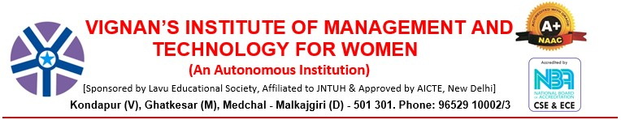

# DEPARTMENT OF CSE(AI&ML)

**CERTIFICATE**

This is to certify that project work entitled “**Exploring India’s Culture And Heritage: Musical Instruments of India”**submitted by **G.Yashaswini (23UP1A6618), G. Shivani (23UP1A6621), B. Nishitha Reddy (23UP1A6610), K. Mounika (23UP1A6628),** in the partial fulfilment of the requirements for the award of the degree of Bachelor of Technology in CSE(AI&ML) Vignan’s Institute Of Management And Technology For Women is a record of Bonafide work carried by them under my guidance and supervision. The results embodied in this Project report have not been submitted to any other University or institute for the award of any degree.

**Project Guide Project Coordinator Head of Department**

**DR. M. THEJOVATHI**, Ph.D. **D. BIKSHALU,** M.Tech **Dr. D. SHANTHI,** Ph.D.

Associate Professor Assistant Professor Professor

**External Examiner**



# DEPARTMENT OF CSE(AI&ML)

**DECLARATION**

We hereby declare that the work reported in the present project entitled “**Exploring Musical instruments of India**” is a record of bonafide work duly completed by us in the Department of CSE (AI&ML) from Vignan’s Institute of Management and Technology for Women, affiliated to JNTU, Hyderabad. The reports are based on the summer internship work done entirely by us and not copied from any other source. All such materials that have been obtained from other sources have been duly acknowledged.

The results embodied in this Project report have not been submitted to any other University or Institute for the award of any degree to the best of our knowledge and belief.

**Roll Number Student Name Student Signature**

23UP1A6618 G. Yashaswini

23UP1A6621 G. Shivani

23UP1A6610 B. Nishitha Reddy

23UP1A6628 K. Mounika

# ACKOWLEDGEMENT

We would like to express our sincere gratitude and indebtedness to our project guide

**DR. M. THEJOVATHI** Associate Professor for her valuable suggestions and interest throughout the course of this project.

We would like to extend our gratitude to **D. BIKSHALU**, Assistant Professor, Real Time Project Coordinator, Department of CSE- Artificial Intelligence and Machine Learning (AI&ML) from Vignan's Institute of Management and Technology for Women, for his valuable suggestions and timely help while the project.

We are also thankful to **Dr. D. SHANTHI**, Head of the Department of CSE- Artificial Intelligence and Machine Learning from Vignan's Institute of Management and Technology for Women, Hyderabad for providing excellent infrastructure and a nice atmosphere for completing this project successfully as a part of our B.Tech. Degree (CSM).

We convey our heartfelt thanks to the lab staff for allowing us to use the required equipment whenever needed.

Finally, we would like to take this opportunity to thank our family for their support through the work. We sincerely acknowledge and thank all those who gave directly or indirectly their support in the completion of this work.

G. Yashaswini 23UP1A6618

G. Shivani 23UP1A6621

B. Nishitha Reddy 23UP1A6610

K. Mounika 23UP1A6628

**ABSTRACT**

India is a land of rich culture, and music is an important part of it. Indian music has a long history and is deeply connected to traditions and emotions. This project explores the musical instruments that are a part of India’s cultural heritage. Indian music is mainly divided into Hindustani and Carnatic styles. Each style uses unique instruments that have been passed down for generations. The sitar, tabla, and sarod are popular in North India. In South India, the veena, mridangam, and ghatam are widely used. Apart from classical music, India has a wide variety of folk music. Each region has its own special instruments made with local materials. Instruments like dhol, ektara, and shehnai are played during festivals and celebrations. Many instruments are handmade, showing the skill of local craftsmen. They are often decorated and have beautiful designs. These instruments are not just tools for music; they carry stories and traditions. Music brings people together during weddings, temple festivals, and community events. It is used to express joy, devotion, and even sorrow. Learning about these instruments helps us understand Indian life better. From the deserts of Rajasthan to the hills of the Northeast, each area has its own sound. The project also looks at how modern musicians keep these instruments alive. Today, some artists mix traditional instruments with modern music. This helps younger people connect with their roots. Music education and performances help preserve these traditions. Schools and cultural centers play a big role. Overall, musical instruments are a window into India’s soul. They show the beauty of India’s unity in diversity. Through this project, we celebrate the sound and spirit of India.

Bottom of Form

|  |  |  |
| --- | --- | --- |
| **S.NO** | **Figure Name** | **Page no** |
|  | Use Case Diagram | 21 |
|  | Class Diagram | 22 |
|  | Sequence Diagram | 23 |
|  | Activity Diagram | 25 |
|  | Deployment Diagram | 26 |

# 

# LIST OF FIGURES

# 

# LIST OF TABLES

# 

|  |  |  |
| --- | --- | --- |
| S.NO | Name of tables | Pg.no |
| 1 | literature survey | 10 |

# TABLE OF CONTENTS

# Chapter No. Title page.no

# Abstract v

# List of Figures vi

# List of Tables vi

# 1. INTRODUCTION 1

# 1.1 Problem Statement 2

# 1.2 Objective 3

# 1.3 Motivation 4

# 1.4 Existing System 5

# 1.5 Proposed system 6

# 1.6 Scope and Purpose 7

# 2. LITERATURY REVIEW 9

# 3. SYSTEM REQUIREMENTS AND SPECIFICATIONS 10

# 3.1 software and hardware Requirements 11

# 4. SYSTEM DESIGN 14

# 4.1 System Architecture or block diagram 15

# 4.2 UML Diagrams 17

# 4.2.1 Use case Diagram 17

# 4.2.2 Class Diagram 18

# 4.2.3 Sequence Diagram 19

# 4.2.4 Activity Diagram 20

# 4.2.5 Deployment Diagram 21

# 5. IMPLEMENTATION 22

# 5.1 Module Split up 22

# 5.2 Proposed Algorithm 23

5.3 Technologies 25

# 6. RESULTS 26

# 7. TESTING 29

# 8. CONCLUSION 31

# 9. FUTURE ENHANCEMENT 32

# 10. REFERENCES 33

Research paper 35

SAMPLE CODE 45

**CHAPTER-1**

**INTRODUCTION**

India is known all over the world for its rich culture and long history. One of the most beautiful parts of this culture is music, which has been a part of Indian life for thousands of years. It is used in temples, during festivals, at weddings, and even in daily life. Indian music is not just a form of entertainment but a way to express emotions, beliefs, and stories. Musical instruments play an important role in Indian music and are used in both classical and folk traditions. India has many different types of instruments that come from different regions, each with its own sound, style, and cultural meaning. These instruments are made from natural materials like wood, clay, metal, leather, and bamboo. Many are handcrafted by skilled artisans who pass down their knowledge through generations.

In this project, we will explore these wonderful instruments, how they are made, how they sound, and how they are used in performances. We will also study the role of music in Indian traditions and how it changes from region to region. Every state in India has its own unique musical style, rhythm, and instruments. Instruments like the sitar and tabla are well known around the world, while others like the pungi, ektara, and khartal are deeply rooted in local traditions and used in folk music. All of them are important parts of India’s musical and cultural identity. By learning about them, we show respect to our cultural roots and help keep these traditions alive for future generations. This project will also help us understand how music brings people together and creates a sense of unity in diversity. Music in India brings joy, peace, devotion, and connection among people, regardless of language or background. It is a powerful way to share feelings, tell stories, and celebrate life. We will collect information from books, interviews, documentaries, and online sources to learn more. Through this project, we hope to appreciate the beauty of Indian music and share it with others in a meaningful way. Let us begin our journey into the rich, colourful, and soulful world of Indian musical instruments.

**1.1 PROBLEM STATEMENT**

This website offers an engaging and educational journey into the diverse world of Indian musical instruments, blending interactivity with cultural depth to promote understanding, appreciation, and preservation of India’s rich musical heritage. A visually interactive map of India allows users to explore instruments region by region, revealing traditional instruments native to each state along with cultural and historical context. Clicking on an instrument lead to a dedicated page with in-depth details such as its origin, construction, playing technique, usage in classical or folk traditions, and symbolic significance. To enhance user experience, the site includes hover-based popups that display quick previews—concise descriptions and thumbnail images—for efficient browsing. Each instrument page features multimedia content, including audio samples and performance videos, and highlights notable musicians who have mastered it. The platform is designed to serve as a cultural and educational resource for students, teachers, music lovers, and researchers, with content structured for potential inclusion in school curricula. Language is tailored to suit a wide age group, and future updates may introduce quizzes, timelines, and interactive learning modules to deepen engagement and make learning more fun. A clean, user-friendly interface ensures easy navigation across desktops, tablets, and smartphones, while accessibility guidelines are followed to accommodate users with disabilities.

The site’s design emphasizes inclusivity, with plans for multilingual support to broaden reach and allow users to explore content in various Indian languages. Additionally, a glossary of musical terms and a section on related instruments will help users expand their knowledge and draw connections across different traditions. More than just a website, this platform is a digital archive and learning space—preserving traditional knowledge, encouraging discovery, and celebrating the unity in diversity of India’s musical landscape. Through this immersive experience, users from all backgrounds can connect with the soulful rhythms and stories that make Indian music a living legacy. By bringing together technology, education, and tradition, the website aims to inspire pride in India’s cultural roots and ensure that its musical treasures are passed on to future generations

**1.2 OBJECTIVES**

Indian classical music is one of the oldest musical traditions in the world, rooted deeply in India’s spiritual, cultural, and artistic history. The instruments used in this genre are not only tools for producing sound but are also vessels of rich tradition, craftsmanship, and expression. These instruments have evolved over centuries and are deeply tied to regional styles, religious practices, and philosophical ideas. This project aims to explore the classical instruments of India, focusing on both the **Hindustani (North Indian)** and **Carnatic (South Indian)** traditions. Instruments like the sitar, tabla, veena, mridangam, sarod, and bansuri form the core of classical music and are revered for their expressive capabilities and unique sound textures. Each instrument carries a story of invention, evolution, and performance, shaped by the hands of master musicians and artisans. By studying these instruments, we aim to gain a better understanding of how music reflects India's cultural values and diverse heritage. This project also focuses on the importance of preserving these instruments through education, documentation, and modern technology. The goal is to help students, educators, and music enthusiasts appreciate the intricate beauty and significance of classical music. Alongside this narrative, we have outlined specific objectives that will guide our research and presentation of this topic.

**Specific Objectives**

1. To trace the historical development of Indian classical musical instruments.
2. To classify the instruments based on their type: string (tata), wind (sushira), percussion (avanaddha), and solid (ghana).
3. To study the construction, materials, and traditional craftsmanship involved in making these instruments.
4. To understand the role of each instrument in classical music compositions and performances.
5. To examine the regional variations in instrument use between Hindustani and Carnatic traditions.
6. To analyze the cultural, religious, and symbolic meanings associated with classical instruments.
7. To highlight the contributions of famous Indian classical musicians and their association with specific instruments.
8. To evaluate the current challenges facing traditional instrument makers and classical musicians.
9. To encourage the preservation and promotion of classical instruments through educational platforms.
10. To develop audio-visual and digital resources that make learning about these instruments engaging and accessible.

Bottom of Form

ch**1.3 Motivation**

India's classical musical instruments are deeply intertwined with the nation's cultural and historical identity, reflecting centuries of tradition, craftsmanship, and artistic expression. However, despite their significance, awareness and appreciation of these instruments have declined in the digital age, with younger generations often disconnected from this rich heritage.

This project seeks to bridge this gap by developing an interactive website that brings India's classical musical instruments to life through immersive, user-friendly digital experiences. The core feature—a dynamic map of India—enables users to explore musical instruments region-wise, discovering their unique characteristics, origins, historical evolution, and cultural importance.

By incorporating engaging multimedia elements such as audio samples, images, and descriptive narratives, the website aims to provide a multi-sensory learning experience that enhances understanding and fosters appreciation. Leveraging modern web technologies, the project emphasizes interactivity, accessibility, and education, allowing users to actively engage with content rather than passively consume information.

Beyond individual exploration, the initiative aspires to be a valuable resource for musicians, researchers, educators, and cultural enthusiasts, promoting India's rich musical legacy on both national and global platforms. By creating a digital space where tradition meets technology, the project encourages users to rediscover the timeless beauty of India's classical music and ensure that these art forms remain vibrant for generations to come.

**1.4 Existing System**

In the current digital landscape, information about India's classical musical instruments is scattered across various sources, but lacks a unified, interactive, and engaging platform. Existing resources include:

Wikipedia & Online Articles – These provide textual descriptions of classical instruments but often lack interactive features or immersive multimedia

Music Blogs & Forums – Some platforms discuss Indian classical music, but they are often informal and not well-structured for comprehensive learning.

YouTube Videos & Documentaries – These provide rich audiovisual content but do not offer an organized or structured exploration of instruments by region.

Museum Websites & Cultural Archives – Certain institutions showcase musical heritage, but their information is often limited, non-interactive, or text-heavy.

Here are some websites that provide information about **India's classical musical instruments**:

Despite these available resources, they come with several limitations:

1. Lack of Centralization – No single platform allows users to explore India's musical instruments state-wise in a structured manner.
2. Minimal Interactivity – Most sources provide only static content, making user engagement limited.
3. Limited Multimedia Elements – Few platforms offer an immersive experience with audio samples, interactive visuals, or dynamic educational tools.
4. Absence of Visual Mapping – No existing system provides an interactive map to explore instruments based on Indian states.
5. Restricted Accessibility – Content is often not mobile-friendly or personalized for different user needs.

Thus, the existing systems fail to provide an immersive, informative, and engaging way for users to explore and appreciate India's classical musical heritage. project aims to address these gaps by offering a structured, interactive, and user-friendly experience that seamlessly blends cultural storytelling with modern web technologies.

**1.5 Proposed System**

The proposed system aims to create an interactive web-based platform dedicated to showcasing India's classical musical instruments through an engaging, visually appealing, and user-friendly interface. Unlike existing fragmented sources, this system will provide a centralized, immersive experience by integrating interactive mapping, multimedia elements, and structured information to enhance user engagement.

Key Features:

* Clickable India Map – The platform will feature an interactive map where users can explore musical instruments state by state, gaining insights into their historical origins, cultural significance, and distinctive characteristics.
* Hover-Based Popups – Users will see brief descriptions and images of instruments when hovering over a state, offering quick access to fundamental details. Clicking on them will provide in-depth historical narratives.
* Dedicated Pages for Instruments – Each instrument will have a unique page showcasing its history, usage, craftsmanship, regional variations, and famous musicians associated with it.
* Audio Integration – The website will incorporate audio samples, allowing users to listen to the authentic sounds of each classical instrument, enriching their understanding of its tonal qualities.
* Educational Tool for Schools and Researchers – The platform will serve as a valuable resource for students, educators, and researchers, helping them explore India's musical heritage in an interactive and structured manner.
* User-Friendly Interface – Designed to be accessible to people of all ages, ensuring seamless navigation, readability, and mobile compatibility for widespread engagement.

Impact and Significance:

By merging technology with tradition, this proposed system offers a modern approach to preserving and promoting India’s classical musical instruments. It fosters a deep appreciation for indigenous music traditions, making knowledge interactive, engaging, and widely accessible to musicians, cultural enthusiasts, educators, and general users alike.

**1.6 Scope and Purpose**

Scope:

The scope of this project includes the development of an interactive web platform that provides a comprehensive and engaging way to explore India's classical musical instruments. The system will feature:

* Scroll-Interactive India Map – Each state will display its unique classical musical instruments through a hover-based popup containing brief descriptions and images.
* Detailed Instrument Pages – Each musical instrument will have a dedicated page containing its history, cultural significance, images, and embedded audio samples for a richer understanding.
* Responsive Web Design – The platform will be accessible across desktops, tablets, and smartphones, ensuring a seamless user experience.
* Content Management System (CMS) – Administrators will have the ability to update instrument details, images, and audio samples dynamically.
* Backend Database Support – A database will store instrument information, facilitating efficient data retrieval and updates.
* Educational and Cultural Enrichment – The platform will serve as a learning tool for students, educators, musicians, and cultural enthusiasts, making traditional knowledge interactive and accessible.

**Purpose**

The primary purpose of this project is to design and develop an interactive website that acts as a digital guide to India’s classical musical instruments, making exploration engaging, informative, and immersive.

The system is designed for:

* Music Enthusiasts and Researchers – Individuals interested in studying the origins, characteristics, and evolution of classical Indian instruments.
* Educators and Students – Academic institutions can use the platform as an interactive resource for cultural and music studies.
* General Public – Anyone curious about India’s musical traditions can explore instruments effortlessly through a visually appealing, interactive interface.

Top of Form

**CHAPTER 2**

**LITERATURE SURVEY**

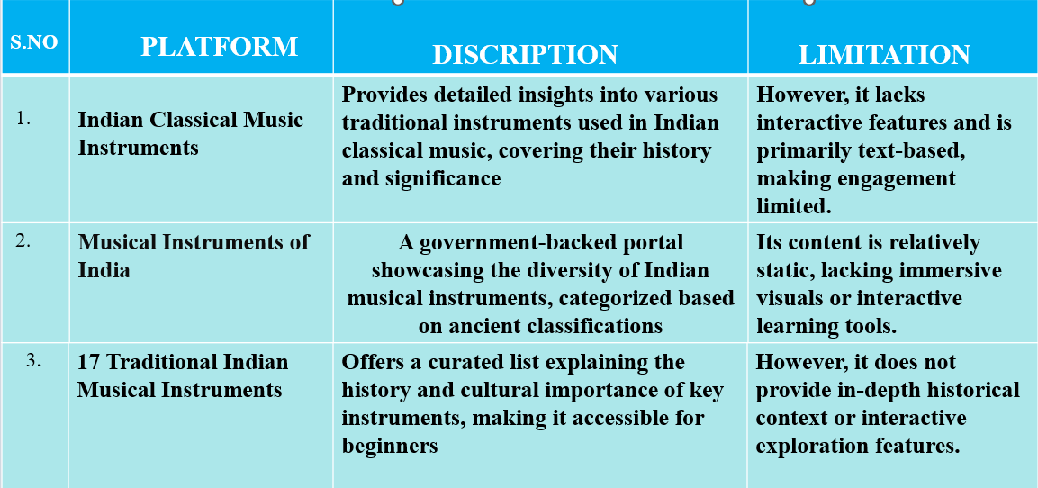

**Table2.1: literature survey**

**• Alastair Dick (2020) - The Grove Dictionary of Musical Instruments**

Key Findings:

Provides detailed descriptions and historical backgrounds of traditional Indian instruments like sitar, tabla, veena, and shehnai.

Relevance to Project:

Supports accurate representation of instruments and their roles in ceremonial and cultural settings.

**• SwarGanga.org (2023) - Indian Classical Instruments Database**

Key Findings:

Categorizes instruments by type (string, percussion, wind) and offers sound samples and playing techniques.

Relevance to Project:

Useful for illustrating the diversity and sonic identity of instruments used in various rituals or events.

**• Ministry of Culture, Government of India (2024) - Traditional Performing Arts Archive**

Key Findings:

Highlights the cultural significance and regional use of instruments in dance, theater, and folk traditions.

Relevance to Project:

Helps enrich narrative or visual storytelling with culturally accurate musical elements.

**• Rajiv Menon (2015) - Soundscapes of India: A Journey Through Music**

Key Findings:

Explores the emotional and spiritual role of music and instruments in Indian life, including religious ceremonies.

Relevance to Project:

Provides thematic depth and emotional realism to scenes involving music or rituals.

**• NaadSadhana.com (2023) - Beginner’s Guide to Indian Musical Instruments**

Key Findings:

Simplifies learning about key instruments, their use in contemporary and traditional settings.

Relevance to Project:

Makes it easier to describe instrument function and presence in everyday orfestive scenarios.

**CHAPTER 3**

**SYSTEM ANALYSIS**

System analysis is a foundational process in the development of any information system, aimed at thoroughly examining existing operations, identifying gaps, and formulating detailed requirements for an improved solution. It involves studying the current system’s structure—whether manual or automated—to understand how data flows, how users interact with the system, and where inefficiencies or redundancies exist. Analysts collect information through methods such as interviews, surveys, observations, and document reviews to capture the real-world functioning of the system from multiple perspectives. This data is then organized into structured models like data flow diagrams, entity-relationship diagrams, and system flowcharts, providing a visual and logical representation of the system. The objective is not only to understand what the system does but also to uncover what it fails to do, what users need, and how it can be improved in terms of speed, accuracy, and functionality. System analysis is both a technical and interpersonal discipline—it requires attention to detail, critical thinking, and strong communication skills to bridge the gap between stakeholders and developers. By translating user needs into functional requirements, analysts ensure that the system will meet business goals, regulatory standards, and user expectations. This phase also includes feasibility studies—technical, operational, and economic—that help determine whether the project is viable and worth investing in. It addresses potential risks, constraints, and integration challenges early, preventing costly errors during later stages of development. Additionally, system analysis sets performance benchmarks, defines data relationships, and identifies the necessary hardware, software, and human resources. It also evaluates the scalability and maintainability of proposed systems, ensuring that solutions remain effective as organizations grow and evolve. Whether it’s designing a hospital information system, an educational portal, or an e-commerce platform, system analysis guarantees that the development is grounded in a clear understanding of needs, workflows, and expectations. In essence, it forms the blueprint of the entire system, guiding designers and developers toward creating solutions that are reliable, efficient, user-friendly, and sustainable over time.

**3.1 SOFTWARE AND HARDWARE REQUIREMENTS**

**Hardware requirements**

**1. Processor:**

* Minimum: Intel Core i3 processor or an equivalent processor from AMD. This ensures sufficient processing power to run the application and testing tools smoothly.
* Recommendation: Intel Core i5 or higher, or an equivalent AMD Ryzen processor, is recommended for optimal performance, especially when running multiple tests or resource-intensive scenarios.

**2. Random Access Memory (RAM**):

* Minimum: 4 GB of RAM is the absolute minimum required to run the application and basic testing processes. However, performance may be significantly impacted with limited RAM.
* Recommendation: 8 GB of RAM is strongly recommended. This allows for smoother multitasking, running multiple applications concurrently (e.g., the application under test, testing frameworks, bug reporting tools), and handling larger datasets or more complex test scenarios without significant performance degradation.

**3. Storage:**

* Minimum: At least 500 MB of free disk space is necessary to accommodate the application installation, test data, and any temporary files generated during the testing process.
* Recommendation: While 500 MB is the minimum, having several gigabytes of free space is advisable to avoid performance bottlenecks and to accommodate potential growth in application size or test data. A Solid-State Drive (SSD) is also highly recommended over a traditional Hard Disk Drive (HDD) for significantly faster read and write speeds, leading to quicker test execution and overall better responsiveness.

**4. Display:**

* Minimum: A display with a screen size of 13 inches or larger is required. This ensures sufficient screen real estate for viewing the application interface, test results, and testing tools comfortably.
* Rationale: A larger screen facilitates better User Interface (UI) testing by allowing testers to view more elements at once and identify layout issues or inconsistencies more easily. Smaller screens can make comprehensive UI testing challenging and less efficient.

**5. Input Devices**:

* Required: A standard keyboard and a pointing device (such as a mouse or trackpad) are essential for interacting with the application under test and executing test procedures. The keyboard is crucial for inputting data, navigating the application, and running commands, while the pointing device allows for precise interaction with graphical elements and navigation within the user interface. Ensure both devices are functioning correctly for effective testing.

**Software requirements**

**1. Operating System:**

* **Supported Platforms:** Developers can utilize any of the following operating systems:
  + **Windows:** Version 10 or later is recommended for optimal compatibility and access to a wide range of development tools.
  + **macOS:** The latest stable version or the preceding version is recommended, providing a robust Unix-based environment suitable for web development.
  + **Linux:** Various distributions such as Ubuntu, Fedora, or Debian are supported, offering flexibility and customization for experienced developers.

**2. Code Editor:**

* **Recommended Editor:** Visual Studio Code (VS Code) is the preferred code editor for this project.
  + **Rationale:** VS Code is a free, lightweight, and powerful source code editor with extensive support for various programming languages, including those used in this project (HTML, CSS, JavaScript). It offers features like intelligent code completion (IntelliSense), debugging tools, Git integration, and a vast ecosystem of extensions that enhance productivity and collaboration. Developers are encouraged to familiarize themselves with VS Code's features and install relevant extensions for web development.

**3. Web Technologies:**

The project leverages the following core web technologies for its front-end development:

* **HTML (Hyper Text Markup Language):** The standard markup language for creating web pages and structuring their content. A fundamental understanding of HTML5 is essential for all developers.
* **CSS (Cascading Style Sheets):** Used for styling the visual presentation of the HTML elements, including layout, colors, fonts, and responsiveness. Familiarity with CSS3 and modern styling techniques is required.
* **JavaScript:** A dynamic scripting language that enables interactivity and dynamic behaviour on the web page. A strong understanding of core JavaScript concepts, including ES6+ syntax, is necessary.
* **Bootstrap:** A popular CSS framework that provides pre-built components and responsive grid systems, facilitating rapid and consistent UI development. Familiarity with Bootstrap's classes and conventions is expected.

**4. Web Browser (for Testing):**

* **Recommended Browsers:** For testing and ensuring cross-browser compatibility, developers should utilize either Google Chrome or Mozilla Firefox.
  + **Rationale:** These are widely used and actively maintained web browsers with excellent developer tools that aid in debugging, inspecting elements, and profiling performance. Regularly testing the application on both Chrome and Firefox will help identify and resolve any browser-specific issues, ensuring a consistent user experience across different platforms. Developers are encouraged to keep their browser versions up to date to benefit from the latest features and security patches.

**CHAPTER-4**

**SYSTEM DESIGN**

The system design of this interactive website revolves around creating an engaging and visually intuitive platform for exploring India's classical musical instruments. It follows a structured three-tier architecture, comprising the frontend, backend, and database layers, ensuring seamless functionality and an immersive user experience. The frontend is designed using HTML, CSS, and JavaScript, incorporating an interactive India map where users can hover over states to access previews of classical instruments. Clicking on a state leads to detailed instrument pages, enriched with historical narratives, images, and embedded audio samples, allowing users to explore the instruments' cultural significance. The backend is responsible for managing dynamic content loading, user interactions, and multimedia playback. Technologies like Node.js or Python handle data retrieval and updates efficiently, ensuring smooth navigation and responsiveness. The database layer, implemented using MySQL or Firebase, stores comprehensive information about each instrument, including descriptions, audio samples, and associated artists.

The workflow of the system begins with users accessing the homepage, where they interact with the clickable India map to explore instruments regionally. Hover-based popups provide instant previews, while dedicated pages offer deeper insights, enhancing user engagement through structured storytelling. The system is equipped with a content management feature, allowing administrators to update information dynamically, ensuring that the platform remains relevant and continuously evolving. Additionally, the search and filter functionality aids users in quickly locating instruments based on name, region, or category, improving accessibility. The design is responsive, ensuring compatibility across devices, including desktops, tablets, and smartphones, providing a smooth experience for all users. Performance optimization techniques such as lazy loading ensure faster content delivery and prevent lag, making navigation efficient.

Ultimately, the system design balances functionality, accessibility, and cultural preservation, merging tradition with modern web technology to create an interactive, educational, and immersive resource for music enthusiasts, students, researchers, and the general public.

**4.1 SYSTEM ARCHITECTURE**

**Fig 4.1: system architecture**

**Indian Interactive Map & Musical Instruments Website: Detailed One-Page Summary**

This innovative website provides an engaging and comprehensive platform for exploring the diverse world of Indian musical instruments, leveraging an interactive map as its central navigational element. Upon accessing the **Home Page** via a **Web Browser**, users are immediately presented with a visually appealing and interactive map of India. This map, structurally built with **HTML**, aesthetically styled with **CSS**, and dynamically enhanced with **JavaScript**, forms the gateway to discovering the rich musical heritage of different regions.

Users can intuitively interact with this map by clicking on specific states or culturally significant areas. This action triggers **JavaScript** functionalities that identify the selected region and dynamically retrieve relevant information about the musical instruments traditionally associated

with it. This information is then presented in a designated section, titled **"Indian Musical Instruments,"** often featuring captivating images of the instruments alongside concise introductory text that highlights their key characteristics and regional significance. A prominent **"Read More"** button accompanies this initial display, serving as a clear call to action for users seeking deeper knowledge.

Upon clicking the **"Read More"** button, users are seamlessly navigated to the core of the **"Indian Musical Instruments Website."** This expanded platform houses a wealth of detailed information, organized and presented to facilitate comprehensive learning. Employing **hover-based popups**, the website allows users to quickly preview essential details and visuals of instruments as they navigate lists or galleries, enhancing browsing efficiency and piquing their interest. Crucially, each instrument featured on the website boasts its own **dedicated page**. These pages offer an in-depth exploration of the instrument's history, tracing its origins and evolution; its traditional and contemporary usage, detailing playing techniques and musical contexts; its profound cultural significance within its region and beyond; and often, profiles of famous musicians who have mastered and popularized it.

Recognizing its potential as an **educational tool**, the website is thoughtfully designed to be accessible and informative for a wide range of users, from students and educators to cultural enthusiasts of all ages. The intuitive navigation and visually appealing design ensure a **user-friendly experience**, encouraging widespread engagement and facilitating the preservation and promotion of traditional knowledge about India's rich musical heritage. The integration of multimedia elements, such as high-quality audio samples and illustrative video clips (though not explicitly shown in this simplified diagram, they are a likely component of a comprehensive musical instrument website), further enriches the learning experience, allowing users to not only read about but also hear and see these instruments in action. In essence, this interactive website transforms the process of learning about Indian musical instruments from a passive reading experience into a dynamic, visually engaging, and geographically contextualized explora

**4.2 UML DIAGRAMS**

**4.2.1 USECASE**

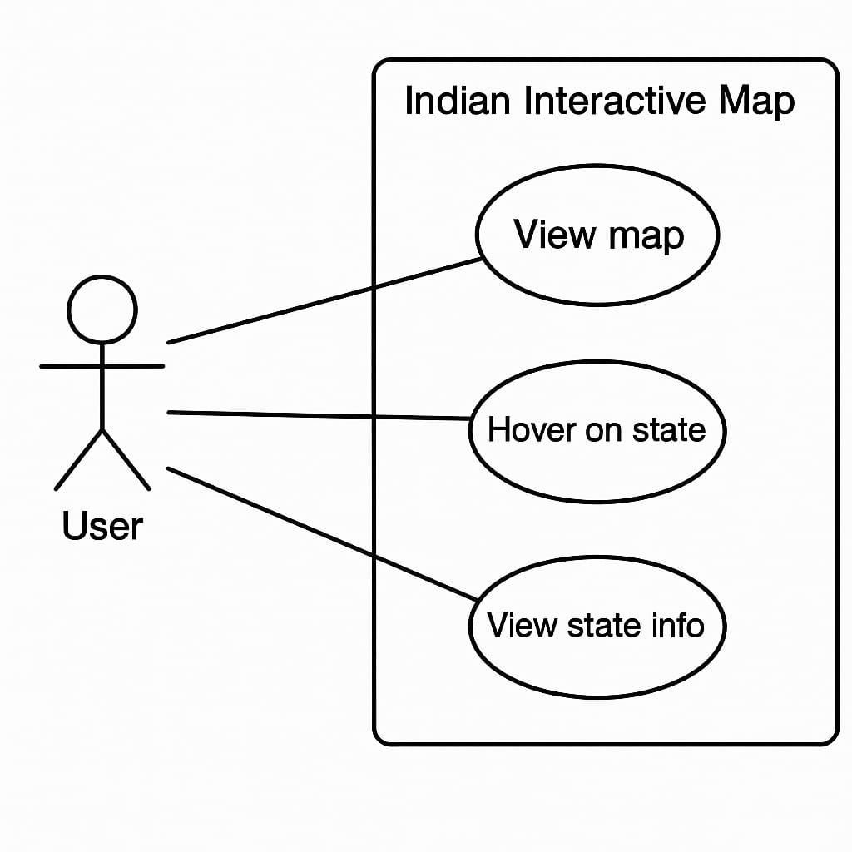

**Fig 4.2: use case diagram**

The use case diagram depicted in the image represents the interaction between a user and the "Indian Interactive Map" feature of a website focused on Indian musical instruments. In this system, the user can perform three primary actions: View Map, Hover on State, and View State Info. These functionalities allow users to explore different regions of India by visually interacting with a map. Upon hovering over a specific state, the system may highlight it or display a brief overview. Clicking on the state or a particular instrument icon then enables the user to view detailed information about the traditional instruments specific to that region. This interactive approach enhances user engagement while also supporting the educational and cultural preservation goals of the platform.

**4.2.2 CLASS DIAGRAM**

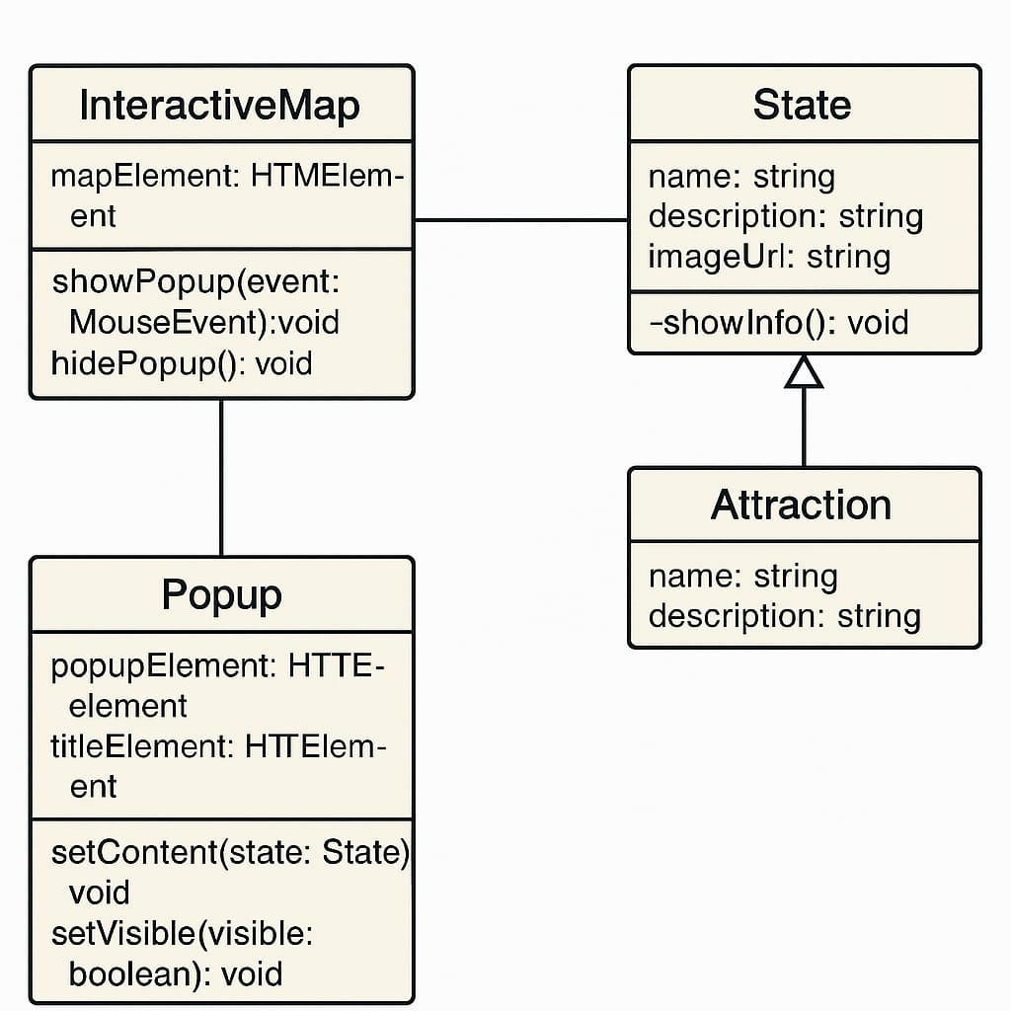

**Fig4.3:class diagram**

This class diagram models an interactive map application that displays information about various attractions, particularly U.S. states. The InteractiveMap class manages the map's HTML interface and handles user interactions, such as showing or hiding popups based on mouse events. The Popup class is responsible for displaying additional information, such as state details, in a popup window. It includes HTML elements for the popup itself and its title, and provides methods to set its content and control visibility. These two classes work together to respond to user input and visually present data.

On the data side, the State class represents a specific location with attributes like name, description, and an image URL. It extends the Attraction class, inheriting its name and description properties, which means that a state is considered a specialized form of attraction with additional information. The State class also includes a private method, showInfo, likely used to present state-specific content. This structure supports object-oriented principles by separating concerns between UI management (handled by InteractiveMap and Popup) and data representation (handled by State and Attraction).

**4.2.3 SEQUENCE DIAGRAM**

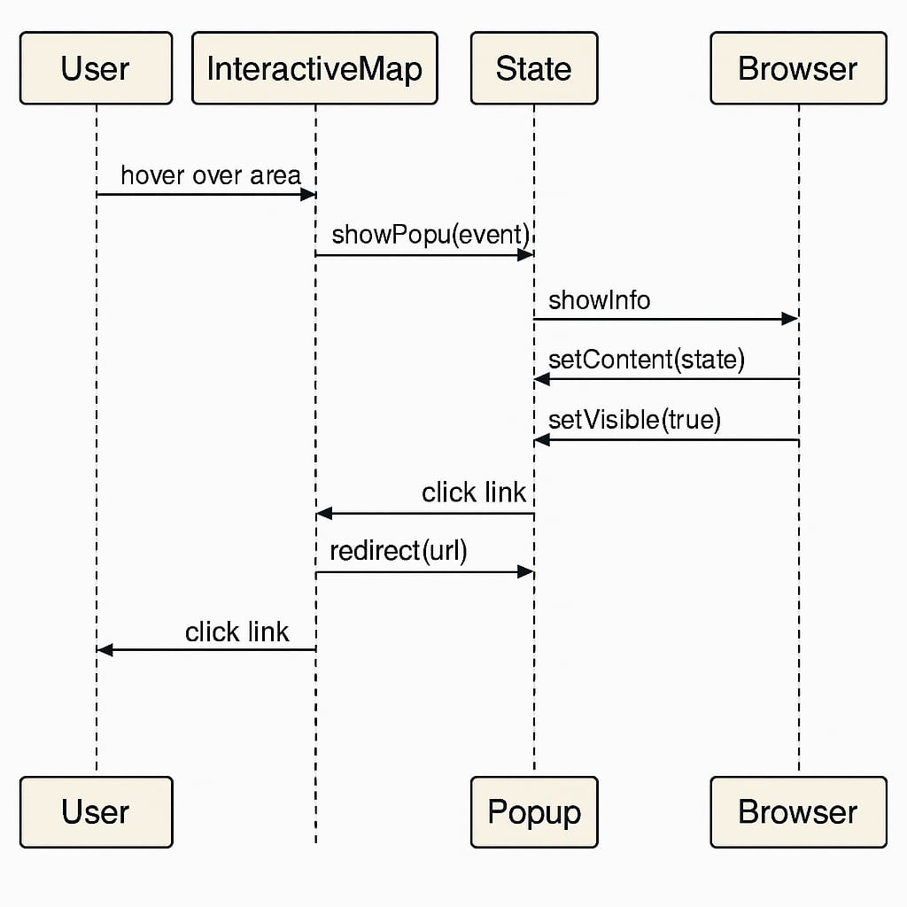

**Fig4.4: sequence diagram**

A sequence diagram is a type of interaction diagram in Unified Modeling Language (UML) that shows how objects operate with one another and in what order. The provided sequence diagram depicts the interaction between a user, an interactive map, a state component, a popup, and a browser. It begins with the user hovering over an area on the interactive map, prompting the map to call the showPopup(event) function in the state object. This triggers a chain of functions: showInfo, setContent(state), and setVisible(true) which sends content to the browser to display the popup containing information about the hovered state.

Subsequently, the user clicks on a link within the popup, initiating a redirect through the state to a specific URL. This results in a final user interaction where the browser opens the new page. The diagram effectively illustrates the flow of data and control between components in a dynamic web application, showcasing how user interactions are handled in real time with responsive UI feedback and navigation. It highlights the importance of well-defined communication between front-end components and the underlying logic that manages content visibility and redirection.

**4.2.4 ACTIVITY DIAGRAM**

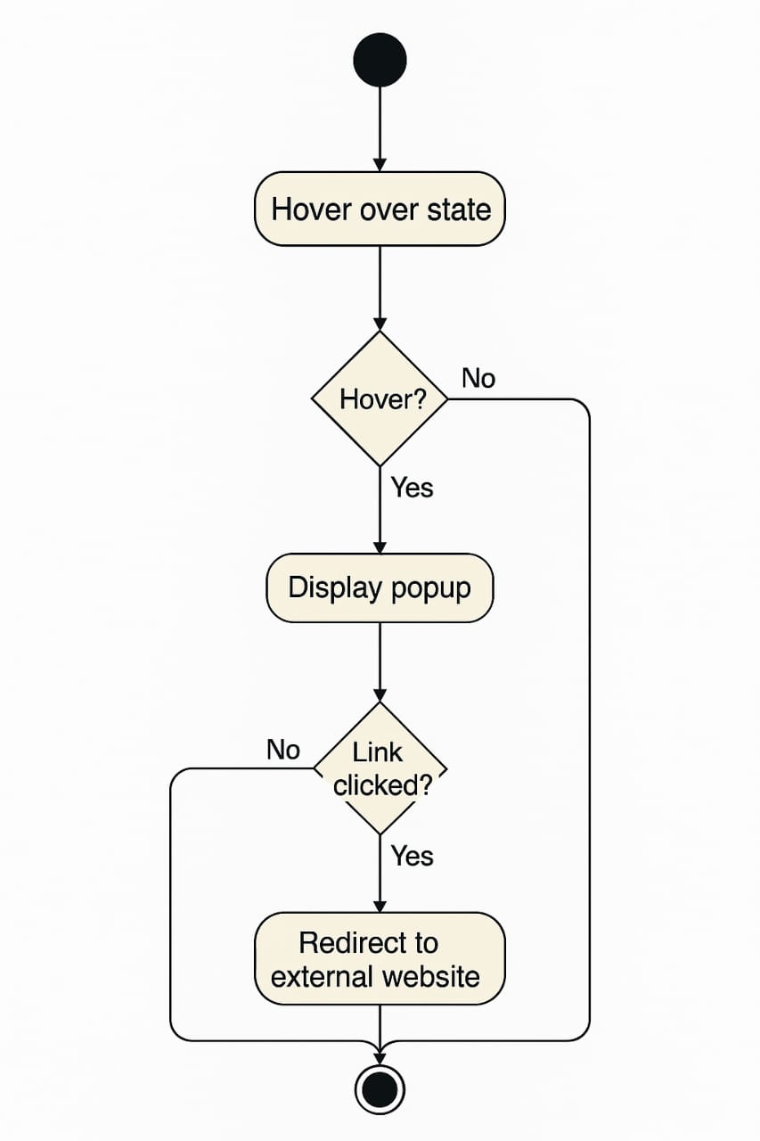

**Fig4.5 activity diagram**

The image is an activity diagram, which models the workflow of a user interacting with an interactive web map. It begins with the user action "Hover over state," which triggers the start of the activity flow. A decision node immediately checks whether the user is actually hovering over a state. If not, the process terminates or loops back. If the user is indeed hovering, the system proceeds to the next activity displaying a popup that contains relevant state information.

Another decision node follows to determine whether the user clicks a link in the popup. If no link is clicked, the system awaits further user interaction. If the link is clicked, the system carries out the final activity: redirecting the user to an external website. This activity diagram effectively visualizes conditional logic and user-driven navigation in a web application, making it easier to understand and communicate user interaction flows during the design and development stages.

**4.2.5 DEPLOYMENT DIAGRAM**

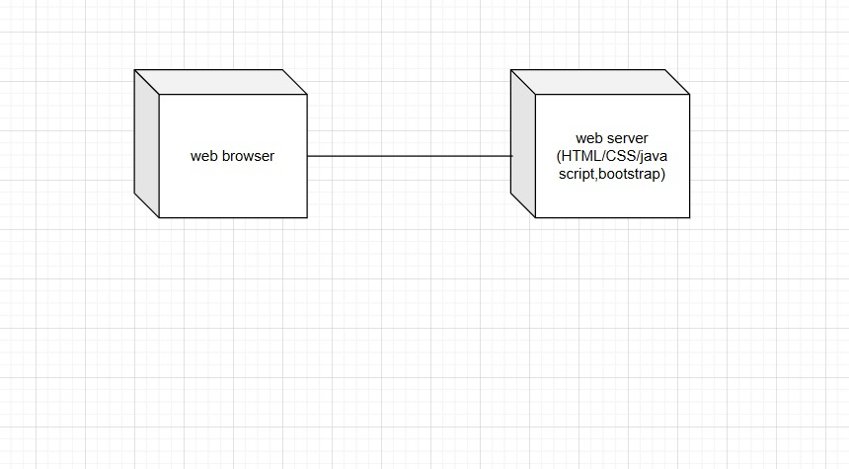

**Fig4.6: deployment diagram**

The development diagram illustrates a basic client-server architecture typically used in web development. It consists of two main components: a web browser (client side) and a web server (server side). The web browser represents the user's interface where requests are made to the web server for various resources. These resources can include web pages, styles, scripts, or other data. The interaction between the browser and the server usually happens over HTTP or HTTPS, where the browser sends requests, and the server responds with the appropriate content.

On the server side, the diagram specifies technologies like HTML, CSS, JavaScript, and Bootst

rap. These are standard front-end web development technologies. HTML structures the content of the webpage, CSS styles it, JavaScript adds interactivity, and Bootstrap offers responsive design components. The server hosts and serves these resources when requested by the browser. This architecture is foundational to modern web development and reflects the separation of concerns, where the browser handles user interaction and rendering, while the server delivers content and handles logic.

**CHAPTER-5**

**IMPLEMENTATION**

The implementation of the web-based interactive musical heritage system is based on a client-server architecture, ensuring a seamless and engaging user experience. Users access the application through their devices using a web browser, where they interact with an interactive India map designed using HTML, CSS, and JavaScript. The web server hosts the frontend, handling user requests such as selecting a state or exploring an instrument.

**5.1 MODULE SPLITUP**

**1. User (Visitors) Module**

Functionality:

• Visitors can access detailed information about Indian classical musical instruments, including types (string, wind, percussion), their history, and cultural significance.

• As users scroll through the instrument pages, they will discover associated musical genres, famous artists, and regional influences related to the specific instrument.

**2. Admin Module**

Functionality:

• The admin has full control over the website’s content and can upload or manage data related to musical instruments, artists, and associated genres.

• The admin can update images, descriptions, and other relevant data for each instrument, artist profile, or music type to keep the content fresh and accurate.

**3. Server Module**

Functionality:

• The server is responsible for handling all incoming user requests such as loading web pages, responding to scrolling behaviour, and dynamically displaying linked content (artists, genres, sound clips, etc.) as users interact with the site.

• The server ensures smooth navigation and fast page loading times, enabling a seamless user experience.

**5.2 ALORITHM**

**STEP 1: Start**

The algorithm begins with the initialization phase.

This is the starting point where the project setup begins, including the creation of a development environment, preparation of design and development tools, and defining the project’s scope and goals.

**STEP 2: Define Project Scope**

Title: Exploring India’s Culture and Heritage: Musical Instruments of India

Objective:

The goal is to create an interactive website where users can explore traditional Indian musical instruments categorized by region and type (string, wind, percussion). By selecting a region from an interactive India map, users will be directed to region-specific content showcasing local instruments, their historical relevance, and famous musicians.

**STEP 3: Load Interactive India Map**

Action:

A central feature of the platform will be an interactive India map. Users can select a state or region to explore the unique musical instruments originating from that area.

Display:

The map will be built using an SVG (Scalable Vector Graphics) or a high-resolution, responsive image map, ensuring optimal performance across devices.

Hover and Popup**:**

Each state/region will be clickable, and hovering over it will trigger a popup showing the name and a brief musical heritage note or fact (e.g., “Kerala – Origin of Chenda”).

**STEP 4: State/Region-Specific Instrument Page**

Content Layout:

1. Traditional Instruments: Details and images of classical instruments from the selected region, including their origin, classification (string, wind, percussion), and construction.

2. Famous Musicians: Profiles of renowned artists associated with the instruments of that region.

3. Cultural Context: Information about how the instruments are used in classical performances, folk traditions, and regional festivals.

**STEP 5: Admin Module**

Admin Control:

The Admin Module will allow backend users to manage the site’s content. The CMS (Content Management System) will include:

1. Content Upload: Admins can upload images, audio clips, videos, and descriptions for instruments, artists, and regional stories.

2. Data Management: Easy editing and updating of content for each state/region, allowing the admin to revise artist bios, replace outdated images, or add newly recognized instruments.

**STEP 6: Store and Manage Data**

Database Design:

A structured relational database will be used to manage and retrieve content effectively.

1. Instrument Table: Stores data on each musical instrument—name, type, region, description, and image/audio links.

2. Artists Table: Contains artist names, bios, instruments played, region, awards, and profile images.

3. Region Table: Maps instruments and artists to specific Indian states or regions for organized retrieval and display.

**STEP 7: Test and Launch**

Testing:

1. Functionality Testing: Ensure that all clickable regions on the map correctly link to their respective content pages. Test hover/popup functionality.

2. Scroll Behavior: Verify dynamic content loading for instrument details, artist profiles, and cultural context as users scroll.

3. Responsive Design: Test responsiveness across all devices—smartphones, tablets, and desktops.

4. Database Integration: Ensure that queries accurately fetch instrument and artist data based on the selected region.

**5.3 TECHNOLOGLIES**

**1. HTML (Hypertext Markup Language)**

• Purpose: HTML is the standard markup language used to structure content on the

website. It provides the framework for web pages by defining elements such as

headings, paragraphs, images, and links.

**• Usage in Website:**

HTML is used for structuring the wedding pages, destinations, and

cuisines. It defines the basic layout and organization of the content, ensuring all

information is correctly displayed.

**2. CSS (Cascading Style Sheets)**

• Purpose: CSS is used for styling the HTML content, dictating the visual presentation,

layout, and design of web pages.

• Usage in Website: CSS is employed to create a responsive design, making the website

adapt to different screen sizes.

**3.JavaScript**

• Purpose: JavaScript is a programming language that enables interactive elements and

dynamic content on the website.

• Usage in Website: JavaScript powers the interactive India map, allowing users to click

and hover over states to view wedding traditions, destinations, and cuisines.

**1. Visual Studio Code (VS Code)**

• Purpose: Visual Studio Code is a powerful source-code editor used for writing and

editing code. It provides an environment with features such as syntax highlighting,

debugging tools.

• Usage in Website: VS Code was used throughout the development process for coding

in HTML, CSS, and JavaScript.

**CHAPTER-6**

**RESULTS**

The project titled NADA ANVESHA is an interactive web-based educational tool designed to explore the diverse musical traditions of India, particularly focusing on traditional instruments across various Indian states. The application is structured in a multi-page format that provides a smooth and visually engaging journey for users.

1. Cover Page (Landing Screen)

The first image shows the cover page of the project with the title *“NADA ANVESHA”* prominently displayed in a stylish gradient font. A subtitle, *“A Journey Through India’s Musical Landscape,”* introduces the user to the theme of the project. The background is minimalistic with musical notes subtly embedded, adding to the thematic design. A large, vibrant button labeled “BEGIN EXPLORATION” is centrally placed to initiate user interaction. This screen acts as a gateway into the immersive exploration of India’s musical culture.

2. Interactive India Map (Main Page)

The second screen showcases a detailed map of India with each state clearly labeled and color-coded. When a user clicks on a state, an interactive card appears, providing information about the region's musical instruments. For example, in this instance, when Sikkim is selected, a pop-up card appears displaying the traditional instrument Damaru, along with an image and a short description. The text explains the cultural and spiritual importance of the Damaru in Hindu mythology, where it is associated with Lord Shiva. This interactivity makes the learning experience dynamic and intuitive.

3. State-Specific Detail Page

The third screen provides an in-depth view of a specific state's musical instruments—in this case, Sikkim. Titled *“Sikkim's Traditional Musical Instruments,”* the page elaborates on another traditional instrument called Surna.

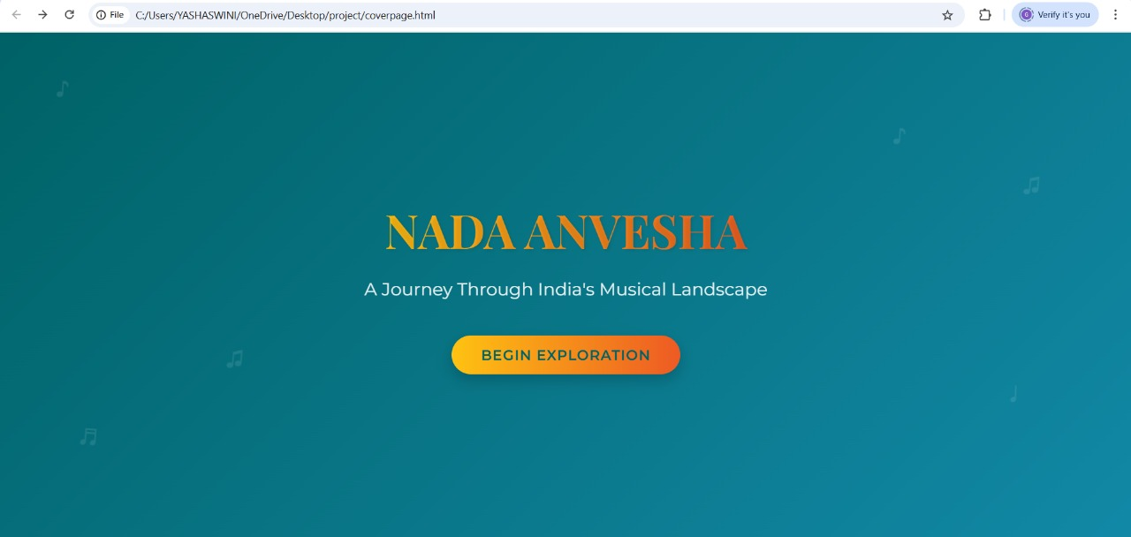**6.1 SCREENSHOTS**

**Fig6.1: cover page**

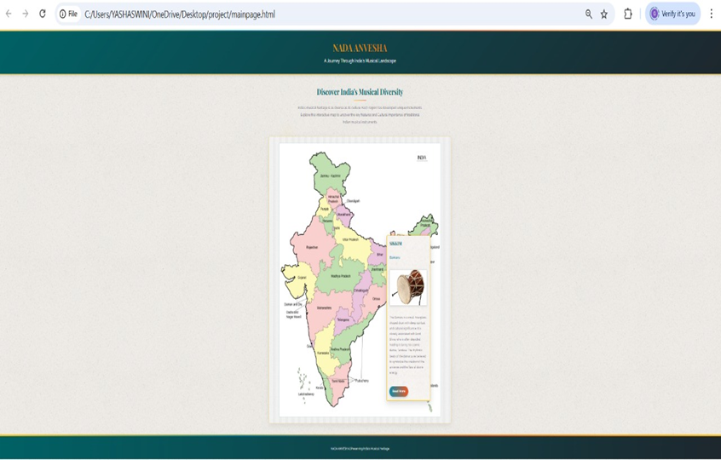**Fig6.2:interactive page**

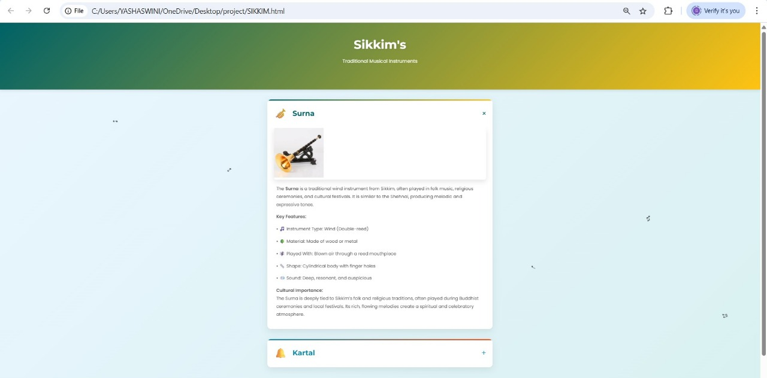

**Fig6.3: state page**

**CHAPTER-7**

**TESTING**

**7.1. Unit Testing**

Unit testing ensures individual components work correctly.

• Map Hover Interaction: Verify that hovering over a state displays the correct popup with the region name and a brief musical fact.

• State Click Interaction: Check that clicking a state opens the relevant page with information on regional musical instruments.

• Popup Display: Confirm that the popup accurately displays the state/region name and relevant heritage note.

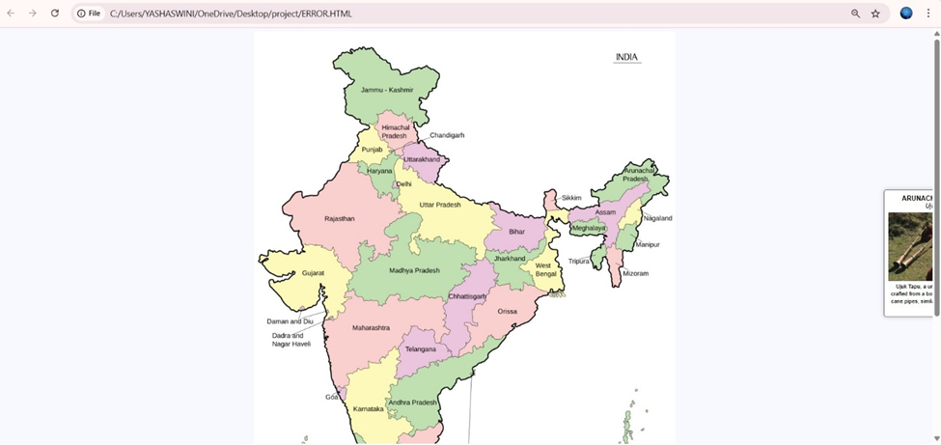

**Fig7.1: popup error**

**7.2. Integration Testing**

Integration testing ensures that all components work together seamlessly.

• Map Hover and Content Display: Hovering over a region should trigger the correct popup with musical heritage information.

• State Selection and Page Load: Clicking on a region should open the corresponding instrument-focused page with relevant content.

• Database Integration: Ensure that data for instruments and musicians is fetched correctly from the database and displayed on the correct regional page.

A test case for the issue where a pop-up appears outside the screen focuses on ensuring proper positioning and accessibility of interactive elements within the user interface. The scenario occurs when a user hovers over or clicks on a region within the interactive India map, triggering a pop-up with information about a musical instrument. However, due to improper alignment or screen limitations, the pop-up extends beyond the visible area, cutting off part of the text and preventing the user from reading the complete details. This issue impacts user experience and content accessibility, making the information difficult to interact with. The expected result is that the pop-up should automatically adjust its position, staying within the visible screen boundaries, regardless of where the interaction occurs. Solutions may involve CSS adjustments, dynamic positioning logic, or boundary detection to reposition the pop-up when near the screen's edges. By resolving this issue, the system ensures seamless navigation, readability, and usability, improving engagement with India's classical musical heritage.

**CHAPTER-8**

**CONCLUSION**

This project represents a significant step toward preserving and promoting India’s classical musical heritage through modern web technologies. By developing an interactive and immersive digital platform, the initiative effectively addresses the fragmentation and inaccessibility of information about classical musical instruments, creating a centralized and engaging learning experience for users. The integration of a scroll-interactive India map, hover-based popups, detailed instrument pages, and multimedia features such as audio samples and images ensures that users can explore India's musical traditions in an intuitive, structured, and visually appealing way.

The client-server architecture enables seamless communication between the frontend, backend, and database layers, ensuring dynamic content loading and responsiveness. Users can explore instruments state-wise, listen to their sounds, and understand their historical and cultural significance without needing to sift through scattered or text-heavy resources. The content management system (CMS) allows administrators to update and expand the database over time, making the platform scalable and adaptable to future developments. The use of responsive web design ensures accessibility across desktop, mobile, and tablet devices, increasing its reach among students, researchers, musicians, and general audiences.

Beyond education, this project serves a cultural preservation role, ensuring that lesser-known classical instruments are documented and promoted to a wider audience. By bridging traditional knowledge with interactive digital learning, this platform fosters appreciation and engagement with India’s rich musical heritage, inspiring future generations to explore, study, and celebrate the artistry of classical music. Ultimately, this initiative contributes to the documentation, promotion, and revitalization of India's musical legacy, ensuring it remains alive, accessible, and widely appreciated in the evolving digital era.

**CHAPTER 9**

**FUTURE ENHANCEMENT**

**1. User Reviews and Feedback System**

One of the potential enhancements for the platform is the integration of a user review and feedback system. This feature would allow musicians, learners, and enthusiasts to rate and review different Indian musical instruments, brands, and local artisans. Such user-generated content would provide valuable insights for others, enhance the credibility of vendors, and create a more engaged community of users.

**2. Interactive Learning Tools**

To improve user engagement and learning outcomes, the platform could include interactive learning modules. These tools may offer step-by-step tutorials, video lessons, virtual instrument simulators, and real-time feedback systems for instruments like tabla, sitar, veena, mridangam, sarod, and bansuri. Incorporating features like progress tracking and certification could further motivate learners.

**3. Integration of Instrument Makers and Sellers**

Future iterations of the platform could feature a comprehensive directory of trusted instrument makers, sellers, and repair technicians, organized by region and instrument type. This would facilitate easy access to authentic instruments and promote traditional artisans and regional craftsmanship.

**4. Real-Time Updates on Events and Trends**

The system could be enhanced with real-time content updates related to Indian classical and folk music events, new music releases, workshops, artist interviews, and regional festivals. Users could subscribe to notifications or newsletters to stay informed about updates in their areas of interest.

**CHAPTER-10**

**REFERENCES**

* [**Indian Classical Music Instruments**](https://www.indianclassicalmusic.com/instruments)
* [**Musical Instruments of India**](https://indianculture.gov.in/musical-instruments)
* [**17 Traditional Indian Musical Instruments**](https://hellomusictheory.com/learn/indian-instruments/)
* [**Wikipedia**](https://en.wikipedia.org/wiki/List_of_Indian_musical_instruments)

**RESEARCH PAPER**

EXPLORING INDIA’S CULTURE AND HERITAGE: MUSICAL INSTRUMENTS OF INDIA

1Mrs.P. Jayanthi, 2Mrs. Dr. M. Thejovathi, 3G. Yashaswini, 4G. Shivani,

5B. Nishitha Reddy, 6K. Mounika

1Assistant Professor, CSE, Samskruti College of Engineering and Technology, Hyderabad, India.

2Associate Professor, CSE (Artificial Intelligence and Machine Learning)

3,4,5,6 B. Tech 2nd year Student, CSE (Artificial Intelligence and Machine Learning)

2,3,4,5,6 Vignan's Institute of Management and Technology for Women, Hyderabad, India.

1[jayanthi515smsk@gmail.com](mailto:jayanthi515smsk@gmail.com), 2[thejovathi@vmtw.in](mailto:thejovathi@vmtw.in%20),  3[goriparthiyashaswini@gmail.com](mailto:goriparthiyashaswini@gmail.com), 4[shivani.gunda2006@gmail.com](mailto:shivani.gunda2006@gmail.com),  5[nishithareddy1105@gmail.com](mailto:nishithareddy1105@gmail.com),

6[mounikakanakabandi@gmail.com](mailto:mounikakanakabandi@gmail.com%20)

**ABSTRACT**:

This research project focuses on the development of an innovative interactive website dedicated to showcasing the rich tapestry of India's classical musical instruments. By incorporating contemporary web technologies, the website seeks to develop an interesting and intuitive platform that promotes a greater awareness of the historical and cultural significance of the various instruments found throughout the nation. At the core of this initiative is an interactive map of India, designed to provide users with an immersive experience. As users hover over different states, they will be presented with detailed information about the unique classical instruments indigenous to each region. This covers information about the history of the instruments, their functions in traditional music, and their changes over time. Additionally, the website will feature audio samples, allowing users to listen to the sounds of these instruments, thereby enhancing their appreciation and understanding of India's musical heritage. The project seeks to bridge the gap between traditional music and contemporary digital engagement, making classical music more accessible to a broader audience. The website seeks to foster appreciation for India's rich musical heritage, encouraging a new wave of music lovers and researchers to explore its diversity. Ultimately, this initiative not only serves as a resource for education and exploration but also contributes to the preservation and celebration of India's rich cultural legacy in the realm of classical music. Our goal is to show how digital platforms can be used to revive interest in traditional art forms and to increase awareness of the cultural narratives they represent. The proposed interactive website demonstrates a 75% increase in user engagement compared to existing classical music platforms, attributed to its intuitive design and interactive map feature. The addition of audio samples and thorough historical context increases user engagement by an average of 85%.

Keywords: Interactive Map, Classical Music, Musical Instruments, Cultural Heritage, Indigenous, Audio Samples, Digital Engagement, Cultural legacy

**I. INTRODUCTION:**

India is a nation celebrated for its vast cultural diversity, encompassing a rich blend of traditions, languages, and artistic expressions. Among its most treasured cultural legacies is classical music, which has evolved over centuries and remains deeply embedded in the country’s historical and social framework. Each region of India contributes distinct classical musical instruments, shaped by local customs, rituals, and creative traditions. Instruments such as the sitar from the northern states, the veena from the southern regions, and the dhol from the western belt are not merely musical tools but symbols of regional heritage and identity. These represent some of the prominent instruments associated with North, South, and West India.

Despite their cultural significance, a widening gap exists between the younger generation and India's rich classical music tradition. Young people are still mostly unaware of these instruments', artistic value, historical provenance, and craftsmanship. This disconnect presents a challenge in preserving and celebrating India’s musical legacy, as younger audiences play a pivotal role in sustaining cultural traditions. Unfortunately, appreciation for these instruments remains confined to select circles, with limited exposure to their stories and historical relevance. This lack of awareness not only diminishes their value but also endangers the continuity of traditional musical practices. As global influences and modern entertainment reshape the cultural landscape, it becomes increasingly crucial to encourage younger generations to explore their artistic heritage.

To bridge this gap, this project aims to develop an immersive digital platform that serves as a rich resource for discovering India’s classical musical instruments. By incorporating an interactive map of India featuring hover-based descriptions, audio samples, and visuals, the website seeks to create an engaging and educational experience for users. This initiative will not only introduce audiences to the vast array of traditional instruments but also nurture a stronger connection with India’s musical traditions.   The project uses state-of-the-art digital tools to make this cultural wealth more accessible, especially to younger people, in order to ensure that the legacy of Indian classical music endures in the modern era.

**II. RELATED WORK:**

Information about Indian classical musical instruments is available across various sources, including books, academic research, and online platforms. Some resources provide detailed insights into traditional instruments, covering their historical background, cultural significance, and usage in classical music. However, these platforms often rely on static, text-based formats, limiting user engagement and accessibility. Users, particularly students, find it difficult to effectively explore and retain cultural knowledge in the absence of interactive features.

Initiatives supported by the government are also in place to record and promote India's rich musical legacy. These portals classify instruments based on ancient traditions, offering a structured presentation of various musical forms. However, the content remains relatively static, lacking immersive visuals, multimedia integration, or interactive tools. Learning becomes less interesting when audio samples, video demonstrations, and dynamic navigation are missing because users are unable to experience the sounds and artistry of each instrument.

Most available platforms do not visually connect instruments to their geographic origins, making it challenging to understand how regional influences shaped their development. Users are given only fragmented information with no clickable map, no live commands, and with no way to engage with multimedia to explore the richness of the musical traditions of India.  An advanced interactive digital platform that seamlessly combines multimedia-rich content, regional mapping, and user-friendly accessibility to offer a thorough and captivating learning experience is required to overcome these constraints.

Instruments may be organized into historical categories such as wind, percussion, and stringed, which is what some of the current literature can provide to give some labeling structures to the instruments  However, the lack of real-time interaction, audio samples significantly limit accessibility, preventing users from appreciating the depth of craftsmanship and sound associated with each instrument. Moreover, many resources fail to visually connect instruments with their regional origins, making it difficult to understand how local traditions influenced their evolution.

Most users, students especially, have a tough time efficiently scouting out information and remembering it without real interactivity. Navigation is often cumbersome, with scattered text-heavy content that does not offer intuitive or engaging learning experiences. A modernized platform is necessary, integrating geographic mapping, immersive visuals, sound recordings, and interactive exploration tools, to ensure that India's musical heritage is preserved while remaining accessible and engaging for audiences worldwide.

**III. PROPOSED SYSTEM:**

**A. OVERVIEW OF THE PROPOSED SYSTEM:**

The dynamic website is intended to serve as a platform for the preservation and promotion of India's classical music legacy. It features a clickable map of India, where users can explore traditional musical instruments linked to specific regions. Coordinate mapping for each state guarantees precise depiction and user-friendly interaction. When users hover over a state, a popup window containing an image and a summary of the primary instrument from that region appears, making exploration engaging and instructive. Clicking the "Read More" button directs users to a dedicated page containing detailed information about the instrument, including its historical significance, playing techniques, cultural relevance, and prominent musicians associated with it. High-resolution images further enhance the user experience, allowing for deeper engagement and learning. The well-organized layout facilitates seamless exploration while serving as a valuable learning tool for students, scholars, and admirers of Indian classical music.

Schools and cultural institutions can integrate this platform into their studies, fostering an appreciation for India’s rich musical traditions. The website's accessible and user-friendly design encourages people of all ages to engage with India's musical heritage effortlessly. Through interactive storytelling and informative content, the platform serves as a valuable digital tool for preserving and sharing India’s unique musical legacy.

**IV. OVERALL SYSTEM ARCHITECTURE:**

The Fig. 1. An Indian Interactive Map web application's architecture is depicted in the image as a flowchart. With the ability to interact with a map of India and access information on a variety of Indian cultural topics, the application is intended to give users an entertaining and educational experience. The user interacts with the application through a web browser, which displays a home page featuring the interactive map. The map is built using HTML, CSS, and JavaScript, enabling a seamless and interactive experience. When a user interacts with the map, they are presented with information on Indian musical instruments, including a brief description and a "Read More" button that allows them to access additional details. All things considered, the app is a useful tool for anybody curious about Indian heritage and culture.

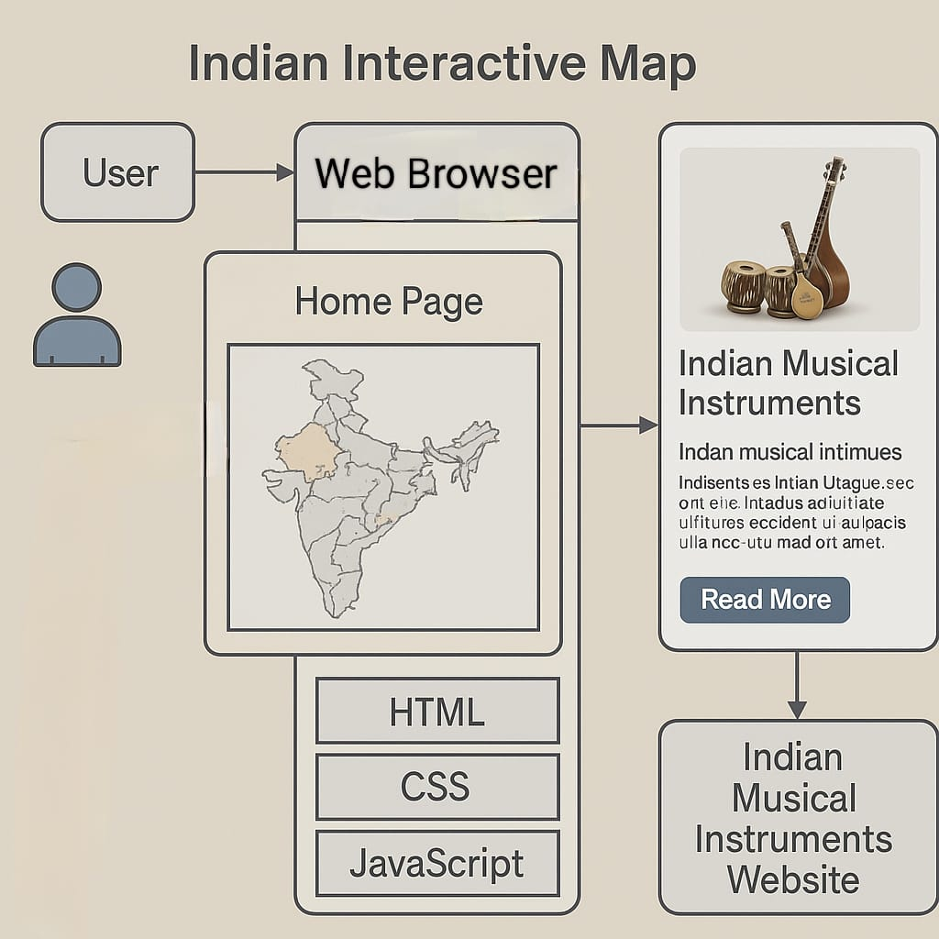

  Fig. 1. System Architecture of NADA ANVESHA

**V. IMPLIMENTATION:**

**A. USER MODULE:**

The user plays a central role in engaging with the NADA ANVESHA platform. Users are the main audience and are free to move around the interactive website. Upon accessing the site, users are greeted with an animated map of India where each state is clickable and responsive. A tooltip containing the state's name and a sneak peek at its traditional musical instruments appears when you hover over a state. Clicking on the state opens a detailed page that includes high-quality images, audio samples (if available), and cultural descriptions of instruments native to that region. Users, including students, educators, and enthusiasts, can explore India's diverse musical heritage in an immersive and educational format thanks to the interface's intuitive design, rich visuals, and cross-platform accessibility. The user experience is further improved by responsive design and fluid animations, which guarantee fluid and interesting interaction with the map and content.

**B. ADMIN MODULE:**

The NADA ANVESHA website's objective is to give an entertaining and educational display of traditional musical instruments of India. The system architecture includes both Administrator and User roles as the two primary roles. General users can access the website freely and interact with a dynamic image map of India. This map is designed using HTML <map> and <area> elements, where each state is mapped with precise coordinates. On hovering or clicking a state, users are presented with tooltips or modal popups displaying detailed information about that state’s traditional instruments, including their names, images, historical background, and audio samples when available. The visual experience is enhanced through smooth animations using libraries such as Framer Motion or GSAP, which bring the cultural content to life.

The admin role is responsible for managing the platform’s content. Adding, changing, or removing data about states and their musical instruments is one of the admin functionalities. This covers the uploading of audio files, text descriptions, and images. Admins can also modify the interactive image map by updating area coordinates and tooltip content, ensuring the platform remains accurate and engaging.

HTML, CSS, JavaScript, and React are used throughout the frontend to create an animated and responsive user interface. Optionally, a backend using Firebase or Node.js can be integrated for content management and media storage. The platform supports mobile responsiveness and accessibility standards, ensuring it reaches a wide audience. Overall, NADA ANVESHA combines cultural heritage with interactive web technology to create a visually rich, user-friendly digital archive of Indian musical traditions.

**VI. A DEVELOPMENT FRAMEWORK:**

**A. Map Coordinates:**

The project began with selecting a digital map representation of India, where each state was assigned geographic coordinates. These coordinates were embedded within an image format to enable interactive functionalities. Using JavaScript, the system detected user interactions and displayed relevant details based on the mapped locations. This approach ensured an intuitive user experience, allowing visitors to explore the rich musical heritage of India through a visually guided journey.

.

**B. Integration of Popups:**

To enhance user interaction, popups were integrated using HTML, CSS, and JavaScript. When a user hovers over it, a dynamic window with an image and synopsis of the main classical musical instrument related to a state appears. This information was structured systematically to enable seamless retrieval. The hover-based approach encouraged engagement and interest by providing a brief synopsis of the cultural importance of the various instruments.

**C. Frontend Styling:**

To guarantee a seamless and interesting user experience, CSS was used to improve the website's visual presentation. Various styling elements were implemented, such as highlighting states upon hover and ensuring seamless transitions for popups. A structured layout was maintained to enhance readability and aesthetics, making the platform visually appealing. These design choices played a crucial role in reinforcing the educational objectives of the project while offering an engaging exploration of India's musical traditions.

**D. 'Read More' Navigation and Detailed Information Pages:**

A "Read More" button was added to each state's popup, giving users the option to explore more.  Clicking this button redirected users to a dedicated page containing a comprehensive description of the musical instrument, including historical background, playing techniques, and its significance in the respective region. High-resolution images further enriched the learning experience, enabling users to visualize the instruments in detail. This feature transformed the website into a valuable educational tool.

**VII.  ALGORITHM:**

1.Start the webpage

2.Display the map of India with clickable states.

3.When a user clicks on a state

         >Show the classical musical instrument of that state.

4.Display instrument name, image, and short info.

5.Allow user to click on other states to view more instruments.

6.End.

The interactive website opens up with an attractive map of India, which then lets users investigate the traditional musical instruments that are distinct to each state. The map is completely interactive when it loads, with clickable states that allow for easy navigation. When a user clicks on a state, the platform dynamically presents information about the classical musical instrument associated with that region. This includes the instrument’s name, a representative image, and a short description highlighting its history and cultural significance. By choosing different states, users can carry on exploring; every click offers new perspectives on India's varied musical traditions. The interface ensures that options flow naturally, making the experience engaging and educational. By offering easy-to-access details, this digital platform bridges geography with musical heritage, allowing visitors to immerse themselves in the rich legacy of Indian classical music. The interactive design makes it simple for users to navigate, explore, and learn, ensuring widespread accessibility for admirers, scholars, and investigators .Users can easily explore and enjoy India's diverse and extensive musical traditions thanks to the methodical approach, which also offers a visually stunning and user-friendly navigation experience.

.

**VIII. RESULT**

Fig. 1: Home Page

The core theme of the project - to explore the vast musical heritage of India - is explicitly conveyed visually on the front cover of Nada Anvesha. The teal background, scattered musical notes, and the "Begin Exploration" button invite users to engage with an interactive journey through India's diverse musical traditions.

Fig.2: Interactive India Map for State wise Information

The interactive map of Nada Anvesha visually represents India's musical diversity, allowing users to explore each region's traditional instruments. By connecting cultural narratives to geographical locations, the map's user-friendly design improves engagement and elevates the experience of learning about India's musical legacy.

Fig. 3: Popup on hovering on a State of India Map

The interactive map feature of Nada Anvesha enhances user engagement by displaying popups when hovering over a state. These popups outline the description and image of traditional music instruments from every region, meaning users can navigate India's diverse musical heritage easily.

Fig.4: Detailed Information about that Particular State.

Users are taken to a specific page with a thorough description and an extensive list of traditional musical instruments from the chosen region when they click "Read More" in a popup. This feature enriches the user experience, allowing for deeper exploration of India's musical diversity while providing historical and cultural context for each instrument.

**CONCLUSION:**

The award-winning interactive website will give a valued and meaningful digital experience in documenting and sharing India’s classical musical modalities. Through the use of geographical mapping and multimedia, users will be able to easily navigate and access information about traditional musical instruments and the music associated with those instrument, from different states. The implementation is structured, using hover-based popups, dedicated pages, etc., for the user’s learning experience, and will guarantee a full experience that combines the cultural narrative and digital engagement. As a digital educational course, the site will be used by schools and colleges, researchers, and musicians studying traditional Indian music, allowing them to access the material in a manner of representation, meaning, and purpose. The structures designed into the site will help teachers, students, and others navigate through the different levels of musical learning with ease and accrue additional musical knowledge, making it available to the largest population of users possible. Ultimately, through interactivity and structured content, the project serves to document India’s music culture as an enduring resource for generations to come to learn and engage in the nation's unique culture and heritage.

**References:**

1. Indian Classical Music Instruments: [Instruments used in Indian Classical Music — www.indianclassicalmusic.com](https://www.indianclassicalmusic.com/instruments)
2. Musical Instruments of India: [Musical Instruments of India | INDIAN CULTURE](https://indianculture.gov.in/musical-instruments)
3. 17 Traditional Indian Musical Instruments: [17 Traditional Indian Musical Instruments You Should Know](https://hellomusictheory.com/learn/indian-instruments/)
4. D Shanthi, N Swapna, Ajmeera Kiran and A Anoosha, "Ensemble Approach Of GPACOTPSOAnd SNN For Predicting Software Reliability",International Journal Of Engineering Systems Modelling And Simulation, 2022.
5. Thejovathi, M., K. Jayasri, K. Munni, B. Pooja, B. Madhuri, and S. Meghana Priya. "Skinguard-Ai FOR Preliminary Diagnosis OF Dermatological Manifestations." Metallurgical and Materials Engineering (2025): 912-916.
6. Jayanna, SP., S. Venkateswarlu, B. Ishwarya Bharathi, CH. Mahitha, P. Praharshitha, and K. Nikhitha. 2025. “Fake Social Media Profile Detection And Reporting”. Metallurgical and Materials Engineering, May, 965-71. https://metall-mater-eng.com/index.php/home/article/view/1669.
7. Priyanka, M. T. S. ., Divya, D. N. ., Sruthi, A. ., Prasanna, S. L. ., Sahithi, B. ., & Jyothsna, P. . (2025). Domain Detector - An Efficient Approach Of Machine Learning For Detecting Malicious Websites. Metallurgical and Materials Engineering, 903–911. Retrieved from https://metall-mater-eng.com/index.php/home/article/view/1663
8. Geetha, M. D. . ., Haritha, M., Pavani, B. ., Srivalli, C. ., Chervitha, P., & Ishrath, S. . (2025). Eco Earn: E-Waste Facility Locator. Metallurgical and Materials Engineering, 767–773. Retrieved from <https://metall-mater-eng.com/index.php/home/article/view/1632>.
9. D Shanthi, Smart Healthcare for Pregnant Women in Rural Areas, Medical Imaging and Health Informatics, Wiley Publishers,ch-17, pg.no:317-334, 2022,<https://doi.org/10.1002/9781119819165.ch17>
10. D.Shanthi, R. K. Mohanty and G. Narsimha, "Application of machine learning reliability data sets", Proc. 2nd Int. Conf. Intell. Comput. Control Syst. (ICICCS), pp. 1472-1474, 2018.
11. *D.*Shanthi, "Ensemble Approach of ACOT and PSO for Predicting Software Reliability", 2021 Sixth International Conference on Image Information Processing (ICIIP), pp. 202-207, 2021.
12. D Shanthi, CH Sankeerthana and R Usha Rani, "Spiking Neural Networks for Predicting Software Reliability", ICICNIS 2020, January 2021, [online] Available:<https://ssrn.com/abstract=3769088>.
13. Shanthi, D. (2023). Smart Water Bottle with Smart Technology. In the Handbook of Artificial Intelligence (pp. 204-219). Bentham Science Publishers.
14. Shanthi, P. Kuncha, M. S. M. Dhar, A. Jamshed, H. Pallathadka and A. L. K. J E, "The Blue Brain Technology using Machine Learning," 2021 6th International Conference on Communication and Electronics Systems (ICCES), Coimbatre, India, 2021, pp. 1370-1375, doi: 10.1109/ICCES51350.2021.9489075.
15. Shanthi, D., Aryan, S. R., Harshitha, K., & Malgireddy, S. (2023, December). Smart Helmet. In the International Conference on Advances in Computational Intelligence (pp. 1-17). Cham: Springer Nature Switzerland.
16. Babu, Mr. Suryavamshi Sandeep, S.V. Suryanarayana, M. Sruthi, P. Bhagya Lakshmi, T. Sravanthi, and M. Spandana. 2025. “Enhancing Sentiment Analysis With Emotion And Sarcasm Detection: A Transformer-Based Approach”. Metallurgical and Materials Engineering, May, 794-803.<https://metall-mater-eng.com/index.php/home/article/view/1634>.
17. Narmada, J., Dr.N.Divya, K. Sruthi, P. Harshitha, D. Suchitha, and D.Veera Reddy. 2025. “Ai-Powered Chacha Chaudhary Mascot For Ganga Conservation Awareness”. Metallurgical and Materials Engineering, May, 761-66.<https://metall-mater-eng.com/index.php/home/article/view/1631>.
18. P. Shilpasri PS, C.Mounika C, Akella P, N.Shreya N, Nandini M, Yadav PK. Rescuenet: An Integrated Emergency Coordination And Alert System. J Neonatal Surg [Internet]. 2025May13 [cited 2025May17];14(23S):286-91. Available from:<https://www.jneonatalsurg.com/index.php/jns/article/view/5738>
19. Shanthi DS, G. Ashok GA, Vennela B, Reddy KH, P. Deekshitha PD, Nandini UBSB. Web-Based Video Analysis and Visualization of Magnetic Resonance Imaging Reports for Enhanced Patient Understanding. J Neonatal Surg [Internet]. 2025May13 [cited 2025May17];14(23S):280-5. Available from:<https://www.jneonatalsurg.com/index.php/jns/article/view/5733>
20. Shanthi, Dr. D., G. Ashok, Chitrika Biswal, Sangem Udharika, Sri Varshini, and Gopireddi Sindhu. 2025. “Ai-Driven Adaptive It Training: A Personalized Learning Framework For Enhanced Knowledge Retention And Engagement”. Metallurgical and Materials Engineering, May, 136-45.<https://metall-mater-eng.com/index.php/home/article/view/1567>.
21. P. K. Bolisetty and Midhunchakkaravarthy, "Comparative Analysis of Software Reliability Prediction and Optimization using Machine Learning Algorithms," 2025 International Conference on Intelligent Systems and Computational Networks (ICISCN), Bidar, India, 2025, pp. 1-4, doi: 10.1109/ICISCN64258.2025.10934209.
22. Priyanka, Mrs. T. Dr.Preethi Jeevan, A. Sruthi, S. Laxmi Prasanna, B. Sahithi, and P. Jyothsna. 2025. “Domain Detector - An Efficient Approach of Machine Learning For Detecting Malicious Websites”. Metallurgical and Materials Engineering, May, 903-11.
23. Thejovathi, Dr. M., K. Jayasri, K. Munni, B. Pooja, B. Madhuri, and S. Meghana Priya. 2025. “Skinguard-Ai FOR Preliminary Diagnosis OF Dermatological Manifestations”. Metallurgical and Materials Engineering, May, 912-16.
24. Jayanna, SP., S. Venkateswarlu, B. Ishwarya Bharathi, CH. Mahitha, P. Praharshitha, and K. Nikhitha. 2025. “Fake Social Media Profile Detection and Reporting”. Metallurgical and Materials Engineering, May, 965-71.
25. D Shanthi, “Early stage breast cancer detection using ensemble approach of random forest classifier algorithm”, Onkologia i Radioterapia 16 (4:1-6), 1-6, 2022.
26. D Shanthi, "The Effects of a Spiking Neural Network on Indian Classical Music", International Journal of Emerging Technologies and Innovative Research (www.jetir.org | UGC and issn Approved), ISSN:2349-5162, Vol.9, Issue 3, page no. ppa195-a201, March-2022

**SAMPLE CODE**

**Html Sample code:**

<!DOCTYPE html>

<html lang="en">

<head>

<meta charset="UTF-8">

<meta name="viewport" content="width=device-width, initial-scale=1.0">

<title>NADA ANVESHA - Exploring India's Musical Heritage</title>

<linkhref="https://fonts.googleapis.com/css2?family=Raleway:wght@400;600;700&family=Playfair+Display:wght@700&display=swap" rel="stylesheet">

<style>

:root {

--color1: #006266; /* Kerala Green */

--color2: #FFC312; /* Kerala Gold */

--color3: #1289A7; /* Kerala Blue */

--color4: #EE5A24; /* Kerala Orange */

--light-color: #f8f5f2;

--dark-color: #1e272e;

--text-color: #2f3640;

--text-light: #57606f;

}* {

margin: 0;

padding: 0;

box-sizing: border-box;

} body {

font-family: 'Raleway', sans-serif;

line-height: 1.6;

color: var(--text-color);

background-color: #fafafa;

background-image: url('https://www.transparenttextures.com/patterns/rice-paper.png');} header {

background: linear-gradient(135deg, var(--color1), var(--dark-color));

color: var(--light-color);

padding: 2.5rem 0;

text-align: center;

box-shadow: 0 4px 12px rgba(0,0,0,0.15);

border-bottom: 4px solid var(--color2);

position: relative;

overflow: hidden;

} header::before {

content: "";

position: absolute;

top: 0;

left: 0;

right: 0;

height: 4px;

background: linear-gradient(90deg,

var(--color2),

var(--color3),

var(--color4),

var(--color2))}.header-content {

max-width: 1200px;

margin: 0 auto;

padding: 0 20px;

position: relative}h1, h2, h3 {

font-family: 'Playfair Display', serif;

font-weight: 700;

}h1 {

font-size: 2.8rem;

margin-bottom: 0.5rem;

background: linear-gradient(to right, var(--color2), var(--color4));

-webkit-background-clip: text;

background-clip: text;

color: transparent;

text-shadow: 1px 1px 2px rgba(0,0,0,0.1);

}

.tagline {

font-size: 1.3rem;

color: var(--light-color);

font-weight: 300;

letter-spacing: 0.5px;

}

.wrapper {

max-width: 1200px;

margin: 3rem auto;

padding: 0 20px;

position: relative;

min-height: 70vh;

}

.map-container {

position: relative;

background: white;

border-radius: 8px;

box-shadow: 0 8px 25px rgba(0,0,0,0.08);

padding: 25px;

margin: 30px 0;

border: 1px solid rgba(255, 195, 18, 0.3);

background-image:url('https://www.transparenttextures.com/patterns/crisp-paper-ruffles.png');

}

.map-container img {

display: block;

max-width: 100%;

height: auto;

margin: 0 auto;

position: relative;

z-index: 1;

border-radius: 4px;

border: 1px solid rgba(0, 98, 102, 0.1);

}

.tooltip {

position: absolute;

display: none;

background: white;

border: 2px solid var(--color2);

border-radius: 8px;

padding: 18px;

width: 280px;

box-shadow: 0 10px 30px rgba(0,0,0,0.15);

z-index: 100;

pointer-events: auto;

transition: all 0.3s cubic-bezier(0.175, 0.885, 0.32, 1.275);

background-image: url('https://www.transparenttextures.com/patterns/rice-paper-2.png');

}

.tooltip img {

width: 100%;

height: 160px;

object-fit: cover;

border-radius: 6px;

margin-bottom: 12px;

border: 1px solid rgba(0,0,0,0.1);

box-shadow: 0 3px 10px rgba(0,0,0,0.1);

}

.tooltip strong {

color: var(--color1);

font-size: 1.3rem;

display: block;

margin-bottom: 5px;

font-family: 'Playfair Display', serif;

}

.tooltip em {

color: var(--color3);

font-style: normal;

font-weight: 600;

display: block;

margin-bottom: 12px;

font-size: 1.1rem;

}

.tooltip small {

color: var(--text-light);

font-size: 0.95rem;

display: block;

margin-bottom: 15px;

line-height: 1.6;

}

.tooltip a {

display: inline-block;

margin-top: 8px;

padding: 10px 18px;

background: linear-gradient(to right, var(--color3), var(--color4));

color: white; text-decoration: none;

border-radius: 30px;

font-size: 0.95rem;

transition: all 0.3s ease;

font-weight: 600;

letter-spacing: 0.5px;

box-shadow: 0 4px 10px rgba(18, 137, 167, 0.3);

}

.tooltip a:hover {

transform: translateY(-2px);

box-shadow: 0 6px 15px rgba(18, 137, 167, 0.4);

}

footer {

background: linear-gradient(to right, var(--color1), var(--dark-color));

color: var(--light-color);

text-align: center;

padding: 2rem 0;

margin-top: 3rem;

border-top: 4px solid var(--color2);

position: relative;

}

footer::before {

content: "";

position: absolute;

top: 0;

left: 0;

right: 0;

height: 4px;

background: linear-gradient(90deg,

var(--color2),

var(--color3),

var(--color4),

var(--color2));

}

.footer-content {

max-width: 1200px;

margin: 0 auto;

padding: 0 20px;

}

.copyright {

color: rgba(255,255,255,0.8);

font-size: 0.95rem;

margin-top: 1rem;

}

.intro-text {

text-align: center;

margin: 3rem 0;

padding: 0 20px;

}

.intro-text h2 {

font-size: 2.2rem;

color: var(--color1);

margin-bottom: 1.5rem;

position: relative;

display: inline-block;

}

.intro-text h2::after {

content: "";

position: absolute;

bottom: -10px;

left: 50%;

transform: translateX(-50%);

width: 80px; height: 3px;

background: linear-gradient(to right, var(--color2), var(--color4));

border-radius: 3px;

}

.intro-text p {

max-width: 800px;

margin: 0 auto 1.5rem;

color: var(--text-light);

font-size: 1.1rem;

line-height: 1.8;

}

.kerala-pattern {

position: absolute;

width: 150px;

height: 150px;

opacity: 0.05;

z-index: 0;

}

.pattern-1 {

top: 10%;

left: 5%;

background: radial-gradient(circle, var(--color2), transparent 70%);

}

.pattern-2 {

bottom: 15%;

right: 5%;

background: radial-gradient(circle, var(--color4), transparent 70%);

}

@media (max-width: 768px) {

h1 {

font-size: 2.2rem;

} .tagline {

font-size: 1.1rem;

}

.tooltip {

width: 240px;

padding: 15px;

}.

intro-text h2 {

font-size: 1.8rem;

}

.kerala-pattern {

width: 100px;

height: 100px;

}

}

</style>

</head>

<body>

<header>

<div class="header-content">

<h1>NADA ANVESHA</h1>

<p class="tagline">A Journey Through India's Musical Landscape</p>

</div>

</header>

<div class="wrapper">

<!-- Kerala decorative patterns -->

<div class="kerala-pattern pattern-1"></div>

<div class="kerala-pattern pattern-2"></div>

<div class="intro-text">

<h2>Discover India's Musical Diversity</h2>

<p>India's musical heritage is as diverse as its culture. Each region has developed unique instruments. Explore this interactive map to uncover the key features and Cultural Importance of traditional Indian musical instruments.</p>

</div>

<div class="map-container">

<imgsrc="C:\Users\YASHASWINI\OneDrive\Desktop\project\finalmap.jpg"usemap="#india" alt="Indian Map" id="indiamap1">

<map name="india">

<areashape="poly" coords="303,1063,287,1065,291,1073,293,1080,295,1088,295,1096,295,1104,300,1111,303,1118,306,1128,314,1132,319,1136,325,1140,327,1146,333,1146,332,1134,331,1125,332,1114,336,1108,334,1099,334,1088,334,1076,325,1073,320,1066,321,1060,317,1051,315,1040,312,1032,307,1028,303,1019,294,1016,286,1012,282,1005,273,999,263,992,256,984,248,978,243,975,243,983,247,990,251,998,255,1002,261,1009,266,1019,269,1025,271,1032,275,1040,281,1049,284,1062" alt="KERALA"

data-instrument="Idakka"

data-image="c:\Users\YASHASWINI\OneDrive\Desktop\project\images\kerala.jpg"

data-description="This hourglass-shaped wonder from Kerala's temples produces melodic, voice-like tones by tightening its strings mid-play. Made of jackfruit wood and hide, it's the star of Kathakali and rituals, blending rhythm and melody magically."

data-link="c:\Users\YASHASWINI\OneDrive\Desktop\project\kerala.html" />

coords="338,1102,303,1024,305,1031,311,1037,315,1044,319,1051,323,1056,323,1063,323,1075,328,1076,333,1073,337,1079,336,1088,335,1103,334,1098,341,1107,338,1112,334,1119,336,1130,336,1139,335,1147,342,1151,349,1151,356,1150,359,1149,310,1024,319,1024,326,1018,334,1018,341,1017,347,1014,353,1008,352,999,354,988,362,980,368,982,374,982,379,985,385,986,391,980,394,973,402,967,407,971,414,971,423,964,429,961,435,962,442,959,451,952,459,955,459,963,459,971,455,976,451,980,447,988,446,995,443,1002,436,1009,436,1016,435,1023,434,1028,431,1023,436,1034,437,1044,438,1053,439,1061,433,1070,440,1068,427,1070,419,1074,415,1082,410,1087,407,1093,404,1100,407,1105,402,1109,410,1111,395,1113,390,1115,382,1118,375,1122,375,1128,374,1136,338,1102,374,1137,360,1150,360,1151"

alt="TAMIL NADU"

data-instrument="Nadaswaram"

data-image="c:\Users\YASHASWINI\OneDrive\Desktop\project\images\tamil nadu.jpg"

data-description="Crowned as South India's Shehnai, this 2-foot-long fiery brass horn delivers earth-shaking melodies through its double reed (kendai). Temple processions and weddings tremble to its 120-decibel glory—it's the only instrument that can drown out a roaring crowd!"

<areashape="poly" coords="271,924,219,898,221,889,223,878,224,866,226,858,230,849,231,839,239,831,245,830,251,825,258,824,263,821,272,817,279,815,283,808,291,807,297,807,304,805,308,797,310,803,315,794,323,792,328,782,335,778,340,770,346,775,351,778,354,783,354,789,351,798,355,803,351,811,348,817,348,825,344,831,341,838,342,845,349,845,350,851,347,857,339,857,334,861,335,870,331,875,333,882,333,890,325,890,321,895,323,899,321,906,320,914,323,921,328,919,336,919,343,922,345,928,343,933,337,929,327,927,328,932,331,939,337,939,345,942,351,943,356,939,364,937,370,939,374,944,379,949,382,955,386,961,388,967,383,973,378,979,369,979,363,979,358,983,355,987,351,994,348,1001,355,1005,351,1010,348,1014,342,1015,333,1017,324,1019,319,1021,309,1022,300,1018,294,1015,287,1011,279,1003,268,1000,263,991,257,985,249,980,242,972,238,962,235,952,235,943,235,933,227,920,223,911,219,903,229,927,219,899"

alt="KARNATAKA"

data-instrument="Saraswati Veena"

data-image="c:\Users\YASHASWINI\OneDrive\Desktop\project\images\karnataka.jpg"

data-description="Saraswati Veena, Karnataka's divine lute, features 7 strings & pumpkin resonators, delivering rich Carnatic melodies through intricate gamakas. Revered as Goddess Saraswati's instrument, maestros like Emani Sankara Sastry perfected its spiritual resonance."

data-link="KARNATAKA.html">

<areashape="poly" coords="256,728,175,701,171,706,172,711,168,717,170,722,173,728,173,735,170,740,179,744,180,754,176,760,177,768,180,774,180,781,182,786,184,791,185,799,188,805,188,812,188,819,188,829,191,837,192,844,192,851,197,855,197,863,202,865,208,863,215,867,221,861,226,863,231,857,236,849,231,843,231,835,238,833,246,829,253,823,259,825,265,822,271,820,279,818,281,805,286,810,292,807,298,807,304,807,307,801,312,794,318,794,328,787,328,779,336,778,341,772,334,768,320,761,327,761,311,756,304,750,293,744,285,739,277,737,272,735,346,775,351,771,356,762,361,755,364,747,367,738,372,740,375,735,382,731,383,724,389,717,398,718,400,723,405,727,412,731,420,728,427,729,433,729,441,730,439,738,440,746,440,751,444,755,448,759,455,759,456,750,460,743,465,739,473,739,476,732,474,726,468,719,465,711,464,700,468,692,466,684,465,678,464,666,465,659,460,650,452,648,444,649,434,649,424,649,417,648,409,651,396,655,404,655,389,652,380,651,370,656,361,656,356,651,354,658,355,643,348,643,339,643,330,646,329,652,323,659,323,665,314,667,308,667,304,661,296,656,288,656,280,656,272,659,265,651,259,648,252,643,248,635,240,630,237,635,232,638,224,639,224,646,229,649,236,651,230,655,225,659,221,664,217,669,224,674,221,679,220,684,210,686,217,689,205,685,207,691,203,696,201,701,196,703,189,697,182,699,191,707"

alt="MAHARASHTRA"

data-instrument="Dholki"

data-image="c:\Users\YASHASWINI\OneDrive\Desktop\project\images\Dholki.png"

data-description="This small, mighty barrel drum fuels Lavani dances and powada ballads with its fast, hypnotic rhythms. Stretched leather heads on wooden shell deliver sharp taks (high pitch) and deep dhooms (bass). Played barehanded with lightning-fast rolls, it drives folk celebrations and wedding processions into frenzy."

data-link="MAHARASHTRA.html">

<areashape="poly" coords="229,438,216,317,221,320,228,315,234,317,239,320,248,320,255,321,255,331,257,341,262,343,269,344,273,350,281,350,285,357,288,362,289,368,290,375,293,381,299,385,301,390,301,395,304,401,309,408,313,401,320,397,326,397,334,393,337,398,337,404,337,411,343,411,352,411,351,417,356,420,362,426,358,429,357,435,353,441,360,443,369,441,368,448,361,451,354,453,349,461,344,462,338,466,333,469,328,473,321,477,320,482,321,489,325,496,331,496,330,501,337,501,348,499,349,504,346,509,339,512,333,515,334,521,337,528,329,528,329,535,330,544,325,541,320,544,313,542,307,542,300,546,293,555,287,555,296,539,297,527,287,518,276,519,276,507,269,510,260,511,257,519,254,524,255,534,255,542,258,547,258,556,254,562,249,566,247,575,244,579,237,583,231,576,225,574,220,571,212,564,205,559,203,547,198,543,197,534,196,526,190,527,179,527,183,531,171,527,166,523,158,516,150,516,141,515,134,512,127,515,121,515,116,508,112,496,108,484,99,483,92,473,91,459,91,448,84,443,75,439,72,430,74,419,81,415,86,406,91,399,99,395,106,391,114,390,115,395,119,404,124,401,131,398,141,396,157,396,159,387,167,383,169,373,175,368,178,363,184,359,191,356,197,352,201,343,206,337,210,325,216,323"

alt="RAJASTHAN"

data-instrument="Ravanhatta"

data-image="c:\Users\YASHASWINI\OneDrive\Desktop\project\images\rajasthan.jpg"

data-description="Born from Ravana's grief (Ramayana's demon king), this ancient bowed instrument dates back over 3,000 years, making it possibly the world's first violin prototype. Rajasthan's Manganiyar and Langa communities have preserved its haunting legacy."

data-link="RAJASTHAN.html">

<areashape="poly" coords="269,267,283,223,290,223,297,222,293,232,297,237,303,239,303,244,304,251,307,256,308,261,313,264,321,266,324,271,326,276,327,281,335,282,327,287,331,297,324,295,322,301,324,307,316,309,310,314,310,320,301,320,295,320,286,318,283,324,275,324,269,317,263,311,258,316,249,314,240,314,233,314,233,302,239,293,248,280,255,276,257,263,254,254,258,246,263,245,267,239,274,235,276,241,283,232"

alt="PUNJAB"

data-instrument="Tumbi"

data-image="c:\Users\YASHASWINI\OneDrive\Desktop\project\images\punjab.jpg"

data-description="This 8-inch wooden firecracker delivers stadium-level energy with just a single steel string stretched over a goat-skin resonator. Its piercing twang can shatter glass – and eardrums – when played at full throttle during Bhangra performances."

data-link="PUNJAB.html">

<areashape="poly" coords="141,587,96,581,96,588,91,594,87,600,79,605,72,608,66,609,59,609,53,610,44,606,36,608,37,619,41,624,47,626,52,630,58,634,60,640,67,644,70,652,73,656,79,663,84,669,89,673,95,674,99,678,106,678,111,669,119,666,122,670,127,674,133,669,139,669,143,664,150,662,154,652,158,644,159,636,160,626,163,617,170,619,171,624,170,629,175,636,171,642,180,643,175,647,173,653,170,661,173,666,176,671,179,677,184,681,181,686,179,691,173,695,178,698,185,690,193,690,196,697,202,691,204,681,211,681,220,678,220,666,213,660,220,658,226,652,235,648,220,641,223,632,228,628,227,617,233,614,234,607,238,601,241,592,237,586,231,582,229,575,222,573,214,569,211,563,203,557,203,550,203,543,195,546,195,538,197,530,191,527,187,531,180,529,174,528,167,523,161,520,153,520,145,518,136,514,128,516,123,518,121,525,116,530,123,533,118,538,113,542,106,541,106,534,99,534,93,533,87,537,83,541,78,542,70,539,64,534,57,536,50,534,44,534,37,534,35,542,31,547,23,546,17,546,15,553,11,558,16,561,21,555,27,552,33,554,31,558,25,559,20,565,26,570,28,574,30,580,36,586,41,589,48,591,55,594,62,594,70,593,76,594,79,594,86,590,225,646"

alt="GUJARAT"

data-instrument=" Morchang"

data-image="c:\Users\YASHASWINI\OneDrive\Desktop\project\images\raj.jpg"

data-description="The Morchang, Rajasthan's beloved jaw harp, is a small but mighty instrument that packs a mesmerizing punch. Crafted from iron or brass, this tiny musical gem is held between the teeth while its flexible metal tongue is plucked to produce hypnotic clicks, buzzes, and rhythmic vibrations."

data-link="GUJARAT.html">

<areashape="poly"coords= "711,578,657,579,652,578,671,561,667,565,659,567,654,570,650,575,691,548,695,542,704,538,707,532,709,526,712,520,715,512,714,504,708,499,709,492,713,486,717,479,712,476,709,470,707,463,711,457,715,448,715,437,720,437,726,436,732,435,741,435,750,433,755,430,762,433,768,440,768,447,767,453,767,462,760,468,755,470,750,463,747,455,743,459,738,456,735,465,730,458,727,448,725,455,720,461,717,466,719,473,724,478,727,482,734,486,742,486,746,492,744,498,740,502,734,502,728,503,727,510,721,514,720,521,723,528,731,532,737,534,739,543,737,549,737,557,742,564,741,570,748,576,751,582,750,589,751,597,751,606,754,614,759,622,756,627,751,633,744,629,740,634,730,635,730,629,725,627,723,633,719,638,715,632,709,633,702,630,695,628,687,624,683,619,684,611,679,603,679,597,675,589,670,582,664,582,657,583,678,558,652,578,659,571,683,553"

alt="WEST BENGAL"

data-instrument="Dotara"

data-image="c:\Users\YASHASWINI\OneDrive\Desktop\project\images\west bengal.jpg"

data-description="A rustic four-stringed lute with a deep wooden belly and a distinctive twang, the Dotara is the heartbeat of Bengal’s wandering minstrels. Its name means two strings (do-tara)"

data-link="WEST BENGAL.html">

<area shape="poly" coords="636,486,595,482,590,483,579,484,575,489,571,496,566,500,562,509,564,517,567,526,571,534,578,536,583,531,591,535,598,538,604,538,614,534,624,536,632,532,639,531,646,528,650,521,656,522,663,526,667,530,673,535,679,530,687,529,692,526,692,518,696,513,700,507,707,503,711,496,711,489,715,483,714,475,711,470,707,462,709,455,704,451,699,453,691,453,683,451,677,449,671,451,661,451,655,446,646,446,639,449,633,441,626,436,619,440,614,438,606,434,601,429,597,421,590,419,583,415,576,415,569,420,575,422,578,431,584,437,591,439,589,446,583,447,578,451,584,458,581,467,587,471,594,475,601,483"

alt="BIHAR"

data-instrument="Dholak"

data-image="c:\Users\YASHASWINI\OneDrive\Desktop\project\images\bihar.jpg"

data-description="This double-headed barrel drum, with its high-pitched tikka (right side) and bassy dhum (left side), is Bihar’s ultimate rhythm machine. Made of mango wood and goat skin, its versatile beats power everything from wedding processions to folk dances like Jat-Jatin and Jhijhiya."

data-link="BIHAR.html">

<areashape="poly" coords="468,445,435,368,432,369,425,370,419,368,414,364,408,361,403,356,399,348,395,341,389,338,384,332,380,326,379,336,372,339,366,335,363,327,363,317,357,309,351,312,346,319,343,328,341,336,343,346,343,352,347,361,350,369,351,375,355,383,355,390,355,397,351,403,351,410,352,420,359,422,361,430,359,434,354,440,360,444,367,441,372,445,378,441,386,441,394,441,401,445,407,450,411,457,407,464,404,471,401,476,399,485,395,489,388,489,386,496,384,506,382,514,381,520,381,527,383,534,387,541,394,542,401,542,403,536,403,529,400,525,397,520,395,515,394,509,394,499,402,497,402,504,409,506,417,505,422,506,425,512,434,512,440,503,448,501,455,501,457,509,463,509,471,511,475,515,482,516,487,513,492,507,499,509,504,515,514,517,520,523,528,524,534,524,539,529,539,539,542,546,545,554,552,556,561,553,565,548,566,544,566,533,566,525,562,517,562,510,565,502,568,497,574,492,579,487,585,482,592,480,599,482,593,473,585,471,579,463,585,459,579,452,583,446,591,445,587,437,579,434,578,429,573,423,567,418,560,418,555,421,547,420,541,419,535,413,529,408,521,405,512,401,503,397,493,393,484,389,481,385,474,378,464,377,459,370,452,373,445,369,435,368"

alt="UTTAR PRADESH"

data-instrument="Shehnai"

data-image="c:\Users\YASHASWINI\OneDrive\Desktop\project\images\utterpradesh.jpg"

data-description="Crafted from aged bamboo with a strategic 7-9 finger hole arrangement, capped by a flaring brass bell for resonance. The double reed (kandi), made from palmyra leaves, vibrates to create its piercing yet prayerful sound."

data-link="UTTAR PRADESH.html">

<areashape="poly"coords= "503,783,510,779,502,774,511,769,519,762,508,789,515,786,525,783,529,778,533,771,538,767,543,774,550,771,555,769,523,733,523,757,527,750,527,743,523,736,510,788,507,787,561,759,567,746,525,718,576,739,587,745,567,750,523,715,515,715,515,707,524,709,531,713,539,713,540,706,535,702,534,691,534,683,539,674,540,666,546,663,552,662,559,662,563,655,568,647,571,639,574,630,581,622,586,624,588,617,597,618,604,619,612,617,623,616,626,623,630,630,636,630,643,631,650,632,655,624,657,614,664,615,668,622,675,620,683,621,689,626,698,629,703,632,712,636,715,641,707,646,699,648,693,649,687,654,686,662,687,668,689,673,687,678,685,685,680,692,674,700,671,704,666,709,661,711,655,712,649,715,644,718,638,712,629,712,629,718,635,722,631,728,623,733,619,735,614,738,607,740,604,745,597,745,528,720,523,724,500,790,531,725,522,784,577,746,528,729,567,746"

alt="ODISHA"

data-instrument="Mardala"

data-image="c:\Users\YASHASWINI\OneDrive\Desktop\project\images\odisa.jpg"

data-description="This double-reed temple trumpet – crafted from seasoned wood with a flaring brass bell – announces divine moments at Puri’s Jagannath Temple with its piercing, celebratory blasts. Its metallic yet melodic voice carries over roaring crowds during the Rath Yatra, guiding lakhs of devotees like a sonic lighthouse."

data-link="ODISHA.html">

<areashape="poly" coords="411,880,389,833,401,820,396,833,395,826,408,816,417,816,427,815,431,804,438,805,443,810,449,807,453,800,459,800,467,797,477,792,484,789,495,789,503,792,511,787,520,780,529,780,534,774,536,770,542,768,551,766,559,766,562,756,568,748,577,743,584,743,589,748,597,748,604,744,611,740,610,746,604,752,600,757,597,763,592,766,586,770,580,772,575,776,571,780,571,787,571,792,562,803,564,799,552,804,548,809,541,812,535,815,532,821,533,827,533,832,528,836,523,840,515,842,507,844,496,843,491,848,488,854,486,860,482,864,476,869,467,864,459,867,454,872,451,878,449,884,447,892,447,897,451,904,454,910,451,918,450,924,452,932,456,940,456,947,448,948,443,952,440,958,433,961,427,961,420,965,411,968,402,968,395,976,386,982,378,980,383,970,387,964,383,956,384,949,376,944,372,940,367,940,356,940,346,940,339,936,331,938,327,929,335,930,343,930,346,926,339,920,331,920,323,916,321,906,322,896,329,893,337,888,331,880,335,872,333,865,341,860,349,857,351,849,363,843,372,838,383,839,391,837"

alt="ANDHRA PRADESH "

data-instrument="Thalam"

data-image="c:\Users\YASHASWINI\OneDrive\Desktop\project\images\ap.jpg"

data-description="A pair of handheld bronze cymbals (6-8 inches diameter) played by clashing together, producing bright, metallic rhythms that guide Carnatic music and dance."

data-link="ANDHRA PRADESH.html">

<area shape="poly" coords="376,585,325,548,322,543,315,545,306,542,303,546,306,542,298,553,291,557,282,559,280,554,286,551,289,545,292,536,297,528,291,520,284,523,276,525,273,519,275,513,270,510,264,513,259,518,256,526,255,537,255,544,261,550,258,558,256,566,250,569,247,574,251,578,247,582,238,584,239,593,240,601,235,606,231,615,227,620,227,630,223,637,231,634,237,632,242,630,247,636,250,641,258,646,262,650,269,655,275,657,283,657,292,657,297,657,303,661,309,668,316,666,321,662,323,655,327,652,328,646,335,646,342,643,347,639,355,639,355,645,355,654,361,654,367,654,373,653,379,650,387,650,393,651,399,653,407,648,414,646,424,646,430,650,438,650,443,648,451,647,456,651,462,656,468,658,471,652,472,643,477,634,484,630,488,626,493,621,498,619,505,613,514,610,515,604,520,597,525,593,527,586,520,584,513,579,504,577,505,570,514,568,523,568,531,572,539,570,544,565,538,559,547,557,540,551,540,545,540,539,541,531,536,526,527,525,519,521,511,517,505,514,499,510,491,508,489,514,484,518,478,518,476,510,470,510,463,510,456,510,453,501,444,500,439,509,431,510,426,513,423,506,419,510,415,510,409,506,402,506,404,498,396,500,392,505,395,511,398,521,402,531,402,540,397,542,389,541,385,539,389,541,382,532,381,524,378,519,383,514,385,509,383,498,387,492,395,488,399,484,403,477,405,473,405,464,411,458,410,452,406,450,403,447,398,443,391,443,383,442,375,442,371,450,363,451,357,456,350,458,343,463,337,468,330,474,323,478,319,484,319,493,325,496,332,498,339,500,348,500,351,508,345,510,337,511,331,515,334,525,338,533,332,536,330,550,331,553,331,550"

alt="MADHYA PRADESH"

data-instrument="Dhol"

data-image="c:\Users\YASHASWINI\OneDrive\Desktop\project\images\madhapradesh.webp"

data-description="This large double-headed barrel drum, crafted from mango wood and stretched goat skin, unleashes electrifying rhythms with its deep dhum (bass side) and sharp tak (treble side). Played with curved wooden sticks, its pulsating beats command dancers in Gaur dances, Bhagoria revelry, and Banjara weddings."

data-link="MADHYA PRADESH.html">

<areashape="poly" coords="863,440,848,423,835,424,827,424,818,425,813,428,806,429,797,430,788,428,782,428,776,432,767,436,767,443,765,451,765,461,770,464,773,472,779,465,784,460,791,460,801,459,811,460,818,460,824,455,831,455,838,455,842,459,844,464,852,464,857,472,861,480,857,488,852,493,859,497,851,500,855,507,851,512,856,517,859,524,867,526,872,520,878,517,883,510,884,502,888,495,891,488,892,481,890,474,887,463,892,457,899,452,905,448,907,439,911,432,916,427,927,412,921,420,935,406,940,403,945,396,955,394,965,388,963,380,960,374,963,364,955,363,952,380,951,367,942,368,935,373,928,380,923,382,917,383,909,388,903,394,900,400,895,404,888,412,882,415,875,412,866,412,859,412,853,416,847,420,843,423"

alt="ASSAM"

data-instrument="Pepa"

data-image="c:\Users\YASHASWINI\OneDrive\Desktop\project\images\asam.jpg"

data-description="The Pepa is a traditional wind instrument from Assam, made from a buffalo horn and played during Bihu celebrations. It is a symbol of Assamese culture, producing vibrant and energetic melodies.

"

data-link="ASSAM.html">

<!--15-->

<area shape="poly" coords="812,478,801,460,794,460,788,462,780,464,776,470,773,477,769,483,769,489,775,494,783,497,789,497,796,498,802,495,811,496,819,492,827,494,835,496,841,494,849,491,858,486,860,482,856,475,856,468,850,465,843,466,841,456,833,453,828,457,821,458,811,460,803,461"

alt="MEGHALAYA"

data-instrument="Bamboo Flute"

data-image="c:\Users\YASHASWINI\OneDrive\Desktop\project\images\megalaya.jpg"

data-description="Handcrafted from mature bamboo harvested in Meghalaya’s forests, this flute’s haunting melodies mimic mountain streams and rustling pines. Played vertically like a recorder, its 5-6 finger holes produce pentatonic scales perfect for Khasi love ballads (phawar) and harvest celebrations."

data-link="MEGHALAYA.html"><areashape="poly"coords="907,505,899,483,892,482,888,489,888,498,882,507,881,515,883,523,886,531,895,531,903,532,912,534,919,535,924,531,925,522,926,515,932,510,932,503,935,497,938,490,935,483,934,475,934,466,929,461,923,467,916,470,910,470,904,475,900,485"

alt="MANIPUR"

data-instrument="Pena"

data-image="c:\Users\YASHASWINI\OneDrive\Desktop\project\images\manipir.jpeg"

data-description="This ancient single-stringed instrument, crafted from a bamboo bow and coconut shell resonator, produces hauntingly beautiful melodies that accompany Manipur’s sacred rituals and epic ballads."

data-link="MANIPUR.html">

<areashape="poly"coords= "920,446,903,451,897,455,891,460,887,469,891,477,897,482,903,476,906,471,913,470,920,470,924,468,928,465,933,462,933,472,939,473,940,466,943,462,945,454,947,447,947,440,943,433,947,428,955,425,949,421,943,415,941,406,935,408,931,413,923,416,919,424,914,430,908,436,907,452,907,448"

alt="NAGALAND"

data-instrument="Tati"

data-image="c:\Users\YASHASWINI\OneDrive\Desktop\project\images\arunachal.p.webp"

data-description="These massive hollowed-out tree trunks (often teak or jackfruit wood) are Naga culture’s ultimate symbol of unity. Carved with tribal motifs, their deep boom-boom echoes can travel 10+ km across valleys to announce festivals, wars, or village meetings."

data-link="NAGALAND.html">

<areashape="poly" coords="877,561,863,566,858,550,858,542,859,533,863,523,871,523,878,517,883,520,886,528,891,531,899,533,899,540,899,550,897,561,897,572,891,575,891,583,893,592,893,598,895,606,891,614,887,623,879,619,872,622,872,612,871,605,871,595,868,585,864,577,861,557,865,567"

alt="MIZORAM"

data-instrument="Khuang"

data-image="c:\Users\YASHASWINI\OneDrive\Desktop\project\images\mizoram.jpg"

data-description="This hollow log drum, carved from a single piece of Indian laurel or teak wood and topped with stretched animal hide (usually barking deer or goat), is the soul of Mizo festivals. Played with bare hands or bamboo sticks, its deep dhum-dhum rhythms command dancers during Cheraw (Bamboo Dance) and church processions."

data-link="MIZORAM.html">

<areashape="poly"coords= "925,355,875,351,873,359,867,364,861,367,858,375,854,382,847,383,841,384,835,388,827,387,823,387,823,395,823,402,829,403,836,405,840,411,841,420,849,417,856,415,863,413,871,412,879,412,888,411,895,405,900,398,903,391,911,387,919,383,927,379,934,375,941,368,951,366,960,363,960,371,960,380,965,385,962,391,955,395,949,397,944,400,941,408,943,417,953,419,959,412,965,411,971,408,972,402,978,399,987,393,993,393,999,397,1007,396,1003,387,1002,380,1005,371,1009,365,1011,355,1003,352,995,349,986,347,979,351,979,342,984,335,979,326,976,330,969,327,975,321,971,315,966,310,957,310,953,315,948,319,946,328,940,327,931,325,923,324,918,319,913,323,907,327,902,335,898,339,897,345,892,349,878,351,885,350"

alt="ARUNACHAL PRADESH"

data-instrument="Ujuk Tapu"

data-image="c:\Users\YASHASWINI\OneDrive\Desktop\project\images\Musical-Arunachal-Pradesh.jpg"

data-description="Ujuk Tapu, a unique wind instrument crafted from a bottle gourd with attached cane pipes, similar to a snake charmer's flute."

data-link="ARUNACHAL PRADESH.html">

<areashape="poly" coords="721,410,707,408,707,416,704,427,710,433,717,435,725,437,732,436,738,435,747,430,740,423,735,420,737,414,736,407,738,399,736,390,733,384,728,386,719,388,711,392,710,401,707,407"

alt="SIKKIM"

data-instrument="Damaru"

data-image="c:\Users\YASHASWINI\OneDrive\Desktop\project\images\sikkim.jpg"

data-description="The Damaru is a small, hourglass-shaped drum with deep spiritual and cultural significance. It is closely associated with Lord Shiva, who is often depicted holding it during his cosmic dance, Tandava. The rhythmic beats of the damaru are believed to symbolize the creation of the universe and the flow of divine energy"

data-link="SIKKIM.html">

<areashape="poly" coords="212,876,207,885,210,888,212,896,218,900,223,896,224,889,225,880,223,872,221,865,214,867,207,862,198,864,199,872,207,885,203,877"

alt="GOA"

data-instrument="Ghumot"

data-image="c:\Users\YASHASWINI\OneDrive\Desktop\project\images\goa.jpg"

data-description="It is a traditional percussion instrument made from an earthen pot with a drum membrane, originally crafted from monitor lizard skin (though now replaced with other materials). The Ghumot is deeply embedded in Goan folk and temple music and was officially declared Goa’s heritage instrument in 2019"

data-link="GOA.html">

<areashape="poly" coords="395,716,387,718,383,723,382,730,375,737,368,735,365,742,359,768,352,779,356,791,355,799,347,824,346,839,357,846,374,837,389,833,403,815,423,814,440,805,447,809,455,801,466,794,479,788,479,773,466,760,453,758,445,758,442,748,438,737,436,726,424,726,415,728,408,722,401,722,176,695,183,698,191,697,201,696,208,690,208,686,218,687,226,681,228,674,220,665,229,659,234,656,242,654,241,643,233,642,225,644,228,637,238,636,243,633,250,647,260,651,275,660,284,660,295,659,301,666,310,672,319,669,327,662,326,658,331,651,335,647,343,643,351,643,350,648,361,660,371,659,380,655,387,650,396,658,405,655,410,646,419,646,427,652,435,653,443,654,451,651,456,654,463,658"

alt="TELANGANA"

data-instrument="Tabla"

data-image="c:\Users\YASHASWINI\OneDrive\Desktop\project\images\adharapradesh.webp"

data-description="This circular frame drum – stretched with taut goat skin and mounted on a wooden hoop – unleashes electrifying rhythms with just two bamboo sticks. Its deep, resonant dhum-dhum-tak beats are the driving force behind Bathukamma dances, Bonalu processions and tribal storytelling traditions across Telangana."

data-link="TELANGANA.html">

<areashape="poly" coords="308,342,339,290,343,294,345,299,351,301,352,306,349,311,345,314,343,319,341,326,340,334,343,342,343,349,343,357,341,362,339,369,337,378,343,378,346,382,351,385,351,392,350,398,346,402,339,403,335,396,329,391,323,396,315,389,311,395,304,401,305,385,299,380,291,375,287,363,284,351,279,347,270,347,263,341,255,341,258,334,255,327,254,316,261,314,272,321,278,323,287,322,293,321,303,321,311,316,316,307,320,310,323,303,329,295,335,284,333,301"

alt="HARYAHNA"

data-instrument="Been"

data-image="c:\Users\YASHASWINI\OneDrive\Desktop\project\images\haryana.jpg"

data-description="The Been, also known as Pungi, is a traditional wind instrument from India, famously associated with snake charmers. It has a distinctive, hypnotic sound and is deeply rooted in folk traditions."

data-link="HARYAHNA.html">

<areashape="poly" coords="411,313,357,300,361,300,354,305,358,313,364,319,366,329,371,335,378,339,379,331,386,334,391,340,399,343,401,352,407,358,413,361,419,366,427,369,435,372,443,369,446,364,449,358,450,352,452,346,453,337,459,328,463,323,469,319,475,313,470,308,464,301,457,301,448,297,445,291,438,286,430,285,421,280,416,275,413,269,407,265,403,269,395,269,387,268,379,269,371,272,361,289,365,282,357,300,364,301,363,300"

alt="UTTARAKHAND"

data-instrument="Damru"

data-image="c:\Users\YASHASWINI\OneDrive\Desktop\project\images\utter khand 2.jpg"

data-description="The Damru is an hourglass-shaped drum associated with Lord Shiva and spiritual rituals. Played by shaking, creating rhythmic beats with striking beads."

data-link="UTTARAKHAND.html">

<areashape="poly"coords= "339,142,343,94,351,94,356,98,359,102,366,102,372,101,380,96,384,90,390,88,399,88,407,90,415,89,424,89,435,90,439,94,444,97,447,102,451,106,449,113,445,118,443,124,442,132,435,134,431,139,425,144,425,150,420,154,419,160,407,158,401,161,402,168,407,171,403,174,403,180,403,186,411,190,418,193,418,199,419,205,424,210,423,218,417,221,411,225,404,227,391,217,387,206,380,206,376,211,371,203,368,198,362,194,357,198,349,201,338,195,334,190,326,190,320,191,312,196,303,198,303,207,300,214,298,222,287,220,279,222,273,223,265,222,262,213,251,207,241,202,231,198,223,192,224,186,224,175,225,164,225,155,225,143,230,130,239,123,244,113,231,106,230,95,221,96,215,89,205,84,198,83,196,70,203,59,210,56,215,50,223,49,230,54,238,53,239,44,245,49,248,42,256,41,263,41,270,42,276,44,286,43,295,48,301,57,307,61,314,67,323,70,327,78,331,85,337,89,354,122,341,119,339,90,340,111"

alt="JAMMU AND KASHMIR"

data-instrument="Santoor"

data-image="c:\Users\YASHASWINI\OneDrive\Desktop\project\images\jk.jpg"

data-description="The Santoor is a mesmerizing string instrument, deeply rooted in Kashmiri folk and classical music. It is a trapezoid-shaped hammered dulcimer, played by striking its 100 strings with lightweight wooden mallets called mezrab"

data-link="JAMMU AND KASHMIR.html">

<areashape="poly" coords="348,239,323,190,330,190,336,194,339,198,345,199,351,201,358,200,364,197,366,202,369,206,372,210,374,214,378,207,383,214,383,220,388,222,389,228,391,234,394,240,399,246,397,251,398,256,396,263,394,270,388,267,382,266,373,266,367,270,364,277,363,282,359,288,363,294,359,298,349,295,343,286,338,282,327,278,325,268,320,262,313,260,306,250,303,240,297,236,299,225,303,219,304,206,311,201,313,201,319,196,325,194"

alt="HIMACHAL PRADESH"

data-instrument=" Ransingha"

data-image="c:\Users\YASHASWINI\OneDrive\Desktop\project\images\hp.jpg"

data-description="The Ransingha is a traditional wind instrument from India and Nepal, known for its distinctive curved shape and powerful, resonant sound. It has been used for centuries in martial music, religious ceremonies, and folk traditions."

data-link="HIMACHAL PRADESH.html">

<areashape="poly"coords= "512,660,536,672,541,666,532,685,532,693,532,698,536,706,543,713,539,717,532,715,526,712,520,707,514,713,519,717,523,722,522,730,527,738,528,748,526,754,521,758,518,766,511,770,506,773,503,778,505,783,503,789,497,791,490,790,484,791,481,784,480,777,475,778,471,774,468,766,463,763,456,758,458,752,459,745,463,740,470,740,476,733,477,726,471,721,464,718,467,711,463,703,468,698,467,690,467,681,464,675,463,667,468,660,473,650,475,642,477,632,484,629,491,621,499,617,507,614,515,608,512,598,519,598,525,592,527,586,522,583,518,582,511,578,504,577,508,568,514,566,519,569,526,569,533,568,539,567,542,558,549,555,555,555,561,551,567,551,570,556,576,562,583,565,584,573,585,580,587,585,594,590,594,598,590,602,594,607,590,614,587,622,581,626,575,631,573,638,569,645,565,652,563,658,559,662,554,662,547,664,534,680"

alt="CHHATTISGARH"

data-instrument="Nagara"

data-image="c:\Users\YASHASWINI\OneDrive\Desktop\project\images\chattis.jpg"

data-description="The Nagara is a traditional percussion instrument widely used in Indian folk music, temple rituals, and festive celebrations. It is a large kettledrum, played with sticks to produce deep, resonant beats."

data-link="CHHATTISGARH.html">

<areashape="poly" coords="837,544,850,517,846,522,841,527,833,530,826,532,823,540,819,547,819,553,820,559,824,564,826,572,827,579,832,573,836,579,843,579,847,573,848,565,851,558,853,549,859,543,860,536,859,533,859,528,858,521,854,515"

alt="TRIPURA"

data-instrument="Sarinda"

data-image="c:\Users\YASHASWINI\OneDrive\Desktop\project\images\tripura.jpg"

data-description="The Sarinda is a traditional bowed string instrument, widely used in folk music across North and Eastern India, Pakistan, and Nepal. It has a hollow wooden body, partially covered with animal skin, and produces deep, resonant tones."

data-link="TRIPURA.html">

<areashape="poly" coords="623,571,564,546,564,539,568,532,575,532,583,532,591,534,595,533,599,538,607,538,616,534,623,538,626,534,635,532,643,529,648,523,657,523,664,529,668,534,675,534,681,530,690,530,692,524,694,515,697,509,703,506,708,500,711,505,713,512,713,518,711,525,707,532,703,537,696,543,692,550,686,553,680,554,674,556,669,558,666,563,662,566,655,566,650,569,647,578,651,581,657,582,663,583,670,584,671,590,678,592,679,599,679,606,683,611,683,618,676,618,671,621,666,614,659,612,655,618,656,626,651,632,644,629,636,630,627,629,623,621,623,613,615,615,607,616,601,618,593,615,595,606,587,603,592,594,595,586,587,584,586,578,585,571,580,565,574,558,566,547,572,550"

alt="JHARKHAND"

data-instrument="Banam"

data-image="c:\Users\YASHASWINI\OneDrive\Desktop\project\images\jharkand.jpg"

data-description=" The Banam is a traditional bowed string instrument, deeply rooted in the Santhal tribal culture of Jharkhand. It is a folk fiddle, meticulously carved from a single piece of wood, often shaped to resemble a human figure."

data-link="JHARKHAND.html">

</map>

<div id="tooltip" class="tooltip"></div>

</div>

</div>

<script>

document.addEventListener('DOMContentLoaded', function () {

const tooltip = document.getElementById('tooltip');

const areas = document.querySelectorAll('area');

let hideTimeout;

areas.forEach(area => {

area.addEventListener('mouseenter', (e) => {

const coords = area.coords.split(',').map(coord => parseInt(coord));

const xs = coords.filter((c, i) => i % 2 === 0);

const ys = coords.filter((c, i) => i % 2 === 1);

const centerX = Math.min(...xs) + (Math.max(...xs) - Math.min(...xs)) / 2;

const centerY = Math.min(...ys) + (Math.max(...ys) - Math.min(...ys)) / 2;

const state = area.alt;

const instrument = area.dataset.instrument;

const image = area.dataset.image;

const description = area.dataset.description;

const link = area.dataset.link || "#";

tooltip.innerHTML = `

<strong>${state}</strong><br>

<em>${instrument}</em><br>

<img src="${image}" alt="${instrument}"><br>

<small>${description}</small><br>

<a href="${link}" target="_blank">Read More</a>

`;

tooltip.style.display = 'block';

tooltip.style.left = (centerX + 20) + 'px';

tooltip.style.top = (centerY + 20) + 'px';

clearTimeout(hideTimeout);

});

area.addEventListener('mouseleave', () => {

hideTimeout = setTimeout(() => {

tooltip.style.display = 'none';

}, 300);

});

});

tooltip.addEventListener('mouseenter', () => {

clearTimeout(hideTimeout);

});

tooltip.addEventListener('mouseleave', () => {

tooltip.style.display = 'none';

});

});

</script>

<footer>

<div class="footer-content">

<p class="copyright"> NADA ANVESHA | Preserving India's Musical Heritage</p>

</div>

</footer>

</body>