Software Requirements Specification

**Friend Finder 1.1**

### PREPARED BY

RAKESH S[1JT13CS036]

SANKET S KULKARNI[1JT13CS042]

YASHASWINI N[1JT13CS056]

NAGBHUSHAN H S[1JT13CS029]

# 

**Contents**

INTRODUCTION………………………………………………………………………3

1.1 Purpose…………………………………………………………………………….3

1.2 Scope………………………………………………………………………………3

REQUIREMENT SPECIFICATION…………………………………………………...3

2.1 Software requirements……………………………………………………………..3

2.1.1 JDK………………………………………………………………………………3

Components of JDK……………………………………………………………………3

2.1.2 Eclipse……………………………………………………………………………4

2.1.3 Software development kit………………………………………………………...4

FUNCTIONAL REQUIREMENTS……………………………………………………..5

OTHER FUNCTIONAL REQUIREMENTS……………………………………………5

Performance requirements……………………………………………………………...6

Safety requirements…………………………………………………………………….6

Product security reqirements…………………………………………………………...6

Software quality attributes……………………………………………………………..6

DESIGN DOCUMENT………………………………………………………………….7

Use case diagram………………………………………………………………………7

Sequence diagaram…………………………………………………………………….7

Block diagram…………………………………………………………………………8

Data Flow Diagram……………………………………………………………………8

**INTRODUCTION**

**1.1 Purpose**

In today’s scenario of metropolitan cites it is very difficult to stay in contact with friends or informing parent’s whereabouts. The idea was to make an application for mobile devices that would make it easier for the user to stay in touch with friends. The application is able to gather information of the phone’s GPS locations from the phone and present the information in a simple and convenient way

**1.2 Scope**

Since today is an era of android, so taking that under consideration we aim at developing an android app which can be used easily by peoples and Android provides a software development kit with necessary tools and documentation for developing applications with the Java programming language. The Application is designed to facilitate the user to search contacts on the map and store them in a database in a better organized way. The present SRS is an attempt in this direction so as to facilitate subsequent development and implementation of an interactive app.

**Requirement specification**

The requirement specification in this project consists of both hardware and software requirements.

**2.1 Software requirements**

1. Technology : Java JDK, Android SDK

2. IDE : Android Studio

3. Backend : SQLite

**2.1.1 JDK**

The Java Development Kit (JDK) is a Oracle product aimed at Java developers. Since the introduction of Java, it has been by far the most widely used Java SDK. It consists of a runtime environment that “site on top” of the OS layer as well as the tools and programming those developers need to compile, debug, and run applets and applications written in the Java language.

**2.1.2 Eclipse**

Eclipse is a platform that has been designed from the ground up for building integrated web and application development tooling. By design, the platform does not provide a great deal of end user functionality by itself. The value of the platform is what it encourages: rapid development of integrated features based on a plug-in model. Eclipse provides a common user interface (UI) model for working with tools. It is designed to run on multiple operating systems while providing robust integration with each underlying OS. Plug-ins can program to the Eclipse portable APIs and run unchanged on any of the supported operating systems.

**2.1.3 SDK (Software Development Kit)**

The Android Software Development Kit (Android SDK) provides all necessary tools to develop Android applications. This includes a compiler, debugger and a device emulator (so that Android applications can be tested without a real Android phone), as well as its own virtual machine to run Android programs. We can create Android virtual devices (AVD) via the Android SDK, which run in this emulator. The Android SDK contains the Android debug bridge (adb) tool which allows connecting to a virtual or real android device. The Android software development kit (SDK) includes everything that need to start developing, testing, and debugging Android applications. Included in the SDK download are:

**The Android APIs:**

The core of the SDK is the Android API libraries that provide developer

access to the Android stack. These are the same libraries used at Google to create native Android application.

**Development Tools:**

To turn Android source code into executable Android applications, the SDK includes several development tools that let to compile and debug applications.

The Android Emulator:

The Android Emulator is a fully interactive Android device emulator featuring several alternative skins. Using the emulator, how the applications will look can be

seen and behave on a real Android device.

All Android applications will within the Dalvik VM so that the software emulator is an excellent environment – in fact, as it is hardware-neutral, it provides a better independent test environment than any single hardware implementation.

**Tools Used :**

The techniques used for developing the software are java for analysis and for designing the code, tool used is Android Studio. Platform used for building GPS Friend Finder. Android is a new, next-gen mobile operating system that runs on the Linux Kernel. Android Mobile Application Development is based on Java language codes, as it allows developers to write codes in the Java language .

**FUNCTIONAL REQUIREMENTS**

A functional requirement defines a function of a software system or its component. A function is described as a set of inputs, the behavior, and outputs. It captures the intended behavior of the system. This behavior may be expressed as services, tasks or functions the system is required to perform.

**Primary List of Functional Requirements**

Friend Finder is a combination of two different applications, it does not only works as friend finder but it can trace the path of user. It allow’s to search your friend without their knowledge but it also take care of privacy of individual by prior connection building process in add friend activity.

1. Software shall have the capability to save the app state from a menu.

1. Identification of location through friend finder android app(Friends and Relatives)
2. Installation of app into devices of friends and relatives for which we try to implement accelarometers
3. Acessing of person profile, find their location history, request location update. This app is always free and works globally depending on your carrier.
4. Authentication of app through users(which may include friends and relatives).
5. Friend finder app tracks the location of your friend or family member.

**Constraints**

1. Internet should be available in both the devices(The devices must have at least a connectivity of 3g).
2. App should be installed in both devices.
3. Android phones with 4.0 and above O.S.

**Limitations**

1. Location should be enabled.
2. Network signals should be available.

**NON FUNCTIONAL REQUIREMENTS**

Non Functional Requirements is a requirement that specifies criteria that can be used to judge the operation of a system, rather than specific behaviors.

This section deals with the various non-functional requirements of our project:

1. Interoperability:

It is the ability for a range of systems within and between organizations to exchange Interoperability information, understand information and act upon that information. Interoperability is achieved by each system with the bigger system.

1. Expandability:

The ability of a computer system to accommodate additions to its capacity or capabilities. From a hardware point of view, expandability  may include additional or larger hard disks and more memory.

1. Upgradability:

The capability of being [improved](https://en.wiktionary.org/wiki/improve) in [functionality](https://en.wiktionary.org/wiki/functionality) by the [addition](https://en.wiktionary.org/wiki/addition) or [replacement](https://en.wiktionary.org/wiki/replacement) of [components](https://en.wiktionary.org/wiki/component).

1. Availability:

The degree to which a system, subsystem or equipment is in a specified operable and committable state at the start of a mission.

1. Security:

The mobility domain has a privacy sensitive nature,specifically with regards to location tracking.In order to create a valuable software for the user we have to build a simple,transparent system that can be understood and trusted by the people using it.

1. Reliability:

Reliability is an attribute of any computer-related component (software, or hardware, or a network, for example) that consistently performs according to its specifications. It has long been considered one of three related attributes that must be considered when making, buying, or using a computer product or component.

Safety Requirements

No harm is expected from the use of the product either to the OS or any data.

Product Security Requirements

The product is protected from un-authorized users from using it. The system allows

only authenticated users to work on the application. The users of the system are registered users.

Software Quality Attributes

The product is user friendly as it is developed using xml. The application is reliable and ensures its functioning maintaining the users and their confidential data. As it is developed in java it is interoperable on any android OS. The system requires minimum maintenance

**ANDROID DEBUG BRIDGE (ADB)**

Provides link to a running emulator. Can copy files to emulator, install .apk files and

run commands

**DESIGN DOCUMENT**

**Use case diagram**

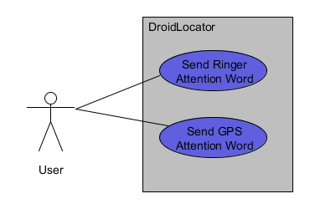

**Locator**

**Sequence diagram**

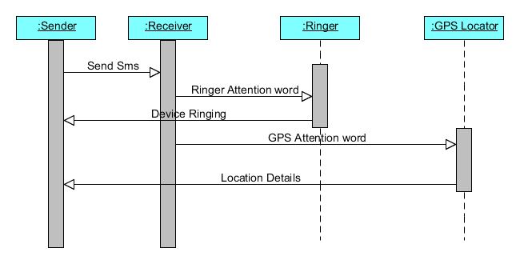

**Block diagram**

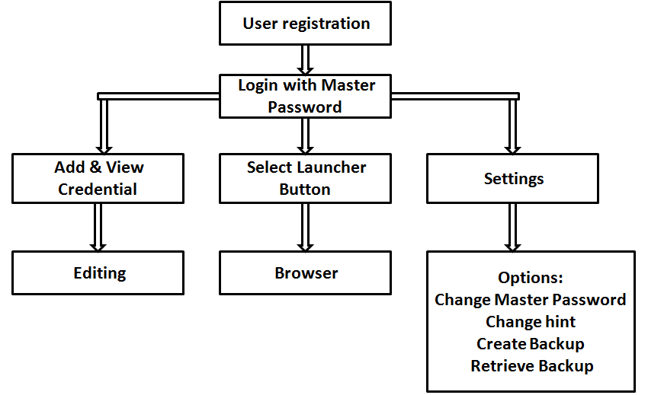

**Select Friend**

**View on Map**

**Data Flow Diagram**

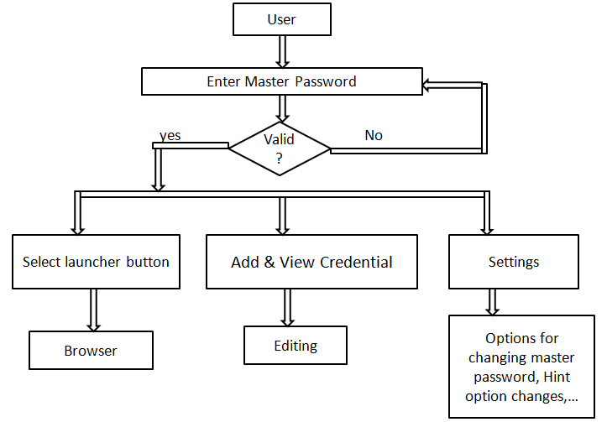

**Select Friend**

**View on Map**