Final_Cleaned_EC2_Instances (2).csv(text/csv) - 48289 bytes, last modified: 11/17/2025 - 100% done
Saving Final_Cleaned_EC2_Instances (2).csv to Final_Cleaned_EC2_Instances (2) (1).csv
📂 You uploaded: Final_Cleaned_EC2_Instances (2) (1).csv
✅ Dataset loaded: (402, 20)

📘 Columns:
['Instance type', 'Release Date', 'Instance vCPU', 'Platform Total Number of vCPU', 'Platform CPU Name', 'Instance Memory (in GB)', 'Platform Memory (in GB)', 'Storage Type', 'Platform Storage Drive Quantity', 'RAMWatt @ Idle', 'RAMWatt @ 10%', 'RAMWatt @ 50%', 'RAMWatt @ 100%', 'Delta Full Machine', 'Platform Additional Memory Scope 3 Emissions', 'Platform Additional Storage Scope 3 Emissions', 'Platform Additional GPU Scope 3 Emissions', 'Platform Additional CPU Scope 3 Emissions', 'Total Platform Scope 3 Emissions (kgCO?eq)', 'Instance Hourly Manufacturing Emissions (gCO?eq)']

🔑 Using columns:
CPU name : Platform CPU Name
Idle watt : RAMWatt @ Idle
Full watt : Delta Full Machine
vCPU: Instance vCPU
Scope 3 : Total Platform Scope 3 Emissions (kgCO?eq)

⚡ STEP 3 – Energy calculations

🔍 Sample energy rows:
Platform CPU Name RAMWatt @ Idle Delta Full Machine Estimated Power (W) \
0 Graviton 0.4 0.5 0.45
1 Graviton 0.8 1.0 0.90
2 Graviton 1.6 2.0 1.80
3 Graviton 3.2 4.0 3.60
4 Graviton 6.4 8.0 7.20

IT_kWh Total_kWh
0 3.942 5.5188
1 7.884 11.0376
2 15.768 22.0752
3 31.536 44.1504
4 63.072 88.3008

🌍 STEP 4 – CO₂ calculations (kg CO₂e PER YEAR)

🔍 Sample CO₂ rows:
Platform CPU Name Operational_CO2e_kg_per_year Embodied_CO2e_kg_per_year \
0 Graviton 2.20752 255.55
1 Graviton 4.41504 255.55
2 Graviton 8.83008 255.55
3 Graviton 17.66016 255.55
4 Graviton 35.32032 255.55

Total_CO2e_kg_per_year
0 257.75752
1 259.96504
2 264.38008
3 273.21016
4 290.87032

🌐 Baseline CO₂ totals (one of each instance, PER YEAR):
Operational CO₂ per year : 86,417.52 kg
Embodied CO₂ per year : 231,959.98 kg
TOTAL CO₂ per year : 318,377.49 kg

🧠 STEP 6 – Aggregate by Platform CPU Name

📊 Total CO₂ per CPU platform (kg CO₂e per year):
PlatformCPUName Operational_CO2e_kg_per_year \
0 Xeon Platinum 8176M 37898.703360
1 Graviton2 12217.642080
2 Xeon E5-2686 v4 9051.518784
3 Xeon E7-8880 v3 12455.808960
4 EPYC 7571 5462.876160
5 Xeon E5-2676 v3 1817.500272
6 Xeon E5-2670 v2 1968.249360
7 EPYC 7R32 1682.375520
8 Xeon E5-2670 917.396256
9 Xeon Platinum 8375C 1696.356480
10 Xeon E5-2666 v3 551.144160
11 Xeon E5-2650 74.516064
12 Xeon E5-2665 216.533184
13 Xeon E5-2680 v2 231.912240
14 Graviton 103.753440
15 Xeon E5-2651 v2 23.644992
16 Core i7-8700B 47.584320

Embodied_CO2e_kg_per_year Total_CO2e_kg_per_year Rows
0 44702.875 82601.578360 1
1 50349.925 62567.567080 39
2 39632.200 48683.718784 19
3 24461.900 36917.708960 6
4 19431.400 24894.276160 130
5 11921.200 13738.700272 8
6 10122.200 12090.449360 2
7 7109.200 8791.575520 6
8 7808.100 8725.496256 10
9 4022.775 5719.131480 19
10 2902.500 3453.644160 24
11 2888.400 2962.916064 28
12 2349.150 2565.683184 5
13 1701.250 1933.162240 75
14 1533.300 1637.053440 16
15 768.050 791.694992 5
16 255.550 303.134320 9

✅ Most CO₂-efficient CPUs (lowest kg CO₂e per vCPU per year):
PlatformCPUName CO2e_kg_per_vCPU_per_year
0 Core i7-8700B 25.261193
1 Xeon Platinum 8176M 36.875705
2 EPYC 7R32 41.818181
3 Xeon Platinum 8375C 55.096440
4 Xeon E5-2666 v3 60.245015
5 Xeon E5-2680 v2 69.663958
6 Xeon E5-2686 v4 81.096754
7 Xeon E5-2670 v2 82.627761
8 Graviton2 83.782596
9 Graviton 87.390853

📈 STEP 7 – Pareto analysis

🔍 Pareto head (Top 10):
PlatformCPUName Total_CO2e_kg_per_year Cumulative_pct
0 Xeon Platinum 8176M 82601.578360 25.944541
1 Graviton2 62567.567080 45.596548
2 Xeon E5-2686 v4 48683.718784 60.887742
3 Xeon E7-8880 v3 36917.708960 72.483319
4 EPYC 7571 24894.276160 80.302426
5 Xeon E5-2676 v3 13738.700272 84.617650
6 Xeon E5-2670 v2 12090.449360 88.415170
7 EPYC 7R32 8791.575520 91.176538
8 Xeon E5-2670 8725.496256 93.917152
9 Xeon Platinum 8375C 5719.131480 95.713488

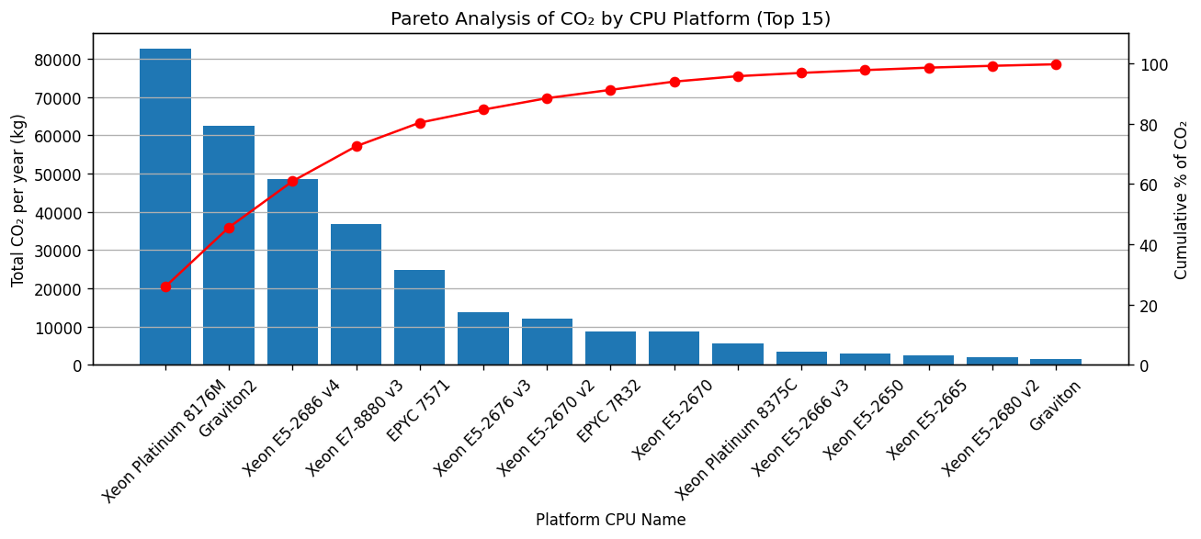
📊 STEP 8 – Graphs for ALL CPU platforms

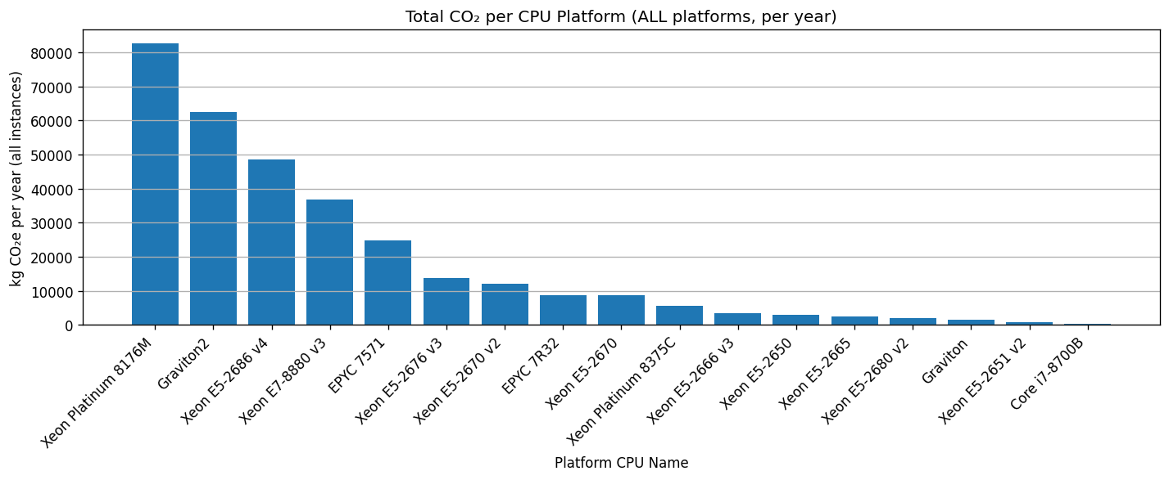
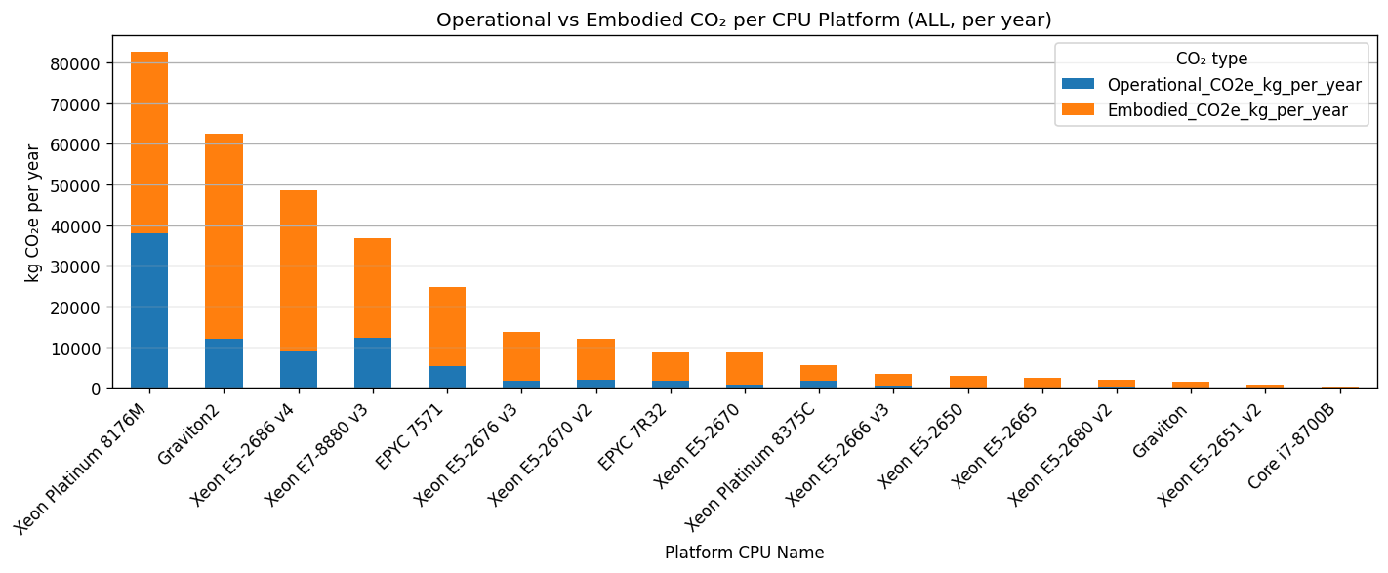
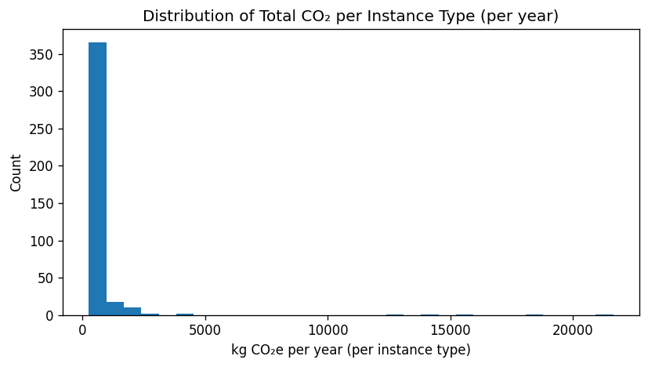
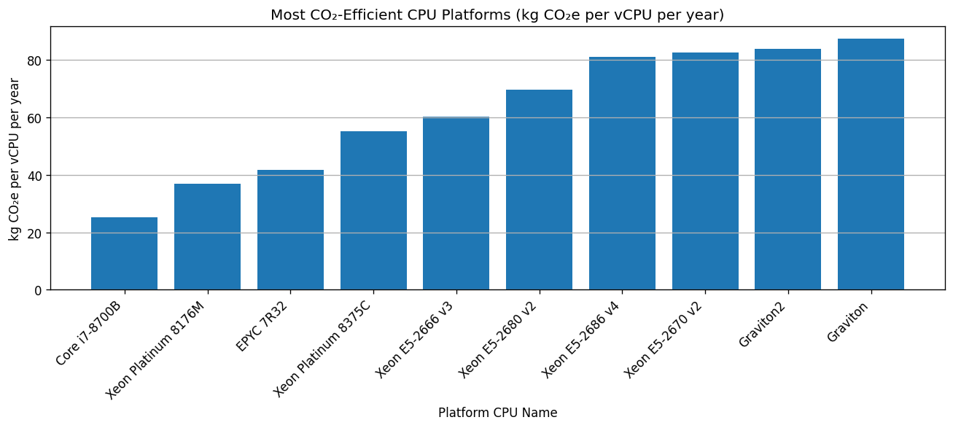
🌿 STEP 9 – Lean Scenario 1: Improve PUE from 1.4 to 1.2
Total CO₂ per year (PUE 1.4) : 318,377.49 kg
Total CO₂ per year (PUE 1.2) : 306,032.13 kg
CO₂ saved by better PUE : 12,345.36 kg (3.9% reduction)

🌿 STEP 10 – Lean Scenario 2: Autoscaling (25% fewer hours)
Total CO₂ per year after autoscaling : 296,773.11 kg
CO₂ saved by runtime cut : 21,604.38 kg (6.8% reduction)

🌿 STEP 11 – Lean Scenario 3: Ideal consolidation on best CPU
Total vCPU in dataset : 11065
Best CPU platform (CO₂ per vCPU/year) : EPYC 7R32
Best CO₂ per vCPU per year : 5.65 kg
Idealized total CO₂ per year : 62,536.77 kg
Potential CO₂ reduction (upper bound) : 255,840.72 kg (80.4% reduction)

📊 STEP 12 – KPI Dashboard & trend lines

KPI table:
Scenario Total_CO2e_kg_per_year Operational_CO2e_kg_per_year \
0 Baseline 318377.490632 86417.515632
1 PUE 1.2 306032.131256 74072.156256
2 Autoscaling -25% hrs 296773.111724 64813.136724
3 Ideal Consolidation 62536.765894 NaN

Embodied_CO2e_kg_per_year
0 231959.975
1 231959.975
2 231959.975
3 NaN

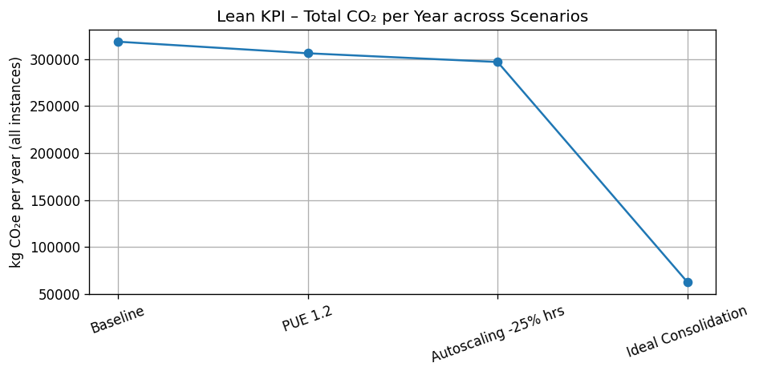
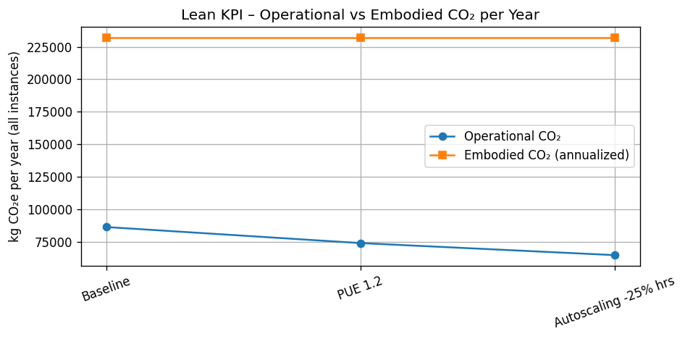
✅ Done – full data analysis, ALL CPU platform graphs, Pareto, Lean scenarios and KPI trends are generated.

