**GOVERNMENT POLYTECHNIC NAGAMANGALA**

**DEPARTMENT OF COMPUTER SCIENCE AND ENGINEERING**

**“V”th Semester Diploma**

**Artificial Intelligence and Machine Learning** (20CS51)

**Assignment:03**

**NAME: YASHASWINI S**

**ROLL NO:158CS22057**

**AIML (20CS51)**

**ASSIGNMENT – WEEK 02**

1. Download any two datasets from the internet and perform the following operations.

a) Analyze the univariate dataset Ex- Mean, Mode, Median, Range, Std, and Variance and perform Univariate tests for the dataset.

b) Analyze the multivariate of the dataset Ex- co-variance, co-relation.

c) Visualize the univariate and multivariate with various plots.

d) Push the code to your GitHub Repository.

1. Download any two datasets from the internet and perform the following operations.

a) Analyze the univariate dataset Ex- Mean, Mode, Median, Range, Std, and Variance and perform Univariate tests for the dataset.

MEAN:

import pandas as pd

path = ("//content/annual-enterprise-survey-2023-financial-year-provisional (3).csv")

df = pd.read_csv(path)

df.mean(numeric_only=True)

OUTPUT:

Year 2018.0

dtype: float64

MEDIAN:

df.median(numeric_only=True)

**OUTPUT:**

Year 2018.0

dtype: float64

MODE:

df.mode(numeric_only=True)

OUTPUT:

| **Year** |
| --- |
| **0** | 2013 |
| **1** | 2014 |
| **2** | 2015 |
| **3** | 2016 |
| **4** | 2017 |
| **5** | 2018 |
| **6** | 2019 |
| **7** | 2020 |
| **8** | 2021 |
| **9** | 2022 |
| **10** | 2023 |

RANGE

df.max(numeric_only=True) - df.min(numeric_only=True)

OUTPUT:

Year 10

dtype: int64

VARIANCE

df.var(numeric_only=True)

**OUTPUT:**

Year 10.000196

dtype: float64

addCode

addText

STANDARD DEVIATION

df.std(numeric_only=True)

**OUTPUT:**

Year 3.162309

dtype: float64

T-TEST:

import pandas as pd

import scipy.stats as stats

df=pd.read_csv('/content/annual-enterprise-survey-2023-financial-year-provisional (3).csv')

Year_df=df['Year'].values

t_stat, p_val=stats.ttest_1samp(Year_df, popmean=0)

print(f"One-sample t-test: t_stat={t_stat}, p_val={p_val}")

**OUTPUT:**

One-sample t-test: t_stat=144091.41779301083, p_val=0.0

CHI – SQUARE TEST:

import pandas as pd

from scipy.stats import chi2_contingency

df=pd.read_csv('/content/annual-enterprise-survey-2023-financial-year-provisional (3).csv')

contingency_table=pd.crosstab(df['Variable_name'],df['Value'])

chi2, p, dof, ex = chi2_contingency(contingency_table)

print(f"Chi-Square Test of Independent: chi2={chi2}, p={p}, dog={dof}, expected={ex}")

**OUTPUT:**

Chi-Square Test of Independent: chi2=795016.4394285574, p=0.0, dog=546880, expected=[[2.07119741e-01 2.58899676e-02 2.58899676e-02 ... 5.17799353e-02

5.91585761e+01 4.66019417e-01]

[2.39913700e-01 2.99892125e-02 2.99892125e-02 ... 5.99784250e-02

6.85253506e+01 5.39805825e-01]

[2.31283711e-01 2.89104639e-02 2.89104639e-02 ... 5.78209277e-02

6.60604099e+01 5.20388350e-01]

...

[2.39913700e-01 2.99892125e-02 2.99892125e-02 ... 5.99784250e-02

6.85253506e+01 5.39805825e-01]

[2.39913700e-01 2.99892125e-02 2.99892125e-02 ... 5.99784250e-02

6.85253506e+01 5.39805825e-01]

[2.19201726e-01 2.74002157e-02 2.74002157e-02 ... 5.48004315e-02

6.26094930e+01 4.93203883e-01]]

ANOVA:

import numpy as np

from scipy import stats

import pandas as pd

df = pd.read_csv('/content/annual-enterprise-survey-2023-financial-year-provisional (3).csv')

df['Value'] = pd.to_numeric(df['Value'], errors='coerce')

groups = df.groupby('Variable_name')['Value'].apply(list)

f_value, p_value=stats.f_oneway(*groups)

print(f"F-value: {f_value}")

print(f"P-value: {p_value}")

**OUTPUT:**

F-value: nan

P-value: nan

b) Analyze the multivariate of the dataset Ex- co-variance, co-relation.

CO-VARIANCE

df.cov(numerical_only=True)

**OUTPUT:**

|  | **Year** |
| --- | --- |
| **Year** | 10.000196 |

COR-RELATION

df.corr(numeric_only=True)

**OUTPUT:**

|  | **Year** |
| --- | --- |
| **Year** | 1.0 |

import matplotlib.pyplot as plt

import seaborn as sns

import pandas as pd

df=pd.read_csv('//content/annual-enterprise-survey-2023-financial-year-provisional.csv')

plt.figure(figsize=(16, 4))

plt.subplot(1, 4, 1)

plt.scatter(df['Year'], df['Year'], color='green')

plt.xlabel('Year')

plt.ylabel('Year')

plt.title('Scatter Plot')

plt.subplot(1, 4, 2)

sns.pairplot(df, vars=['Units', 'Value', 'Year'])

df['Value'] = pd.to_numeric(df['Value'], errors='coerce')

plt.subplot(1, 4, 3)

sns.heatmap(df.corr(), annot=True, cmap='coolwarm')

plt.title('Heatmap')

numeric_df = df.select_dtypes(include=['number'])

plt.subplot(1, 4, 4)

sns.jointplot(x='Value', y='Year', data=df, kind='hex', color='purple')

plt.tight_layout()

plt.show()

**OUTPUT:**

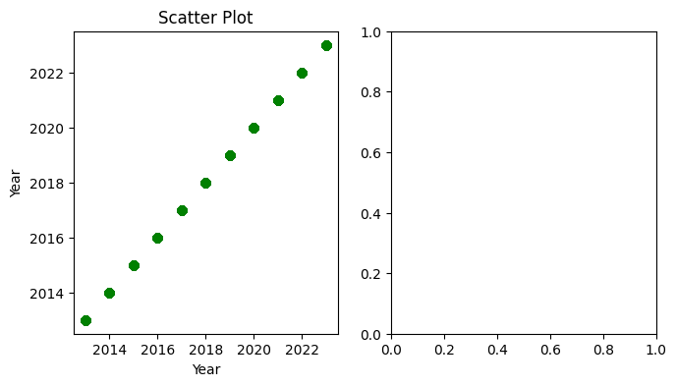

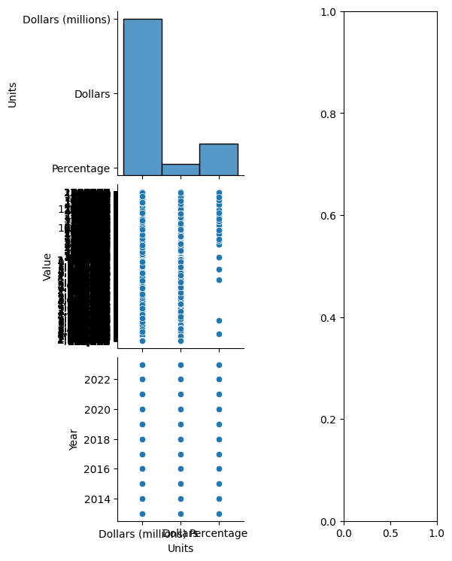

UNIVARIATE PLOTS:

import matplotlib.pyplot as plt

import seaborn as sns

import pandas as pd

data = pd.read_csv("/content/annual-enterprise-survey-2023-financial-year-provisional (3).csv")

plt.figure(figsize=(16,14))

plt.subplot(1,4,1)

plt.hist(data['Year'],bins=10, color='blue')

plt.title('Histogram of year')

plt.xlabel('year')

plt.ylabel('Frequency')

plt.show

plt.subplot(1,4,2)

sns.boxplot(data=data, x='Year', color='salmon')

plt.xlabel('Year')

plt.title('Box plot')

plt.subplot(1,4,3)

sns.violinplot(data=data, x='Year', color ='green')

plt.xlabel('Year')

plt.title('Violinplot')

plt.subplot(1,4,4)

sns.displot(data['Year'], kde=True, color='purple')

plt.xlabel('Year')

plt.title('distribution Plot')

plt.tight_layout()

plt.show()

**OUTPUT:**

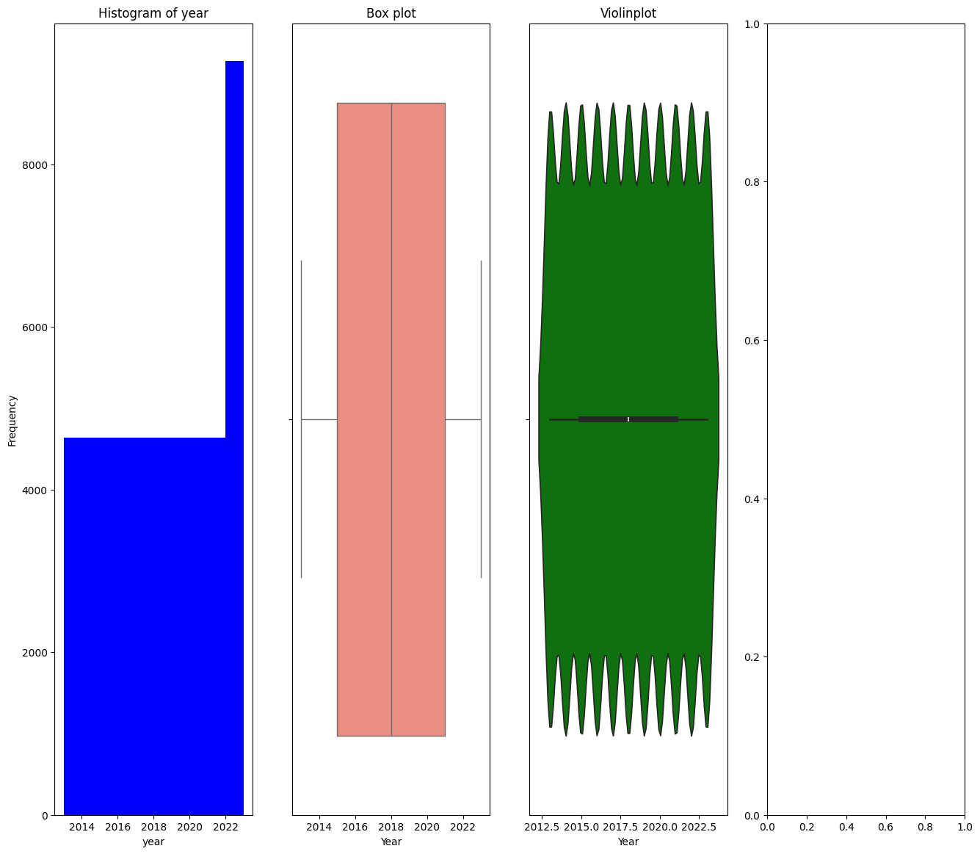

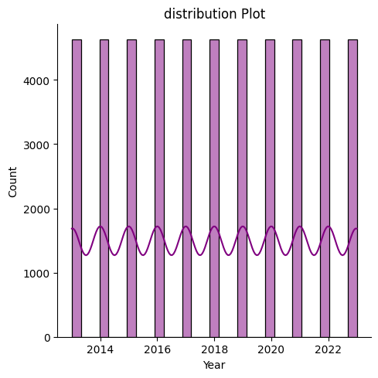

**DATASET – 2**

MEAN:

import pandas as pd

path = ('/content/tatauranga-umanga-maori-statistics-on-maori-businesses-march-2024-quarter.csv')

df = pd.read_csv(path)

df.mean(numeric_only=True)

**OUTPUT:**

Table_Number 4.625000

Quarter 202021.137931

dtype: float64

MODE:

df.mode(numeric_only=True)

**OUTPUT:**

|  | **Table_Number** | **Quarter** |
| --- | --- | --- |
| **0** | 7.0 | 201703 |
| **1** | NaN | 201706 |
| **2** | NaN | 201709 |
| **3** | NaN | 201712 |
| **4** | NaN | 201803 |
| **5** | NaN | 201806 |
| **6** | NaN | 201809 |
| **7** | NaN | 201812 |
| **8** | NaN | 201903 |
| **9** | NaN | 201906 |
| **10** | NaN | 201909 |
| **11** | NaN | 201912 |
| **12** | NaN | 202003 |
| **13** | NaN | 202006 |
| **14** | NaN | 202009 |
| **15** | NaN | 202012 |
| **16** | NaN | 202103 |
| **17** | NaN | 202106 |
| **18** | NaN | 202109 |
| **19** | NaN | 202112 |
| **20** | NaN | 202203 |
| **21** | NaN | 202206 |
| **22** | NaN | 202209 |
| **23** | NaN | 202212 |
| **24** | NaN | 202303 |
| **25** | NaN | 202306 |
| **26** | NaN | 202309 |
| **27** | NaN | 202312 |
| **28** | NaN | 202403 |

MEDIAN:

df.median(numeric_only=True)

**OUTPUT:**

Table_Number 5.0

Quarter 202009.0

dtype: float64

RANGE:

df.max(numeric_only=True) - df.min(numeric_only=True)

**OUTPUT:**

Table_Number 6

Quarter 700

dtype: int64

VARIANCE:

df.var(numeric_only=True)

**OUTPUT:**

Table_Number 3.695363

Quarter 43870.876720

dtype: float64

STANDARD DEVIATION:

df.std(numeric_only=True)

**OUTPUT:**

Table_Number 1.922333

Quarter 209.453758

dtype: float64

CO-VARIANCE:

df.cov(numeric_only=True)

**OUTPUT:**

|  | **Table_Number** | **Quarter** |
| --- | --- | --- |
| **Table_Number** | 3.695363 | 0.00000 |
| **Quarter** | 0.000000 | 43870.87672 |

COR-RELATION:

df.corr(numeric_only=True)

**OUTPUT:**

Table_NumberQuarterTable_Number1.000000e+001.164446e-12Quarter1.164446e-121.000000e+00

CHI-SQUARE TEST:

import pandas as pd

from scipy.stats import chi2_contingency

df=pd.read_csv('/content/tatauranga-umanga-maori-statistics-on-maori-businesses-march-2024-quarter.csv')

contingency_table=pd.crosstab(df['Value'],df['Unit'])

chi2, p, dof, ex = chi2_contingency(contingency_table)

print(f"Chi-Square Test of Independent: chi2={chi2}, p={p}, dog={dof}, expected={ex}")

**OUTPUT:**

Chi-Square Test of Independent: chi2=1377.3473684210526, p=7.645825814782184e-49, dog=685, expected=[[7.125 1.875 ]

[0.79166667 0.20833333]

[0.79166667 0.20833333]

...

[1.58333333 0.41666667]

[0.79166667 0.20833333]

[6.33333333 1.66666667]]

ANOVA:

import numpy as np

from scipy import stats

import pandas as pd

df = pd.read_csv('/content/tatauranga-umanga-maori-statistics-on-maori-businesses-march-2024-quarter.csv')

df['Value'] = pd.to_numeric(df['Value'], errors='coerce')

groups = df.groupby('Unit')['Value'].apply(list)

f_value, p_value=stats.f_oneway(*groups)

print(f"F-value: {f_value}")

print(f"P-value: {p_value}")

**OUTPUT:**

F-value: nan

P-value: nan

mport pandas as pd

from scipy.stats import chi2_contingency

df=pd.read_csv('/content/tatauranga-umanga-maori-statistics-on-maori-businesses-march-2024-quarter.csv')

contingency_table=pd.crosstab(df['Unit'],df['Value'])

chi2, p, dof, ex =i chi2_contingency(contingency_table)

print(f"Chi-Square Test of Independent: chi2={chi2}, p={p}, dog={dof}, expected={ex}")

**OUTPUT:**

Chi-Square Test of Independent: chi2=1377.3473684210526, p=7.645825814782184e-49, dog=685, expected=[[7.125 0.79166667 0.79166667 ... 1.58333333 0.79166667 6.33333333]

[1.875 0.20833333 0.20833333 ... 0.41666667 0.20833333 1.66666667]]

UNIVARIATE:

import pandas as pd

import matplotlib.pyplot as plt

import seaborn as sns

data = pd.read_csv('/content/tatauranga-umanga-maori-statistics-on-maori-businesses-march-2024-quarter.csv')

plt.figure(figsize=(16, 4))

plt.subplot(1,4,1)

plt.hist(data['Unit'], bins=10, color='Skyblue', edgecolor='black')

plt.xlabel('Unit')

plt.ylabel('Value')

plt.title('Histogram')

plt.show()

plt.subplot(1, 4, 2)

sns.boxplot(data=df, x='Value', color='pink')

plt.xlabel('Value')

plt.title('Box Plot')

plt.subplot(1, 4, 3)

sns.violinplot(data=df, x='Unit', color='orange')

plt.xlabel('Unit')

plt.title('Violin Plot ')

plt.subplot(1, 4, 4)

sns.displot(df['Unit'], kde=True, color='blue')

plt.xlabel('Unit')

plt.title('Distribution Plot ')

plt.tight_layout()

plt.show()

**OUTPUT:**

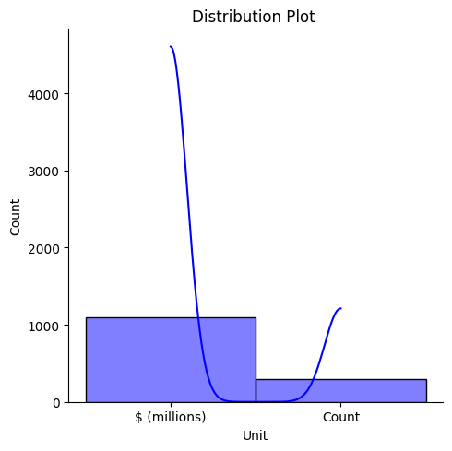

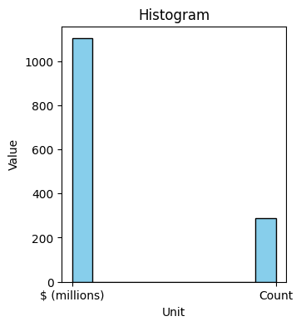

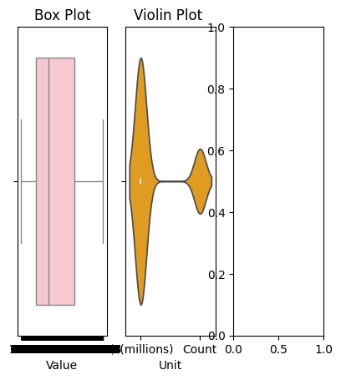

MULTIVARIATE PLOTS:

