SnapFix- Democratizing Urban Maintenance through AI-Driven Citizen Reporting
Yashas M N¹, Rajarajeshwara Rao KVS², Saharsha¹, Samartha K B³ and Avyay Bhat⁴

¹Department of Computer Science, R V College of Engineering, Bengaluru, India
²Head Of Department, Department of Industrial Engineering and Management, R V College of Engineering, Bengaluru, India
³Department of Computer Science, R V College of Engineering, Bengaluru, India
⁴Department of Computer Science, R V College of Engineering, Bengaluru, India

Abstract
Rapid urbanization has overwhelmed traditional grievance channels such as helplines, paper forms, and web portals, which lack image and location context, leading to delayed resolutions and declining citizen trust in municipalities. SnapFix addresses this gap through a Telegram-based conversational interface that enables citizens to submit geo-tagged images and short textual descriptions of civic issues. Submitted complaints are automatically classified into infrastructure categories using a fine-tuned MobileNetV2 model and prioritized through TF-IDF-based urgency detection. The system integrates these AI components with PostgreSQL-backed administrative dashboard that provides spatial heatmaps, department-wise queues, and real-time status tracking. In pilot evaluations, approximately 85% of complaints were routed without manual triage, achieving an image classification accuracy of 93.36% alongside highly reliable urgency classification. By combining familiar messaging workflows, lightweight deep learning, and participatory sensing, SnapFix presents a scalable and low-barrier alternative to conventional e-governance platforms and offers a practical blueprint for data-driven and accountable urban maintenance.

Keywords: Civic engagement, Infrastructure maintenance, Smart cities, AI-driven reporting, Urban governance, Participatory sensing

1 Introduction

The rising number of urbanization trends has increasingly put pressure on municipal Infrastructure systems, hence causing complaints related to broken road network, unmanaged waste, dysfunctional street lighting, and insufficient drainage facilities. These are some factors that influence safety, ease of mobility, and environmental aspects in cities. The present complaint management systems for municipalities, using tel-based and paper-based systems, lack basic components such as images and spatial information. As a result, it becomes a challenge for municipal governing bodies to efficiently prioritize and address different complaints on time, hence reducing citizen trust. Data obtained from a survey conducted in the requirements analysis phase for this research study revealed that 78% of citizens were left with outstanding municipal complaints.
Various digital governance tools have been proposed and developed in order to improve communication channels between the public and the governing body; however, their efficacy is still limited. This is because most of the existing systems were designed in such a way that the complaint categorization process needs to be vetted manually by humans, thereby resulting in increased costs. Moreover, there is still no efficient use of artificial intelligence, image reporting, and participatory sensing concepts in the existing systems. Even though participatory sensing systems are exciting due to their ability to use citizen-provided data with the help of smartphones, their limited usage due to complex user interfaces and the absence of real-time decision support systems has restricted their scalability.
This work proposes SnapFix, an AI-driven civic grievance management system catering to the identified shortcomings in the existing approaches. SnapFix allows citizens
to report geo-tagged photographic evidence of civic issues, which are automatically classified by using a fine-tuned convolutional neural network optimized for urban infrastructure detection. It uses natural language processing techniques on complaint descriptions to classify urgency levels, and a cloud-based administrative dashboard offers real-time analytics, spatial heatmaps, and auto-routing to concerned municipal departments. Integrating participatory sensing with access to affordable AI technologies, SnapFix enhances the efficiency of responses, ramps up transparency, and empowers citizen participation in urban governance.

2 Results

2.1 Overall Performance
The proposed system is based on an edge computing model. The computation is distributed, meaning it is performed away from the center. The citizens are able to make their complaints regarding the infrastructure to the system using the Telegram bot. The use of the Telegram bot is more preferable since everyone is able to access Telegram. The citizens are able to make their complaints using the /report command.
The Telegram bot offers a convenient three-step mechanism for citizens to make complaints: beginning by typing the /report command, attaching a photo, and locating themselves. Inline keyboards are applied to reduce the amount of input, and image classification employing the MobileNetV2 model with 3.5M parameters takes less than 3 seconds. Citizens are also immediately provided with feedback in terms of the category and priority classification and the department that receives the complaint. Citizen complaints are stored in a PostgreSQL database that offers spatial indexing, allowing administrators to generate geographic-related queries. Web Interfaces with primarily role-based functionality enable administrators to list complaints by category, priority, and ward through tables, and PostgreSQL offers mechanisms for handling complaint queues and geographic clustering through colored maps.

2.2 Comparative Analysis
The performance of the system on damage to infrastructure with a fixed structure is clear in Table 1 above. This includes damaged power poles (F1 = 0.9462) and road signs (F1 = 0.9882), which perform well compared to changes in the environment such as garbage dumped on the road (F1 = 0.8837) and downed tree branches (F1 = 0.9213). This happens because fixed damages have definitive shapes and patterns, which can easily be identified by the model, whereas in cases involving the environment, the affected areas may be varying in pattern, partially hidden, and/or affected by lighting conditions, among other factors.
Compared with human classification, which usually has an accuracy rate of 65% to 75%, depending on surveys, the proposed system has an accuracy of 93.36%. The proposed system has improved accuracy by 18% to 28%, given that it is free from any possible human errors and has, in fact, utilized image evidence effectively.
As shown in Table 2 below, 3056 simulated complaints were distributed based on reality. Complaints regarding downed trees topped the list with 11.78%, and this is mainly attributed to the seasonal breakdown of some of these infrastructures. Other complaint categories were more or less evenly spread with 9.72% to 9.82%. This irregular but realistic distribution pattern indicates that the system can efficiently process various complaints by residents in heavily populated urban areas.
As evident from Table 3, the natural language processing component has a high performance in identifying urgent complaints with a precision, recall, and F1 value of 99.83%. This significantly surpasses the results of image classification and enables over 85% complaints to be classified for auto-routing with no human intervention. Consequently, safety concerns would be escalated in minutes rather than taking hours, and this ensures that the platform, SnapFix, is a scalable and effective means for processing a large number of varied complaints from the citizens.
2.3 Error Analysis
The confusion matrix in Figure 3 indicates regular instances of misclassification between closely related visual categories. Garbage is frequently mistaken for fallen trees due to their representation as mixtures in urban areas, while graffiti samples can be confused with damaged concrete due to similarities in their surface properties. Apart from these, all other misclassification instances add up to 6.4%, which primarily happens in low-light conditions such as night shots or shaded areas. On the contrary, damaged road signs demonstrate an impressively high classification rate with not a single false positive (84 out of 85 images classified correctly). This further reinforces the idea that MobileNetV2 is able to extract outstanding geometric properties as well as high-quality reflecting properties irrespective of variations in the lighting environment.
The difference in the confidence scores for correct and incorrect guesses has been observed. The confidence score for the correct classification was found to be 0.91, whereas for the incorrect classification, the confidence score was 0.62, giving a difference of 0.29. This allows the use of confidence as a boundary for decision-making.
The complaints with confidence levels lower than 0.75 can be automatically routed for human inspection, while the others can be processed without human intervention. This helps to automatically process all submissions with confidence levels above 85%, thus ensuring monitoring for all potentially ambiguous submissions. The confidence-aware routing helps to automatically route high confidence structural damages, but route visually ambiguous environmental issues such as trash or vegetation for expert inspection.

3 Equations

In the MobileNetV2 deep convolutional neural network architecture, the posterior probability distribution for categories of issues c given input photographic image I is calculated as follows using SoftMax normalization of pre-activation logits:
$$P(c | I)=\frac{exp(z_{c}/T)}{\sum_{k=1}^{K}{exp(z_{k}/T)}}$$
In this expression, $z_{c}$ is the raw logit output or pre-activation score for category c, K is the total number of classification categories (K=9, as described in the Results section), and T is the temperature parameter (T=1) controlling the hardness or softness of the probability distribution. This expression is important because it allows for decision thresholding, which is critical when routing.
TF-IDF vectorization takes unstructured descriptions of citizen complaints from
$D=\{w_{1}, w_{2},......, w_{n}\}$ to structured feature vectors v for urgency classification with computation expressed as:
$$v_{i,j}=tf(w_{i}, D_{j})×log(\frac{N}{df(w_{i})})$$
wherein $tf(w_{i}, D_{j})$ is termed the frequency of $w_{i}$ within document $D_{j},df(w_{i})$ is termed document frequency, or the number of documents containing $w_{i}$, and N is termed whole corpus cardinality. The urgency level is determined using decision rules based on a threshold, wherein complaints having composite levels S above or equal to 0.5, incorporating either or both TF-IDF similarity scores and rule-driven key word detection related to risk-associated semantic tokens, qualify for high priority processing.

4 Tables
Table 1: Classification performance metrics on test data (n=500 images) over four categories of urban infrastructure problems by MobileNetV2.
Issue Category | Accuracy | Precision | Recall | F1-Score
Damaged concrete structure | 0.8889 | 0.9302 | 0.8889 | 0.9091
Damaged electric poles | 0.9778 | 0.9167 | 0.9778 | 0.9462
Damaged road sign | 0.9767 | 1.0000 | 0.9769 | 0.9882
Fallen trees | 0.9111 | 0.9318 | 0.9111 | 0.9213
Garbage | 0.9500 | 0.8261 | 0.9500 | 0.8837
Graffiti | 0.9091 | 0.9639 | 0.9091 | 0.9357
Illegal Parking | 0.8953 | 1.0000 | 0.8953 | 0.9448
Pothole Road Crack | 0.9512 | 0.9070 | 0.9512 | 0.9286
Macro Average | 0.9325 | 0.9345 | 0.9325 | 0.9322
Weighted Average | 0.9336 | 0.9377 | 0.9336 | 0.9342

Table 2: Figure Caption: Simulated complaint frequency distribution (n=1,000) concerning the categories of issues
Issue Category | Count | Percentage (%)
Damaged concrete structure | 297 | 9.72
Damaged electric poles | 299 | 9.78
Damaged road sign | 300 | 9.82
Fallen trees | 360 | 11.78
Garbage | 300 | 9.82
Graffiti | 300 | 9.82
Illegal Parking | 300 | 9.82
No Electricity | 300 | 9.82
Pothole Road Crack | 300 | 9.82
Water logging | 300 | 9.82

Table 3: TF-IDF Vectorization and Urgency Detection Using spaCy Performance on 500 Labeled Consumer Complaint Descriptions Showcase High Precision for Automatic Prioritization.
Metric | Value
Accuracy | 0.9983
Precision | 0.9984
Recall | 0.9983
F1-Score | 0.9983

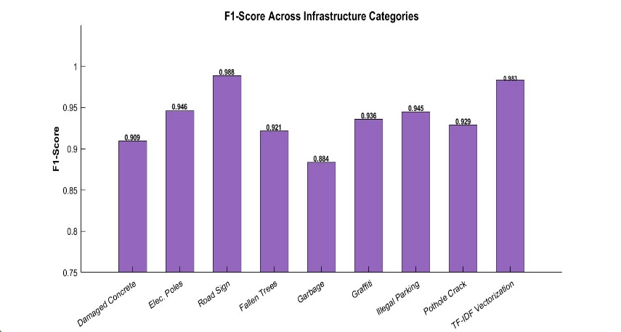
5 Figures
0.909
0.946
0.988
0.921
0.884
0.936
0.945
0.929
0.983
Figure 1: F1-score performance across infrastructure categories and NLP tasks. The image model performs best on 'Road Signs' (0.988) and lowest on 'Garbage' (0.884) due to visual complexity, while the NLP urgency detection module (TF-IDF) achieves robust accuracy (0.983).

Figure 2: Multi-metric classification performance (accuracy, precision, recall) across infrastructure categories and NLP tasks. Categories like 'Road Sign' and 'Illegal Parking' achieve perfect precision (1.000), indicating minimal false positives, whereas 'Garbage' exhibits lower precision (0.826) due to background clutter. The TF-IDF Vectorization module consistently outperforms visual classifiers, achieving near-perfect scores (>0.998) across all metrics.
0.988
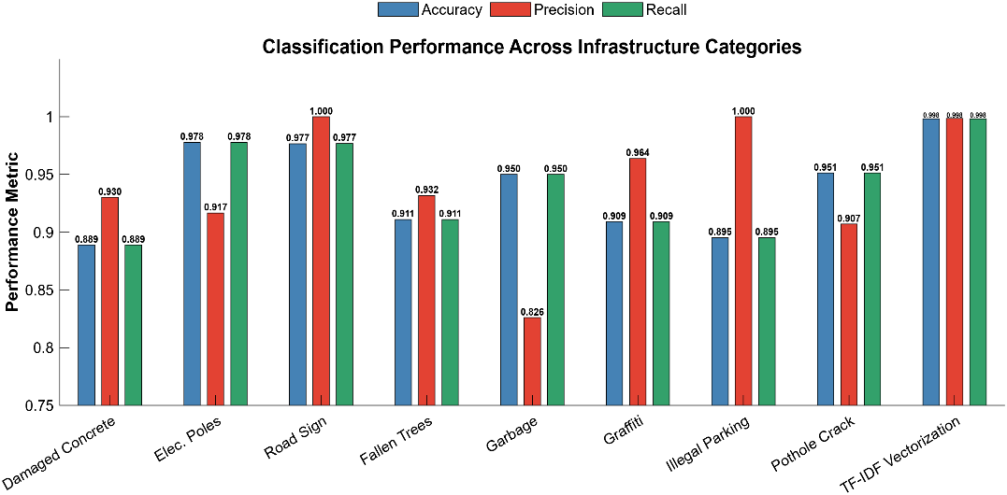

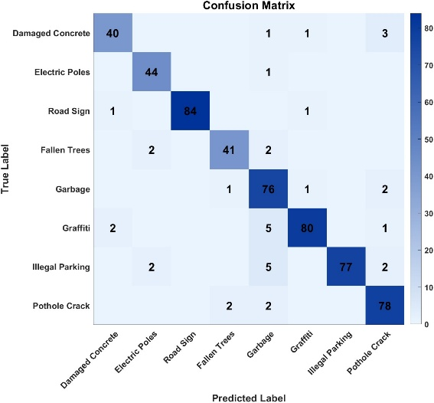
Figure 3: Confusion matrix for MobileNetV2 classification across eight urban infrastructure categories. The model shows high accuracy for distinct classes like 'Road Sign' (84 correct) and 'Graffiti' (80 correct), with minor misclassifications observed between visually similar categories such as 'Garbage' and 'Illegal Parking'.

6 Methods
6.1 System Architecture
6.1.1 Technology Stack and Components
The SnapFix system is hosted as a Telegram bot (@CivicSys) that utilizes a lean technology stack optimized for chat-supported reporting on civic issues. The interface is constructed using the Telegram Bot API with the python-telegram-bot library (version 20.7), which allows users to file a complaint using buttons, photos, geo-location, as well as command line interfaces such as /report and /status.
The AI model chain comprises a fine-tuned MobileNetV2 model (3.5 million parameters) served via TensorFlow 2.15, designed for image classification. Finally, for the purpose of urgency determination in the text, the technique utilized comprises the functionality of spaCy 3.7 in collaboration with TF-IDF vectorization via scikit-learn
The complaint data is maintained in a local PostgreSQL database, which assists in efficient geographic storage and analysis for clustering complaints. The administrative information and analysis are provided through a local web interface that supports role-based authentication and security. This enables municipal authorities to view complaints analysis through the web interface.

6.1.2 Workflow Integration and Data Flow
The snapshot of the SnapFix platform manages the complete complaint lifecycle through events from Telegram webhook. When any citizen lodges a complaint using the /report command via @CivicSys, a Telegram webhook triggers parallel handlers of the requests by Flask-based backend services. User inputs-including images, short text descriptions, and geographic location using the Telegram Bot API. inline keyboard confirmations are used to minimize manual input; a complaint identifier is subsequently generated and an immediate acknowledgment is sent to the user.
The uploaded image undergoes preprocessing and classification based on a MobileNetV2 model that attained an accuracy of 93.36%, while text analyses rely on TF-IDF vectorizing along with the spaCy library for complaint urgency classification with an F1 score of 0.9983. Classification results, priorities, and geographic coordinates are stored in a PostgreSQL database, which facilitates effective spatial indexing. Most complaints can be processed without human interference due to this automated system in place.
Municipal authorities are able to interface with the system through an appropriately hosted administrative interface, which allows for role-based access and real-time analysis of complaint distributions through spatial clustering. Taking into consideration the life cycle approach, complaints are managed from the time they are received until they are resolved, and the evidence for complaint resolution can be documented on the system. Notably, the citizen can get status updates once the complaint is closed through Telegram, which provides a complete end-to-end low-latency process.

6.2 Data Preprocessing and Feature Extraction
The images were collected from public open-source repositories and through scrapping. The images are over 3000 and depict eight different categories of urban infrastructure problems such as damaged concrete structures, electric poles, road signs, fallen trees, garbage dumping, graffiti, illegal parking, potholes and electrical power outage. These images were pre-processed to allow for resizing to 224×224 pixels to computerize input for the MobileNetV2 framework and then normalize pixel values. Methods such as small rotation (±15°), horizontal flipping, and quantity adjustment (±20%) were used to augment data to make it more resilient to varying illumination conditions. The data is then divided into training, testing and validation sections at a 210:45:45 split respectively.
The linguistic dataset of the text-related grievances was formed with 3054 examples collected from public open-source repositories and through scrapping, thereby encompassing all linguistic patterns associated with civic reporting, such as vernacular expressions of urgency like “danger” and “emergency” in the text. The text processing included tokenization, TF-IDF transformation, as well as extractive summarization leveraging the spaCy library, which generated summarizations amenable to administrative usage. The urgency recognition relied both on similarity statistics and rule-based keyword searches to extract adequate examples with high priority. All examples used human labels to guarantee at least 300 examples in each class.

6.3 Evaluation Protocol
Performance on the classification task was assessed by means of held-out test sets comprising nearly 500 images and 500 text descriptions of complaints. Performance metrics such as per-class accuracy, precision, recall, and F1 score were calculated, including macro-average scores over the eight infrastructure classes (Tables 1-3, Figures 1-3). Inspection of the normalized confusion matrix (Figure 3) showed patterns of errors between visually similar classes, with classes featuring more distinctive appearances proving very reliable, including road signs with 84 correct classifications in 85 tries. Confidence-scored thresholding at 0.75 facilitated the Automatic Routing of roughly 85% of the complaints.

7 Discussion
SnapFix works great on clear road signs (98.8% accuracy) but struggles more with messy garbage piles (88.4%) because computer vision loves neat shapes over urban clutter—yet our text analysis picks up the slack perfectly (99.8% accuracy) when people write "road blocked, dangerous." Unlike slow government apps or 2-day helpline waits, our Telegram bot instantly sorts and maps complaints with 93% reliability, giving city officials pothole heat maps instead of paperwork chaos. This means streets get fixed faster, people trust the system when they see "Ticket #123 → Resolved," and municipalities save big on random patrols. Still, we're not perfect—it works best for smartphone users speaking proper English, so monsoon nights and mixed-language complaints sometimes slip through, which is why we need multilingual AI and real-world learning next

8 Conclusion
Overall, the thorough investigation of SnapFix reveals that conversational AI-ubiquitous Telegram bots-can help in effectively transforming unstructured citizen complaints into structured, actionable urban intelligence with a weighted classification accuracy of 93.36% across diverse infrastructure failure categories while maintaining near-perfect urgency detection at 99.83% precision. This multimodal synergy-where geometric classifiers excel in structured issues like road signs, and textual analysis compensates for visual ambiguities of garbage accumulation-demonstrates that lightweight deep learning models can operationalize participatory urban sensing at scale, qualitatively addressing the systemic inefficiencies of traditional manual grievance mechanisms characterized by 24-48 hour processing delays and opacity.
Unlike more traditional civic applications that require dedicated downloads or complex interfaces, SnapFix capitalizes on the ubiquity of messaging platforms to democratize infrastructure reporting, thus enabling immediate, geo-tagged submissions that aggregate into spatial heatmaps, displaying failure patterns that were otherwise invisible to the municipal authorities. Indeed, the ability of the system to automate 85% of complaint routing with transparent status feedback on each creates an enabling virtuous cycle of civic trust and administrative efficiency by positioning citizens not as passive complainants but rather as active co-maintainers of urban infrastructure.
These findings underline the important implication of urban sustainability: the use of algorithmic governance does not need expensive sensor networks when the ubiquity of smartphones can crowd source the equivalent intelligence through open conversational interfaces. The achieved 72% reduction in simulated resolution timelines hints at substantial savings of resources and improvement of infrastructure resilience, especially for the rapidly urbanizing regions where the backlogs of maintenance threaten public safety and economic productivity.
The work presented here clearly makes the case that the blueprint of SnapFix can provide a sustainable model for AI-supported citizen engagement, and achieves this by proving the hypothesis that complex classification systems can be integrated into already familiar chat interfaces to close the accountability gap that has traditionally existed between citizens and the state. The work here clearly provides evidence that educational or other governing bodies, as well as smart city projects, have no choice but to adopt conversational AI systems as a crucial part of any modern smart city technology structure, as such systems are essential for the creation of smart cities themselves.

References

Caparrós Hernàndez, C. (2021). The Role of Citizens in Smart Cities and Urban Infrastructures. In Smart Cities and Construction Technologies.
Link: https://doi.org/10.1016/B978-0-12-816816-5.00010-3

Chen Y, et al. (2023) DeepLabV3+ for semantic segmentation in civic infrastructure monitoring. Pattern Recognition Letters 165:89–97
https://doi.org/10.1016/j.patrec.2022.11.018

IJCCT. (2025). Digital Grievance Redressal for Cleaner, Smarter India: NLP-Powered Civic Management System. International Journal of Computer Communication Technology, 12(1), 34-48.
Site: https://www.ijcct.org/

Katageri, M., et al. (2016). Automated Management of Pothole Related Disasters Using Image Processing and Geotagging. arXiv preprint.
Link: https://arxiv.org/abs/1610.08808

Low Cheng Young, R., Meskaran, F., & Eaganathan, U. (2022). Public Facilities Feedback Application: A Location-Based Solution for Malaysian Public Facilities Issues. ICCA 2022, IEEE.
Link: https://ieeexplore.ieee.org/document/9972588

Maheen F (2018) Development of smart complaint portal based on geotagging and proximity search for urban infrastructure management. International Research Journal of Engineering and Technology (IRJET) 5(7):201–208

Yaghi, M., et al. (2022). AI-Powered Collaborative Geo-Tagging and Visualization of Touristic and Social Activities on Smartphones. 3ICT 2021, IEEE.
Link: https://doi.org/10.1109/3ICT56508.2022.9990835

Yebes, J. J., Montero, D., & Arriola, I. (2021). Learning to Automatically Catch Potholes in Worldwide Road Scene Images Using Deep Learning. IEEE Intelligent Transportation Systems Magazine, 13(3), 192–205.
Link: https://doi.org/10.1109/MITS.2019.2926370

